Peptide Aptamer sP10 Targeting NPM1 Attenuates Liver Fibrosis and Hepatocellular Carcinoma

Running title：Targeting NPM1 inhibits liver fibrosis and hepatoma

Xian Feng^{1,#}, Hai-Bin Pang^{1,#},Yong-Gui Wei^{1,#}, Dong-Hui Xu^{1,2,#}, Xin-Le Zhu^{1,#}, Dai Cao¹,Yang Yu¹, Ya-Fen Chen¹, Ling Yang¹, Yu-Jun Zhang³, Xiao-Ling Deng¹, Li-Ping Bai^{4,5,}*, Kuan-Can Liu^{6,}*, Song-Lin Shi^{1,3,}*

¹ Cancer Research Center, School of Medicine, Xiamen University, Xiamen, China.
² Department of Hepatic Biliary Pancreatic Vascular Surgery, the First Affiliated Hospital of Xiamen University, School of Medicine, Xiamen University, Xiamen, China.
³ Department of Basic Medical Sciences, School of Medicine, Xiamen University, Xiamen, China.
⁴ Department of Gastrointestinal Surgery, the Affiliated Zhongshan Hospital, and Institute of Gastrointestinal Oncology, School of Medicine, Xiamen University, Xiamen, Fujian, China.
⁵ School of Clinical Medicine, Fujian Medical University, Fuzhou, Fujian 350000, P.R. China.
⁶ Xiang'an Hospital of Xiamen University, School of Medicine, Xiamen University, Xiamen, China.

# The authors contributed equally to this work.
*Corresponding author: Song-Lin Shi (E-mail:shisonglin@xmu.edu.cn), Kuan-Can Liu (E-mail: liukuancan@xmu.edu.cn ), and Li-Ping Bai (E-mail:bailiping@xmu.edu.cn). Address: Room 303, No.4221-122, Xiang'annan Road, Xiang'an District, Xiamen City, 361102.

Supplementary Figures and Tables

Fig. S1 Intracellular expressed protein structure containing peptide aptamer sequences.
The TrxA protein served as the foundation for the peptide aptamer sequence, and the peptide aptamer sequence P10 was situated on the globular surface of the TrxA protein. P128 and P128 served as negative controls with the deletion of the P10 sequence. The intracellular expressed peptide aptamers were also marked with the C-terminal Myc tag and His tag for the purpose of identifying the expression of the peptide aptamer.

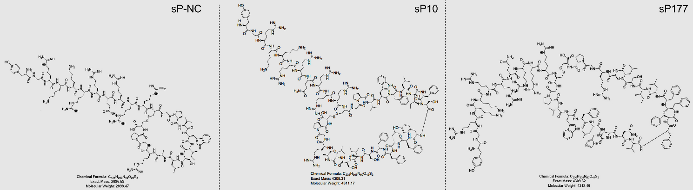
Fig. S2 The structure of the synthesized peptide aptamers. The cysteine residues on both sides of the peptide aptamer were linked through disulfide bonds, resulting in a more stable configuration for the peptide aptamer.

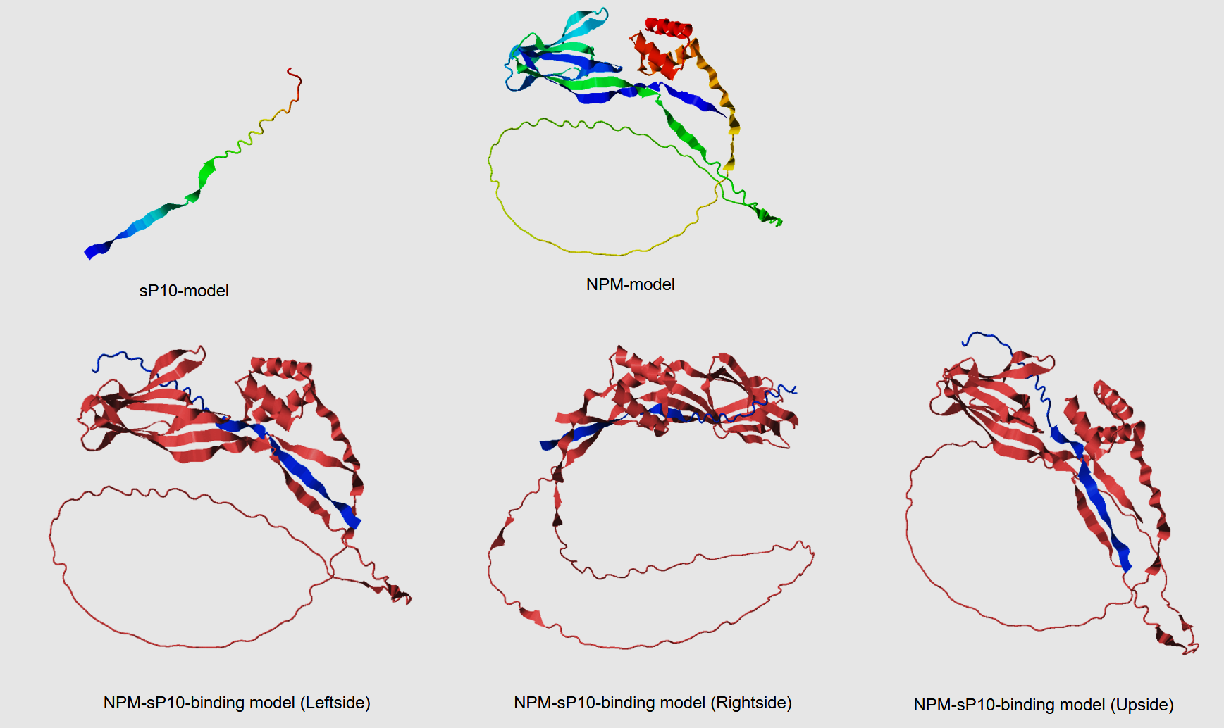
Fig. S3A The structure of NPM protein and its binding sites with sP10 peptide were predicted using DMPfold. The prediction analysis results show that different sites of the sP10 peptide sequence can respectively bind to the N-terminal and C-terminal domains of NPM protein.
Fig. S3B The inhibitory effect of sP10 on cell proliferation is NPM-dependent. (A) qRT-PCR showed that siNPM successfully knocked down the expression of NPM in LX-2 cells. (B) CCK-8 results indicated that sP10 inhibited the proliferation of LX-2 cells. (C) CCK-8 results indicated that after the expression of NPM was knocked down by two different siNPMs, sP10 no longer inhibited cell proliferation of LX-2 cells. All data (n = 3) were expressed as Mean ± SD. "ns" indicated no significant statistical difference, "***" indicated p < 0.001, and "****" indicated p < 0.0001.
Fig. S4 P10 and synthetic peptide sP10 inhibited the malignant phenotype of liver cancer
(A) The wound-healing assay results revealed that the intracellular expressed peptide aptamer P10 or the treatment with synthetic peptide sP10 hindered the migration of human HCC cell line SK-Hep1 and mouse HCC cell line Hepa1-6, respectively. (B) In the SK-Hep1 subcutaneous xenograft experiment, the intracellular expression of P10 or the treatment of the tumor-bearing mice with sP10 did not significantly influence the body weight of the mice. (C) The IHC results of subcutaneous xenograft expressing P10 or negative control peptide indicated that P10 down-regulated the expression of NPM1 and Ki67. (D) No lung metastatic nodules were observed in subcutaneous xenograft expressing P10 or negative control P128. (E) In the xenograft of wild-type SK-Hep1 cells, the treatment with sP10 down-regulated the expression of NPM1 and Ki67 proteins in tumor tissues. (F) No lung metastasis was detected in the xenograft of wild-type SK-Hep1 cells. (G) sP10 treatment inhibited lung metastasis of subcutaneous xenograft in NSG mice. (H) SK-Hep1 cells were transfected with lentivirus to screen cell lines stably expressing luciferase. (I) When SK-Hep1 cells expressing luciferase were subcutaneously inoculated into BALB/c nude mice, sP10 treatment significantly inhibited tumor growth. (J) In a BALB/c nude mouse lung metastasis model by tail vein injection of SK-Hep1 cells expressing luciferase, sP10 significantly reduced the fluorescence intensity in the lung, suggesting that sP10 inhibited the formation of pulmonary metastatic nodules.

Fig. S5 sP10 and sP177 did not have a significant effect on the localization of NPM1 protein in LX-2 cells.

Fig. S6 sP10 and sP177 respectively promoted the apoptosis of LX-2 cells in a dose-dependent manner.

Fig. S7 sP10 and sP177 have different effects on ROS of hepatic stellate cells LX-2 and hepatoma cells SK-Hep1. (A) sP10 and sP177 upregulated ROS in LX-2 cells; (B) sP10 inhibited ROS in the hepatoma cell line SK-Hep1.
Fig. S8 RNA sequencing of sP10- or sP177-treated LX2 cells demonstrated highly overlapping biological processes and pathways.(A) Transcriptomic analysis of LX-2 cells revealed that, compared to the control group, sP10 treatment upregulated 773 genes and downregulated 786 genes, while sP177 treatment upregulated 1,090 genes and downregulated 1,140 genes. (B,C) Gene Ontology (GO) and Kyoto Encyclopedia of Genes and Genomes (KEGG) pathway analyses of these shared DEGs indicated that both sP10 and sP177 significantly influenced biological processes such as positive regulation of cytoplasmic translation,mitotic nuclear membrane reassembly and organization, as well as pathways including autophagy, ferroptosis, and mitophagy. These findings suggest that sP10 and sP177 inhibit HSC activation by suppressing proliferation and promoting autophagy and cell death. (D) The first 20 differential genes.

Fig. S9 The nanoparticle size and zeta potential analyzer was used to analyze sP10 (A), sP177 (B), and the lipid-coated sP10-formed nanoparticles sP10-LNP (lip-CA-sP10) (C), characterizing changes in their particle size and zeta potential.​

Protein | Concentration  for WB | Concentration  for IHC/IF | Host | Company,Cat No. and RRID
NPM | 1:1000 | 1:300 | Rabbit | Abcam; ab52644; RRID:AB_881735
TGFβ-1 | 1:1000 | 1:200 | Rabbit | Proteintech; 21898-I-AP; RRID: AB_2811115
TGF-β2 | 1: 200 | / | Mouse | Santa Cruz Biotechnology; sc-374659; RRID:AB_10988781
Collagen I | 1: 1000 | / | Rabbit | Abcam; ab34710; RRID:AB_731684
α-SMA | 1: 2000 | 1:200 | Rabbit | Proteintech; 14395-1-AP; RRID:AB_2223009
P-Akt | 1: 2000 | / | Rabbit | Cell Signaling Technology;4060; RRID:AB_2315049
Akt | 1: 1000 | / | Rabbit | Cell Signaling Technology; 4685; RRID:AB_2225340
Flag | 1: 2000 | / | Mouse | Beyotime;AF2852 ; RRID: AB_2943049
β-actin | 1: 20000 | / | Mouse | Proteintech; 66009-1-Ig; RRID:AB_2687938
α-tubulin | 1: 20000 | / | Mouse | Proteintech;66031-1-Ig; RRID:AB_11042766
GAPDH | 1: 5000 | / | Mouse | Proteintech; 60004-1-Ig; RRID:AB_2107436
P- Smad2 | 1: 1000 | / | Rabbit | Cell Signaling Technology;3104;RRID:AB_390732
Smad2 | 1: 1000 | / | Mouse | Cell Signaling Technology;3103;RRID:AB_490816
Ki67 | / | 1:200 | Rabbit | Cell Signaling Technology; 12202; RRID:AB_2620142
Myc-tag | 1: 1000 | / | Mouse | Beyotime; AM926; RRID:AB_2895205
anti-Rabbit IgG | 1: 10000 | / | Goat | Thermo Fisher Scientific; A11037; RRID:AB_2534095
anti-Rabbit IgG | 1: 10000 | / | Goat | Thermo Fisher Scientific; A27034; RRID:AB_2536097
Table S1 Primary antibodies for WB, IHC and IF.

Aptamers | DNA Sequence | Amino Acid Sequence
P10 | TTCTTAATTTTTTCTTATTTTTTATTTTTTTCG | FLIFSYFLFFS
P34 | TGTGCACGTTTTTTAGGTATATCTTTTTTTTTG | CARFLGISFFI
P140 | CTCACATACATTCTTTTAGTTTTTTCTTCTGTG | LTYILLVFSSV
P177 | TTTTTGCATACTAATGTTTTTTTTTTTTTTTTG | FLHTNVFFFFL
Table S2. DNA sequence and amino acid sequence of the peptide aptamer.

