Supplemental Materials

The intensity and frequency of lucid dreaming were reflected in high scores on the FILD questionnaire. Participants reported experiencing lucid dreams at least two to three times per month, corresponding to a mean score of 4.5 ± 0.34. This value was substantially higher than that reported in a normative cohort of 919 German individuals (0.65 ± 0.71) published by Schredl and colleagues¹⁹. In addition, Dream Yoga participants scored highly on momentary lucid dreaming (6.0 ± 0.89) and reported strong confidence in their lucidity during more than 60–70% of their lucid dreams, reflecting a pronounced sense of clarity and awareness within the dream state. The duration of lucid dreams was typically described as spanning 2.0 ± 0.89 dream scenes (Table S1).

Participants reported high scores in the LUSK questionnaires (27.17 ± 2.99), with a higher score reflecting a greater proficiency in various aspects of lucid dreaming, including awareness of the dream state, maintaining lucidity, exerting control over dream content, and performing intentional actions within the dream state.
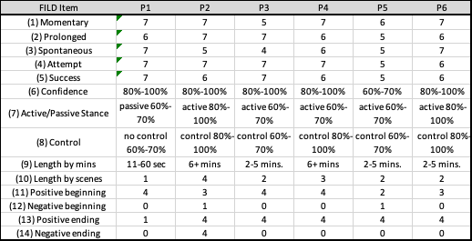

Table S1. Results from the Frequency and Intensity of Lucid Dreaming (FILD) Questionnaire. Range values are expressed in midpoints (i.e. 80%-100% is 90) and mean and SD are calculated using these values. Items 1-5 and 11-14, are expressed in an 8-point Likert scale where 0: never experienced, 1: only during childhood, 2: less than once a year, 3: once or twice a year, 4: 3-11 times a year, 5: once or twice a month, 6: 3 or 4 times a month, 7: twice a week or more. Items 6-8 are expressed as follows 0-20% is 0 never/rarely; 21-40% is 1 rarely; 41-60% is 2 sometimes/occasionally; 61-80% is 3 often; 81-100% is 4 Almost always/always.

