Appendix 1. Descriptive statistics concerning the results related to the analysis identified by Figure 1. https://docs.google.com/spreadsheets/d/1nqC7Upp1ugiyMh7_IRRWARmly-ZjyNxI/edit?usp=sharing&ouid=109536681888630160892&rtpof=true&sd=true.

Appendix 2. Statistics of journals indexed in SCImago without Q assigned. https://docs.google.com/spreadsheets/d/1zlwv8t0HPhYHgD1_8JlbFy2kyy_J2mDc/edit?usp=sharing&ouid=109536681888630160892&rtpof=true&sd=true.

Appendix 3. Cluster analysis.

As a last addition to the analysis, we conducted a hierarchical clustering analysis, based on Ward.D2 linkage and a set of longitudinal performance indicators, identified k = 3 clusters as the optimal solution. The choice of k was guided by the silhouette scan, which reached its maximum average silhouette width at k = 3 (0.42), slightly higher than the k = 2 alternative (0.421), and considerably higher than all k > 3. The elbow plot of within-cluster sum of squares displayed a smooth decline without a distinct bend, confirming that the silhouette criterion should take precedence. The final solution assigns 5,341 journals to Cluster 1, 3,849 journals to Cluster 2, and only 7 journals to Cluster 3. The silhouette plot for this partition shows average silhouette widths of 0.51 for Cluster 1, 0.31 for Cluster 2, and 0.40 for Cluster 3, indicating that Cluster 1 is both the most cohesive internally and the best separated from other clusters. Cluster 2 is less cohesive and overlaps more with other groups in the feature space, while Cluster 3 (despite its very small size) exhibits reasonable internal similarity. The PCA projection for k = 3 shows that Cluster 1 (red, n = 5,341) forms a dense, elongated band along PC1 with minimal spread along PC2, reflecting its internal uniformity. Cluster 2 (green, n = 3,849) is more dispersed, spanning a wider range of PC1 and PC2 values, consistent with its lower silhouette score. Cluster 3 (blue, n = 7) appears as a set of isolated points far from the main clusters, consistent with its outlier status.
The clustering variables were derived from robust year-to-year and longitudinal trends. Specifically, the analysis included the following 12 parameters:
- median percentage change in total documents per year;
- interquartile range of yearly document change (volatility);
- median yearly percentage change in citations;
- citation volatility;
- median annual change in SJR score;
- SJR score volatility;
- probability of quartile improvement between years;
- trend slope for document counts;
- trend slope for SJR;
- Kendall correlation between document count and SJR score over time (coupling between output and prestige);
- number of years a journal appears in the dataset;
- total observed time span from first to last appearance.
All variables were standardised to zero mean and unit variance before clustering, and missing values were median-imputed to retain all journals.
Cluster 1 journals tend to show moderate year-to-year changes in both volume and citations, positive or steady SJR score trends, and stronger coupling between document production and SJR, reflected in higher average Kendall correlation between document count and SJR over time. Their probability of quartile improvement between years is often above the median, indicating a tendency for gradual improvement in ranking categories. They also generally have longer coverage spans and higher presence years (in terms of indexation presence), two findings suggesting sustained presence in the dataset. Cluster 2 journals exhibit greater volatility in both output and citations, more variable SJR score volatility values, and weaker or inconsistent coupling between document output and prestige. Their quartile mobility patterns are mixed, and while some improve, others remain static or decline, producing a lower probability of quartile improvement between years average. Coverage spans in Cluster 2 are also typically shorter than in Cluster 1, although they still represent substantial temporal presence. Cluster 3, with only 7 journals, contains highly atypical profiles, some with short presence spans, extreme SJR score volatility values, or large swings in both volume and citations. These journals may have unusual trajectories such as sudden surges or collapses in output, abrupt shifts in prestige, or rare quartile jumps. The high silhouette score for Cluster 1 (0.51) confirms that these journals are compactly grouped and distinctly different from the others in the multi-dimensional feature space. The low silhouette score for Cluster 2 (0.31) suggests greater internal diversity, which is also visible in the PCA spread. Cluster 3’s moderate silhouette score (0.40) despite its tiny size reflects that these journals are genuinely different from the rest rather than statistical noise. To underline again, the Ward.D2 method’s variance-minimizing nature helps explain why the large, stable groups formed first, with the small outlier set only emerging clearly at k = 3, since choosing k = 2 would have absorbed these outliers into one of the main groups, slightly reducing average silhouette width, while increasing k beyond 3 would have fragmented the main clusters without producing new well-separated structures.
In practical terms, the three clusters represent three distinct “regimes” in the social sciences journal ecosystem. Cluster 1 (n = 5,341, avg sil = 0.51) are built up of stable growers with sustained presence, moderate change rates, and strong output–prestige coupling, members of Cluster 2 (n = 3,849, avg sil = 0.31) are volatile movers with high variability in performance and weaker coupling, and journals in Cluster 3 (n = 7, avg sil = 0.40) are rare outliers with extreme or atypical trajectories. This segmentation provides a statistically sound and interpretable framework for further profiling and comparative analysis and also enables targeted investigation of journals in each group, whether to identify role-model stability patterns, understand volatility drivers, or explore the causes of extreme outlier behaviours for future research agenda. Furthermore, it lays a foundation for policy-relevant discussions on how different publication strategies, editorial practices, or external shocks may manifest in longitudinal bibliometric indicators. (Figure 6)
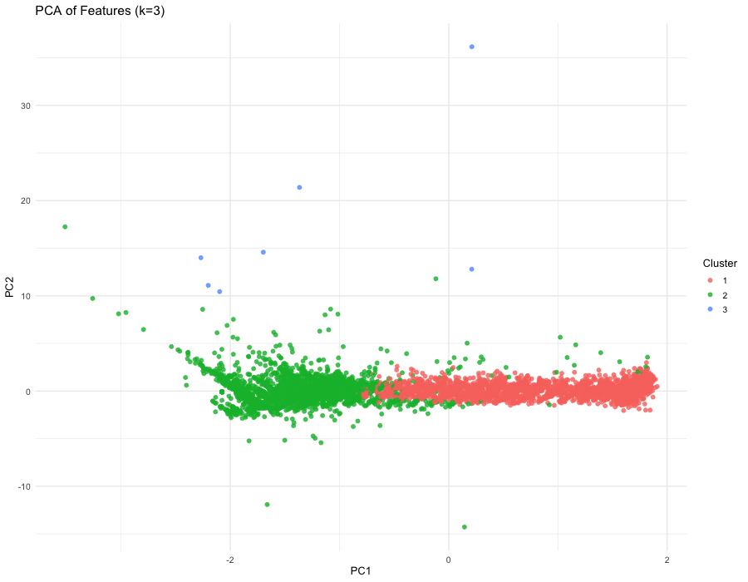
Figure 6. Cluster analysis based on the 12 parameters at k = 3

