Supplementary Figures
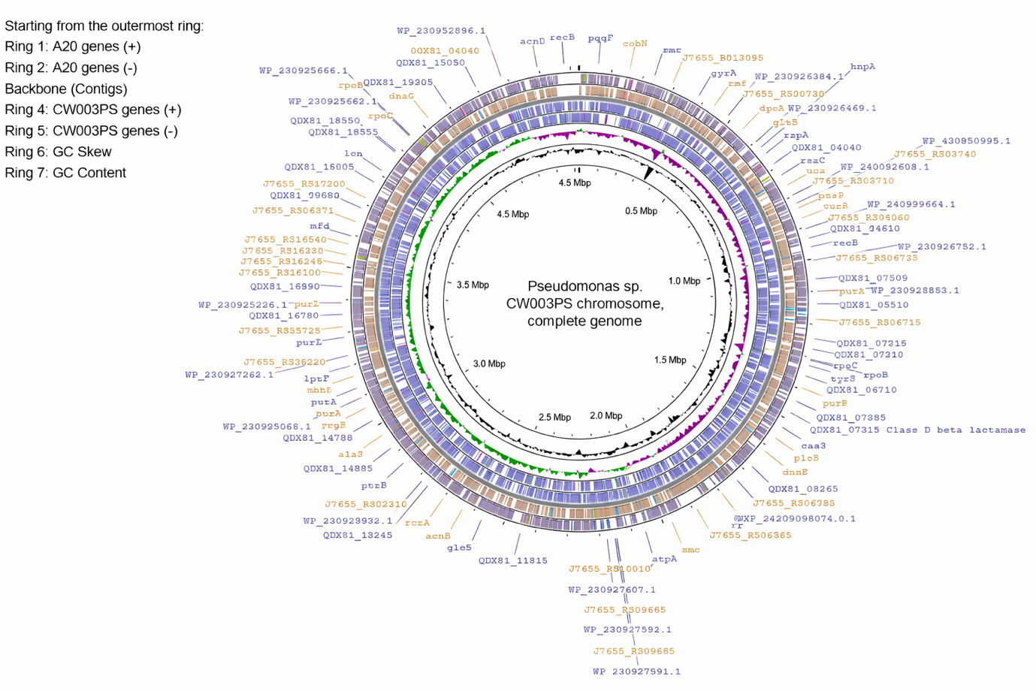
Figure S1 The genome mapping.
Figure S2 Pan-genome analysis
Figure S3 KEGG mapping associated to beta lactam resistance.

