Supplemental
S 1. Mean, standard deviation, and 90th quantile values of RH98, RH100, PAI, raw FHD, and WSCI values across NPCs and PAs.
RH98 RH100 PAI FHD RAW WSCI
Country Status Mean 𝜎 p90 Mean 𝜎 p90 Mean 𝜎 p90 Mean 𝜎 p90 Mean 𝜎 p90
BEN NPC 6.9 4.67 11.86 8.45 4.81 13.51 0.56 0.97 1.4 1.87 0.48 2.44 9.11 0.66 9.89
BEN PA 8 5 13.92 9.62 5.07 15.54 0.62 0.94 1.5 2.02 0.47 2.58 9.28 0.62 9.99
CIV NPC 12.78 8.78 23.41 14.29 8.85 25.04 1.62 1.72 4.47 2.28 0.52 2.94 9.56 0.69 10.42
CIV PA 13.78 9.2 25.46 15.29 9.28 27.12 1.77 1.8 4.63 2.34 0.54 3.01 9.69 0.67 10.52
CMR NPC 24.23 13.08 40.08 25.71 13.12 41.68 2.76 1.88 4.98 2.79 0.57 3.29 10.50 0.57 10.98
CMR PA 26.14 12.4 40.68 27.6 12.47 42.3 3.14 1.79 5.06 2.88 0.49 3.3 10.62 0.45 11.00
COD NPC 22.49 10.39 34.71 23.9 10.51 36.32 3.25 4.71 5.2 2.83 0.51 3.29 10.37 0.53 10.82
COD PA 22.6 10.19 34.26 23.99 10.32 35.86 3.31 8.13 5.2 2.84 0.51 3.29 10.22 0.68 10.83
COG NPC 25.68 10.95 38.78 27.11 11.11 40.41 3.44 12.76 5.22 2.92 0.49 3.3 10.52 0.47 10.96
COG PA 25.34 10.93 38.73 26.76 11.08 40.3 3.3 1.7 5.14 2.9 0.49 3.3 10.57 0.48 10.98
GAB NPC 28.68 10.9 41.64 30.1 11.14 43.37 3.92 1.51 5.41 3.03 0.37 3.31 10.67 0.33 10.98
GAB PA 28.76 10.94 42.24 30.19 11.18 43.98 3.97 18.61 5.46 3.03 0.37 3.31 10.70 0.34 11.03
GHA NPC 9.53 6.46 17.93 11.09 6.52 19.46 1.03 1.49 3.69 2.11 0.49 2.74 9.59 0.70 10.43
GHA PA 15.22 11.4 32.64 16.79 11.44 34.3 1.69 1.84 4.58 2.39 0.55 3.12 10.04 0.71 10.86
GIN NPC 11.31 7.74 19.99 12.84 7.8 21.51 1.28 1.57 4 2.22 0.53 2.85 9.61 0.64 10.35
GIN PA 11.59 7.9 20.3 13.14 7.96 21.86 1.28 1.51 3.87 2.24 0.52 2.88 9.58 0.67 10.34
GMB NPC 5.7 4.23 11.61 7.19 4.47 13.48 0.3 0.52 0.76 1.71 0.53 2.45 8.90 0.74 9.80
GMB PA 6.61 4.4 12.39 8.32 4.59 14.33 0.39 0.62 0.93 1.87 0.5 2.53 8.69 0.59 9.54
GNB NPC 10.27 6.16 17.69 11.71 6.27 19.26 1.28 1.41 3.41 2.13 0.54 2.75 9.35 0.71 10.09
GNB PA 10.75 6.49 18.68 12.17 6.59 20.22 1.48 1.55 3.97 2.16 0.54 2.8 9.54 0.65 10.24
GNQ NPC 28.54 9.62 40.06 29.9 9.85 41.74 3.84 1.41 5.27 3.03 0.29 3.3 10.66 0.35 10.98
GNQ PA 27.95 9.82 40.1 29.26 10.05 41.71 3.93 1.37 5.3 3.03 0.31 3.3 10.68 0.32 10.97
LBR NPC 25.38 10.81 37.95 26.75 10.95 39.55 3.51 14.76 5.19 2.92 0.44 3.3 10.44 0.56 10.90
LBR PA 27.23 10.21 38.79 28.59 10.4 40.43 3.82 1.48 5.27 3.01 0.37 3.31 10.53 0.50 10.94
NGA NPC 7.29 6.58 16.67 8.71 6.68 18.05 0.71 1.29 2.75 1.82 0.61 2.71 9.48 0.81 10.43
NGA PA 8.85 8.52 19.14 10.3 8.57 20.52 0.89 1.41 3.42 1.94 0.62 2.82 9.46 0.80 10.52
SEN NPC 5.24 3.92 11.11 6.75 4.16 12.93 0.25 0.49 0.69 1.69 0.49 2.4 9.11 0.52 9.68
SEN PA 5.54 3.97 11.71 7.11 4.21 13.59 0.26 0.45 0.72 1.75 0.48 2.45 9.07 0.49 9.64
SLE NPC 15.12 9.29 26.68 16.54 9.37 28.26 2.08 1.87 4.7 2.44 0.57 3.11 9.77 0.70 10.60
SLE PA 18.07 10.95 32.95 19.57 11.05 34.67 2.39 1.94 4.88 2.57 0.57 3.22 10.15 0.63 10.83
TGO NPC 8.81 7.14 16.74 10.28 7.24 18.15 0.96 1.44 3.48 2 0.54 2.69 9.36 0.73 10.34
TGO PA 10.07 8.02 21.27 11.5 8.09 22.73 1.14 1.57 3.95 2.08 0.62 2.91 9.66 0.77 10.53

S 2 Relative distribution of FHD, RH98, PAI, and WSCI values in each country. Relative frequency is calculated using a kernel density estimation available in the R ggplot package. PA values are depicted in blue and NPC values are depicted in purple. Areas of green indicate where area difference between plots is positive in PAs and areas of gray indicate where area difference between plots is negative in PAs.
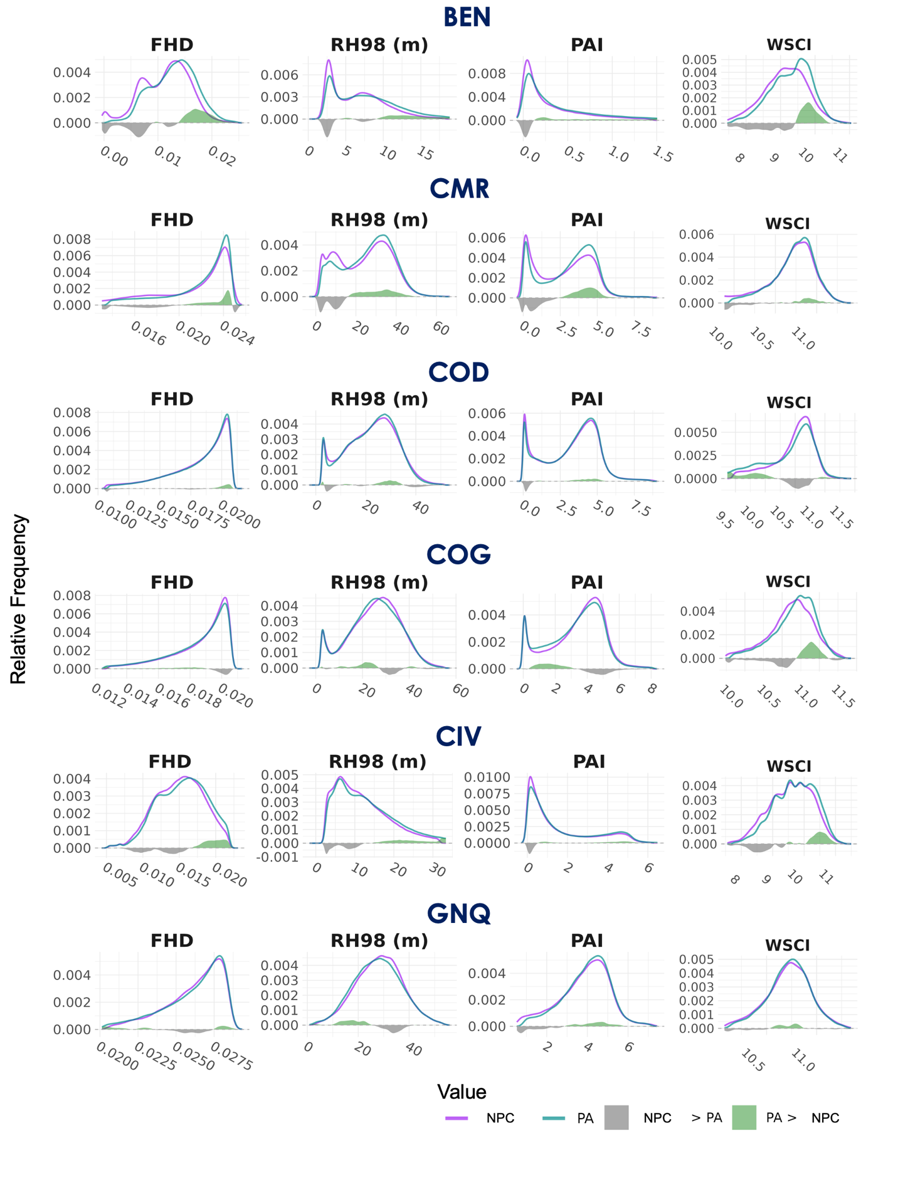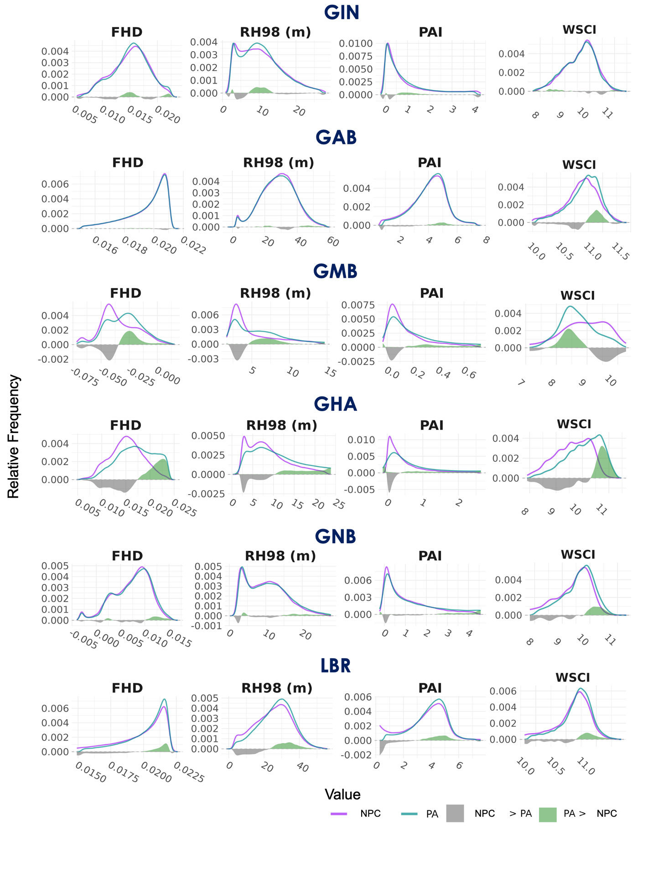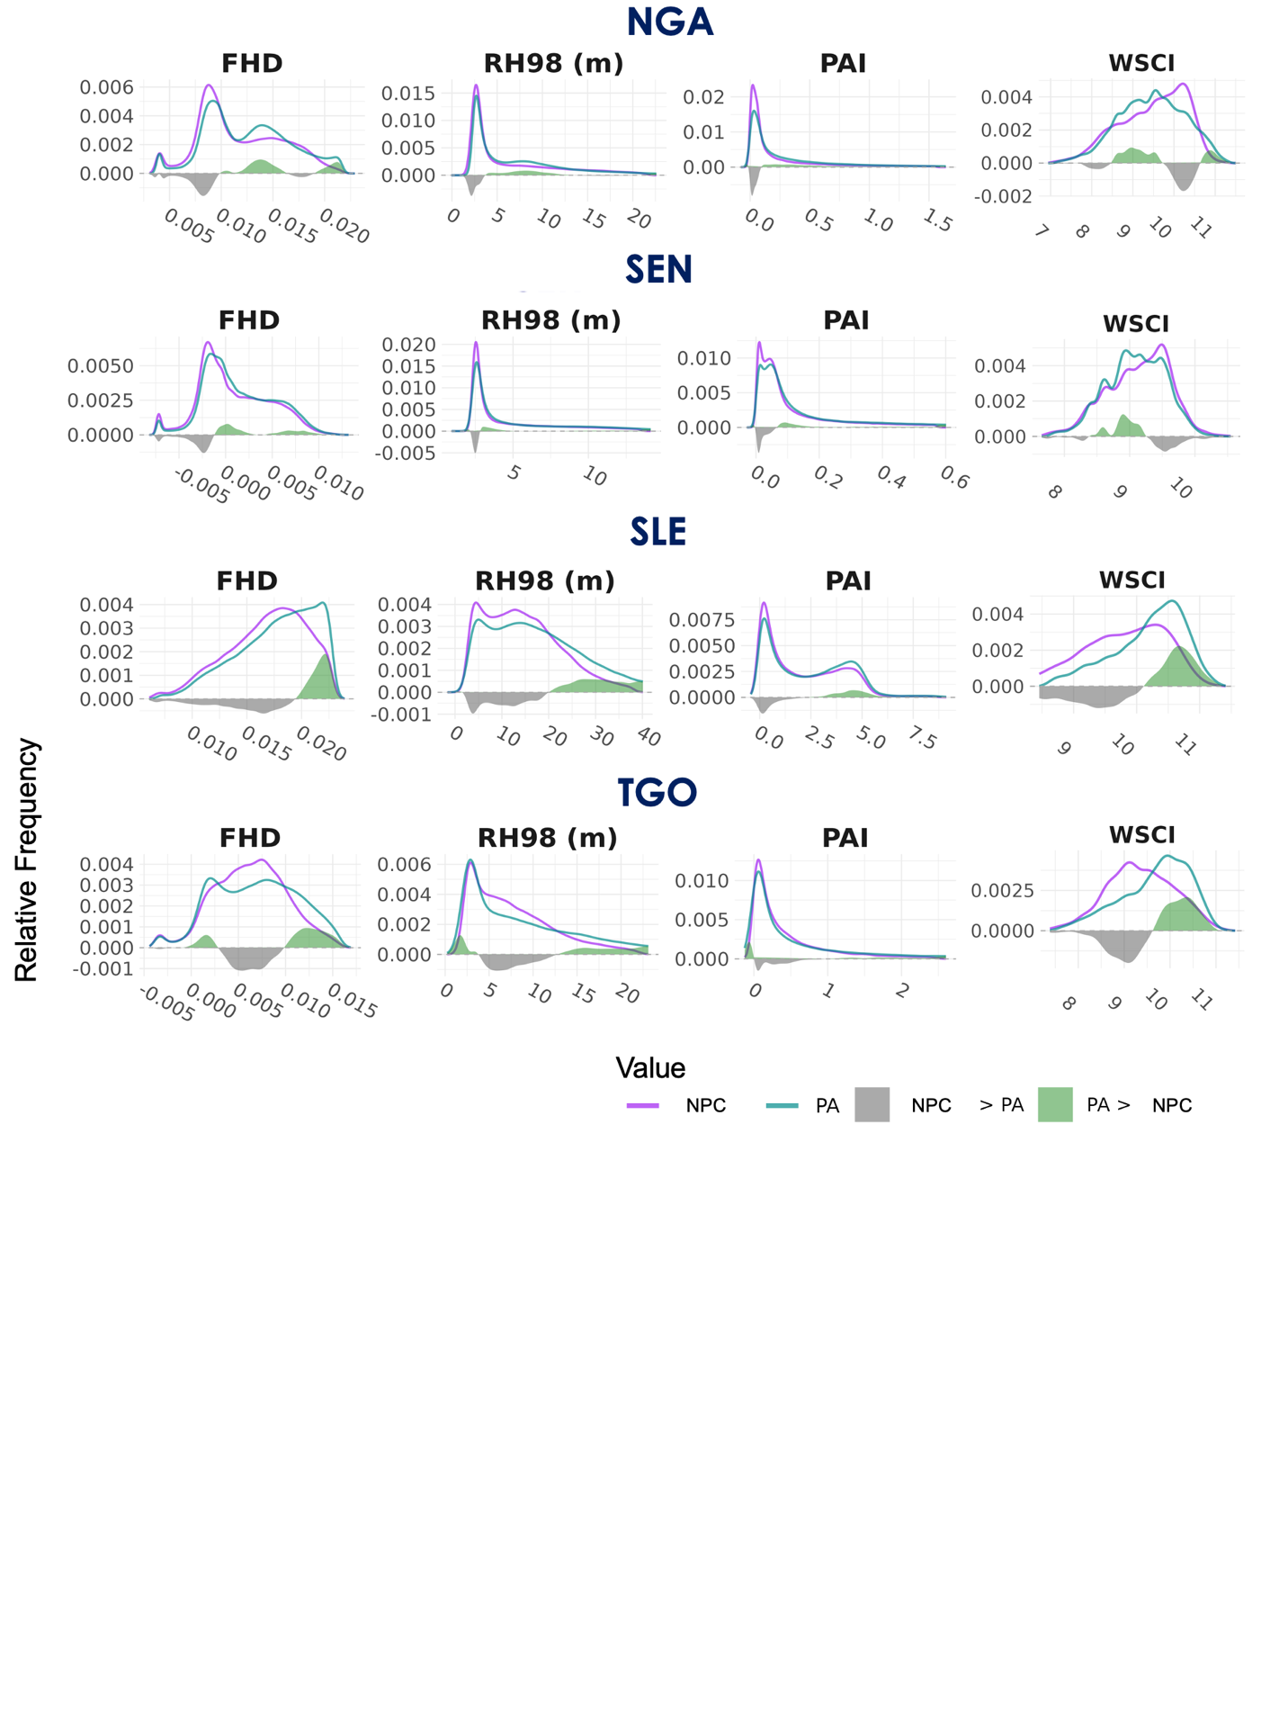
S 3. Number of PAs and GEDI Shots used for each PA designation type as defined by the WDPA. Numbers reflect L2A and L2B shots.
PA Designation | # PAs | #GEDI Shots
Other | 1559 | 12118048
National Park | 104 | 13020888
Ramsar Site | 55 | 5037650
Hunting Focus | 48 | 4944109
UNESCO-MAB | 13 | 1731536
World Heritage Site | 11 | 6647562

S 4. Relative distribution of FHD, RH98, and PAI values in each country separated by PA governance designation. PA values are depicted in blue and NPC values are depicted in purple. Areas of green indicate where area difference between plots is positive in PAs and areas of gray indicate where area difference between plots is negative in PAs.

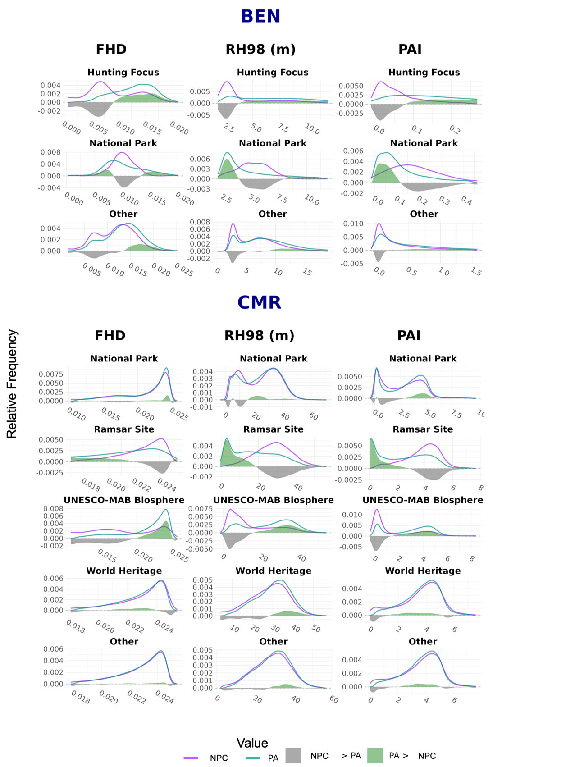
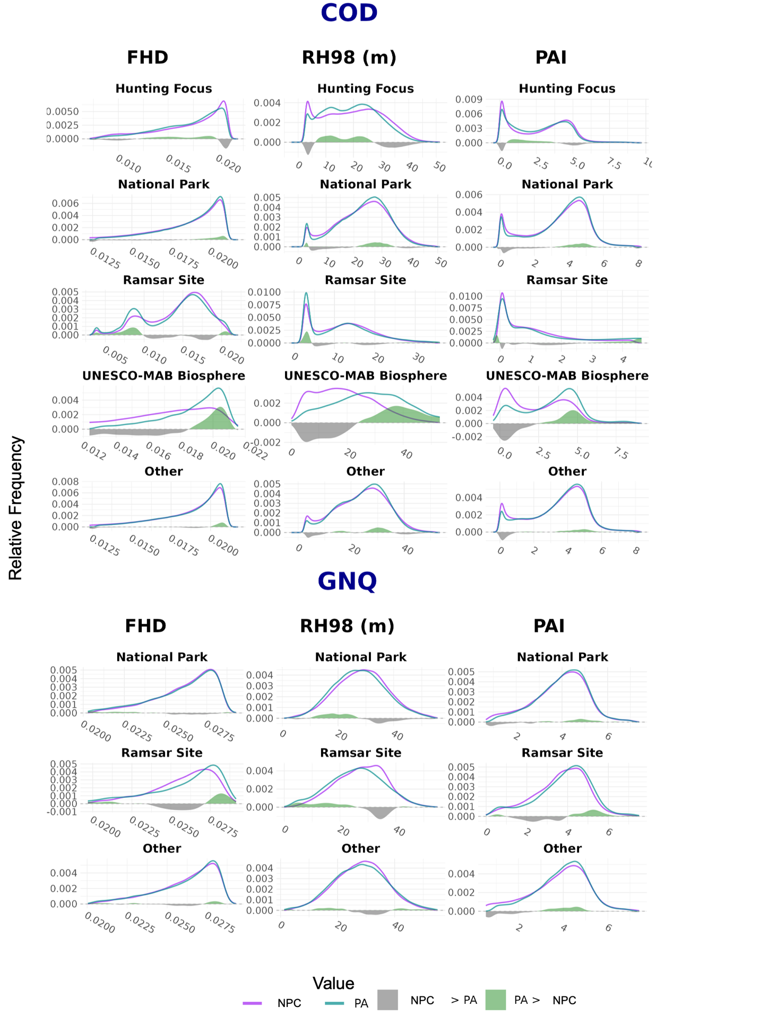
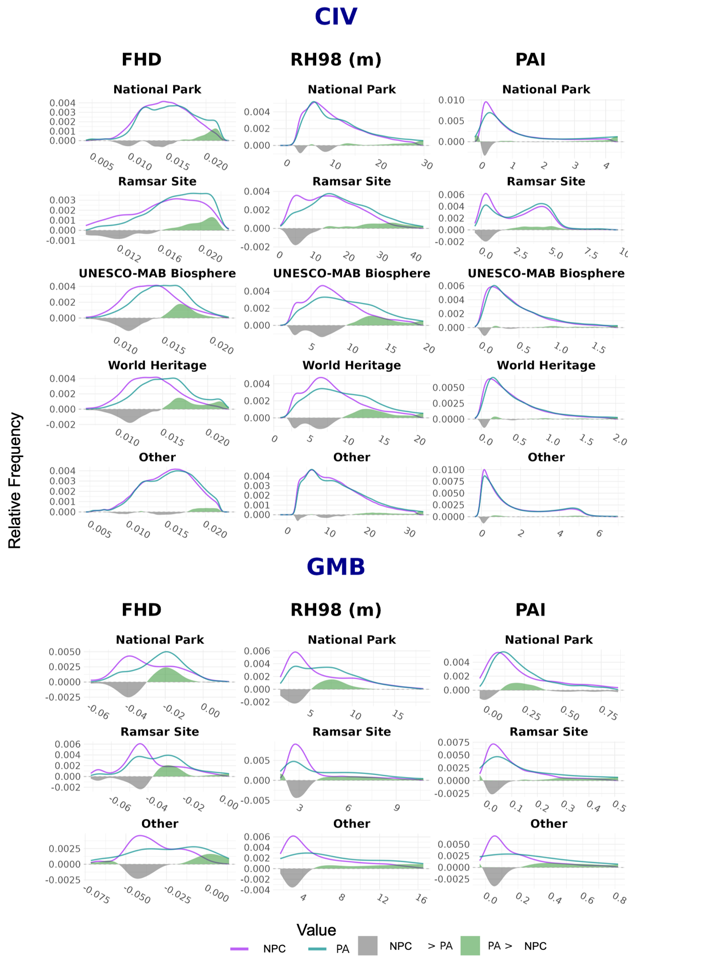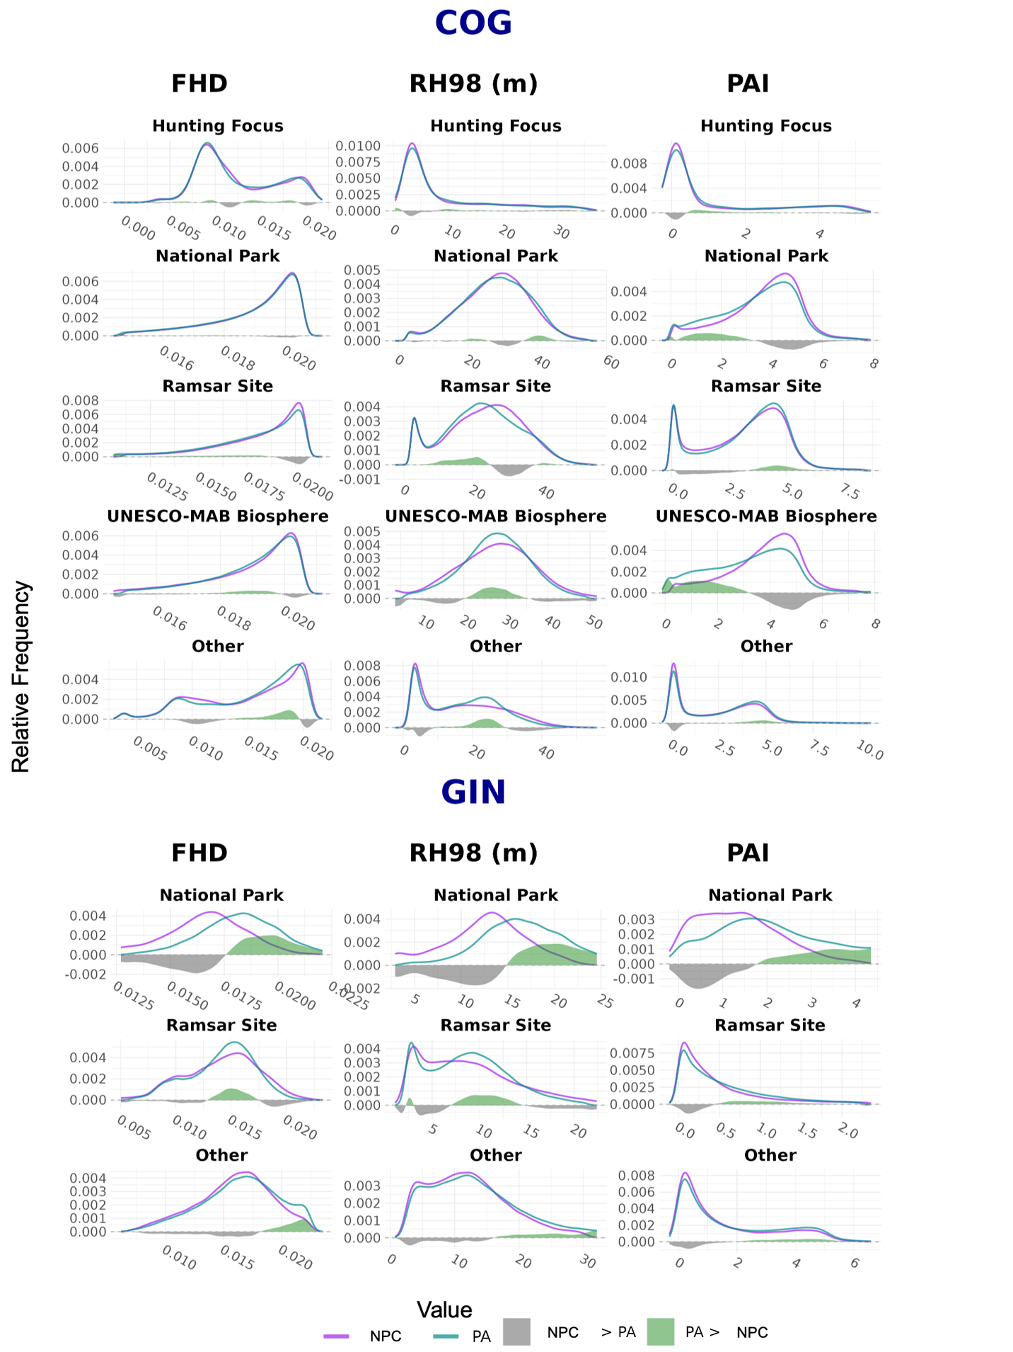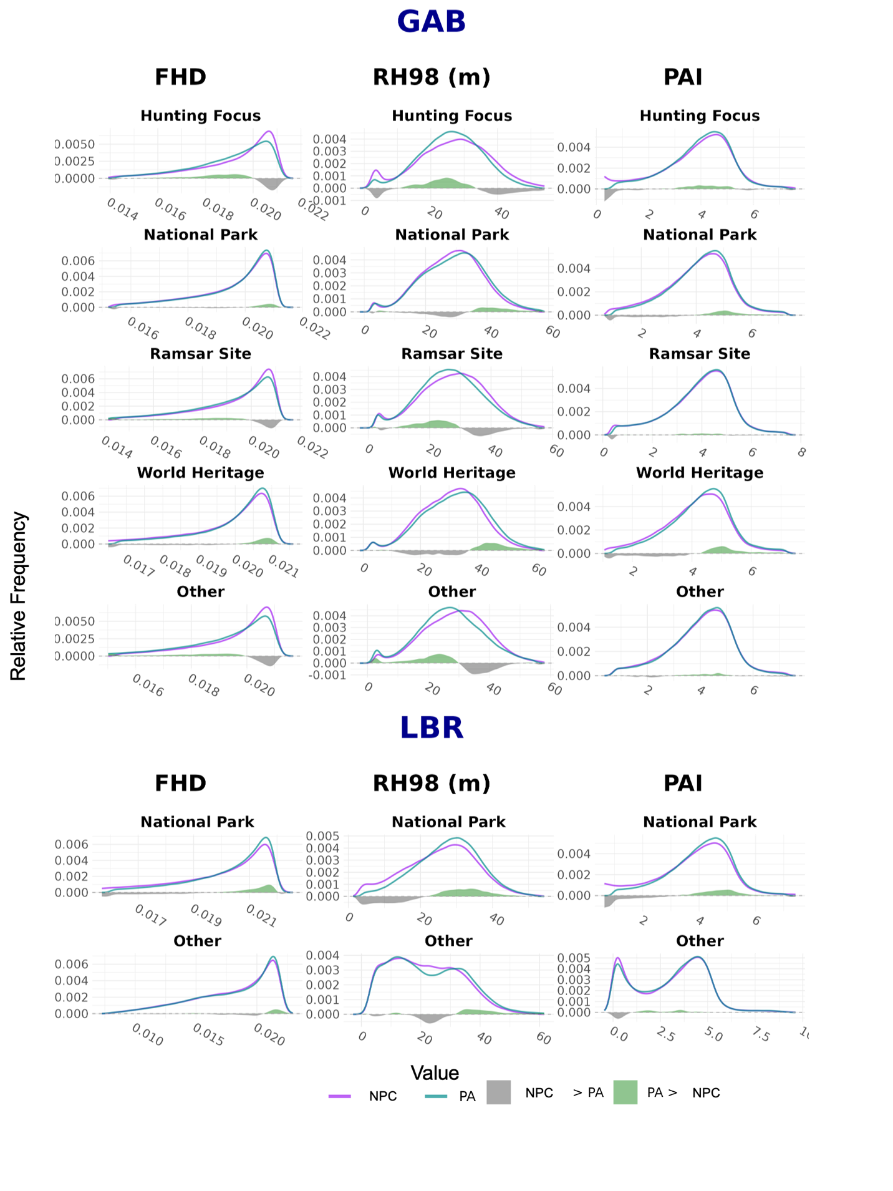
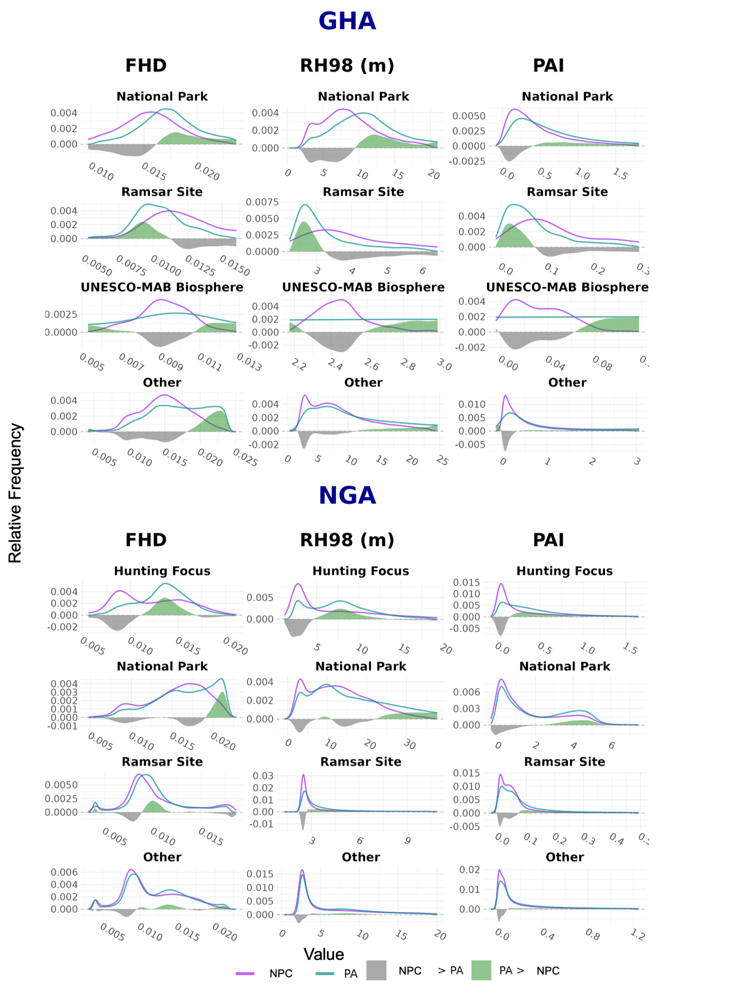
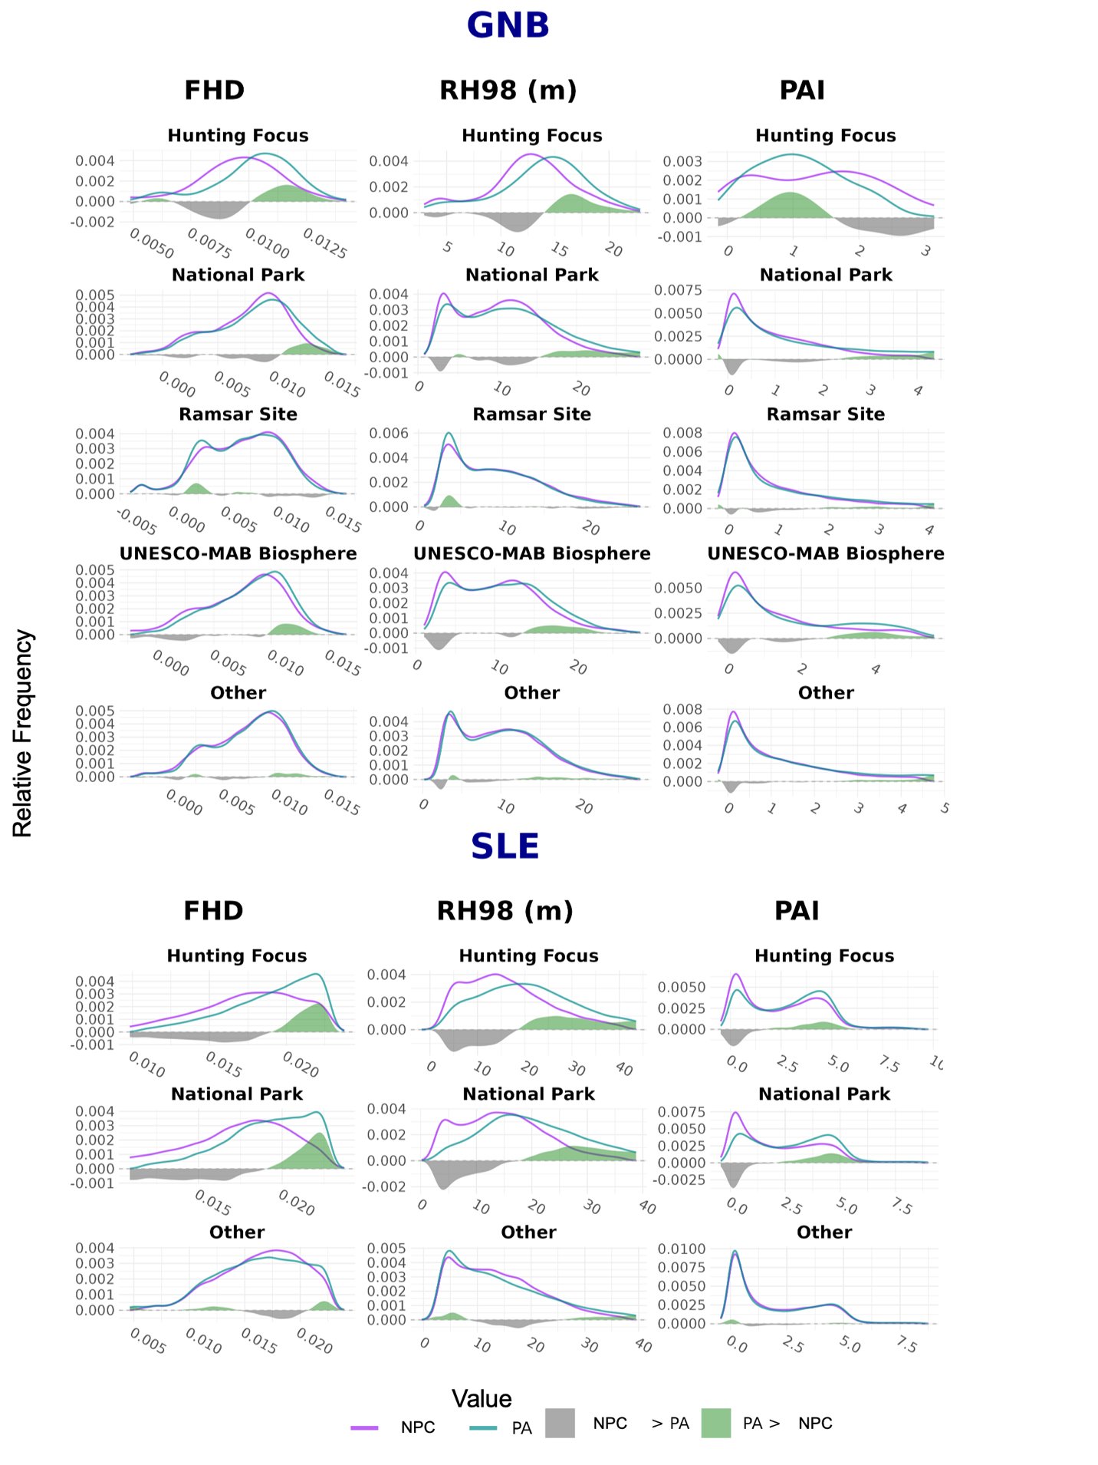
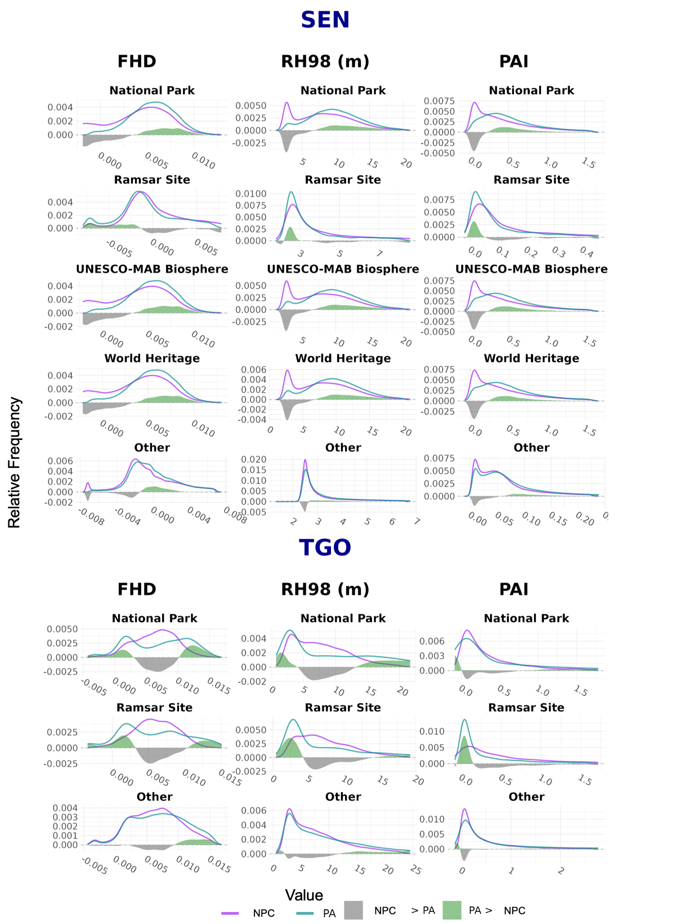

S 5. Relative distribution of WSCI values in each country separated by PA governance designation. PA values are depicted in blue and NPC values are depicted in purple. Areas of green indicate where area difference between plots is positive in PAs and areas of gray indicate where area difference between plots is negative in PAs.

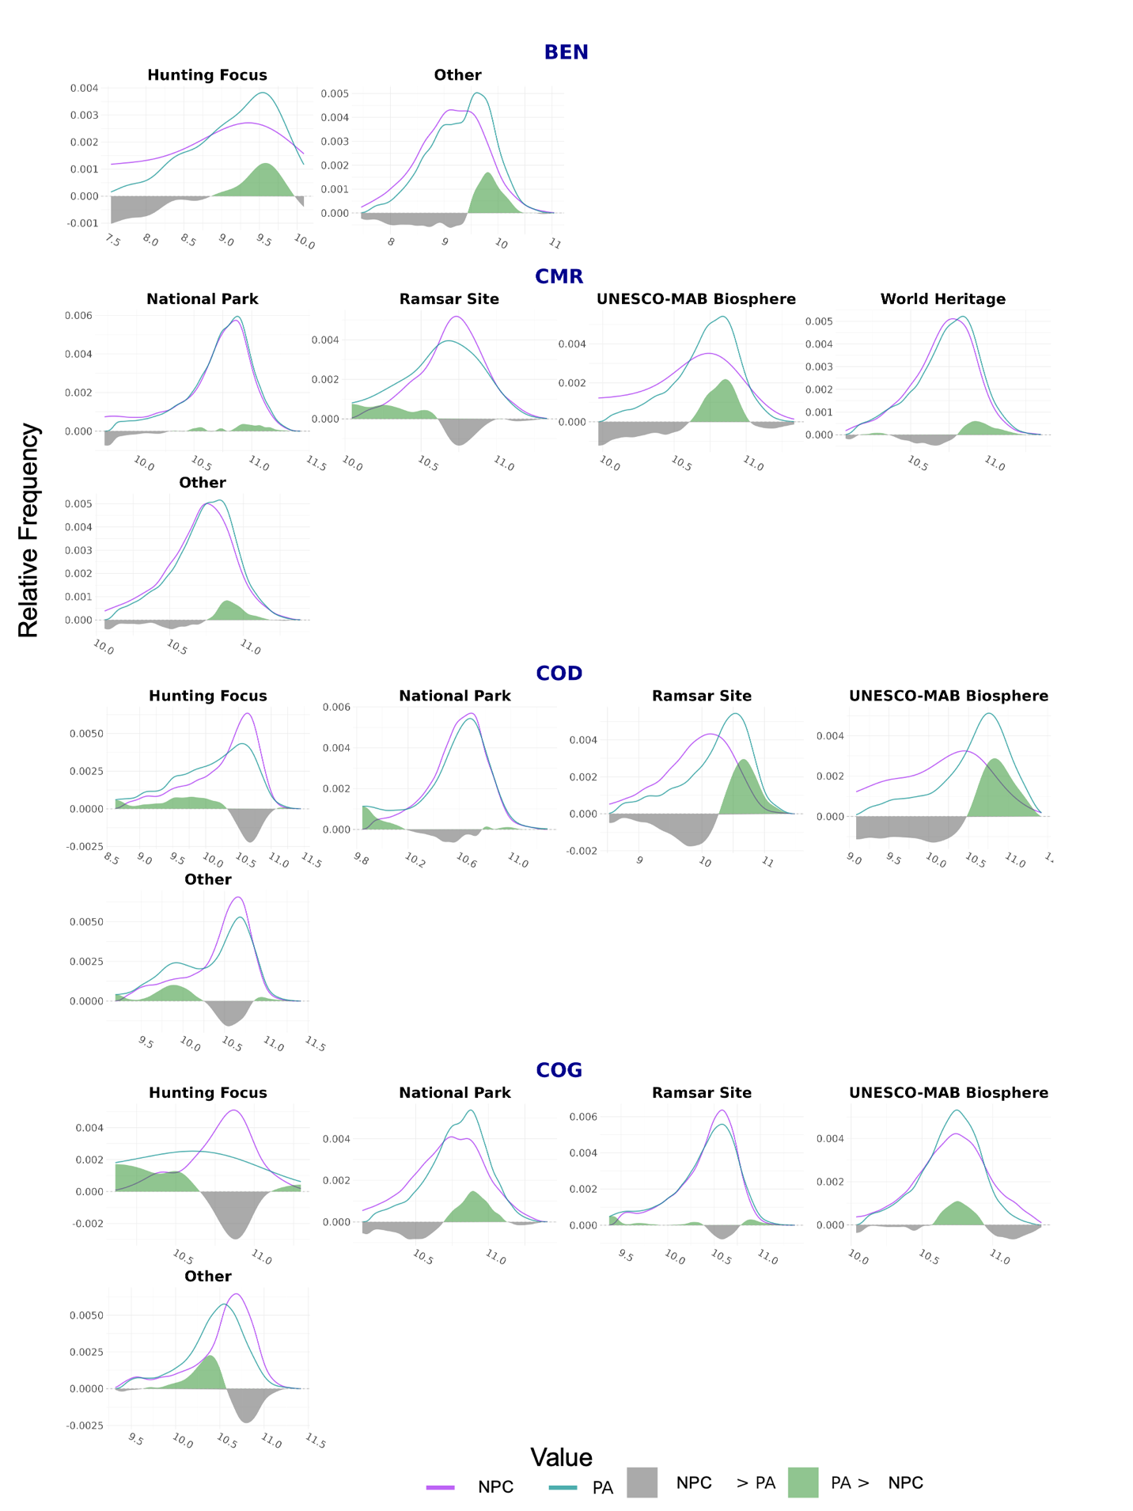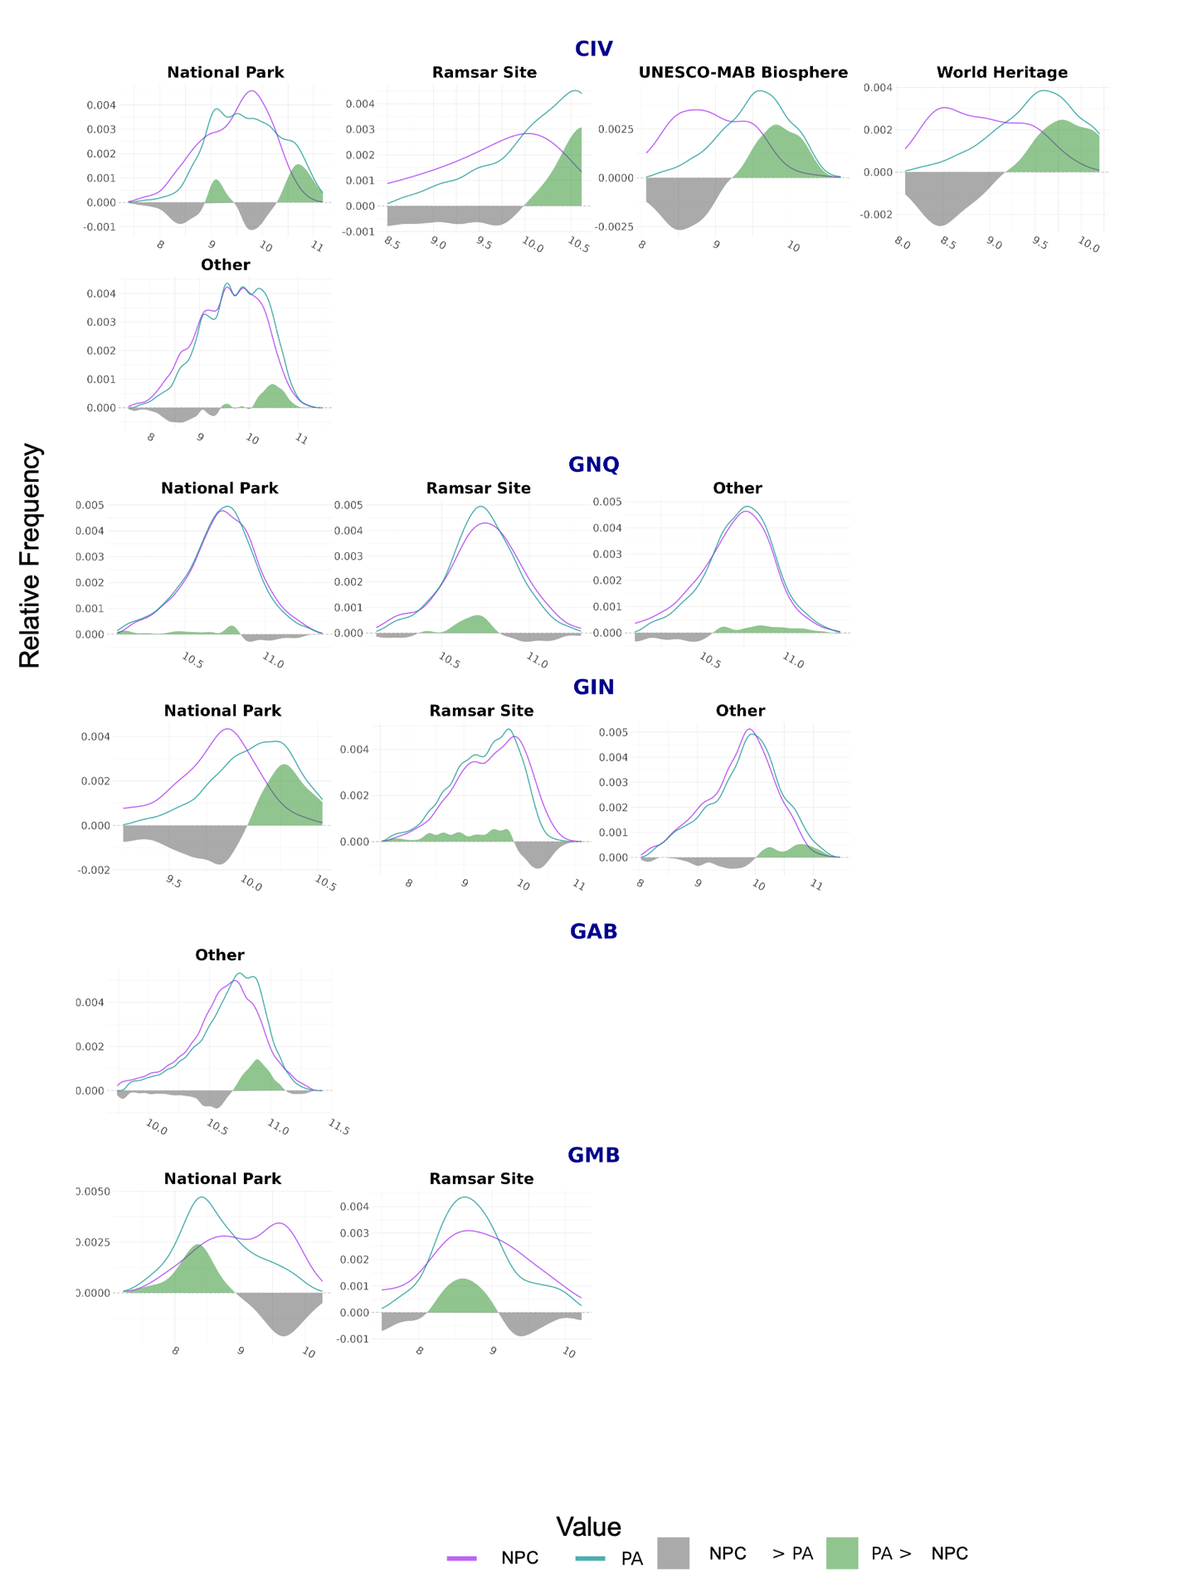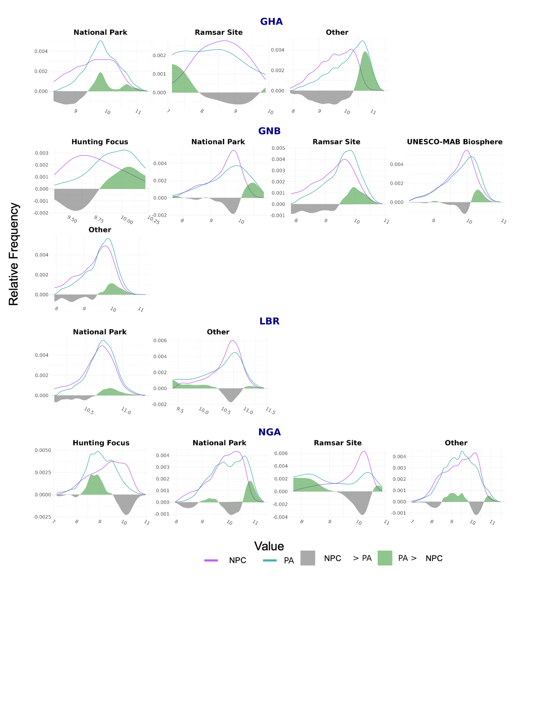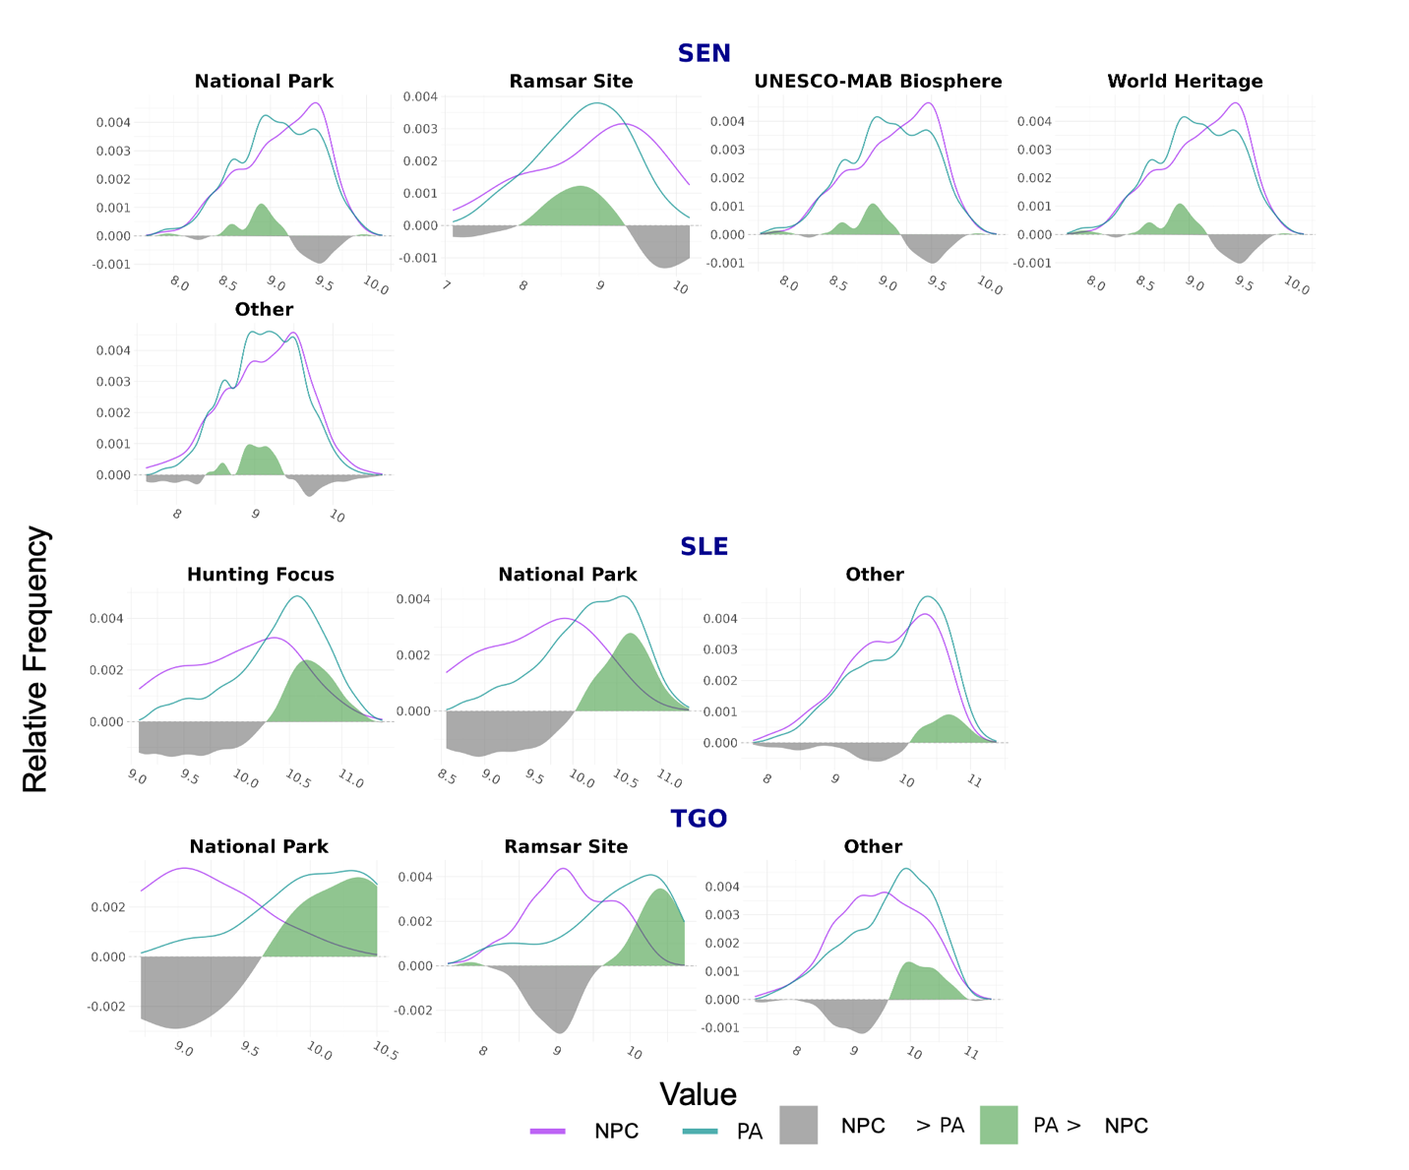

S 6. Precent difference of FHD, RH98, PAI, and WSCI values in each country separated by PA governance designation. Green indicates a positive difference in PAs. Gray indicates a negative difference in PAs.