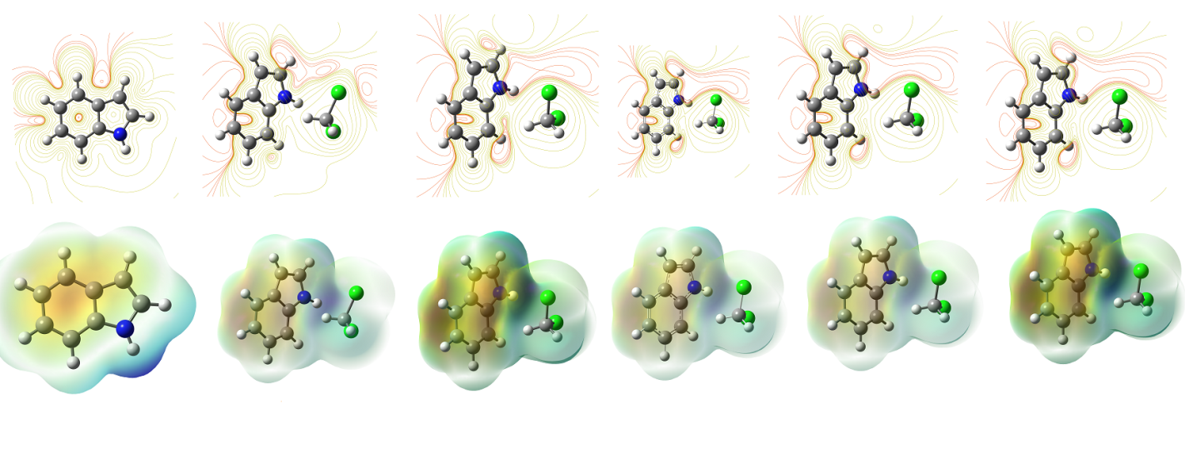
The influence of hydrogen bonding was used to monitor hydrogen bonding in IND and DC systems.

