Supplemental Material

Acoustic Trait | Definition
Duration | Total song length
Skewness | Asymmetry of the frequency spectrum
Entropy | Spectral entropy x time entropy  - Spectral entropy 🡪 energy distribution of freq spectrum (pure tone ~1, noisy ~0)  - Time entropy 🡪 energy distribution of time envelope (amplitude concentrated in a specific time point ~ 0, amplitude equally distributed across time ~1)
Minimum Frequency | lowest frequency of song
Maximum Frequency | highest frequency of song
Frequency Range | Difference between min and max frequency (aka “bandwidth)
Modulation Index | cumulative absolute difference between adjacent measurements of dominant frequencies divided by the dominant frequency range
Mean Peak Frequency | Frequency with highest amplitude
Element Duration | Duration of song element
Song Rate | Number of song elements divided by song duration
Gap Duration | Duration of silence between song elements

Supplemental Table 1: List of 11 acoustic traits used to define acoustic space of our bird communities and their definitions. All traits and definitions are from Raven Pro v1.5 and R package warbleR software.

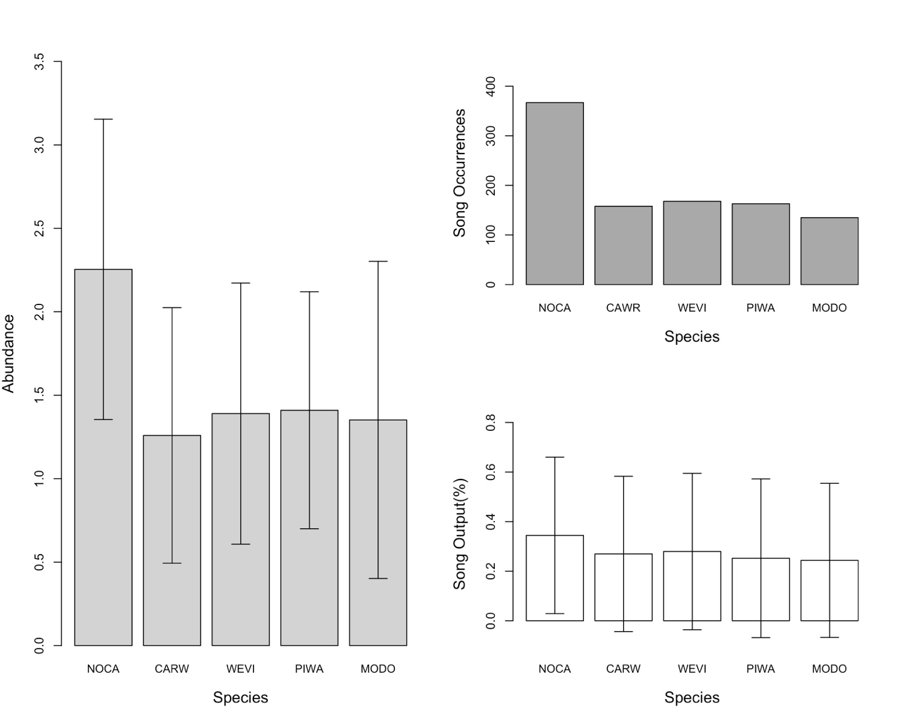

Supplemental Figure 1: Abundance estimates of NOCA across 7 pine flatwood sites in Florida, USA. The figure on the left shows the average number of NOCAs detected via auditory point counts across the environmental gradient. Figure in the upper right shows the raw number of 10-minute recordings each species sang in (aka “song occurrences”), while the figure in the bottom right shows the song output percentage of all 5 species across all sites.

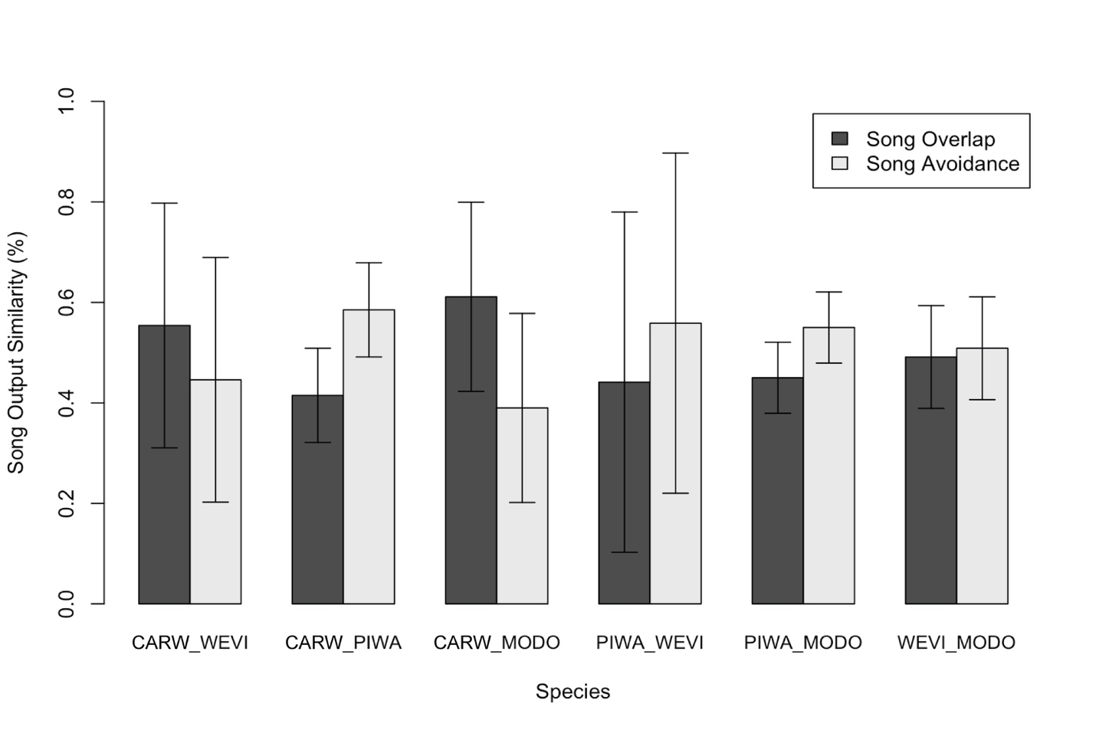

Supplemental Figure 2: Comparison of average song overlap and avoidance behavior between four species, totaling 6 species pairs listed on the x-axis, within 3-hour recording periods across 7 sites. The y-axis here indicates the percentage of incidences where each species’ song peak overlapped (dark grey) and avoided (light grey) that of the other species. This data includes two days’ worth of recording data from two ARUs per site (n=7 in total).

