Supplementary material
Chemotactic Light-harvesting Dual-Lanthanide Nanomotor for Revascularization and Neuroprotection of Ischemic Stroke
Shuo Li,^{a,1} Mengnan Yang,^{b,1} Zhongyu Wei,^{c,1} Jing Wang,ª Kangxi Zhou,ª and Kesheng Dai^{a,*}
ª Jiangsu Institute of Hematology, National Clinical Research Center for Hematologic Diseases, NHC Key Laboratory of Thrombosis and Hemostasis, The First Affiliated Hospital and Collaborative Innovation Center of Hematology, Soochow University, Suzhou, China
^{b} Department of Oncology, Central Laboratory, Suzhou Ninth People's Hospital, Suzhou Ninth Hospital Affiliated to Soochow University, Suzhou, China
^{c} School of Chemistry and Chemical Engineering, Shanghai Jiao Tong University, Shanghai, China
¹ These authors contributed equally to this work.
* Corresponding authors.
E-mail address: kdai@suda.edu.cn

Materials and methods
Materials and Instruments
Arginine, fluorescein isothiocyanate (FITC), and 2,2-diphenyl-1-picrylhydrazyl (DPPH) were obtained from Macklin Biochemical Co., Ltd. (Shanghai, China). FeCl₃ and tetracycline hydrochloride (TC) were purchased from Aladdin Biochemical Technology Co., Ltd. (Shanghai, China). Oxytetracycline hydrochloride (OTC), chlortetracycline hydrochloride (CTC), doxycycline hydrochloride (DC), and lumbrokinase (LK) were purchased from Yuanye Bio-Technology Co., Ltd. (Shanghai, China). maleimide-terminated polyethylene glycol-conjugated distearyl phosphatidyl ethanolamine (DSPE-PEG200-Mal) was obtained from Yusi Medical Technology Co., Ltd. (Chongqing, China). Purified anti-mouse/rat CD62P (P-selectin) Antibody and FITC anti-human CD11b were obtained from BioLegend Co., Ltd. (USA). Goat Anti-Mouse IgG H&L (Alexa Fluor® 555) was obtained from Abcam Biotechnology Co., Ltd. (USA). Thrombin was obtained from Sigma Co., Ltd. (USA). Reactive oxygen species assay kit, cell counting kit-8, and phorbol 12-myristate 13-acetate (PMA) were purchased from yeasen Biotechnology Co., Ltd. (Shanghai, China). Human peripheral blood neutrophil isolation kit was purchased from Solarbio Technology Co., Ltd. (Beijing, China). Collagent was obtained from Chrono-Log (USA). DAPI fluoromount-G® was obtained from SouthernBiotech (USA). Dulbecco’s modified Eagle’s media (DMEM) medium was purchased from Gibco. Phosphate buffered saline (PBS), penicillin and streptomycin were purchased from Invitrogen. Fetal bovine serum (FBS), trypsin-EDTA, and calcein AM were obtained from Thermo Fisher Scientific. Deionized water (18 Ω·cm) was obtained from a Milli-Q purification system (Millipore, Molsheim, France).
Powder X-ray diffraction (PXRD) pattern was obtained on a D8 Advance diffractometer (Bruker AXS, Germany) to characterize the structure of MOFs. A Fourier transform infrared (FT-IR) spectrometer (PerkinElmer, USA) was used to obtain the FT-IR spectra. The morphology and size of MOFs were observed by JEM-2100 transmission electron microscopy (TEM, JEOL, Japan). The elemental analysis of MOFs was performed on K-Alpha X-ray photoelectron spectroscopy (XPS, Thermo, USA). The excitation and emission spectra were tested on an FL-4700 fluorescence spectrometer (Hitachi, Japan), and the ultraviolet spectrum was measured by ‌SpectraMax M2 spectrometer (Molecular Devices, USA). Zeta potential and hydrodynamic diameter were obtained by ZSP Nano Zetasizer (Malvern, UK). Fluorescence images were collected on a Leica-LCS-SP8-STED confocal laser scanning microscope (Leica, Germany).
Synthesis of Eu-MOFs
Eu-MOFs were synthesized according to the modifying methods as previously reported [29, 30].
Synthesis of Ce/Eu-BTC. First, the ligand H₃BTC (105.1 mg, 0.5 mmol) was dissolved in 3 mL of DMF, (NH₄)₂Ce(NO₃)₆ (145 mg, 0.25 mmol) and Eu(NO₃)₃·6H₂O (111.5 mg, 0.25 mmol) were dissolved in 1 mL of deionized water. Then the above solutions were mixed. The mixture was transferred to a Teflon-lined stainless steel reactor, heated at 100°C for 1 hours, and naturally cooled to room temperature.
Synthesis of Ce/Eu-BTEC. First, H₄BTEC (127.1 mg, 0.5 mmol) was dissolved in 3 mL of DMF, (NH₄)₂Ce(NO₃)₆ (145 mg, 0.25 mmol) and Eu(NO₃)₃·6H₂O (111.5 mg, 0.25 mmol) were dissolved in 1 mL of deionized water. Then the above solutions were mixed. The mixture was transferred to a Teflon-lined stainless steel reactor, heated at 100°C for 1 hours, and naturally cooled to room temperature.
After the reaction, the solid precipitates were separated from the solution by centrifugation, washed with ethanol and deionized water twice, respectively, and freeze-dried overnight to obtain the corresponding MOF products.
Selection of tetracycline-class ligands
Doxycycline hydrochloride (DC), Oxytetracycline hydrochloride (OTC), tetracycline hydrochloride (TC), and chlortetracycline hydrochloride (CTC) were selected as candidate ligand to sensitize Eu³⁺ luminescence. 100 μL of Ce/Eu-BDC aqueous solution (20 mg mL⁻¹), 100 μL of different kinds of tetracyclines aqueous solution (10 mg mL⁻¹), and 100 μL of Arg aqueous solution (10 mg mL⁻¹) were mixed by magnetic stirring for 2 h. The solution was transferred to a cuvette to scan the fluorescence spectrum.
uPA loading
The loading capacity was determined from the uPA decrease in the supernatant. Firstly, 1 mg uPA was weighted, and transferred into a centrifuge tube, then 5 mL HEPES buffer was added to make the uPA solution. Secondly, 0.3 mL FITC methanol solution (3 mg mL⁻¹) was added, then the centrifuge tube was placed at 4°C away from light and stirred. After 12 h, an appropriate amount of ammonium chloride (50 mmol L ⁻¹) was added to stop the reaction. The free FITC and FITC-uPA was separated by dialysis bag (molecular weight cutoff = 10 kDa), and the FITC-uPA solution was freeze-dried to obtain powdered product. Then, different volume of FITC-uPA (1 mg mL⁻¹, dissolved in 0.9% NaCl) were added to synthesize LNM. After the loading process, we collected the supernatants and determined the uPA amounts. The difference between the uPA amounts in the supernatant before and after the loading process was considered to have been loaded on the MOF. The supernatants containing the FITC-uPA were characterized using a fluorescence microplate reader (λ_{ex} = 494 nm, λ_{em} = 525 nm).
Theoretical calculation
Theoretical calculations were performed via Gaussian 09 package. The frontier molecular orbital energy of molecules was calculated by the density functional theory (DFT) method, and the polarization function was set at B3LYP/6-31G+ level. The frontier molecular orbital energy results of molecules were exported for graphic analysis by Multiwfn program and visual molecular dynamics (VMD) software.
uPA release
To test the release behaviors of LNM, samples were immersed in deionized water and PBS at 37°C and isolated by ultracentrifugation. At different time points, 20 μL of buffer was taken, and an equal volume of fresh buffer was added to ensure a constant volume. The content of uPA was determined using the BCA kit.
Cell cculture and MCAO mouse model
PC-12 cells and bEnd. 3 cells were all provided by Wuhan Pricella Biotechnology Co., Ltd.. PC-12 cells and bEnd. 3 cells were grown in Dulbecco’s modified Eagle’s media (DMEM) medium supplemented with 10% heat-inactivated FBS and 1% double antibiotic (penicillin-streptomycin). All cells were cultured in a 5% CO₂ humid incubator at 37°C.
Specific pathogen-free (SPF) male C57BL/6 mice (8 weeks) were purchased from Suzhou Cavensbiagle Experimental Animals Co., Ltd.. The backs of the anesthetized mice were fixed on the operating table, and the necks were disinfected with iodophor. The common carotid artery (CCA), external carotid artery (ECA) and internal carotid artery (ICA) of mice were separated under a microscope, and sutures were hung at the distal and proximal ends of CCA and ECA. The ICA was temporarily clipped. A small incision was made near the CCA bifurcation, and a silicone-coated monofilament was inserted. The clip on the ICA was then released, and the filament was advanced until its tip reached the origin of the middle cerebral artery to achieve occlusion. After 3 hours of ischemia, the filament was withdrawn to allow reperfusion. Sham-operated mice underwent identical procedures, excluding the filament insertion. All animal procedures were carried out under the guidelines set by the Institutional Animal Care and Use Committee of Jiangsu Province, and the overall project protocols were approved by the Animal Ethics Committee of SoochowUniversity.
Cell uptake
Cellular uptakes of LNM by PC-12 cells and bEnd. 3 cells were examined using CLSM. PC-12 cells and bEnd. 3 cells (2 × 10⁴ cells) were cultured for 24 h and treated with LNM for 2h, 5 h, and 8h, respectively. The cells were washed with PBS and fixed with antifade mounting medium with DAPI for 30 min.
Cell viability evaluation assay
Cell viability was determined by cell counting kit-8 (CCK-8) assay. bEnd. 3 cells were seeded at a density of 5 × 10³ cells per well in 96-well microplates with 200 μL cell suspension per well and cultured overnight in a 5% CO₂, 37°C humid incubator, resulting in a cell density of 80–90%. The cells were incubated in fresh medium containing Ce/Eu-BDC, Ln-MOF, and LNM of different concentrations (50, 100, 150, 200 and 250 μg mL⁻¹) for 24 h.
Hemolysis assay
Fresh blood sample collected from mouse (500 μL) was mixed with normal saline (5 mL) and centrifuged at 3000 rpm for 3 min. The sediment was washed three times with PBS, and red blood cells were dispersed in 10 mL of PBS buffer. Erythrocytes (200 μL) were added to water, 0.9% NaCl solution, as well as different concentrations of LNM in 0.9% NaCl solution (0.8 mL). After 4 h of incubation at 37 °C, the solution was centrifuged at 12000 rpm for 10 min. The supernatants were characterized by recording the absorbance at 544 nm. The hemolysis percentage was calculated according to the following equation:
Hemolysis (%) = (A-A_{PBS})/(A₀-A_{PBS}) 100%
where the A is the absorbance of hemoglobin with different concentrations of LNM, A_{PBS} is the absorbance of hemoglobin in PBS, and A₀ is the absorbance of hemoglobin in water corresponding to the complete hemolysis.
In vitro ROS scavenging ability of LNM
To investigate the in vitro ROS scavenging ability of LNM, PC-12 cells (5 × 10³ cells/well) in 96-well plates were cultivated for 24 h, and then various concentrations of LNM (100, 200, 300, and 400 μg mL⁻¹) were added to the cells and incubated for another 12 h. Finally, the cells were treated with 200 μM H₂O₂ for 2 h. Cell viability was determined by CCK-8 assay.
Intracellular ROS scavenging ability
PC-12 cells were seeded in 24-well plates at a density of 2 × 10⁵ cells/well for 24 h. Except for the negative control sample, the PC-12 cells were treated with different concentrations of LNM (100, 200, and 300 μg mL⁻¹) for 12 h. Subsequently, the cells were incubated with 10 μM 2’,7’-dichlorodihydrofluorescein diacetate (DCFH-DA) probe for 30 min. Finally, the cells were treated with 200 μM H₂O₂ for 2 h, washed with PBS three times. The intracellular ROS level of each group was quantified using flow cytometry.
PC-12 cells were seeded in confocal dishes at a density of 1 × 10⁵ cells/dish for 24 h. Except for the negative control sample, the PC-12 cells were treated with 200 μM H₂O₂ for 2 h, washed with PBS three times. Then, the cells were treated with different concentrations of LNM (100, 300, and 500 μg mL⁻¹) for 4 h. Finally, the cells were incubated with 10 μM DCFH-DA probe for 20 min, and observed by a confocal laser scanning microscope.
Study on the interaction of LNM with PLTs
For the preparation of washed human PLTs, the whole blood collected from the cubital vein was slowly injected into a centrifuge tube filled with 1/7 volume of acid-citrate-dextrose (ACD, 2.5% trisodium citrate, 2.0% D-glucose, and 1.5% citric acid). Platelet-rich plasma (PRP) was obtained by 200 g centrifugation. PRP was centrifuged at 1000 g for 2 min to pellet PLTs. PLTs were washed with CGS buffer (0.123 M NaCl, 0.033 M D-glucose, 0.013 M trisodium citrate, pH 6.5), resuspended in modified Tyrode’s buffer (2.5 mM HEPES, 150 mM NaCl, 2.5 mM KCl, 12 mM NaHCO₃, 5.5 mM D-glucose, 0.1% bovine serum albumin, 1 mM CaCl₂, 1 mM MgCl₂, pH 7.4) to a concentration of 3 × 10⁸ mL⁻¹, and allowed to stay at room temperature for 1–2 hours. Then, 200 μL of PLTs (activated (0.025 U mL⁻¹ thrombin) or resting) were incubated with LNM (200 μg mL⁻¹) at room temperature for 60 min. Next, 100 μL of PLTs were subsequently fixed with 100 μL 4% formalin for 4 min, washed with PBS buffer. Platelet samples were prepared into cell sheets using a cell centrifuge at 1200 rpm for 5 minutes. PLTs were then incubated with Calcein-AM (1:400 dilution) for 30 min at room temperature. Coverslips were treated with mounting media for 30 min. Fluorescent images were acquired using Leica-LCS-SP8-STED with a 63×objective. Green channel at 500–550 nm with λ_{ex} = 488 nm, red channel at 600–650 nm with λ_{ex} = 405 nm.
Study on the interaction of LNM with neutrophils
Neutrophils were obtained using human peripheral blood neutrophil isolation kit, and resuspended in serum-free DMEM (5 × 10⁶ mL⁻¹). Next, 200 μL of cells (activated (100 nM PMA) or resting) were incubated with LNM (200 μg mL⁻¹) at room temperature for 60 min. Next, cells were prepared into cell sheets using a cell centrifuge at 1200 rpm for 5 minutes. Cells were then incubated with CD11b (1:1000 diluted with 1% BSA) for 60 min at room temperature. Coverslips were treated with mounting media with DAPI for 30 min. Fluorescent images were acquired using Leica-LCS-SP8-STED with a 63×objective. Green channel at 500–550 nm with λ_{ex} = 488 nm, red channel at 600–650 nm with λ_{ex} = 405 nm, blue channel at 600–650 nm with λ_{ex} = 405 nm.
Platelet aggregation
For the preparation of washed murine PLTs, mice with were selected for blood collection through the inferior vena cava and anticoagulated with 1/7 volume of ACD. The whole blood was mixed with normal saline and centrifuged to obtain PRP at 200 g. PRP was centrifuged at 1200 g for 2 min to pellet PLTs. PLTs were washed twice with CGS buffer, resuspended in modified Tyrode’s buffer to a concentration of 3 × 10⁸ mL⁻¹, and allowed to stay at room temperature for 1-2 hours. Then, PLTs were preincubated with Ln-MOF (200 μg mL⁻¹), LNM (200 μg mL⁻¹), and uPA (uPA activity: 750 U mL⁻¹) for 30 min at 37°C in platelet aggregation dishes. Under stirring, platelet aggregation experiments were started immediately after the addition of collagen (0.5 μg mL⁻¹) to each group. Changes of light transmission were monitored for 8 minutes using aggregometer.
Clot retraction assay
Blood was obtained from the inferior vena cava of mice using syringes rinsed with anticoagulants. The whole blood was mixed with normal saline and centrifuged to obtain platelet-rich plasma (PRP) at 200 g. PRP (400 μL) was incubated with Ln-MOF (200 μg mL⁻¹), uPA (uPA activity: 750 U mL⁻¹), and LNM (200 μg mL⁻¹) for 10 min, and then 5 μL red blood cells were added to each group and mixed up. Next clot formation was initiated by adding thrombin (0.1 U mL⁻¹) to each group. The formation of clots was observed at room temperature for 50 min, and clot volume was quantified using ImageJ (NIH, Bethesda, MD, USA) as an evaluation index of clot retraction.
In vivo thrombosis
Washed mouse PLTs were labeled with Calcein-AM (5 μg mL⁻¹) at room temperature for 30 min. Labeled PLTs were washed with CGS buffer (0.123 M NaCl, 0.033 M D-glucose, 0.013 M trisodium citrate, pH 6.5) and resuspended with Modified Tyrode’s buffer (2.5 mM HEPES, 150 mM NaCl, 2.5 mM KCl, 12 mM NaHCO₃, 5.5 mM D-glucose, 0.1% bovine serum albumin, 1 mM CaCl₂, 1 mM MgCl₂, pH 7.4) to a concentration of 1×10⁹ mL⁻¹. Mice in each group were intravenously administered with different prepared formulations (200 μL LNM (2 mg mL⁻¹) and saline). Calcein-labeled WT PLTs were injected into 4-week-old male mice through the orbital canthus venous plexus gyrus. Mice were anesthetized, the mesenteric vascular bed was removed, and one arteriole was chosen and visualized with an inverted fluorescent microscope and recorded on videotape. Blood vessel damage and thrombosis were induced using a 3-mm² filter paper soaked with 6% FeCl₃. Vascular occlusion time was defined as the time when blood flow stopped completely. If no thrombus formed after 30 min, it was recorded as 30 min.
Partial Results
Adsorption capacity of Ce/Eu-BDC, Ce/Eu-BTC, and Ce/Eu-BTEC for proteins
In order to verify the adsorption ability of the Ce/Eu-MOF to the protein. We choose H₂BDC, H₃BTC, and H₄BTEC as ligands for the synthesis of Ce/Eu-BDC, Ce/Eu-BTC, and Ce/Eu-BTEC. As shown in Fig. S1, the three kinds of MOF show different adsorption capacities for Hb, the absorption spectrum of Hb adsorbed supernatant showed that the adsorption method (Hb in solution was adsorbed after synthesis of MOFs) could load Hb more efficiently, the encapsulation method (Hb was added during the synthesis of MOFs) cannot completely adsorb Hb. Moreover, the pink color of Ce/Eu-BDC after two methods could also indicate the successful loading of Hb (Fig. S1D). Similar results were obtained for LK adsorption by Ce/Eu-BDC (Fig. S2). Therefore, Ln-MOFs are very promising protein-loading materials, especially Ce/Eu-BDC. Appropriate modification of Ce/Eu-BDC can achieve targeted drug delivery for the treatment of diseases.
Selection of tetracycline-class ligands
Under the excitation light of 270 nm, Ce/Eu-BDC shows the special red fluorescence emission of Eu³⁺ (614 nm) (Fig. S3). However, this feature limits the application research of Ce/Eu-BDC. Therefore, we want to find functional ligands that can extend the excitation wavelength of Ce/Eu-BDC to the visible light region (400-750 nm). Tetracycline is a kind of broad-spectrum antibiotic with a tetracyclic skeleton. Its core structure is a hydrogenated and tetraphenyl mother nucleus (containing four rings), and it has multiple substituents (such as hydroxyl, methyl, amino, etc.) (Fig. S4). In addition, tetracycline antibiotics, due to having a large number of hydroxyl and carbonyl groups in their structure, are prone to coordination with metal ions, and are ideal ligands for sensitizing the luminescence of Eu³⁺. Through the preliminary experiments, it can be found that the maximum excitation wavelength of Ce/Eu-BDC-DC, Ce/Eu-BDC-OTC, Ce/Eu-BDC-TC, Ce/Eu-BDC-CTC is extended to more than 450 nm (Fig. S5).
Optimization of synthesis condition of Ln-MOF
Several synthesis conditions that influence the fluorescence and antioxidant activity of Ln-MOF were optimized, including the volume of DC and Arg solution. The synthesis conditions were determined by using the fluorescence intensity at 614 nm and absorbance of DPPH as indicators. As shown in Fig. S9A, the fluorescence reaches the maximum at 100 μL, which is the optimal volume of DC solution. And the antioxidant activity gradually increases as the dosage of DC increases (Fig. S9C). Thus, the optimal volume of DC is set at 100 μL. For the investigation of arginine dosage, seen in Fig. S9B, fluorescence shows an increasing trend between 50–150 μL. As the amount of arginine continue to increase, the fluorescence and antioxidant activity of MOF decrease (Fig. S9B and D), which may be due to the basicity of arginine, thus the optimal volume of arginine is set at 150 μL.

Fig. S1. The adsorption capacity of Eu-MOF to hemoglobin (Hb). (A) Absorption spectra of Hb adsorbed by Ce/Eu-BDC. (B) Absorption spectra of Hb adsorbed by Ce/Eu-BTC. (C) Absorption spectra of Hb adsorbed by Ce/Eu-BTEC. (D) The images of free Hb and the Hb solution adsorbed by MOF through adsorption method and encapsulation method, respectively.

Fig. S2. The adsorption capacity of Eu-MOF to lumbrokinase (LK). (A) Absorption spectra of LK adsorbed by Ce/Eu-BDC. (B) Absorption spectra of LK adsorbed by Ce/Eu-BTC. (C) Absorption spectra of LK adsorbed by Ce/Eu-BTEC. (D) The images of free LK and the LK solution adsorbed by MOF through adsorption method and encapsulation method, respectively.
Fig. S3. The fluorescence excitation and emission spectra of Ce/Eu-BDC (λ_{ex}=270 nm, λ_{em}=614 nm).

Fig. S4. Chemical structural formula of doxycycline, oxytetracycline, tetracycline, and chlortetracycline.

Fig. S5. The fluorescence excitation and emission spectra of Ce/Eu-BDC-DC, Ce/Eu-BDC-OTC, Ce/Eu-BDC-TC, and Ce/Eu-BDC-CTC.

Fig. S6. The fluorescence emission spectra of LNM NPs at different excitation wavelengths (405–460 nm).

Fig. S7. Theoretical calculation results of ligand molecules. The frontier molecular orbital (the highest occupied molecular orbital and lowest unoccupied molecular orbital, HOMO and LUMO) diagrams of doxycycline, oxytetracycline, tetracycline, and chlortetracycline obtained by Multiwfn and VMD.
Fig. S8. Homo-Lumo gap of doxycycline, oxytetracycline, tetracycline, and chlortetracycline (green). The fluorescence intensity of MOFs with doxycycline, oxytetracycline, tetracycline, and chlortetracycline as the ligand (orange).
Fig. S9. The optimization of DC solution volume (A, C) and arginine solution volume (B, D). Error bars represent the standard deviation of three independent measurements.

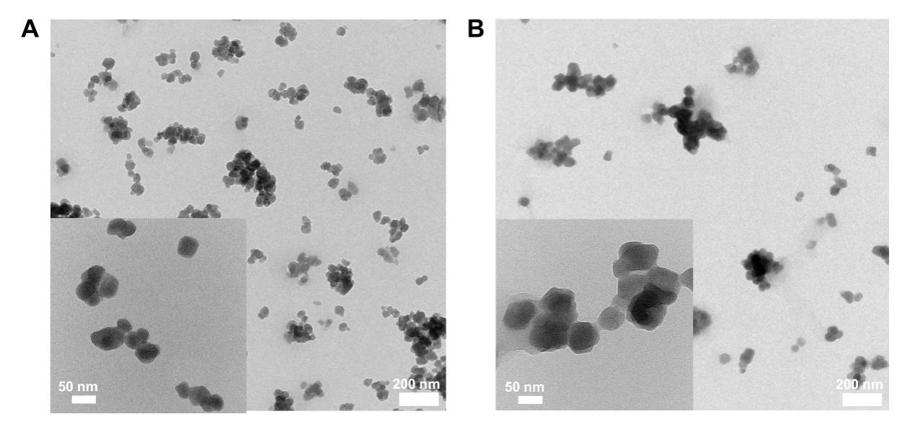
Fig. S10. Representative TEM images of Ce/Eu-BDC (A) and Ln-MOF (B).

Fig. S11. XPS results of Ce/Eu-BDC and Ln-MOF. (A) The survey scan of Ce/Eu-BDC and Ln-MOF. The refinement spectra of C 1s (B), O 1s (C), N 1s (D), Ce3d (E), and Eu3d (F).

Fig. S12. Representative TEM images and elemental distribution of Ln-MOF.

Fig. S13. FT-IR spectra of Ce-BDC, Ce/Eu-BDC, and LNM NPs.
Fig. S14. The absorption spectra of supernatant containing FITC-uPA before and after Ln-MOF loading. The decreased absorption intensity at peak 494 nm indicated that the FITC-uPA can be loaded on the Ln-MOF.

Fig. S15. Variation of the loading capacity with different amounts of uPA.

Fig. S16. Flow cytometry results of ROS level in PC-12 treated with different concentration of LNM NPs.
Fig. S17. Fluorescence images of thrombin-activated PLTs. The concentration of thrombin is 0.025 U mL⁻¹.

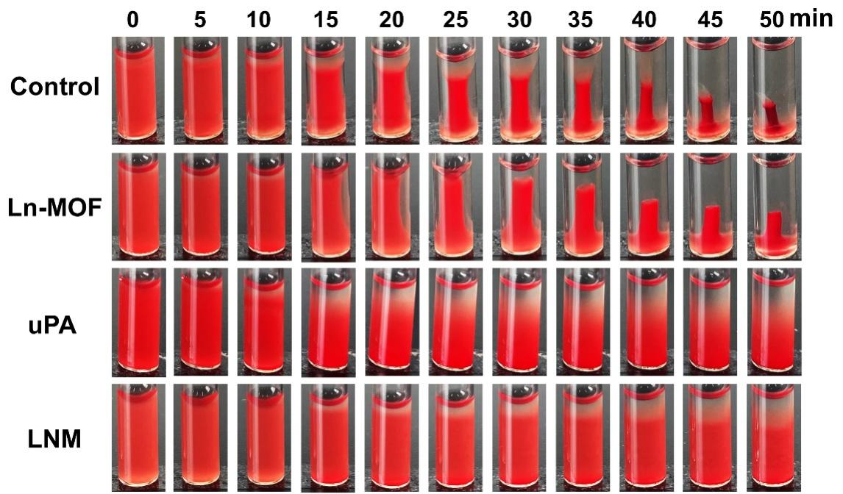
Fig. S18. Representative picture of clot reaction in PLTs after treatment with Ln-MOF, uPA, and LNM.

Fig. S19. Cell viabilities of bEnd.3 cells after incubation with different concentration of Ce/Eu-BDC, Ln-MOF, and LNM.
Fig. S20. Hemolysis rate induced by different concentrations of LNM.
Fig. S21. Fluorescent images of bEnd.3 cells uptake of LNM NPs for different times. Scale bar: 25 μm.

Fig. S22. Quantified fluorescence determination of LNM in the ischemic hemispheres shown in Fig. 5B.

Fig. S23. Quantified cerebral infarct volume of MCAO mice in each treatment group at 24 h post-stroke (n = 4).

Fig. S24. Quantitative analysis of immunostaining of CD16 in each treatment group at 24 h post-stroke.

Fig. S25. Immunostaining of CD206 (blue: DAPI; green: Iba-1; orange: CD206) to determine phenotype of microglia (scale bar = 200 μm).

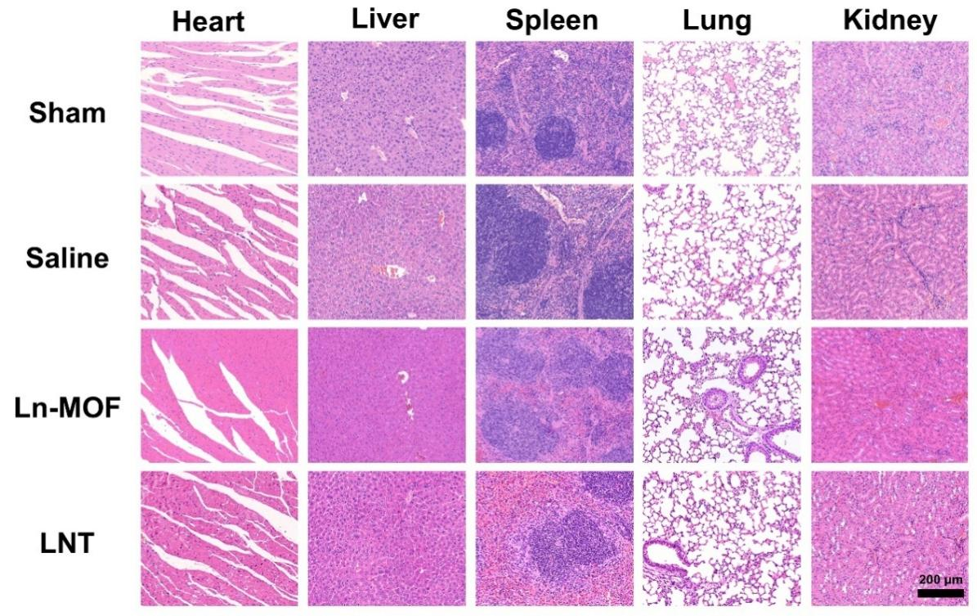
Fig. S26. H&E staining of major organs (heart, liver, spleen, lung, and kidney) in sham and stroke mice treated with saline, Ln-MOF and LNM. Scale bar: 200 μm.

Fig. S27. Blood routine analysis results of sham mice and mice treated with Ln-MOF and LNM.

