Synthesis and Characterization of Silica Nanoparticles recovered from Polymer-Silica Hybrid Films
Abdullah A. Al Haddad, Ali Bumajdad*, Fakhreia Al Sagheer*
ªChemistry Department, Faculty of Science, Kuwait University, P.O. Box: 5969, Safat 13060, Kuwait.
* Corresponding Author: Ali Bumajdad (a.bumajdad@ku.edu.kw); Fakhreia Al Sagheer (fakhreia@gmail.com)

3.1 Hybrid-film characterization
3.1.1 Energy dispersive X-ray spectroscopy (EDS)

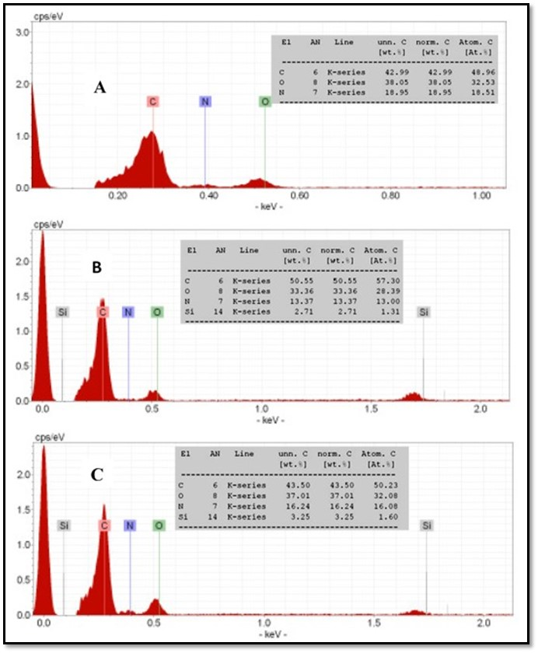

D
E

Figure 1S. EDS spectra of aramid-silica hybrids; (A) pure aramid film, (B) UB-Ar-5% hybrid film and (C) UB-Ar-5% hybrid film. EDS spectra of chitosan-silica hybrids; (D) pure chitosan film, (E) Cs-Si-20% hybrid film.

3.1.2 Fourier-transform infrared, FT-IR
(a)

(b)

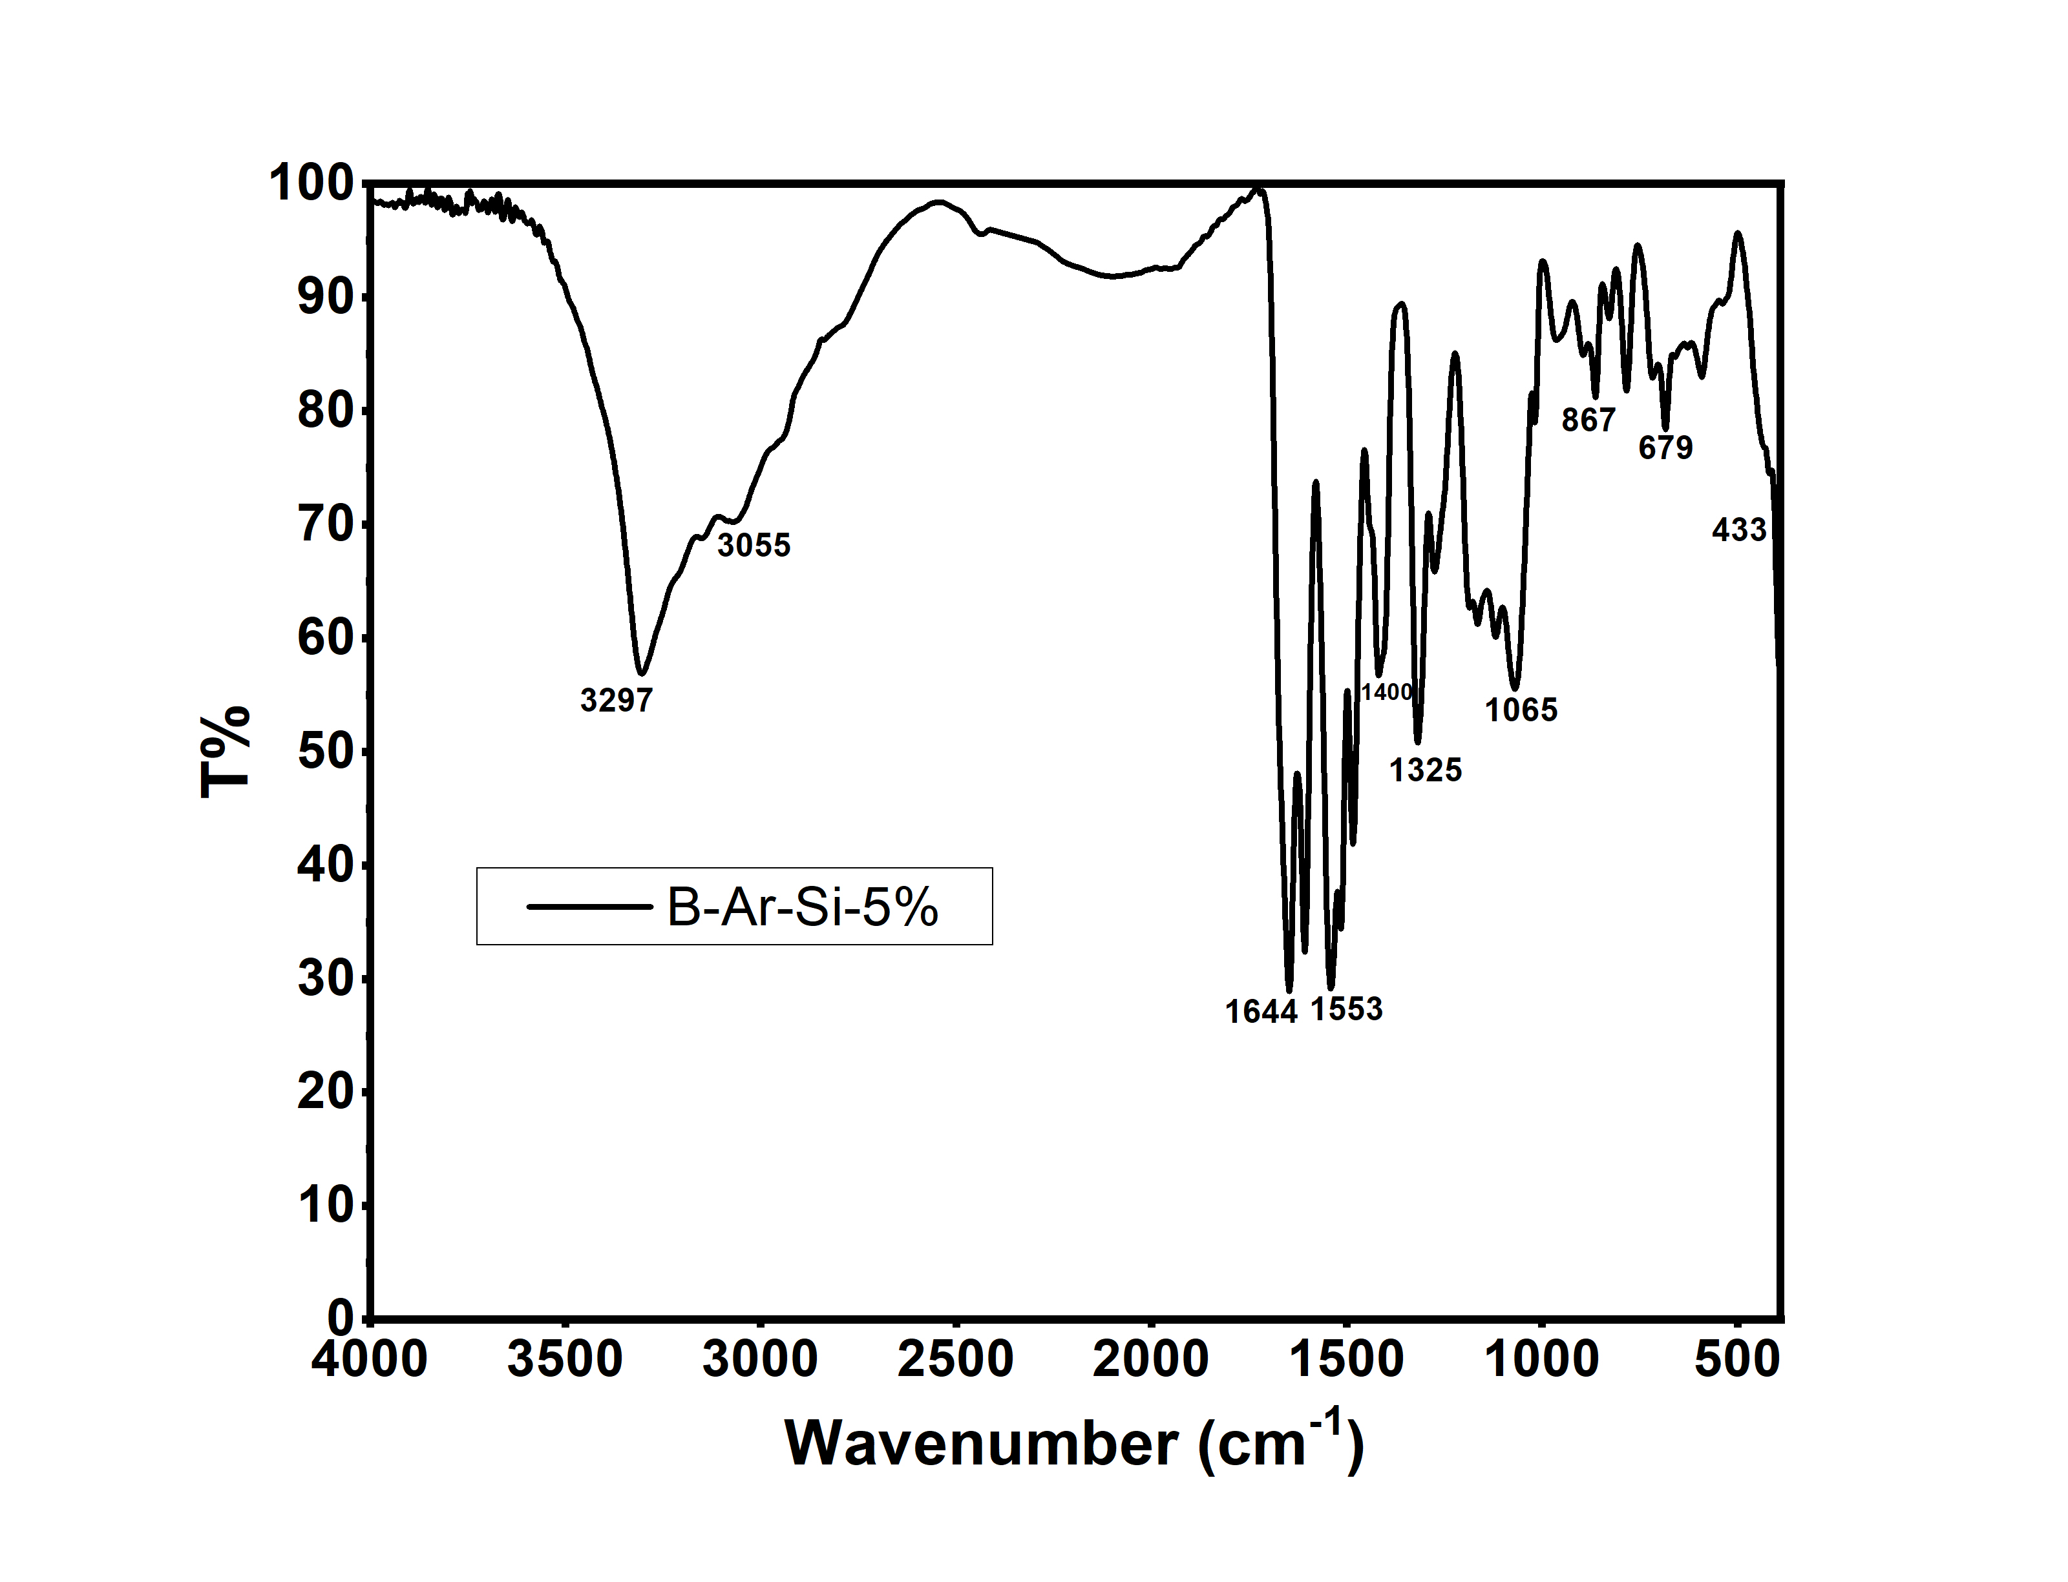
(C)

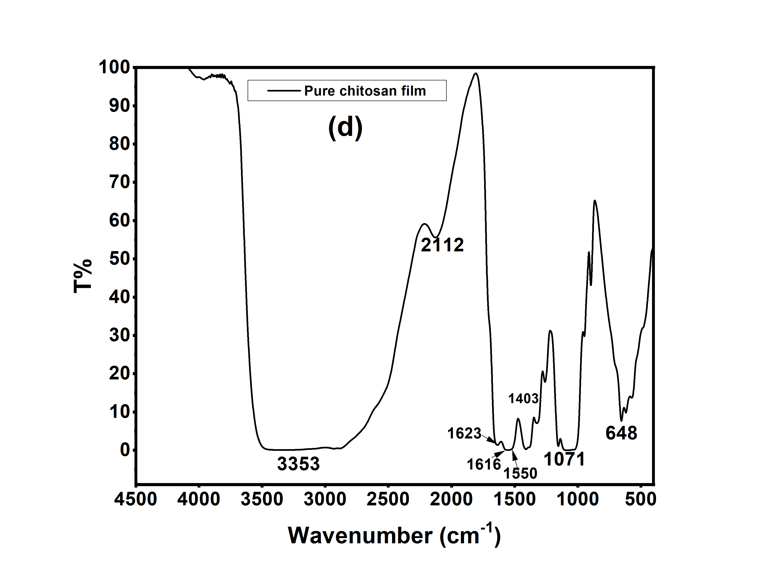

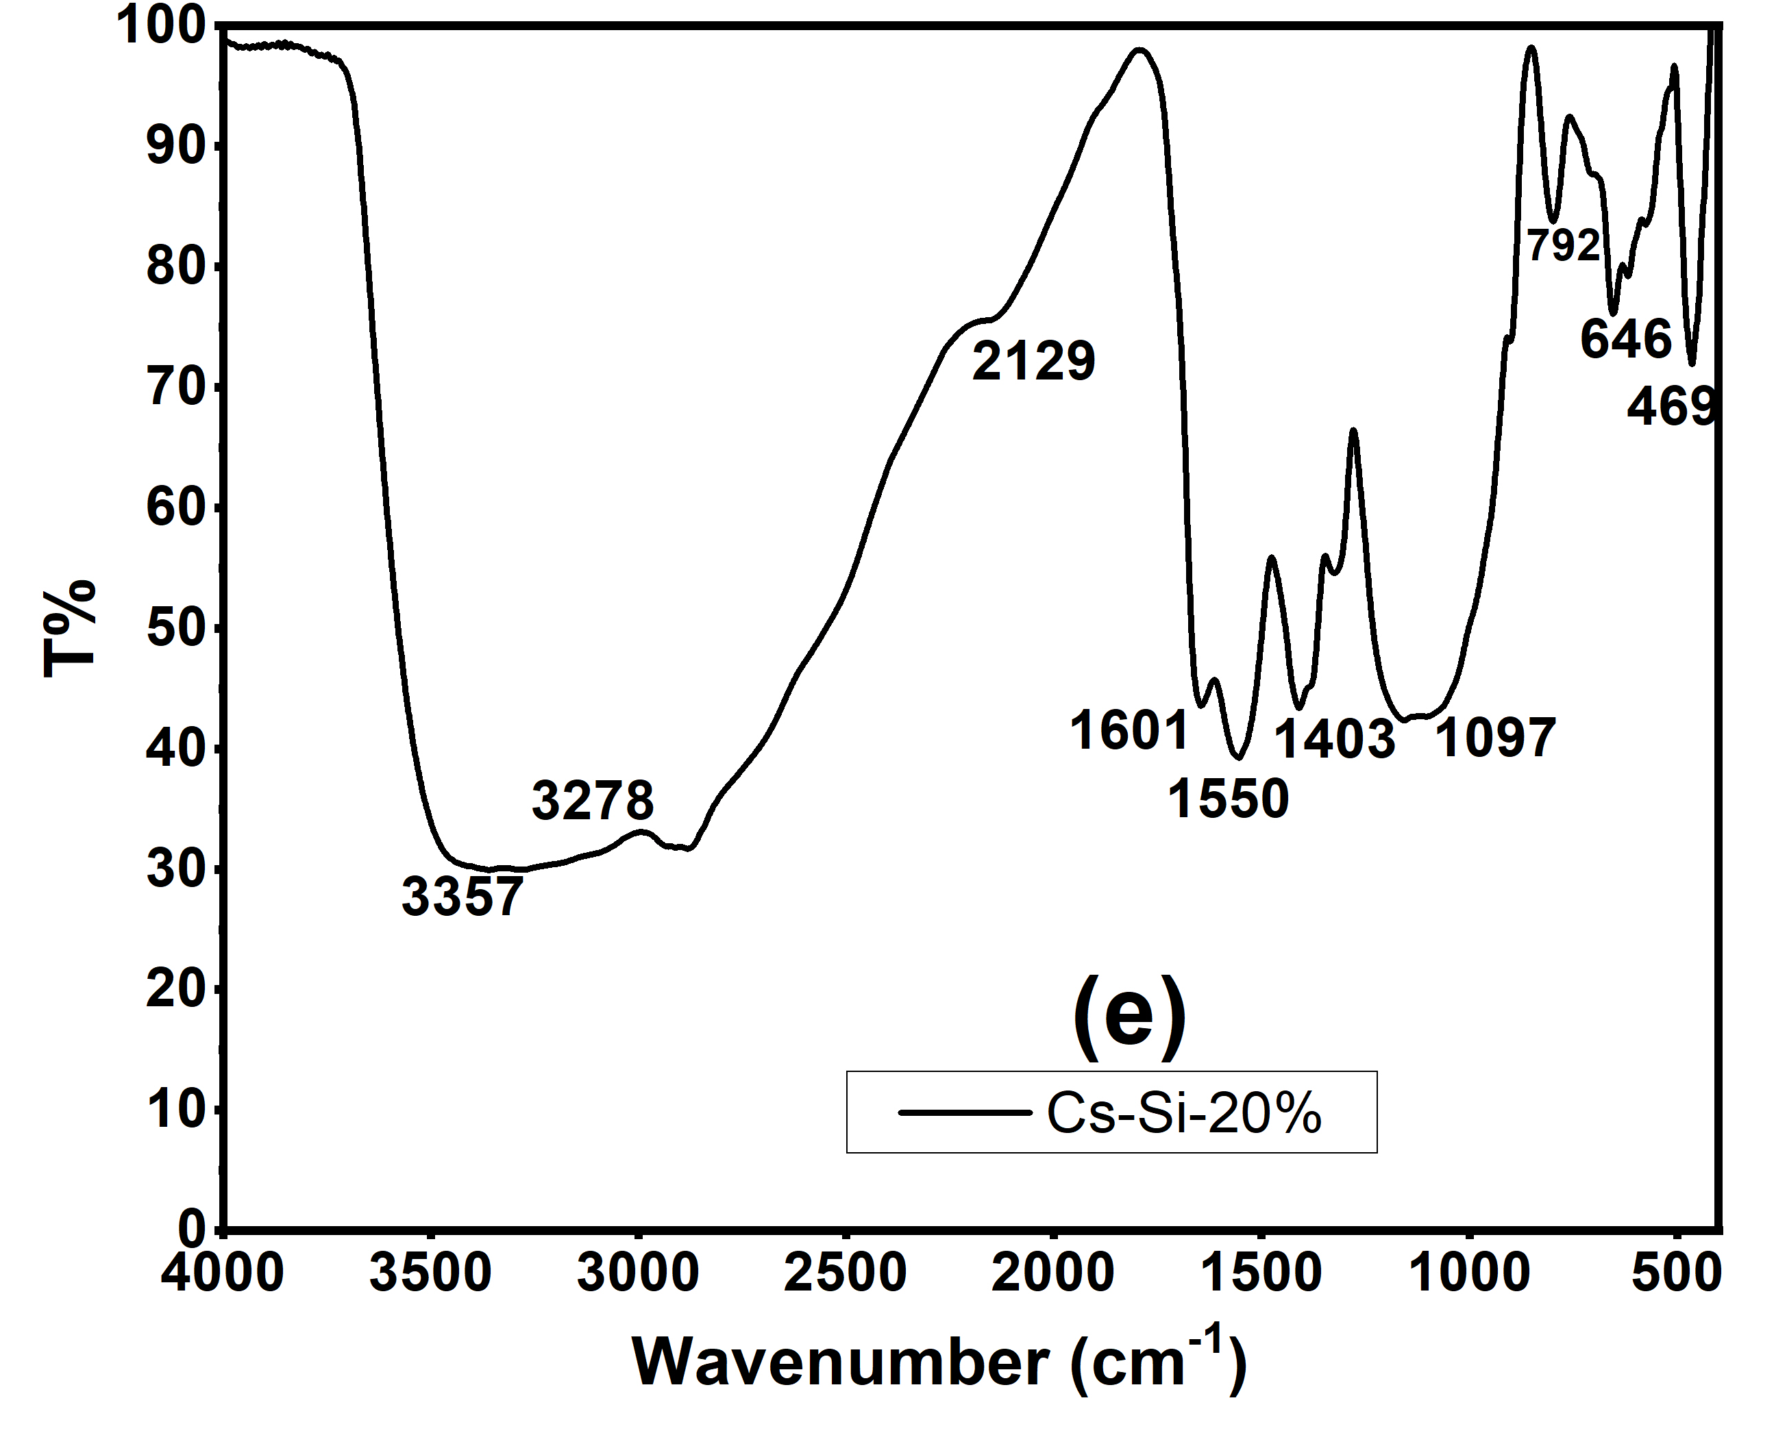

Figure 2S. FTIR spectrum of Pure aramid (a), UB-Ar-Si-5% (b), B-Ar-Si-5% (c), pure chitosan (d), and Ch-Si-20% (e) hybrid film.

3.2 Silica characterization
3.2.1 Fourier-transform infrared, FT-IR

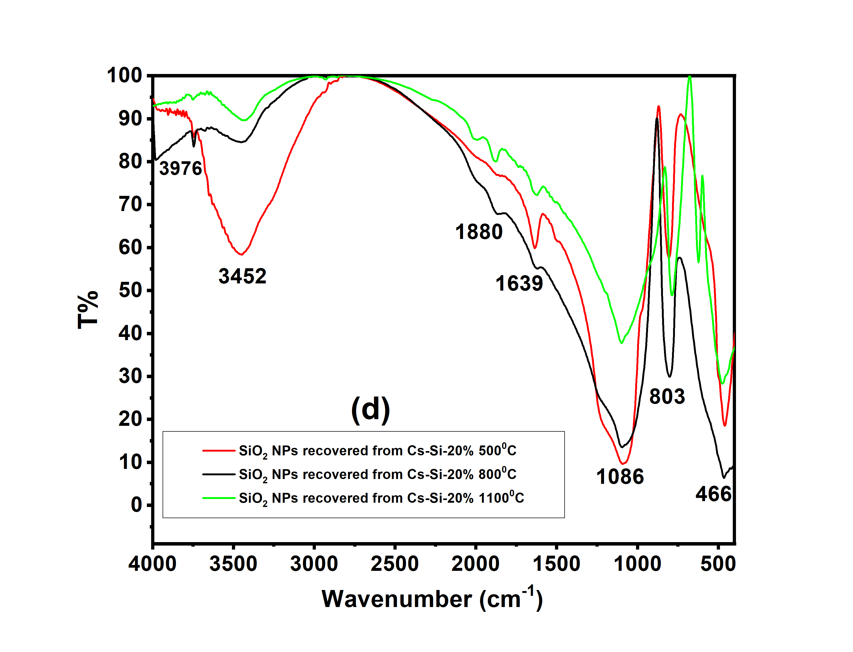

Figure 3S. FTIR spectra for SiO₂ NPs recovered at 500°C from UB-Ar-Si-5% and B-Ar-Si-5% hybrid films (5% loading (a) and 10% loading (b)). FTIR spectra for SiO₂ NPs recovered at 500°C from Cs-Si-5% and Cs-Si-10% (c). FT-IR spectra of SiO₂ NPs recovered from Cs-Si-20% after calcination at three different temperatures 500, 800 and 1100°C (d).

3.2.2 Thermogravimetric analysis, TGA

Figure 4S. TGA spectra for SiO₂ NPs recovered at 500°C from: UB-Ar-Si-5% and B-Ar-Si-5% (a) UB-Ar-Si-10% and UB-Ar-Si-10% (b) and Cs-Si-5%, Cs-Si-10% and Cs-Si-20% (c).

3.2.3 X-ray diffraction, XRD

Figure 5S. XRD spectra for SiO₂ NPs obtained using UB-Ar-Si-5&10%, B-Ar-Si-5&10%, after calcination of hybrid films at 800 ^{ο}C and 1100^{ο}C.

Table 1S. Crystallite size of the silica NPs prepared using aramid-silica and chitosan-silica hybrids.
Sample | Calcination Temperature (°C) | Crystallite size of NPs (nm)ª
UB-Ar-Si-5% | 500 | 1.8
UB-Ar-Si-5% | 800 | 1.5
UB-Ar-Si-5% | 1100 | 1.4
UB-Ar-Si-10% | 500 | 1.7
UB-Ar-Si-10% | 800 | 1.3
UB-Ar-Si-10% | 1100 | 1.2
B-Ar-Si-5% | 500 | 2.2
B-Ar-Si-5% | 800 | 1.4
B-Ar-Si-5% | 1100 | 1.3
B-Ar-Si-10% | 500 | 2.3
B-Ar-Si-10% | 800 | 1.5
B-Ar-Si-10% | 1100 | 1.3
Cs-Si-5% | 500 | 1.1
Cs-Si-5% | 800 | 14.0
Cs-Si-5% | 1100 | 5.6
Cs-Si-10% | 500 | 1.1
Cs-Si-10% | 800 | 10.2
Cs-Si-10% | 1100 | 8.0
Cs-Si-20% | 500 | 1.1
Cs-Si-20% | 800 | 8.6
Cs-Si-20% | 1100 | 7.0

ª Adopting the line-broadening technique and Sherrer formula

Figure 6S. XRD of SiO₂ NPs recovered (at 5 and 10 loading%) from the 3%-washed Cs at the indicated temperature.

3.2.4 N₂ sorpotiometry

Ι. Sorption isotherms

Figure 7S. Comparison of N₂ sorption isotherm of SiO₂ NPs recovered at 500°C from the three-studied hybrid films at 5 and 10 loading%.

ΙΙ. Specific surface area and porosity

Figure 8S. Comparison of pore size distribution of SiO₂ NPs recovered at the indicated temperature from the three studied hybrid films at 5 and 10 loading%.

3.2.4 Microscopy analysis

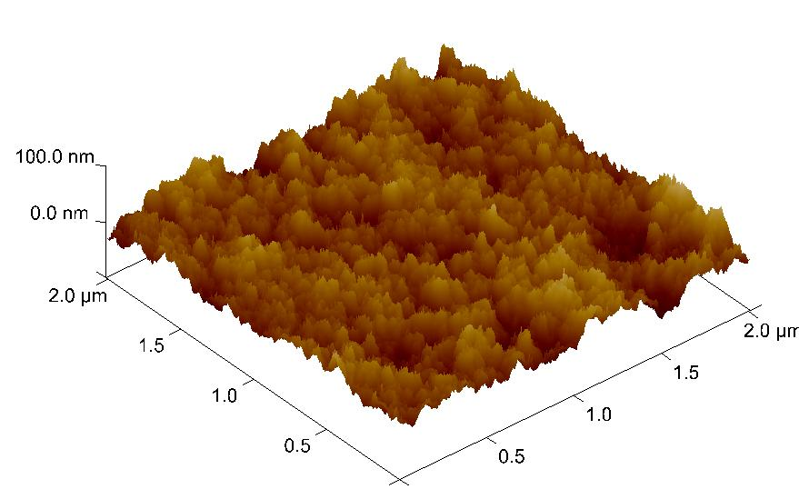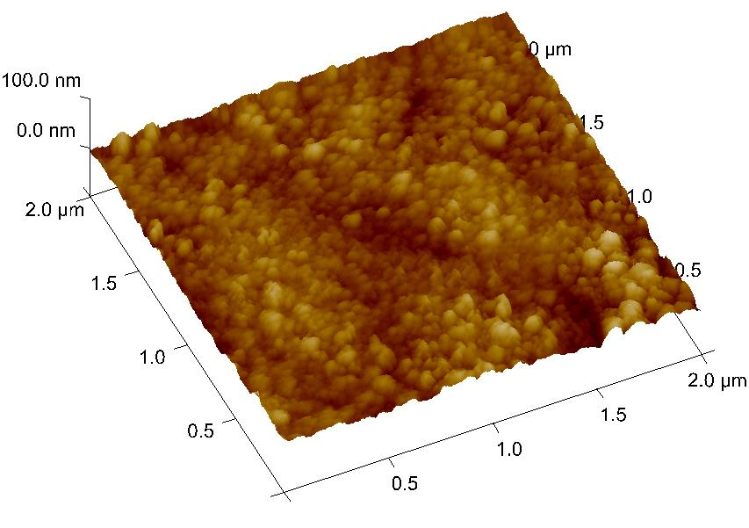
(a)
(b)

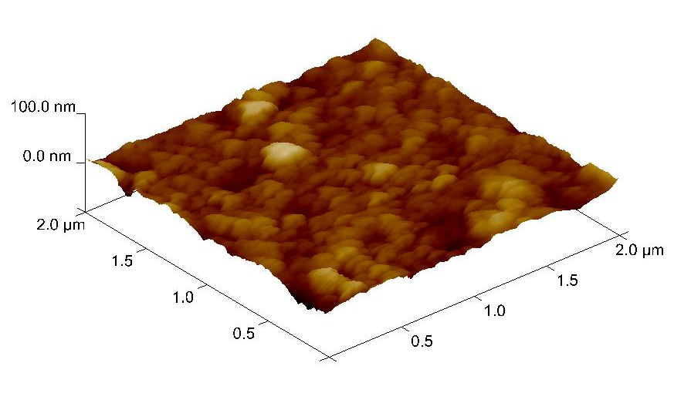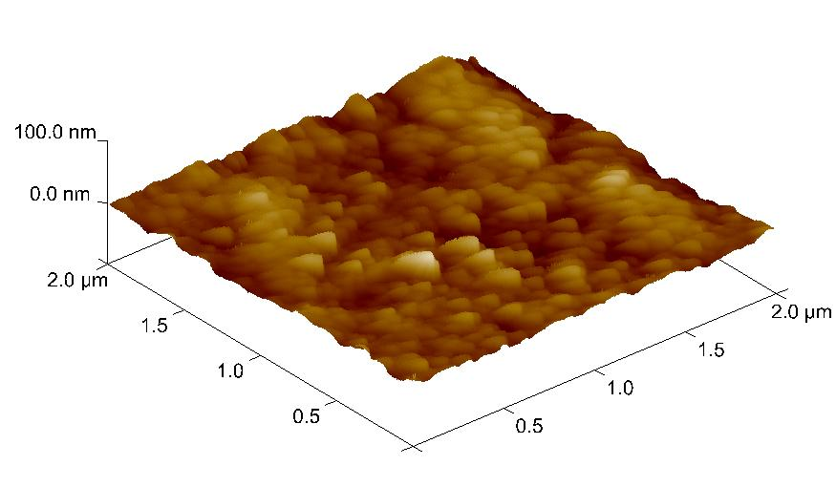
(c)
(d)

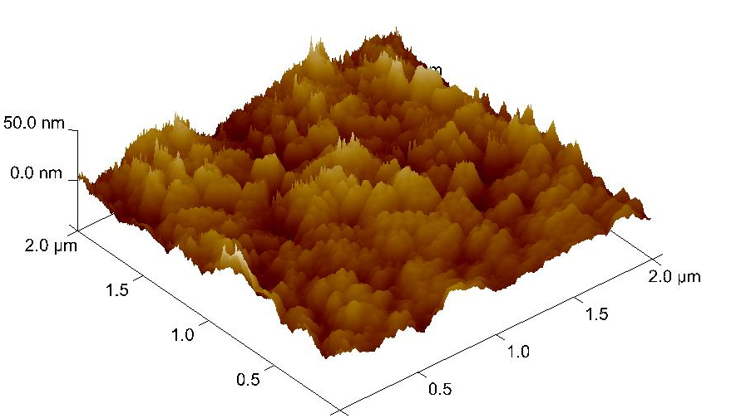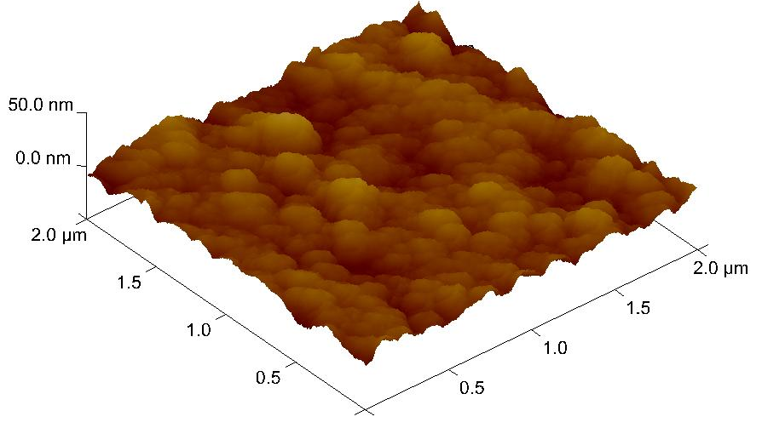
(e)
(f)

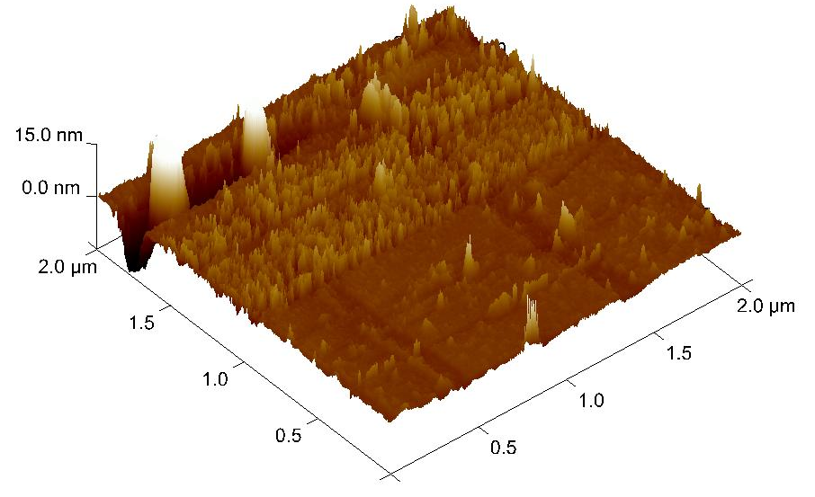
(g)

Figure 9S AFM micrograph of SiO₂ NPs recovered at 500°C from UB-Ar-Si-5% (a), UB-Ar-Si-10% (b), B-Ar-Si-5%(c), B-Ar-Si-10% (d), Cs-Si-5% (e), and Cs-Si-10% (f) hybrid films. (g) Cs-Si-5% recovered at 800°C.

