Supplementary material
Supplementary a - Temporal variation of the variables measured during the eighteen months of the study. A - Synchronism of vegetative and reproductive phenophases among the ten individuals of Byrsonima coccolobifolia Kunth (Malpighiaceae) monitored between September 2018 to February 2020 evaluated at relative frequency index. B - Synchronism of gall phenophases among the ten individuals of Byrsonima coccolobifolia monitored between September 2018 to February 2020 evaluated at relative frequency index.
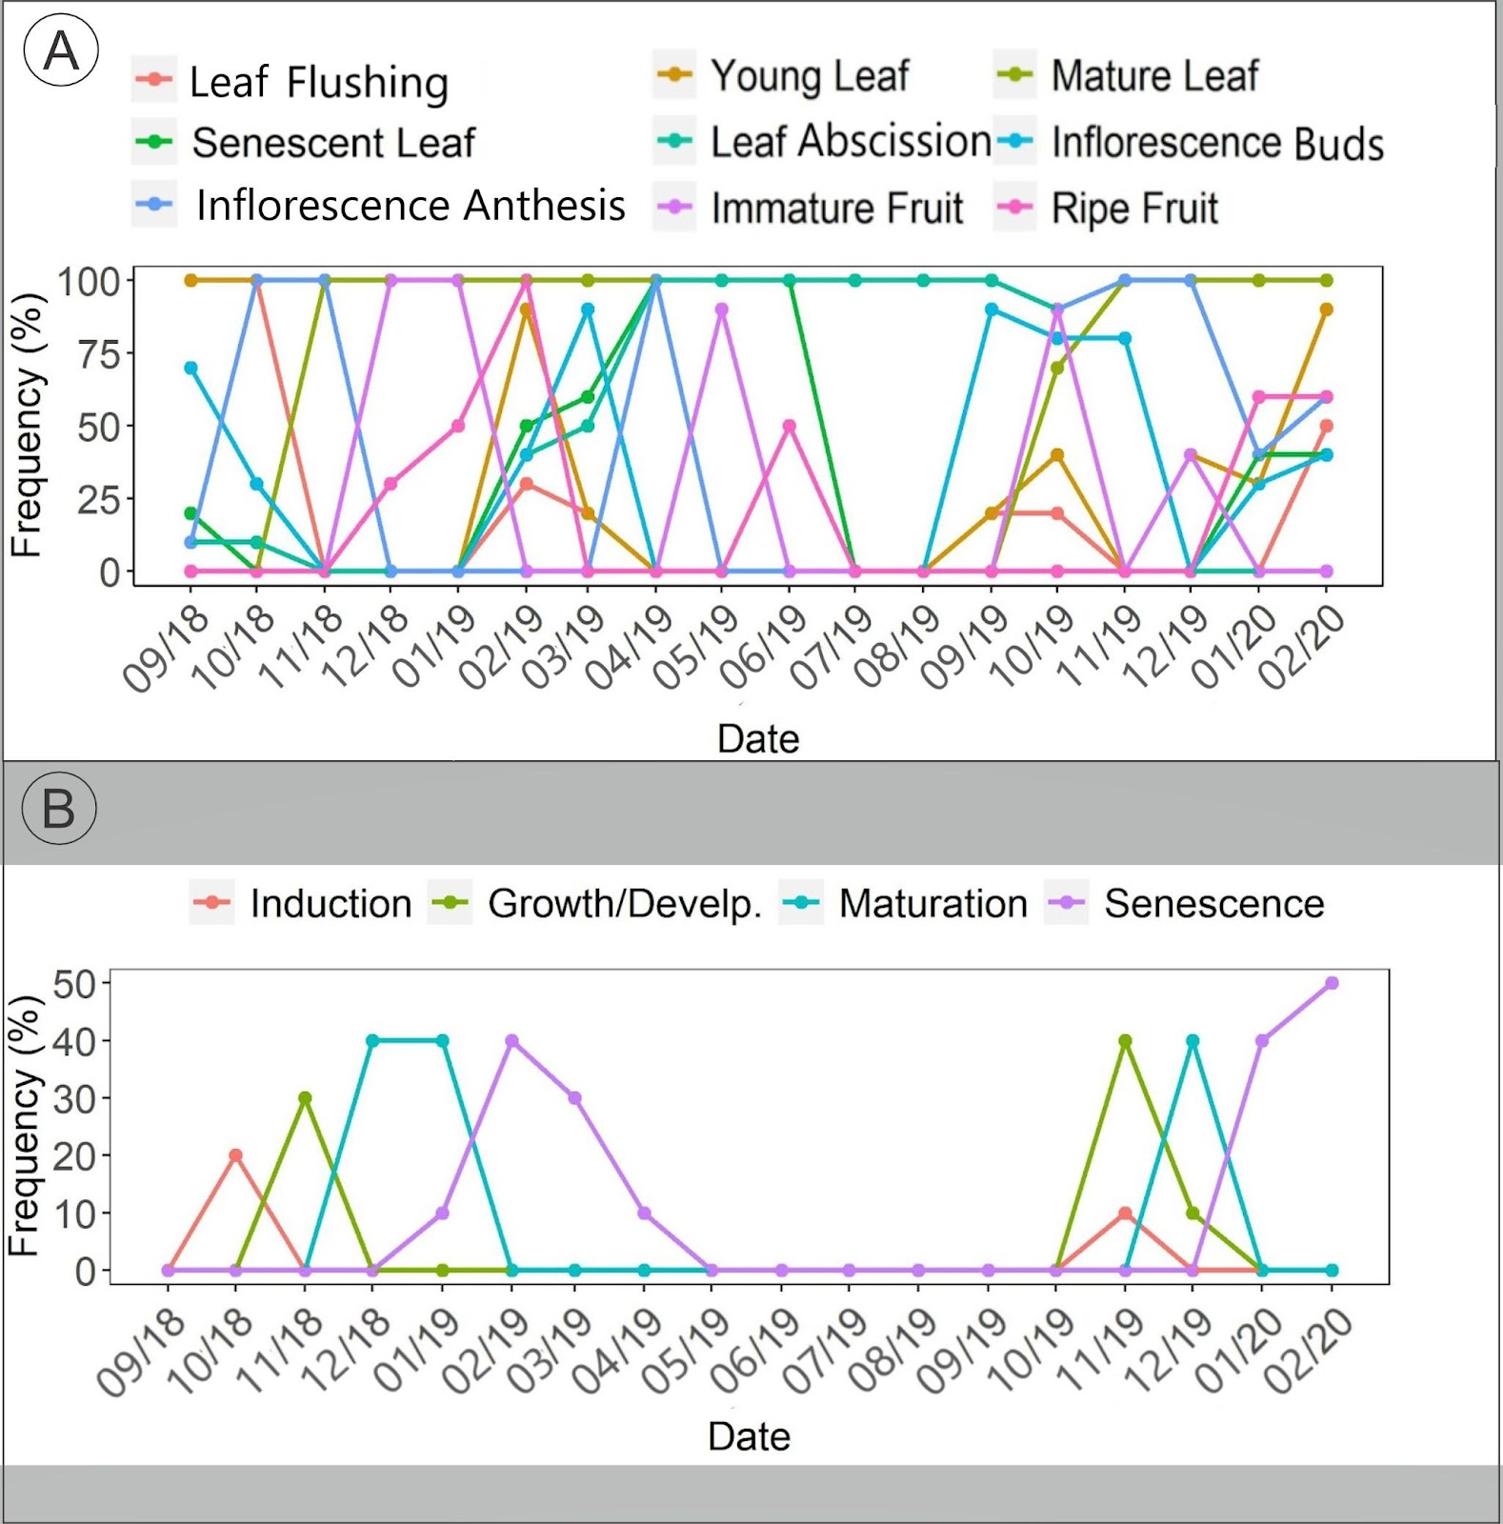

Supplementary b - Illustrative plots of the host plant phenophases for the significant non-parametric Kendall’s correlations followed by their respective p-values. Strong correlations are above 0.7 and correlations between 0.4 and 0.69 are considered moderate. Correlations near 1, indicate a high synchrony, values near -1.
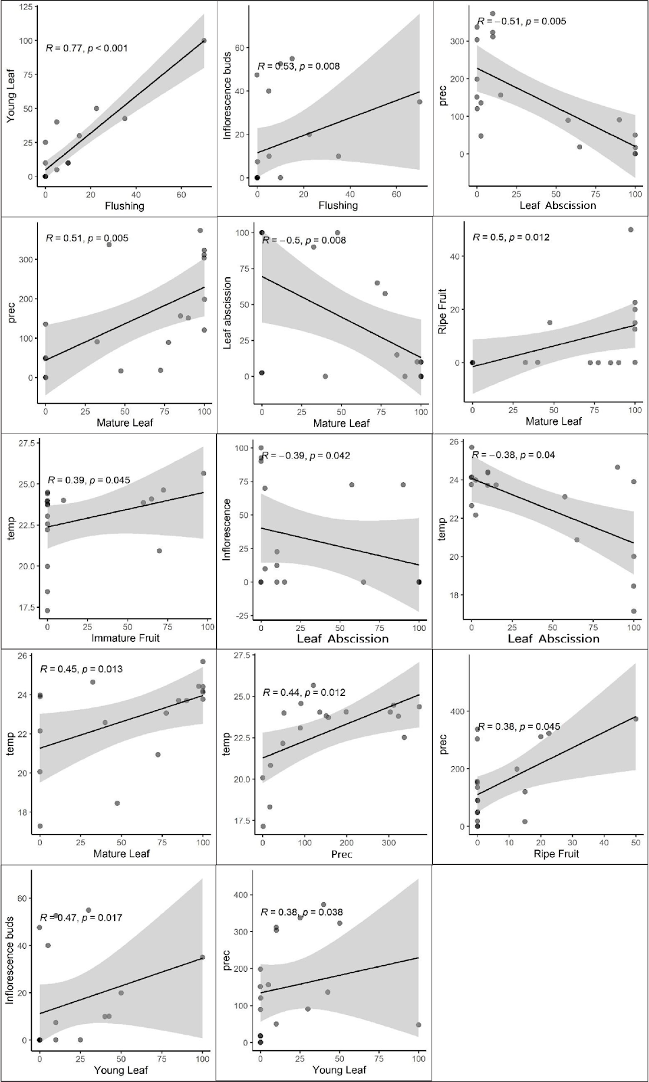
Supplementary c - Illustrative plots of the gall phenophases for the significant non-parametric Kendall’s correlations followed by their respective p-values. Strong correlations are above 0.7 and correlations between 0.4 and 0.69 are considered moderate. Correlations near 1, indicate a high synchrony, values near -1.
