CLINICAL  FEATURES | Sex (‘sexe'), Performans Status ('OMS'), Age ('age'), BMI ('BMI'), Weight ('poids'), Height ('taille'), Dyspnea Scale according to mMRC ('dyspnee_NYHA'), Charlson Comorbidity Index ('score_charlson'), Leukemia ('score_leucemie'), Lymphoma ('score_lymphome’), Myocardial Infarction ('score_IDM'), Localised solid tumor ('score_kc_local'), Metastatic solid tumor ('score_kc_meta'), Moderate-Severe CKD ('score_IRC'), Uncomplicated Diabetes ('score_diabete'), End-organ damage Diabetes ('score_diabete_comp'), Mild liver disease ('score_hepatique_mod'), Moderate-severe liver disease ('score_hepatique_HTP'), Peptic ulcer disease ('score_ulcere'), Peripheral vascular disease ('score_vasc_periph'), Connective tissue disease ('score_systeme'), Chronic pulmonary disease ('score_systeme'), Congestive heart failure ('score_ICC'), Dementia ('score_demence'), CVA or TIA ('score_AIT_AVC'), Patient age group over 50 years ('score_age_50'), Hypertension ('HTA'), Aids ('score_sida'), Active smoking ('tabac'),  Smoking cessation ('tabac_sevre'), Number of pack-years ('tabac_PA'), Histology ('histo'), Sleep Apnea Syndrome ('SAS'), Clinical Tumor Stage ('T'), Clinical Nodal Stage ('N'), Clinical Metastatic Stage ('M'), Central location ¹ ('centrale'), Pulmonary lobe localisation ('loc'), Number of treated tumor by patient ('nbre_cibles'), History of other primary pulmonary tumor ('ATCD_neo_pulm'), History of other primary tumor ('ATCD_neo_NP'), Localisation 1 of the primary tumor history ('ATCD_loc_1') , Localisation 2 of the primary tumor history ('ATCD_loc_2'), Localisation 3 of the primary tumor history ('ATCD_loc_3')
DOSIMETRIC FEATURES | Total dose ('dose_tot'), BED₁₀ ('BED_10'), Dose per fraction ('dose_fraction'), Overall duration of treatment ('etalement'), GTV Volume ('vol_GTV'), ITV Volume ('vol_ITV'), PTV volume ² ('vol_PTV'), Minimum dose in PTV ('min_PTV'), Mean dose in PTV ('mean_PTV'), Maximum dose in PTV ('max_PTV'), PTV coverage ³ ('couv_PTV')
RADIOMICS FEATURES  SHAPE RADIOMICS  TEXTURAL RADIOMICS | 'MORPHOLOGICAL_Volume', 'MORPHOLOGICAL_ApproximateVolume',  'MORPHOLOGICAL_SurfaceArea', 'MORPHOLOGICAL_SurfaceToVolumeRatio', 'MORPHOLOGICAL_Compacity', 'MORPHOLOGICAL_voxelsCounting',  'MORPHOLOGICAL_Compactness1', 'MORPHOLOGICAL_Asphericity',  'MORPHOLOGICAL_Compactness2', 'MORPHOLOGICAL_SphericalDisproportion',  'MORPHOLOGICAL_Sphericity', 'MORPHOLOGICAL_CentreOfMassShift', 'MORPHOLOGICAL_Maximum3DDiameter', 'MORPHOLOGICAL_SphereDiameter', 'MORPHOLOGICAL_IntegratedIntensity'
RADIOMICS FEATURES  SHAPE RADIOMICS  TEXTURAL RADIOMICS | 'GLCM_JointMaximum', 'GLCM_JointAverage', 'GLCM_JointVariance', 'GLCM_JointEntropyLog2', 'GLCM_JointEntropyLog10', 'GLCM_DifferenceAverage', 'GLCM_DifferenceVariance', 'GLCM_SumAverage', 'GLCM_SumVariance', 'GLCM_AngularSecondMoment', 'GLCM_Contrast', 'GLCM_Dissimilarity', 'GLCM_InverseDifference', 'GLCM_NormalisedInverseDifference', 'GLCM_InverseDifferenceMoment', 'GLCM_NormalisedInverseDifferenceMoment', 'GLCM_InverseVariance', 'GLCM_Correlation', 'GLCM_Autocorrelation', 'GLCM_ClusterTendency', 'GLCM_ClusterShade', 'GLCM_ClusterProminence', 'GLRLM_ShortRunsEmphasis', 'GLRLM_LongRunsEmphasis', 'GLRLM_LowGreyLevelRunEmphasis', 'GLRLM_HighGreyLevelRunEmphasis', 'GLRLM_ShortRunLowGreyLevelEmphasis', 'GLRLM_ShortRunHighGreyLevelEmphasis', 'GLRLM_LongRunLowGreyLevelEmphasis', 'GLRLM_LongRunHighGreyLevelEmphasis', 'GLRLM_GreyLevelNonUniformity', 'GLRLM_RunLengthNonUniformity', 'GLRLM_RunPercentage', 'NGTDM_Coarseness', 'NGTDM_Contrast', 'NGTDM_Busyness', 'NGTDM_Complexity', 'NGTDM_Strength', 'GLSZM_SmallZoneEmphasis', 'GLSZM_LargeZoneEmphasis', 'GLSZM_GreyLevelNonUniformity',  'GLSZM_LowGrayLevelZoneEmphasis', 'GLSZM_HighGrayLevelZoneEmphasis', 'GLSZM_SmallZoneLowGreyLevelEmphasis', 'GLSZM_SmallZoneHighGreyLevelEmphasis', 'GLSZM_LargeZoneLowGreyLevelEmphasis', 'GLSZM_LargeZoneHighGreyLevelEmphasis', 'GLSZM_NormalisedGreyLevelNonUniformity', 'GLSZM_ZoneSizeNonUniformity', 'GLSZM_GreyLevelVariance', 'GLSZM_NormalisedZoneSizeNonUniformity', 'GLSZM_ZonePercentage', 'GLSZM_ZoneSizeVariance', 'GLSZM_ZoneSizeEntropy'
Supplementary Table S1. List of clinical, dosimetric, shape and textural radiomics features used in this study. BMI = Body Masse Index. mMRC = modified Medical Research Council. CKD = Chronic Kidney Disease. CVA = Cerebrovascular Accident. TIA = Transient Ischemic Attack. BED₁₀ = Biologically Effective Dose for 𝞪/𝛃=10). GTV = Gross Tumor Volume. ITV = Internal Target Volume. PTV = Planning Target Volume. ¹ According to the Timmerman et al. Classification (38). ² PTV corresponded to an isometric margin of 3 to 5 mm around the GTV or ITV. ³ PTV covered by 95% of the prescription dose.

RADIOMICS FEATURES  INTENSITY RADIOMICS | 'INTENSITY-BASED_MeanIntensity', 'INTENSITY-BASED_IntensitySkewness', 'INTENSITY-BASED_IntensityKurtosis', 'INTENSITY-BASED_MedianIntensity', 'INTENSITY-BASED_MinimumIntensity', 'INTENSITY-BASED_10thIntensityPercentile', 'INTENSITY-BASED_25thIntensityPercentile', 'INTENSITY-BASED_50thIntensityPercentile', 'INTENSITY-BASED_75thIntensityPercentile', 'INTENSITY-BASED_90thIntensityPercentile', 'INTENSITY-BASED_StandardDeviation', 'INTENSITY-BASED_MaximumIntensity', 'INTENSITY-BASED_IntensityInterquartileRange', 'INTENSITY-BASED_IntensityRange', 'INTENSITY-BASED_IntensityBasedMeanAbsoluteDeviation', 'INTENSITY-BASED_IntensityBasedRobustMeanAbsoluteDeviation', 'INTENSITY-BASED_IntensityBasedMedianAbsoluteDeviation', 'INTENSITY-BASED_AreaUnderCurveCIVH', 'INTENSITY-BASED_IntensityBasedEnergy', 'INTENSITY-BASED_RootMeanSquareIntensity', 'INTENSITY-BASED_TotalLesionGlycolysis', 'LOCAL_INTENSITY_BASED_GlobalIntensityPeak', 'LOCAL_INTENSITY_BASED_LocalIntensityPeak',  'INTENSITY-HISTOGRAM_IntensityHistogramMean', 'INTENSITY-HISTOGRAM_IntensityHistogramVariance', 'INTENSITY-HISTOGRAM_IntensityHistogramSkewness', 'INTENSITY-HISTOGRAM_IntensityHistogramKurtosis', 'INTENSITY-HISTOGRAM_IntensityHistogramMedian', 'INTENSITY-HISTOGRAM_IntensityHistogramMinimumGreyLevel', 'INTENSITY-HISTOGRAM_IntensityHistogram10thPercentile', 'INTENSITY-HISTOGRAM_IntensityHistogram25thPercentile', 'INTENSITY-HISTOGRAM_IntensityHistogram50thPercentile', 'INTENSITY-HISTOGRAM_IntensityHistogram75thPercentile', 'INTENSITY-HISTOGRAM_IntensityHistogram90thPercentile', 'INTENSITY-HISTOGRAM_IntensityHistogramStd', 'INTENSITY-HISTOGRAM_IntensityHistogramMaximumGreyLevel', 'INTENSITY-HISTOGRAM_IntensityHistogramMode', 'INTENSITY-HISTOGRAM_IntensityHistogramInterquartileRange', 'INTENSITY-HISTOGRAM_IntensityHistogramRange', 'INTENSITY-HISTOGRAM_IntensityHistogramMeanAbsoluteDeviation', 'INTENSITY-HISTOGRAM_IntensityHistogramRobustMeanAbsoluteDeviation', 'INTENSITY-HISTOGRAM_IntensityHistogramMedianAbsoluteDeviation', 'INTENSITY-HISTOGRAM_IntensityHistogramCoefficientOfVariation', 'INTENSITY-HISTOGRAM_IntensityHistogramQuartileCoefficientOfDispersion’, 'INTENSITY-HISTOGRAM_IntensityHistogramEntropyLog10', 'INTENSITY-HISTOGRAM_IntensityHistogramEntropyLog2', 'INTENSITY-HISTOGRAM_AreaUnderCurveCIVH', 'INTENSITY-HISTOGRAM_Uniformity', 'INTENSITY-HISTOGRAM_RootMeanSquare', 'INTENSITY-HISTOGRAM_MaximumHistogramGradient', 'INTENSITY-HISTOGRAM_MaximumHistogramGradientGreyLevel', 'INTENSITY-HISTOGRAM_MinimumHistogramGradient', 'INTENSITY-HISTOGRAM_MinimumHistogramGradientGreyLevel', 'LOCAL_INTENSITY_HISTOGRAM_GlobalIntensityPeak', 'LOCAL_INTENSITY_HISTOGRAM_LocalIntensityPeak'
Supplementary Table S2. List of intensity radiomics features used in this study.

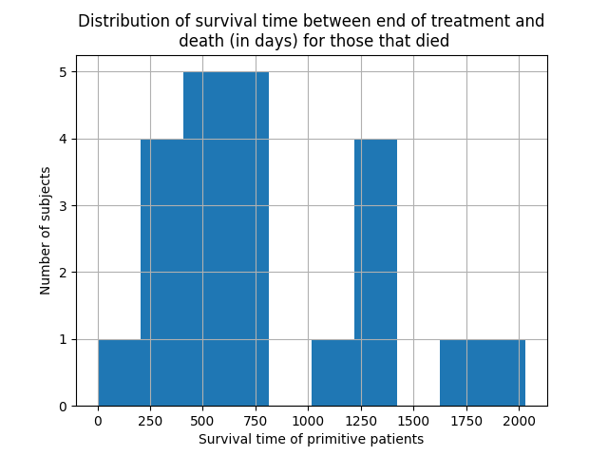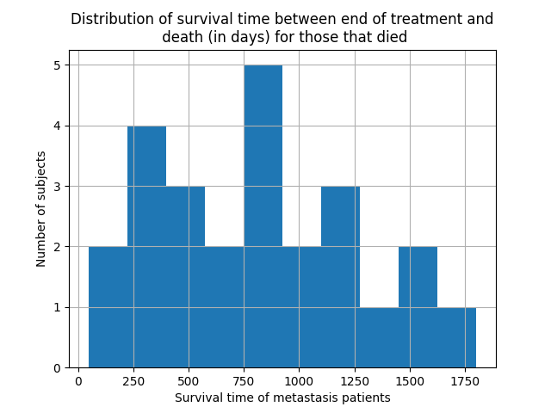
Supplementary Figure S3. Distribution of overall survival times in patients with primary (left) and secondary (right) lung tumors. The barplot illustrates the number of patients within specific survival intervals.

 | Values explored
colsample_bytree | Real(0.001, 1)
learning_rate | Real(0.01, 0.5, prior='log-uniform')
max_depth | Integer(3, 10)
min_child_weight | Integer(1, 10)
scale_pos_weight | Integer(2, 8)
subsample | Real(0.5, 1)

Supplementary Table S4. XGBoost hyperparameter values explored during Bayesian hyperparameter optimization. Real(X, Y) indicate that the parameter takes a real value between X an Y. Integer(Y, Z) indicate that the parameter takes an integer value between Y and Z.

 | Primitive tumor patients | Secondary tumor patients
ROC AUC | 0.89 ± 0.05 | 0.87 ± 0.10
Brier score | 0.14 ± 0.07 | 0.19 ± 0.12
Precision | 0.47 ± 0.10 | 0.66 ± 0.22
Recall | 0.64 ± 0.21 | 1.00 ± 0.00
Accuracy | 0.75 ± 0.08 | 0.72 ± 0.21
AUC-PR | 0.73 ± 0.06 | 0.88 ± 0.10
F1 score | 0.52 ± 0.06 | 0.78 ± 0.15

Supplementary Table S5. Model performances during nested cross-validation.

