SUPPLEMENTARY MATERIAL
A
B
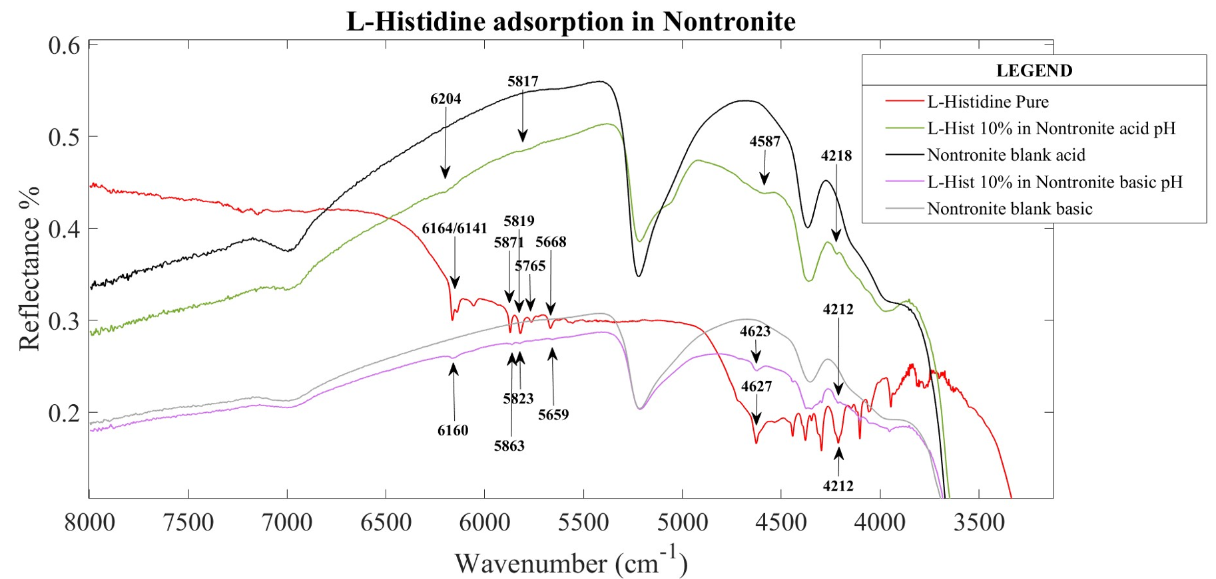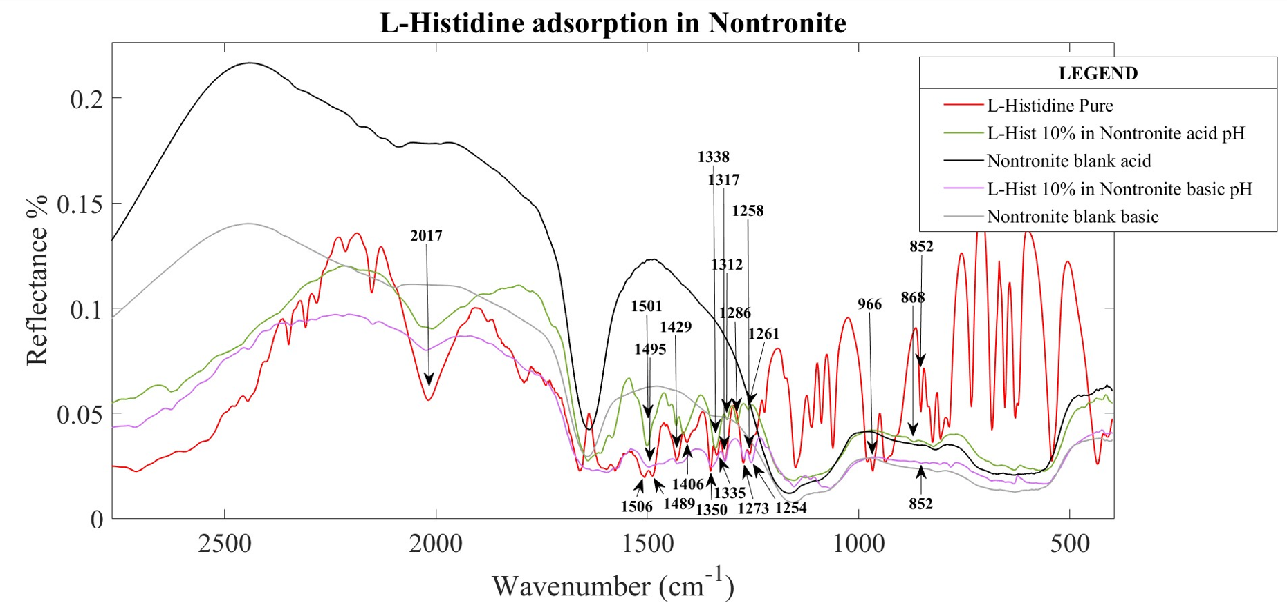
Figure S1: a) Spectra range zoomed 8000 to 3500 cm⁻¹. b) Spectra range zoomed 3000 to 450 cm⁻¹. The wavenumber positions of the bands are marked.

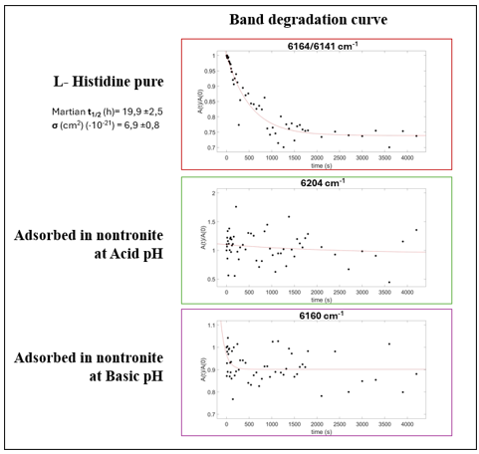
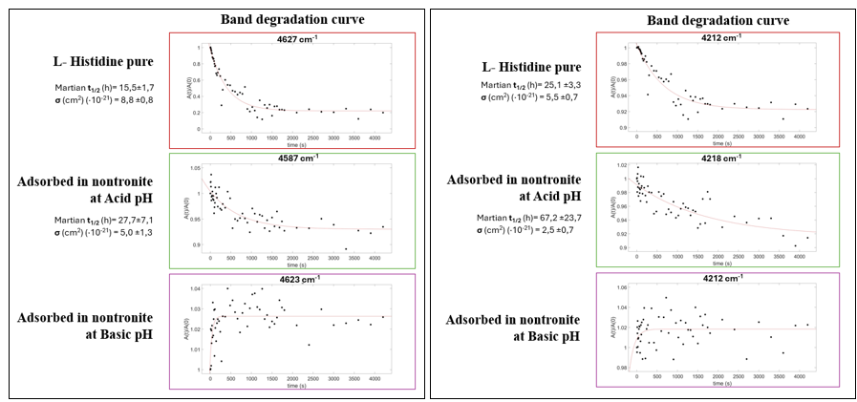Figure S2: Degradation curves for the bands at 6164/6141 cm⁻¹; 4627 cm⁻¹ and 4412 cm⁻¹ in pure L-histidine and adsorbed at acid and basic pHs. Martian half-life degradation time (t_{1/2}) expressed in hours (general mars flux by Patel et al., 2002) and degradation cross section (σ) expressed in cm².

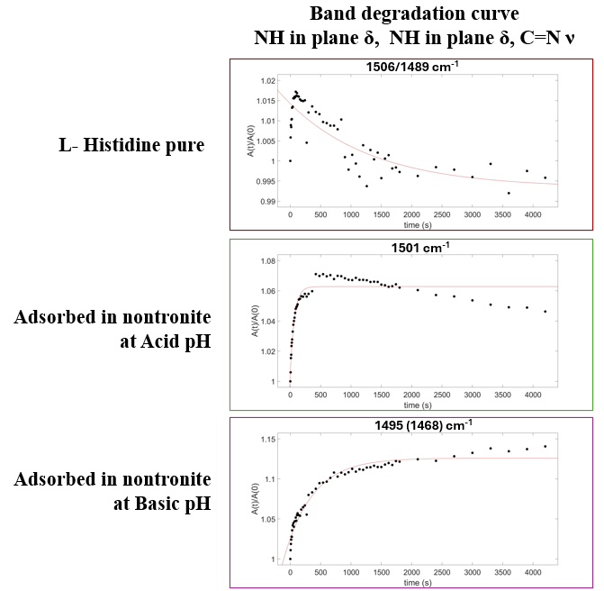
Figure S3: Degradation curves for the bands 1506/1489 cm⁻¹ in the pure L-histidine and adsorved into nontronite at acid anc basic pHs.

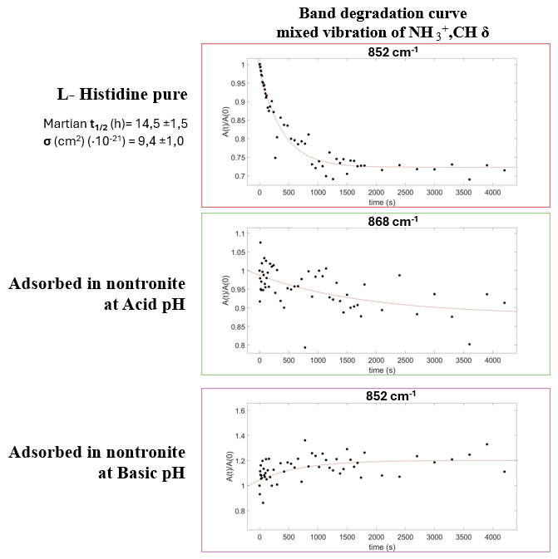
Figure S4: Degradation curves for the band at 852 cm⁻¹ in the pure L-histidine and adsorved into nontronite at acid anc basic pHs. Martian half-life degradation time (t_{1/2}) expressed in hours (general mars flux by Patel et al., 2002) and degradation cross section (σ) expressed in cm².

