Identification of small molecules as potential inhibitors of NAT10 for the treatment of colon cancer
Chao Xu ¹, Shilei Zhao ², Bing Xu ³, Jiaping Xu ¹, Yongli Wu ¹, Dan Zhang ⁴, Bensheng Wu ^{5, *}, Qing Zhou ^{6, *}
¹ Department of Proctology, Danyang TCM Hospital, Danyang 212300, China
² College of pharmacy Nanjing, University of Chinese Medicine, Nanjing 211198, China
³ Department of Spleen and Stomach, Danyang TCM Hospital, Danyang 212300，China
⁴ Department of Colorectal Medicine, Jiangsu Provincial Hospital of TCM, Nanjing 210001, China
⁵ Department of Colorectal Surgery, Suzhou TCM Hospital Affiliated to Nanjing University of Chinese Medicine, Suzhou 215009, China
⁶ Department of Preventive Medicine, Jiangsu Provincial TCM Hospital, Nanjing 210001, China
* Corresponding author: 13601401869@163.com (Q.Z.); 472044066@qq.com (B.W.)

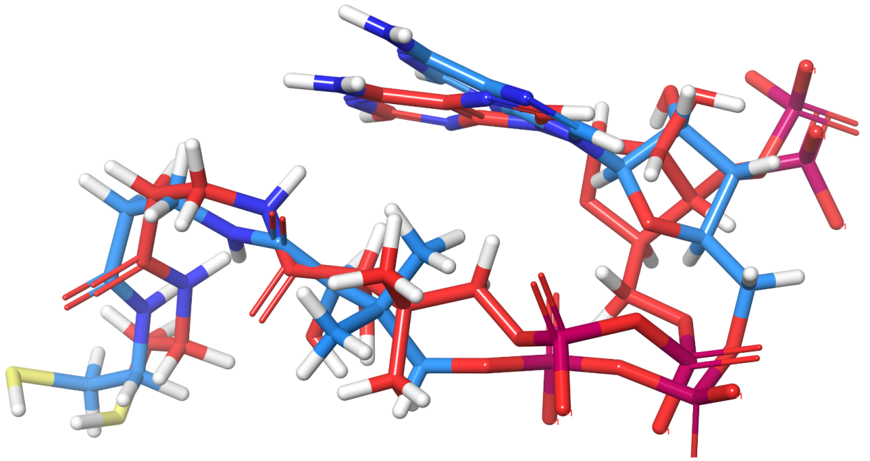
Figure S1. Alignment of the crystal ligand (red) with the redocked ligand (blue).

Table S1. List of the top 55 compounds and their docking scores based on glide XP docking approach (kcal/mol).
NO. | ID | XP Gscore | Prime MM/GBSA | NO. | ID | XP Gscore | Prime MM/GBSA
1 | D271-0001 | -10.963 | -40.10 | 29 | G856-6821 | -9.475 | -55.45
2 | 4798-0007 | -10.697 | -55.43 | 30 | 4038-0140 | -9.44 | -44.76
3 | D490-0635 | -10.582 | -44.60 | 31 | G856-6827 | -9.439 | -65.33
4 | Y512-0140 | -10.548 | -1.61 | 32 | 4428-0280 | -9.417 | -59.86
5 | 8018-8166 | -10.324 | -52.00 | 33 | D084-0769 | -9.379 | -52.13
6 | F076-0496 | -10.203 | -48.92 | 34 | 8011-2037 | -9.376 | -45.76
7 | S396-0095 | -10.112 | -63.72 | 35 | 7427-0110 | -9.376 | -33.03
8 | Y512-0126 | -10.014 | -53.31 | 36 | 3232-1817 | -9.362 | -25.10
9 | 6530-0468 | -9.98 | -58.03 | 37 | 8017-2486 | -9.33 | -45.08
10 | G856-6818 | -9.935 | -55.27 | 38 | D487-0366 | -9.311 | -55.53
11 | 2159-4164 | -9.934 | -30.76 | 39 | T424-0080 | -9.261 | -54.67
12 | Y511-6683 | -9.927 | -4.59 | 40 | Y700-0782 | -9.256 | -48.75
13 | G856-6848 | -9.925 | -60.42 | 41 | G317-0542 | -9.237 | -34.56
14 | G856-6846 | -9.893 | -53.45 | 42 | K906-2234 | -9.231 | -43.65
15 | Y020-2833 | -9.831 | -51.90 | 43 | Y020-8337 | -9.224 | -49.20
16 | S396-0093 | -9.799 | -55.52 | 44 | 8020-6484 | -9.218 | -33.59
17 | G856-6814 | -9.777 | -56.89 | 45 | 8017-9276 | -9.215 | -51.79
18 | Y505-2950 | -9.771 | -50.85 | 46 | G856-6826 | -9.194 | -58.67
19 | Y042-2725 | -9.748 | -44.36 | 47 | R052-3840 | -9.185 | -50.80
20 | D041-0037 | -9.646 | -54.46 | 48 | 8018-7341 | -9.177 | -43.12
21 | F571-0685 | -9.598 | -56.46 | 49 | Y021-6005 | -9.172 | -32.27
22 | G856-6783 | -9.59 | -62.28 | 50 | 2954-0011 | -9.158 | -47.37
23 | G856-6849 | -9.59 | -59.19 | 51 | 8020-1064 | -9.145 | -44.10
24 | 8017-0016 | -9.582 | -51.21 | 52 | G856-6767 | -9.099 | -59.51
25 | F076-0466 | -9.55 | -56.19 | 53 | D084-0498 | -9.071 | -52.53
26 | G856-6819 | -9.537 | -59.02 | 54 | Y700-0440 | -9.063 | -45.07
27 | D084-0560 | -9.513 | -44.03 | 55 | 5697-0340 | -9.032 | -55.45
28 | G807-0565 | -9.496 | -65.17

Table S2: Medicinal chemistry properties of the ligands estimated using the ADMETlab 3.0 webserver.
Accepted = “A” and Rejected = “R”

Cpd. | TPSA | QED | F_{sp3} | MCE-18 | NPscore | Lipinski | Pfizer | GSK | GoldenTriangle
G856-6814 | 83.36 | 0.683 | 0.294 | 17 | -1.964 | A | A | A | A
S396-0093 | 78.09 | 0.853 | 0.389 | 57.8 | -1.644 | A | A | A | A

QED: Quantitive Estimate of Druglikeness; QED > 0.67: excellent; QED ≤ 0.67: poor.
SA score: Synthetic accessibility score; ≤ 6: excellent; > 6: poor.
$F_{sp3}$: Number of sp³ hybridized carbons/total carbon count; ≥ 0.42: excellent; < 0.42: poor.
MCE-18: Medicinal chemistry evaluation in 2018; ≥ 45: excellent; < 45: poor.
NPscore: Natural-product likeness score; typical calculated values range from –5 to 5; higher values indicate a higher probability of being a natural product.

Table S3: Absorption properties of the ligands estimated using the ADMETlab 3.0 webserver.
Hits | Caco-2 permeability | MDCK permeability | Pgp inhibitor | Pgp  substrate | HIA | $$F_{20\%}$$ | $$F_{30\%}$$
G856-6814 | -5.217 | -4.715 | 0.412 | 0.121 | 0.011 | 0.022 | 0.092
S396-0093 | -5.014 | -4.870 | 0.050 | 0.003 | 0.006 | 0.001 | 0.013

Caco-2: Human colon adenocarcinoma cell line; Caco2 permeability > -5.15 log unit indicate excellent Caco-2 permeability.
MDCK permeability: Madin-Darby Canine Kidney cells permeability; apparent permeability coefficient ($P_{app}$) > 20 $×$ ${10}^{−6}$ cm/s: high permeability; $P_{app}$ value of 2-20 $×{10}^{−6}$ cm/s: medium permeability; $P_{app}$ < 2 $×{10}^{−6}$ cm/s: low permeability.
Pgp-inhibitor: P-glycoprotein inhibitor; the output values predict the probability of being Pgp-inhibitor; selection of drugs: 0-0.3: excellent; 0.3-0.7: medium; 0.7-1.0: poor.
Pgp-substrate: P-glycoprotein substrate; the output values predict the probability of being Pgp-substrate; selection of drugs: 0-0.3: excellent; 0.3-0.7: medium; 0.7-1.0: poor.
HIA: Human intestinal absorption; the output values predict the probability of being HIA+ (HIA+ indicates < 30% human intestinal absorption); selection of drugs: 0-0.3: excellent; 0.3-0.7: medium; 0.7-1.0: poor.
$F_{20\%}$: Human oral bioavailability 20%; the output values predict the probability of being $F_{20\%}$+ ($F_{20\%}$+ indicates predicted bioavailability < 20%); selection of drugs: 0-0.3: excellent; 0.3-0.7: medium; 0.7-1.0: poor.
$F_{30\%}$: Human oral bioavailability 30%; 0-0.3: the output values predict the probability of being $F_{30\%}$+ ($F_{30\%}$+ indicates predicted bioavailability < 30%); selection of drugs: 0-0.3: excellent; 0.3-0.7: medium; 0.7-1.0: poor.

Table S4: Distribution properties of the ligands estimated using the ADMETlab 3.0 webserver.
Hits | PPB | VDss | BBB penetration | Fu
G856-6814 | 72.00% | 0.69 | 0.78 | 26.52
S396-0093 | 55.97% | 0.59 | 0.18 | 41.13

PPB: Plasma protein binding; PPB ≤ 90%: excellent; otherwise: poor.
VD: Volume distribution; 0.04-20 L/kg: excellent; otherwise: poor.
BBB penetration: Blood-brain barrier penetration; the output values indicate the probability of being BBB+ (BBB+ is the logBBB value > -1, where the BBB penetration is in cm/s); selection of drugs: 0-0.3: excellent; 0.3-0.7: medium; 0.7-1.0: poor.
Fu: Fraction unbound in plasma; ≥ 5%: excellent; < 5%: poor.

Table S5: Metabolism properties of the ligands predicted using the ADMETlab 3.0 webserver.
Cpd. | Inhibition probability |  |  |  |  | Probability of being a substrate
Cpd. | CYP1A2 | CYP2C19 | CYP2C9 | CYP2D6 | CYP3A4 | CYP1A2 | CYP2C19 | CYP2C9 | CYP2D6 | CYP3A4
G856-6814 | 0.0007 | 0.833 | 0.0001 | 0.151 | 0.000 | 0.833 | 0.0001 | 0.151 | 0.000 | 0.003
S396-0093 | 0.006 | 0.0008 | 0.091 | 0.420 | 0.082 | 0.996 | 1.000 | 0.849 | 0.330 | 1.000

CYP 1A2/2C19/2C9/2D6/3A4: Isoenzymes of cytochrome P450; ranged from 0 to 1; the output values represent the probability of being substrate/inhibitor.

Table S6: Excretion properties of the ligands predicted using the ADMETlab 2.0 webserver.
Cpd. | CL | $$T_{\frac{1}{2}}$$
G856-6814 | 5.265 | 0.662
S396-0093 | 4.038 | 0.593

CL: Clearance of a drug in ml/min/kg: CL >15 ml/min/kg: high clearance; 5-15 ml/min/kg: moderate clearance; <5 ml/min/kg: low clearance. CL ≥ 5: excellent; CL < 5: poor.
$T_{\frac{1}{2}}$: The half-life of the drug; long half-life: >3h, short half-life: <3h; the output values represent the probability of having a long half-life.

Table S7: Toxicity analysis of the ligands using the ADMETlab webserver.
Hits | hERG blocker | Hepato toxicity | Drug-induced Liver injury | AMES toxicity | Rat oral acute toxicity | Skin sensitization | Carcinogenicity | Eye corrosion | Eye irritation | Respiratory toxicity
G856-6814 | 0.365 | 0.609 | 0.758 | 0.359 | 0.337 | 0.743 | 0.551 | 0.001 | 0.249 | 0.500
S396-0093 | 0.637 | 0.561 | 0.664 | 0.306 | 0.657 | 0.111 | 0.238 | 0.000 | 0.171 | 0.793

The results indicate the probability of the ligand being active/toxic in the corresponding analyses; selection of drugs with less toxicity/adverse effects: 0-0.3: excellent; 0.3-0.7: medium; 0.7-1.0: poor.

Table S8: Presents the hydrogen bond interactions established by NAT10 with inhibitors and the corresponding average distance and occupancy percentage. Hydrogen bonds greater than 10% occupancy are presented here.
Binding couples |  | Molecular dynamics
Acceptor | Donor | Distance(Å) | Occupancy (%)
G856-6814
Lig@O1 | GLY_642@N | 2.88 | 37.85
Lig@O1 | SER_643@H | 2.90 | 17.98
S396-0093
Lig@O2 | SER_643@H | 2.86 | 62.42
Lig@O2 | GLY_642@H | 2.86 | 21.81
Lig@O2 | SER_643@HG | 2.77 | 14.66

