Table 1. The retained 15 hit compounds.
NO. | ID | Structure | Binding Energy (kcal/mol)
NO. | ID | Structure | XP Gscore | Prime MM/GBSA
1 | G807-0565 | 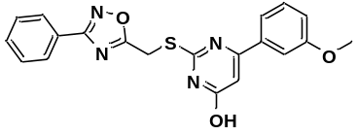 | -9.496 | -65.17
2 | S396-0095 | 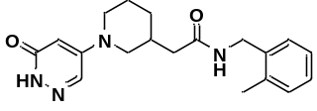 | -10.112 | -63.72
3 | 4428-0280 | 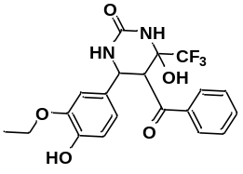 | -9.417 | -59.86
4 | 5697-0340 | 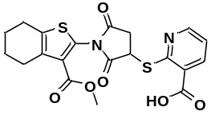 | -9.032 | -59.32
5 | 6530-0468 | 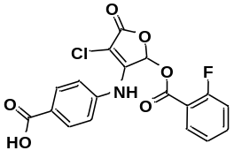 | -9.98 | -58.03
6 | G856-6814 | 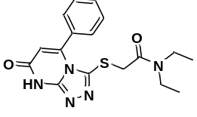 | -9.777 | -56.89
7 | F571-0685 | 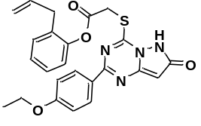 | -9.598 | -56.46
8 | D487-0366 | 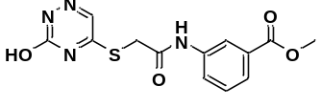 | -9.311 | -55.53
9 | S396-0093 | 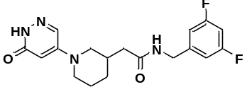 | -9.799 | -55.52
10 | 4798-0007 | 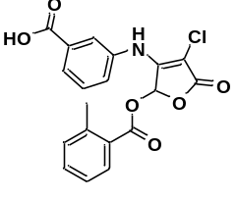 | -10.697 | -55.43

Table 2. Energy Contribution of the Various Energetic Terms to the Total Binding Free Energies of the Protein−Ligand Complexes
Ligand | free energy (kcal/mol)
Ligand | $${\text{E}}_{\text{ele}}$$ | $${\text{E}}_{\text{vdw}}$$ | $${\text{E}}_{\text{polar}\text{, }\text{PB}}$$ | $${\text{E}}_{\text{nonpol}\text{,}\text{PB}}$$ | $${\text{G}}_{\text{binding}}$$
S396-0093 | -5.54 ± 7.02 | -39.41 ± 3.41 | 27.65 ± 6.15 | -5.01 ± 0.21 | -22.31 ± 4.19
G856-6814 | -38.54 ± 8.95 | -40.76 ± 2.81 | 57.74 ± 8.81 | -4.77 ± 0.17 | -26.33 ± 3.37

