Supplementary Information
Selective synthesis of pure CsPbBr₃ and pure Cs₄PbBr₆ nanocrystals towards the fine control of their emission properties
Svetlana Siprova,^{a,b,c}* Vincenzo Caligiuri,^{a,c} Attilio Golemme,^{a,b,c} Roberto Termine,^{c} Antonio De Luca,^{a,c} Iolinda Aiello,^{b,c,d}* Giuseppe Fraschini,^{d} Gianluca Balestra,^{e,f} Massimo Cuscunà,^{e} Maria Laura Amoruso,^{g,h} Mario Scuderi,^{g} Nicolas Godbert.^{b,d}*
- Dipartimento di Fisica, Università della Calabria, via P. Bucci 33b, Rende (CS), 87036, Italy
- LPM-Laboratorio Preparazione Materiali, STAR-Lab, Università della Calabria, via Tito Flavio, Rende (CS), 87036, Italy
- Istituto di Nanotecnologia (CNR-NANOTEC) SS di Rende, via P. Bucci 33c, Rende (CS), 87036, Italy
- MAT-InLAB, LASCAMM CR-INSTM, Unità INSTM della Calabria, Dipartimento di Chimica e Tecnologie Chimiche, Università della Calabria, via P. Bucci 14c, Rende (CS), 87036, Italy
- CNR Nanotec Institute of Nanotechnology, Via Monteroni, Lecce, 73100, Italy
- Department of Mathematics and Physics Ennio De Giorgi, University of Salento, Lecce, 73100, Italy
- CNR–IMM, Strada VIII n.5 Zona Industriale, Catania, 95121, Italy
- UniMe MIFT, Viale Ferdinando Stagno D'Alcontres, Messina, 98166, Italy
*Corresponding Author’s email: svetlana.siprova@cnr.it; nicolas.godbert@unical.it; iolinda.aiello@unical.it.
- Synthesis of CsPbBr₃ nanocrystals
A suspension containing 80 mg (0.25 mmol) of cesium carbonate and 380 mg (1 mmol) of lead acetate trihydrate in 5 mL of oleylamine (OLAM), 1.5 mL of oleic acid (OA), and 25 mL of octadecene (ODE) was stirred and heated at 125°C in an oil bath under vacuum for 2 h. During the first 20 min, a substantial gas release occurred because of decarboxylation of the precursors. The resulting clear and transparent solution was then transferred under a nitrogen atmosphere to an oil bath maintained at 165°C. After 15 min, 355 µL (3 mmol) of benzoyl bromide was rapidly injected, and the reaction mixture was immediately quenched in an ice bath by the addition of 15 mL of dry toluene. Upon cooling, a bright yellow-green fine precipitate formed and was collected by centrifugation (5 min at 5000 rpm). The supernatant was discarded, and 15 mL of dry toluene was added to the precipitate, followed by vigorous shaking to wash the formed nanocrystals (NCs). After a second centrifugation step and removal of the supernatant, 5 mL of n-hexane was added, and the NCs were stored in sealed bottles at 4°C.
- Synthesis of CsPbCl₃ nanocrystals
The synthesis of CsPBCl₃ NCs was performed according to the previously described protocol used for CsPbBr₃ NCs, but benzoyl chloride (345 µL, 3 mmol) was employed instead of benzoyl bromide.
- Synthesis of Cs₄PbBr₆ nanocrystals
A suspension containing 651 mg (2 mmol) of cesium carbonate and 380 mg (1 mmol) of lead acetate trihydrate in 7.5 mL of OLAM, 2.25 mL of OA, and 30 mL of ODE was stirred and heated at 125°C in an oil bath under vacuum for 2 h. During the first 20 min, a substantial gas release occurred because of decarboxylation of the precursors. The resulting clear and transparent solution was then transferred under a nitrogen atmosphere to an oil bath maintained at 50°C. After 15 min, 710 µL (6 mmol) of benzoyl bromide was rapidly injected, and the reaction mixture was immediately quenched in an ice bath by the addition of 15 mL of dry toluene. Upon cooling, a white fine precipitate formed and was collected by centrifugation (5 min at 5000 rpm). The supernatant was discarded, and 15 mL of dry toluene was added to the precipitate, followed by vigorous shaking to wash the formed NCs. After a second centrifugation step and removal of the supernatant, 5 mL of n-hexane was added, and the NCs were stored in sealed bottles at 4°C.
- Synthesis of CsPBCl₆ nanocrystals
The synthesis of Cs₄PBCl₆ NCs was performed according to the previously described protocol used for Cs₄PbBR₆ NCs, but benzoyl chloride (690 µL, 6 mmol) was employed instead of benzoyl bromide.
- Cathodoluminescence analysis of CsPbBr₃/Cs₄PbBr₆ nanocrystals
As observed, the cathodoluminescence (CL) emission from NCs with cubic morphology corresponding to the CsPbBr₃ structure, as demonstrated by transmission electron microscopy (TEM) analysis in the main text, is highly pronounced. In contrast, the CL emission from crystals with rhombohedral morphology (Cs₄PbBr₆) shows negligible intensity compared to that of CsPbBr₃.
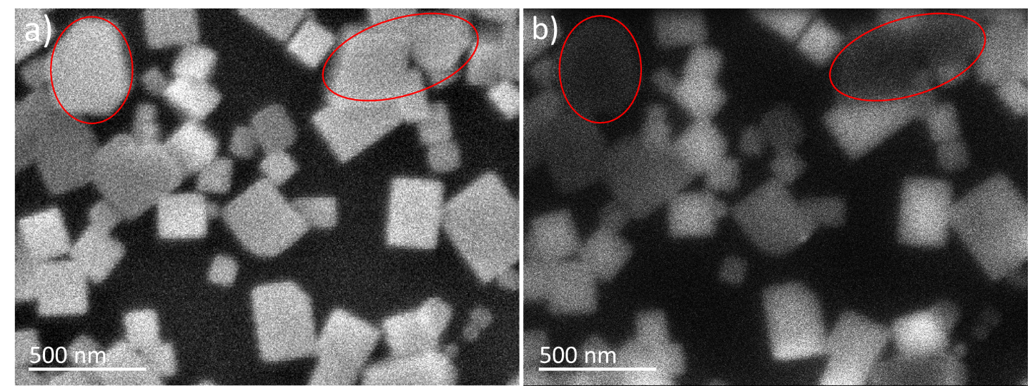
Fig.S1 (a) SEM image of a sample composed of CsPbBr₃ (cubic morphology) and Cs₄PbBr₆ (rhombohedral morphology) perovskite nanocrystals (NCs). (b) Corresponding cathodoluminescence (CL) intensity map. The circled areas in both images highlight a few Cs₄PbBr₆ NCs. The CL emission from these NCs is negligible compared to that of the crystals with cubic morphology (CsPbBr₃).

- Powder X-Ray Diffraction (PXRD) of Cs₄PbBr₆ nanocrystals
PXRD measurements of Cs₄PbBr₆ NCs synthetized with different injection temperature were performed though accumulation in the range 2θ = 13-18° (Fig.S2a) and in the range 2θ = 20.5-22° (Fig.S2b), regions where the reflection peaks associated to the d₁₀₀ (2θ = 15.1°) and the d₁₁₀ (2θ = 21.4°) of the cubic system of CsPbBR₃ are respectively expected. Red line: samples after annealing at 115°C for 10 min. Black line: samples without annealing treatment.
Fig.S2 PXRD patterns of drop casted films of Cs₄PbBr₆ NCs synthetized with different injection temperature (T_{inj}) of the PhCOBr: 50°C, 90°C, 125°C and 165°C.

