Supplementary Information
Macroscale synthesis of vertical MoS₂-WS₂ superlattice heterostructures using Metal-Organic Vapor Deposition

Nikolas Dominik^{1,#}, Sebastian Klenk^{1,#}, Cormac Ó Coileáin¹, Martina Schenkel², Rik Hooijer³, Rita Tilmann⁴, Tanja Stimpel-Lindner¹, Paul Seifert¹, Markus Boese², Erkan Aydin³, Georg S. Duesberg¹*
¹ Institute of Physics & SENS Research Centre, Department of Electrical Power Systems and Information Technology, University of the Bundeswehr Munich, Werner-Heisenberg-Weg 39, 85577 Neubiberg, Germany
² Carl Zeiss Microscopy GmbH, Carl-Zeiss-Straße 22, 73447 Oberkochen, Germany
³ Department of Chemistry and Center for NanoScience (CeNS), Ludwig-Maximilians-Universität München, Butenandtstraße 5–13, 81377 Munich, Germany
⁴ MCA, IMEC, Kapeldreef 75, 3001, Leuven, Belgium

Atomic Force Microscopy (AFM)
HS_thick:
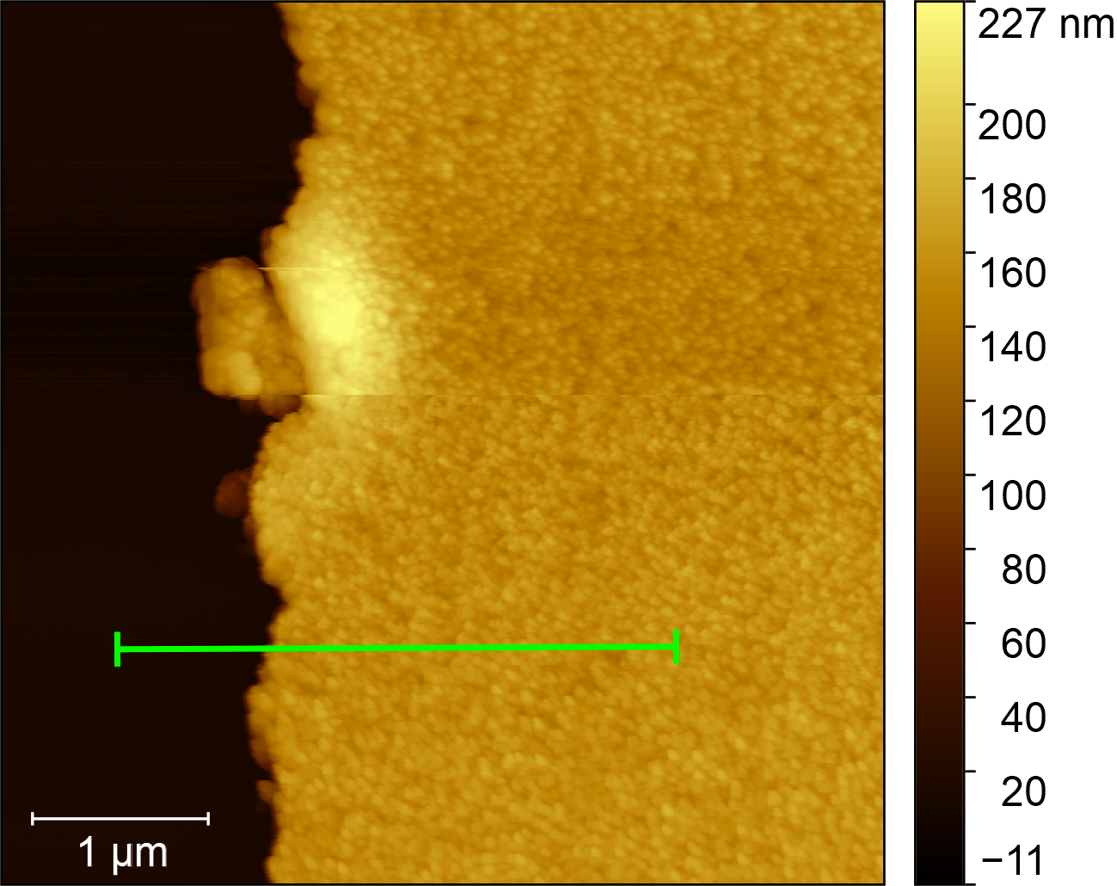
Figure S1: 5 x 5 µm² AFM scan of HS_thick. The RMS roughness of the heterostructure material is 7.2 nm. The average line profile below (Figure S2) is highlighted in green.

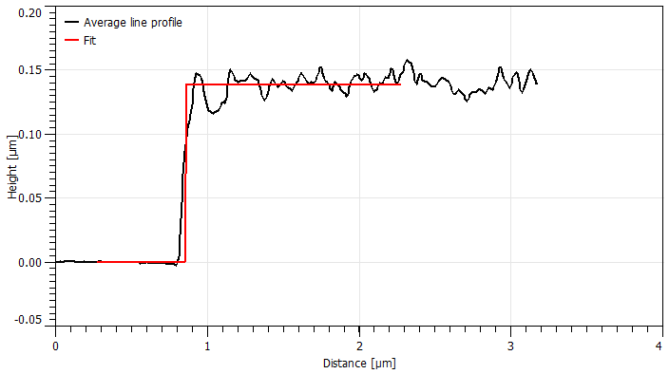
Figure S2: Line profile plot of HS_thick. The extraction region is highlighted in green in Figure S3. The height fit is plotted in red. The fitted step height is 138 ± 8 nm.
HS_thin:
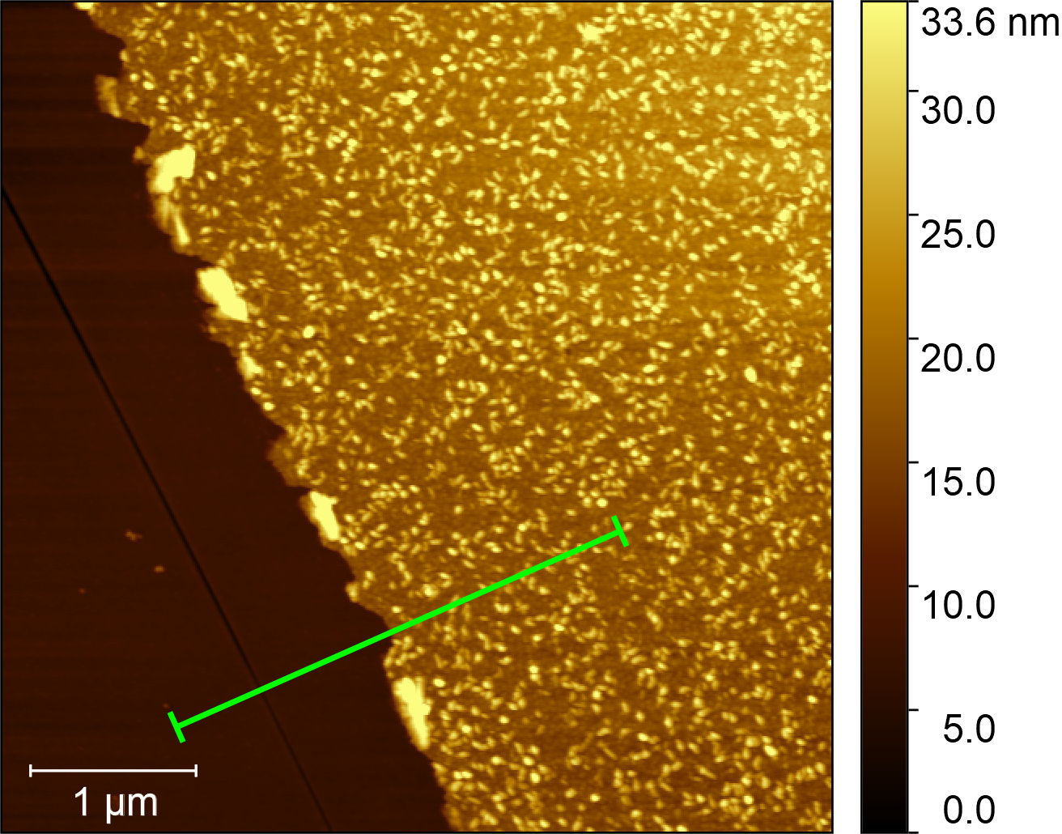
Figure S3: 5 x 5 µm² AFM scan of HS_thin. The RMS roughness of the heterostructure material is 4.3 nm. This increased value can be explained by the emergence of a seeding layer. The average line profile below (Figure S4) is highlighted in green.

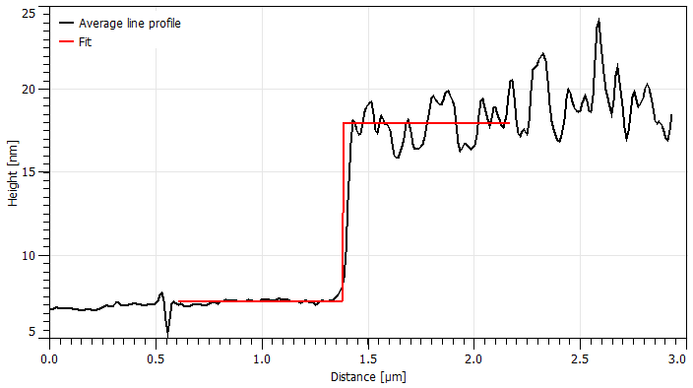
Figure S4: Line profile plot of HS_thin. The extraction region is highlighted in green in Figure S3. The height fit is plotted in red. The fitted step height is 10.8 ± 1.2 nm.

(Scanning) Transmission Electron Microscopy ((S)TEM) and Energy-Dispersive X-ray spectroscopy (EDX)
HS_thick
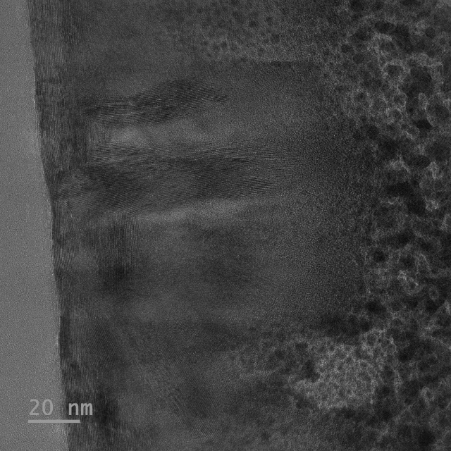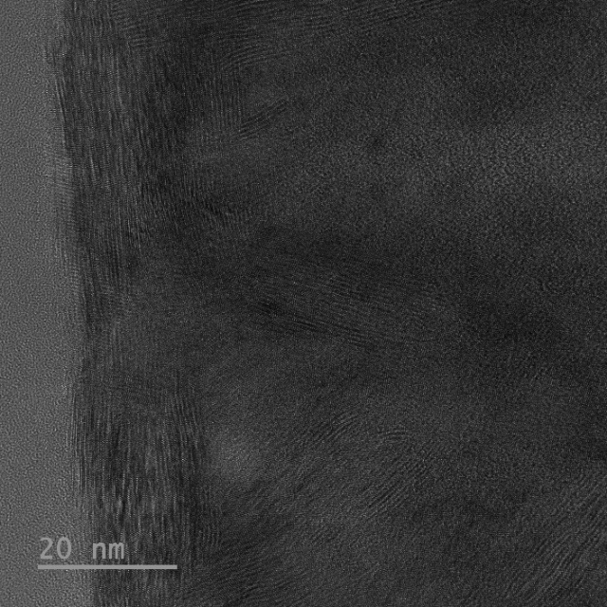
b)

a)

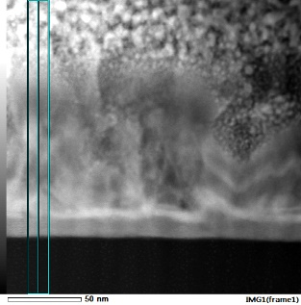
d)

c)

Figure S5: a), b) TEM images of HS_thick. c) STEM image of HS_thick, red mark shows the selected area depicted in d) elemental distribution (EDX) of Mo and W in the selected area.

HS_thin
b)

a)

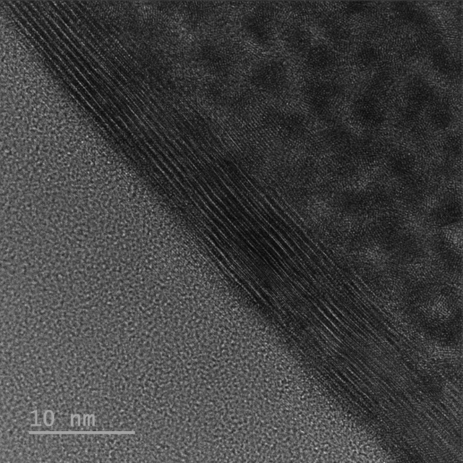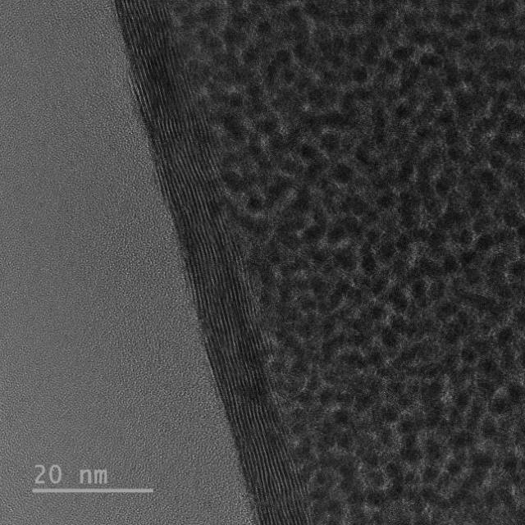
c)

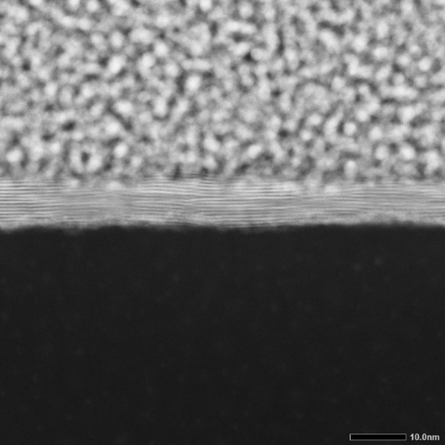
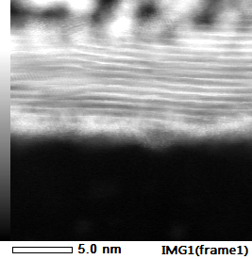
d)

e)

Figure S6: a), b) TEM images of HS_thin, c), d) STEM image of HS_thin, e) elemental distribution (EDX) of Mo and W for the entire area of d).
Raman spectroscopy
No. | Mode | Material | $$ω_{i0} \left[rel. 1/cm\right]$$ |  | $$Q_{i}$$
 |  |  | HS_thick | HS_thin | HS_thick | HS_thin
1 | $$E_{1g}$$ | MoS₂ | 285.6 | 286.5 | $$∞$$ | $$∞$$
2 | $$2LA\left(M\right)-2E_{2g}^{2}\left(M\right)$$ | WS₂ | 295.0 | 294.3 | $$∞$$ | $$∞$$
3 |  | WS₂ | 311.6 | 313.3 | $$∞$$ | $$∞$$
4 | $$2LA\left(M\right)-E_{2g}^{2}\left(M\right)$$ | WS₂ | 320.9 | 320.2 | $$∞$$ | $$∞$$
5 | $$2LA\left(M\right)$$ | WS₂ | 349.5 | 348.5 | $$∞$$ | $$∞$$
6 | $$E_{2g}^{1}$$ | WS₂ | 356.3 | 355.8 | -1.4 | -2.3
7 | $$E_{2g}^{1}$$ | MoS₂ | 381.9 | 382.2 | -6.2 | -6.2
8 | $$A_{1g}$$ | MoS₂ | 406.9 | 405.9 | $$∞$$ | $$∞$$
9 | $$A_{1g}$$ | WS₂ | 419.0 | 418.0 | -9.9 | -12.5
10 | $$2LA\left(M\right)$$ | MoS₂ | 450.9 | 449.5 | -7.6 | $$∞$$
11 | $$A_{2u}$$ | MoS₂ | 462.9 | 463.4 | $$∞$$ | $$∞$$
Table S1: Identified Raman modes of MoS₂ and WS₂ extracted from fitted average spectra of heterostructure regions with differing thickness (HS_thick and HS_thin). The parameters $ω_{i0}$ and $Q_{i}$ represent the peak position and the BWF coupling coefficient, respectively. Spectra were calibrated to the Si TO mode at 520.0 cm⁻¹ before fitting routine.

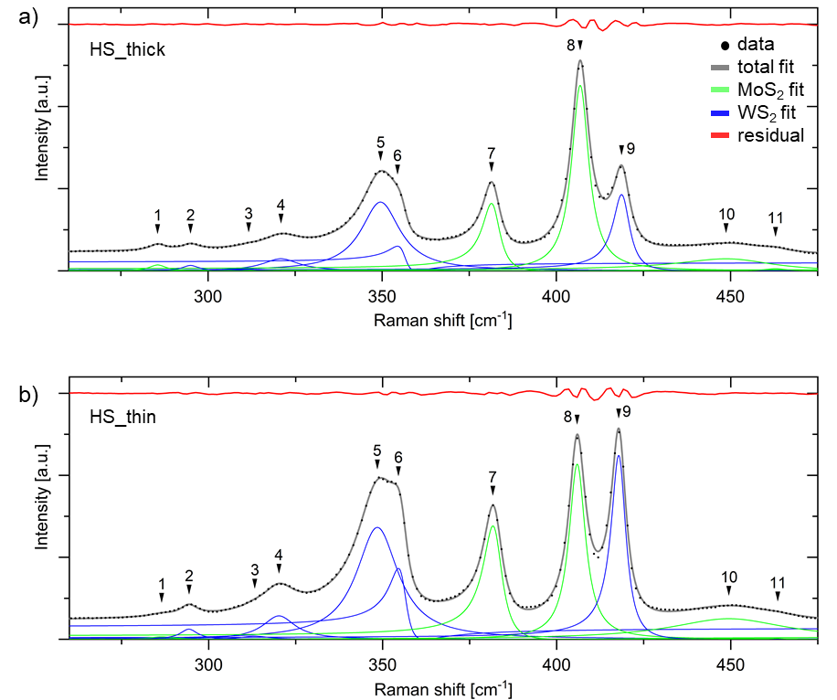
Figure S7: Average spectra of respective quadratic Raman map of a) HS_thick and b) HS_thin. The green fits correspond to MoS₂ modes, the blue fit to WS₂ modes. The red plot is the residual of the fit with R²(HS_thick) = 99.86 % and R²(HS_thin) = 99.88 %.

X-ray Photoelectron Spectroscopy (XPS) and Angle-Resolved X-ray Photoelectron Spectroscopy (ARXPS)
Figure S8: XPS Survey spectrum for HS_thick.

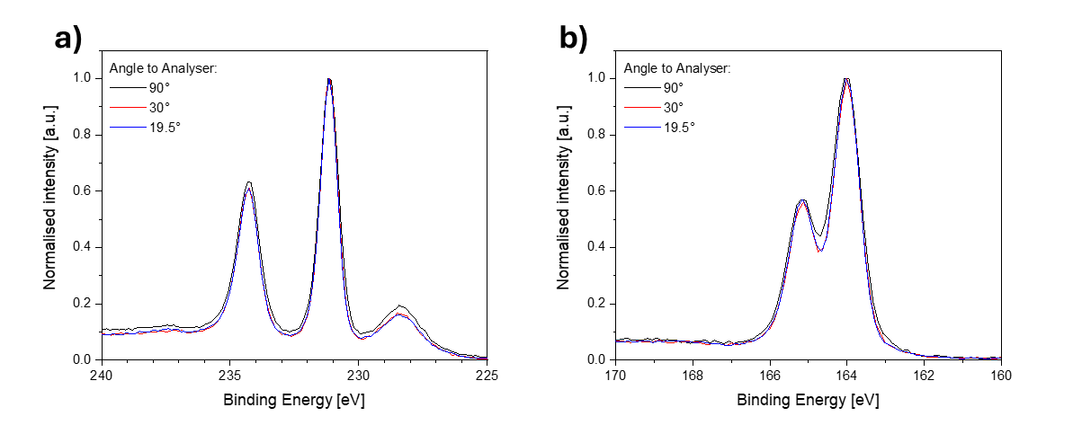
Figure S9: Normalised ARXPS single spectra for a) Mo 3d and b) S 2p for three different angles of HS_thick to the analyser.

Grazing Incidence Wide-Angle X-ray Scattering (GIWAXS):
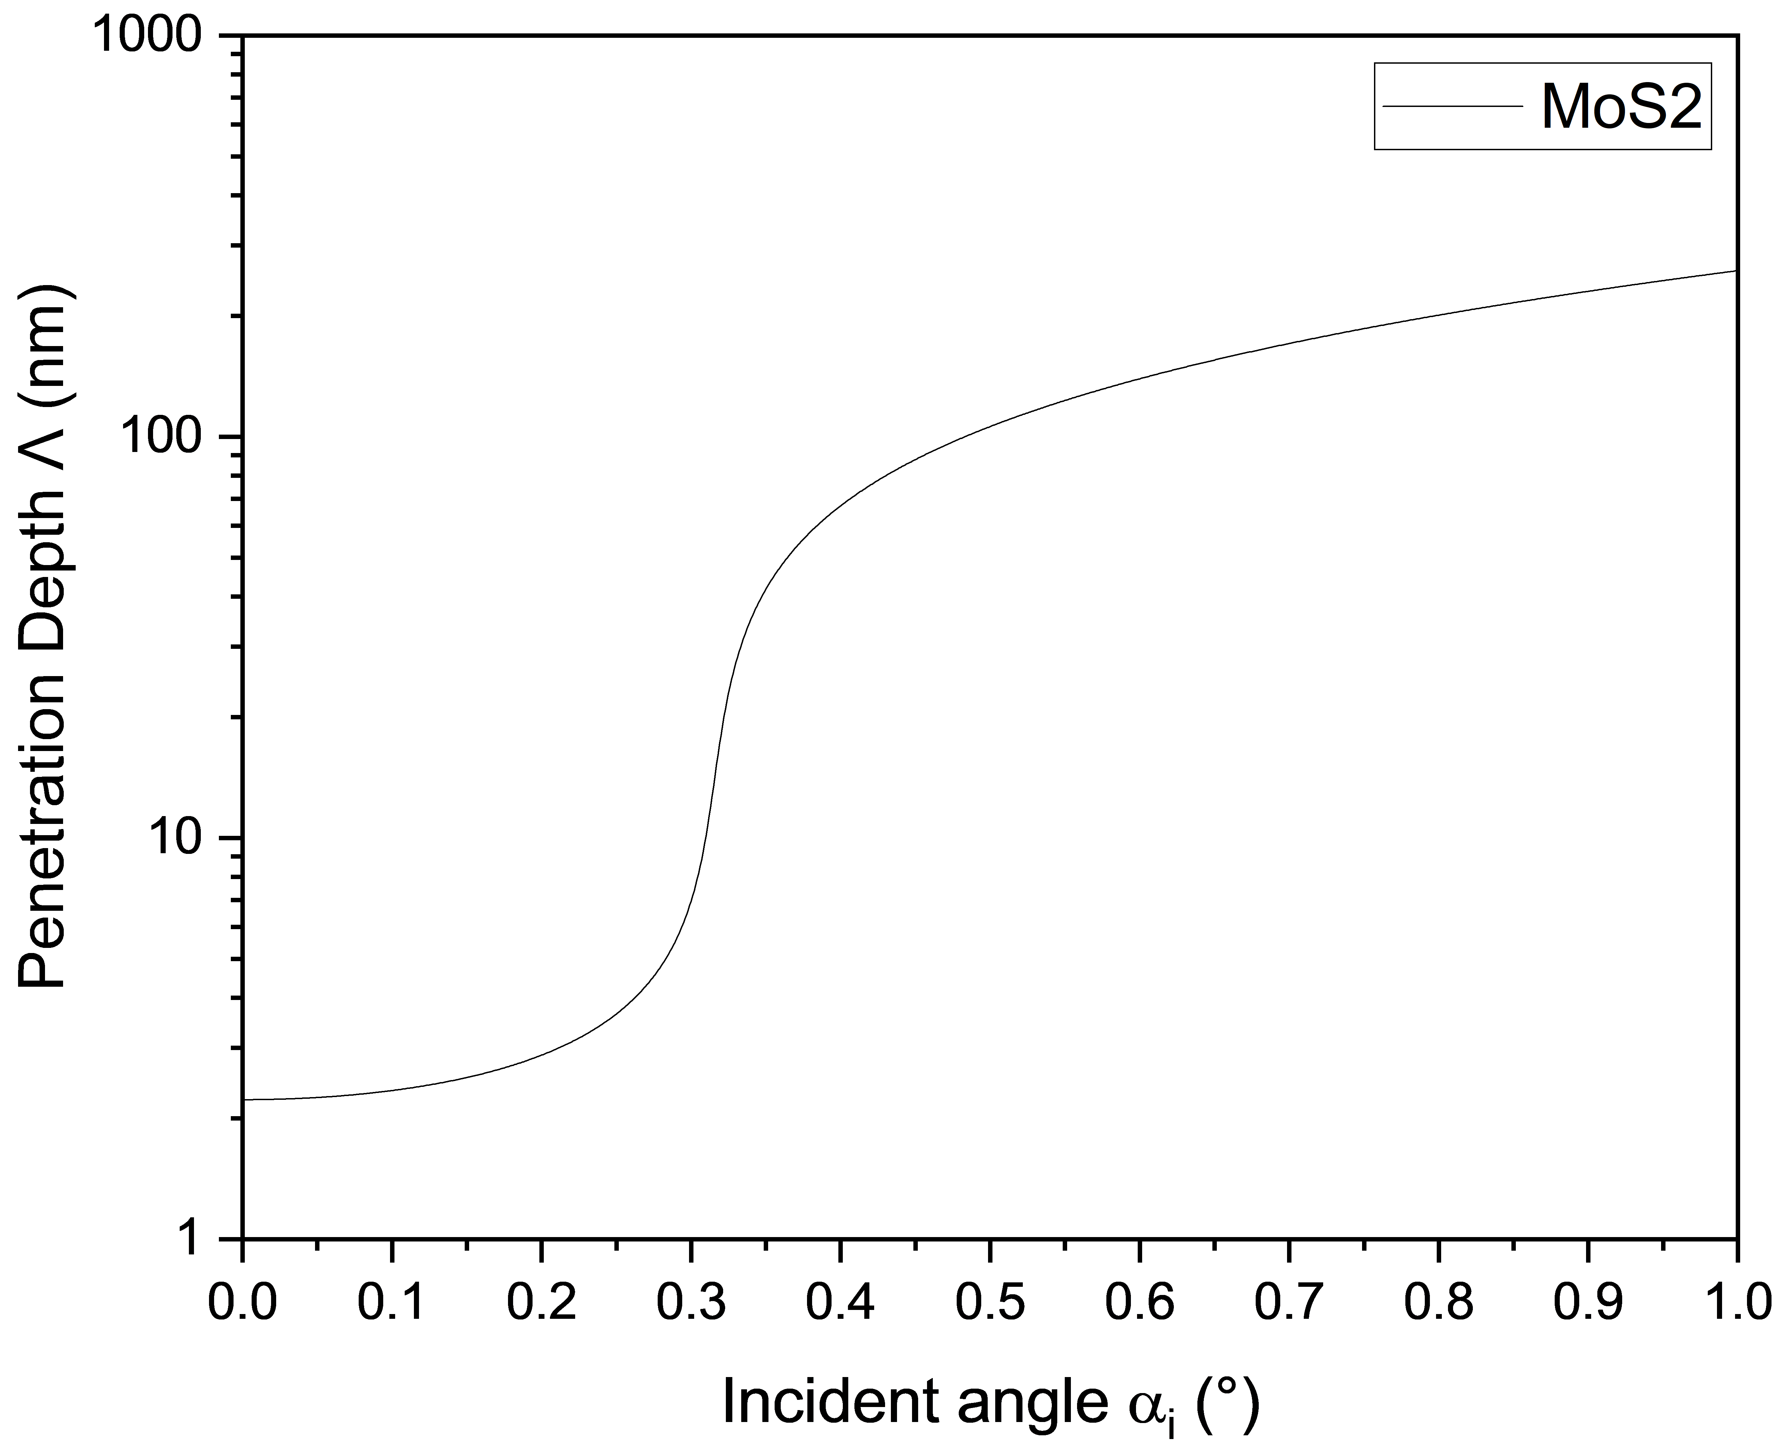
Figure S10: GIWAXS penetration depth depending on incident angle for MoS₂.

 | $$Λ={\left[\sqrt{2}k*\sqrt{\sqrt{{\left(α_{i}^{2}-α_{c}^{2}\right)}^{2}+4β^{2}}-\left(α_{i}^{2}-α_{c}^{2}\right)}\right]}^{-1}$$ | (S1)
Equation S1 shows the dependence of the penetration depth Λ on the wavenumber k, the X-ray incident angle α_{i}, the critical angle α_{c} and the imaginary part of the index of refraction β.

