Supporting information to:

Comparing and quantifying goethite, hematite, lepidocrocite, and ferrihydrite by FTIR

Authors
Ruth H. Ellerbrock ¹, Nisha Bhattarai ¹, Jörg Schaller ^{1,2}*

Affiliations
¹ Leibniz Centre for Agricultural Landscape Research (ZALF), 15374 Müncheberg, Germany
² Julius Liebig University Gießen, Germany

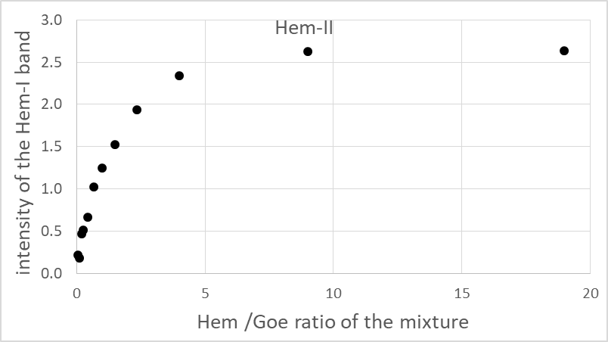
Figure S1 Intensity of Hem-I band maximum vs. the Hem/Goe weight ratio of the studied mixtures.

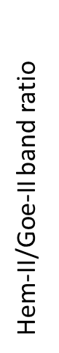  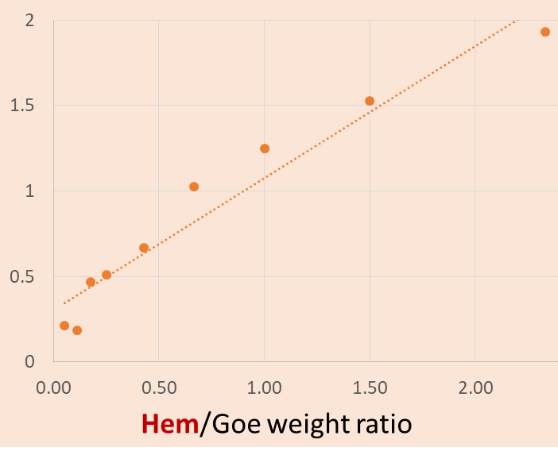  b) | 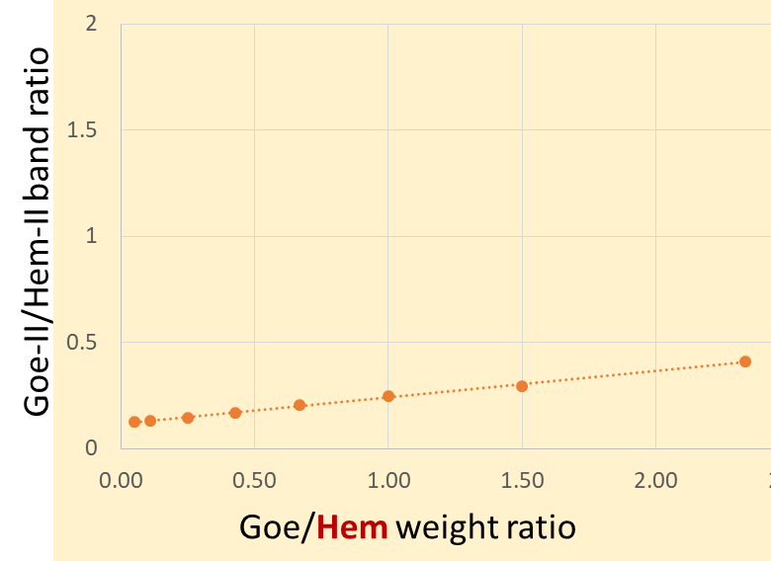  c)

Fig. S2 a) Hem-II/Goe-II and b) Goe-II/Hem-II band ratios in the FTIR of Goethite-Hematite mixtures vs the respective weight ratios a) Hem/Goe and b) Goe/Hem a ratio of 0.05 to 2.5.

