ARTICLE TITLE: Climate change facilitates fungal pathogen expansion while driving endemic host range contractions in a tropical biodiversity hotspot
Journal name: Landscape Ecology
Author names:
Emma L Underwood*
Kerry A Brown
Anna Rönnfeldt
Mark Mulligan
Nigel Walford
Rebekka Allgayer
*Corresponding Author

*Affiliation and email of corresponding author:
Department of Geography, Geology, and the Environment, Centre for Engineering, Environment and Society Research (CEESR), Kingston University, Penrhyn Rd, Kingston upon Thames, KT1 2EE, UK | elmah2707@gmail.com

Online Resource 1 – ODMAP protocol – Calophyllum
Table S1.
Overview, Data, Model, Assessment and Prediction (ODMAP) protocol for Calophyllum SDM ensemble modelling workflow.
Section | Subsection | Element | Value
Overview | Authorship | Study title | Climate change facilitates fungal pathogen expansion while driving endemic host range contractions in a tropical biodiversity hotspot
Overview | Authorship | Author names | Underwood, EL., Brown, KA., Mulligan, M., Walford, N., Allgayer, R.
Overview | Authorship | Contact
Overview | Authorship | Study link | https://github.com/anon-017/anon-fungal-host-sdm
Overview | Model objective | Model objective | forecast
Overview | Model objective | Target output | Suitable vs. unsuitable habitat
Overview | Focal Taxon | Focal Taxon | Calophyllum paniculatum
Overview | Location | Location | Madagascar
Overview | Scale of Analysis | Spatial extent | 43.10, 50.61, -25.62, -11.94
Overview | Scale of Analysis | Spatial resolution | 1km
Overview | Scale of Analysis | Temporal extent | Current (2010) - 2100
Overview | Scale of Analysis | Temporal resolution | 30 years
Overview | Scale of Analysis | Boundary | natural
Overview | Biodiversity data | Observation type | citizen science; field survey
Overview | Biodiversity data | Response data type | presence-only
Overview | Predictors | Predictor types | climatic; habitat; topographic
Overview | Hypotheses | Hypotheses | H1: The future distribution of C. paniculatum will be more limited than the wilt pathogen distribution.
Overview | Assumptions | Model assumptions | H2: Future climate change will lead to southward latitudinal range shifts, and upslope altitudinal shifts in both C. paniculatum and pathogen distributions.
Overview | Algorithms | Modelling techniques | climate in equilibrium
Overview | Algorithms | Model complexity | Maxent, Boosted Regression Trees, Random Forest
Overview | Algorithms | Model averaging | Initial models were computed with 4 and 5 algorithms but ensembles with 3 algorithms performed best
Overview | Workflow | Model workflow | Ensemble (weighted mean)
Overview | Software | Software | Model fitting using sdm package using n=10 replicates (bootstrapping) and a weighting of equal presence to background points. 5-fold cross validation using an 80:20 training/testing split ratio. Top performing trained model built using Malagasy occurrence data used for predictions (forecasting) to future climates in Madagascar.
Overview | Software | Code availability | R version 4.3.2 (R Core TEAM, 2023): rgbif version 3.8.0 (Chamberlain S, 2017, Chamberlain and Boettiger, 2017), terra version 1.8-21 (Hijmans, 2025), readr version 2.1.4 (Wickham H, 2023), doParallel version 1.0.17 (Weston, 2022b), foreach version 1.5.2 (Weston, 2022a), gdalUtilities version 1.2.5 (O'brien, 2023), future.apply (Bengtsson, 2020), data.table version 1.15.4 (Barrett et al., 2024), corrplot version 0.92 (Wei and Simko, 2021b), sdm (Naimi and Araújo, 2016), dplyr version 1.1.4 (Wickham et al., 2023), ggplot2 version 3.3.3 (Wickham, 2016), viridis version 0.6.5 (Garnier et al., 2021), ggtext version 0.1.2 (Wilke, 2022), patchwork version 1.3.0 (Pedersen, 2024), scales version 1.3.0 (Pedersen, 2023), gridExtra version 2.3 (Auguie, 2017), and plotly (Sievert, 2020).
Overview | Software | Data availability | All data used in this study are derived from publicly available repositories and referenced in the manuscript accordingly:  1. Global portals: GBIF, CHELSA, ForestAtRisk  2. Publicly available survey data from published peer-reviewed articles:  a. Ramananjato, V., Razafindratsima, Onja. 2021. Data from: Structure of microhabitats used by Microcebus rufus across a heterogeneous landscape [Dataset]. https://doi.org/10.5061/dryad.2280gb5rs  b. Armstrong, A. H., Shugart, H. H. & Fatoyinbo, T. E. 2011. Characterization of Community Composition and Forest Structure in a Madagascar Lowland Rainforest. Tropical Conservation Science, 4, 428-444. https://doi.org/10.1177/194008291100400406  c. Wright, P. C., Otero Jimenez, B., Rakotonirina, P., Andriananoely, D. H., Shea, A., Ratalata, B. & Razafimahaimodison, J. C. 2020. The Progressive Spread of the Vascular Wilt Like Pathogen of Calophyllum Detected in Ranomafana National Park, Madagascar. Frontiers in Forests and Global Change. https://doi.org/10.3389/ffgc.2020.00091.
Data | Biodiversity data | Taxon names | N/A
Data | Biodiversity data | Taxonomic reference system | Calophyllum paniculatum P.F. Stevens
Data | Biodiversity data | Ecological level | Species
Data | Biodiversity data | Data sources | species
Data | Biodiversity data | Sampling design | GBIF citation add here
Data | Biodiversity data | Sample size | GBIF download (mix of multiple samples) plus field sampling method:
Data | Biodiversity data | Clipping | 62
Data | Biodiversity data | Scaling | Madagascar (mainland)
Data | Biodiversity data | Cleaning | Removal of duplicates within same 1km cell
Data | Biodiversity data | Absence data | Removal of records without spatial location, coordinate cleaner to spot outliers or incorrect lat-lon positions (i.e., the wrong way around)
Data | Biodiversity data | Background data | n/a
Data | Biodiversity data | Errors and biases | Spatial extent: Madagascar mainland, single temporal extent, whole area buffer minus presence locations. Method was tested against target group sampling using ecoregions of presence points and using the whole area performed better.
Data | Data partitioning | Training data | Sampling bias could be present due to field survey data input, but removal of duplicates goes some way to counteract that. Spatial thinning was not applied due to such small number of occurrences.
Data | Data partitioning | Validation data | SDM package: 80:20 partition (80% used for training)
Data | Data partitioning | Test data | 5-fold cross validation (80:20 partition)
Data | Predictor variables | Predictor variables | SDM package: 80:20 partition (20% used for test)
Data | Predictor variables | Data sources | Annual Temperature Range, Precipitation of the Coldest Quarter, Temperature Seasonality, Forest Cover, Precipitation of the Wettest Month, Mean Temperature of the Driest Quarter
Data | Predictor variables | Spatial extent | CHELSA v2.1 (bioclimatic variables); Forestatrisk (forest cover)
Data | Predictor variables | Spatial resolution | Madagsacar mainland
Data | Predictor variables | Coordinate reference system | 1km
Data | Predictor variables | Temporal extent | WGS 1984 Albers for Africa Equal Area Conic coordinate projection system (ESRI:102022)
Data | Predictor variables | Temporal resolution | 1980-2010
Data | Predictor variables | Data processing | 30 years
Data | Predictor variables | Errors and biases | Projecting from WGS84 to ESRI:102022 (terra::project); cropping to study extent (terra::crop), resampling to exact cell position (terra::resample using method='bilinear')
Data | Predictor variables | Dimension reduction | Bias corrected using a trend-preserving bias correction following (Lange 2019) LANGE, S. 2019. Trend-preserving bias adjustment and statistical downscaling with ISIMIP3BASD (v1.0). Geosci. Model Dev., 3055–3070.
Data | Transfer data | Data sources | Downscaling to 1km
Data | Transfer data | Spatial extent | CHELSA v2.1 (bioclimatic variables); Forestatrisk (forest cover)
Data | Transfer data | Spatial resolution | Madagascar (mainland)
Data | Transfer data | Temporal extent | 1km
Data | Transfer data | Temporal resolution | 2011-2100
Data | Transfer data | Models and scenarios | 30 years
Data | Transfer data | Data processing | GFDL-ESM4 model with SSP126, SSP370, SSP585 scenarios (CMIP6)
Data | Transfer data | Quantification of Novelty | Projecting from WGS84 to ESRI:102022 (terra::project); cropping to study extent (terra::crop), resampling to exact cell position (terra::resample using method='bilinear')
Model | Variable pre-selection | Variable pre-selection | MESS analysis
Model | Multicollinearity | Multicollinearity | N/A
Model | Model settings | Model settings (fitting) | Correlation matrix assessing for highly collinear pairs above 0.7, then a variable importance factor ranking the remaining predictors to reduce variables down to the correct ratio to occurrence points (i.e., 6 predictors for 62 occurrences)
Model | Model settings | Model settings (extrapolation) | sdm R package: created an ‘sdmData’ object that specified how presences and background points were equally weighted; used ‘sdm’ function to compute an ensemble fit using three machine learning algorithms with 10 replicates (bootstrapping)
Model | Model estimates | Coefficients | sdm package: sdm::ensemble() to produce projections and predictions using weighted mean maximising the AUC statistic, and optimised for maximum sum of sensitivity and specificity
Model | Model estimates | Parameter uncertainty | Mean: Residual deviance = 0.280, Area Under ROC Curve (AUC) = 0.982, True Skill Statistic (TSS) = 0.933, Point-biserial correlation (COR) = 0.776, Matthews Correlation Coefficient = 0.782, F1 Score = 0.781
Model | Model estimates | Variable importance | Mean Explained deviance = 0.999, Standard Deviation of AUC (SD_AUC) = 0.016, Standard Deviation of TSS (SD_TSS) = 0.041
Model | Model selection - model averaging - ensembles | Model selection | Ranked in most important in descending order: Annual Temperature Range, Precipitation of the Coldest Quarter, Temperature Seasonality, Forest Cover, Precipitation of the Wettest Month, Mean Temperature of the Driest Quarter
Model | Model selection - model averaging - ensembles | Model averaging | Models selected to compute ensemble if their overall scores were AUC > 0.7 & TSS > 0.5
Model | Model selection - model averaging - ensembles | Model ensembles | Weighted average ensemble to maximise AUC, optimised using maximum sum of sensitivity and specificity (max(se+sp))
Model | Analysis and Correction of non-independence | Spatial autocorrelation | Same as previous
Model | Analysis and Correction of non-independence | Temporal autocorrelation | Spatial duplicate removal and spatial thinning of occurrence data (< 1km)
Model | Analysis and Correction of non-independence | Nested data | N/A
Model | Threshold selection | Threshold selection | N/A
Assessment | Performance statistics | Performance on training data | sdm package: sdm::threshold() with optimisation method 2 to maximise ensemble performance metrics using max(se+sp) and repeated binary results with 12 (10th Percentile Training Presence - P10) to compare outputs
Assessment | Performance statistics | Performance on validation data | Threshold independent: Prevalence, AUC, COR, Deviance, Calibration; Threshold dependent: TSS, MCC, F1 (maximised for max(se+sp)
Assessment | Performance statistics | Performance on test data | N/A
Assessment | Plausibility check | Response shapes | Threshold independent: Prevalence, AUC, COR, Deviance, Calibration; Threshold dependent: TSS, MCC, F1 (maximised for max(se+sp))
Assessment | Plausibility check | Expert judgement | All response curves have wide confidence bands showing uncertainty across most of the responses: Annual temperature range has a strong negative relationship with occurrence probability declining from ~0.5 at lower ranges (~8°C) to ~0.2 above 18°C. Precipitation of coldest quarter exhibits a bimodal pattern with modest peaks at ~150mm and ~800mm. Temperature seasonality has a U-shaped response with higher probabilities at both low (~100) and high (~250+) values, reflecting the species' ecological versatility across both consistent temperature regimes (humid rainforests on elevational gradients) and more variable regions (dry-deciduous forests at lower elevations). Forest cover shows a gradual positive relationship, confirming the species' affinity for forested habitats.
Prediction | Prediction output | Prediction unit | Calophyllum predicted suitability under current climatic conditions match that of recorded observations.
Prediction | Prediction output | Post-processing | Binary threshold 0-1 (0=absence, 1=presence)
Prediction | Uncertainty quantification | Algorithmic uncertainty | Threshold selection
Prediction | Uncertainty quantification | Input data uncertainty | Null, residual and explained deviance calculated for each model ID and algorithm per ensemble
Prediction | Uncertainty quantification | Parameter uncertainty | Model based uncertainty/inconsistency, coefficient of variation of probabilities generated from multiple models (CV), standard deviation of probabilities from multiple models (SD), confidence interval length 95% or marginal error (CI)
Prediction | Uncertainty quantification | Scenario uncertainty | Sensitivity analysis to assess impact of input parameters (background method, highly collinear threshold value, and prediction threshold value
Prediction | Uncertainty quantification | Novel environments | Comparison of the two threshold outputs, comparison of SSPs (126, 370, 585)

Online Resource 2 – ODMAP protocol – Leptographium
Table S2.
Overview, Data, Model, Assessment and Prediction (ODMAP) protocol for Leptographium SDM ensemble modelling workflow.
Section | Subsection | Element | Value
Overview | Authorship | Study title | Climate change facilitates fungal pathogen expansion while driving endemic host range contractions in a tropical biodiversity hotspot
Overview | Authorship | Author names | Underwood, EL., Brown, KA., Mulligan, M., Walford, N., Allgayer, R.
Overview | Authorship | Contact
Overview | Authorship | Study link | https://github.com/anon-017/anon-fungal-host-sdm
Overview | Model objective | Model objective | forecast and transfer
Overview | Model objective | Target output | Suitable vs. unsuitable habitat
Overview | Focal Taxon | Focal Taxon | Verticillium; Leptographium (genera)
Overview | Location | Location | Madagascar (mainland)
Overview | Scale of Analysis | Spatial extent | Madagascar (mainland)
Overview | Scale of Analysis | Spatial resolution | 1km
Overview | Scale of Analysis | Temporal extent | Current (2010) - 2100
Overview | Scale of Analysis | Temporal resolution | 30 years
Overview | Scale of Analysis | Boundary | natural
Overview | Biodiversity data | Observation type | citizen science; field survey
Overview | Biodiversity data | Response data type | presence-only
Overview | Predictors | Predictor types | climatic; habitat; topographic
Overview | Hypotheses | Hypotheses | Wilt will have a larger predicted suitable habitat than its host tree (Calophyllum). H1: The future distribution of C. paniculatum will be more limited than the wilt pathogen distribution.
Overview | Assumptions | Model assumptions | H2: Future climate change will lead to southward latitudinal range shifts, and upslope altitudinal shifts in both C. paniculatum and pathogen distributions.
Overview | Algorithms | Modelling techniques | climate in equilibrium
Overview | Algorithms | Model complexity | Maxent, Boosted Regression Trees, Random Forest
Overview | Algorithms | Model averaging | Initial models were computed with 4 and 5 algorithms but ensembles with 3 algorithms performed best
Overview | Workflow | Model workflow | Ensemble (weighted mean)
Overview | Software | Software | Model fitting using sdm package using n=10 replicates (bootstrapping) and a weighting of equal presence to background points. 5-fold cross validation using an 80:20 training/testing split ratio. Top performing trained model built using African occurrence data used for predictions (model transfer) to Madagascar.
Overview | Software | Code availability | R version 4.3.2 (R Core TEAM, 2023): rgbif version 3.8.0 (Chamberlain S, 2017, Chamberlain and Boettiger, 2017), terra version 1.8-21 (Hijmans, 2025), readr version 2.1.4 (Wickham H, 2023), doParallel version 1.0.17 (Weston, 2022b), foreach version 1.5.2 (Weston, 2022a), gdalUtilities version 1.2.5 (O'brien, 2023), future.apply (Bengtsson, 2020), data.table version 1.15.4 (Barrett et al., 2024), corrplot version 0.92 (Wei and Simko, 2021b), sdm (Naimi and Araújo, 2016), dplyr version 1.1.4 (Wickham et al., 2023), ggplot2 (Wickham, 2016), viridis version 0.6.5 (Garnier et al., 2021), ggtext version 0.1.2 (Wilke, 2022), patchwork version 1.3.0 (Pedersen, 2024), scales version 1.3.0 (Pedersen, 2023), gridExtra version 2.3 (Auguie, 2017), and plotly (Sievert, 2020).
Overview | Software | Data availability | "All data used in this study are derived from publicly available repositories and referenced in the manuscript accordingly:
Data | Biodiversity data | Taxon names | 1.
Data | Biodiversity data | Taxonomic reference system | 2.
Data | Biodiversity data | Ecological level | a.
Data | Biodiversity data | Data sources | b.
Data | Biodiversity data | Sampling design | c.
Data | Biodiversity data | Sample size | N/A
Data | Biodiversity data | Clipping | Verticillium; Leptographium
Data | Biodiversity data | Scaling | Genus
Data | Biodiversity data | Cleaning | Genus
Data | Biodiversity data | Absence data | GBIF
Data | Biodiversity data | Background data | n/a
Data | Biodiversity data | Errors and biases | 34
Data | Data partitioning | Training data | African Continent minus Madagascar
Data | Data partitioning | Validation data | Removal of duplicates within same 1km cell
Data | Data partitioning | Test data | Removal of records without spatial location, coordinate cleaner to spot outliers or incorrect lat-lon positions (i.e. the wrong way around)
Data | Predictor variables | Predictor variables | N/A
Data | Predictor variables | Data sources | Spatial extent: African mainland, single temporal extent, 2degrees far buffer away from presence points. Method was tested against target group sampling using ecoregions of presence points and using the 2degrees far (pseudoabsence method) performed better.
Data | Predictor variables | Spatial extent | Sampling bias could be present due to GBIF data input, but removal of duplicates goes some way to counteract that. Spatial thinning was not applied due to such small number of occurrences.
Data | Predictor variables | Spatial resolution | SDM package: 80:20 partition (80% used for training)
Data | Predictor variables | Coordinate reference system | 5-fold cross validation (80:20 partition)
Data | Predictor variables | Temporal extent | SDM package: 80:20 partition (20% used for test)
Data | Predictor variables | Temporal resolution | Mean Precipitation of the Driest Month, Precipitation Seasonality, Mean Temperature of the Coldest Quarter, Mean Precipitation of the Coldest Quarter
Data | Predictor variables | Data processing | CHELSA v2.1 (bioclimatic variables)
Data | Predictor variables | Errors and biases | 43.10, 50.61, -25.62, -11.94
Data | Predictor variables | Dimension reduction | 1km
Data | Transfer data | Data sources | WGS 1984 Albers for Africa Equal Area Conic coordinate projection system (ESRI:102022)
Data | Transfer data | Spatial extent | 1980-2010
Data | Transfer data | Spatial resolution | 30 years
Data | Transfer data | Temporal extent | Projecting from WGS84 to ESRI:102022 (terra::project); cropping to study extent (terra::crop), resampling to exact cell position (terra::resample using method='bilinear')
Data | Transfer data | Temporal resolution | Bias corrected using a trend-preserving bias correction following (Lange 2019) LANGE, S. 2019. Trend-preserving bias adjustment and statistical downscaling with ISIMIP3BASD (v1.0). Geosci. Model Dev., 3055–3070.
Data | Transfer data | Models and scenarios | Downscaling to 1km
Data | Transfer data | Data processing | CHELSA v2.1 (bioclimatic variables); Forestatrisk (forest cover)
Data | Transfer data | Quantification of Novelty | 43.10, 50.61, -25.62, -11.94 (xmin, xmax, ymin, ymax)
Model | Variable pre-selection | Variable pre-selection | 1km
Model | Multicollinearity | Multicollinearity | 2011-2100
Model | Model settings | Model settings (fitting) | 30 years
Model | Model settings | Model settings (extrapolation) | GFDL-ESM4 model with SSP126, SSP370, SSP585 scenarios (CMIP6)
Model | Model estimates | Coefficients | Projecting from WGS84 to ESRI:102022 (terra::project); cropping to study extent (terra::crop), resampling to exact cell position (terra::resample using method='bilinear')
Model | Model estimates | Parameter uncertainty | MESS analysis
Model | Model estimates | Variable importance | N/A
Model | Model selection - model averaging - ensembles | Model selection | Correlation matrix assessing for highly collinear pairs above 0.7, then a variable importance factor ranking the remaining predictors to reduce variables down to the correct ratio to occurrence points (i.e., 6 predictors for 62 occurrences)
Model | Model selection - model averaging - ensembles | Model averaging | sdm package: created sdm::sdmData() object that specified how presences and background points were equally weighted; used sdm::sdm to compute an ensemble fit using 3 machine learning algorithms with 10 replicates (bootstrapping)
Model | Model selection - model averaging - ensembles | Model ensembles | sdm package: sdm::ensemble() to produce projections and predictions using weighted mean based on the Matthews Correlation Coefficient (MCC) of ensemble performance, and optimised using the minimum distance to ROC curve (minROCdist"; opt=4)
Model | Analysis and Correction of non-independence | Spatial autocorrelation | Mean: Residual deviance = 0.355, Area Under ROC Curve (AUC) = 0.950, True Skill Statistic (TSS) = 0.864, Point-biserial correlation (COR) = 0.643, Matthews Correlation Coefficient = 0.662, F1 Score = 0.657
Model | Analysis and Correction of non-independence | Temporal autocorrelation | Mean Explained deviance = 0.998, Standard Deviation of AUC (SD_AUC) = 0.035, Standard Deviation of TSS (SD_TSS) = 0.080
Model | Analysis and Correction of non-independence | Nested data | Ranked in most important in descending order: Mean Precipitation of the Driest Month, Mean Temperature of the Coldest Quarter, Mean Precipitation of the Coldest Quarter, Precipitation Seasonality
Model | Threshold selection | Threshold selection | Models selected to compute ensemble if their overall scores were AUC > 0.7 & TSS > 0.5
Assessment | Performance statistics | Performance on training data | Weighting chosen to optimise Matthews Correlation Coefficient (MCC) performance
Assessment | Performance statistics | Performance on validation data | Same as previous
Assessment | Performance statistics | Performance on test data | Spatial duplicate removal and spatial thinning of occurrence data (< 1km)
Assessment | Plausibility check | Response shapes | N/A
Assessment | Plausibility check | Expert judgement | N/A
Prediction | Prediction output | Prediction unit | sdm package: sdm::threshold() with optimisation method 4 to maximise ensemble performance metrics using minimum distance to ROC curve (minROCdist) and repeated binary results with 12 (10th Percentile Training Presence - P10) to compare outputs
Prediction | Prediction output | Post-processing | Threshold independent: Prevalence, AUC, COR, Deviance, Calibration; Threshold dependent: TSS, MCC, F1 (maximised for max(se+sp)
Prediction | Uncertainty quantification | Algorithmic uncertainty | N/A
Prediction | Uncertainty quantification | Input data uncertainty | Threshold independent: Prevalence, AUC, COR, Deviance, Calibration; Threshold dependent: TSS, MCC, F1 (maximised for max(se+sp)
Prediction | Uncertainty quantification | Parameter uncertainty | All response curves have wide confidence bands showing uncertainty across most of the responses: Precipitation of driest month shows an initial increase in species response up to around response 0.6-0.7 units and 20mm of rainfall, then plateaus and slightly declines after 80mm. Precipitation of coldest quarter has a similar but more gradual pattern to precipitation of the driest month but maintains a stable response. Mean temperature of coldest quarter with a hump-shaped response that peaks around 10-15 degrees Celsius, then notably declines above 20 degrees, suggesting thermal tolerance limits. Precipitation seasonality demonstrates a brief spike in response around 50-70 units followed by a steady decline, suggesting a preference of some variation, but not extreme fluctuation.
Prediction | Uncertainty quantification | Scenario uncertainty | The wilt when first projected (transferred) to Madagascar shows strong suitability along the north-south humid/sub-humid zone, which also includes the location of Ranomafana National Park where the wilt has been observed.
Prediction | Uncertainty quantification | Novel environments | Binary threshold 0-1 (0=absence, 1=presence)

Online Resource 3- Supplementary Methods

Pathogen pseudo-absences - '2° far' approach
For the fungal wilt pathogen, we used a '2° far' approach to construct pseudo-absences (Barbet-Massin et al., 2012, Li et al., 2024), defining them as locations at least two degrees from any known presence within mainland Africa (Figure 1, extent A). All Leptographium and Verticillium occurrences served as proxy for L. calophylli. Since the bark beetle vector Cryphalus trypanus likely mediates pathogen spread (Wainhouse et al., 1998, Webber et al., 1999), we incorporated Cryphalus genera occurrences within the training extent (n = 25) from GBIF into the pseudo-absence design. Known presence locations were buffered by 2° (~ 222 km) using Haversine formula (Equation 1). After removing spatial duplicates within 1 km cells, 340 pseudo-absence points were retained from areas outside the buffer zone (Figure 1).
$buffer distance (m)=R(2(\frac{π}{180}))$( 1 )
Where R equates to the radius of the Earth in metres (R = 6,371,000 m).

Host background points – ‘whole-area’ approach
For C. paniculatum, we randomly generated 620 background points using the 'whole area' approach within Madagascar (Figure 1, extent B), maintaining a 1:10 ratio of presences to background points after masking known presence locations (n = 62).

Environmental data
Climatologies at high resolution for the earth’s land surface areas (CHELSA) bioclimatic data (Karger et al., 2017, Karger et al., 2021) were provided as a global GeoTiff in WGS 1984 map projection (ESPG:4326), which were cropped to our two spatial extents (Figure 1, Africa training extent A and Madagascar projection extent B) and reprojected all layers to the WGS 1984 Albers for Africa Equal Area Conic system (ESRI: 102022) to align with other model inputs and allow area-preserving range calculations. ForestAtRisk data (Vieilledent et al., 2018, Vieilledent et al., 2023) were reclassified to binary data then aggregated from 30 m to 1 km resolution using bilinear interpolation, producing proportional forest cover values (0-1).

Model projection feasibility
Top-performing models were selected through plausibility assessment against known occurrences in Ranomafana National Park following surveys undertaken by Wright et al. (2020). The host ensemble used weighted mean by AUC values, optimised for TSS (Elith et al., 2006). Ten predictions were generated per species: one current projection and nine future forecasts using three SSP pathways to 2100 (Table S3).
Table S3.
Summary and breakdown of the number of weighted ensemble SDM models computed per species, including temporal time frame, spatial extent, future climate pathway, and model type. In total, for the fungal wilt L. calophylli and host C. paniculatum, 20 ensembles were produced (ten per species), a single trained ensemble under current climatic conditions, and nine representing various future pathways and time periods.
Species | Time frame | Spatial extent | Climate pathway* | Model type | No. of models
Incipient fungal wilt  L. calophylli (from Verticillium and Leptographium genera level occurrences) | 1981-2010 | Independent training area (Mainland Africa, Figure 1 - extent A) | Recorded climate | Training and initial projection | 1
 | 2011-2040 | Independent test area (Figure 1, extent B - Madagascar) | SSP1  SSP3  SSP5 | Future prediction | 9
 | 2041-2070 | Independent test area (Figure 1, extent B - Madagascar) | SSP1  SSP3  SSP5 | Future prediction | 9
 | 2070-2100 | Independent test area (Figure 1, extent B - Madagascar) | SSP1  SSP3  SSP5 | Future prediction | 9
 |  |  |  |  | TOTAL: 10
Endemic host  (C. paniculatum) | 1981-2010 | Global native range (Figure 1, extent B - Madagascar) | Recorded climate | Training and initial projection | 1
Endemic host  (C. paniculatum) | 2011-2040 | Global native range (Figure 1, extent B - Madagascar) | SSP1  SSP3  SSP5 | Future prediction | 9
Endemic host  (C. paniculatum) | 2041-2070 | Global native range (Figure 1, extent B - Madagascar) | SSP1  SSP3  SSP5 | Future prediction | 9
Endemic host  (C. paniculatum) | 2070-2100 | Global native range (Figure 1, extent B - Madagascar) | SSP1  SSP3  SSP5 | Future prediction | 9
 |  |  |  |  | TOTAL: 10
*SSP1-RCP2.6 (SSP1), SSP3-RCP7 (SSP3), and SSP5-RCP8.5 (SSP5). These pathways were generated through statistical downscaling and bias correction of Coupled Model Intercomparison Project (CMIP6) Global Climate Model output from GFDL-ESM4 (Krasting et al., 2018), processed using the ISIMIP3b framework (Lange, 2021) with ISIMIP3BASD v2.5.0 methodology (Lange, 2019) and calibrated against the W5E5 v2.0 observational reference dataset (Cucchi, 2020).

Calculating distributional changes
Binary maps were used to calculate total presence area (km²). Cell-by-cell differencing classified changes as: stable (suitable in both periods), expansion (newly suitable), or contraction (losing suitability), expressed as cumulative percentages. Range centroids were calculated as mean coordinates of presence cells. Shifts were expressed as distance (km) and direction, with velocity calculated per decade. Elevation changes were extracted from DEM overlays to assess vertical range displacement (Lenoir and Svenning, 2015). Habitat exposure measured the proportion of current range experiencing novel conditions (Choe et al., 2017). Potential Area of Occupancy (pAOO) was calculated following IUCN protocols with minimum 4km² threshold (Cazalis et al., 2024, Iucn, 2022) using 2×2 km grid resampling (Figure S1). All metrics were computed as cumulative changes from baseline using R Statistical Software v4.3.2 (R Core Team, 2023) with terra package (Hijmans, 2025).
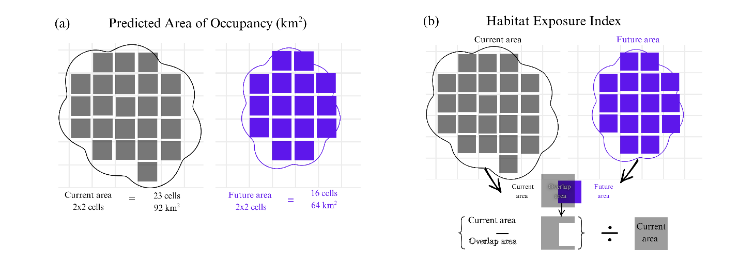Figure S1.
Conceptual diagrams visualising two standardised range shift metrics used to assess the changing geographic distributional properties of wilt pathogen L. calophylli and host C. paniculatum (a) predicted area of occupancy, measured as the area in standardised 2 x 2 km grid cells (IUCN) and (b) habitat exposure index, calculated as the difference between the current area range and the area of intersection between current and future range, divided by current range. The habitat exposure metric determines how different the future climate conditions are compared to those in the current projected habitat. These two methods of measuring geographic change are compared between a range of area under a hypothetical current and a future climate scenario.

Online Resource 4 – Supplementary Results

Collinearity of predictor variables
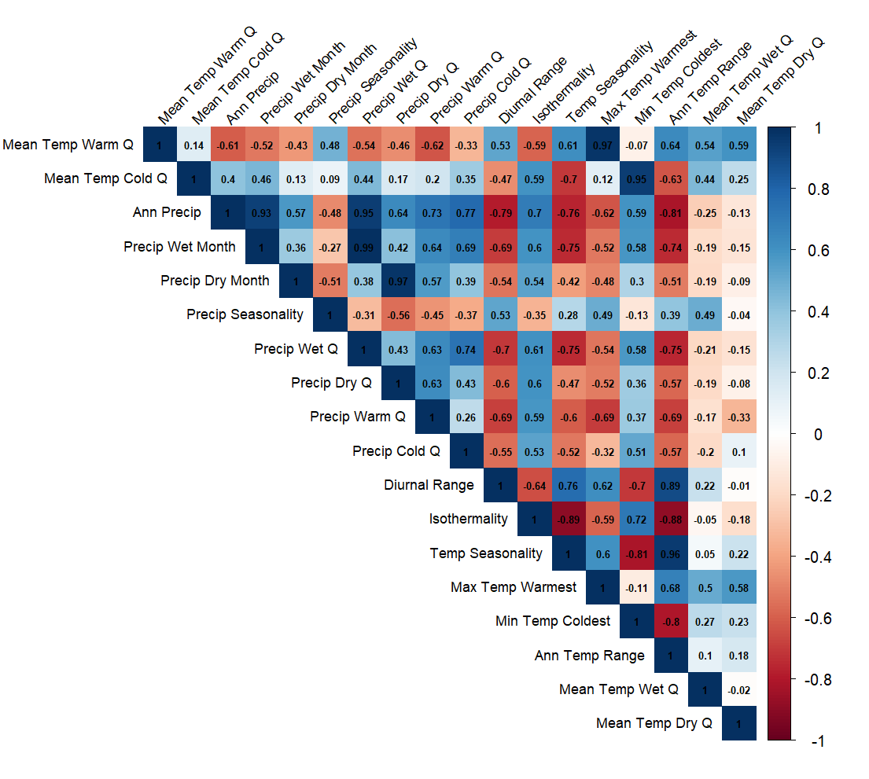
Figure S2.
Correlation matrix of the 19 CHELSA bioclimatic predictor variable values extracted from L. calophylli occurrence data across the African mainland. Darker values of blue correspond to higher positive correlation coefficients between a predictor pair, and darker values of red indicate negative highly correlated pairs. With a threshold at (|r| > 0.7), the strongest positive correlations were mean temperature of warmest quarter with maximum temperature of warmest month (|r| = 0.88) and precipitation of wettest quarter with precipitation of wettest month (|r| = 0.85), indicating a strong link between moisture availability and thermal extremes. Temperature seasonality showed strong negative correlations with minimum temperature of coldest month (|r| = -0.91) and also isothermality (|r| = -0.82), demonstrating that environments with greater temperature fluctuations throughout the year tend to have less consistent day-to-night temperature patterns and significantly lower temperature extremes during cold periods.

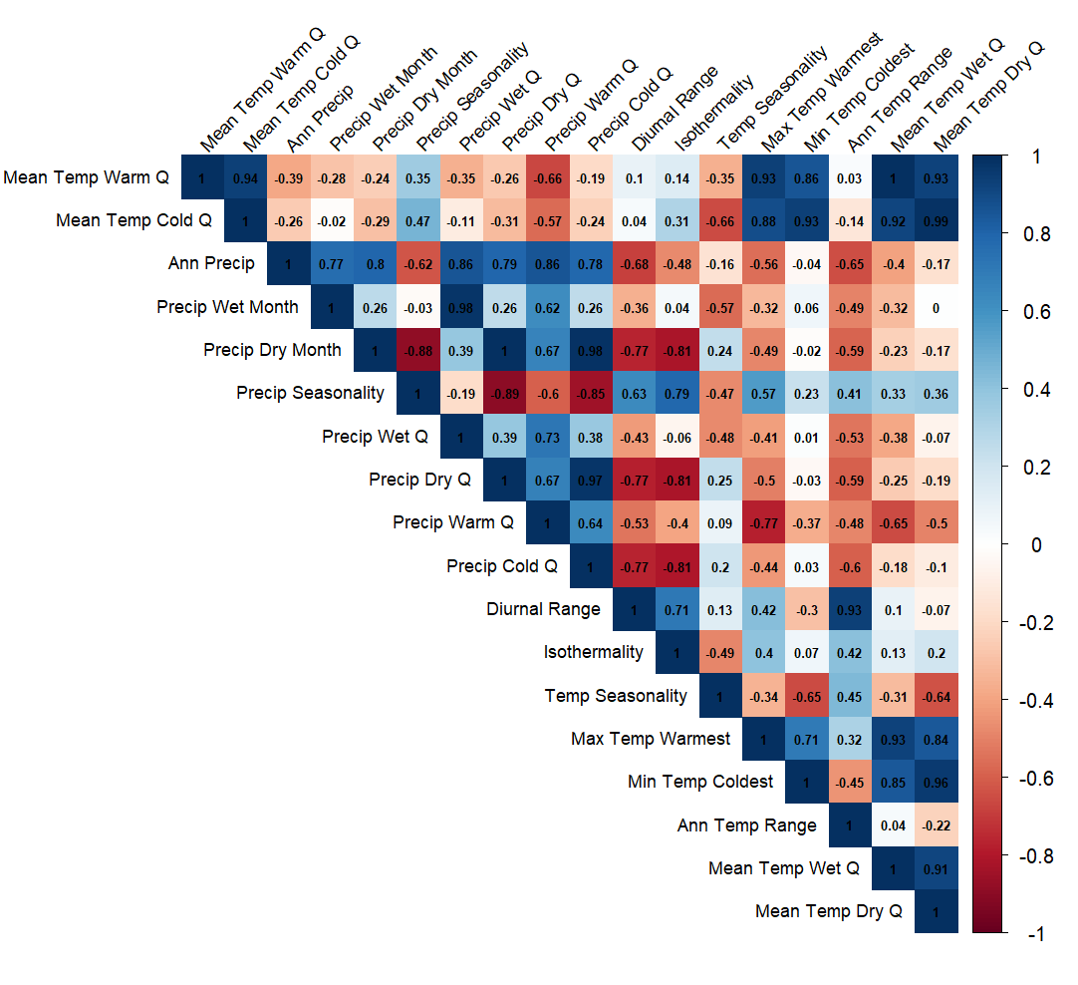
Figure S3.
Correlation matrix of the 19 CHELSA bioclimatic predictor variable values extracted from C. paniculatum occurrence data endemic to Madagascar. Darker values of blue correspond to higher positive correlation coefficients between a predictor pair, and darker values of red indicate negative highly correlated pairs. Amongst the strongest positive correlations were between the mean temperature of the wettest quarter and the mean temperature of the driest quarter (r = 0.93), and the precipitation of the driest quarter with the precipitation of the driest month (|r| = 0.77), indicating strong collinearity in thermal patterns between seasons Temperature extremes are also correlated, particularly the maximum temperature of the warmest month and annual temperature range (|r| = 0.93), and the former and mean temperature of the warmest quarter Highly negative correlations exist between precipitation seasonality and the precipitation of the driest month (|r| = -0.89) and precipitation of the driest quarter (|r| = -0.77), demonstrating that environments with more variable rainfall throughout the year tend to experience more drier conditions during the dry season Occurrence data used in the extraction of environmental data considered in this matrix were built by combining duplicate-free presence and background points. The background sampling method was random generation sampled from across the whole of Madagascar equating to ten times the number of presences, n = 62; background points, n = 619). Using this matrix, all pairs showing strong correlations (|r| > 0.7) were removed.

Ensemble SDM performance evaluation
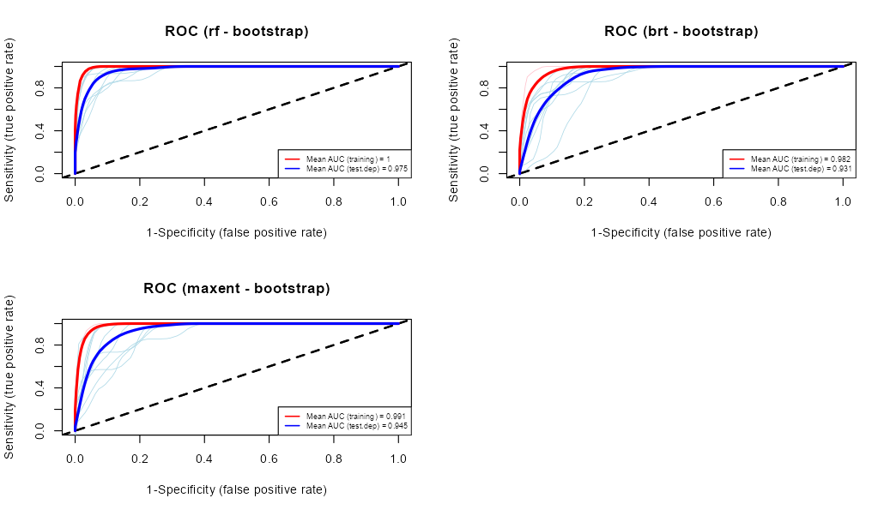
Figure S4.
Smooth Receiver Operating Curves (ROC) showing mean AUC values for both training and test data for each model algorithm within the trained L. calophylli ensemble model across each of the ten bootstrapping replicates. Curves for the training data are shown in red, and test data in blue. The value of Specificity (1 - the false positive rate) is shown on the x-axis, and Sensitivity (true positive rate) is shown on the y-axis. The black dashed line represents a random prediction. The random forest (RF) model replicates performed the best overall with the training and test datasets (training mean AUC = 1, test mean AUC = 0.975), followed by MaxEnt (training mean AUC = 0.991, test mean AUC = 0.945) and boosted regression trees (training mean AUC = 0.982, test mean AUC = 0.931).
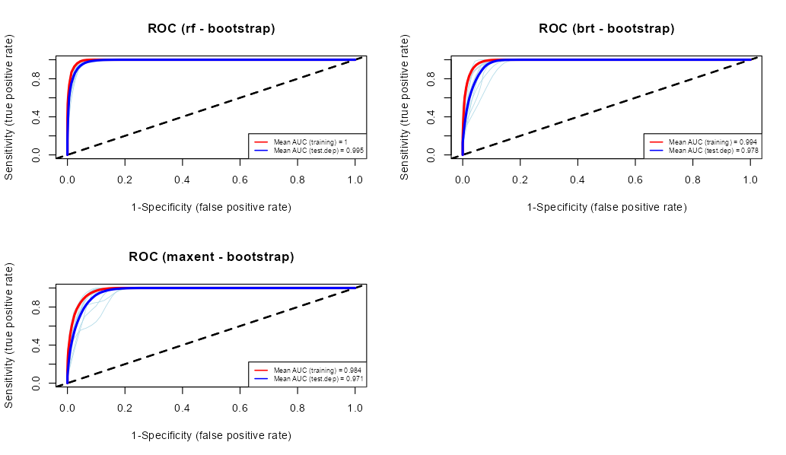
Figure S5.
Smooth Receiver Operating Curves (ROC) showing mean AUC values for both training and test data for each model algorithm within the trained C. paniculatum ensemble model across each of the ten bootstrapping replicates. Curves for the training data are shown in red, and test data in blue. The value of Specificity (1 - the false positive rate) is shown on the x-axis, and Sensitivity (true positive rate) is shown on the y-axis. The black dashed line represents a random prediction. The random forest (RF) model replicates performing the best overall with the training and test datasets (training mean AUC = 1, test mean AUC = 0.995), followed by boosted regression trees (training mean AUC = 0.994, test mean AUC = 0.978), and MaxEnt (training mean AUC = 0.984, test mean AUC = 0.971).

Model projections of continuous probability of presence
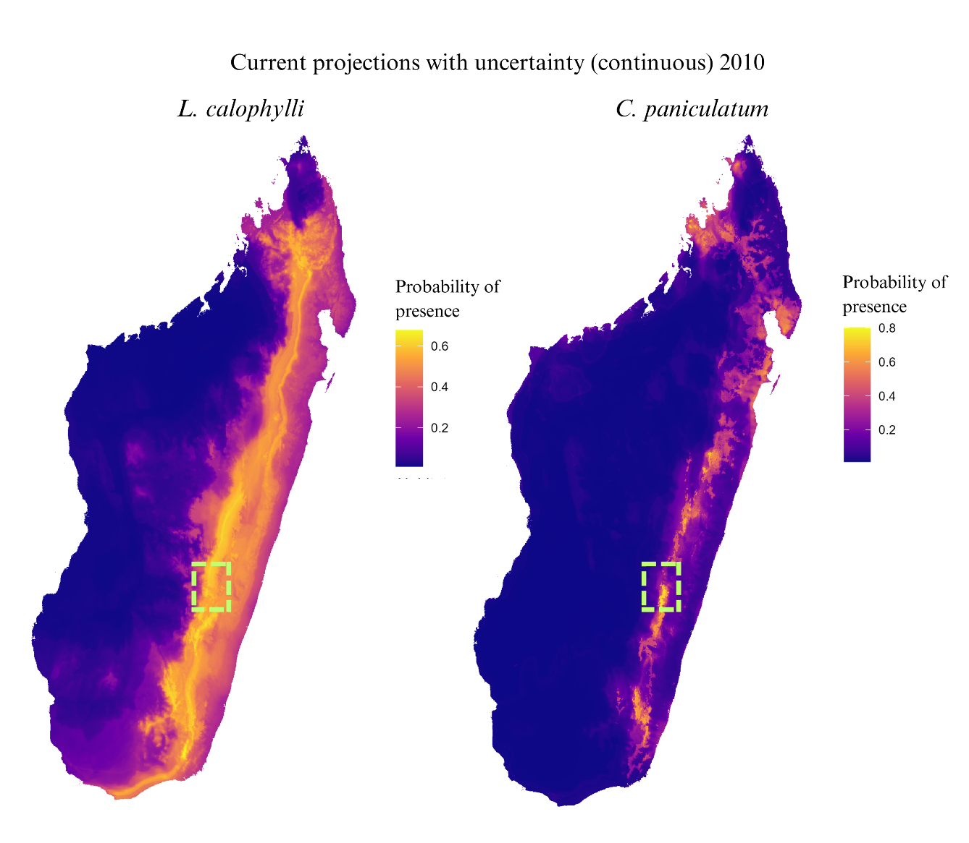
Figure S6.
(a)
(b)
Continuous projections of probability of presence (2010 as baseline) from the top SDM ensemble for (a) L. calophylli and (b). C. paniculatum. Colour scale shows high probability of presence (yellow) for Ranomafana National Park (RNP) which is highlighted with a dashed green rectangle. Presence scales are separate for each model output (maximum presence value of 0.8 for C. paniculatum, and 0.6 for L. calophylli).

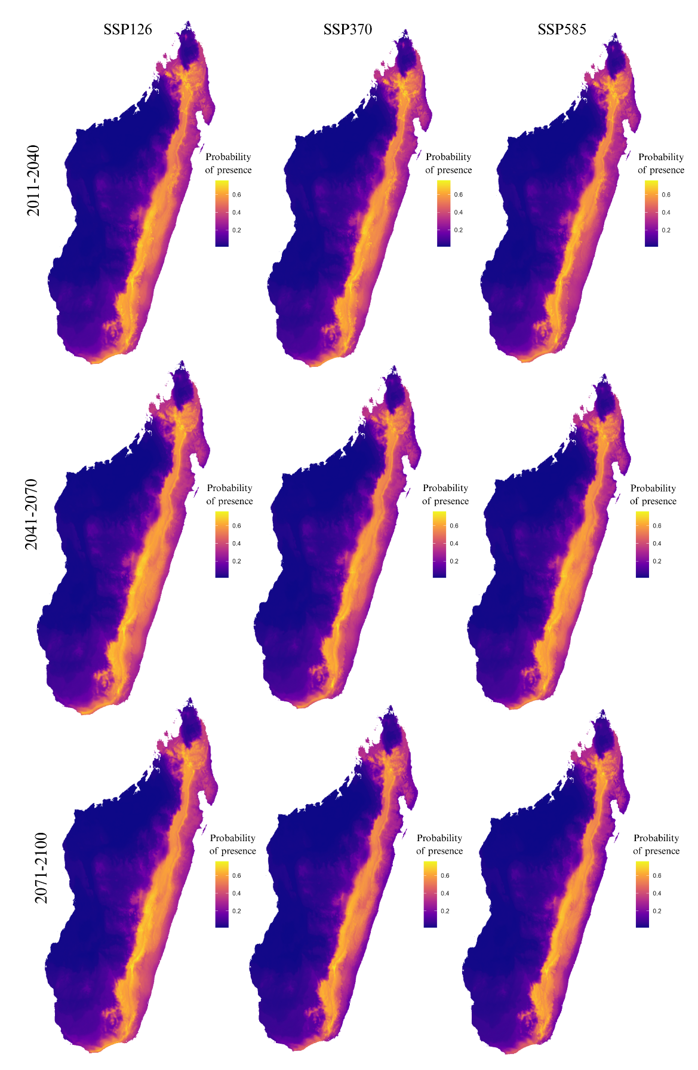
Future predictions of continuous probability of presence
Figure S7.
Continuous predictions of probability of presence for L. calophylli across three future time periods (rows) under three socioeconomic pathway scenarios (columns). Areas in bright yellow are habitats with environmental conditions most suitable to this fungal pathogen. These predictions were produced from the top performing weighted ensemble according to a weighted ranking of AUC and TSS.
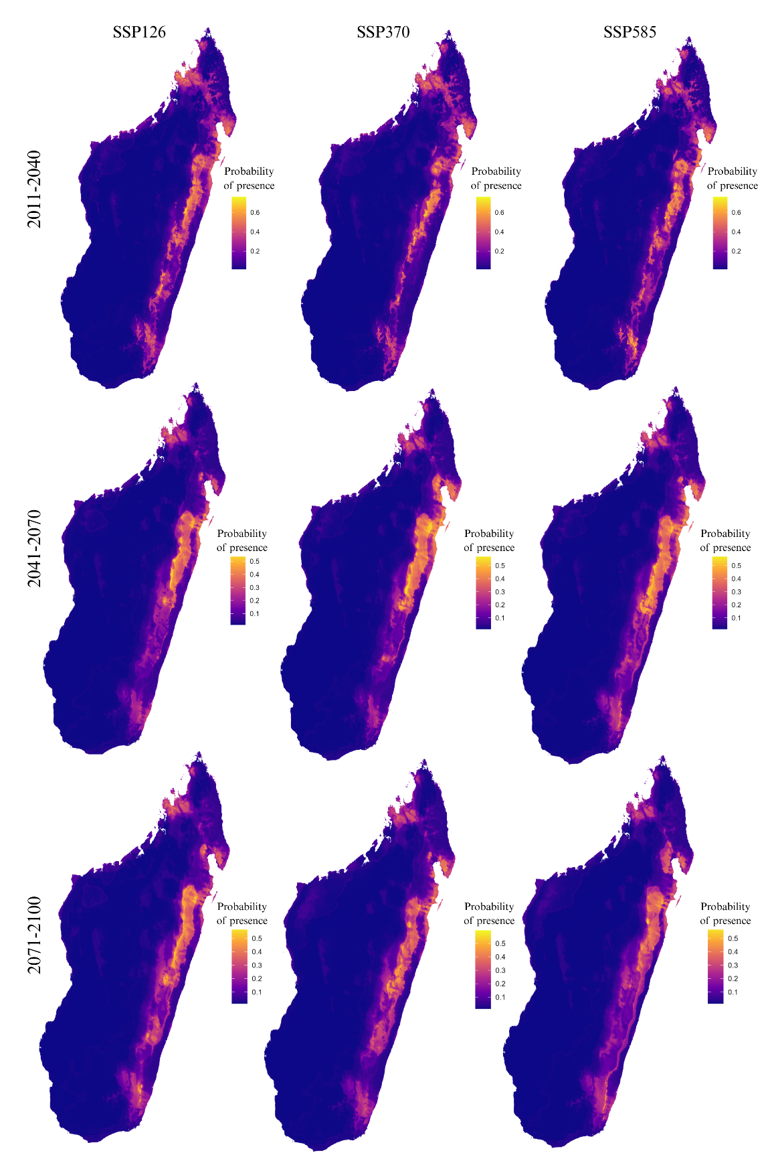
Figure S8.
Continuous predictions of probability of presence for C. paniculatum across three future time periods (rows) under three socioeconomic pathway scenarios (columns). Areas in bright yellow are habitats with environmental conditions and forest cover most suitable to this host tree. These predictions were produced from the top performing weighted ensemble according to a weighted ranking of AUC and TSS. Scaling for individual distributions is altered as conditions.

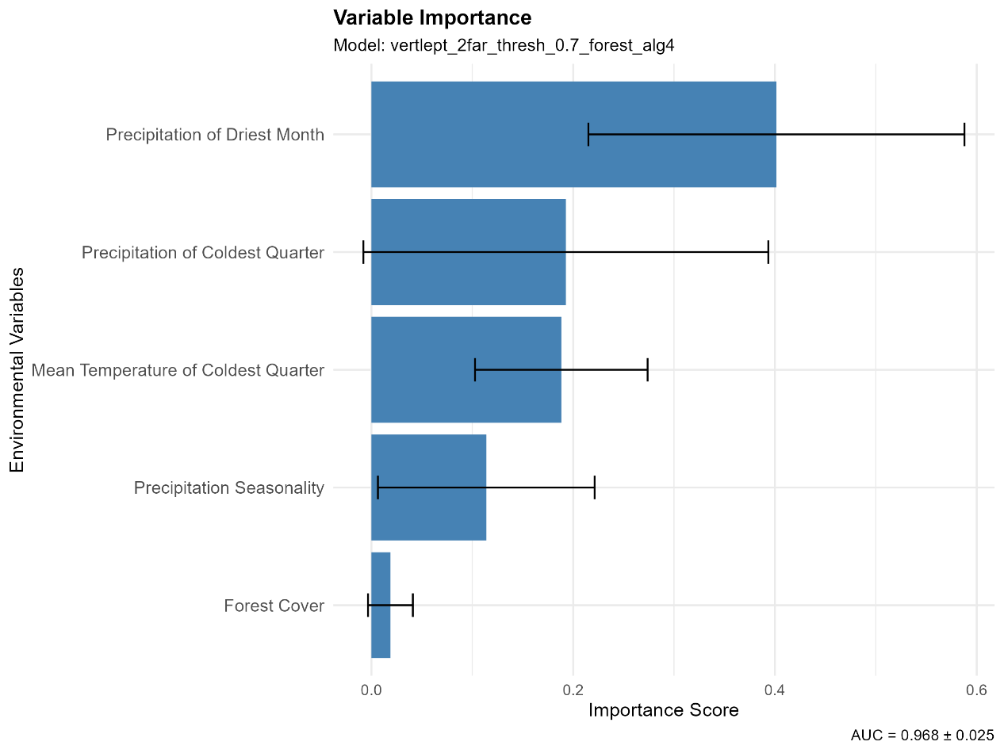
Variable importance
Figure S9.
Variable importance for the top-performing model for fungal pathogen L. calophylli (vertlept_2far_thresh_0.7_forest_alg4.sdm). The blue bars represent the mean importance score for each environmental variable based on the correlation test. Black error bars indicate 95% confidence intervals, reflecting the statistical uncertainty in importance estimates. Model performance: AUC = 0.968 ± 0.025. Precipitation of the driest month is the most important predictor (importance score ~0.35), much higher than all the other predictors. Precipitation of the coldest quarter and mean temperature of the coldest quarter showed moderate importance scores (~0.2) while precipitation seasonality showed lower influence. Forest cover contributed minimally to this top-performing model and was therefore removed from the final selection for ensemble modelling.
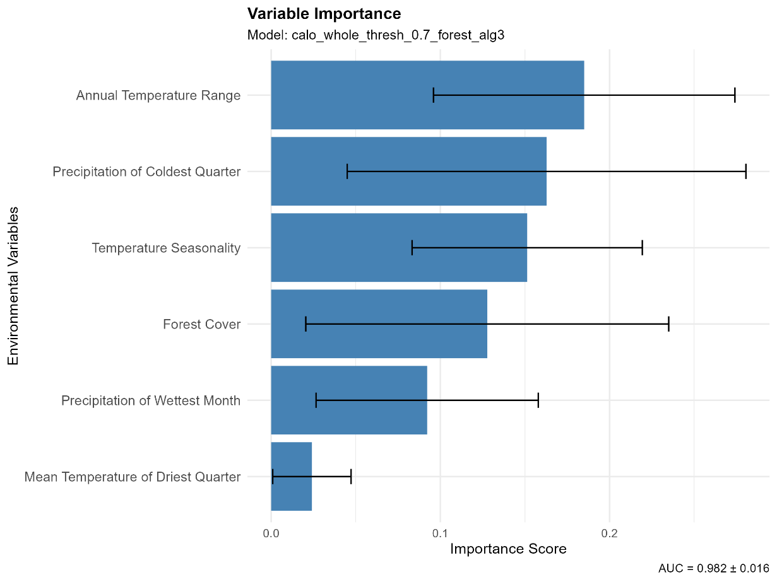
Figure S10.
Variable importance for the top-performing model for host C. paniculatum (calo_whole_thresh_0.7_forest_alg3.sdm). The blue bars represent the mean importance score for each environmental variable based on the correlation test. Black error bars indicate 95% confidence intervals, reflecting the statistical uncertainty in the importance estimates. Model performance: AUC = 0.982 ± 0.016. This analysis showed annual temperature range as the most influential predictor (importance score ~0.13), with precipitation of the coldest quarter and temperature seasonality. Forest cover showed moderate importance to the model, but with large uncertainty estimates and substantial overlap.

Response curves
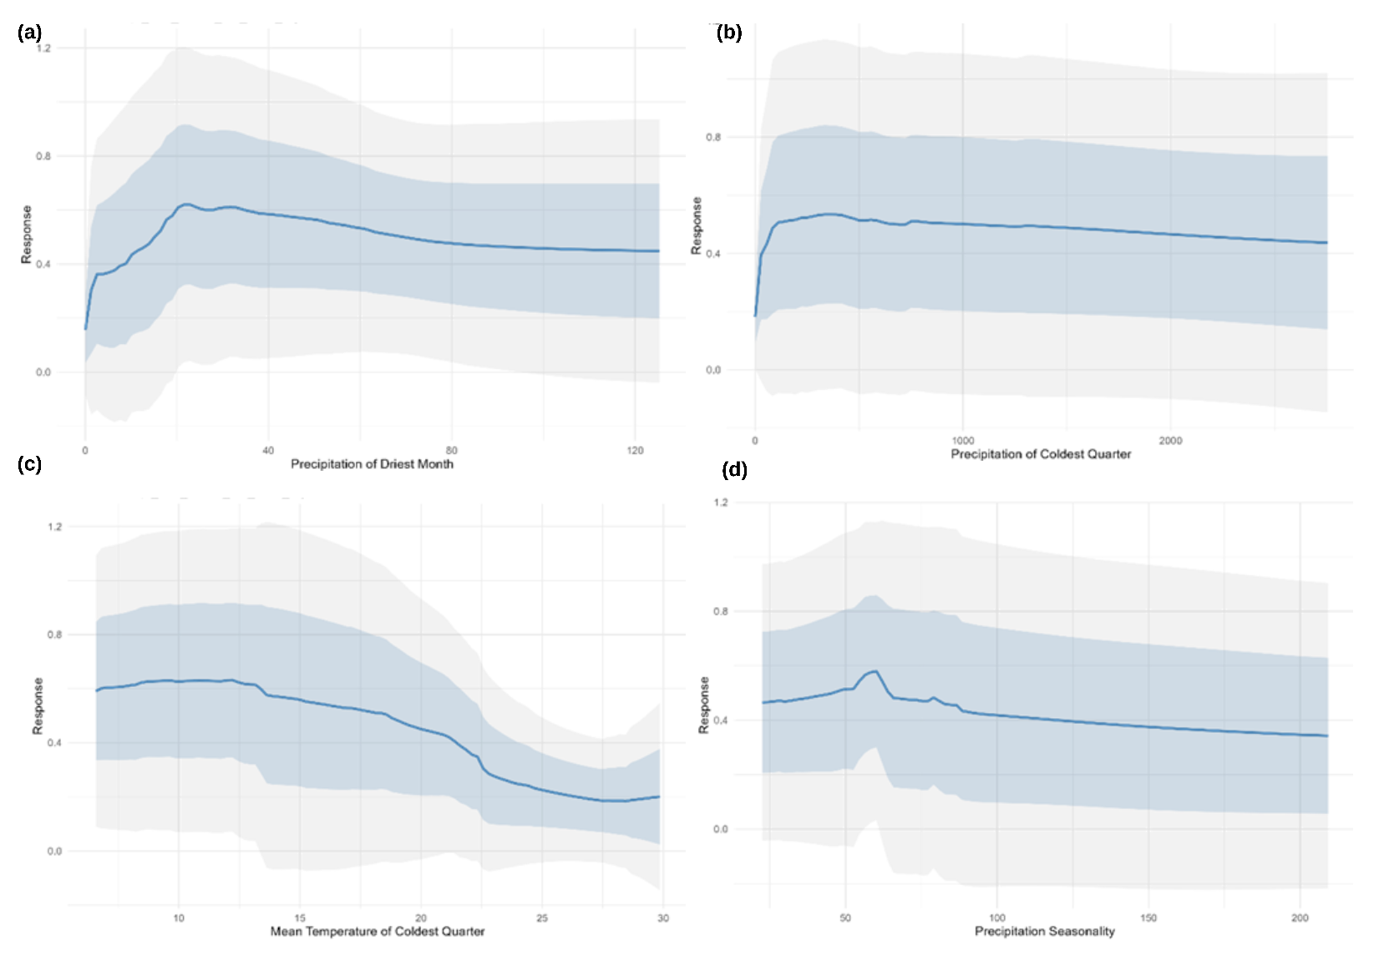
Figure S11.
Pathogen 2D response curves for the four most important predictor variables for the top trained L. calophylli SDM ensemble showing (a) precipitation of the driest month (mm), (b) precipitation of the coldest quarter (mm), (c) mean temperature of the coldest quarter (°C), and (d) precipitation seasonality. Each predictor variable has a different response scale (y-axis). Blue band: +/- 1 standard error (SE). light grey band: 95% confidence interval (CI). Precipitation of the driest month (a) shows a rapid increase in pathogen occurrence probability from very low values to a peak (~0.6) at approximately 20-30mm, followed by a gradual decline as precipitation increases further. Precipitation of coldest quarter (b) sharply increases from near zero to ~0.5 when precipitation reaches approximately 100mm, then maintaining that level across higher precipitation values. The mean temperature of the coldest quarter (c) shows a negative relationship with pathogen occurrence at higher temperature values. The probability remains relatively stable (~0.6) between 5-15°C, then declines to ~0.3 at around 30°C. Precipitation seasonality (d) shows a modest peak in response (~0.6) at intermediate seasonality values (~60-80), with slightly lower probabilities at both lower and higher seasonality. The confidence intervals for precipitation seasonality are wide, suggesting less certainty in areas of consistent rainfall.
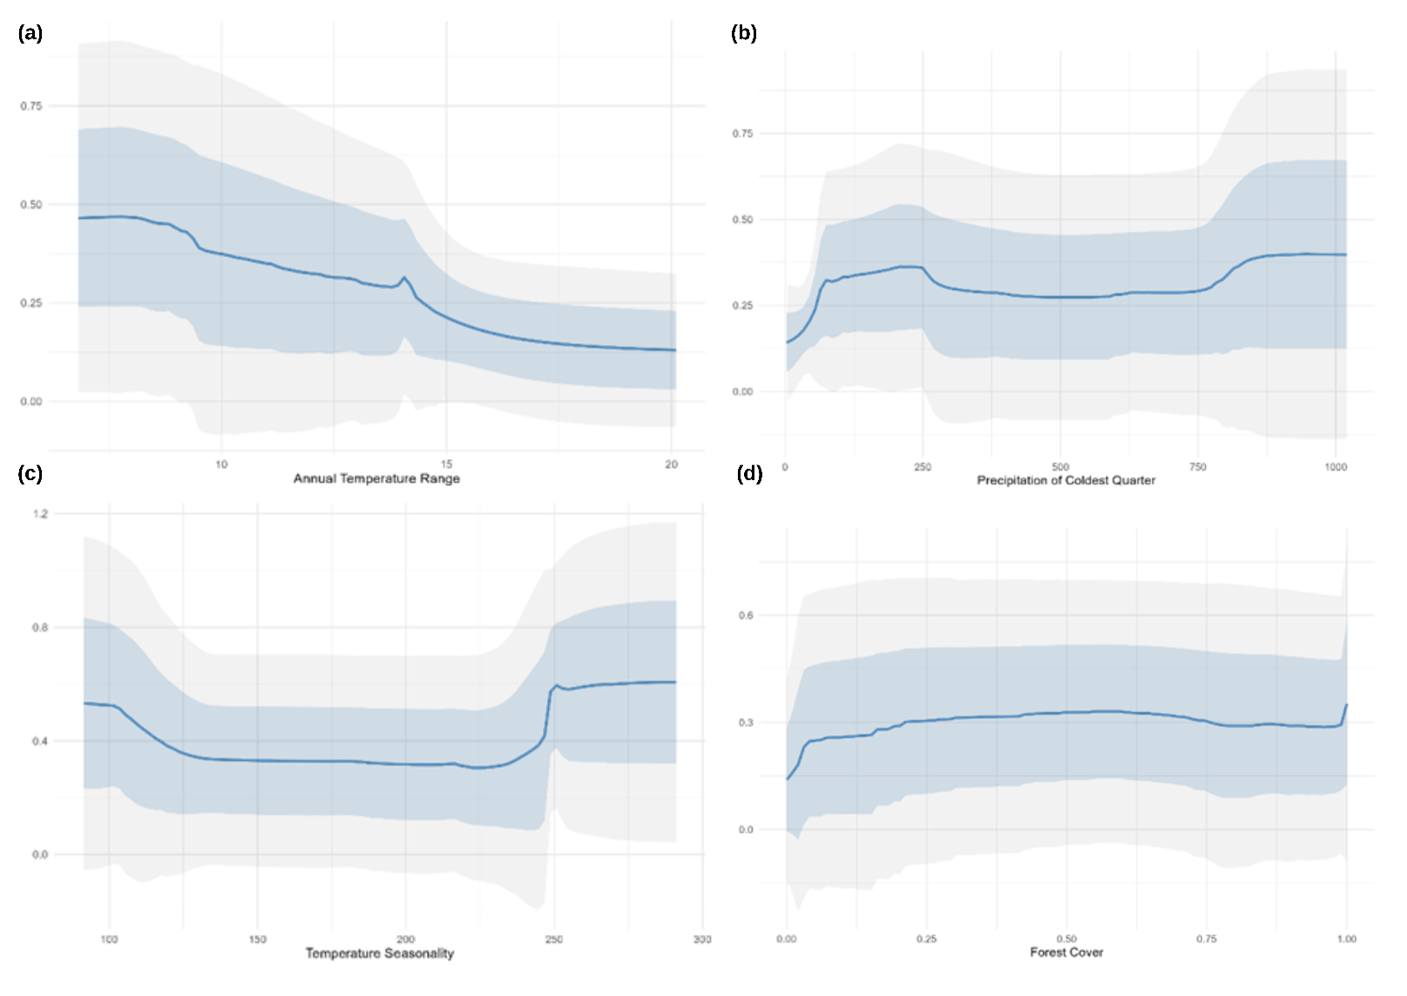
Figure S12.
Host 2D response curves for the four most important predictor variables of the top-trained SDM ensemble for host C. paniculatum showing (a) annual temperature range (°C), (b) precipitation of the coldest quarter (mm), (c) temperature seasonality, and (d) forest cover (forest cover% for each cell). Each predictor variable has a different response scale (y-axis). Blue band: +/- 1 standard error (SE). light grey band: 95% confidence interval (CI). Annual temperature range (a), shows a clear negative relationship with species occurrence, with the highest response values (~0.5) at the lowest temperature ranges (~8°C) and steadily declining to ~0.2 at ranges above 18°C. Precipitation of the coldest quarter (b) displays a slightly bimodal pattern with modest probability peaks around 150mm and 800mm. Temperature seasonality (c) shows a dual response curve with higher probabilities at both low (~100) and high (~250+) seasonality values. Forest cover (d) shows a gradual positive relationship, showing this secondary forest host species benefits from existing forest habitat.

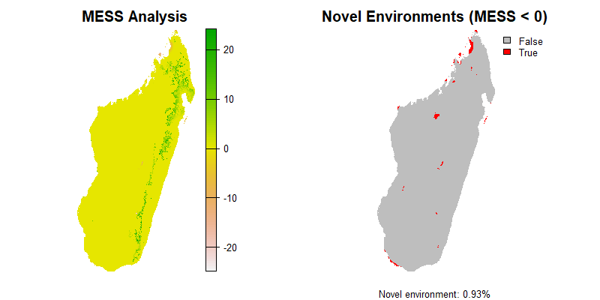
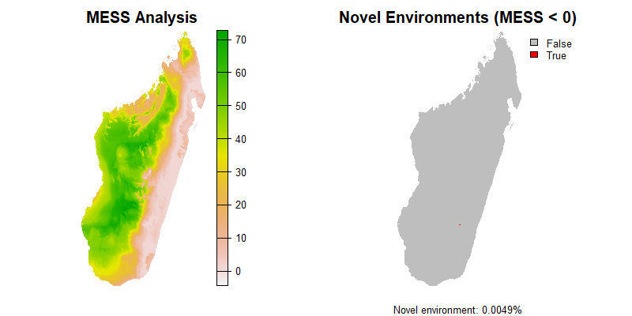
Multivariate Environmental Similarity Surface (MESS) analysis
(a)
(b)
Figure S14.
Multi Environmental Similarity Surface (MESS) analysis plots showing similarity between training and projection environments for (a) fungal pathogen L. calophylli and (b) host C. paniculatum. Novel environments are shown in red on the righthand map. The L. calophylli pathogen MESS analysis shows a low percentage of novel environments (0.005%), likely due to the training environment across Africa having a much broader range of environments compared to Madagascar. Current and future study environments were calculated to be <1% (0.93%) different between training environment and future projections for the endemic host tree.
Table S4.
Cut-off binary presence/absence threshold optimisation and values produced for each chosen ensemble projection (no. of suitable cells based on the 1km pixel) for Calophyllum and Verticillium and Leptographium, and the percentage (%) of the Madagascar study area correctly classified using the “current” climate pathway.
Cut-off threshold  optimisation | Measure | Madagascar ensemble SDM prediction
Cut-off threshold  optimisation | Measure | L. calophylli | C. paniculatum
Minimum distance to ROC curve criterion ("minROCdist")  (opt 4) | Threshold value | 0.26396 | N/A×
 | No. of suitable pixels (1km) | 191218 | N/A×
 | % correct classification | N/A* | N/A×
Max sum of sensitivity and specificity ("max(se+sp)") (opt 2) | Threshold value | N/A× | 0.33759
 | No. of suitable pixels (1km) | N/A× | 30334
 | % correct classification | N/A× | 95.52 %
×N/A – thresholds are species specific.
*L. calophylli ensemble SDM models were trained across Africa, outside of the prediction area (Madagascar) therefore result for % correct classification is not applicable.

Table S5.
Summary of predicted current and future distribution area including stable, expansion, net area (km²), percentage area changes across species, climate scenarios and time periods. Area change calculations were made after applying species-specific binary optimisation thresholds (Bin opt) to create predicted presences and absences. L. calophylli predictions were binarised optimising for Matthews Correlation Coefficient (MC), and C. paniculatum, maximised for TSS (Max TSS).
Species | SSP | Time period | Bin opt | Current projected range area (km²) | Future predicted range area (km²) | Stable area (km²) | Expansion area (km²) | Contraction area (km²) | Net area change (km²) | % Area change
L. calophylli | 126 | 2011-2040 | MC | 198712 | 183511 | 183268 | 243 | 15444 | -15201 | -7.650
L. calophylli | 126 | 2041-2070 | MC | 198712 | 184272 | 183844 | 428 | 14868 | -14440 | -7.267
L. calophylli | 126 | 2071-2100 | MC | 198712 | 182394 | 182121 | 273 | 16591 | -16318 | -8.212
L. calophylli | 370 | 2011-2040 | MC | 198712 | 179386 | 179295 | 91 | 19417 | -19326 | -9.726
L. calophylli | 370 | 2041-2070 | MC | 198712 | 166673 | 166663 | 10 | 32049 | -32039 | -16.123
L. calophylli | 370 | 2071-2100 | MC | 198712 | 139488 | 139488 | 0 | 59224 | -59224 | -29.804
L. calophylli | 585 | 2011-2040 | MC | 198712 | 182507 | 181548 | 959 | 17164 | -16205 | -8.155
L. calophylli | 585 | 2041-2070 | MC | 198712 | 167420 | 167406 | 14 | 31306 | -31292 | -15.747
L. calophylli | 585 | 2071-2100 | MC | 198712 | 136080 | 136080 | 0 | 62632 | -62632 | -31.519
C. paniculatum | 126 | 2011-2040 | Max TSS | 30334 | 37153 | 22481 | 14672 | 7853 | 6819 | 22.480
C. paniculatum | 126 | 2041-2070 | Max TSS | 30334 | 15728 | 7900 | 7828 | 22434 | -14606 | -48.151
C. paniculatum | 126 | 2071-2100 | Max TSS | 30334 | 17875 | 7325 | 10550 | 23009 | -12459 | -41.073
C. paniculatum | 370 | 2011-2040 | Max TSS | 30334 | 26640 | 19705 | 6935 | 10629 | -3694 | -12.178
C. paniculatum | 370 | 2041-2070 | Max TSS | 30334 | 24819 | 10864 | 13955 | 19470 | -5515 | -18.181
C. paniculatum | 370 | 2071-2100 | Max TSS | 30334 | 11109 | 6487 | 4622 | 23847 | -19225 | -63.378
C. paniculatum | 585 | 2011-2040 | Max TSS | 30334 | 23768 | 16793 | 6975 | 13541 | -6566 | -21.646
C. paniculatum | 585 | 2041-2070 | Max TSS | 30334 | 23507 | 10400 | 13107 | 19934 | -6827 | -22.506
C. paniculatum | 585 | 2071-2100 | Max TSS | 30334 | 10354 | 5165 | 5189 | 25169 | -19980 | -65.867

References
Barbet-Massin, M., Jiguet, F., Albert, C. H. & Thuiller, W. 2012. Selecting pseudo-absences for species distribution models: how, where and how many? Methods in Ecology and Evolution, 3, 327-338. https://doi.org/10.1111/j.2041-210X.2011.00172.x.
Cazalis, V., Di Marco, M., Zizka, A., Butchart, S. H. M., González-Suárez, M., Böhm, M., Bachman, S. P., Hoffmann, M., Rosati, I., De Leo, F., Jung, M., Benítez-López, A., Clausnitzer, V., Cardoso, P., Brooks, T. M., Mancini, G., Lucas, P. M., Young, B. E., Akçakaya, H. R., Schipper, A. M., Hilton-Taylor, C., Pacifici, M., Meyer, C. & Santini, L. 2024. Accelerating and standardising IUCN Red List assessments with sRedList. Biological Conservation, 298, 110761. https://doi.org/10.1016/j.biocon.2024.110761.
Choe, H., Thorne, J. H., Hijmans, R., Kim, J., Kwon, H. & Seo, C. 2017. Meta-corridor solutions for climate-vulnerable plant species groups in South Korea. Journal of Applied Ecology, 54, 1742-1754. https://doi.org/10.1111/1365-2664.12865.
Cucchi, M., Weedon, G. P., Amici, A., Bellouin, N., Lange, S., Müller Schmied, H., Hersbach, H., and Buontempo, C. 2020. WFDE5: bias-adjusted ERA5 reanalysis data for impact studies. Earth System Science Data, 12, 2097–2120. https://doi.org/10.5194/essd-12-2097-2020.
Elith, J., H. Graham, C., P. Anderson, R., Dudík, M., Ferrier, S., Guisan, A., J. Hijmans, R., Huettmann, F., R. Leathwick, J., Lehmann, A., Li, J., G. Lohmann, L., A. Loiselle, B., Manion, G., Moritz, C., Nakamura, M., Nakazawa, Y., Mcc. M. Overton, J., Townsend Peterson, A., J. Phillips, S., Richardson, K., Scachetti-Pereira, R., E. Schapire, R., Soberón, J., Williams, S., S. Wisz, M. & E. Zimmermann, N. 2006. Novel methods improve prediction of species’ distributions from occurrence data. Ecography, 29, 129-151. https://doi.org/10.1111/j.2006.0906-7590.04596.x.
Hijmans, R. 2025. terra: Spatial Data Analysis. R package version 1.8.21. https://CRAN.R-project.org/package=terra
Iucn 2022. Guidelines for Using IUCN Red List Categories and Criteria. IUCN. https://www.iucnredlist.org/documents/RedListGuidelines.pdf
Karger, D. N., Conrad, O., Böhner, J., Kawohl, T., Kreft, H., Soria-Auza, R. W., Zimmermann, N. E., Linder, H. P. & Kessler, M. 2017. Climatologies at high resolution for the earth’s land surface areas. Scientific Data, 4, 170122. https://doi.org/10.1038/sdata.2017.122.
Karger, D. N., Conrad, O., Böhner, J., Kawohl, T., Kreft, H., Soria-Auza, R. W., Zimmermann, N. E., Linder, H. P. & Kessler, M. 2021. Climatologies at high resolution for the earth’s land surface areas. EnviDat. https://doi.org/10.16904/envidat.228
Krasting, J. P., John, J. G., Blanton, C., Mchugh, C., Nikonov, S., Radhakrishnan, A., Rand, K., Zadeh, N. T., Balaji, V., Durachta, J., Dupuis, C., Menzel, R., Robinson, T., Underwood, S., Vahlenkamp, H., Dunne, K. A., Gauthier, P. P. G., Ginoux, P., Griffies, S. M., Hallberg, R., Harrison, M., Hurlin, W., Malyshev, S., Naik, V., Paulot, F., Paynter, D. J., Ploshay, J., Reichl, B. G., Schwarzkopf, D. M., Seman, C. J., Silvers, L., Wyman, B., Zeng, Y., Adcroft, A., Dunne, J. P., Dussin, R., Guo, H., He, J., Held, I. M., Horowitz, L. W., Lin, P., Milly, P. C. D., Shevliakova, E., Stock, C., Winton, M., Wittenberg, A. T., Xie, Y. & Zhao, M. 2018. NOAA-GFDL GFDL-ESM4 model output prepared for CMIP6 CMIP. Earth System Grid Federation. https://doi.org/10.22033/ESGF/CMIP6.1407
Lange, S. 2019. Trend-preserving bias adjustment and statistical downscaling with ISIMIP3BASD (v1.0). Geosci. Model Dev., 3055–3070. https://doi.org/10.5194/gmd-12-3055-2019, 2019.
Lange, S., Büchner, Matthias. 2021. ISIMIP3b bias-adjusted atmospheric climate input data (v1.1). ISIMIP Repository. https://doi.org/10.48364/ISIMIP.842396.1
Lenoir, J. & Svenning, J.-C. 2015. Climate-related range shifts – a global multidimensional synthesis and new research directions. Ecography, 38, 15-28. https://doi.org/10.1111/ecog.00967.
Li, X.-D., Chen, Y., Zhang, C.-L., Wang, J., Song, X.-J., Zhang, X.-R., Zhu, Z.-H. & Liu, G. 2024. Assessing the climatic niche changes and global invasion risk of Solanum elaeagnifolium in relation to human activities. Science of The Total Environment, 954, 176723. https://doi.org/10.1016/j.scitotenv.2024.176723.
Vieilledent, G., Grinand, C., Rakotomalala, F. A., Ranaivosoa, R., Rakotoarijaona, J.-R., Allnutt, T. F. & Achard, F. 2018. Combining global tree cover loss data with historical national forest cover maps to look at six decades of deforestation and forest fragmentation in Madagascar. Biological Conservation, 222, 189-197. https://doi.org/10.1016/j.biocon.2018.04.008.
Vieilledent, G., Vancutsem, C., Bourgoin, C., Ploton, P., Verley, P. & Achard, F. 2023. Spatial scenario of tropical deforestation and carbon emissions for the 21st century. bioRxiv, 2022.03.22.485306. https://doi.org/10.1101/2022.03.22.485306.
Wainhouse, D., Murphy, S., Greig, B., Webber, J. & Vielle, M. 1998. The role of the bark beetle Cryphalus trypanus in the transmission of the vascular wilt pathogen of takamaka (Calophyllum inophyllum) in the Seychelles. Forest Ecology and Management, 108, 193-199. https://doi.org/10.1016/S0378-1127(98)00234-5.
Webber, J. F., Jacobs, K. & Wingfield, M. J. 1999. A re-examination of the vascular wilt pathogen of takamaka (Calophyllum inophyllum). Mycological Research, 103, 1588-1592. https://doi.org/10.1017/S0953756299001021.
Wright, P. C., Otero Jimenez, B., Rakotonirina, P., Andriananoely, D. H., Shea, A., Ratalata, B. & Razafimahaimodison, J. C. 2020. The Progressive Spread of the Vascular Wilt Like Pathogen of Calophyllum Detected in Ranomafana National Park, Madagascar. Frontiers in Forests and Global Change. https://doi.org/10.3389/ffgc.2020.00091.

