 |  |  |  | leaf | stem | root | flower | seed | fruit | bark | gum | resin | wood | acorns
 |  |  |  | part used
Family name | Specie name | Local name | Habitt | Le | St | R | Fl | Se | Fr | Br | G | Re | Wo | Co
amranthaceae | Achyranthes aspera | spey botey | Herb | - | - | - | - | + | - | - | - | - | - | -
polypodiaceae | Adiantum capillus-veneris L | Sumble | Herb | - | - | - | - | - | - | - | - | - | - | -
Lamiaceae | Ajuga farviflora Benth | Titapatti | Herb | - | - | - | - | - | - | - | - | - | - | -
Lamiaceae | ajuga bracteosa wall.ex benth | buti | Herb | - | - | - | - | - | - | - | - | - | - | -
amaranthaceae | Amaranthus caudatus L | Ganher | Herb | + | - | + | - | - | - | - | - | - | - | -
Berberidaceae | Berberis lyceum royle | Kowarai | Shrub | - | - | + | - | - | - | + | - | - | - | -
Cannabinaceae | Cannabis sativa Linn | bhang | Herb | + | - | - | - | - | - | - | - | - | - | -
Brassicaceae | Capsellabursa-pastoris(L) medic | Chembela | Herb | + | + | - | - | - | - | - | - | - | - | -
chenopodiaceae | Chenopodium album Linn | Sarmay | Herb | - | - | - | - | - | - | - | - | - | - | -
chenopodiaceae | Chenopodium borty | skha kharawa | Herb | - | - | - | - | - | - | - | - | - | - | -
Asteraceae | Conyza Canadensis (L) cronquist | Paleet | Herb | - | - | - | - | - | - | - | - | - | - | -
Solanaceae | Datura innoxia Miller | Bathora | Herb | + | - | - | - | + | - | - | - | - | - | -
Acantheceae | Justicia adhatoda L. | Baikar | Herb | + | - | + | - | - | - | - | - | - | - | -
Maliaceae | Melia azedarch L | thora shandai | Tree | + | - | - | - | - | + | - | - | - | - | -
Lamiaceae | Mentha longifolia (linn) huds | Podina | Herb | - | - | - | - | - | - | - | - | - | - | -
Nyctaginaceae | Mirabilis jalapa | gulebada | Herb | + | - | - | - | - | - | - | - | - | - | -
Lamiaceae | Mocromeria biflora benth | Shamakay | Herb | - | - | - | - | - | - | - | - | - | - | -
Moraceae | morus nigra L | toor toot | Tree | - | - | - | - | - | + | + | - | - | - | -
Moraceae | murus alba L | spen toot | Tree | - | - | - | - | - | + | + | - | - | - | -
Moraceae | Murus lovoegata wallich.ex brandis | shah toot | Tree | - | - | - | - | - | + | + | - | - | - | -
Oleaceae | Olea ferruginea royle | Khuna | Tree | + | - | - | - | + | - | - | - | - | - | -
Lamiaceae | Origanum vulgare Linn |  | Herb | - | - | - | - | - | - | - | - | - | - | -
Oxalidaceae | Oxalis corniculata | Tarukay | Herb | - | - | - | - | - | - | - | - | - | - | -
Pinaceae | Pinus roxburgii sargent | Nakhter | Tree | - | - | - | - | - | - | - | - | + | + | -
plantginaceae | Plantago lanceolata L | jabai | Herb | + | - | - | - | + | - | - | - | - | - | -
Plantinaceae | Platanus orientalis L | chinar | Tree | + | - | - | - | - | - | + | - | - | - | -
portulacaceae | Portulaca oleracea L | Warkhary | Herb | - | - | - | - | - | - | - | - | - | - | -
Punicaceae | Punica granatum L | anar | Tree | - | + | - | - | - | + | - | - | - | - | -
Fagaceae | Quercus dilatata Lindl.ex royle | Banchkarora | Tree | - | - | - | - | - | - | + | - | - | - | +
Lameaceae | Rabdosia rugusa (wallich ex. Benth) hara | Sperkay | Shrub | - | - | - | - | - | - | - | - | - | - | -
polygonaceae | Remix hostatus D.Don | Shalkhay | Herb | + | - | + | - | - | - | - | - | - | - | -
Rosaceae | Rubus fruiticosus Agg | Karwara | Shrub | + | - | - | - | - | + | - | - | - | - | -
Rosaceae | Rubus santcus | Gobanri | Shrub | - | - | - | - | - | - | - | - | - | - | -
Polygonaceae | Rumex dentatus L | Tarokay | Herb | + | - | + | - | - | - | - | - | - | - | -
Asteraceae | Silybum marianum (L.) gaertn | kareza | Herb | - | - | - | - | - | - | - | - | - | - | -
Solanaceae | Solanum dulcamara L | Kachmacho | Herb | - | - | - | - | - | - | - | - | - | - | -
Solanaceae | Solanum nigrum auct | Mako | Herb | - | - | - | - | - | - | - | - | - | - | -
Asteraceae | Sonchu oleraceae | dodack | Herb | - | - | - | - | - | - | - | - | - | - | -
Asteraceae | Sonchus asper L | garwa | Herb | - | - | - | - | - | - | - | - | - | - | -
Asteraceae | Tagetes minuta L | gwalamesh | Herb | - | - | - | - | - | - | - | - | - | - | -
Asteraceae | Taraxacum officinale weber | Hun | Herb | + | - | + | - | - | - | - | - | - | - | -
Ranunculaceae | Thalictrum falconeri lecoyer | Phalijari | Herb | - | - | + | - | - | - | - | - | - | - | -
Urticaceae | Urtica dioica Linn | Sezonkay | Herb | - | - | - | - | - | - | - | - | - | - | -
Astreaceae | Xanthium strumarium Linn | Markunda | Herb | - | - | - | - | - | - | - | - | - | - | -
Rutaceae | Zanthaxylum armatum DC | Dambara | Shrub | - | - | - | - | + | + | + | - | - | - | -
Rhamnaceae | Zizphus oxyphylla edgew | Markhanai | Shrub | - | - | - | - | - | - | - | - | - | - | -
Rhamnaceae | Zizphus sativa Gaertn | markhanai | Tree | + | - | - | - | - | + | - | - | - | - | -
Amaranthaceae | berberis lyceum royle | Kharbotay | Herb | + | - | - | - | - | - | - | - | - | - | -
Simarubaceae | Ailanthus altissima | desi shanday | Tree | - | - | - | - | - | - | + | - | - | + | -
Asparagaceae | Asparagus adscendens | Tendoni | Herb | - | - | - | - | - | - | - | - | - | - | -
Asteraceae | Cnicus benedictus L |  | Herb | - | - | - | - | - | - | - | - | - | - | -
Thyemeleaceae | Daphne mucronata | ruttilal, jeko | Shrub | - | - | - | - | - | - | - | - | - | - | -
Ebenaceae | Diospyros lotus | toor amlook | Tree | - | - | - | - | + | + | - | - | - | - | -
Ebenaceae | Diospyros kaki | Sor amlook | Tree | - | - | - | - | - | + | - | - | - | - | -
Rosaceae | Duchesnea indica | zmakey toot | Herb | - | - | - | - | - | - | - | - | - | - | -
Euphorbiaceae | Euphorbia hirta | Dudli | Herb | - | - | - | - | - | - | - | - | - | - | -
Euphorbiaceae | Euphorbia helioscopia | mandaro | Herb | + | + | + | - | + | - | - | - | + | - | -
Euphorbiaceae | Euphorbia prostrata | warmaga | Herb | - | + | - | - | - | - | - | - | - | - | -
Moraceae | Ficus palmate | Enzer | Shrub | - | - | - | - | - | + | - | - | - | - | -
Fumariaceae | Fumaria indica | Papra | Herb | - | - | - | - | - | - | - | - | - | - | -
Brassicaceae | Nasturtium officinale | tarmera | Herb | - | - | - | - | - | - | - | - | - | - | -
Ranunculaceae | Ranunculus arvensis Linn | manzare panja | Herb | - | - | - | - | - | - | - | - | - | - | -
Caryophylaceae | Silene vulgaris Gurch | Mangotay | Herb | - | - | - | - | - | + | - | - | - | - | -
Scrophulariaceae | Verbascum thapsus Linn | Khardag | Herb | + | - | - | - | - | - | - | - | - | - | -
Verbinaceae | Verbana officinlis Linn | Shamakay | Herb | - | + | - | - | - | - | - | - | - | - | -
Asteraceae | Carthamus oxycantha M. Bieb | Konjal | Herb
Fabaceae | Cassia fistula L. | Gednali | Herb
Asteraceae | Centaurea calcitrapa L | Katasari | Herb
Amaranthaceae | Chenopodium album L | Batoo | Herb
Asteraceae | Eclipta prostrata (L).L | Spin Gulli | Herb
Equisetaceae | Equisetum ramosissimum Desf | Bandaki | Herb
Asteraceae | Erigeron canadensis L | Zangli wakha | Herb
Amaranthaceae | Achyranthes aspera L. | Buchkanda | Herb
Ranunculaceae | Aconitum chasmanthum Stapf ex Holmes | Da ghra zahar | Herb
Lamiaceae | Ajuga parviflora Benth. | Sra butti | Herb
Alliaceae | Allium griffithianum Boiss. | Zangali piaz | Herb
Alliaceae | Allium humile Kunth | Ogakai | Herb
Asteraceae | Artemisia vulgaris L. | Tarkha | Herb
Poaceae | Avena sativa L. | mastakay | Herb
Berberidaceae | Berberis calliobotrys Bien. | Kwaray | S
Polygonaceae | Bistorta amplixicaulis | Anjabar | Herb
Chenopodiaceae | Chenopodium botrys L. | Skha kharawa | Herb
Asteraceae | Cichorium intybus L. | Hunn | Herb
Malvaceae | Malva neglecta Wallr. | Panerak | Herb
Nyctaginaceae | Mirabilis jalapa L. | Gul e bada | Herb
Brassicaceae | Nasturtium officinale R. | Talmeera | Herb
Lamiaceae | Nepeta erecta Benth. | Jalbang | Herb
Lamiaceae | Ocimum basilicum L. | Kashmalay | Herb
Onagraceae | Oenothera rosea L. Her. Ex Aiton. | Gulabi | Herb
Oxalidaceae | Oxalis acetosella L. | Manzakin tarukay | Herb
Phytolaccaceae | Phytolacca acinosa Roxb. | Tamaku saag | Herb
Rosaceae | Potentilla reptans L. | Spanja | Herb
Brassicaceae | Raphanus raphanistrum L. | Zangali mulai | Herb
Rubiaceae | Rubia cordifolia L. | Kargha makhuka | Herb
Scrophulariaceae | Verbascum Thapsus L. | Khar ghwag | Herb
Rutacaeae | Zanthoxylum armatum DC. | Dambara | S
Primulaceae | Primula denticulate Sm. | Mamira | Herb
Papaveraceae | Papaver somniferum L. | Qashqash | Herb

NOTE: No. 1–10: Plants mentioned; sub-number (−1 to −5): hexane, acetone, ethanol, methanol, water; SA;Staphylococcus aureus, SE: Staphylococcus epidermidis, SF: Streptococcus faecalis, EF: Enterococcus faecalis, ML: Micrococcus luteus, EC: Escherichia coli, PA: Pseudomonas aeruginosa, SS: Shigella sonnei, SF: Shigella flexneri,EA: Enterobacter aerogenes.

No. | Plant name | Gram-positive bacteria |  |  |  |  | Gram-negative bacteria
No. | Plant name | SA | SE | SF | EF | ML | EC | PA | SS | SF | EA
1.1 | ajuga bracteosa wall.ex benth |  | _ | 866 | _ | _ | _ | 395 | _ | _ | 485
1.2 | ajuga bracteosa wall.ex benth | 40 | _ | 111 | _ | 133 | _ | 3 | _ | _ | 273
1.3 | ajuga bracteosa wall.ex benth | 44 | _ | 69 | 18 | _ | _ | 20 | _ | _ | 179
1.4 | ajuga bracteosa wall.ex benth | 13 | 131 | 84 | 31 | 110 | _ | 35 | _ | _ | 389
2.1 | Oxalis corniculata | 349 | 116 | 431 | _ | _ | _ | _ | _ | _ | _
2.2 | Oxalis corniculata | 291 | _ | _ | _ | _ | _ | 167 | _ | _ | _
2.3 | Oxalis corniculata | 39 | 284 | 5 | 24 | 46 | 485 | 14 | _ | _ | 100
2.4 | Oxalis corniculata | 34 | 130 | 1 | 14 | 79 | 235 | 15 | 298 | _ | 99
3.1 | Portulaca oleracea L |  | _ | 866 | _ | _ | _ | 395 | _ | _ | 485
3.2 | Portulaca oleracea L | 40 | _ | 111 | _ | 133 | _ | 3 | _ | _ | 273
3.3 | Portulaca oleracea L | 44 | _ | 69 | 18 | _ | _ | 20 | _ | _ | 179
3.4 | Portulaca oleracea L | 488 | _ | 163 | _ | _ | _ | 97 | _ | _ | _
3.5 | Portulaca oleracea L | 374 | 143 | 90 | 41 | _ | _ | _ | _ | _ | _
4.1 | berberis lyceum royle | _ | _ | _ | _ | _ | _ | 88 | _ | _ | _
4.2 | berberis lyceum royle | 287 | _ | _ | _ | _ | _ | 163 | _ | _ | _
4.3 | berberis lyceum royle | 121 | _ | 1086 | _ | 65 | _ | 352 | _ | _ | _
4.4 | berberis lyceum royle | _ | _ | _ | _ | _ | _ | 319 | 518 | _ | _
4.5 | berberis lyceum royle | _ | 103 | _ | _ | _ | _ |  | 251 | _ | 70
5.1 | Euphorbia helioscopia |  | _ | _ | _ | _ | _ | 500 | _ | _ | _
5.2 | Euphorbia helioscopia | 342 | _ | 673 | _ | _ | _ | 267 | _ | _ | _
5.3 | Euphorbia helioscopia | _ | _ | _ | _ | _ | _ | 252 | _ | _ | _
5.4 | Euphorbia helioscopia | _ | _ | _ | _ | _ | _ | 453 | _ | _ | _
5.5 | Euphorbia helioscopia | _ | _ | _ | _ | _ | _ | _ | _ | 353 | 64
6.1 | Nasturtium officinale | 256 | _ | 984 | _ | _ | _ | _ | 468 | _ | _
6.2 | Nasturtium officinale | 240 | _ | _ | _ | _ | _ | _ | _ | _ | _
6.3 | Nasturtium officinale | 572 | _ | 329 | _ | _ | _ | _ | _ | _ | _
6.4 | Nasturtium officinale | _ | _ | 321 | _ | _ | _ | 498 | _ | _ | _
6.5 | Nasturtium officinale | _ | _ | _ | _ | _ | _ | _ | 161 | _ | _
7.1 | Carthamus oxycantha M. Bieb | _ | _ | 20 | _ | _ | _ | 495 | _ | _ | _
7.2 | Carthamus oxycantha M. Bieb | 241 | _ | _ | _ | 57 | _ | 300 | _ | _ | _
7.3 | Carthamus oxycantha M. Bieb | 145 | _ | 412 | _ | _ | _ | 304 | _ | _ | _
7.4 | Carthamus oxycantha M. Bieb | _ | _ | _ | _ | _ | _ | 212 | _ | _ | _
7.5 | Carthamus oxycantha M. Bieb | _ | _ |  | _ | _ | _ | _ | 51 | _ | 51
8.1 | Equisetum ramosissimum Desf | 288 | _ | 654 | _ | _ | _ | 60 | _ | _ | _
8.2 | Equisetum ramosissimum Desf | 130 | _ | 484 | _ | 110 | _ | 95 | _ | _ | _
8.3 | Equisetum ramosissimum Desf | 221 | 183 | 568 | _ | 845 | _ | 136 | _ | _ | _
8.4 | Equisetum ramosissimum Desf | 298 | _ | 900 | _ | 140 | _ | 84 | _ | _ | _
9.1 | Ajuga parviflora Benth. | _ | _ | _ | 70 | _ | _ | _ | _ | 229 | 139
9.2 | Ajuga parviflora Benth. | 172 | _ | 494 | _ | _ | _ | 117 | _ | _ | _
9.3 | Ajuga parviflora Benth. | 148 | _ | 410 | _ | _ | _ | 111 | _ | _ | _
9.4 | Ajuga parviflora Benth. | 395 | _ | _ | _ | _ | _ | 159 | _ | _ | _
9.5 | Ajuga parviflora Benth. | 258 | _ | _ | _ | _ | _ | _ | _ | _ | _
10.1 | Artemisia vulgaris L. | 111 | 149 | 468 | _ | 147 | _ | 61 | _ | _ | _
10.2 | Artemisia vulgaris L. | 94 | _ | _ | _ | 212 | 834 | 197 | _ | _ | _
10.3 | Artemisia vulgaris L. | 295 | 319 | _ | _ | 552 | _ | 86 | _ | _ | _
10.4 | Artemisia vulgaris L. | 288 | _ | 654 | _ | _ | _ | 60 | _ | _ | _

Table 4. HPLC-UV characterization and quantification of phenolic compounds in different genotypes of

Plant name | No. of Peak | Retention time (min) | Identified Phenolic Compounds | HPLC-UV λmax (nm) | Peak Area of sample | Peak Area of Standard | Con.  (µg/ml) | Identification Reference
Ajuga bracteosa | 1 | 2.2 | Malic acid | 320 | 56.078 | 9.62 | 5.25 | Standard
Ajuga bracteosa | 2 | 4.4 | Gallic acid | 320 | 22.509 | 0.12 | 168.82 | Standard
Ajuga bracteosa | 3 | 10.5 | Quercetin | 320 | 187.054 | 7089.29 | 0.024 | Standard
Ajuga bracteosa | 4 | 12.3 | Morin | 320 | 25.825 | 2.01 | 11.563 | Standard
Ajuga bracteosa | 5 | 16.0 | Elagic acid | 320 | 36.401 | 0.15 | 218.406 | Standard
Ajuga bracteosa | 6 | 21.3 | Rutin | 320 | 117.063 | 2241.22 | 0.023 | Standard
Oxalis corniculata | 1 | 2.2 | Malic acid | 320 | 769.018 | 9.62 | 71.945 | Standard
Oxalis corniculata | 2 | 4.4 | Galic acid | 320 | 63.7816 | 0.15 | 478.362 | Standard
Portulaca oleracea | 1 | 2.2 | Malic acid | 320 | 98.477 | 9.62 | 9.213 | Standard
Portulaca oleracea | 2 | 4.4 | Galic acid | 320 | 2177.057 | 0.12 | 16327.92 | Standard
Portulaca oleracea | 3 | 6.0 | Chlorogenic acid | 320 | 1912.882 | 23.31 | 73.856 | Standard
Portulaca oleracea | 4 | 8.5 | Epigalocatechin gallate | 320 | 135.860 | 12.19 | 10.031 | Standard
Portulaca oleracea | 5 | 10.5 | Quercetin | 320 | 25.6496 | 7089.29 | 0.003 | Standard
Euphorbia helioscopia | 1 | 2.2 | Malic acid | 320 | 186.911 | 9.62 | 17.486 | Standard
Euphorbia helioscopia | 2 | 4.4 | Galic acid | 320 | 1293.658 | 0.12 | 9702.435 | Standard
Euphorbia helioscopia | 3 | 6.0 | Chlorogenic acid | 320 | 547.007 | 23.31 | 21.119 | Standard
Euphorbia helioscopia | 4 | 8.5 | Epigallocatechin gallate | 320 | 142.717 | 12.19 | 10.536 | Standard
Euphorbia helioscopia | 5 | 10.2 | Quercetin | 320 | 35.415 | 7089.29 | 0.004 | Standard
Nasturtium officinale | 1 | 2.2 | Malic acid | 320 | 95.49 | 41.30 | 0.99 | Standard
Nasturtium officinale | 2 | 6.0 | Chlorogenic acid | 320 | 1950.91 | 14.90 | 117.84 | Standard
Nasturtium officinale | 3 | 8.5 | Epigalocatechin gallate | 320 | 5145.81 | 71.76 | 64.54 | Standard
Nasturtium officinale | 4 | 10.5 | Quercetin | 320 | 1345.72 | 92.76 | 13.06 | Standard
Nasturtium officinale | 5 | 12.3 | Morin | 320 | 238.86 | 2.09 | 102.86 | Standard
Nasturtium officinale | 6 | 16.0 | Elagic acid | 320 | 251.57 | 330.31 | 0.68 | Standard

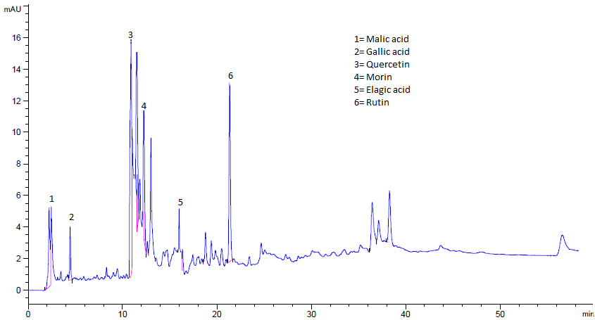
Fig. 1: HPLC-UV Chromatograms of phenolic compounds in Ajuga bracteosa

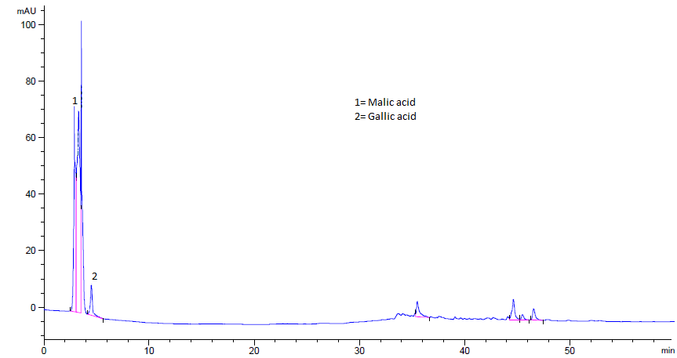
Fig. 2: HPLC-UV Chromatograms of phenolic compounds in Oxalis corniculata

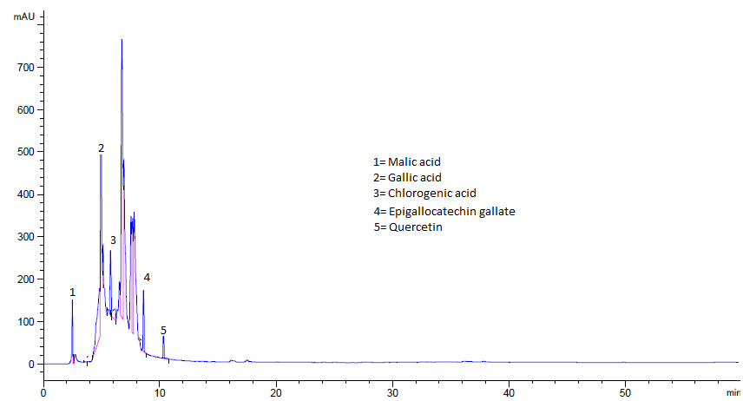

Fig. 3: HPLC-UV Chromatograms of phenolic compounds in Euphorbia helioscopia

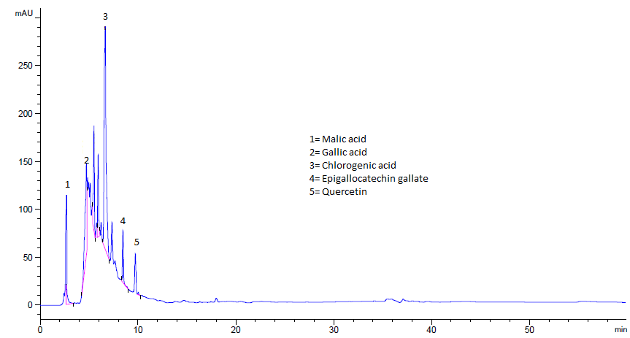Fig. 4: HPLC-UV Chromatograms of phenolic compounds in Nasturtium officinale

