Supplementary information: Planktivorous fishes withstand 20 years of major coral cover oscillations
Mathieu Reynaud, Tom Garine-Wichatitsky, Renato Morais, Valeriano Parravicini, Fabien Morat and Benoit Pujol
Supplementary tables
Table S1: List of species described as strict planktivorous fishes
Family | Genus | Species | Taxon
Acanthuridae | Acanthurus | mata | Acanthurus mata
Anthiadidae | Pseudanthias | mooreanus | Pseudanthias mooreanus
Anthiadidae | Pseudanthias | olivaceus | Pseudanthias olivaceus
Anthiadidae | Pseudanthias | pascalus | Pseudanthias pascalus
Atherinidae | Atherinomorus | sp | Atherinomorus sp
Caesionidae | Pterocaesio | tile | Pterocaesio tile
Carangidae | Decapterus | macarellus | Decapterus macarellus
Chaetodontidae | Hemitaurichthys | polylepis | Hemitaurichthys polylepis
Chaetodontidae | Heniochus | acuminatus | Heniochus acuminatus
Clupeidae | Clupeidae | sp | Clupeidae sp
Hemiramphidae | Hyporhamphus | affinis | Hyporhamphus affinis
Holocentridae | Myripristis | adusta | Myripristis adusta
Holocentridae | Myripristis | berndti | Myripristis berndti
Holocentridae | Myripristis | kuntee | Myripristis kuntee
Holocentridae | Myripristis | murdjan | Myripristis murdjan
Holocentridae | Myripristis | violacea | Myripristis violacea
Labridae | Cirrhilabrus | exquisitus | Cirrhilabrus exquisitus
Labridae | Cirrhilabrus | scottorum | Cirrhilabrus scottorum
Labridae | Pseudocoris | aurantiofasciata | Pseudocoris aurantiofasciata
Labridae | Thalassoma | amblycephalum | Thalassoma amblycephalum
Microdesmidae | Ptereleotris | evides | Ptereleotris evides
Microdesmidae | Ptereleotris | microlepis | Ptereleotris microlepis
Microdesmidae | Ptereleotris | zebra | Ptereleotris zebra
Microdesmidae | Nemateleotris | magnifica | Nemateleotris magnifica
Pomacentridae | Amphiprion | chrysopterus | Amphiprion chrysopterus
Pomacentridae | Dascyllus | aruanus | Dascyllus aruanus
Pomacentridae | Dascyllus | flavicaudus | Dascyllus flavicaudus
Pomacentridae | Dascyllus | reticulatus | Dascyllus reticulatus
Pomacentridae | Dascyllus | trimaculatus | Dascyllus trimaculatus
Pomacentridae | Lepidozygus | tapeinosoma | Lepidozygus tapeinosoma
Pomacentridae | Pomachromis | fuscidorsalis | Pomachromis fuscidorsalis
Pomacentridae | Chromis | alpha | Chromis alpha
Pomacentridae | Chromis | atripectoralis | Chromis atripectoralis
Pomacentridae | Chromis | sp | Chromis sp
Pomacentridae | Chromis | viridis | Chromis viridis
Pomacentridae | Chromis | xanthura | Chromis xanthura
Pomacentridae | Pycnochromis | acares | Pycnochromis acares
Pomacentridae | Pycnochromis | agilis | Pycnochromis agilis
Pomacentridae | Pycnochromis | iomelas | Pycnochromis iomelas
Pomacentridae | Pycnochromis | margaritifer | Pycnochromis margaritifer
Pomacentridae | Pycnochromis | vanderbilti | Pycnochromis vanderbilti
Spratelloididae | Spratelloides | gracilis | Spratelloides gracilis

Table S2: Results of the PERMANOVA analysis on the outer slope planktivorous fish community (999 permutations used)
Term | Df | SumOfSqs | R² | F | p-value
Period | 3 | 21.55 | 0.07757 | 28.228 | 0.001
Residuals | 1007 | 256.25 | 0.92243
Total | 1010 | 277.8 | 1

Table S3: Results of the SIMPER analysis on the forereef planktivorous fish community (999 permutations used)
The SIMPER results to compare responses across pairwise combinations.
Comparison | Species | Average dissimilarity | SD | Contribution % | Cumulative contribution % | P-value
Initial_shock1 | Pycnochromis vanderbilti | 0.316 | 0.225 | 45.574 | 0.457 | 0.001
Initial_shock1 | Pycnochromis iomelas | 0.089 | 0.099 | 13.662 | 0.585 | 0.022
Initial_shock1 | Pycnochromis acares | 0.057 | 0.145 | 15.118 | 0.668 | 1.000
Initial_shock1 | Cirrhilabrus scottorum | 0.056 | 0.064 | 10.903 | 0.748 | 0.767
Initial_shock1 | Lepidozygus tapeinosoma | 0.045 | 0.095 | 8.236 | 0.813 | 0.373
Shock1_Recovery | Pycnochromis vanderbilti | 0.240 | 0.191 | 66.560 | 0.336 | 1.000
Shock1_Recovery | Pycnochromis acares | 0.153 | 0.174 | 41.956 | 0.550 | 0.001
Shock1_Recovery | Pycnochromis iomelas | 0.080 | 0.095 | 13.059 | 0.662 | 0.714
Shock1_Recovery | Cirrhilabrus scottorum | 0.058 | 0.065 | 9.938 | 0.743 | 0.475
Shock1_Recovery | Lepidozygus tapeinosoma | 0.045 | 0.098 | 7.974 | 0.806 | 0.354
Recovery_Shock2 | Pycnochromis vanderbilti | 0.213 | 0.184 | 33.918 | 0.292 | 1.000
Recovery_Shock2 | Pycnochromis acares | 0.173 | 0.159 | 41.448 | 0.527 | 0.001
Recovery_Shock2 | Pycnochromis iomelas | 0.080 | 0.098 | 16.809 | 0.637 | 0.695
Recovery_Shock2 | Cirrhilabrus scottorum | 0.067 | 0.069 | 17.320 | 0.728 | 0.001
Recovery_Shock2 | Lepidozygus tapeinosoma | 0.047 | 0.114 | 12.201 | 0.792 | 0.204
Supplementary figures

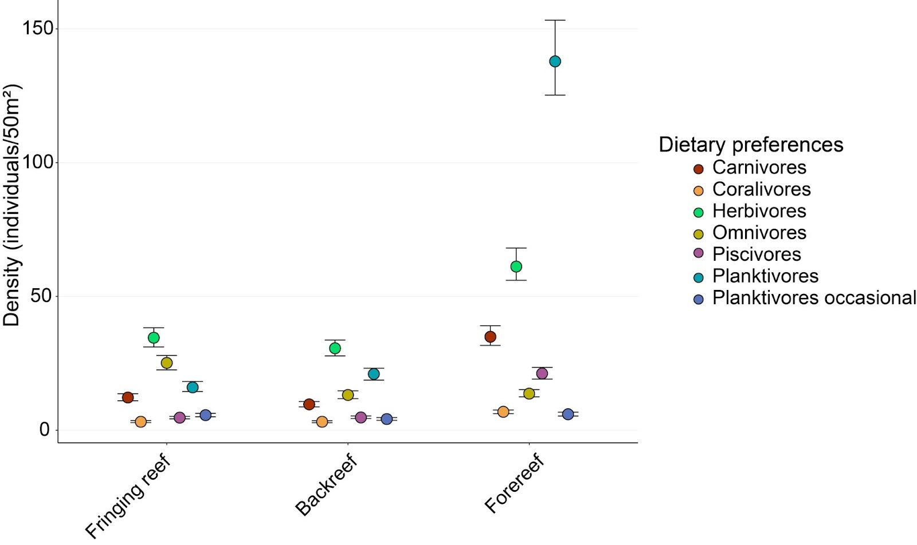
Figure S1: Density for all trophic guilds based on dietary preference
Density of fish among trophic guilds and reef types (fringing reef, backreef and forereef). Full points show the median abundance per 50 m², and error bar correspond to lower and upper from the predictive posterior distribution.

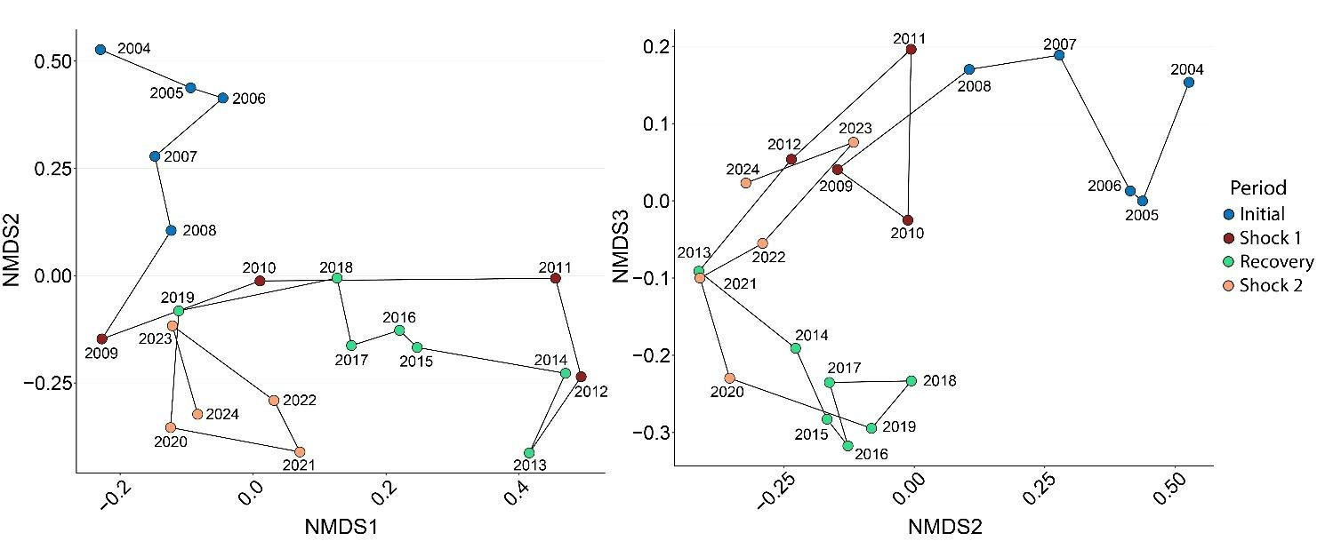
Figure S2: Forereef planktivorous fish trajectory over time
Non-metric multidimensional scaling (NMDS) of planktivorous fish assemblages, showing the temporal trajectory of community composition and density. NMDS1 vs NMDS2 & NMDS2 vs NMDS3.

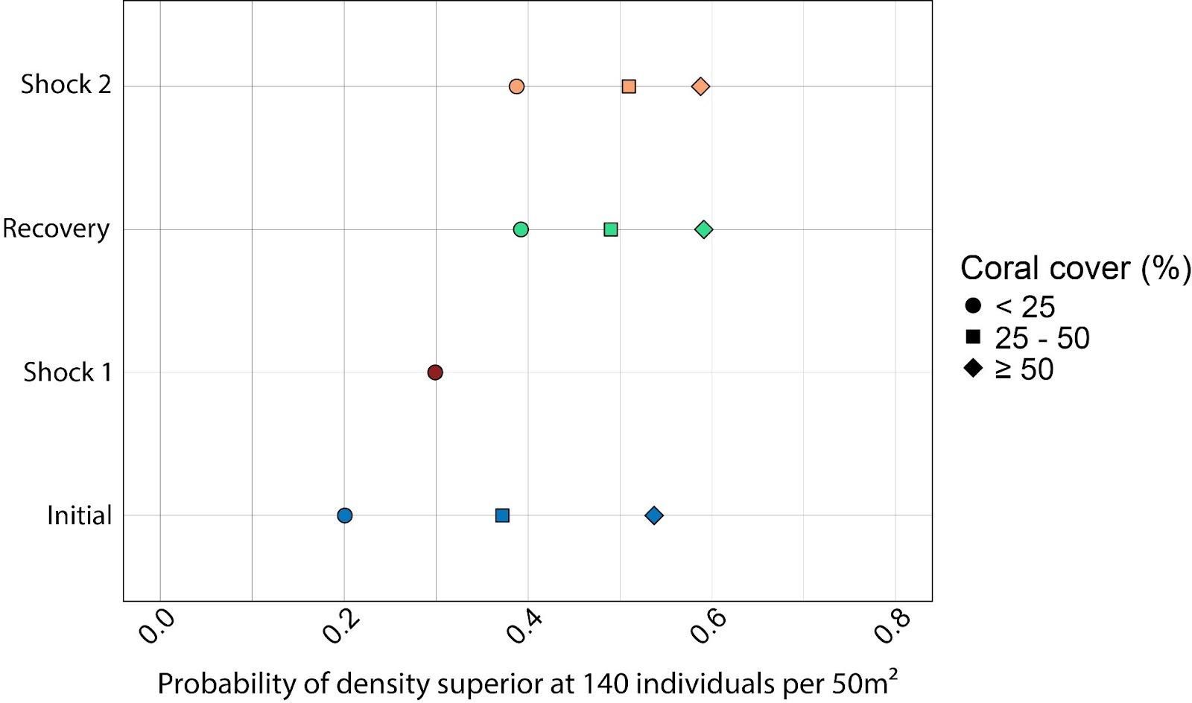
Figure S3: Probability of planktivorous fish density superior to the average per class of percentage of coral cover
For each period, the probability of density superior at the average (140 individuals per 50 m²) per class of percentage of coral cover has been calculated to draw from the posterior distribution.

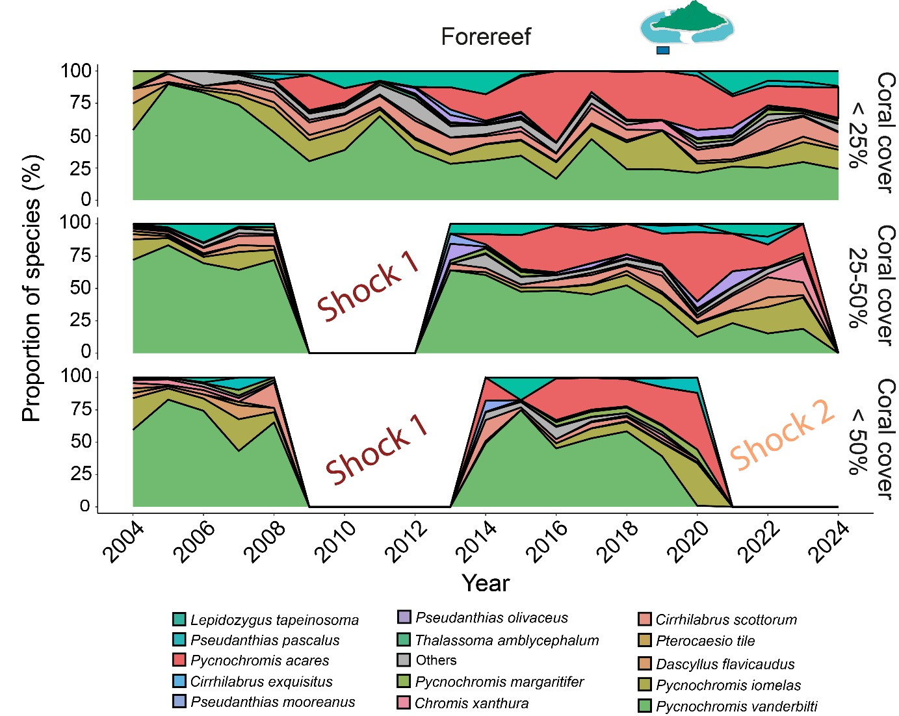
Figure S4: Species proportion among the cover coral zone on the forereef
Proportion of the most present planktivorous fish species on the Forereef. Planktivorous fish species with low occurrence (only few observations) have been grouped in the category “others”.

