An ACQUITY UHPLC I-Class system coupled with a Xevo XS quadrupole time of flight mass spectrometer (Waters, Milford, MA, USA) was used for characterization of chemical components in Leonuri Herba. Chromatographic separation was carried out at 45 °C on a Waters CORTECS C₁₈ column (2.1 mm × 100 mm; 1.6 μm), with 0.1% of formic acid as mobile phase A and acetonitrile as mobile phase B. Gradient elution was performed as follows: 1%-1% B for 0.0-2.0 min, 1%-13% B for 2.0-0.0 min, 13%-25% B for 6.0-15.0 min, 25%–60% B for 15.0-20.0 min.The flow rate was set at 0.25 mL/min. The mass-spectrometry conditions were optimized as follows: ESI positive mode, desolvent gas temperature, 500 °C; capillary voltage, +3.0 kV; source temperature: 150 °C; desolvent gas flow (N₂): 800 L/h; and cone gas flow (N₂): 150 L/h. The MS scan range was m/z 50-1500. Total base peak ion chromatogram (BPI) was shown in Supplement Fig1, the identified compounds list at Supplement Table 1.

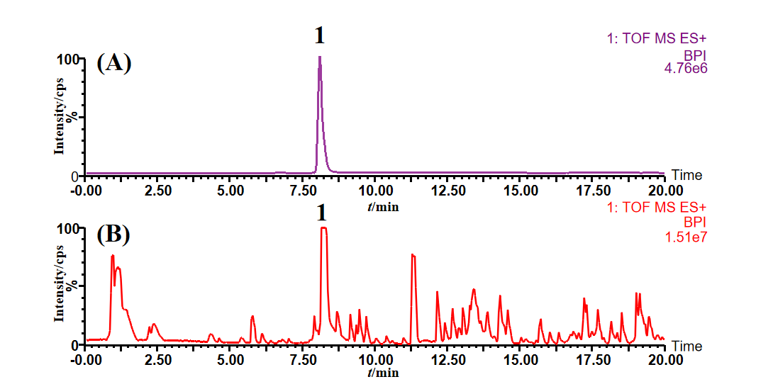
Note: 1 leonurine; (A) reference substance (5000 ng/ml); (B) Extract of Herba Leonuri

Supplement Figure 1 Total base peak ion chromatogram of Leonuri Herba

Supplement Table 1. Characterization of chemical components in Leonuri Herba
by UPLC-Q-TOF-MS/MS
No. | t_{R}/min | MS (m/z) | Theoretical  Mass(m/z) | Error  (ppm) | Molecular | Identification
1 | 0.98 | 144.1037[M+H]⁻ | 144.1025 | 8.65 | C₇H₁₃NO₂ | Stachydrine
2 | 1.09 | 193.0365[M+H]⁻ | 193.0349 | 8.15 | C₆H₈O₇ | Citricacid
3 | 4.4 | 355.1046[M+H]⁻ | 355.1029 | 4.77 | C₁₆H₁₈O₉ | neochlorogenicacid
4 | 4.86 | 355.1003[M+H]⁻ | 355.1029 | -7.34 | C₁₆H₁₈O₉ | Chlorogenic-acid(3-caffeoylquinicacid)
5 | 4.86 | 139.0405[M+H]⁻ | 139.0395 | 7.06 | C₇H₆O₃ | 4-Hydroxybenzoicacid
6 | 6.41 | 355.1046[M+H]⁻ | 355.1029 | 4.77 | C₁₆H₁₈O₉ | 4-DicaffeoylquinicAcid
7 | 7.19 | 199.0618[M+H]⁻ | 199.0606 | 5.79 | C₉H₁₀O₅ | Syringicacid
8 | 7.91 | 315.0723[M+H]⁻ | 315.0716 | 2.20 | C₁₃H₁₄O₉ | Syringyl-malicacid
9 | 8.25 | 312.1582[M+H]⁻ | 312.1559 | 7.22 | C₁₄H₂₁N₃O₅ | Leonurine
10 | 9.15 | 611.1640[M+H]⁻ | 611.1612 | 4.57 | C₂₇H₃₀O₁₆ | Quercetin-3-O-robinobioside
11 | 9.36 | 611.1640[M+H]⁻ | 611.1612 | 4.57 | C₂₇H₃₀O₁₆ | Rutin
12 | 9.46 | 465.1053[M+H]⁻ | 465.1033 | 4.30 | C₂₁H₂₀O₁₂ | Isoquercetin
13 | 9.71 | 465.1053[M+H]⁻ | 465.1033 | 4.30 | C₂₁H₂₀O₁₂ | Hyperoside
14 | 10.95 | 449.1091[M+H]⁻ | 449.1084 | 1.59 | C₂₁H₂₀O₁₁ | Astragalin
15 | 11.29 | 326.1737[M+H]⁻ | 326.1716 | 6.45 | C₁₅H₂₃N₃O₅ | 5-Guanidine-1-pentanolsyringate
16 | 11.32 | 195.0667[M+H]⁻ | 195.0657 | 4.95 | C₁₀H₁₀O₄ | Ferulicacid
17 | 11.95 | 449.1091[M+H]⁻ | 449.1084 | 1.59 | C₂₁H₂₀O₁₁ | Kaempferol-7-O-β-D-glucopyranoside
18 | 12.31 | 449.1091[M+H]⁻ | 449.1084 | 1.59 | C₂₁H₂₀O₁₁ | Quercitrin
19 | 13.71 | 775.2085[M+H]⁻ | 775.2086 | -0.07 | C₃₆H₃₈O₁₉ | LeonurusoideC
20 | 13.96 | 775.2085[M+H]⁻ | 775.2086 | -0.07 | C₃₆H₃₈O₁₉ | LeonurusoideA
21 | 14.55 | 791.1992[M+H]⁻ | 791.2035 | -5.40 | C₃₆H₃₈O₂₀ | LeonurusoideE
22 | 14.67 | 791.1992[M+H]⁻ | 791.2035 | -5.40 | C₃₆H₃₈O₂₀ | 2000-Syringylrutin
23 | 15.72 | 595.1434[M+H]⁻ | 595.1452 | -2.97 | C₃₀H₂₆O₁₃ | Kaempferol-7-coumaroylglu-coside
24 | 16.34 | 595.1434[M+H]⁻ | 595.1452 | -2.97 | C₃₀H₂₆O₁₃ | Kaempferol-7-coumaroylglu-cosideorisomer
25 | 16.88 | 579.1505[M+H]⁻ | 579.1503 | 0.43 | C₃₀H₂₆O₁₂ | Apigenin7-(3''-coumaroyl)-galactopy-ranoside
26 | 17.07 | 584.2769[M+H]⁻ | 584.2761 | 1.44 | C₃₄H₃₇N₃O₆ | N-(3-Aminopropyl)-1,4-buta-nediamine-tricoumarinamide
27 | 17.19 | 579.1505[M+H]⁻ | 579.1503 | 0.43 | C₃₀H₂₆O₁₂ | Apigenin-7-(3''-coumaroyl)-glucoside
28 | 17.69 | 579.1505[M+H]⁻ | 579.1503 | 0.43 | C₃₀H₂₆O₁₂ | Apigenin-7-(2'''-coumaroyl)-galactopy-ranoside
29 | 18.21 | 585.3358[M+H]⁻ | 585.3309 | 8.37 | C₂₇H₅₂O₁₁S | Glycerylsulfoquinovoside
30 | 18.52 | 301.0753[M+H]⁻ | 301.0712 | 13.6 | C₃₆H₃₀O₁₆ | 3-Methylkaempferol
31 | 19.02 | 725.1866[M+H]⁻ | 725.1870 | -0.59 | C₂₁H₂₁NO₄ | Apigenin7-(3',6'-di-O-p-coumaroyl)-galactopyranoside
32 | 19.14 | 271.0640[M+H]⁻ | 271.0606 | 12.36 | C₃₆H₃₀O₁₆ | Apigenin
33 | 19.24 | 725.1866[M+H]⁻ | 725.1870 | -0.59 | C₂₀H₁₇NO₄ | AnisofolinA

