Appendices
Appendix A
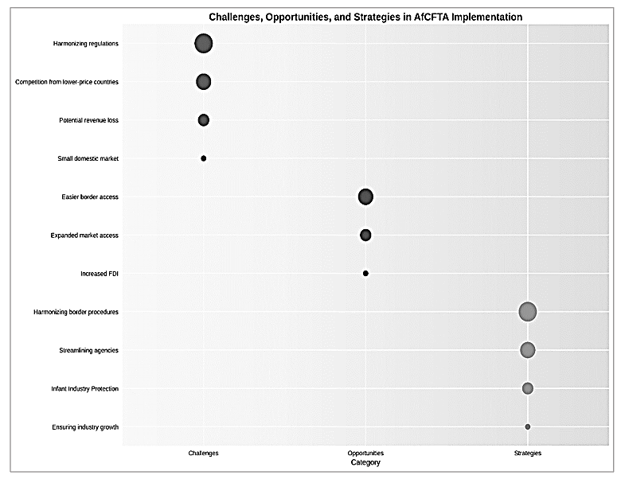
Figure A1. Relative prominence of themes in AfCFTA implementation discussions. Bubble size indicates frequency of mention by participants across interviews at Oshikango border post and ministerial offices (N=23 participants). Challenges were most frequently discussed, followed by strategies for mitigation, with opportunities receiving moderate attention

