Supplementary figures with caption
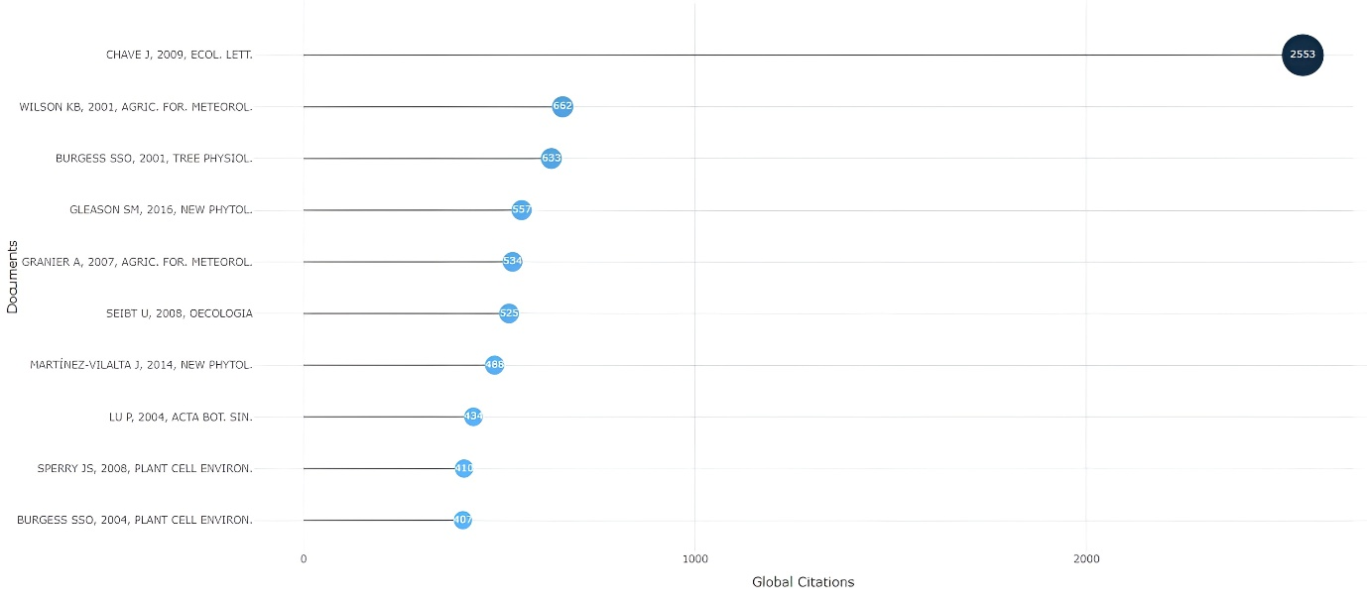
Supplementary Figure 1. Most globally cited documents in sap flow research based on total citation counts in the Scopus database (2000–2024)

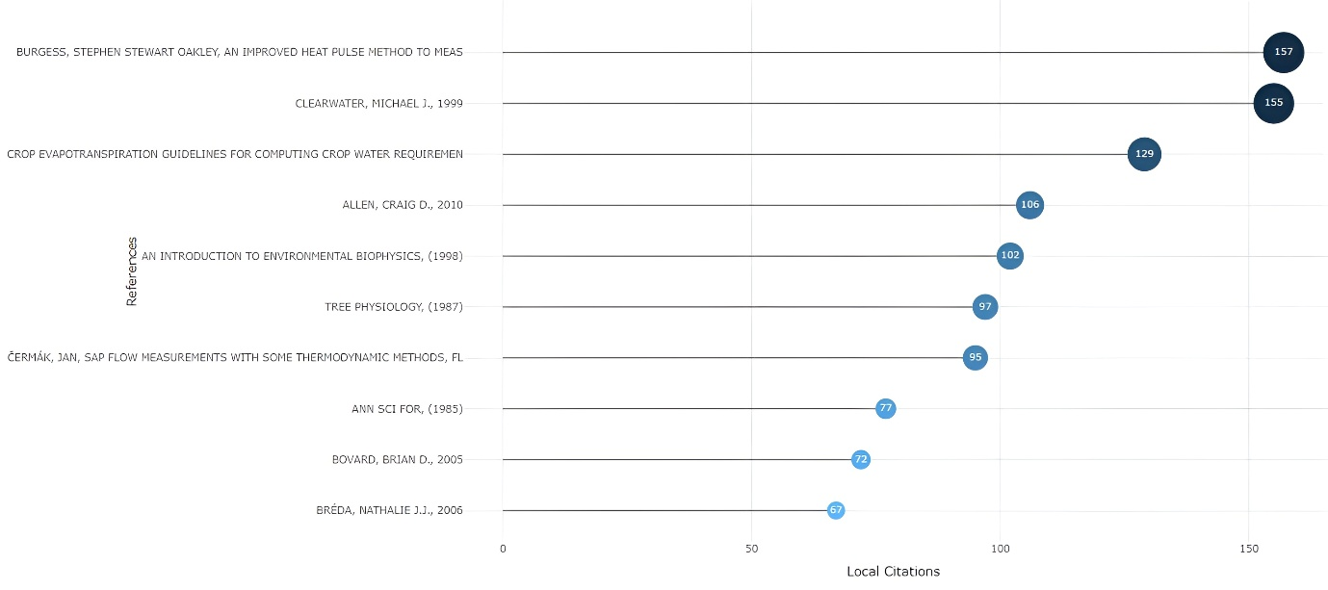
Supplementary Figure 2. Most locally cited documents in sap flow research, based on citation counts within the analysed dataset.

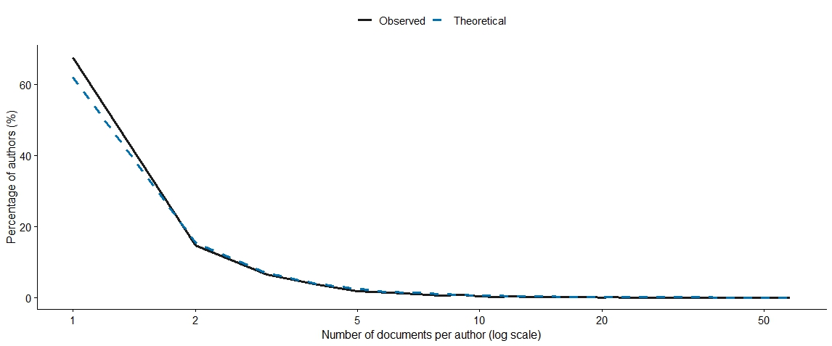
Supplementary Figure 3. Lotka’s law distribution of author productivity in sap flow research (2000–2024). The solid line represents the observed percentage of authors contributing a given number of publications, while the dashed line shows the theoretical distribution predicted by Lotka’s inverse square law.

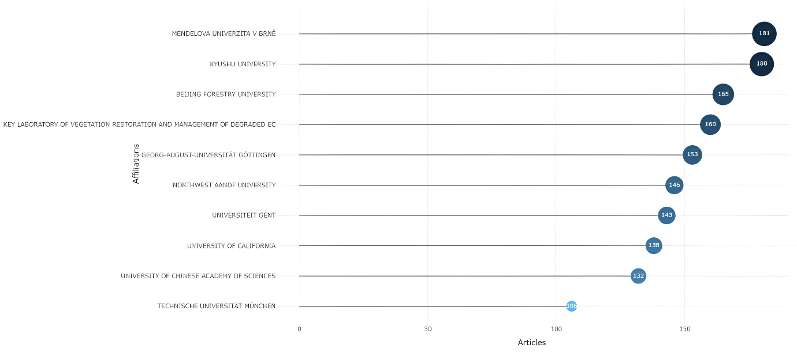
Supplementary Figure 4. Most relevant institutional affiliations in sap flow research based on the number of publications indexed in the Scopus database (2000–2024).

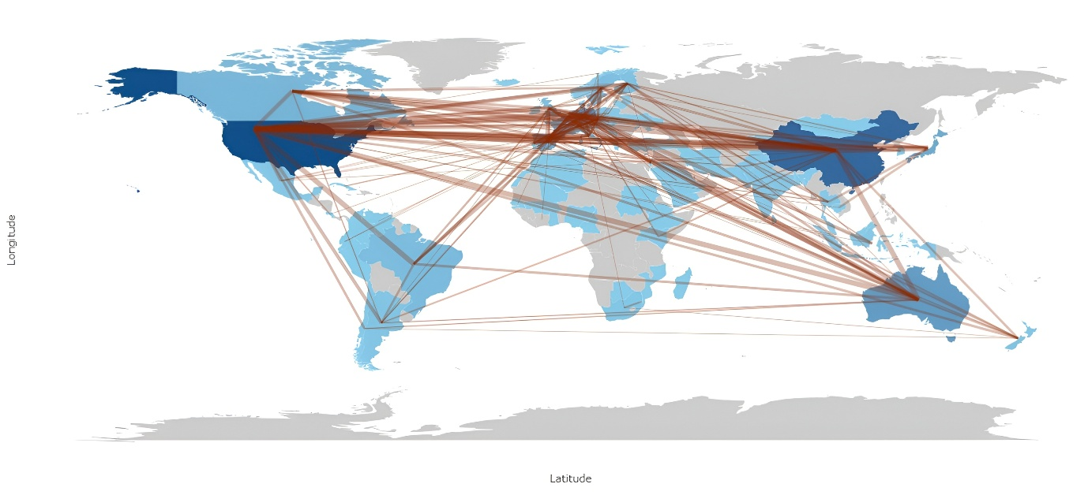
Supplementary Figure 5. International collaboration network among countries engaged in sap flow research. Nodes represent countries and link thickness indicates the strength of co-authorship ties, illustrating major collaborative linkages across regions.

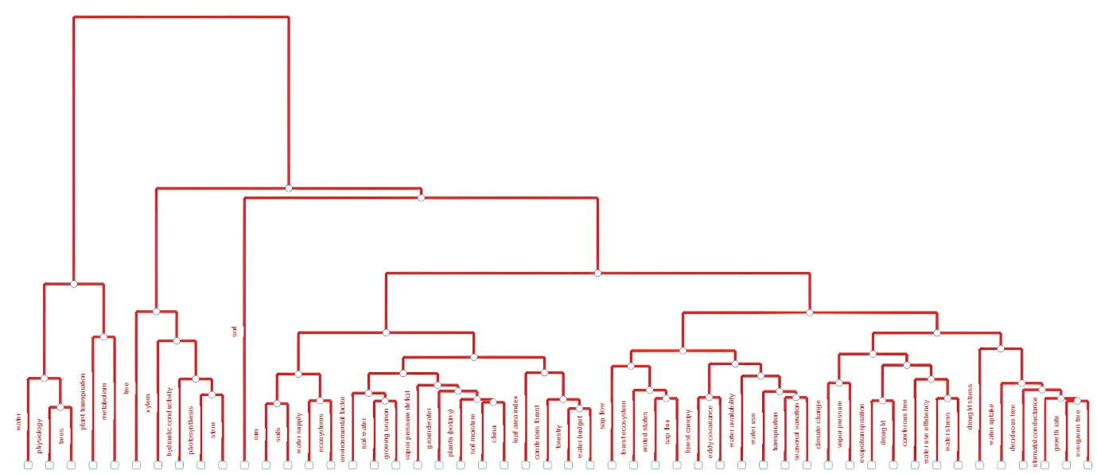
Supplementary Figure 6. Hierarchical dendrogram derived from multiple correspondence analysis showing the clustering of keywords in sap flow research based on their conceptual similarity.

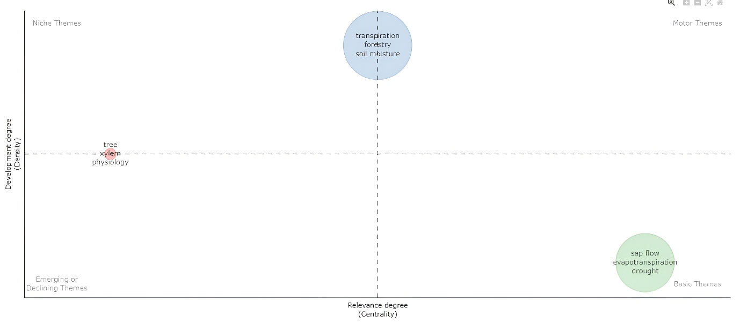
Supplementary Figure 7. Thematic map illustrating the conceptual structure of sap flow research based on keyword co-occurrence analysis. Themes are positioned according to their centrality (relevance) and density (development), distinguishing motor themes, basic themes, niche themes, and emerging or declining themes within the literature.

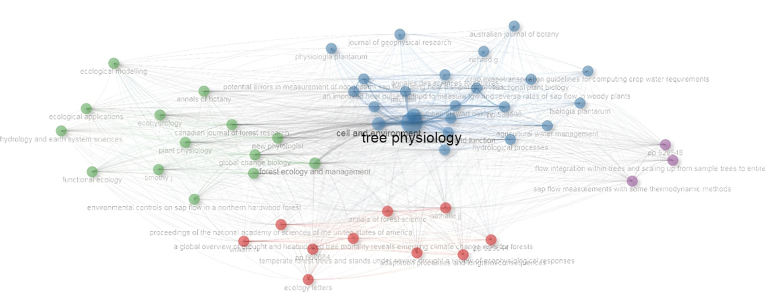

Supplementary Figure 8. Source co-citation network of journals publishing sap flow research based on cited references within the Scopus dataset (2000–2024). Nodes represent journals, node size reflects co-citation frequency, and links indicate co-citation relationships, with colours denoting major source clusters within the literature.

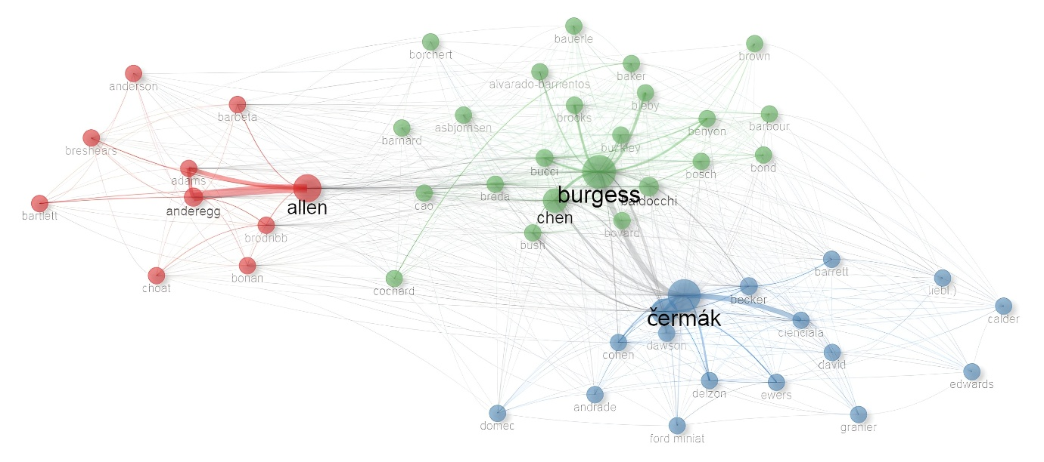
Supplementary Figure 9. Author co-citation network in sap flow research based on cited references within the Scopus dataset (2000–2024). Nodes represent authors, node size reflects co-citation frequency, and links indicate co-citation relationships. Colours denote major co-citation clusters, highlighting key intellectual groupings within the field.

