Supplementary Materials

Supplementary Notes 1 to 2
Supplementary Tables 1 to 2
Supplementary Figs. 1 to 33
Supplementary Video 1
References

Supplementary Note 1
Catalytic Mechanism of a Fully-reducing PKS
In modular type I PKSs, each module acts as a unit of an assembly line that collectively constructs a complex polyketide metabolite. A typical module incorporates a single acyl extender unit through the coordinated actions of the ketosynthase (KS), acyltransferase (AT), and acyl carrier protein (ACP) domains¹. To generate a catalytically competent ACP, the apo-ACP must first be post-translationally modified by a phosphopantetheinyl transferase (PPTase), which transfers a phosphopantetheine (Ppant) group from coenzyme A (CoA) to a conserved serine residue of ACP, producing holo-ACP (Supplementary Note Fig. 1a). The resulting Ppant arm, containing a reactive thiol group at its terminus, transiently tethers substrates and intermediates throughout the catalytic cycle².
During chain extension, the AT domain selects a specific extender unit, such as malonyl-CoA, methylmalonyl-CoA, aminomalonyl-CoA, or hydroxymalonyl-CoA, and forms an acyl-enzyme intermediate via its active-site serine, releasing CoA. The acyl group is then transferred to the thiol of holo-ACP, forming a thioester-linked acyl-ACP intermediate via transacylation (Supplementary Note Fig. 1b)³.
The KS domain accepts the acyl intermediate from the ACP of the upstream module through a translocation, in which the intermediate is transferred to the conserved active-site cysteine of KS, forming a KS-bound thioester (Supplementary Note Fig. 1c). Once the downstream ACP is loaded with the extender unit, the thioester-linked malonate derivative undergoes a decarboxylative Claisen condensation with the KS-bound intermediate. This C–C bond-forming reaction extends the polyketide chain by two carbons and generates a β-ketoacyl-ACP intermediate (Supplementary Note Fig. 1d)².
To diversify polyketide structures, optional β-keto-processing domains can reduce or dehydrate the ACP-tethered intermediate. First, the ketoreductase (KR) domain uses NADPH to stereospecifically reduce the β-ketoacyl group to a β-hydroxyacyl intermediate. Then, the dehydratase (DH) domain catalyzes dehydration to generate an α,β-unsaturated intermediate. Finally, the enoylreductase (ER) domain uses another molecule of NADPH to reduce the double bond, resulting in a saturated acyl chain (Supplementary Note Fig. 1e)². Depending on domain composition within each module, the β-ketoacyl-ACP intermediate can undergo distinct levels of reduction, resulting in characteristic oxidation patterns along the polyketide backbone. For example, modules containing only a KR domain would retain the hydroxyl functionality. When both the KR and DH domains are present, the module will transfer the unsaturated acyl intermediate to the downstream module. Thus, the selective presence or absence of KR, DH, and ER domains dictates the oxidation state of each two-carbon extension unit.
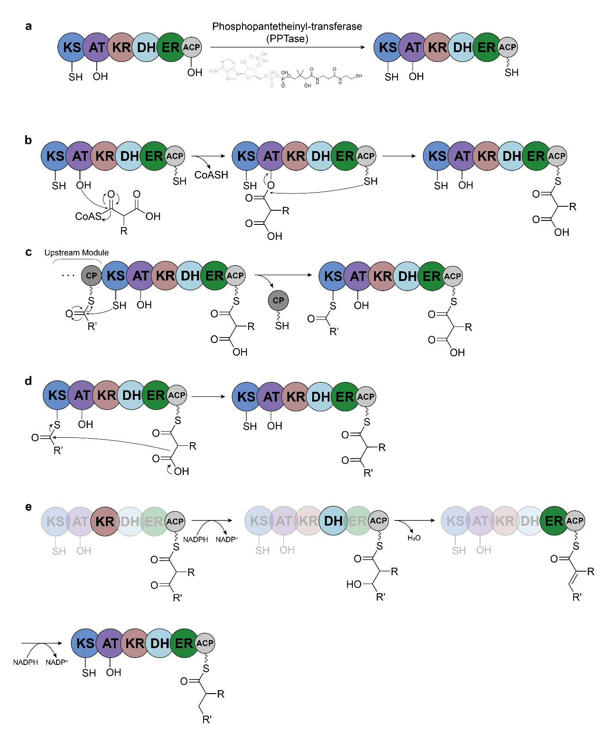

Supplementary Note Fig. 1. Working mechanism of the fully-reducing PKS.
a, Phosphopantetheinylation of the ACP domain via PPTase. b, Substrate selection and transacylation reaction by AT domain. c, Intermediate translocation from upstream carrier protein (CP) to the downstream KS domain. d, Condensation reaction of the ACP-tethered substrate and KS-thioester intermediate. e, β-ketoacyl processing by modifying domains. The domain that catalyzes the reaction is highlighted.

Supplementary Note 2
Determination of the monomer-dimer dissociation constant by mass photometry
Mass photometry is a label-free, single-molecule technique in which the mass of individual biomolecules is determined from the interferometric contrast produced as they land on the glass-water interface. Because each landing event is detected individually, mass photometry of a sample undergoing monomer-dimer exchange yields a mass histogram of two resolved peaks corresponding to the monomeric and dimeric species. The number of particles counted under each peak (N_{M} and N_{D}, respectively) reflects the relative abundance of the two species.
For a homodimerization equilibrium, the dissociation constant is defined as
$$\begin{aligned}K_{d}=\frac{{\left[M\right]}^{2}}{\left[D\right]}\#\left(1\right)\end{aligned}$$
where [M] and [D] are the molar concentrations of the monomeric and dimeric species. The measured counts are proportional to the molar concentrations of the species, N_{M} ∝ [M] and N_{D} ∝ [D]. Hence, the number fractions reported in the mass photometry measurements, f_{M} = N_{M}/(N_{M}+N_{D}) and f_{D} = N_{D}/(N_{M}+N_{D}), are equal to [M]/([M]+[D]) and [D]/([M]+[D]), respectively. To relate the counts to K_{d}, the species concentrations are expressed in terms of the total protein concentration in monomer-equivalent units, C_{tot} = [M] + 2[D]. Substitution into Eq. (1) yields
$$\begin{aligned}K_{d}=\frac{C_{tot}f_{M}^{2}}{f_{D}\left(1+f_{D}\right)}.\#\left(2\right)\end{aligned}$$

Rearranging Eq. (2) and re-expressing the fractions in terms of the raw particle counts gives a linear relationship between a count-based quantity and total protein concentration,
$$\begin{aligned}y=\frac{N_{D}\left(N_{M}+{2N}_{D}\right)}{N_{M}^{2}}=\frac{C_{tot}}{K_{d}}.\#\left(3\right)\end{aligned}$$

Thus, a plot of y against C_{tot} describes a straight line passing through the origin with a slope of 1/K_{d} and the dissociation constant is obtained as the reciprocal of the fitted slope. Measurements were performed in triplicate across a dilution series spanning 6.25-50 nM for ClbB_{PKS} and 25-100 nM for full-length ClbB, respectively, and the linear regression is constrained to pass through the origin.

Supplementary Table 1. Cryo-EM data acquisition and refinement parameters
Sample | apo-ClbB_{PKS} | NADPH-bound ClbB_{PKS}
EMDB | EMD-69442 | EMD-69437
PDB |  | 24CH
Data collection and processing
Data collection Facility | NCCAT | IMP
Microscope | Titan Krios | Titan Krios G4
Voltage (kV) | 300 | 300
Detector | Gatan K3 | BioQuantum K3
Electron exposure (e–/Å²) | 50 | 50
Defocus range (μm) | -0.8 - -2.5 | -0.8 - -2.4
Data collection mode | counting | counting
Pixel size (Å) | 1.065 | 1.100
Symmetry imposed | C1 | C1
Number of total movies | 15,345 | 10,054
Initial particle images (no.) | 4,691,324 | 6,401,545
Final particle images (no.) | 173,397 | 392,982
Map resolution (Å) - FSC threshold 0.143 | 3.59 | 2.46
Refinement
Initial model used (PDB code) | AlphaFold2 | Apo-ClbB_{PKS} and AlphaFold2
Map sharpening B factor (Å²) | -96.09 | -48.99
Model composition
Non-hydrogen atoms |  | 30,470
Protein residues |  | 3,936
Nucleic acid residues | 0 | 0
Ligands | 0 | 4
B factors (Å²)
Protein |  | 42.21
Nucleic acid | 0 | 0
Ligands | 0 | 42.39
R.m.s. deviations
Bond lengths (Å) |  | 0.002
Bond angles (°) |  | 0.557
Validation
MolProbity score* |  | 1.87
Clashscore |  | 4.16
Poor rotamers (%) | 0 | 2.99
Ramachandran plot
Favored (%) |  | 95.6
Disallowed (%) | 0 | 0

Supplementary Table 2. Selection of the PEL-mutation residues
Residue | Interaction Partner | Distance [Å] | Interaction Type | Production Yield
R1974 | E1542 [OE2] | 2.8 | Salt Bridge | 39.5±8.65%
R1974 | S1583 [O] | 3.0 | Hydrogen Bond | 39.5±8.65%
R1974 | V1975 [O] | 3.3 | Hydrogen Bond | 39.5±8.65%
R2386 | NADPH 10’-phosphate | 3.2 | Salt Bridge | 35.1±1.39%
I2792 | L2713 [CD1] | 4.6 | Hydrophobic Patch | 71.9±2.45%
I2792 | I3011 [CD1] | 4.4 | Hydrophobic Patch | 71.9±2.45%
R3006 | E2378 [O] | 2.8 | Hydrogen Bond | 92.9±1.87%
R3014 | N2375 [OD1] | 2.6 | Hydrogen Bond | 43.6±7.28%
E3027 | R1965 [NH1] | 3.0 | Salt Bridge | 77.7±10.3%
E3027 | S3024 [N] | 3.0 | Hydrogen Bond | 77.7±10.3%
R3030 | D1147 [OD2] | 3.7 | Salt Bridge | 67.8±0.44%

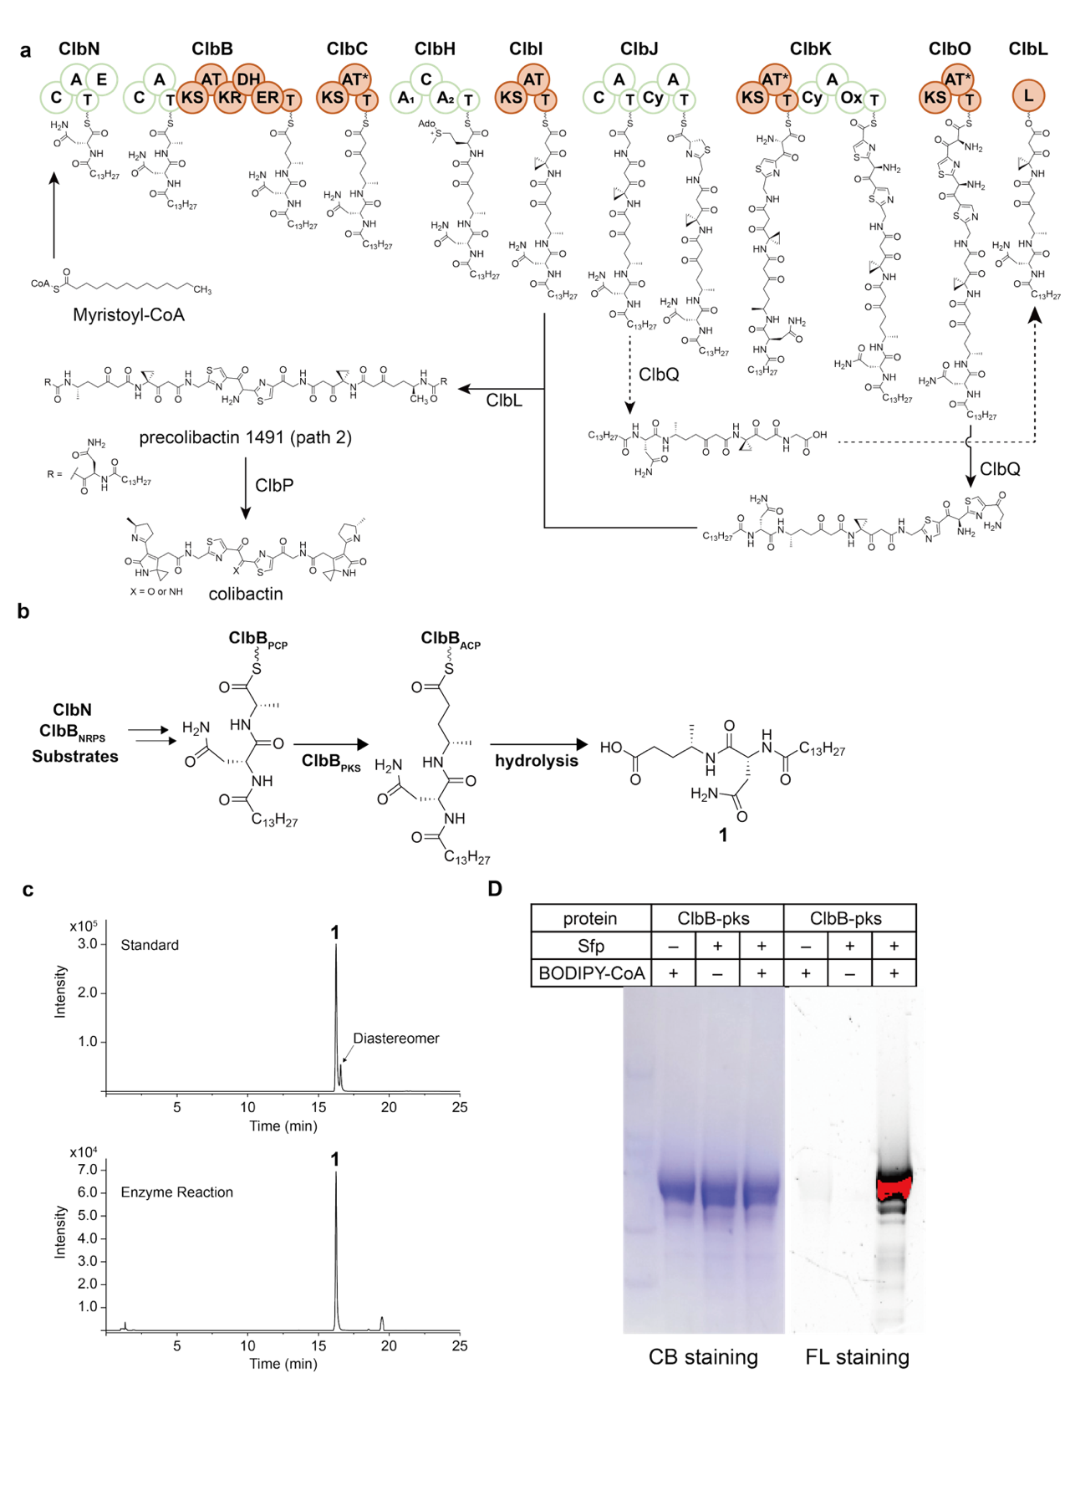
Supplementary Fig. 1. Colibactin biosynthetic pathway and characterization of the purified ClbB_{PKS}.
a, Schematic of the colibactin biosynthetic pathway. b, In vitro biosynthetic analysis of ClbB constructs. c, EICs of 1 (m/z 442) from the synthesized standard (top) and in vitro biosynthesis reaction mixtures using ClbB_{PKS} and ClbB_{NRPS} (bottom). d, The phosphopantetheinylation of the purified ClbB_{PKS} was confirmed by the BODIPY-CoA loading assay. CB staining: Coomassie blue staining, FL imaging: Fluorescence imaging.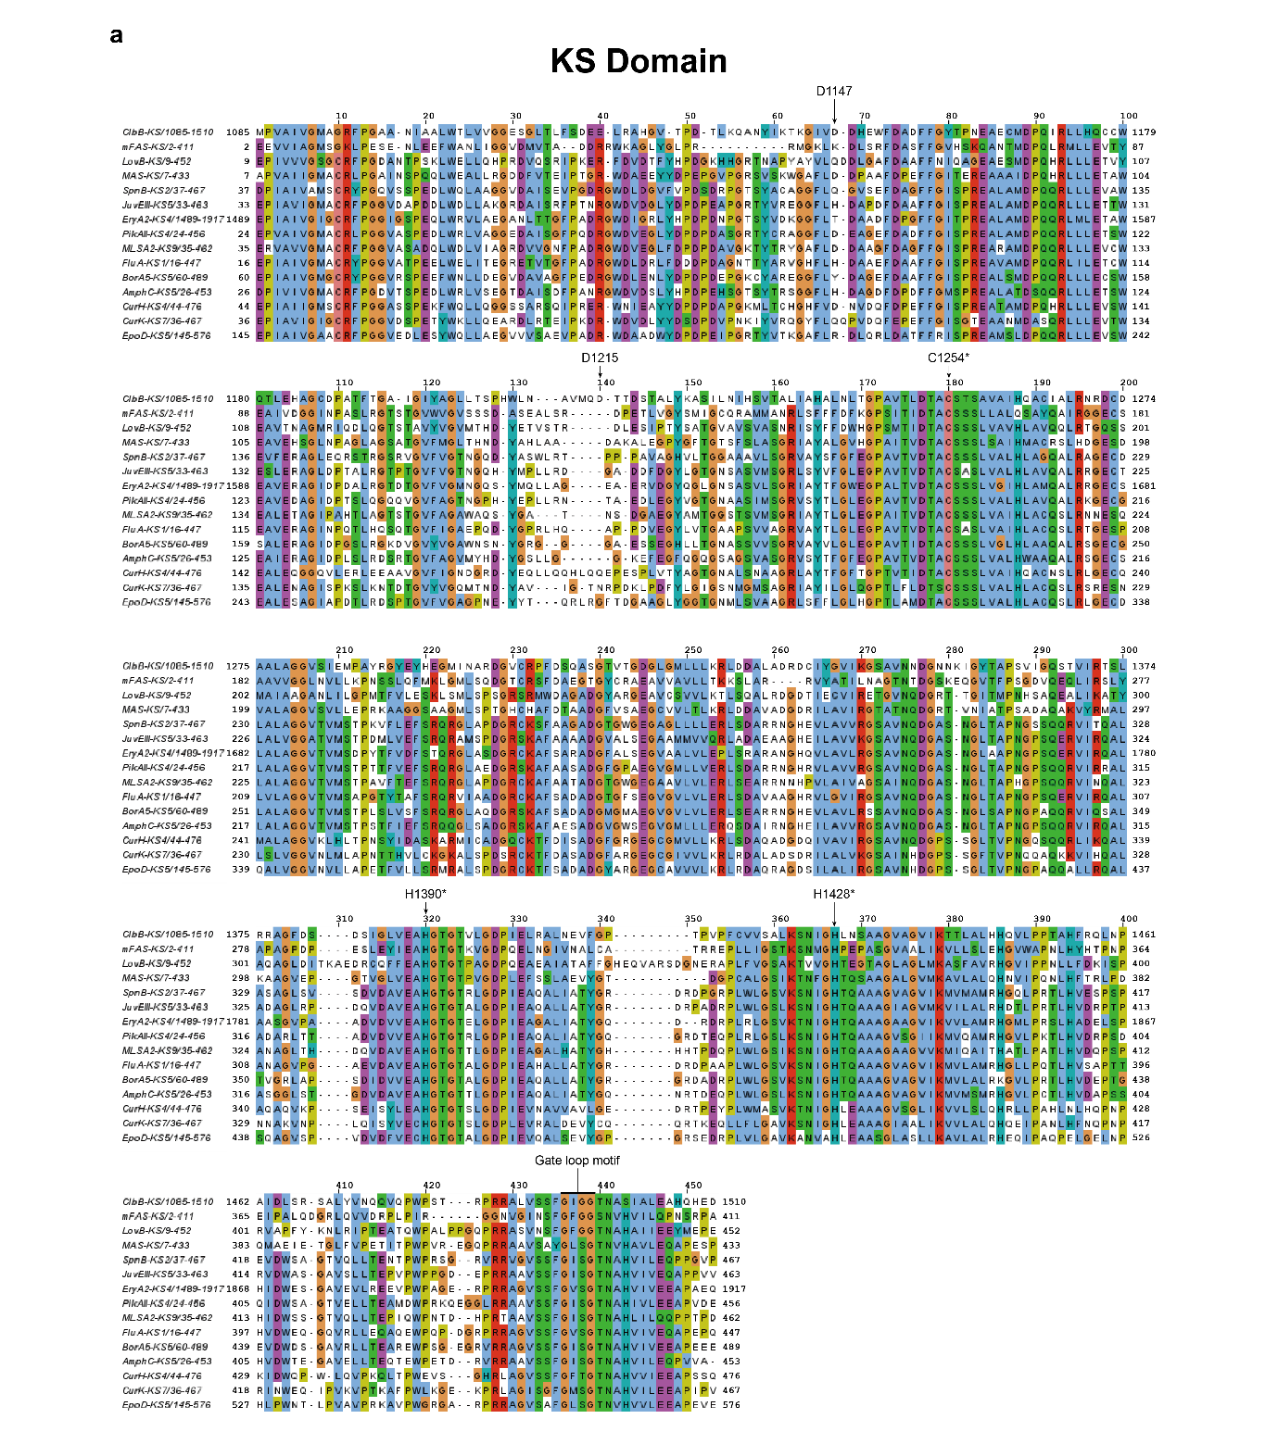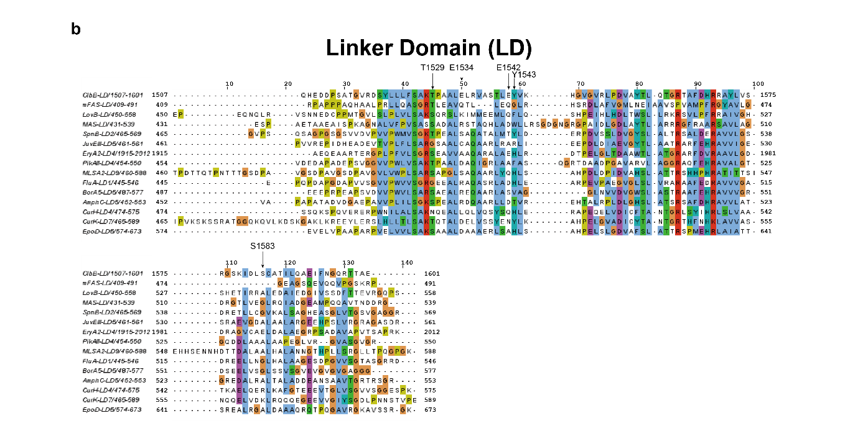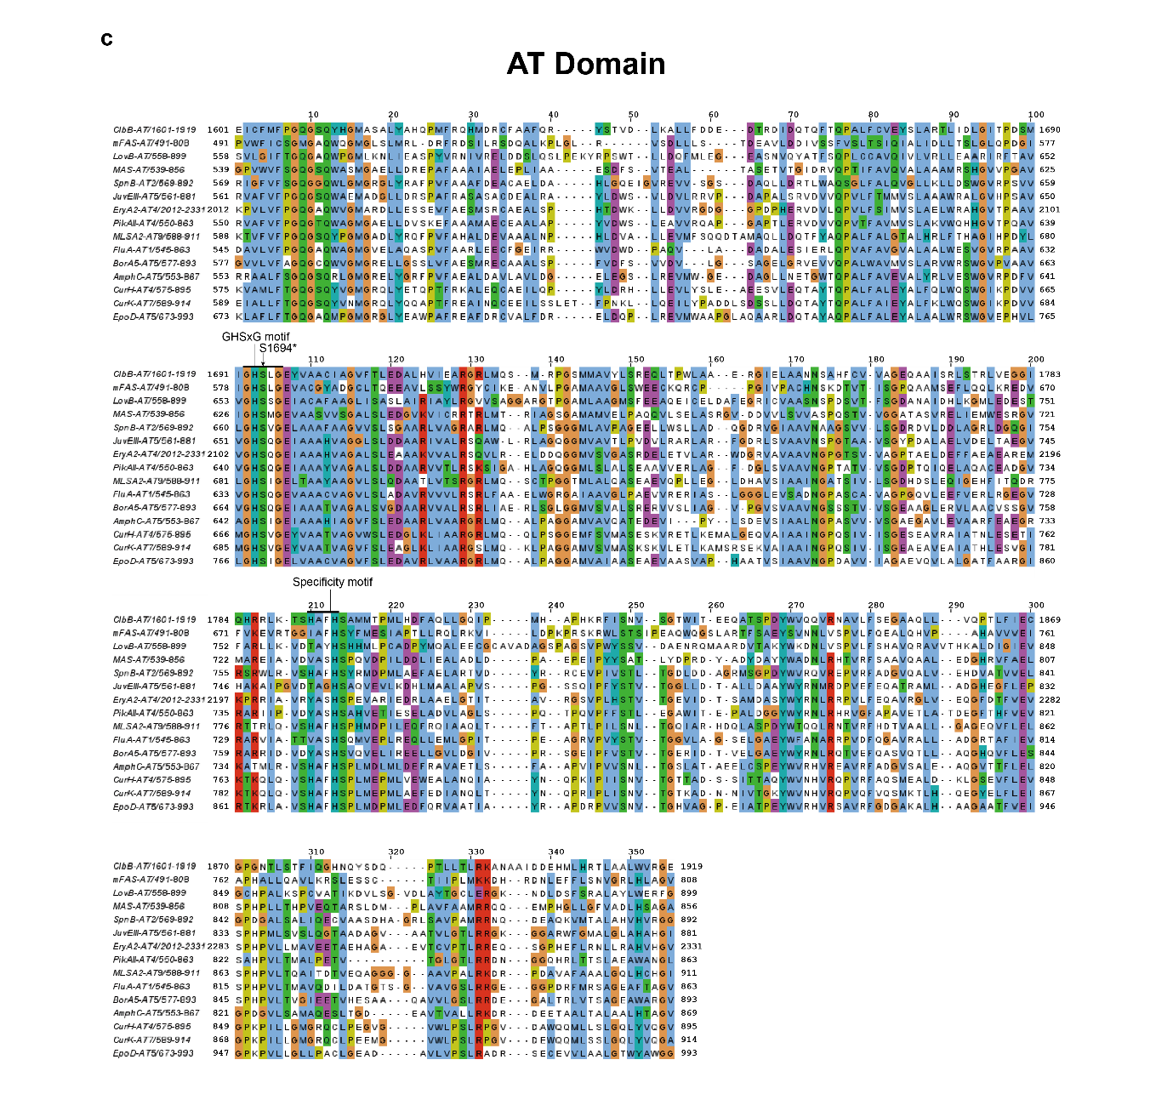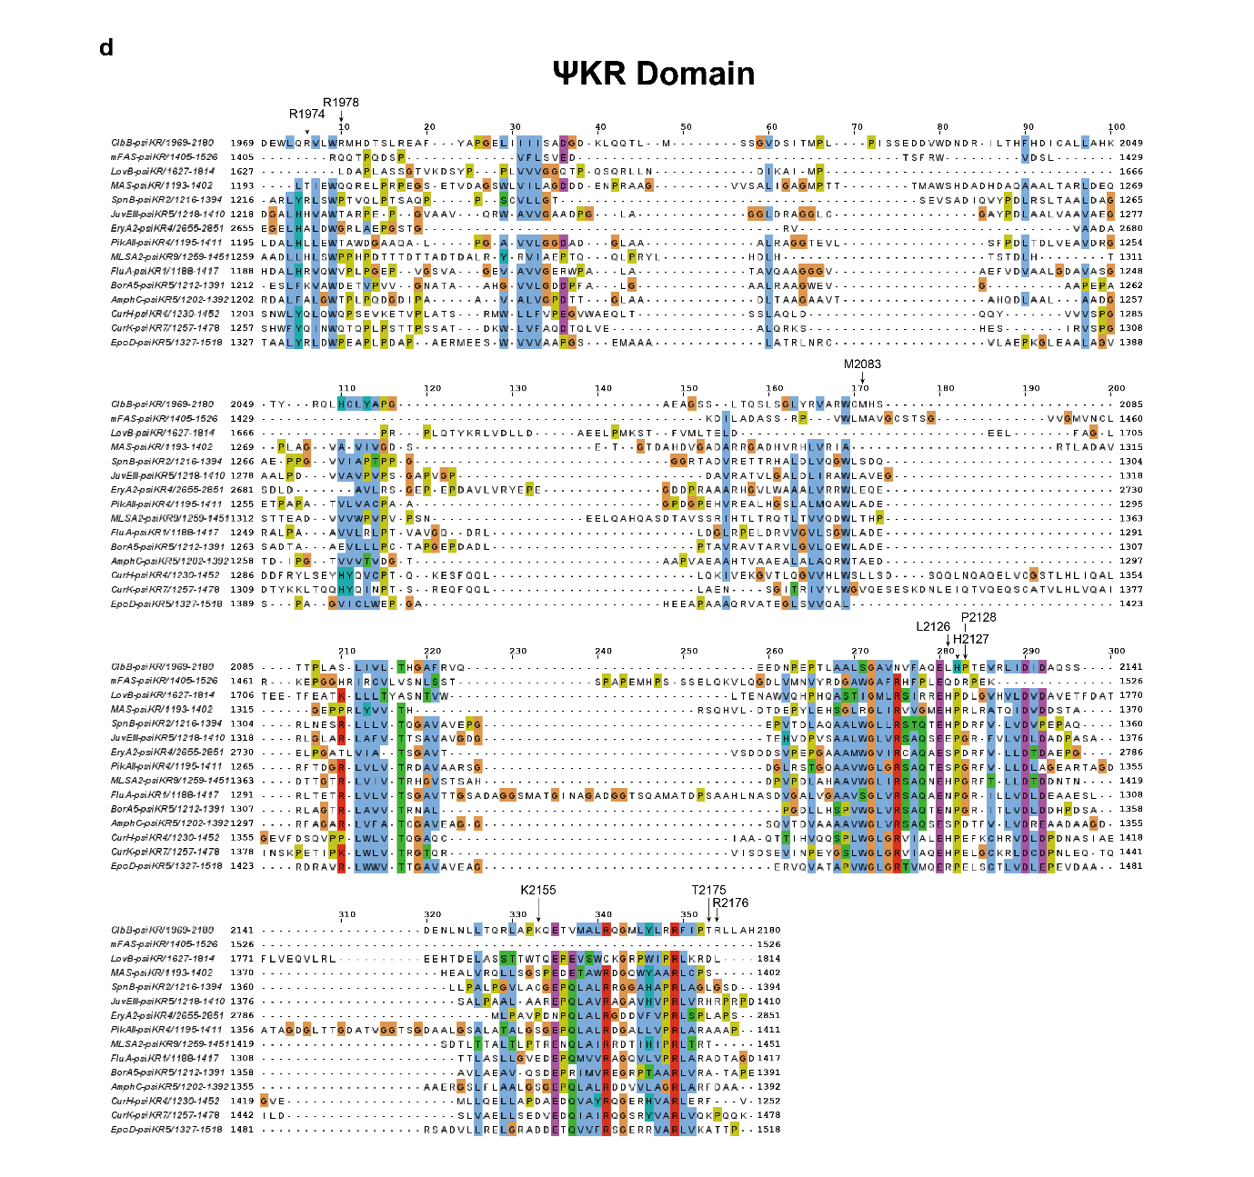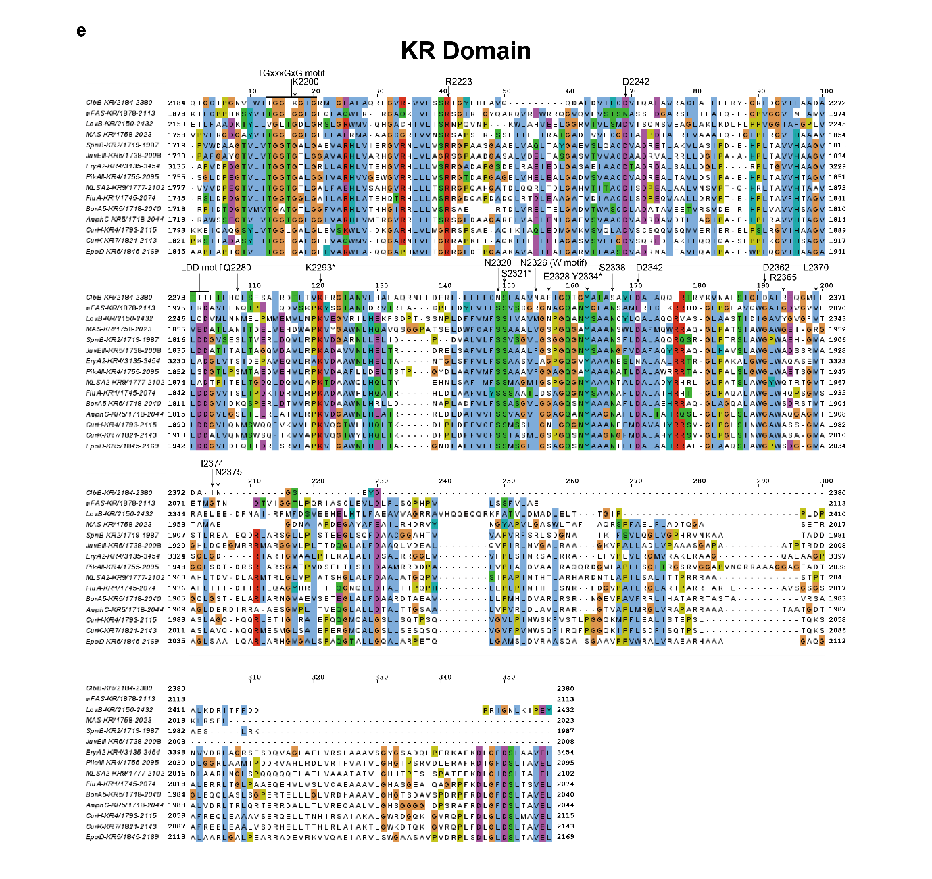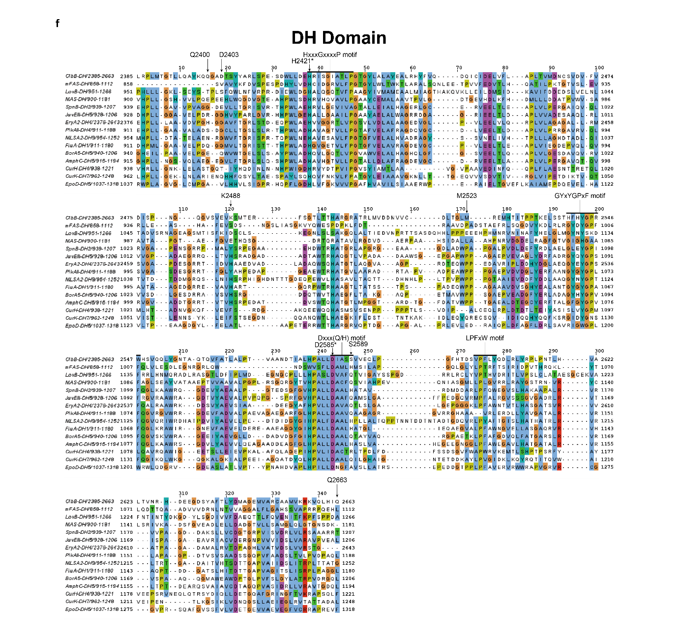 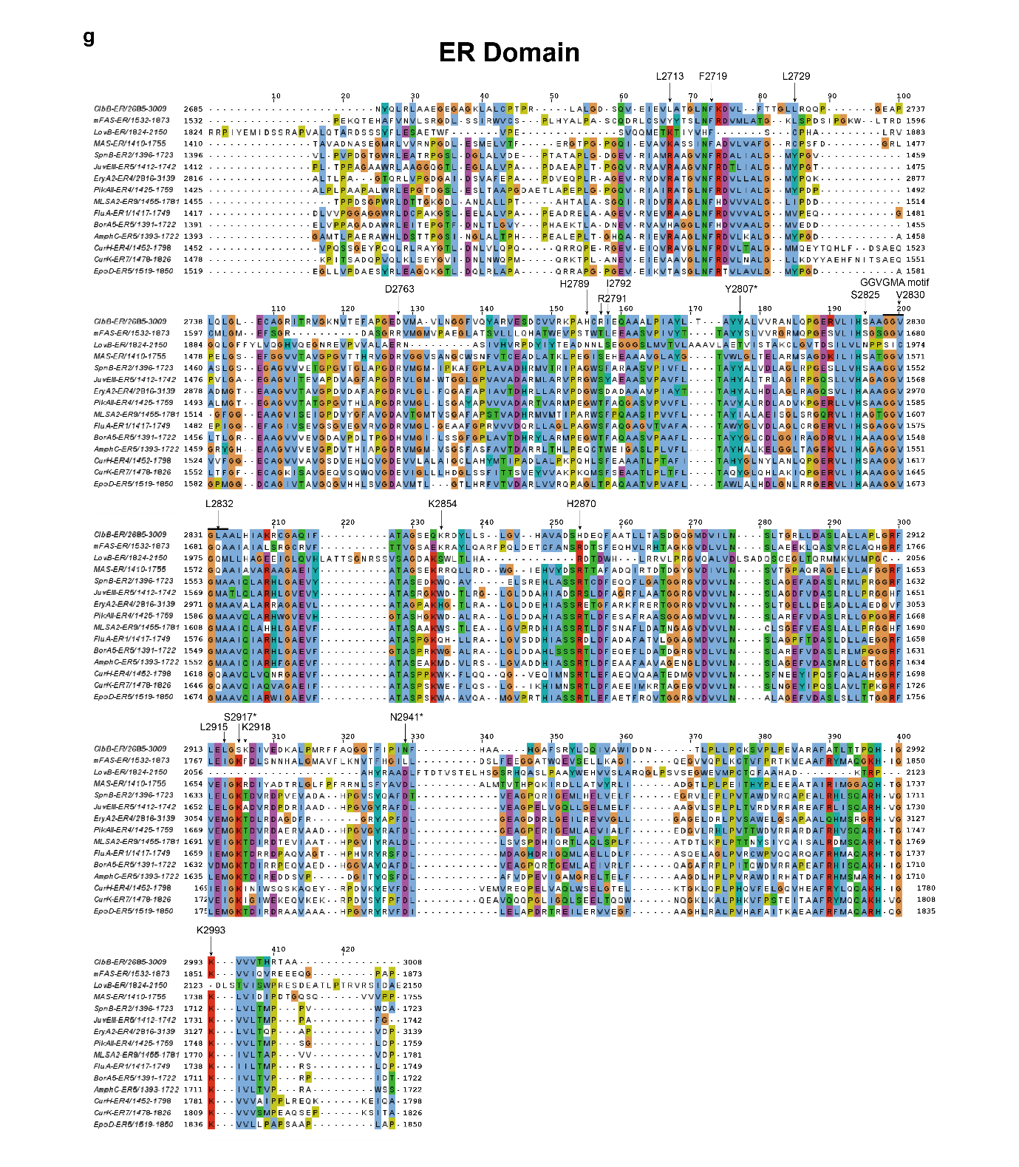
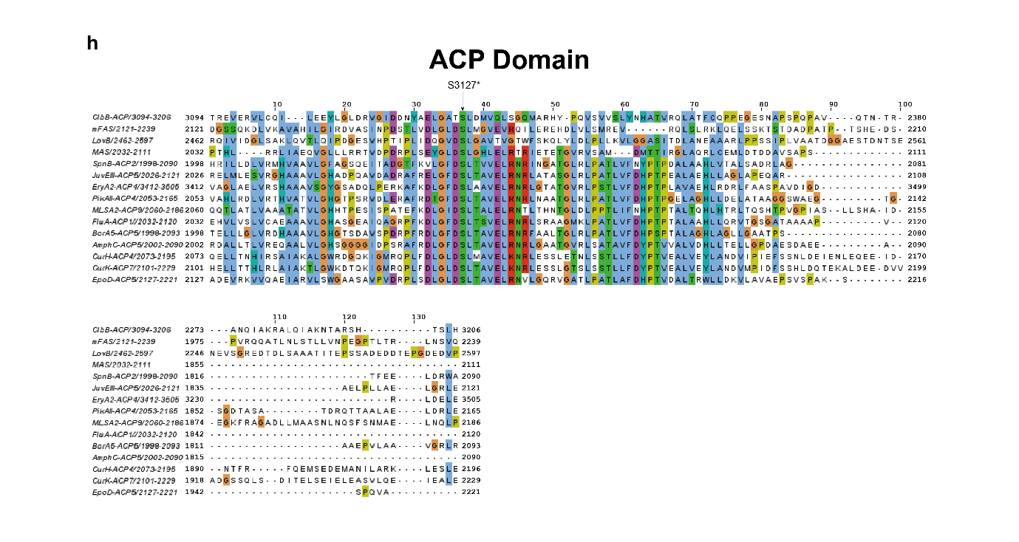

Supplementary Fig. 2. Multiple sequence alignment of ClbB_{PKS} with fully-reducing PKS, iPKS, and mFAS.
a, KS domain, showing the catalytic triad (C1254, H1390, H1428) and gate-loop motif (₁₄₉₃GIGG₁₄₉₆ in ClbB). b, Linker domain (LD). c, AT domain, showing the catalytic motif (GHSxG; catalytic S1694 in ClbB) and the specificity-conferring motif (₁₇₉₂HAFH₁₇₉₅ in ClbB). d, ΨKR domain, with R1974 indicated by arrows. e, KR domain, showing the catalytic triad (K2293, Y2334, S2321), the NADPH-binding motif (TGxxxGxG; ₂₁₉₆IGGEKGIG₂₂₀₃ in ClbB), the LDD motif (₂₂₇₃TTT₂₂₇₅ in ClbB), and the W motif (N2326 in ClbB); compensatory reciprocal substitutions (N2320 and S2338) are indicated by arrows. f, DH domain, showing the catalytic motifs HxxxGxxxP and Dxxx(Q/H) (catalytic H2421 and D2585 in ClbB), as well as additional conserved motifs GYxYGPxF and LPFxW (₂₅₄₀HFHYGPRW₂₅₄₇ and ₂₆₀₂VPFLY₂₆₀₆ in ClbB). g, ER domain, showing the cofactor-binding motif (GGVGMA; ₂₈₂₈GGVGLA₂₈₃₃ in ClbB) and the catalytic Tyr/Lys pair (Y2802, K2993). h, ACP domain, showing the phosphopantetheinylated serine (S3127). Conserved catalytic residues are marked by asterisks. Residues discussed in the manuscript are indicated by arrows and residue numbers.
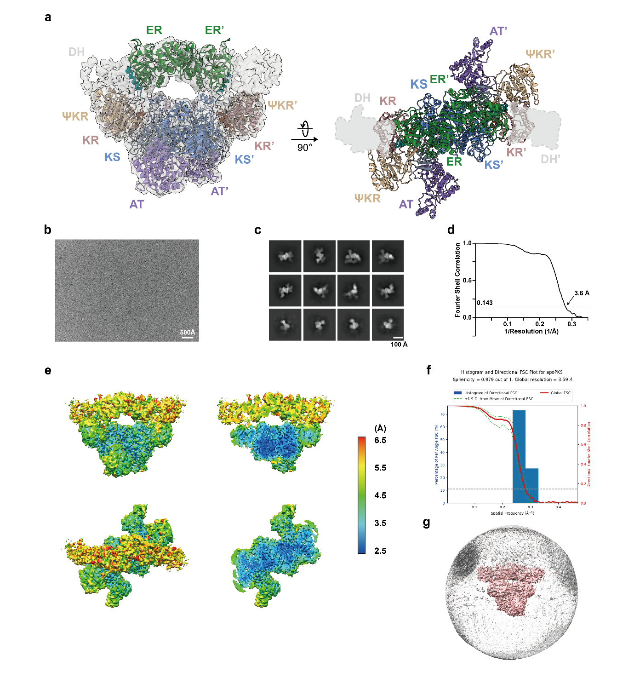

Supplementary Fig. 3. Cryo-EM map analysis of the apo-ClbB_{PKS}.
a, (left) The superimposed local-filtered cryo-EM map and the modeled structure of the apo-ClbB_{PKS} in a front view. (right) The model of the apo-ClbB_{PKS} in a top view. b, A representative cryo-EM image. c, Representative 2D classes. d, The FSC curve. e, Whole and half-cut local resolution maps in a front view (top) and a top view (bottom)⁴. f, 3DFSC of the cryo-EM map⁵. g, Angular distribution of the particle projections.

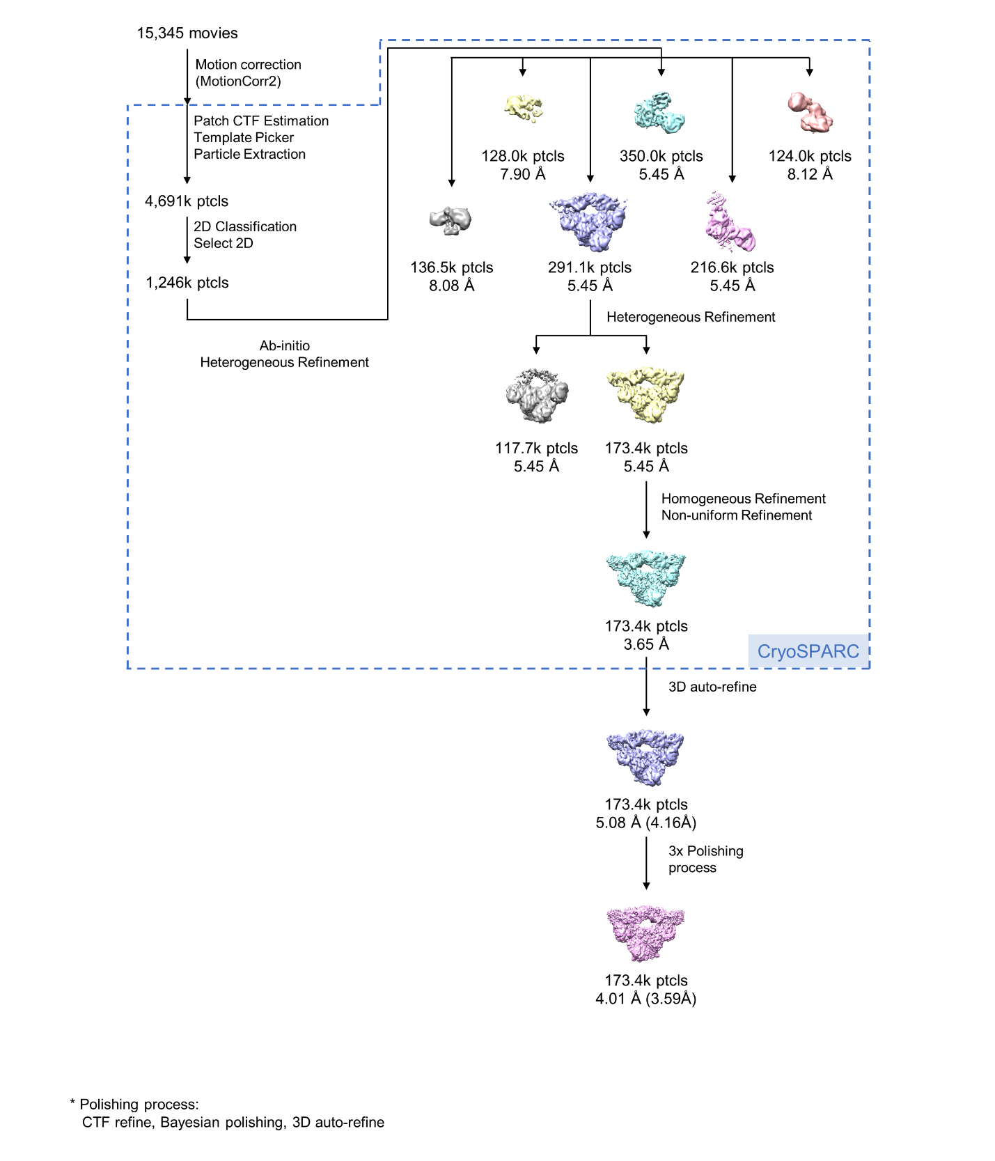

Supplementary Fig. 4. Flowchart for cryo-EM data analysis of the apo-ClbB_{PKS}.
A total of 15,345 movies of apo-ClbB_{PKS} were motion-corrected and dose-weighted using MotionCor2 in RELION 3.1^{6,7}. The resulting micrographs were imported into CryoSPARC v.3.1.0, and CTF parameters were estimated using Patch CTF estimation⁸. Initial particles were picked using a blob picker, extracted with a 320-pixel box size and subjected to 2D classification to generate templates for template-based particle picking. A total of 4,691k particles were then picked using the template picker and further classified by 2D classification. The selected 1,246k particles were classified by heterogeneous refinement into six classes, and the best class was further refined by an additional round of heterogeneous refinement. The class showing stronger DH-ER density was subsequently refined by homogeneous and non-uniform refinement, yielding a 3.65 Å-resolution map. The particles were then exported to RELION 3.1 using UCSF PyEM and subjected to 3D auto-refinement, yielding a 4.16 Å map⁹. Finally, three rounds of polishing process (CTF refine, 3D auto-refine, Bayesian polishing, and 3D auto-refine) were applied to the final particle stack, yielding a postprocessed map at 3.59 Å resolution.

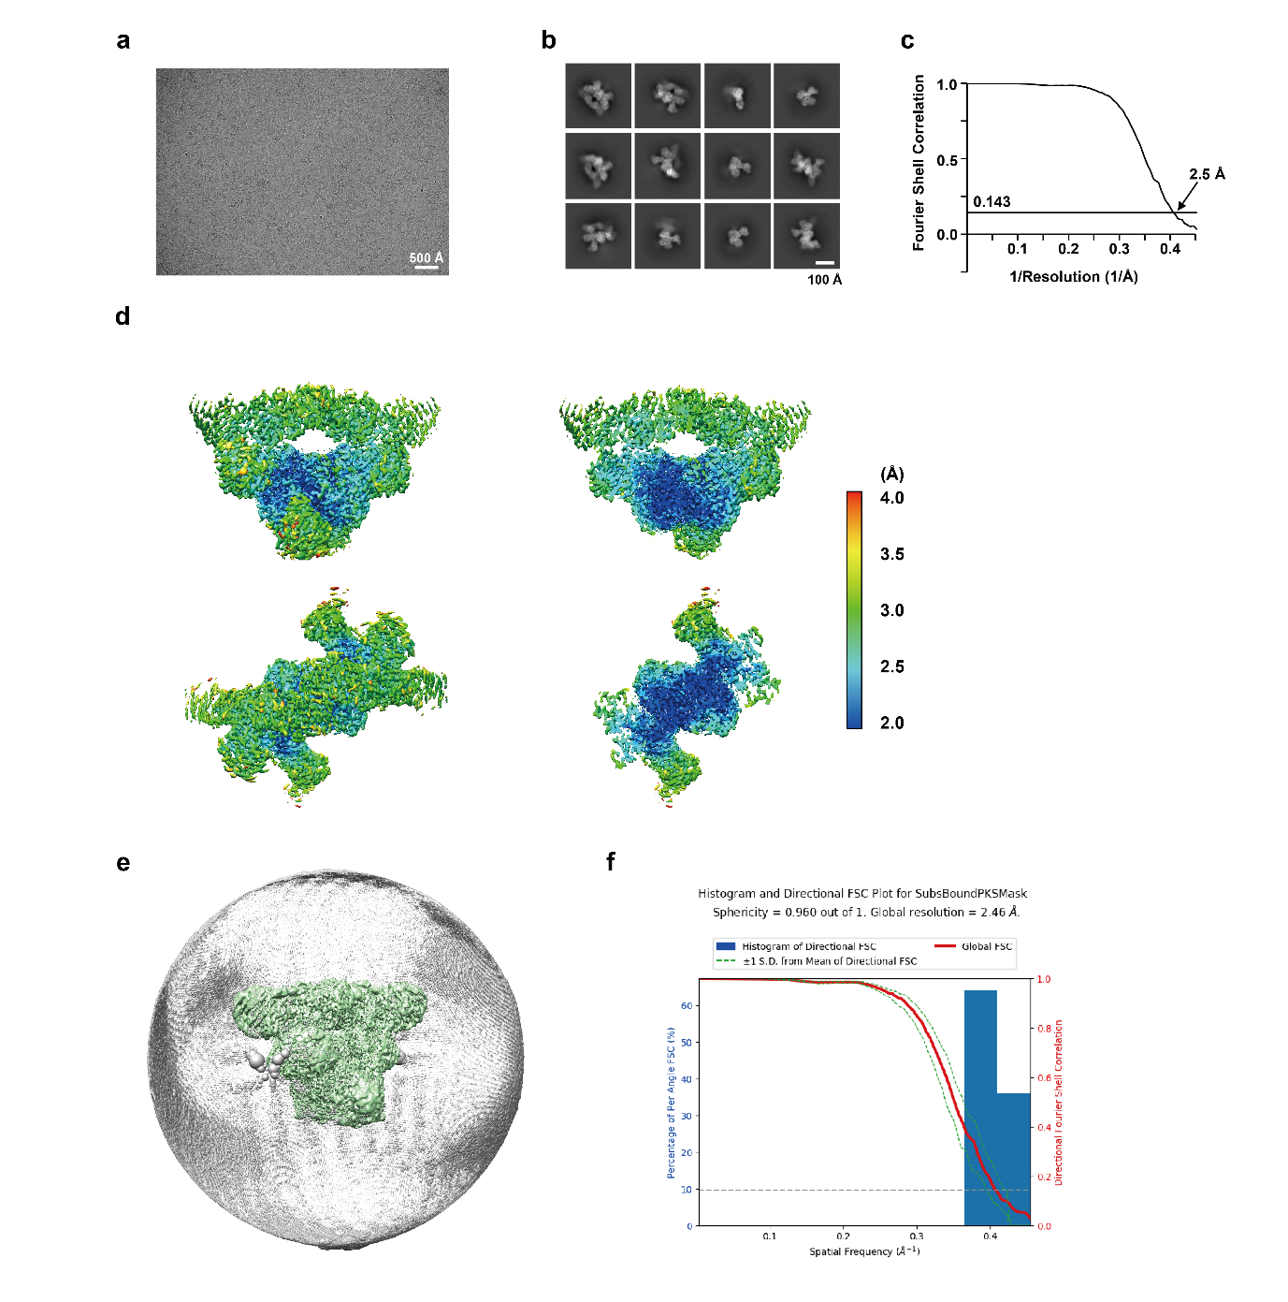

Supplementary Fig. 5. Cryo-EM map analysis of the NADPH-bound ClbB_{PKS}.
a, A representative cryo-EM image. b, Representative 2D classes. c, The FSC curve. d, Whole and half-cut local resolution maps in a front view (top) and a top view (bottom)⁴. e, Angular distribution of the particle projections. f, 3DFSC of the cryo-EM map⁵.
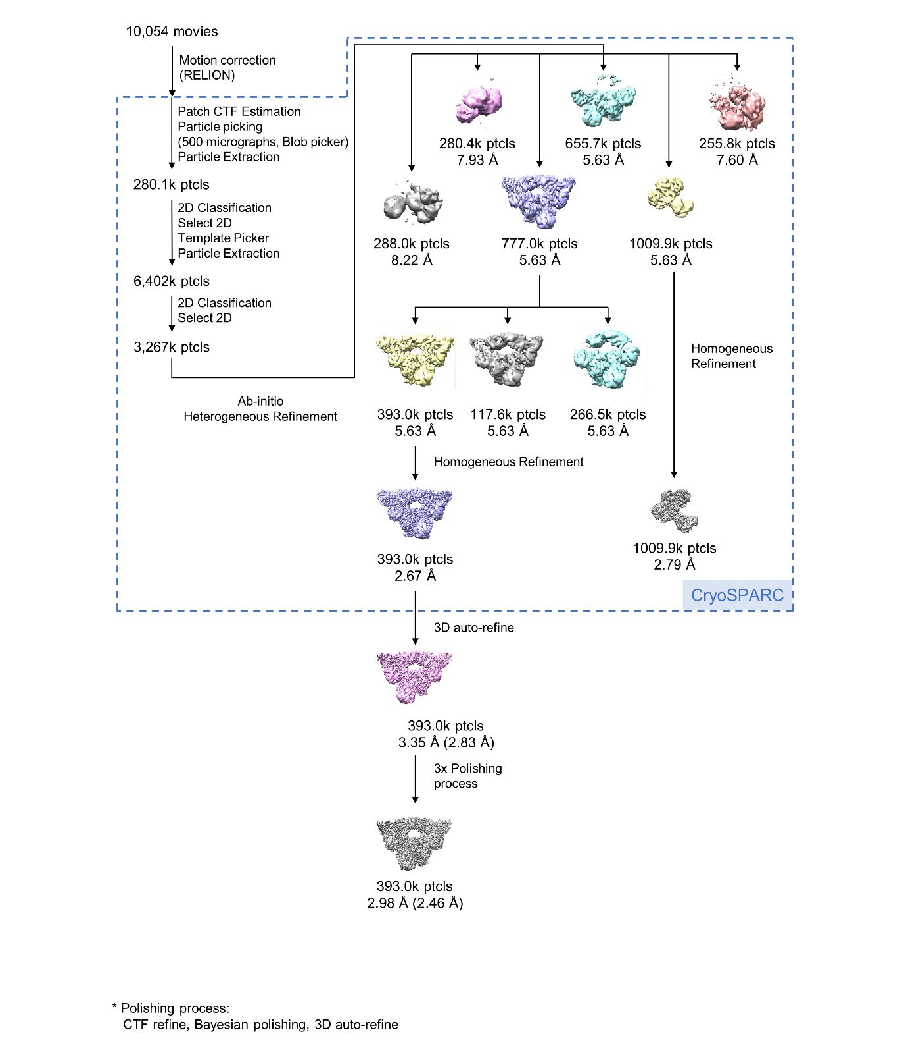

Supplementary Fig. 6. Flowchart for cryo-EM data analysis of the NADPH-bound ClbB_{PKS}.
A total of 10,054 movies of the NADPH-bound ClbB_{PKS} were motion-corrected, summed, and CTF-estimated by MotionCor2 in RELION 3.1 and Patch CTF estimation in cryoSPARC v3.1.0, respectively^{6–8}. A blob picker picked initial particles for 2D template generation. Then, 6,402k particles were picked using a template picker, extracted with a 320-px box size, and 2D classified. The selected 3,267k particles were classified by heterogeneous refinement into six classes, and the best class was subsequently divided into three classes by subsequent heterogeneous refinement. The best class was refined by homogeneous refinement, yielding a 2.67 Å-resolution map. Then, the particles were transferred to RELION 3.1 by PyEM and 3D auto-refined, yielding a 2.83 Å-resolution map⁹. Three rounds of the polishing process in RELION (CTF refine, 3D auto-refine, Bayesian polishing, and 3D auto-refine) yielded a 2.46 Å-resolution map (postprocessed).
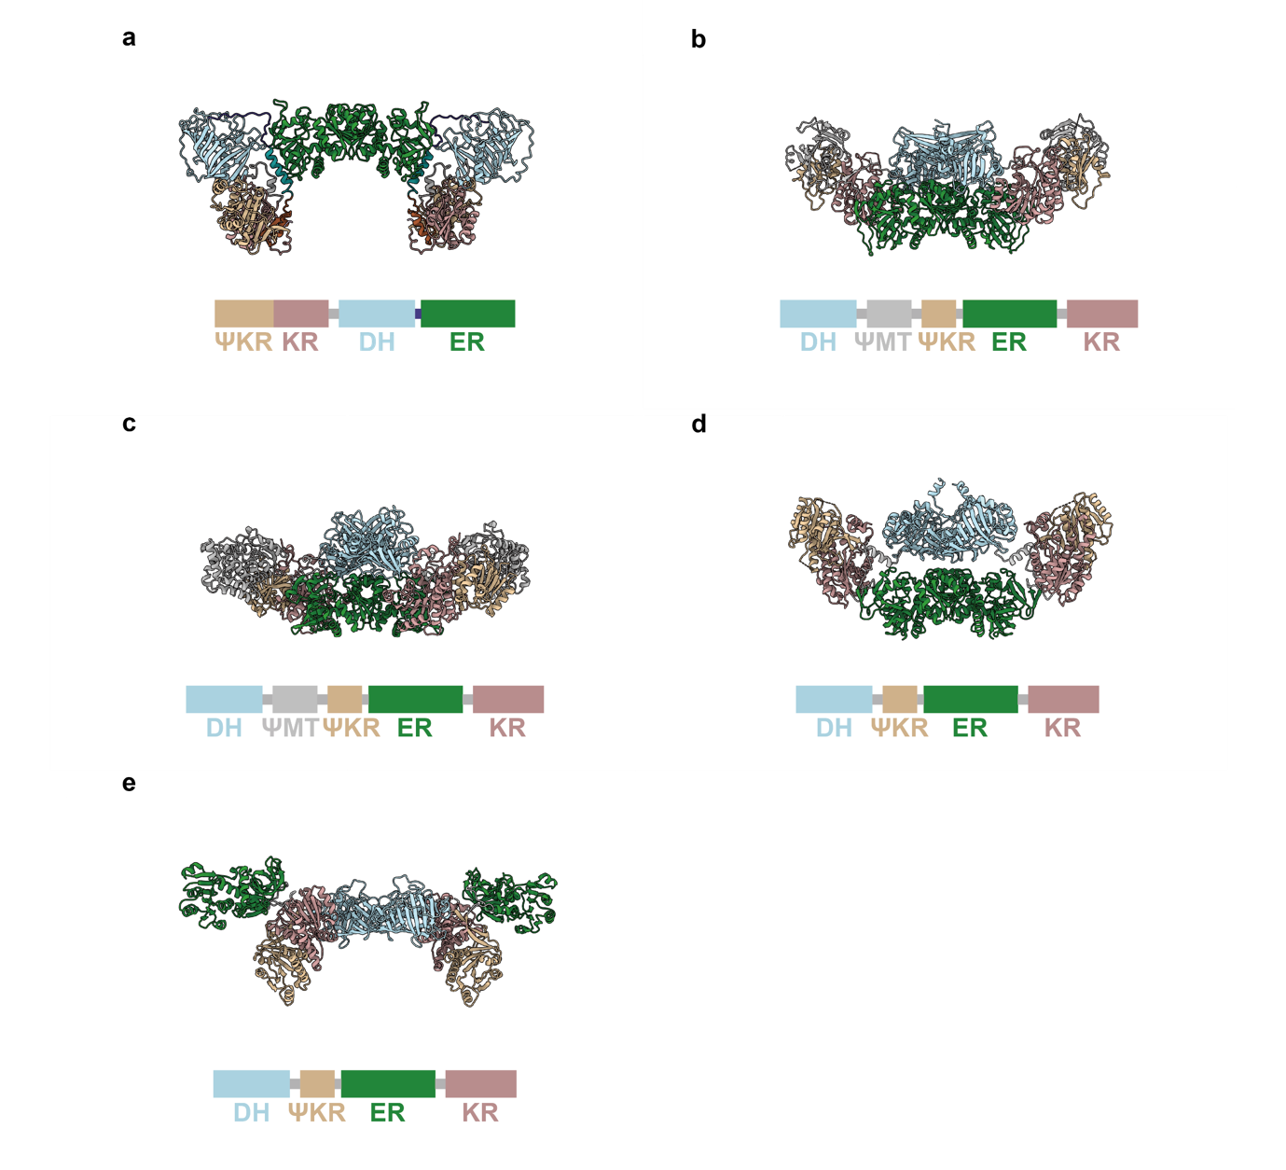

Supplementary Fig. 7. Structural comparison of the reducing domain.

The structures of the reducing regions of the a, ClbB_{PKS}; b, mFAS (PDB: 2VZ8); c, lovastatin synthase (LovB, PDB: 7CPX); d, mycocerosic acid synthase (MAS, PDB: 5BP4); and e, juvenimicin PKS module 5 (JuvEIII). For alignment, the ER dimer was used.

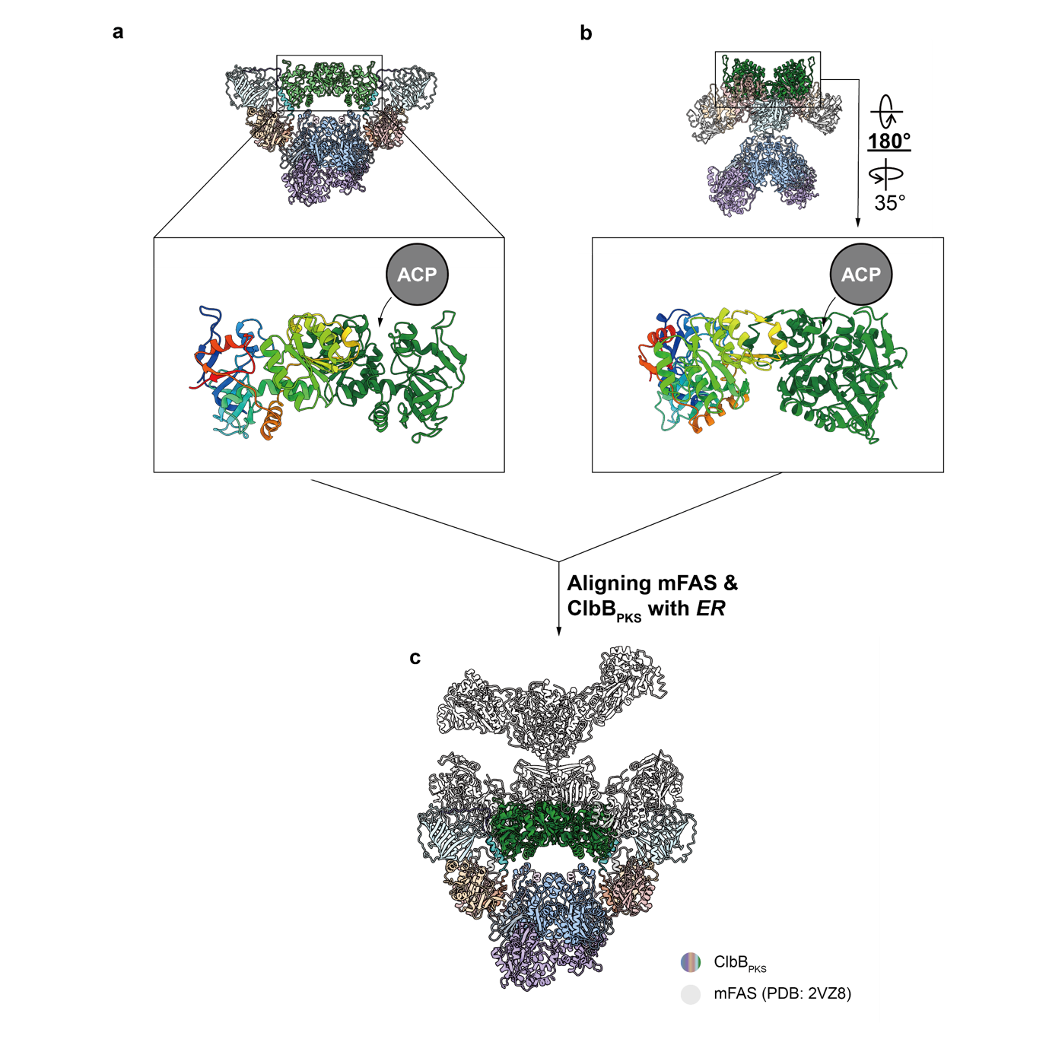

Supplementary Fig. 8. Structural analysis of the ER domain orientation in ClbB_{PKS}.

a, The ClbB ER domain is highlighted, and chain A is colored in rainbow (N-terminal: blue, C-terminal: red). b, mFAS ER domain is highlighted similarly, with appropriate rotations to achieve a structural alignment of the ClbB ER. The active site entrance is indicated by the arrows. c, Superimposed structures of the ClbB_{PKS} and mFAS by the ER domain. ClbB_{PKS} is colored as introduced in Fig. 1d, and mFAS is colored in light gray. The condensing region of the mFAS is apparently horizontally flipped from the view in b.

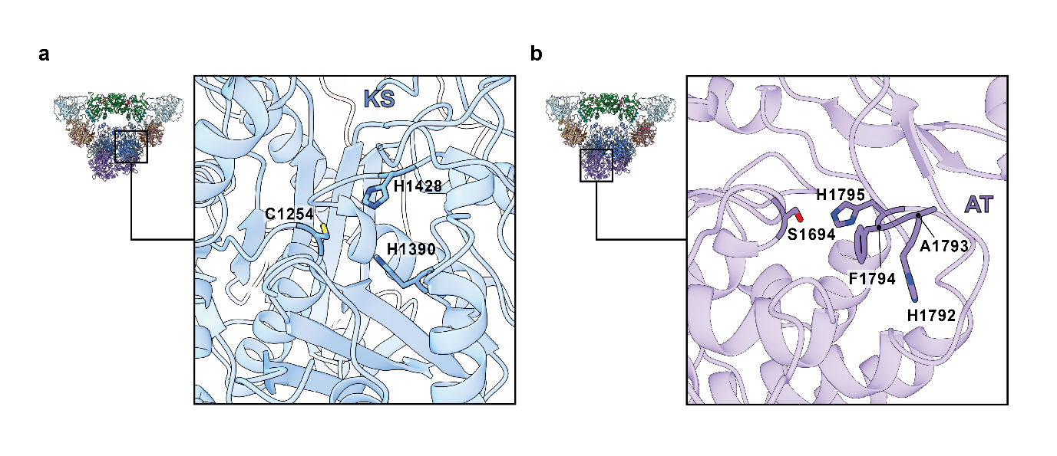

Supplementary Fig. 9. Active sites of the ClbB’s condensing domains.
Active site zoom-in view of a, KS, and b, AT. The active-site residues and the specificity-conferring motif of the AT domain are highlighted and labeled.
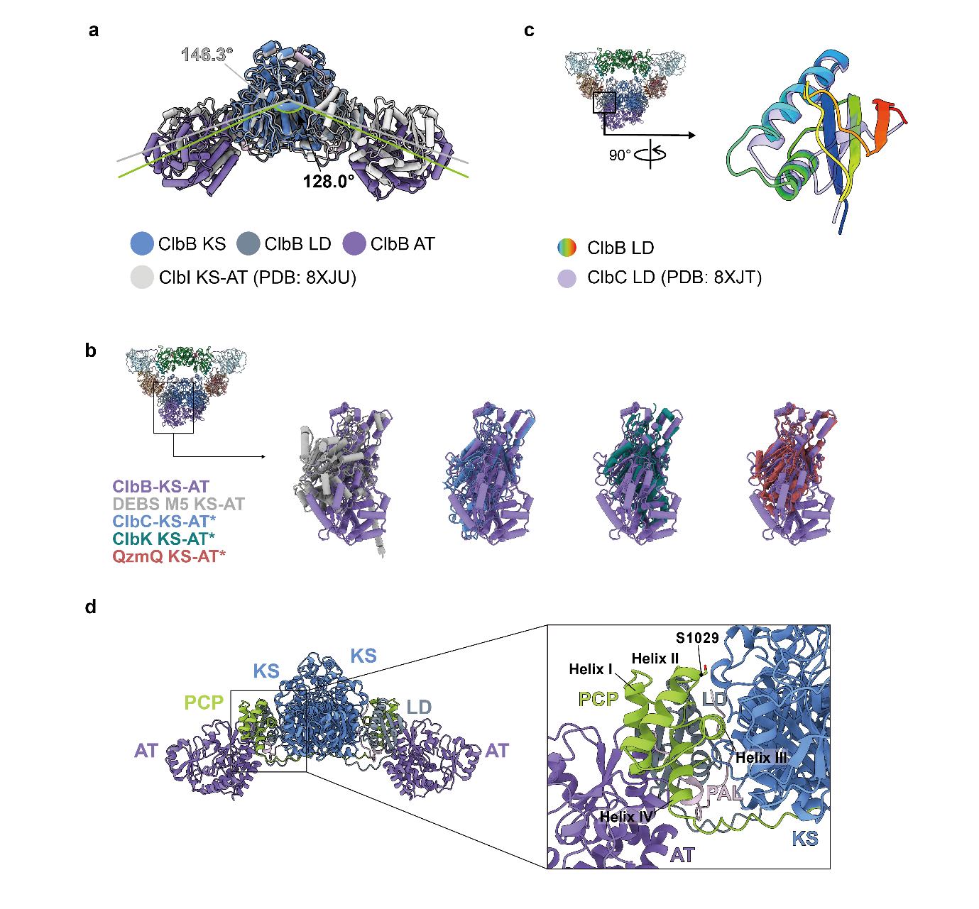
Supplementary Fig. 10. Structural comparison of the condensing regions in ClbB and other PKSs.
a, Superposition of ClbB and ClbI KS-LD-AT (PDB 8XJU), aligned by the KS dimer. Structures are colored as indicated. The inter-axial angle between the two KS-LD-AT domains is indicated in pale green. b, ClbB AT superimposed with DEBS module 5, ClbC, ClbK, and OzmQ. The structures were aligned by LD using MatchMaker. c, Superposition of ClbB LD and ClbC LD (PDB: 8XBL). ClbB LD is colored in rainbow (N-terminal: blue, C-terminal: red), and ClbC LD is colored in purple with 50% transparency. d, AlphaFold3 model of ClbB PCP-KS-LD-AT dimer. All the resulting models have a similar PCP binding interface on KS.

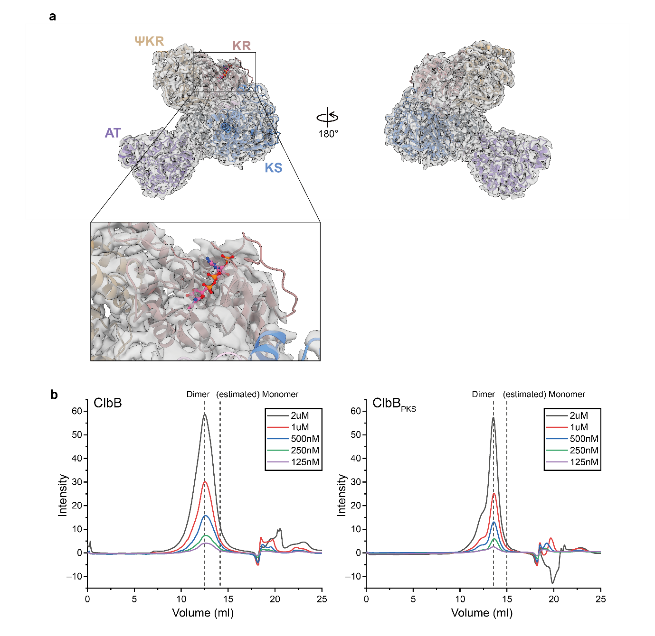

Supplementary Fig. 11. Atomic model fitting of monomeric ClbB_{PKS} and Size-exclusion chromatography (SEC) profiles of ClbB proteins.
a, Atomic model of NADPH-bound ClbB_{PKS} fitted to the monomeric ClbB_{PKS} density map. For clarity, domains not visible in the density map were omitted. The NADPH-binding site of the KR domain is shown in an inset at a low map threshold (σ = 0.3). b, SEC profiles of full-length ClbB (left) and ClbB_{PKS} (right). In both plots, traces from purified protein samples injected at the indicated concentrations are shown in different colors. Dashed lines mark the estimated elution positions of the dimeric and monomeric species.

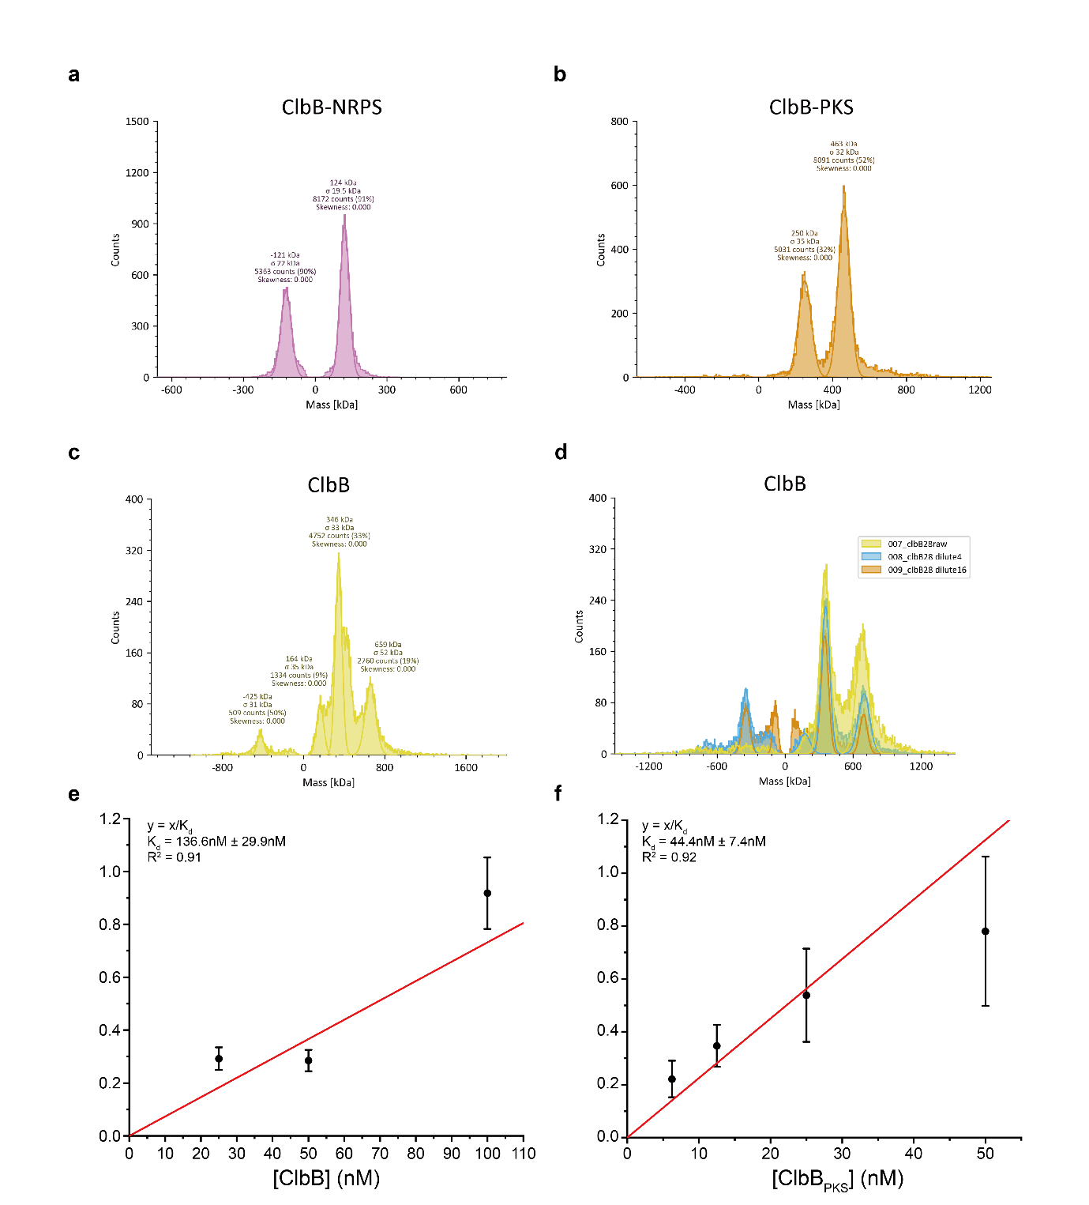

Supplementary Fig. 12. Mass photometry of ClbB_{NRPS}, ClbB_{PKS}, and ClbB.
The mass photometry results of a, ClbB_{NRPS}, b, ClbB_{PKS}, c, full-length ClbB, and d, full-length ClbB in a series of concentrations. The plots of total protein concentration and a unitless parameter y (see Supplementary Note 2) of e, full-length ClbB, and f, ClbB_{PKS}. The estimated K_{d} values and R² values are indicated.

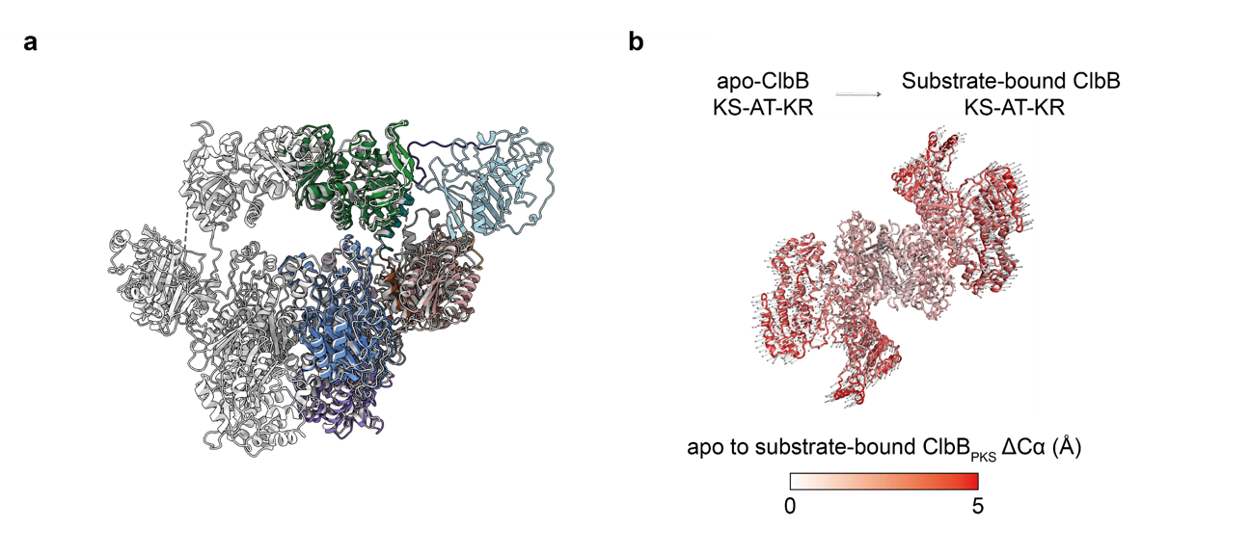
Supplementary Fig. 13. Structural comparison of the apo-ClbB_{PKS} and NADPH-bound ClbB_{PKS}.
a, The apo- and NADPH-bound ClbB_{PKS} are colored by light gray and domain colors in the main text, respectively, and aligned by the KS-AT didomain. b, Conformational change in substrate-bound ClbB_{PKS} compared to apo-ClbB_{PKS}. Apo-ClbB_{PKS}’s KS-AT-KR is shown in a loop and colored according to the C𝑎(NADPH-bound ClbB_{PKS})-C𝑎(apo-ClbB_{PKS}), where the two structures were aligned by the rigid KS-AT dimer. The arrows indicate the direction and distance (multiplied by a factor of 2) for the C𝑎(NADPH-bound ClbB_{PKS})-C𝑎(apo-ClbB_{PKS}) changes. The average 𝛥C𝑎 is 2.8 Å (±1.5 Å SD).
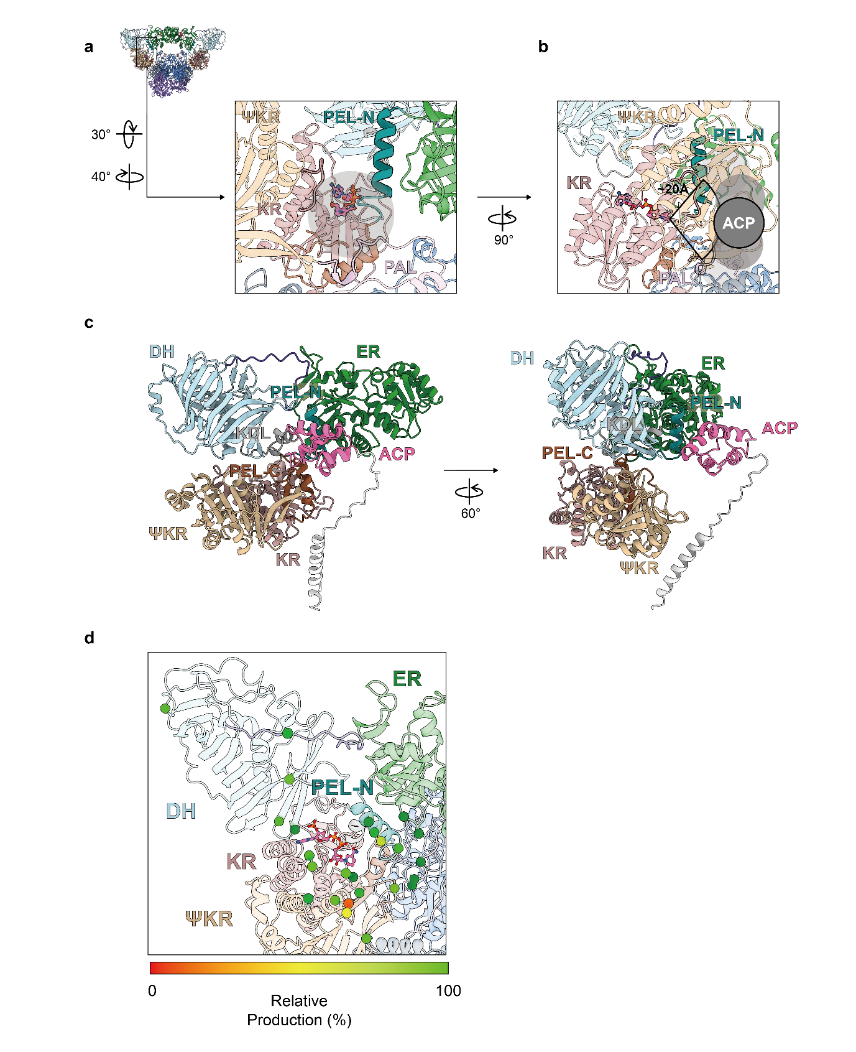
Supplementary Fig. 14. Active site entrance of ClbB_{PKS} KR.
Active site entrance of the ClbB KR in two different views. a, b. The potential binding site of ACP is marked with a semi-transparent gray circle. c, ClbB reducing region (ΨKR-KR-DH-ER) associated with ACP was modeled using AlphaFold3. C-terminal peptide of ACP was colored in gray. d, Locations of residues subjected to alanine substitution at the entrance of the KR active site, shown as spheres at the corresponding C𝑎 positions. Relative product formation of the alanine mutants is indicated by color.
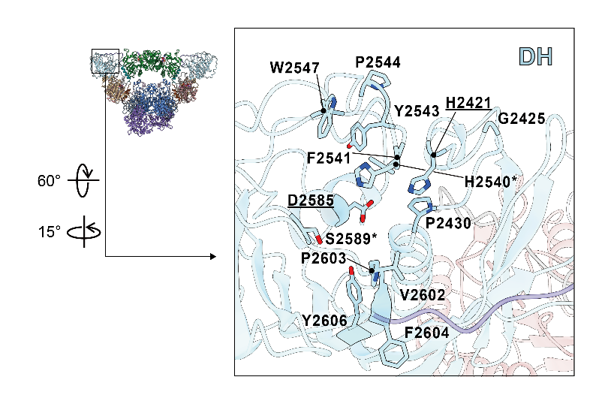
Supplementary Fig. 15. Key motifs of ClbB_{PKS} DH.
The catalytic dyad residues (H2421, D2585) are underlined and two conserved DH-associated motifs, the LPFxW motif and GYxYGPxF motif are highlighted. In GYxYGPxF motif, the first glycine is substituted with histidine, and in the Dxxx(Q/H) motif, the conserved Q/H position is replaced by serine. The substituted residues are indicated with *.

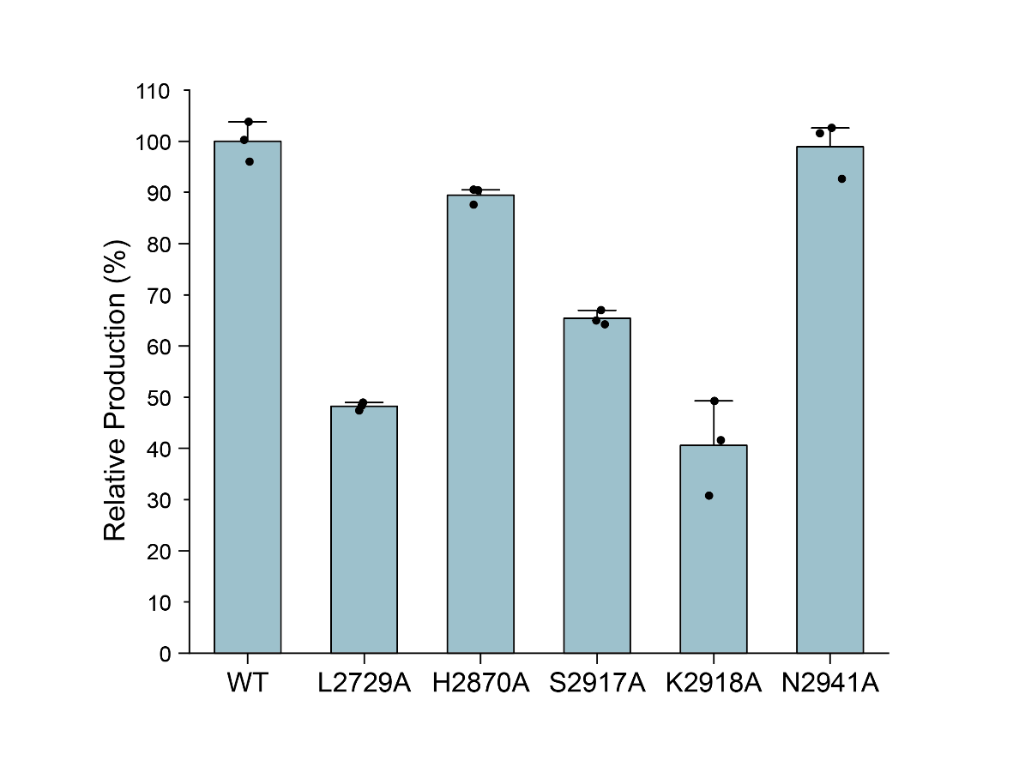
Supplementary Fig. 16. Activity of the ClbB_{PKS} ER domain mutants.
LC-MS analysis of the products from in vitro colibactin precursor (1, shown in Fig. 4e) biosynthesis using wild-type and ER active site mutants.
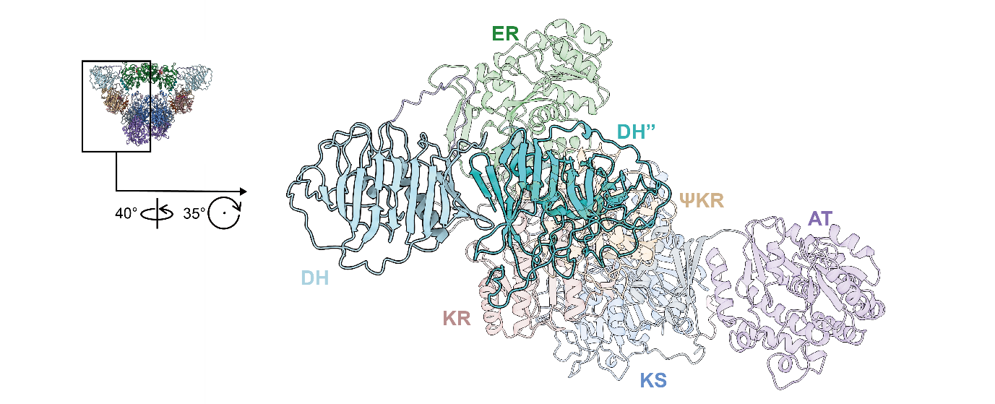

Supplementary Fig. 17. ClbB DH dimer model.
If the DH were to form a dimer in the ClbB_{PKS} architecture, as in canonical PKSs, the modeled DH protomer (labeled as DH’’ in the figure) would clash with ΨKR, KR, KR-to-DH linker, and PEL-N.
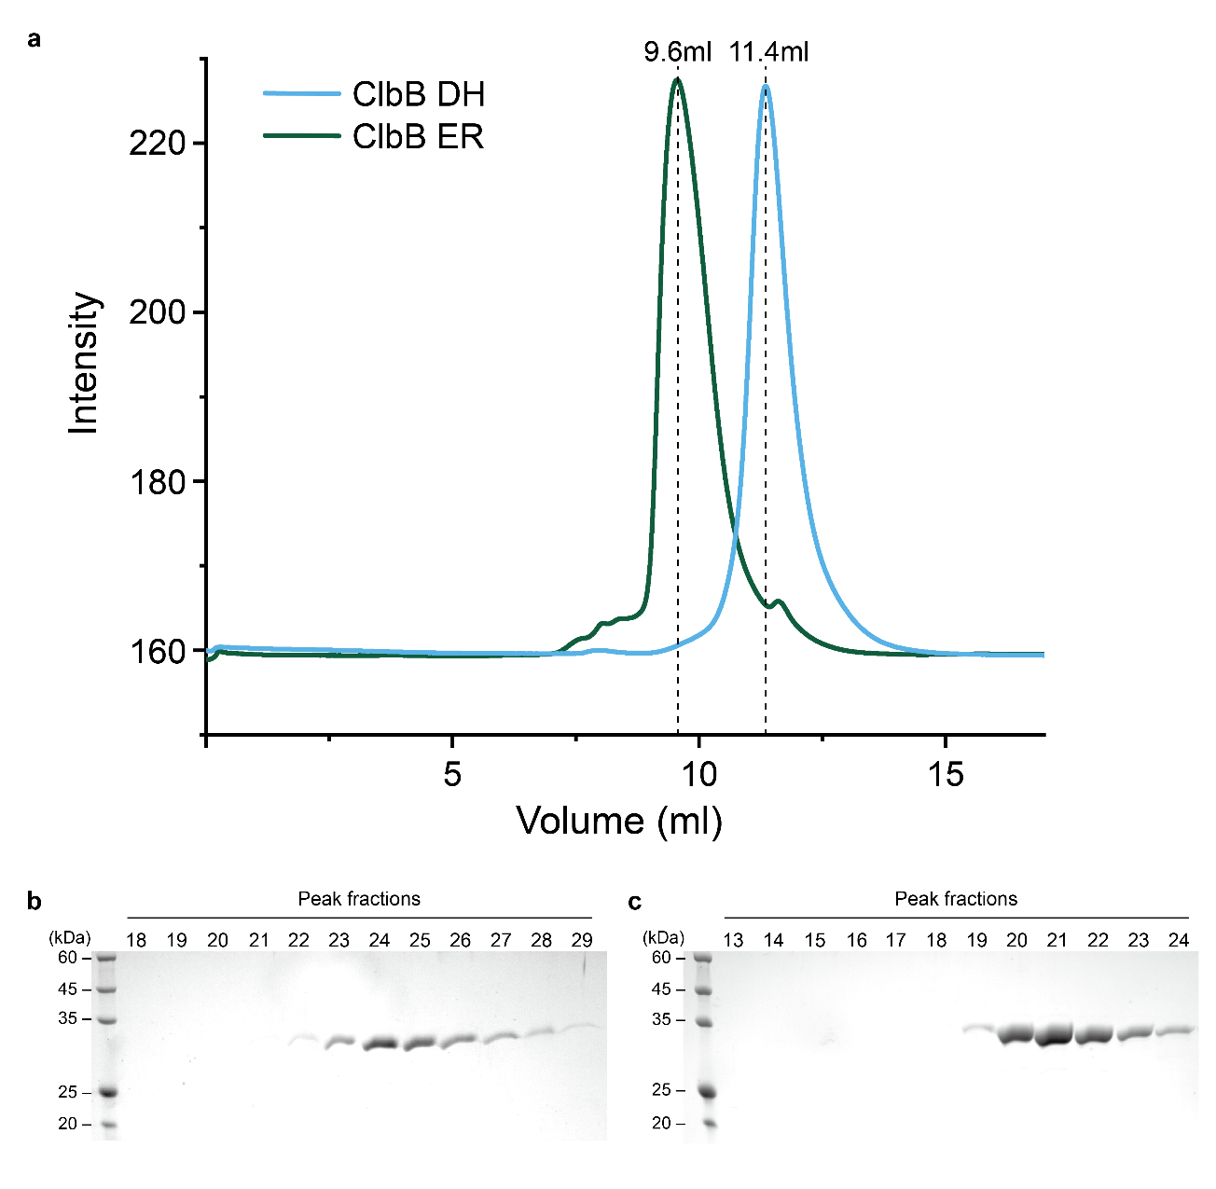

Supplementary Fig. 18. SEC analysis of the excised ClbB domains.
a, SEC profiles of the ClbB DH and ER domains. Analyses were performed on a Superdex 75 10/300 GL column (Cytiva) with a flow rate of 0.5 mL/min and 1 min per fraction. b, SDS-PAGE analysis of peak fractions from the ClbB DH domain. c, SDS-PAGE analysis of peak fractions from the ClbB ER domain.
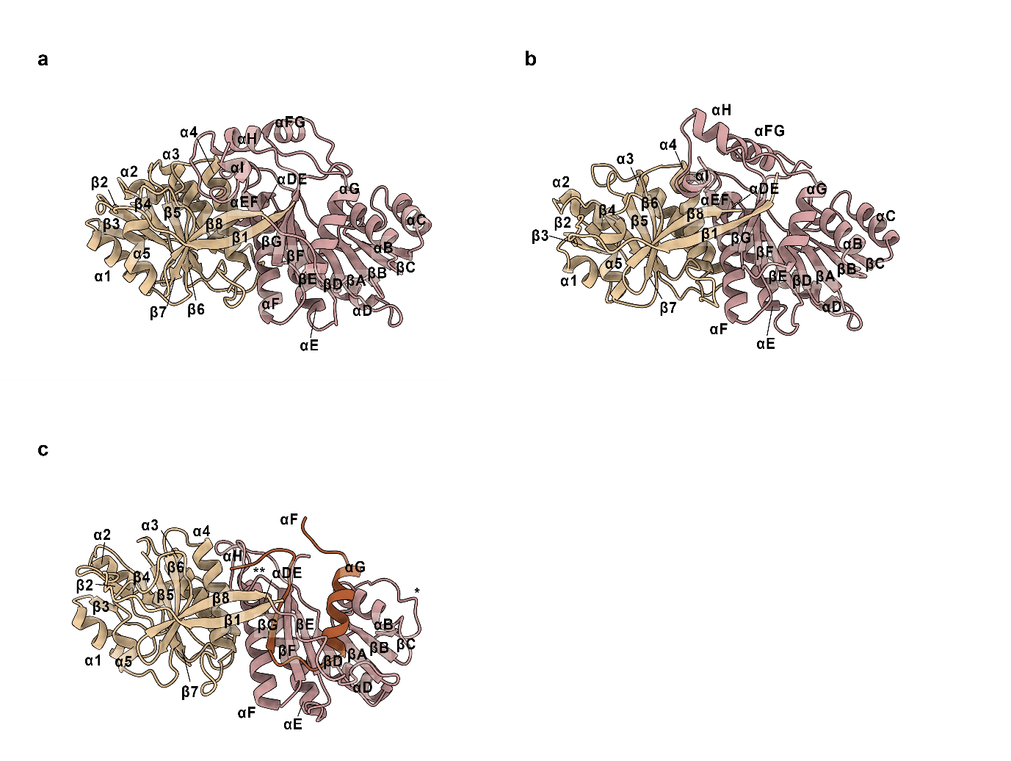

Supplementary Fig. 19. Secondary structure annotation of the KR domain.
a, Secondary structure annotation of the KR domain from DEBS module 1 (PDB: 2FR0), based on the annotation of Keatinge-Clay et al., Structure, 2006¹⁰. b, Secondary structure annotation of the KR domain from the JuvEIII (PDB: 8G7X). c, Secondary structure annotation of the KR domain from ClbB. The annotations in b and c are referenced to that of DEBS module 1 KR, and deviation was marked as follows: *, missing αC; **, missing αEF.
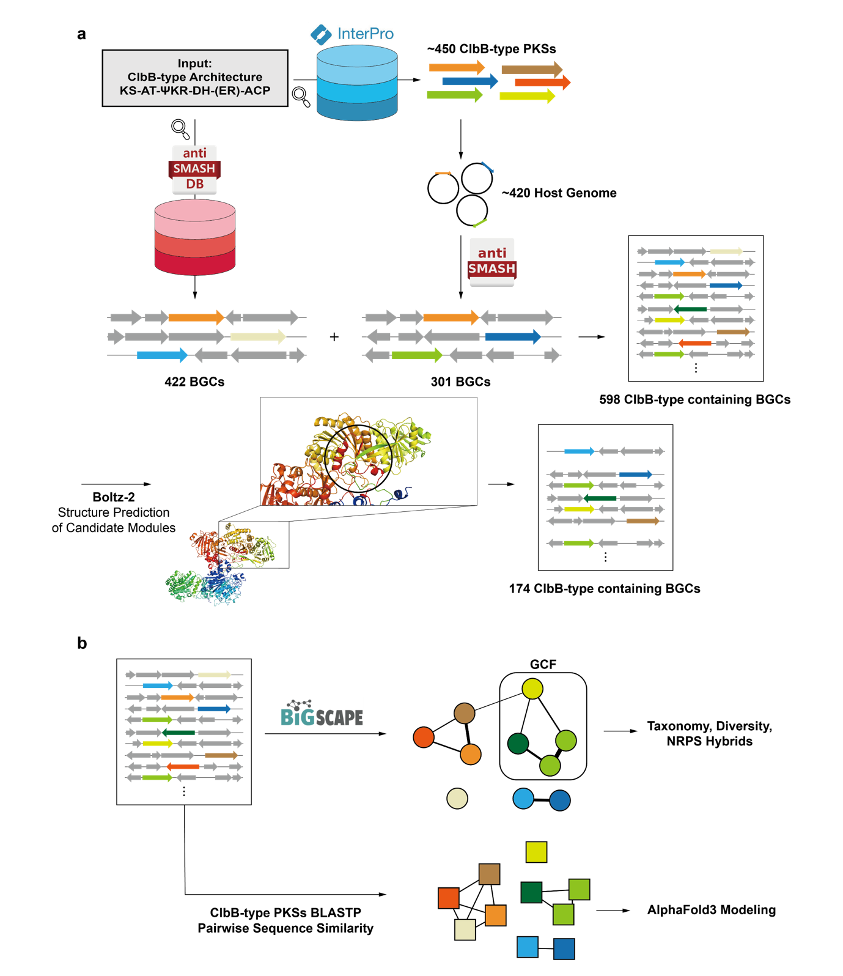

Supplementary Fig. 20. Workflow of bioinformatic analysis of ClbB-type PKSs.
a, Analysis workflow describing ClbB-type BGC collection. b, BiG-SCAPE and SSN analysis workflow from the collected ClbB-type BGCs.
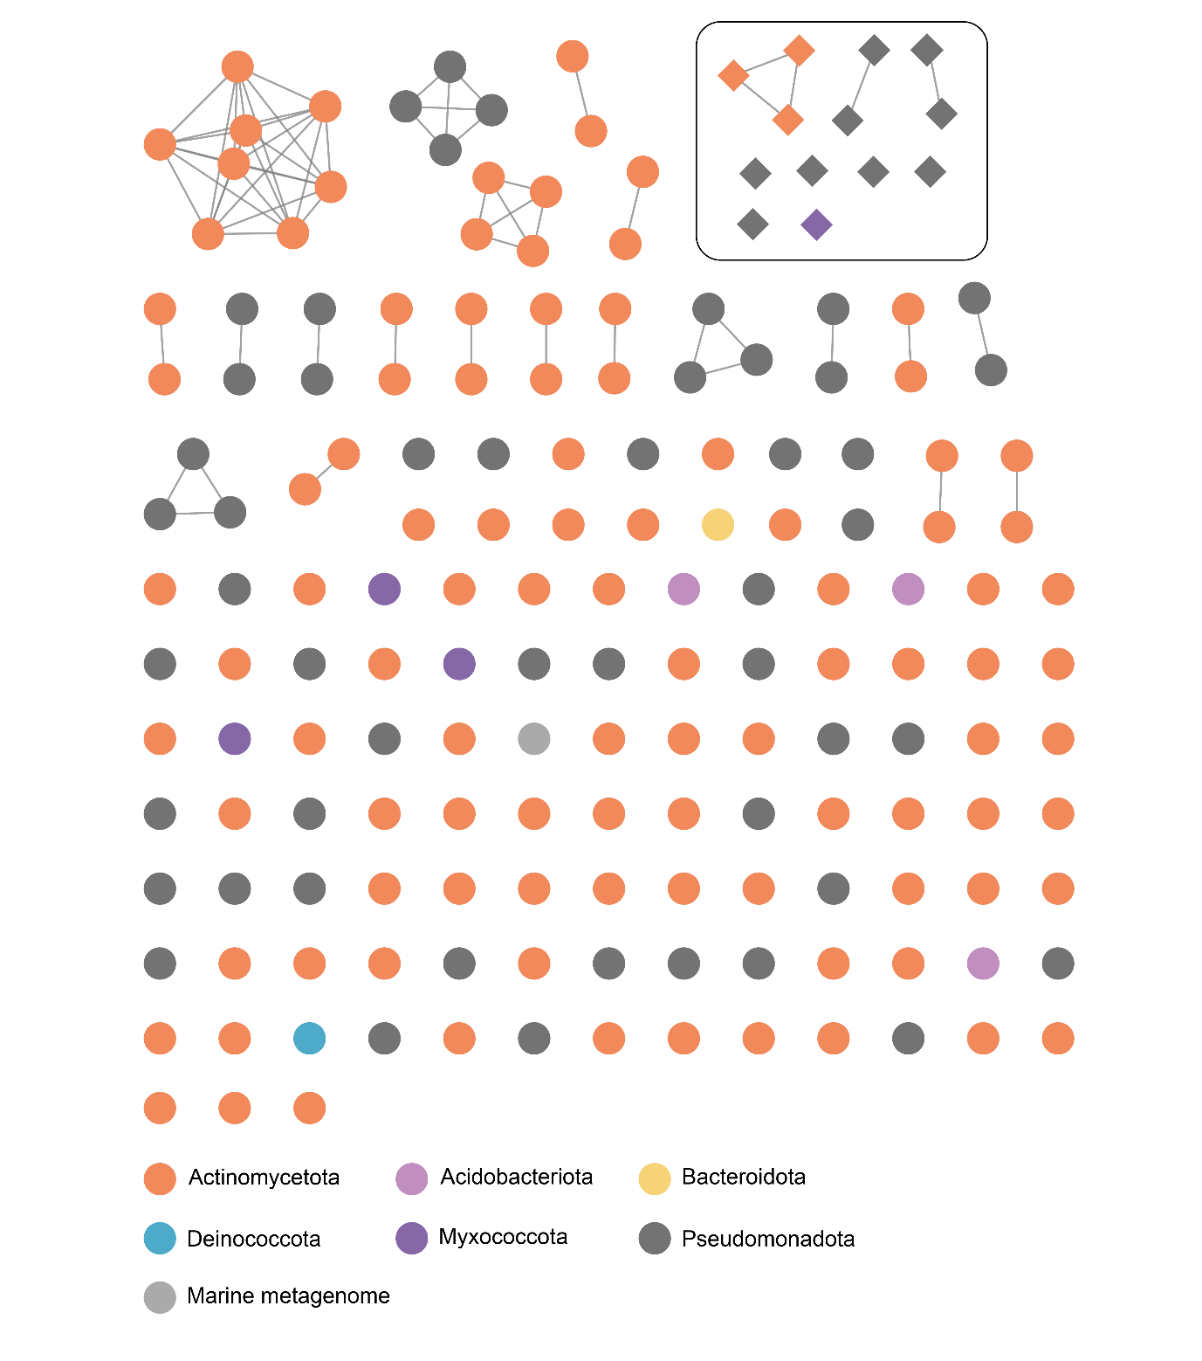
Supplementary Fig. 21. Sequence similarity network of the BGCs containing ClbB-type modules.
Network representation of 174 biosynthetic gene clusters (BGCs) containing ClbB-type PKS, clustered using BiG-SCAPE. Each node represents a BGC containing a PKS module order of KS-AT-KR-DH(-ER), and nodes are connected when the similarity between two BGCs is higher than 0.3. Nodes in circles indicate modules without an ER domain, and nodes in diamonds show modules with an ER domain and are included in a box in the right upper corner.
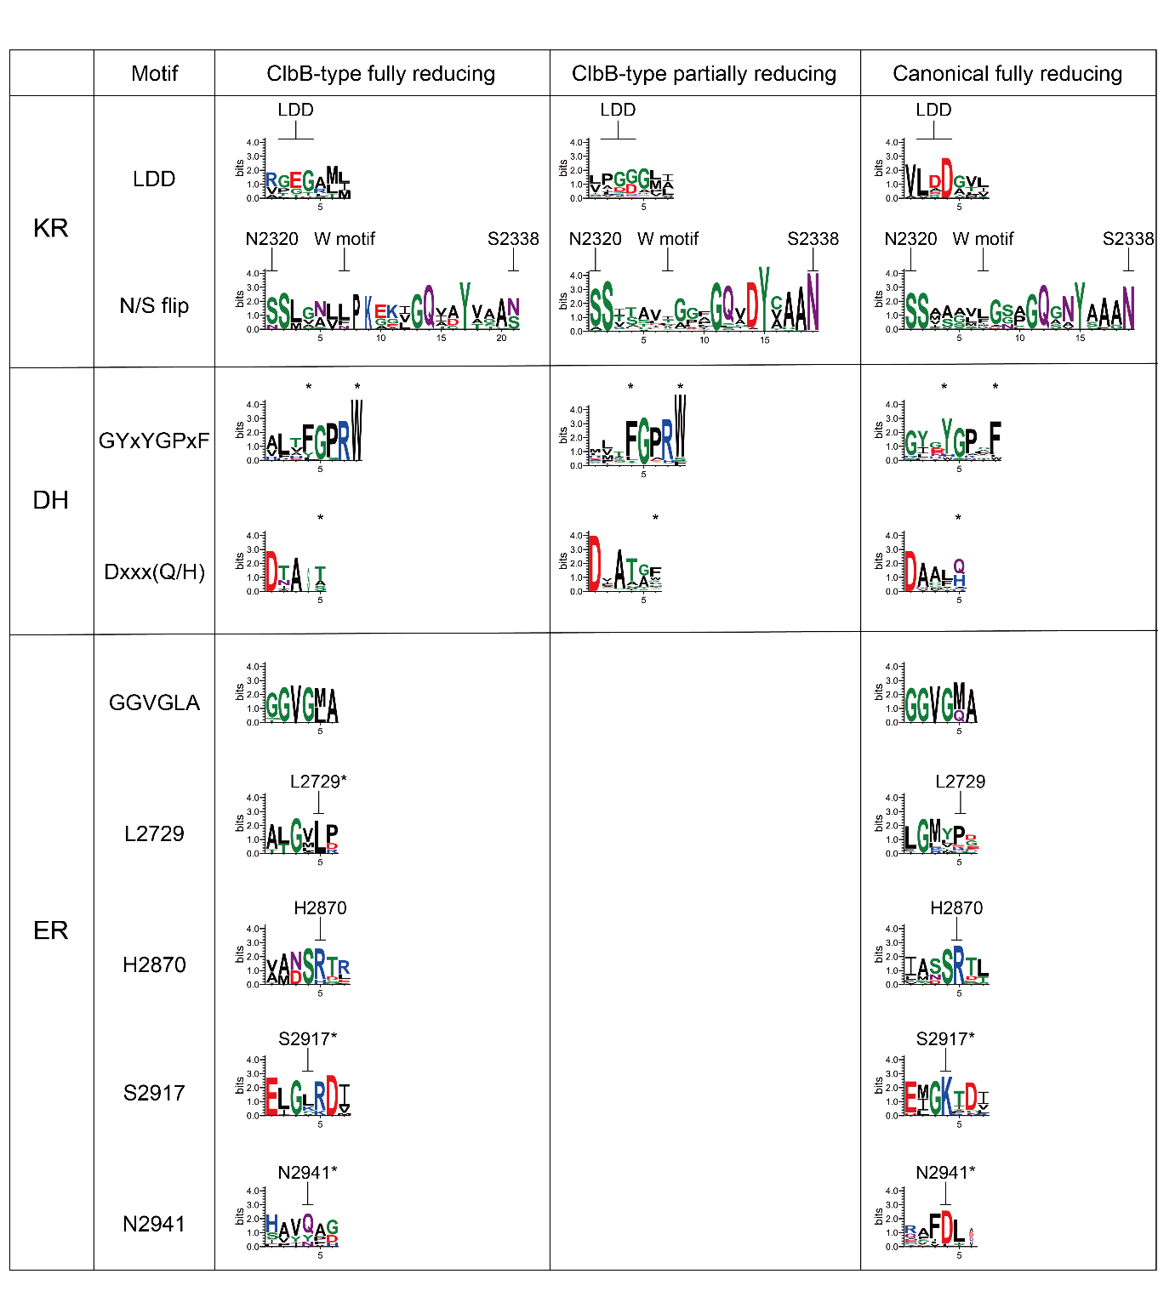

Supplementary Fig. 22. Sequence logos of conserved motifs in β-keto processing domains of ClbB-type and canonical PKSs.
Sequence logos of the conserved motifs of β-keto processing domains in ClbB-type fully-reducing, ClbB-type partially-reducing, and canonical fully-reducing PKSs.
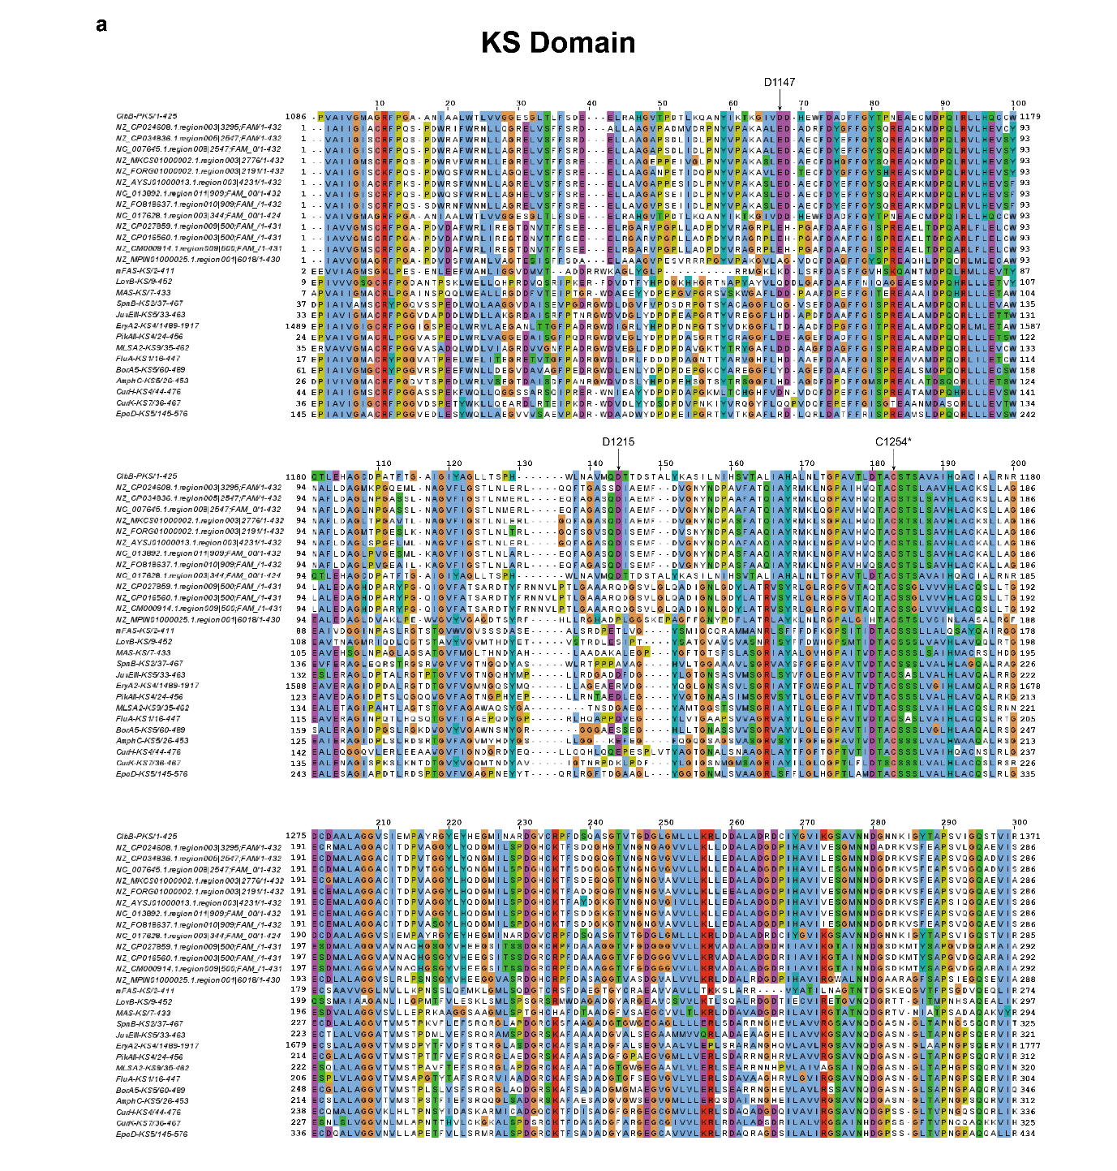
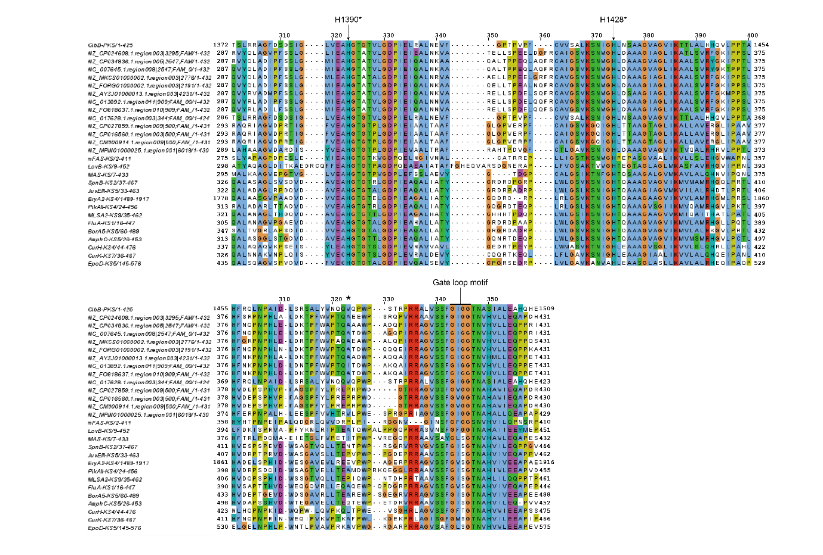
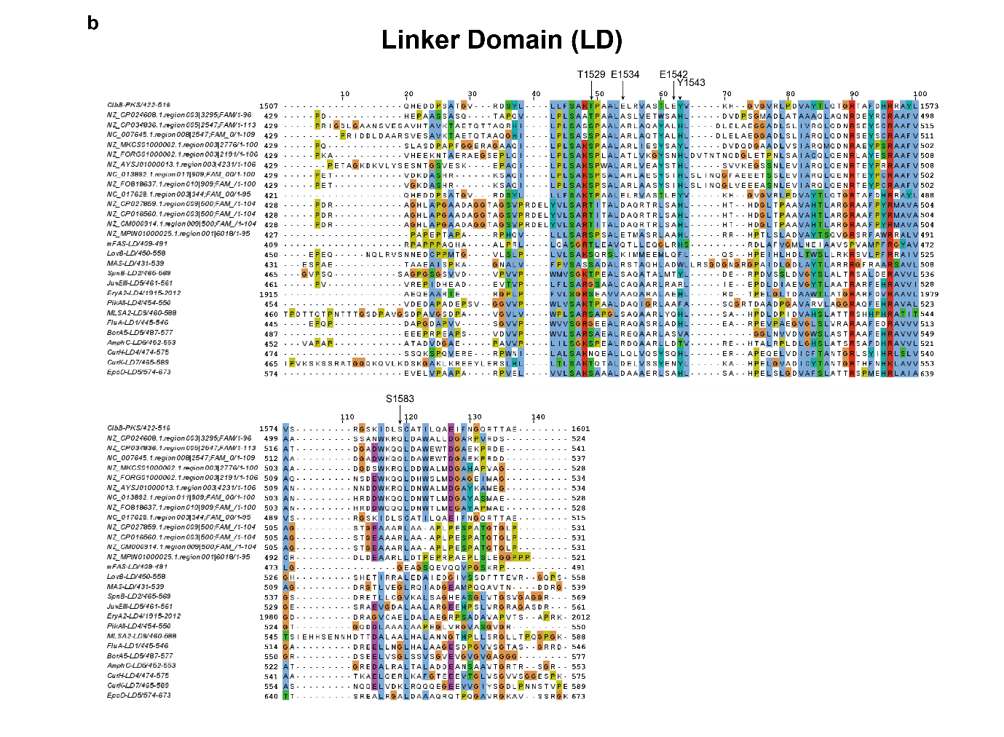
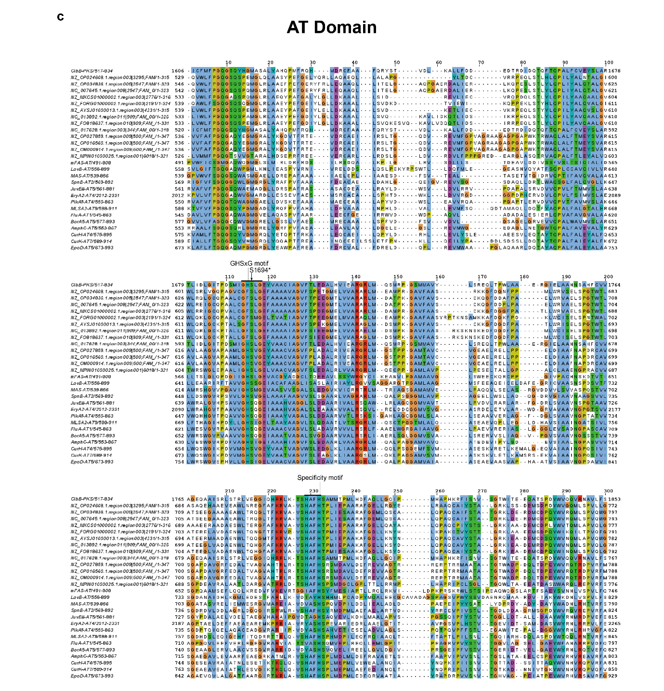
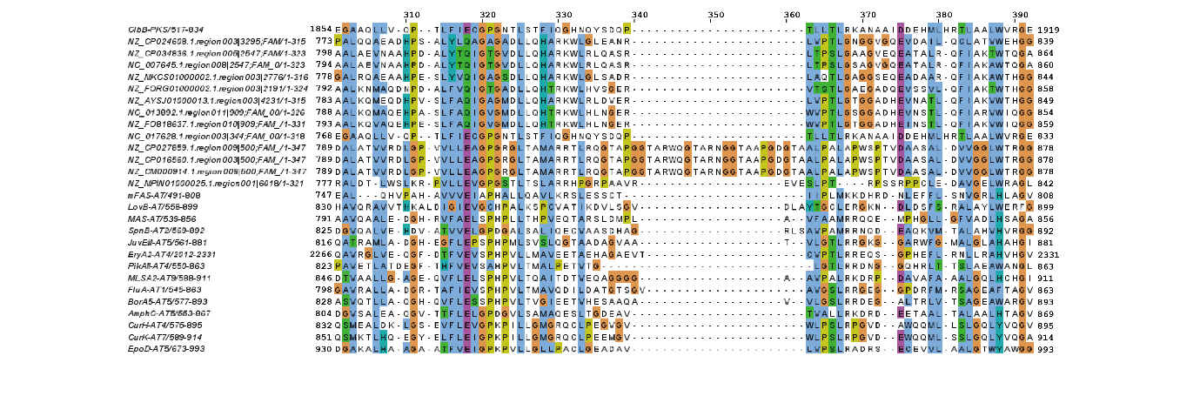
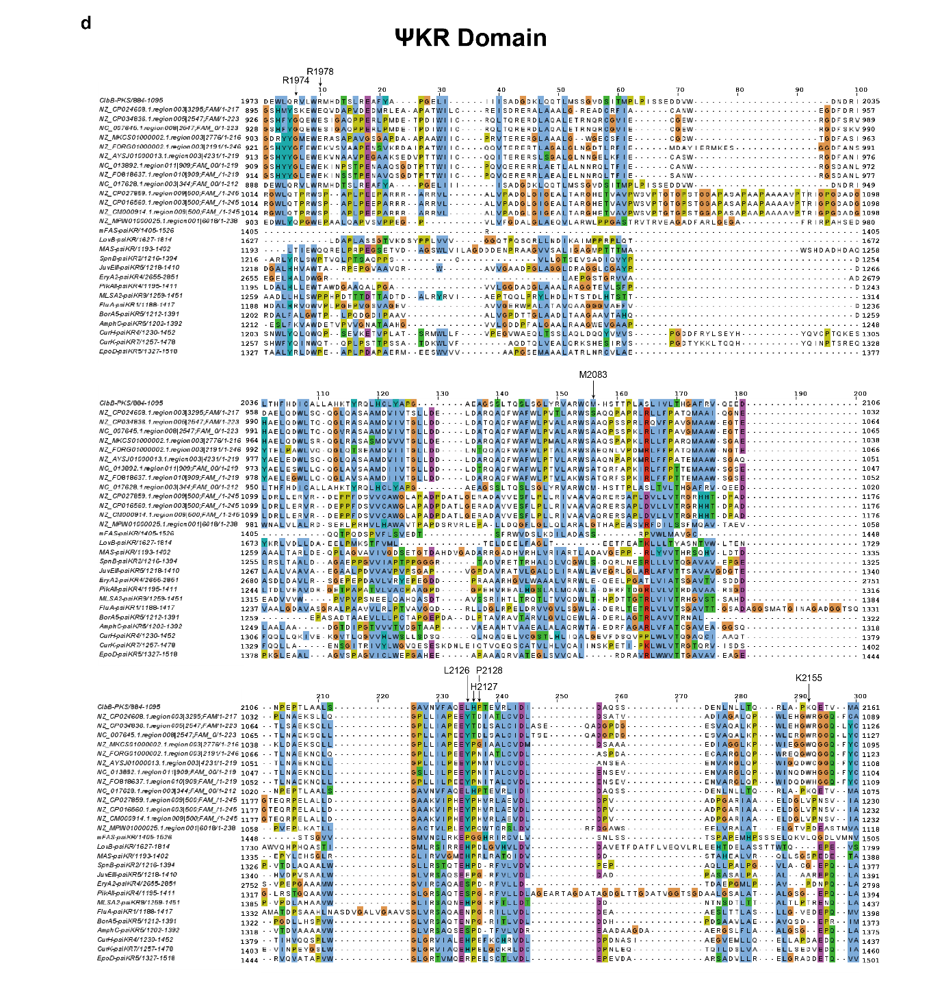
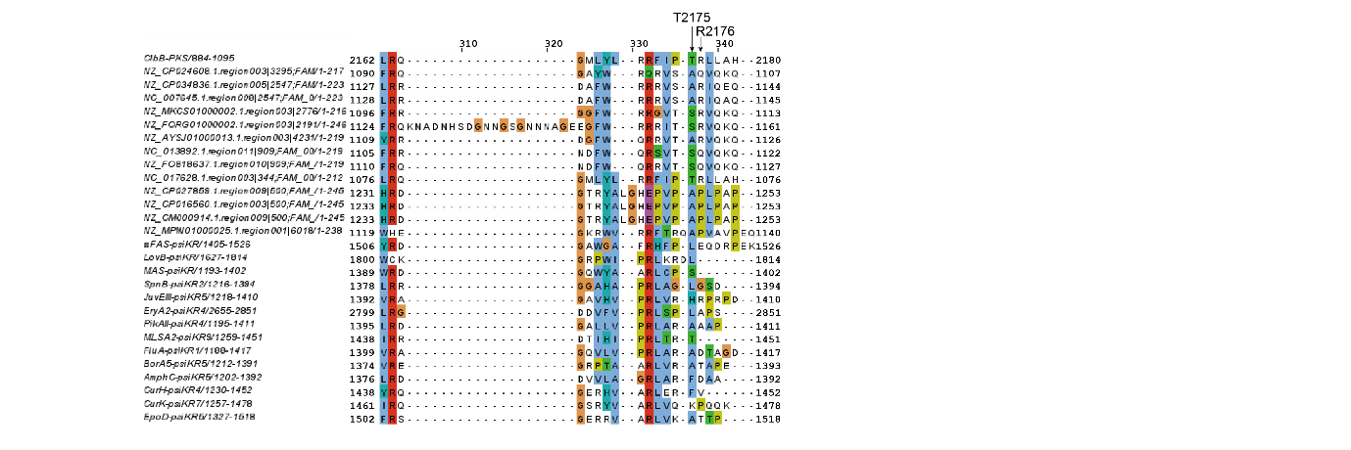

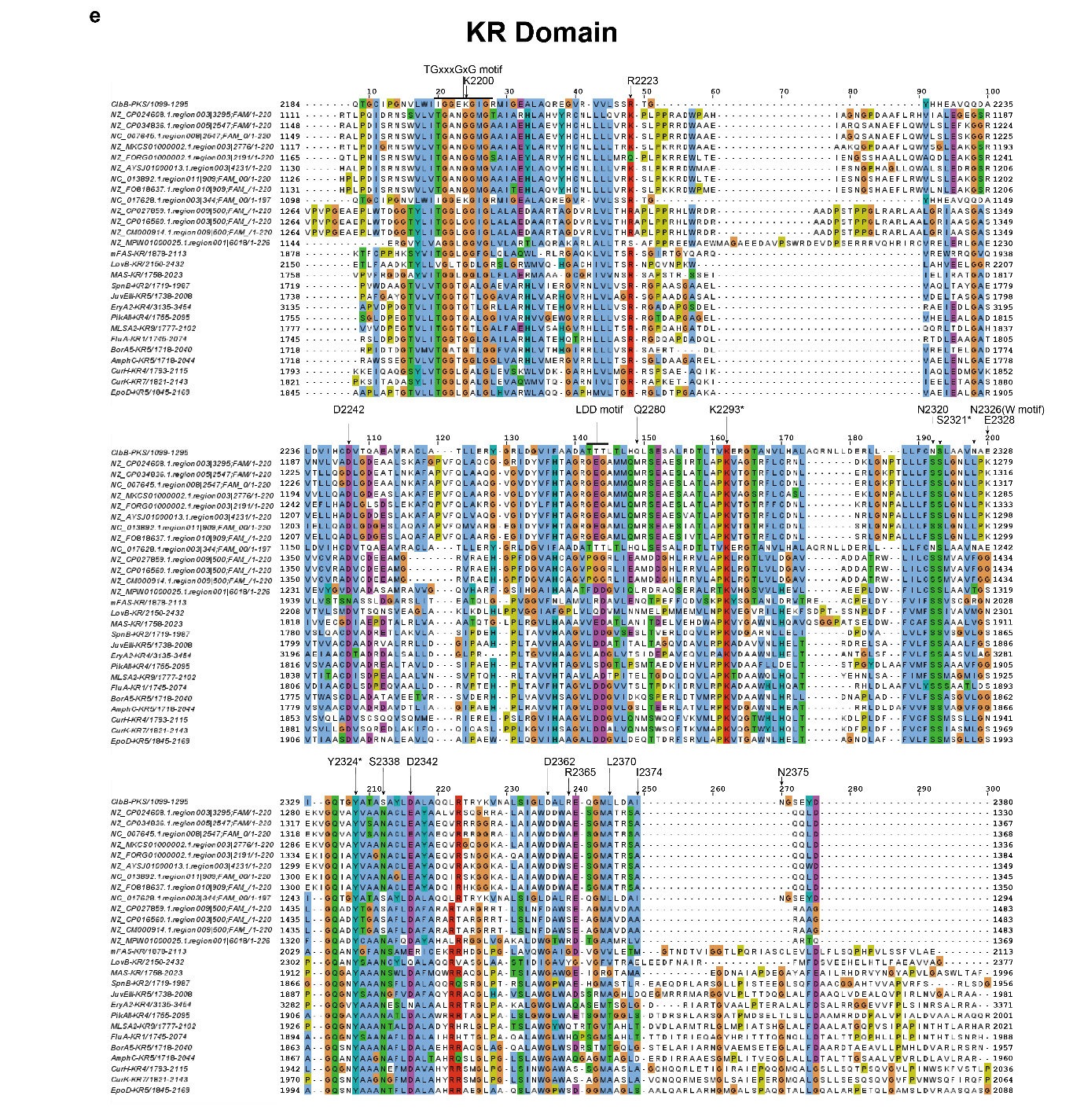
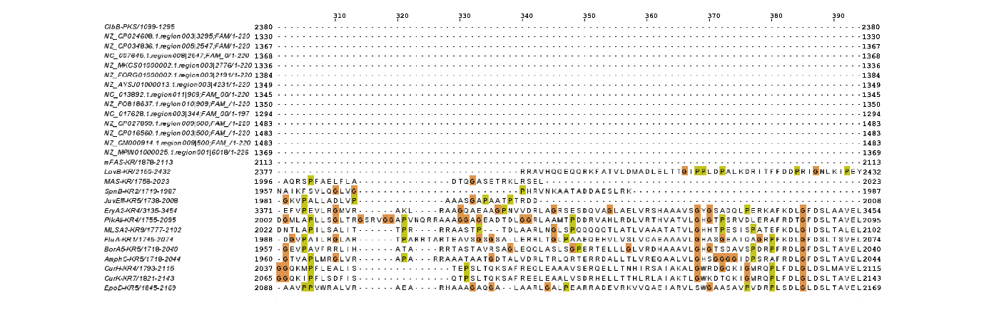
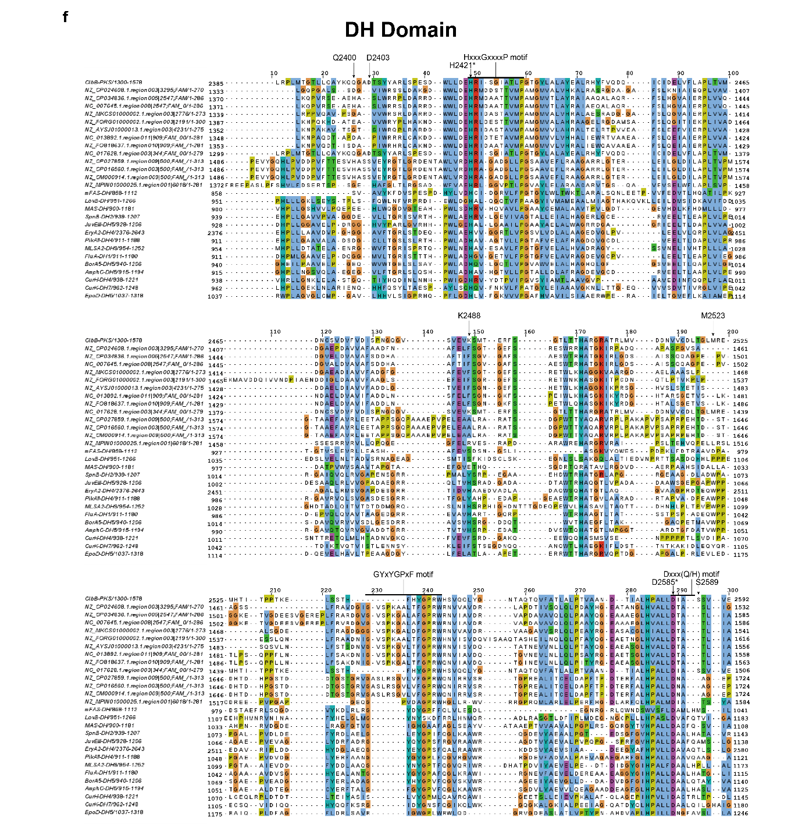
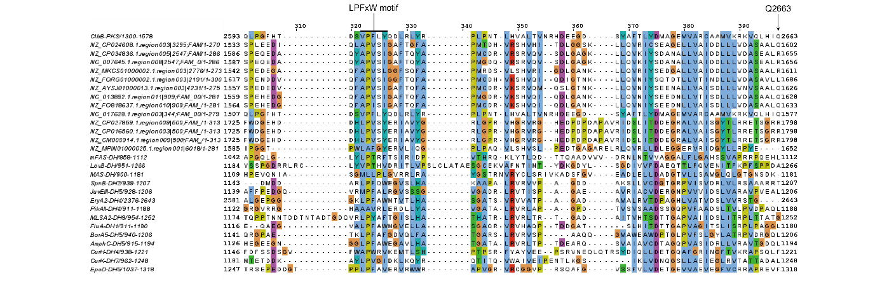
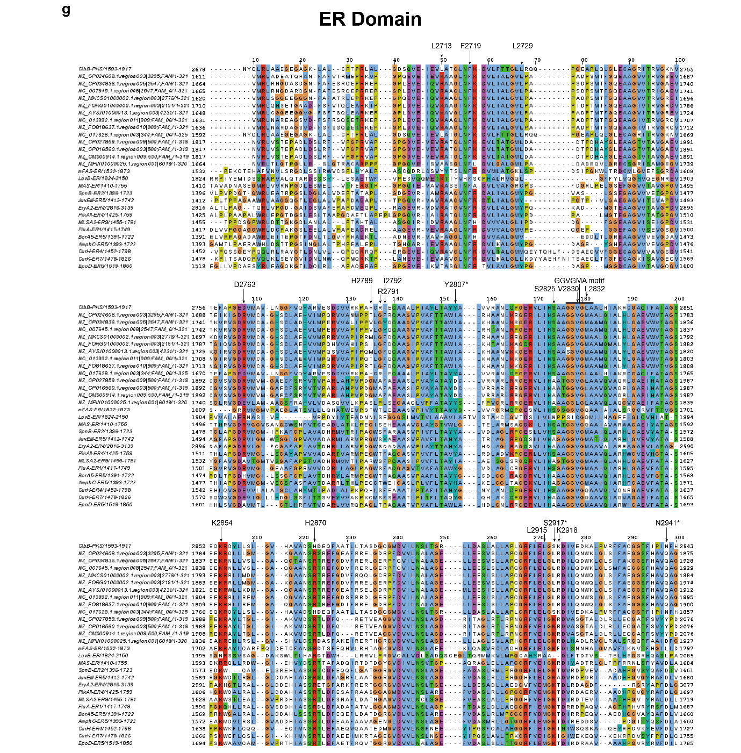
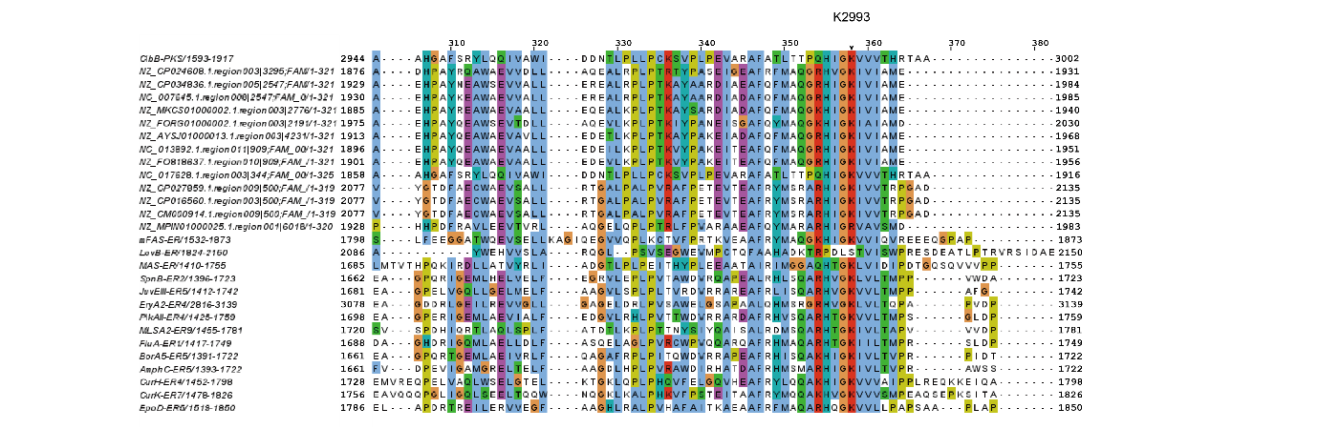
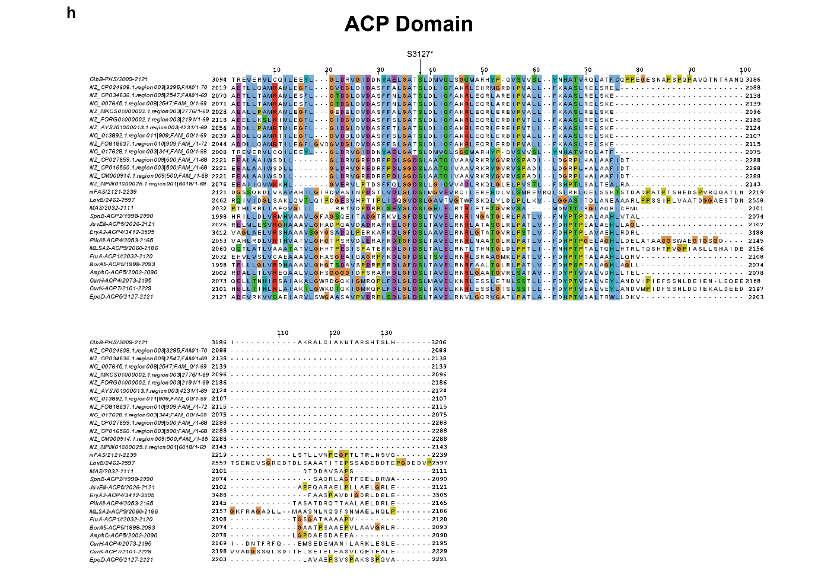

Supplementary Fig. 23. Multiple sequence alignment of ClbB-type fully-reducing PKSs with fully-reducing PKS, iPKS, and mFAS
a, KS domain, showing the catalytic triad (C1254, H1390, H1428) and gate-loop motif (₁₄₉₃GIGG₁₄₉₆ in ClbB). b, Linker domain (LD). c, AT domain, showing the catalytic motif (GHSxG; catalytic S1694 in ClbB) and the specificity-conferring motif (₁₇₉₂HAFH₁₇₉₅ in ClbB). d, ΨKR domain, with R1974 indicated by arrows. e, KR domain, showing the catalytic triad (K2293, Y2334, S2321), the NADPH-binding motif (TGxxxGxG; ₂₁₉₆IGGEKGIG₂₂₀₃ in ClbB), the LDD motif (₂₂₇₃TTT₂₂₇₅ in ClbB), and the W motif (N2326 in ClbB); compensatory reciprocal substitutions (N2320 and S2338) are indicated by arrows. f, DH domain, showing the catalytic motifs HxxxGxxxP and Dxxx(Q/H) (catalytic H2421 and D2585 in ClbB), as well as additional conserved motifs GYxYGPxF and LPFxW (₂₅₄₀HFHYGPRW₂₅₄₇ and ₂₆₀₂VPFLY₂₆₀₆ in ClbB). g, ER domain, showing the cofactor-binding motif (GGVGMA; ₂₈₂₈GGVGLA₂₈₃₃ in ClbB) and the catalytic Tyr/Lys pair (Y2802, K2993). h, ACP domain, showing the phosphopantetheinylated serine (S3127). Conserved catalytic residues are marked by asterisks. Residues discussed in the manuscript are indicated by arrows and residue numbers.
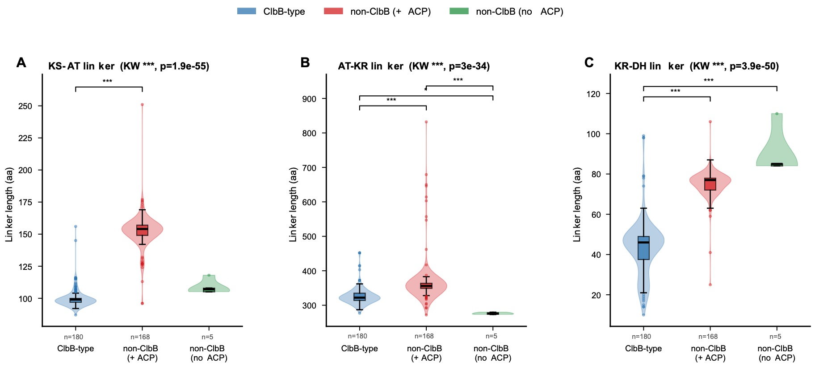

Supplementary Fig. 24. Interdomain linker length analysis among three groups, ClbB-type, non-ClbB-type (+ACP), and non-ClbB-type (no ACP).
Lengths of three interdomain linker regions (KS–AT, AT–KR, and KR–DH) were compared across ClbB-type PKSs, non-ClbB PKSs containing an intervening ACP domain (non-ClbB (+ACP)), and non-ClbB-type PKSs lacking such an ACP insertion (non-ClbB (no ACP)). Kruskal-Wallis tests followed by Dunn’s post hoc tests with Bonferroni correction showed highly significant differences among groups (KS–AT: P = 1.9 × 10⁻⁵⁵; AT–KR: P = 3.0 × 10⁻³⁴; KR–DH: P = 3.9 × 10⁻⁵⁰). ClbB-type modules exhibited the shortest KR–DH linker (median 46 aa) compared to non-ClbB (+ACP) (median 77 aa) and non-ClbB (no ACP) (median 85 aa) groups (P < 0.001), consistent with insertion of the DH(-ER) unit within the KR domain in ClbB-type PKSs. The AT–KR linker was markedly longer in the non-ClbB (+ACP) group (median ~356 aa), consistent with the presence of an intervening ACP domain between AT and KR. The KS–AT linker was also significantly shorter in ClbB-type PKSs than in the non-ClbB (+ACP) group, consistent with the structural observation that the ClbB LD is shorter than canonical LDs and may influence the arrangement of the KR domains.
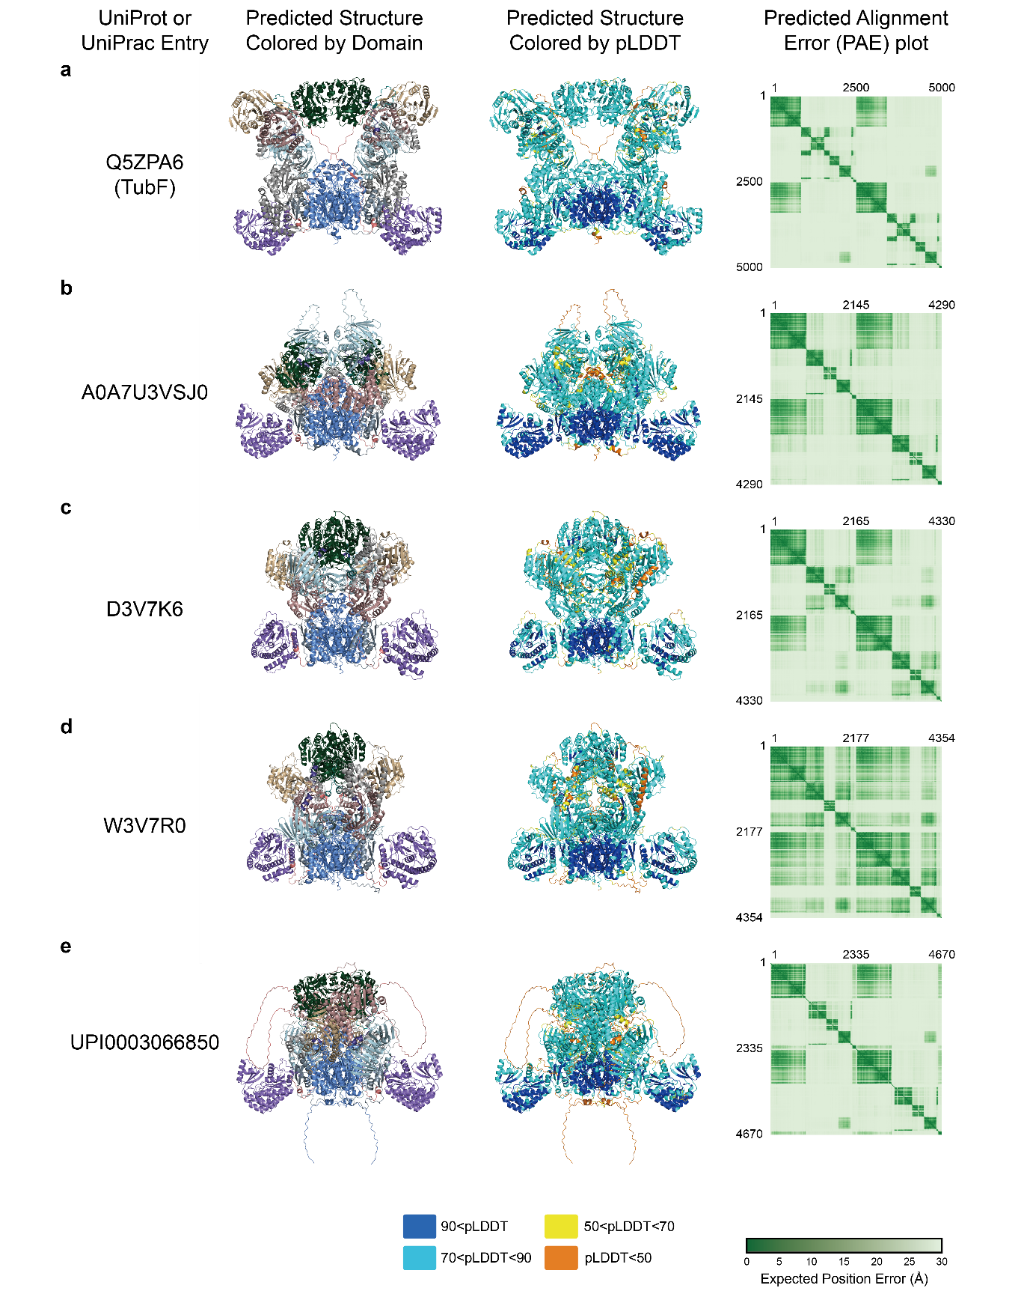

Supplementary Fig. 25. AlphaFold3 models and confidence metrics of ClbB-type fully-reducing PKSs.
Shown are UniProt entry name, the predicted structure colored by the domain scheme of ClbB_{PKS}, the same structure colored by pLDDT values, and the predicted alignment error for a, Q5ZPA6 (TubF; KS-AT-ΨKR-MT-KR-DH-ER-ACP); b, A0A7U3VSJ0; c, D3V7K6; d, W3V7R0; and e, UPI0003066850 . These sequences were selected from different SSN clusters in Fig. 5a.

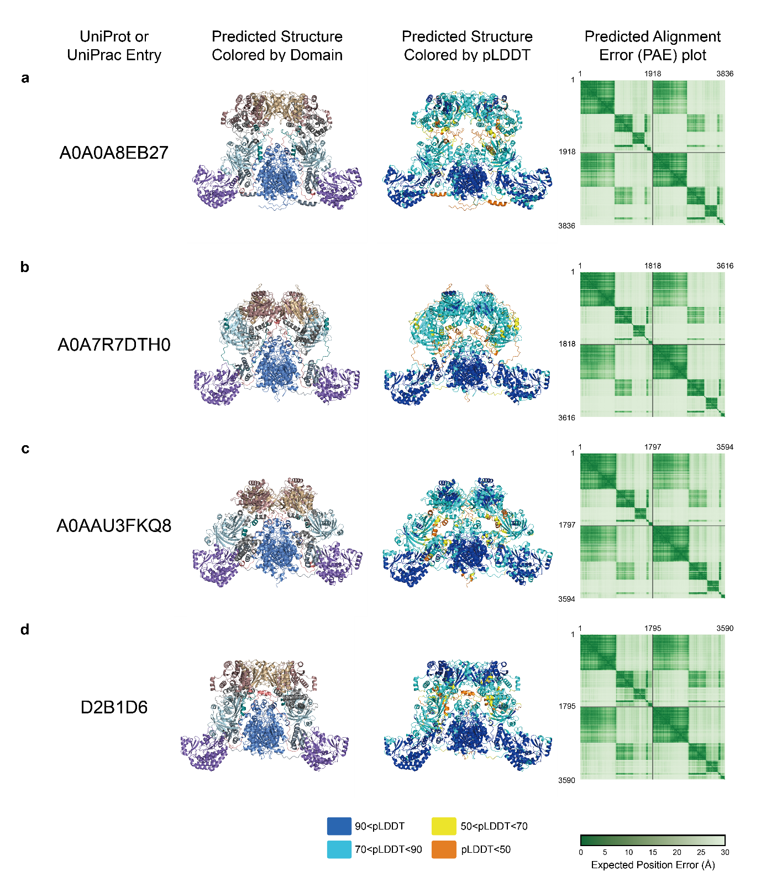

Supplementary Fig. 26. AlphaFold3 models and confidence metrics of ClbB-type partially-reducing PKSs.
Shown are UniProt entry name, the predicted structure colored by the domain scheme of ClbB_{PKS}, the same structure colored by pLDDT values, and the predicted alignment error of a, A0A0A8EB27, b, A0A7R7DTH0, c, A0AAU3FKQ8, and d, D2B1D6 (KS-AT-ΨKR-KR-DH-ACP). These sequences were selected from different SSN clusters in Fig. 5a.

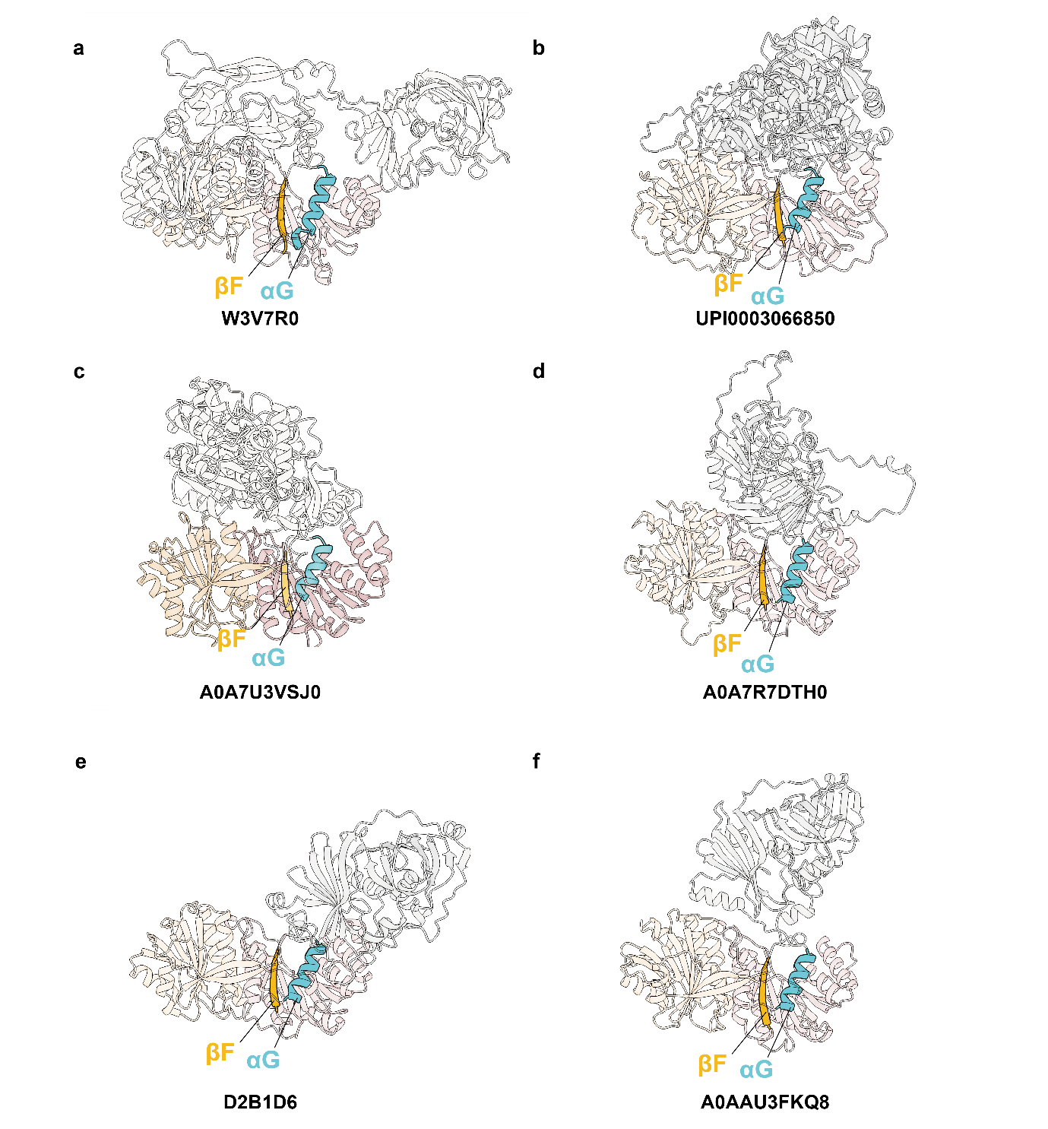
Supplementary Fig. 27. AlphaFold3 models of ClbB-type fully- and partially-reducing PKSs.
Shown are the reducing-domain organization of the representative AlphaFold3 models of a, W3V7R0; b, UPI0003066850; c, A0A7U3VSJ0; d, A0A7R7TH0; e, D2B1D6; and f, A0AAU3FKQ8.
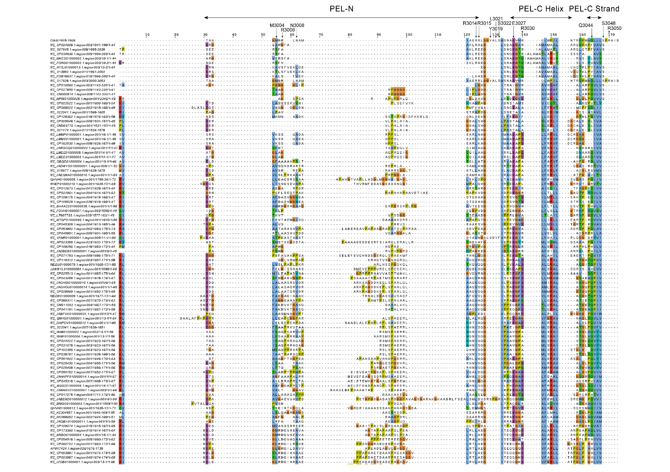
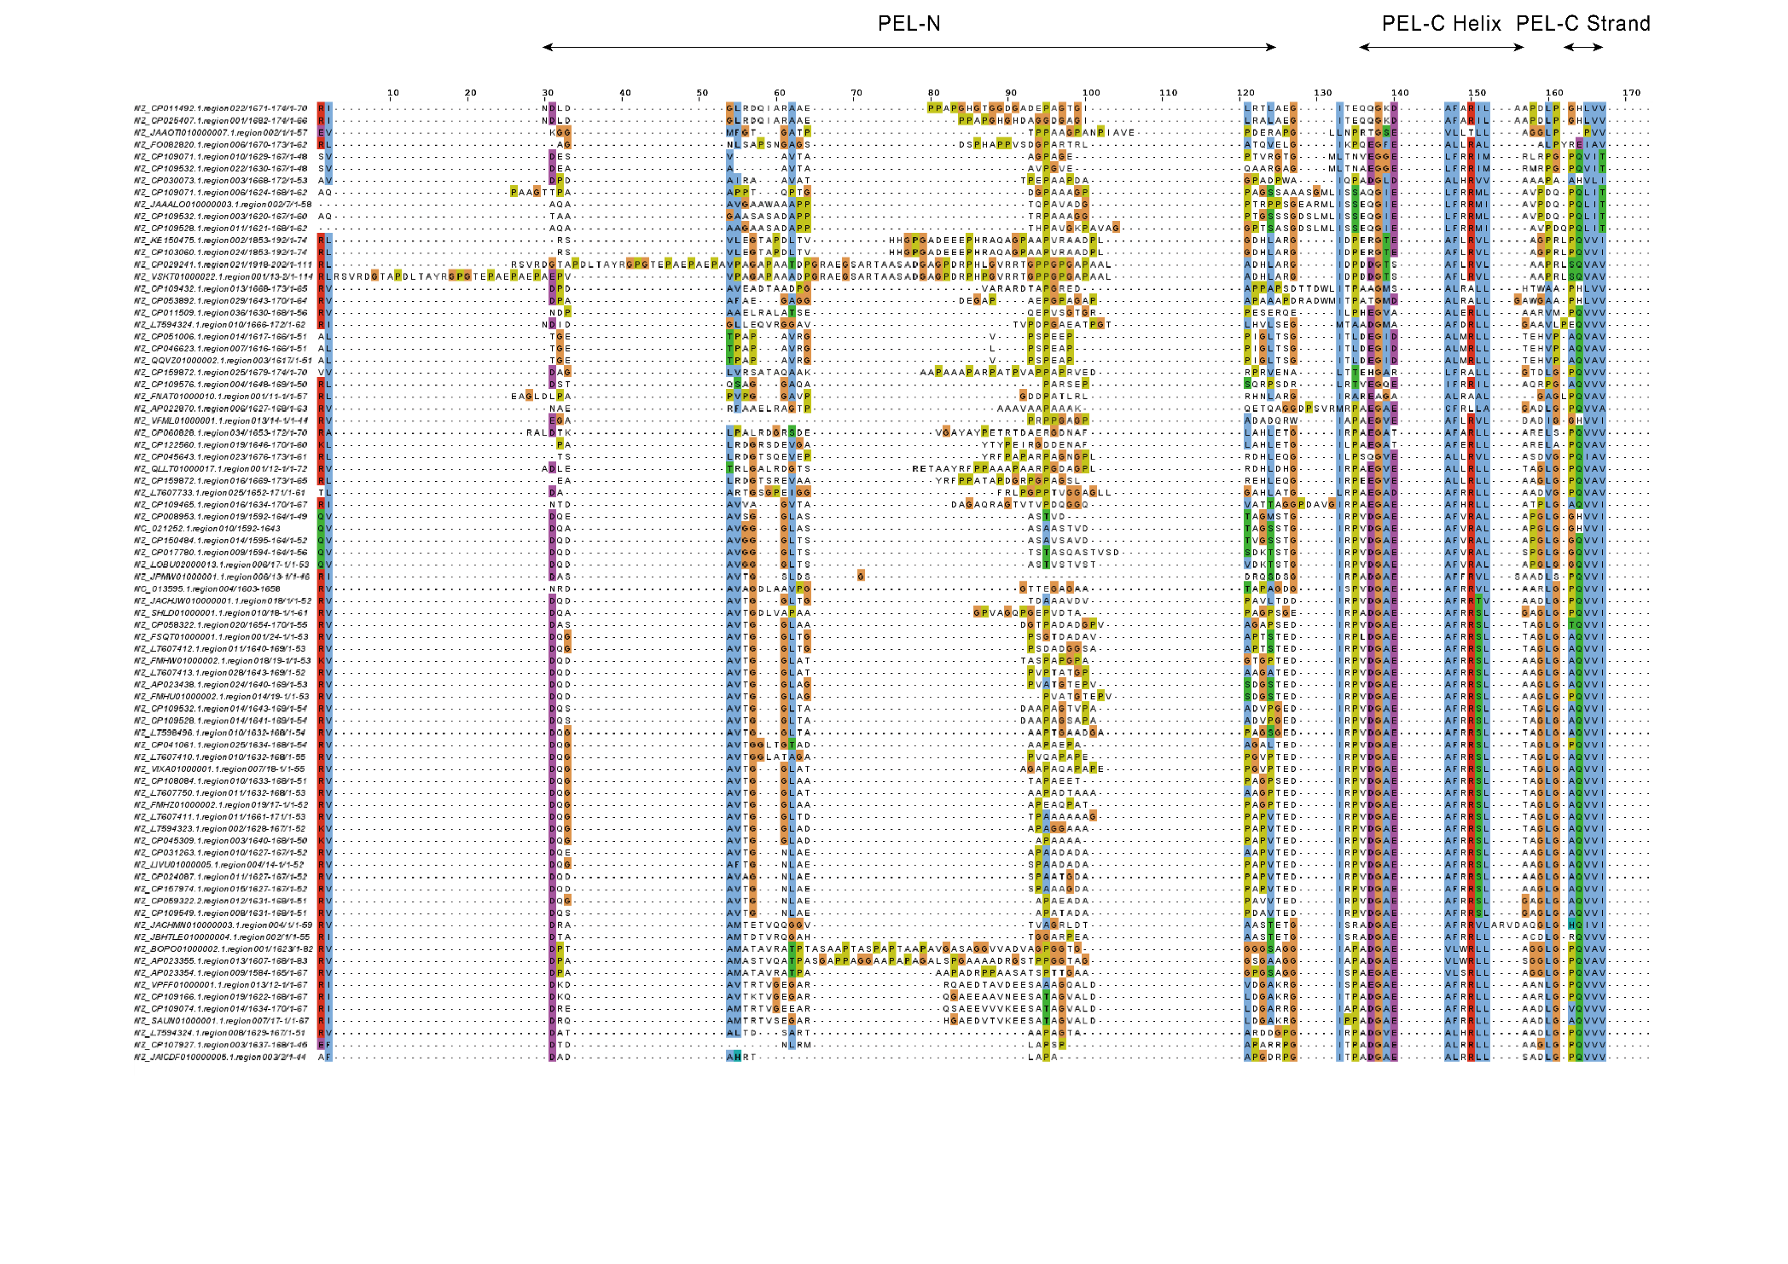
Supplementary Fig. 28. Multiple sequence alignment of the PEL regions in ClbB-type PKSs.
Multiple sequence alignment of the PEL regions from ClbB-type fully- and partially-reducing PKSs. Residues discussed in the manuscript are indicated by arrows and residue numbers.
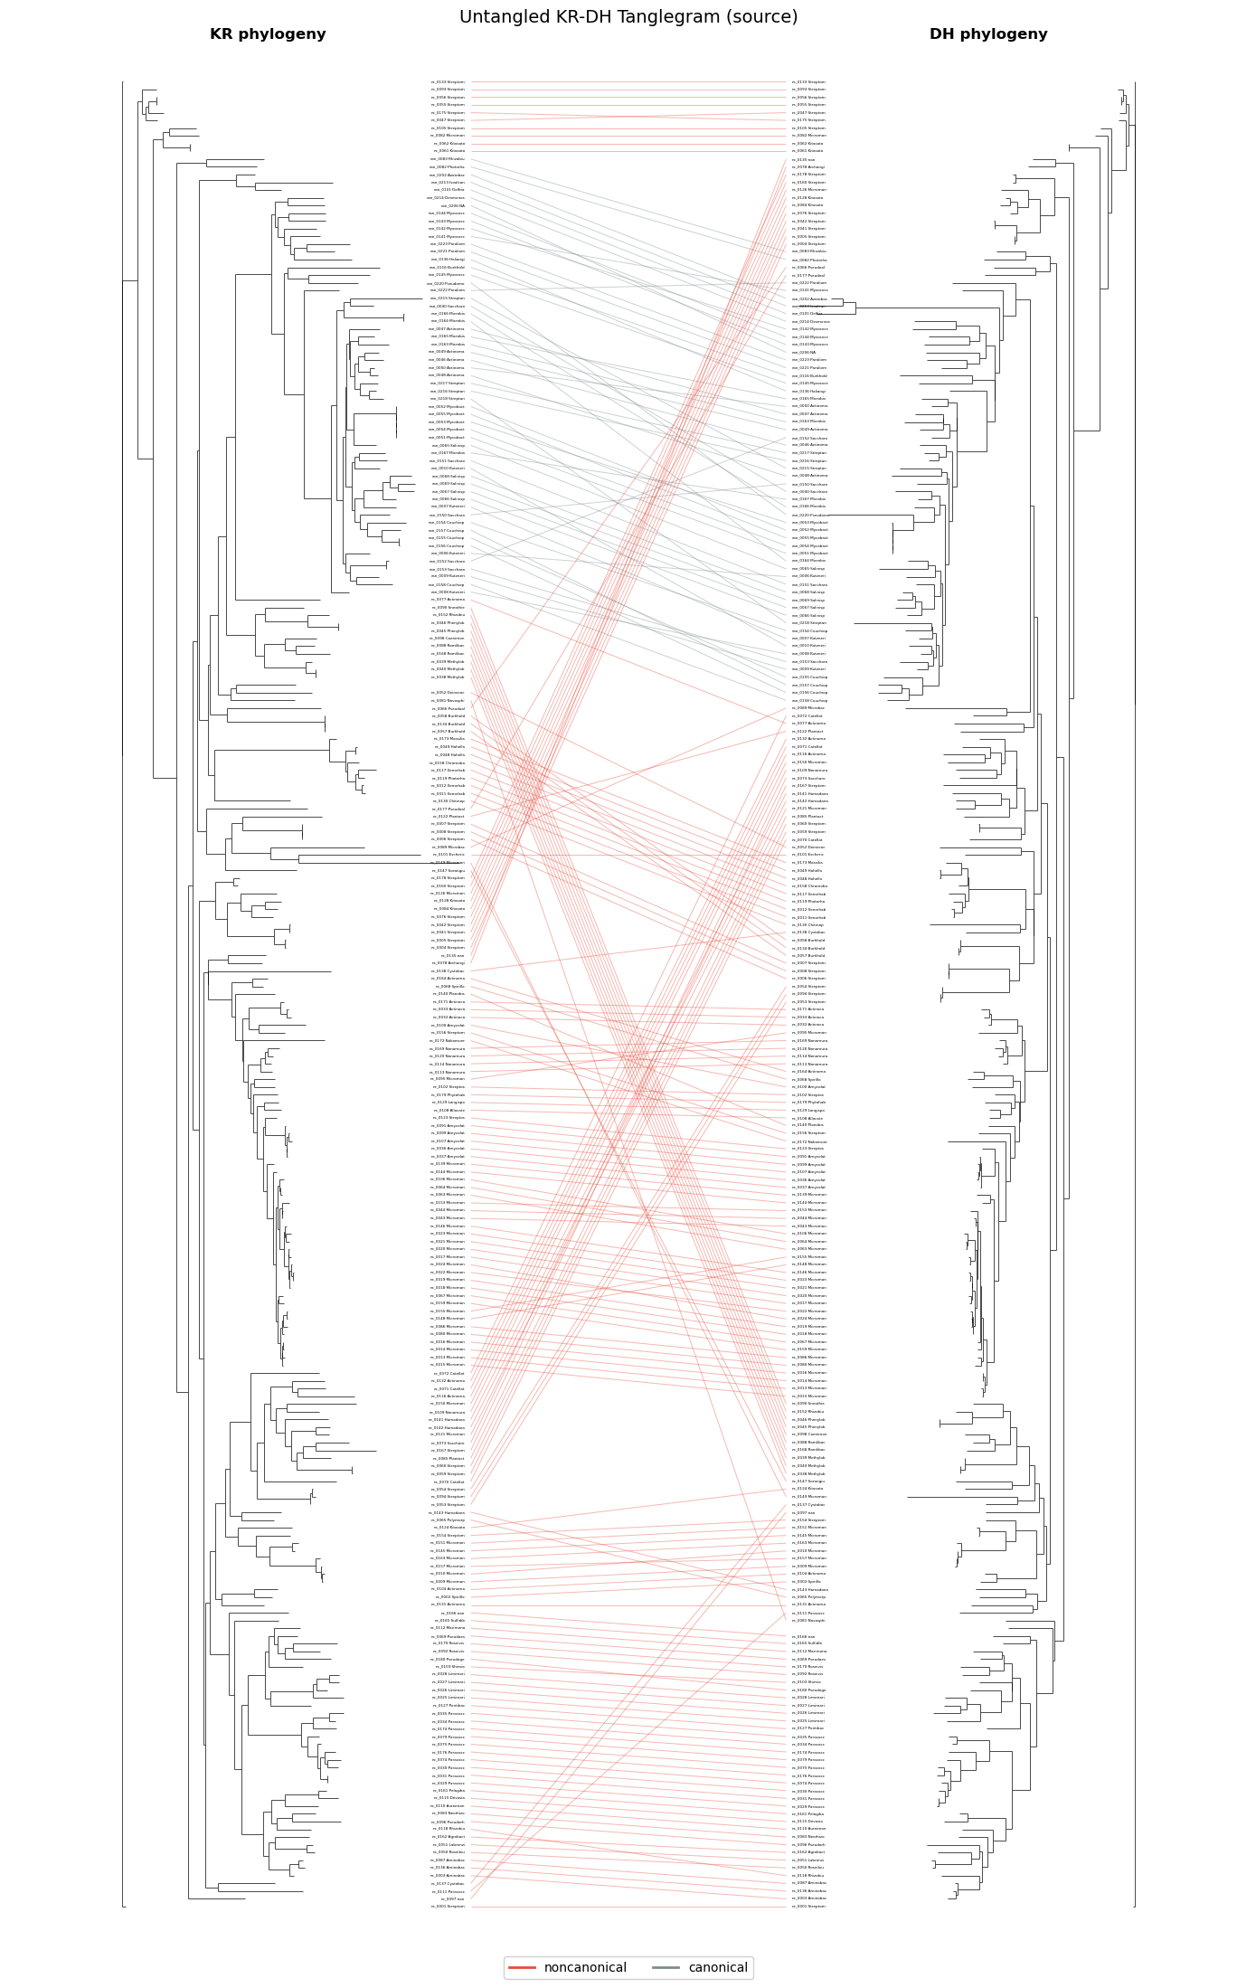
Supplementary Fig. 29. Cophylogenetic analysis of KR and DH domains.
Maximum-likelihood phylogenies of paired KR domains and their corresponding DH domains are shown on the left and right, respectively. Leaves were matched by module identifier, and connecting lines represent KR–DH pairs from the same module. Noncanonical KR–DH modules are highlighted in red, whereas canonical modules are shown in gray. Internal nodes were rotated to reduce line crossing while preserving tree topology and branch lengths.
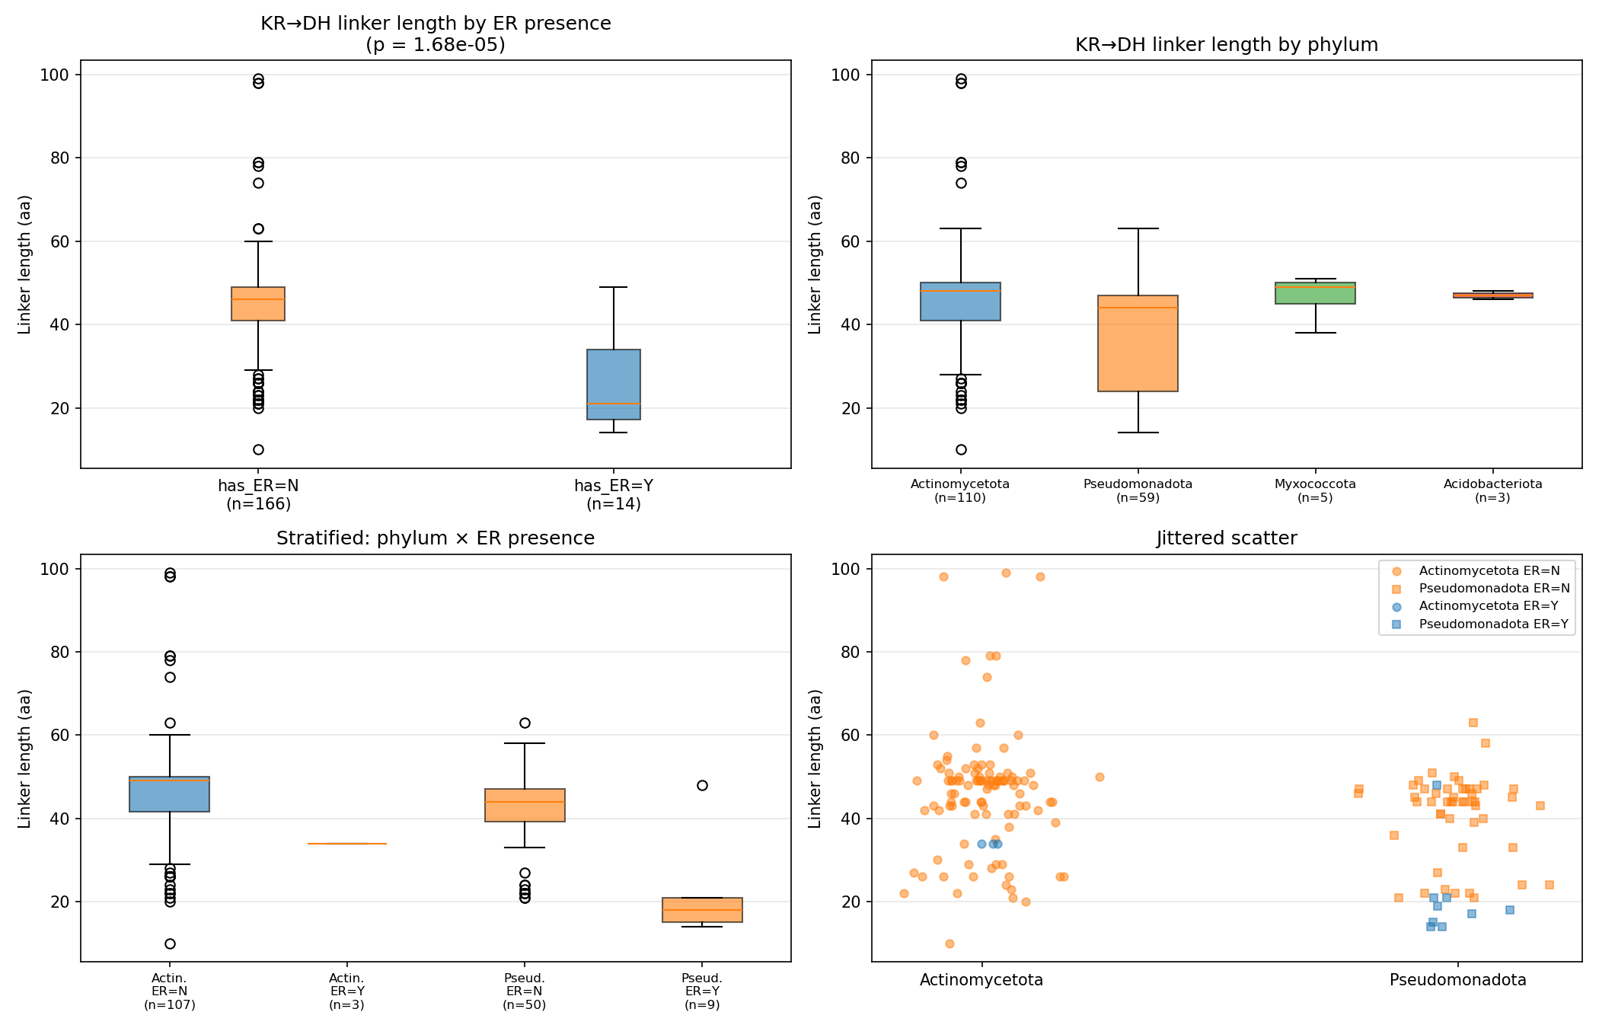
Supplementary Fig. 30. KR–DH linker sequence analysis.
KR–DH interdomain linker lengths were measured for noncanonical modules and compared according to ER-domain presence and host phylum. ER-containing modules had markedly shorter KR–DH linkers than ER-lacking modules, with the difference supported by a two-sided Mann–Whitney U test. Linker length distributions also differed across host phyla, but this pattern coincided with differences in ER-domain representation. Stratification by both phylum and ER status showed that the shorter linker phenotype was primarily associated with ER presence rather than phylum alone.

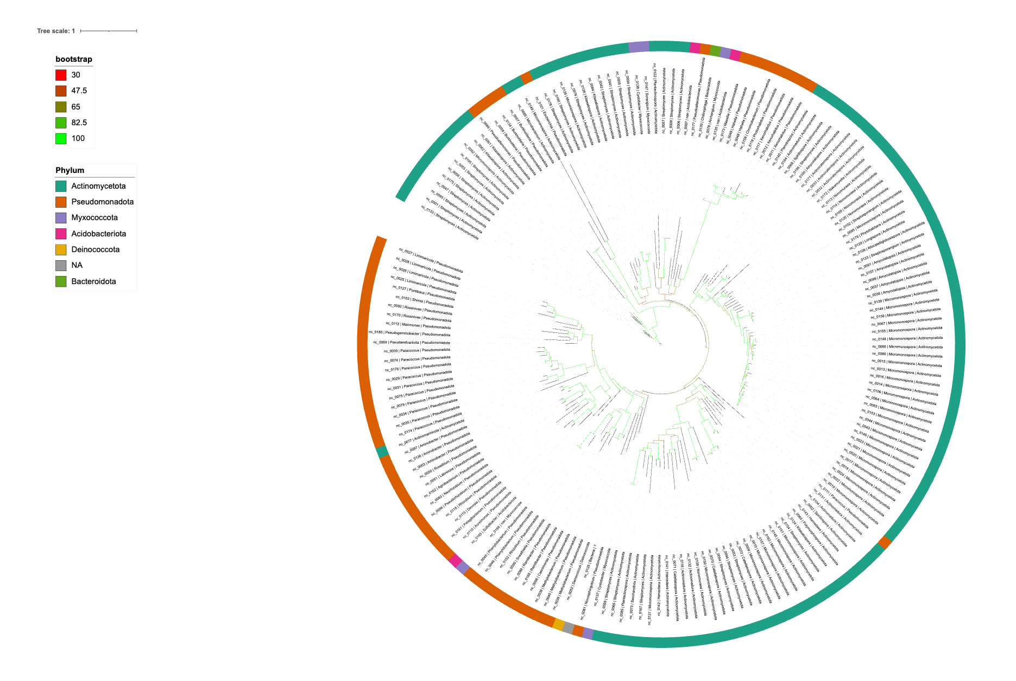
Supplementary Fig. 31. Phylogenetic analysis of ClbB-type KR domains.
A maximum-likelihood phylogeny of the ClbB-type KR domains was generated using MAFFT alignment with maximum-likelihood inference using IQ-TREE (Q.PFAM+F+I+R5 selected as best model from ModelFinder) and bootstrapped using UFBoot and 1,000 SH-aLRT.
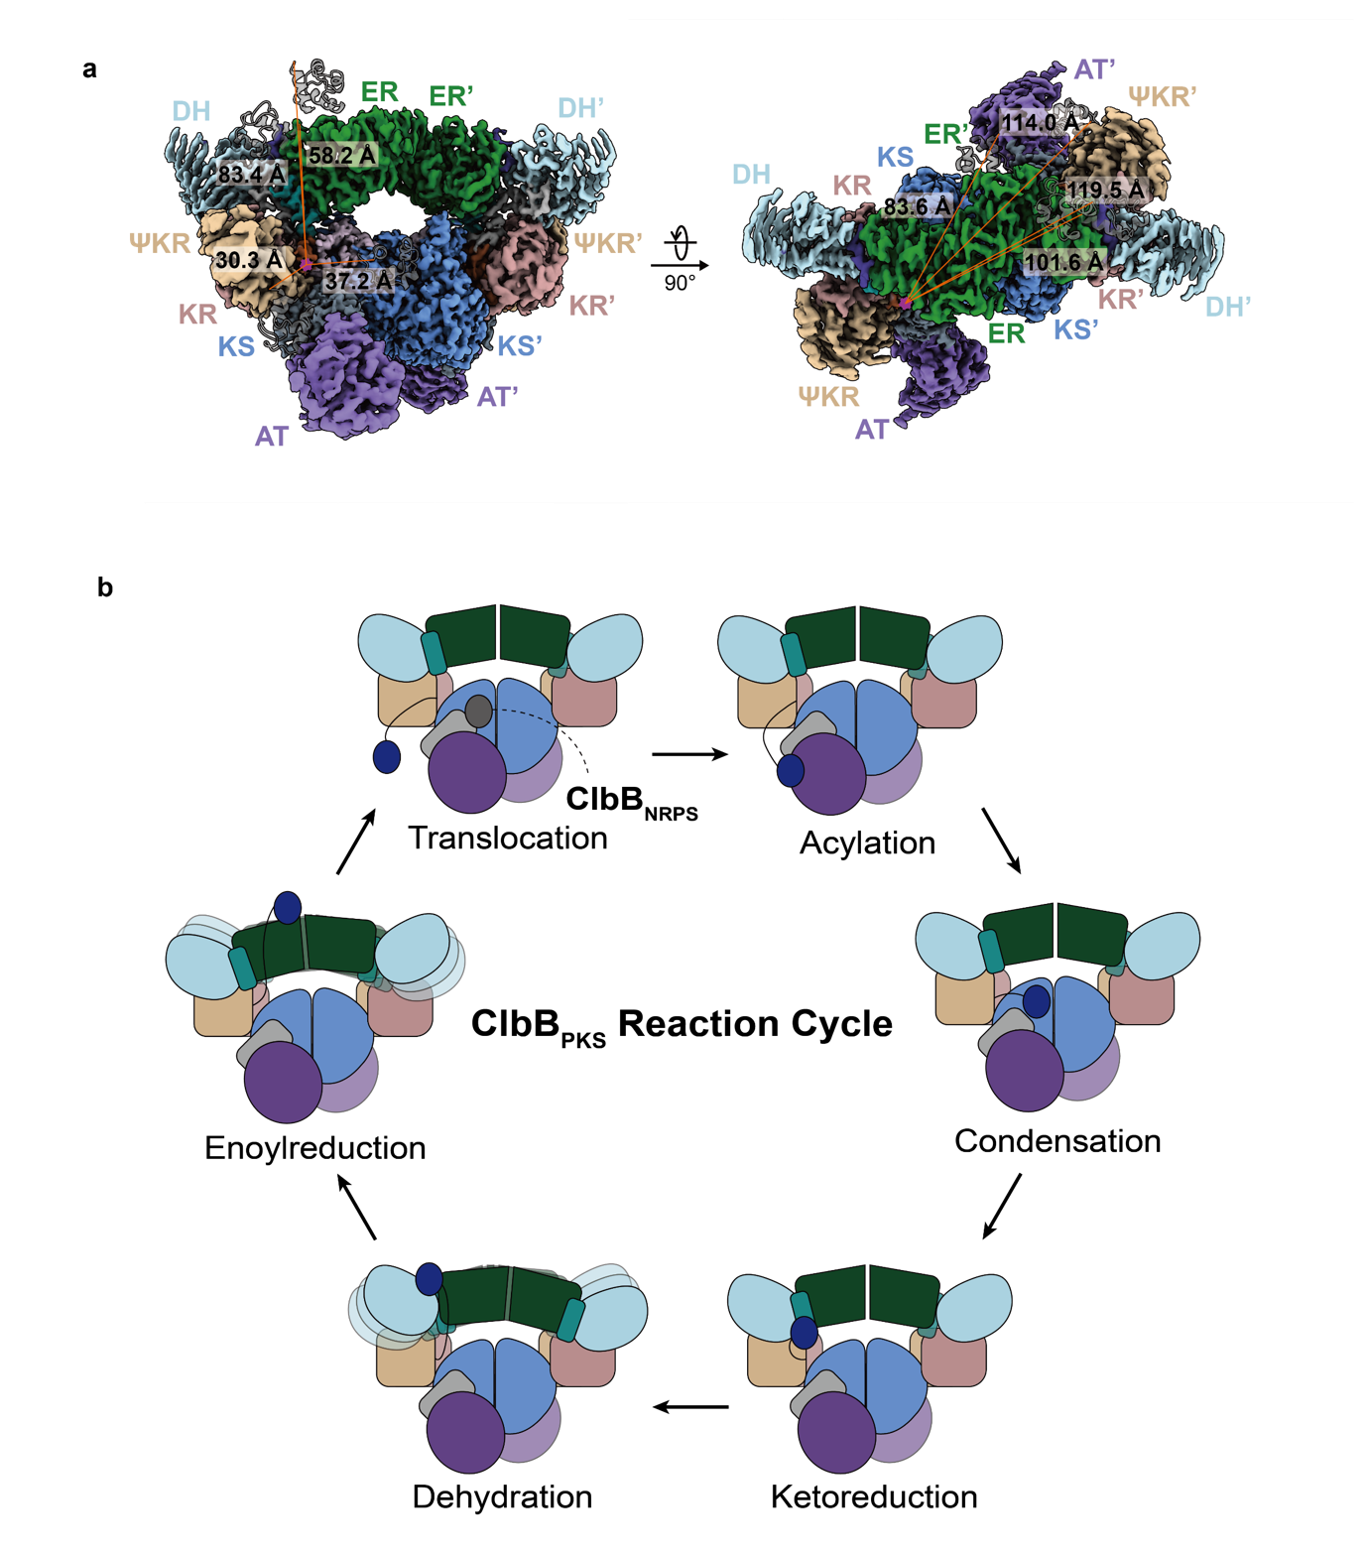

Supplementary Fig. 32. ACP-binding modes of ClbB_{PKS} and proposed reaction cycle of ClbB_{PKS}.

a, ACP docking models were generated from previously determined ACP–domain complexes (PDB 7S6B, 7S7C, 8VG4, and 8VF7). Each complex was first aligned to ClbB_{PKS}, followed by alignment of the AlphaFold3 ClbB ACP model to the ACP component, yielding composite ClbB ACP–domain docking models. b, Proposed reaction cycle of ClbB_{PKS}. The upstream module, ClbB_{NRPS}, transfers the intermediate tethered to its holo-PCP to the KS domain of ClbB_{PKS}. The AT domain then loads a malonyl group onto the holo-ACP domain. The KS domain catalyzes condensation between the transferred intermediate and the ACP-tethered malonyl extender unit. After β-ketoreduction, NADP⁺ dissociates from the KR domain, increasing the mobility of the DH–ER didomain. This movement may allow the DH domain to engage the ACP at its binding interface, promoting the dehydration reaction. Finally, the ER domain reduces the intermediate, which is subsequently transferred to the downstream enzyme, ClbC.

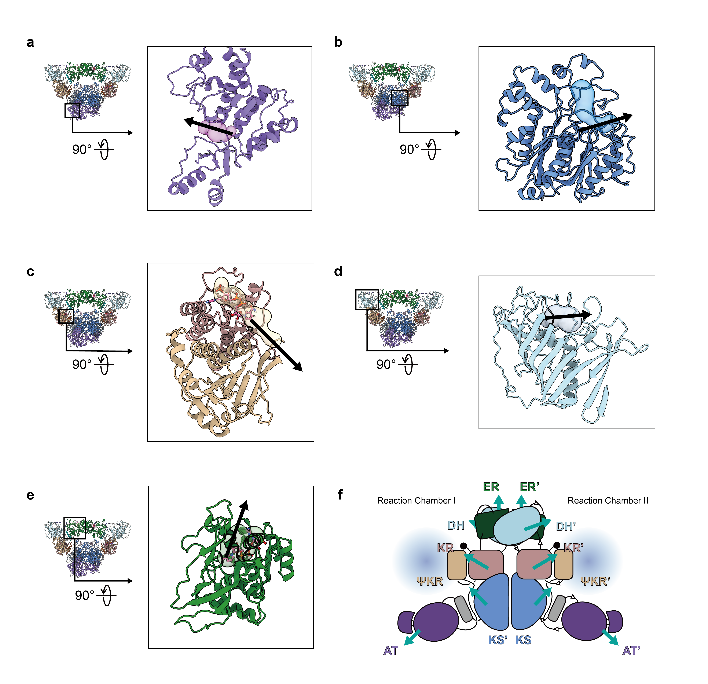
Supplementary Fig. 33. Cavity analysis of ClbB_{PKS}.
Catalytic cavities of the a, AT; b, KS; c, KR; d, DH; and e, ER domains of ClbB_{PKS}, shown as semi-transparent volumes with silhouettes. Black arrows indicate the directions of the cavity entrances. f, Schematic summary of cavity entrance orientations across all domains. Cyan arrows denote cavity entrance directions, and reaction chambers formed within each protomer are indicated by shaded blue.

Supplementary Video 1. Flexibility of the DH-ER didomain of apo-ClbB_{PKS} observed in the Multibody refinement.
References
1. Soohoo, A. M., Cogan, D. P., Brodsky, K. L. & Khosla, C. Structure and Mechanisms of Assembly-Line Polyketide Synthases. Annu. Rev. Biochem. 93, 471–498 (2024).
2. Keatinge-Clay, A. T. The structures of type I polyketide synthases. Nat. Prod. Rep. 29, 1050–1073 (2012).
3. Park, H., Kevany, B. M., Dyer, D. H., Thomas, M. G. & Forest, K. T. A polyketide synthase acyltransferase domain structure suggests a recognition mechanism for its hydroxymalonyl-acyl carrier protein substrate. PLoS One 9, (2014).
4. Cardone, G., Heymann, J. B. & Steven, A. C. One number does not fit all: Mapping local variations in resolution in cryo-EM reconstructions. J. Struct. Biol. 184, 226–236 (2013).
5. Zi Tan, Y. et al. Addressing preferred specimen orientation in single-particle cryo-EM through tilting. Nat. Methods 14, 793–796 (2017).
6. Zheng, S. Q. et al. MotionCor2: Anisotropic correction of beam-induced motion for improved cryo-electron microscopy. Nat Methods 14, 331–332 (2017).
7. Scheres, S. H. W. RELION: Implementation of a Bayesian approach to cryo-EM structure determination. J. Struct. Biol. 180, 519–530 (2012).
8. Punjani, A., Rubinstein, J. L., Fleet, D. J. & Brubaker, M. A. CryoSPARC: Algorithms for rapid unsupervised cryo-EM structure determination. Nat. Methods 14, 290–296 (2017).
9. Asarnow, D., Palovcak, E. & Cheng, Y. UCSF pyem v0.5. Zenodo https://doi.org/10.5281/zenodo.3576630 (2019).
10. Keatinge-Clay, A. T. & Stroud, R. M. The Structure of a Ketoreductase Determines the Organization of the β-Carbon Processing Enzymes of Modular Polyketide Synthases. Structure 14, 737–748 (2006).

