Supplementary Material

Microstructure modulation improving the mechanical and electrochemical properties of Pb-Ag-Ca Alloy
Dacheng Liu^{1,3}, Yiwen Chen¹, Ruidong Xu^{1,2}, Buming Chen^{1,2,3*}, Jun Guo^{1,2*}， Zhongcheng Guo^{1,2,3}
1 Faculty of Metallurgical and Energy Engineering, Kunming University of Science and Technology, Kunming 650093, China
2 Research Center of Metallurgical Electrode Materials Engineering Technology, Yunnan Province, Kunming 650106, China
3 Kunming Hendera Science and Technology Co., Ltd., Kunming, 650106, China)
* Corresponding Author Email: bumchen@kust.edu.cn (B. Chen); 1308gj@kust.edu.cn (J. Guo);
The supporting information includes 2 pages and 2 figures.
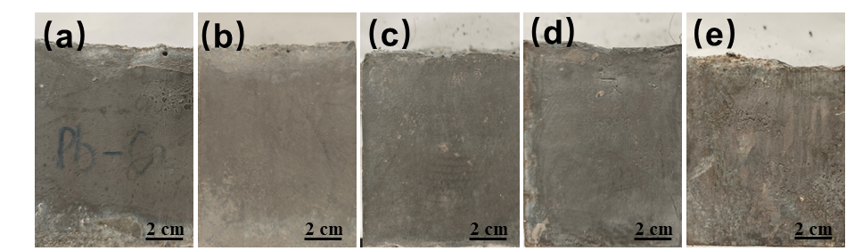
Fig.S1 (a) Cast alloy with 0 r/min, (b) Cast alloy with 50 r/min, (c) Cast alloy with 100 r/min, (d) Cast alloy with 150 r/min, (e) Cast alloy with 200 r/min
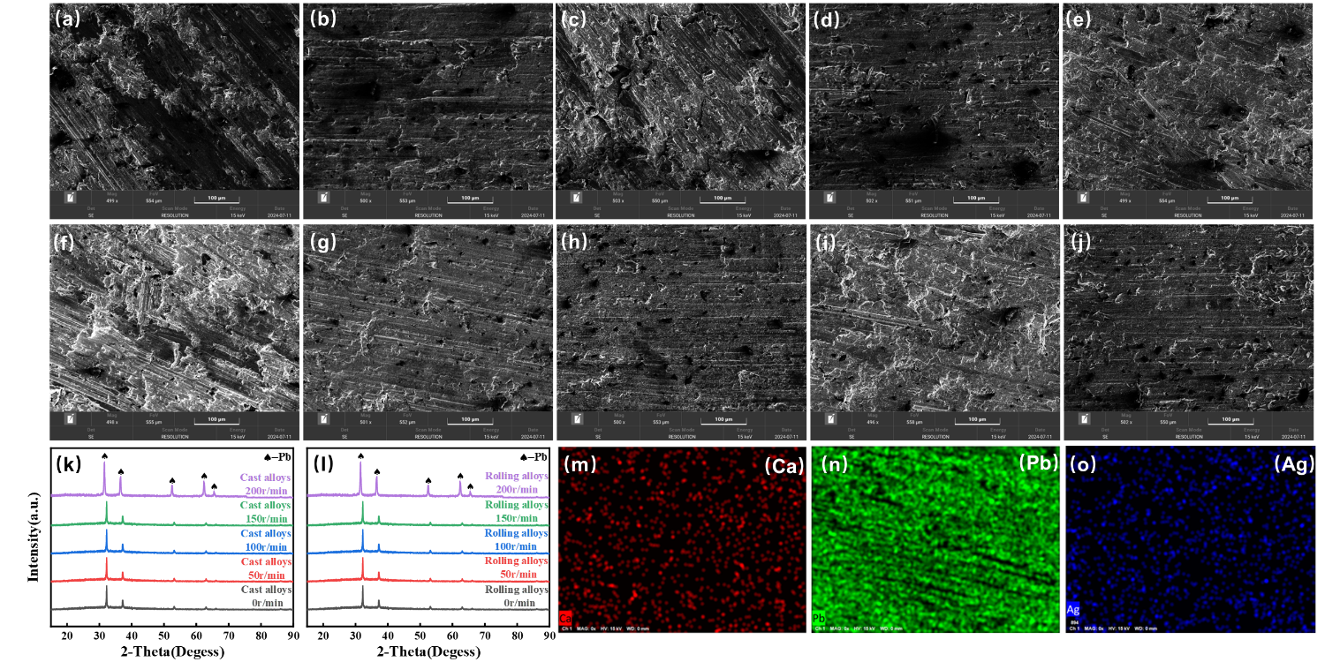
Fig. S2 (a)SEM of cast alloy with 0 r/min, (b)SEM of cast alloy with 50 r/min, (c)SEM of cast alloy with 100 r/min, (d)SEM of cast alloy with 150 r/min, (e)SEM of cast alloy with 200 r/min, (f)SEM of rolling alloy with 0 r/min, (g)SEM of rolling alloy with 50 r/min, (h)SEM of rolling alloy with 100 r/min, (i)SEM of rolling alloy with 150 r/min, (j)SEM of rolling alloy with 200 r/min, (k)XRD of Cast alloy, (l)XRD of rolling alloy, (m)EDS of Ca, (n) EDS of Pb, (o) EDS of Ag

