Precise and convergence pattern was obtained in the detection of mammary gland carcinoma using molybdenum enhanced poly taurine nano-biofilms compared to pathological examination
Hassan Nasrollahpourª, Balal Khalilzadeh^{b*}, Reza Rahbarghazi^{b,c}, Nevin Erk^{d}, Mohammad-Reza Rashidi^{e}, Abdolhossein Naseri^{a*}

ª Department of Analytical Chemistry, Faculty of Chemistry, University of Tabriz, Tabriz, Iran.
^{b} Stem Cell Research Center, Tabriz University of Medical Sciences, Tabriz, Iran.
^{c} Department of Applied Cell Sciences, Faculty of Advanced Medical Sciences, Tabriz University of Medical Sciences, Tabriz, Iran.
^{d} Department of Analytical Chemistry, Faculty of Pharmacy, Ankara University, Ankara 06560, Turkey.
^{e} Research Center for Pharmaceutical Nanotechnology (RCPN), Tabriz University of Medical Sciences, Tabriz, Iran.

Corresponding authors:
Balal Khalilzadeh, PhD, Stem Cell Research Center (SCRC), Tabriz University of Medical Sciences, 51664-14766 Tabriz- Iran, Tel: +98(41)-33363311; Fax: +98(41)33363231
Email: khalilzadehb@tbzmed.ac.ir, balalkhalilzadeh@gmail.com
Abdolhossein Naseri, PhD, Department of Analytical Chemistry, Faculty of Chemistry, University of Tabriz, PO Box 51644‐14766, Tabriz, Iran. Email: a_naseri@tabrizu.ac.ir

Figure captions:
Figure S1: Investigation of the effect of each modifier on the electrochemical behavior of the proposed framework. All the data were obtained in K₄[Fe (CN)₆] (5 mM).
Figure S2: The EDX and dot mapping quantitative elemental analysis of the different modified electrodes. A and B: MoO₃ modified electrode. C and D: p-Tau modified electrode. E and F: MoO3/p-Tau modified electrode.
Figure S3: Effect of the deposition cycle numbers on the electrochemical signals. A) DPV voltammograms and B) Correlated histograms. All the signals were obtained in K₄[Fe(CN)₆] (5 mM).
Figure S4: Incubation time study of anti-HER-2 on the as-prepared MoO3/p-Tau/GCE at different time points (10, 30, 45, 60, 90 and 120 minutes).
Figure S5: Evaluation of the selectivity of the design immunosensor in the presence of 10 pg/mL of CEA, BSA and CA-15-3, different concentrations of HER-2 (1pg/mL and 1 fg/mL) and also in the presence of mixture of them.
Figure S6: The reproducibility screening of the suggested framework at different three electrodes with the same procedure.
Figure S7: The signal stability of the immunosensor for 10 consecutive signals.

Figure S1

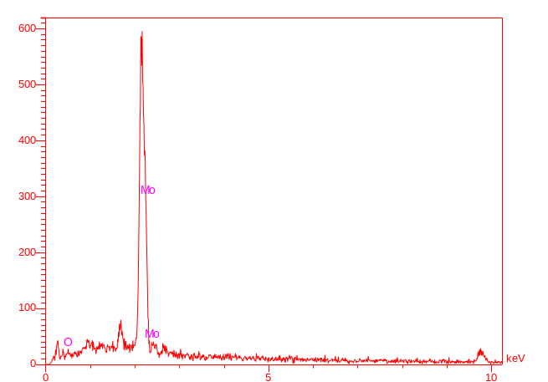
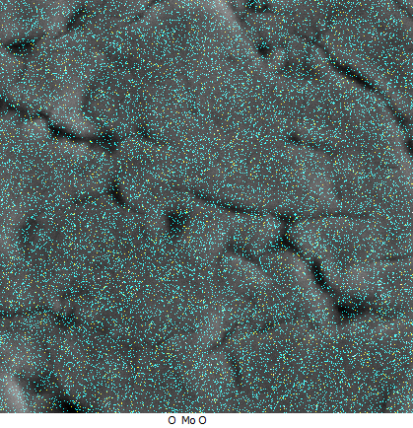
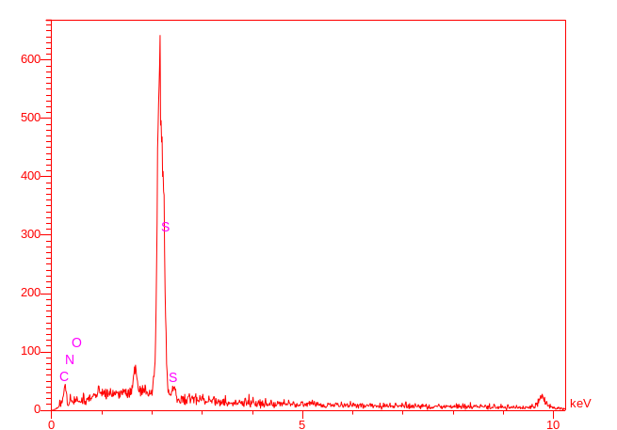
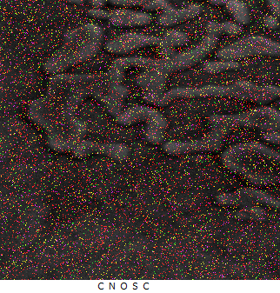
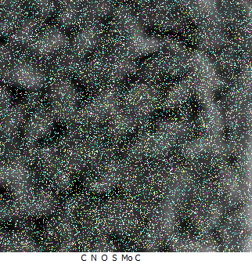
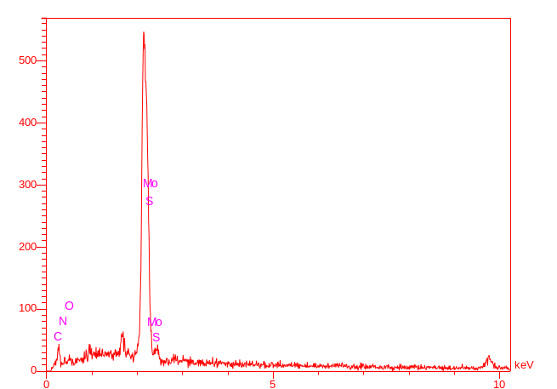
A
B
C
D
F
E

Figure S2

Figure S3

Figure S4

Figure S5

Figure S6

Figure S7

