Supplementary Material.
Supp Table 1: Latitude and Longitude coordinates for each plate array and the beginning of each plankton tow transect.
Site | Latitude | Longitude
Education Centre_Array | -37.822370 | 144.909182
Education Centre_T1 | -37.821619 | 144.909950
Education Centre_T2 | -37.821212 | 144.909676
Education Centre_T3 | -37.820881 | 144.909429
Education Centre_T4 | -37.820470 | 144.909112
Education Centre_T5 | -37.820182 | 144.908860
Yarraville_Array | -37.822475 | 144.904498
Yarraville_T1 | -37.828421 | 144.900658
Yarraville_T2 | -37.828343 | 144.900274
Yarraville_T3 | -37.828148 | 144.899756
Yarraville_T4 | -37.828012 | 144.899262
Yarraville_T5 | -37.827872 | 144.898865
Station Pier_Array | -37.842115 | 144.931001
Station Pier_T1 | -37.841858 | 144.930064
Station Pier_T2 | -37.841748 | 144.929725
Station Pier_T3 | -37.841528 | 144.929349
Station Pier_T4 | -37.841363 | 144.928845
Station Pier_T5 | -37.841232 | 144.928351

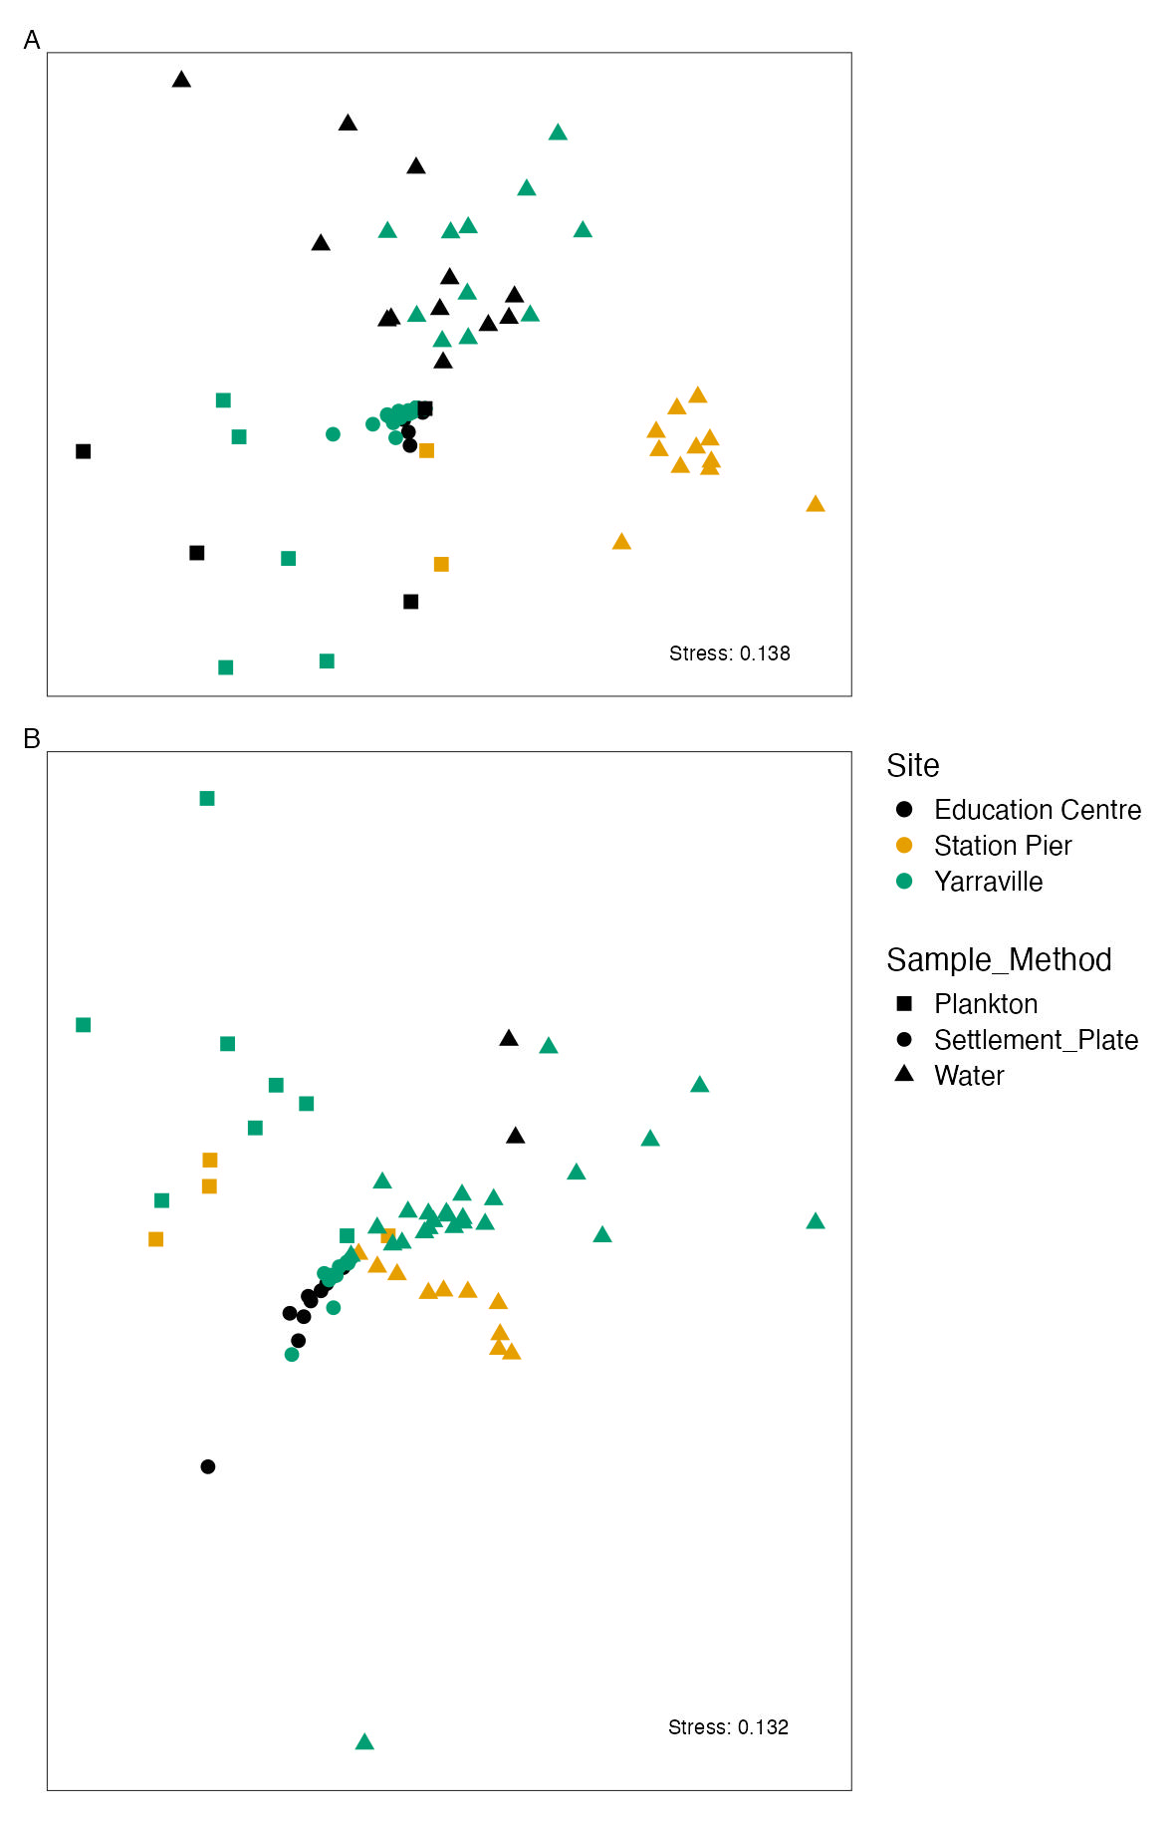
Supp Figure 1: nMDS of communities detect at OTU level for A) 18S and B) COI amplicons showing OTUs detected for plankton tows (Square), settlement plates (Circle) and water samples (Triangle) at Education Centre (Black), Station Pier (Yellow) and Yarraville (Green) during the summer sampling period.

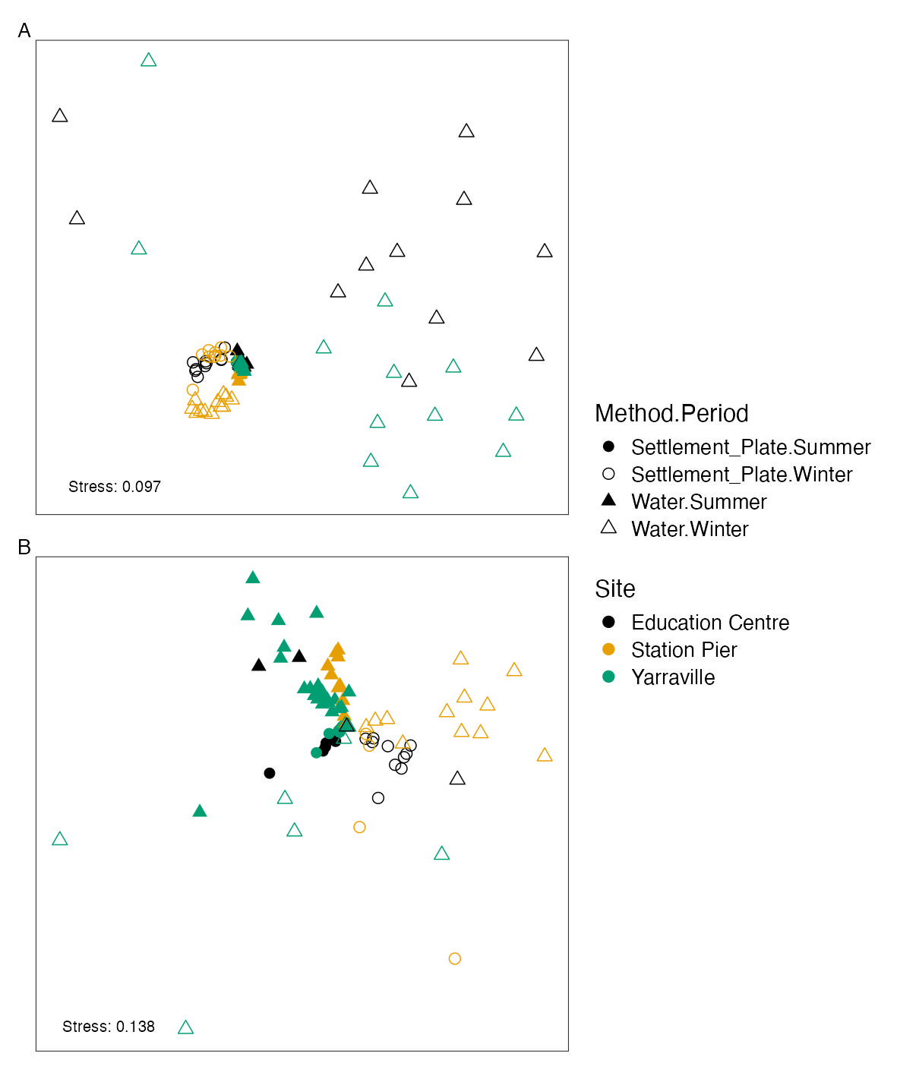
Supp Figure 2: nMDS of communities detect at OTU level for A) 18S and B) COI amplicons showing OTUs detected for settlement plates (Circle) and water samples (Triangle) during the summer (filled) and winter (hollow) sampling periods at Education Centre (Black), Station Pier (Yellow) and Yarraville (Green).

