Supplementary Figures

Supplementary Figure 1. Automated hypothalamic subunit segmentation of all subjects. T1-weighted images from multiple participants demonstrate robust and anatomically consistent parcellation of supraoptic nucleus– and paraventricular nucleus–associated subunits across individuals.

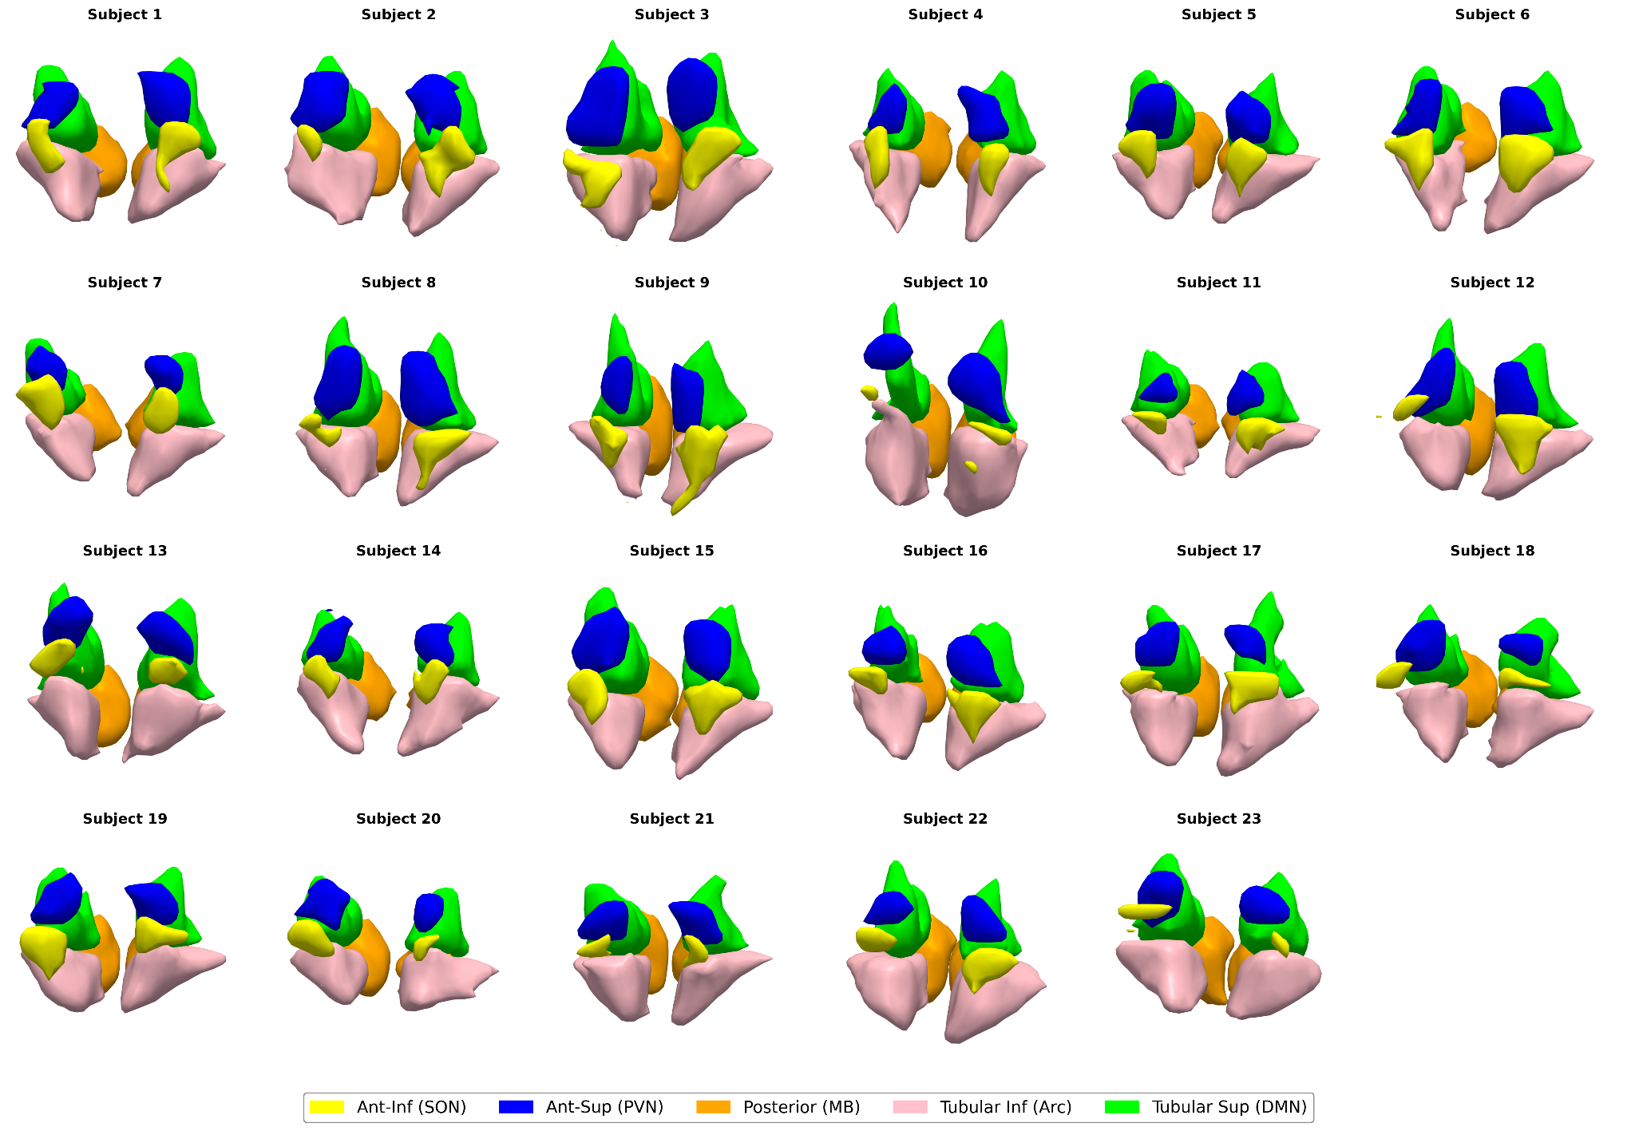
Supplementary Figure 2. Posterior hypothalamic volumes and neurodevelopmental traits. (a) Partial correlation between mammillary body–dominant posterior hypothalamic subunit volume and Autism-Spectrum Quotient scores. (b) Partial correlation between mammillary body–dominant posterior hypothalamic subunit volume and ADHD symptom scores. Both correlations show no significant associations, supporting the anatomical specificity of anterior magnocellular subunit findings. ns, not significant.
