Table 1 In vitro antiproliferative activity of target compounds and 5-fluorouracil against five human cancer cell lines
Compd. | R | IC₅₀(μM)ª
Compd. | R | HepG2 | MCF-7 | NCI-H1650 | U87MG | A549
16a | 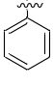 | N.D. | 12.68±1.46 | N.D. | N.D. | 11.10±1.47
16b | 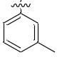 | N.D. | N.D. | N.D. | 11.61±0.95 | 10.70±0.92
16c | 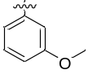 | 9.22±0.78 | 9.35±0.75 | N.D. | N.D. | N.D.
16d | 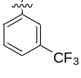 | 11.76±0.99 | N.D. | N.D. | N.D. | 16.66±2.38
16e | 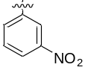 | N.D. | N.D. | N.D. | N.D. | 16.67±2.06
16f | 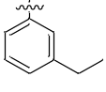 | 5.82±0.35 | 8.40±0.49 | 11.85±1.31 | 3.28±0.15 | 7.57±0.53
16g | 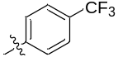 | N.D. | N.D. | N.D. | N.D. | 15.98±1.25
16h | 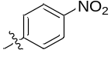 | N.D. | N.D. | N.D. | 13.69±1.58 | N.D.
16i | 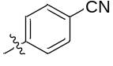 | 24.66±1.78 | N.D. | N.D. | 10.69±0.86 | N.D.
16l | 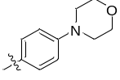 | N.D. | N.D. | N.D. | 19.04±1.07 | N.D.
16m | 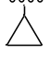 | 7.27±0.19 | N.D. | N.D. | 7.78±0.61 | N.D.
16p | 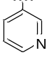 | 6.25±0.59 | N.D. | N.D. | 6.3±0.47 | N.D.
16q | 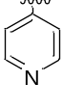 | 9.35±0.73 | N.D. | N.D. | N.D. | N.D.
16r | 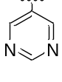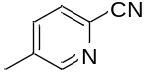 | 7.66±0.82 | 8.42±1.19 | 7.38±1.01 | N.D. | N.D.
16t |  | N.D. | 12.14±0.96 | 10.78±0.91 | N.D. | 11.49±1.01
16u | 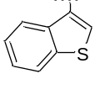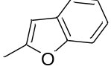 | N.D. | N.D. | N.D. | 10.50±1.01 | 15.95±1.42
16v |  | N.D. | N.D. | N.D. | 11.68±1.09 | N.D.
5-FU^{b} | - | 6.25±0.65 | 9.45±0.83 | 15.98±1.27 | 12.25±1.36 | 7.39±0.83
ª Antitumor activity was assayed by exposure for 72 h to substances and expressed as concentration required to inhibit tumor cell proliferation by 50% (IC₅₀). Data are presented as the mean ± SDs of three independent experiments. ^{b} Positive control. N. D.: Not Detected

