Design, Synthesis and Antitumor Activity Evaluation in Vitro of
Novel 1,6-Naphthyridine Derivatives
Xiao-Jie Si ¹, Xin-Yi Ma ², Su-Lin Zhang ², Ming-Yue Zheng ², Motahareh Asgari ^{1*}, Chen-Guo Feng ^{1*}

- Motahareh Asgari
motahareh_asgari@shutcm.edu.cn
- Chenguo Feng
fengcg@shutcm.edu.cn

¹ The Research Center of Chiral Drugs, Shanghai Frontiers Science Center for TCM Chemical Biology, Innovation Research Institute of Traditional Chinese Medicine, Shanghai University of Traditional Chinese Medicine, Shanghai, 201203, China.
² Drug Discovery and Design Center, State Key Laboratory of Drug Research, Shanghai Institute of Materia Medica, Chinese Academy of Sciences, 555 Zuchongzhi Road, Shanghai 201203, China.

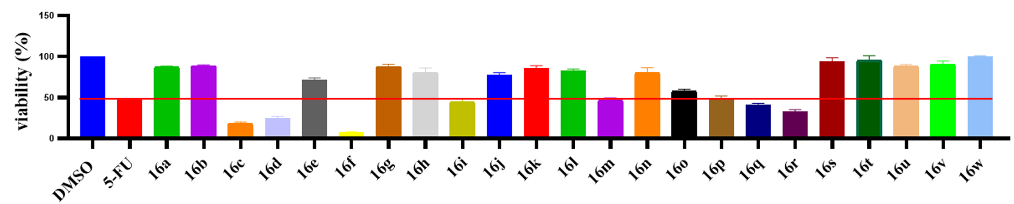
Fig. S1 The inhibitory activity of the compounds (16a–16w) against HepG2 cells
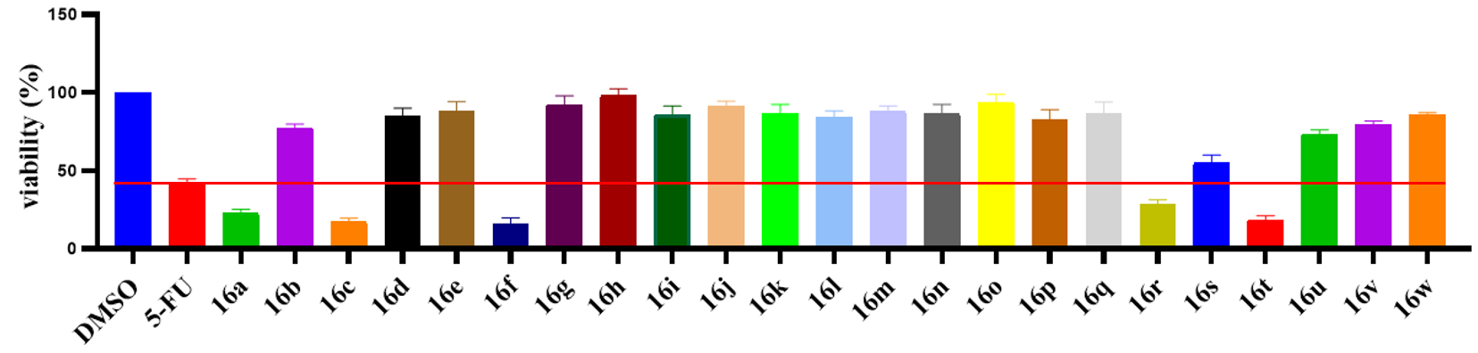
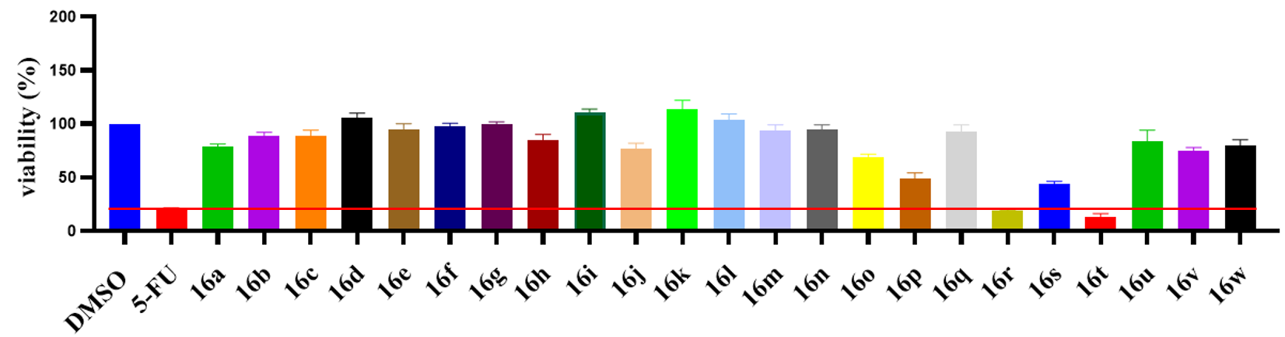
Fig. S2 The inhibitory activity of the compounds (16a–16w) against MCF-7 cells
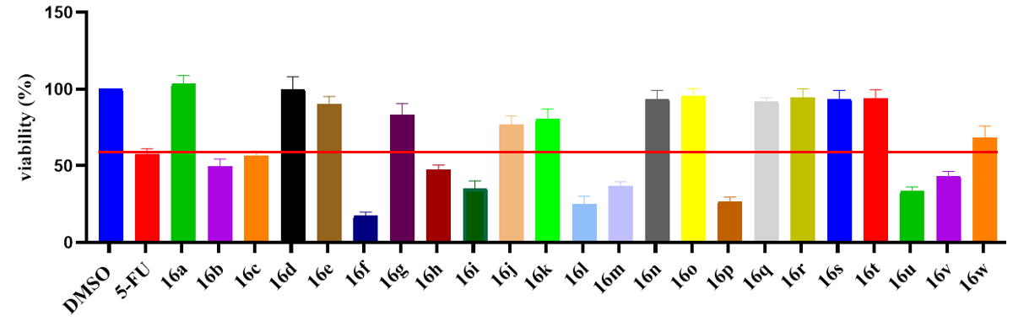
Fig. S3 The inhibitory activity of the compounds (16a–16w) against NCI-H1650 cells
Fig. S4 The inhibitory activity of the compounds (16a–16w) against U87MG cells

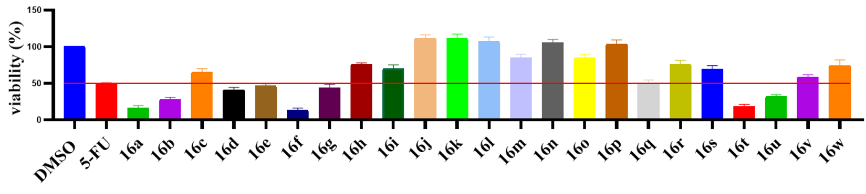
Fig. S5 The inhibitory activity of the compounds (16a–16w) against A549 cells

