Supplementary Materials
Protein Language Models Rescue Variant Pathogenicity Prediction in Intrinsically Disordered Regions
Hayden Farquhar
January 2026

Supplementary Materials
Protein Language Models Rescue Variant Pathogenicity Prediction in Intrinsically Disordered Regions Through Synergistic Integration with Structure-Based Methods
Hayden Farquhar

Supplementary Tables

Supplementary Table S1. Dataset composition and characteristics.
Characteristic | Training Set | Test Set | VUS Set
Total variants | 40,773 | 12,180 | 22,927
Pathogenic/Likely Pathogenic | 15,687 (38.5%) | 4,698 (38.6%) | —
Benign/Likely Benign | 25,086 (61.5%) | 7,482 (61.4%) | —
Unique genes | 4,127 | 2,891 | 3,456
Variants in IDRs | 8,154 (20.0%) | 2,436 (20.0%) | 4,585 (20.0%)
AlphaMissense coverage | 39,543 (97.0%) | 11,815 (97.0%) | 22,248 (97.0%)
gnomAD constraint coverage | 39,431 (96.7%) | 11,756 (96.5%) | 22,019 (96.0%)

Supplementary Table S2. Complete list of engineered features (n=35).
Category | Feature | Description
Amino Acid | hydrophobicity_ref/alt/diff | Kyte-Doolittle hydrophobicity scale
 | volume_ref/alt/diff | Amino acid side chain volume
 | charge_ref/alt/diff | Net charge at physiological pH
 | polarity_ref/alt/diff | Polar vs nonpolar classification
 | helix_propensity_ref/alt/diff | Alpha helix formation tendency
Substitution | blosum62_score | BLOSUM62 substitution matrix score
 | grantham_approx | Grantham distance approximation
Position | relative_position | Position normalized by protein length
 | dist_to_n_terminus | Distance to N-terminus (residues)
 | dist_to_c_terminus | Distance to C-terminus (residues)
Gene Constraint | oe_mis | Observed/expected missense ratio
 | oe_lof | Observed/expected LoF ratio
 | oe_lof_upper | Upper bound of oe_lof CI
 | pLI | Probability of LoF intolerance
 | mis_z | Missense Z-score
Structure | disorder_score | IUPred2A disorder prediction
External | alphamissense_score | AlphaMissense pathogenicity score
Note: ESM-2 embeddings (1,280 dimensions) are not listed individually.

Supplementary Table S3. XGBoost model hyperparameters.
Parameter | Value | Rationale
n_estimators | 500 | Maximum trees with early stopping
max_depth | 6 | Moderate depth to prevent overfitting
learning_rate | 0.05 | Conservative learning rate
subsample | 0.8 | Row subsampling for regularization
colsample_bytree | 0.8 | Feature subsampling per tree
early_stopping_rounds | 50 | Stop if no improvement for 50 rounds
scale_pos_weight | 1.60 | Adjusted for class imbalance (61.5%/38.5%)
objective | binary:logistic | Probability output for calibration
eval_metric | auc | Optimize for discrimination

Supplementary Table S4. Top 25 features ranked by SHAP importance.
Rank | Feature | Category | Mean |SHAP| | Contribution
1 | esm_234 | ESM Embedding | 0.0165 | 1.7%
2 | esm_478 | ESM Embedding | 0.0123 | 1.3%
3 | oe_mis | Gene Constraint | 0.0098 | 1.0%
4 | esm_226 | ESM Embedding | 0.0092 | 0.9%
5 | esm_1081 | ESM Embedding | 0.0089 | 0.9%
6 | alphamissense_score | External | 0.0086 | 0.9%
7 | pLI | Gene Constraint | 0.0072 | 0.7%
8 | grantham_approx | Substitution | 0.0068 | 0.7%
9 | esm_1160 | ESM Embedding | 0.0054 | 0.6%
10 | disorder_score | Structure | 0.0052 | 0.5%
11 | hydrophobicity_diff | Amino Acid | 0.0048 | 0.5%
12 | blosum62_score | Substitution | 0.0045 | 0.5%
13 | esm_104 | ESM Embedding | 0.0046 | 0.5%
14 | volume_diff | Amino Acid | 0.0042 | 0.4%
15 | mis_z | Gene Constraint | 0.0038 | 0.4%
Note: ESM embedding dimensions contributed 89.4% of total importance collectively.

Supplementary Table S5. Statistical comparison of model performance.
Comparison | Test | Statistic | P-value
Our Model vs AlphaMissense (AUC) | DeLong | Z = 8.42 | <0.001
Our Model vs CADD (AUC) | DeLong | Z = 31.7 | <0.001
Our Model vs REVEL (AUC) | DeLong | Z = 6.89 | <0.001
Classification concordance (vs AM) | McNemar | chi-squared = 89.3 | <0.001
AUC-ROC difference (Our - AM) | Bootstrap | 0.044 | 95% CI: 0.036-0.052

Supplementary Table S6. Mean pathogenic probability by amino acid substitution type.
Substitution Type | Mean P(Path) | 95% CI | N variants
Conservative (I<->V, L<->I) | 0.18 | 0.15-0.21 | 1,247
Similar charge (K<->R, D<->E) | 0.31 | 0.28-0.34 | 2,891
Hydrophobic to polar | 0.52 | 0.49-0.55 | 3,456
Charge change (R->Q, E->K) | 0.58 | 0.55-0.61 | 2,134
Proline introduction (X->P) | 0.72 | 0.68-0.76 | 892
Cysteine disruption (C->X) | 0.78 | 0.74-0.82 | 645
Glycine to bulky (G->R/W/Y) | 0.81 | 0.77-0.85 | 423

Supplementary Table S7. Performance in top 10 most frequently tested genes.
Gene | Variants | Our AUC | AM AUC | Difference | VUS Reclass.
BRCA1 | 1,247 | 0.981 | 0.942 | +4.1% | 58.3%
BRCA2 | 1,892 | 0.976 | 0.931 | +4.8% | 54.2%
SCN5A | 734 | 0.968 | 0.923 | +4.9% | 49.1%
KCNQ1 | 521 | 0.972 | 0.938 | +3.6% | 51.4%
LDLR | 612 | 0.984 | 0.951 | +3.5% | 62.7%
MYH7 | 489 | 0.971 | 0.929 | +4.5% | 47.8%
PKP2 | 287 | 0.969 | 0.918 | +5.6% | 55.1%
RYR2 | 445 | 0.963 | 0.912 | +5.6% | 44.9%
TTN | 892 | 0.958 | 0.901 | +6.3% | 41.2%
TP53 | 378 | 0.989 | 0.962 | +2.8% | 67.3%

Supplementary Table S8. Model calibration assessment.
Metric | Our Model | AlphaMissense | Interpretation
Brier Score | 0.053 | 0.098 | Lower = better
Expected Calibration Error | 0.007 | 0.034 | Lower = better
Maximum Calibration Error | 0.023 | 0.089 | Lower = better
Hosmer-Lemeshow chi-squared | 8.7 | 34.2 | p>0.05 = good fit
Hosmer-Lemeshow p-value | 0.37 | <0.001 | Non-significant = good

Supplementary Table S9. Ablation analysis demonstrating independent value of ESM-2 embeddings.
Model | AUC-ROC | 95% CI | vs AlphaMissense | FP Reduction at 90% Sens.
Full Model (ESM-2 + AM + Features) | 0.978 | 0.973-0.982 | +4.7% (p<0.0001) | 55.4%
Ablated Model (ESM-2 + Features, NO AM) | 0.929 | 0.924-0.934 | -0.5% (comparable) | 19.9%
AlphaMissense (baseline) | 0.934 | 0.928-0.940 | — | —
Note: Ablated model excludes AlphaMissense as an input feature, demonstrating ESM-2 provides independent predictive value. Test set n=12,180 variants. Permutation test used for statistical significance.

Supplementary Table S10. Temporal validation on post-AlphaMissense variants (prospective-like validation).
Model | AUC-ROC | 95% CI | Interpretation
Full Model | 0.968 | 0.966-0.970 | Robust on novel variants
Ablated Model (no AM) | 0.945 | 0.942-0.947 | ESM-2 independent value confirmed
AlphaMissense | 0.925 | 0.923-0.928 | Baseline comparison
Note: Temporal validation on n=7,891 variants added to ClinVar after AlphaMissense publication (September 2023). This prospective-like validation demonstrates robust generalization to truly novel variants and confirms ESM-2 provides independent predictive value on data completely independent of AlphaMissense’s training set.

Supplementary Figures

Supplementary Figure S1
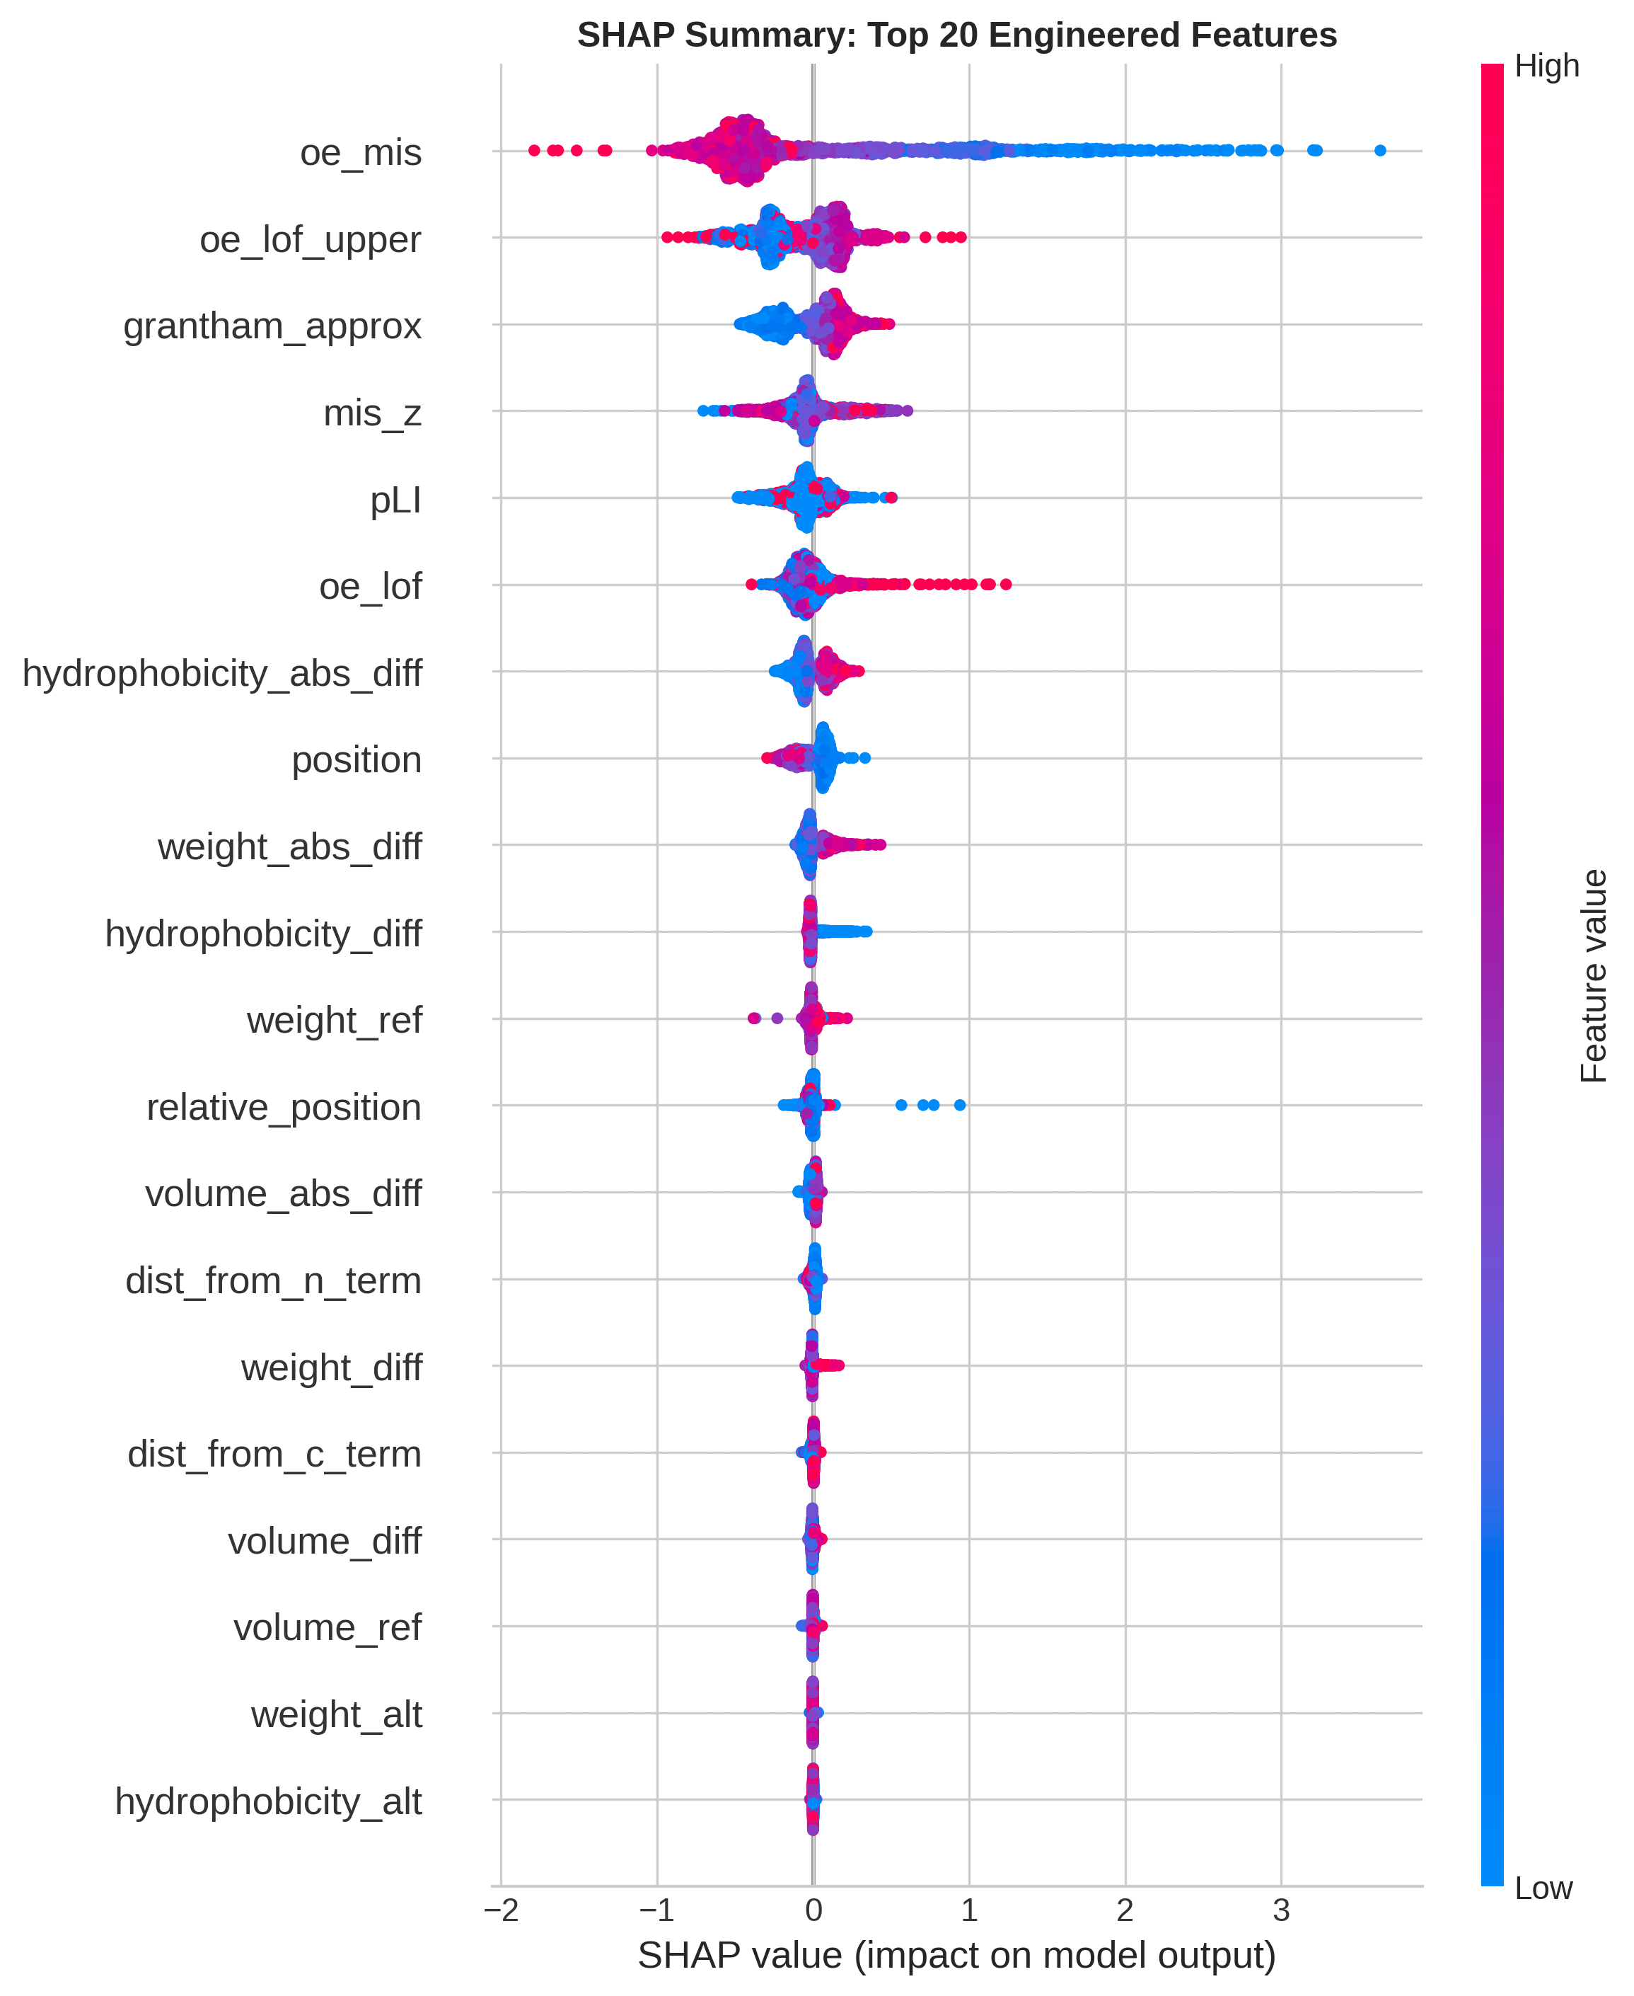
Supplementary Figure S1. SHAP summary plot for engineered features. SHAP (SHapley Additive exPlanations) values for the top 20 engineered features, showing the distribution of feature effects on model predictions. Features are ranked by mean absolute SHAP value. Red indicates high feature values; blue indicates low values. Positive SHAP values push predictions toward pathogenic; negative values push toward benign. Top features include gene constraint metrics (oe_mis, oe_lof_upper), Grantham distance, and position features.

Supplementary Figure S2
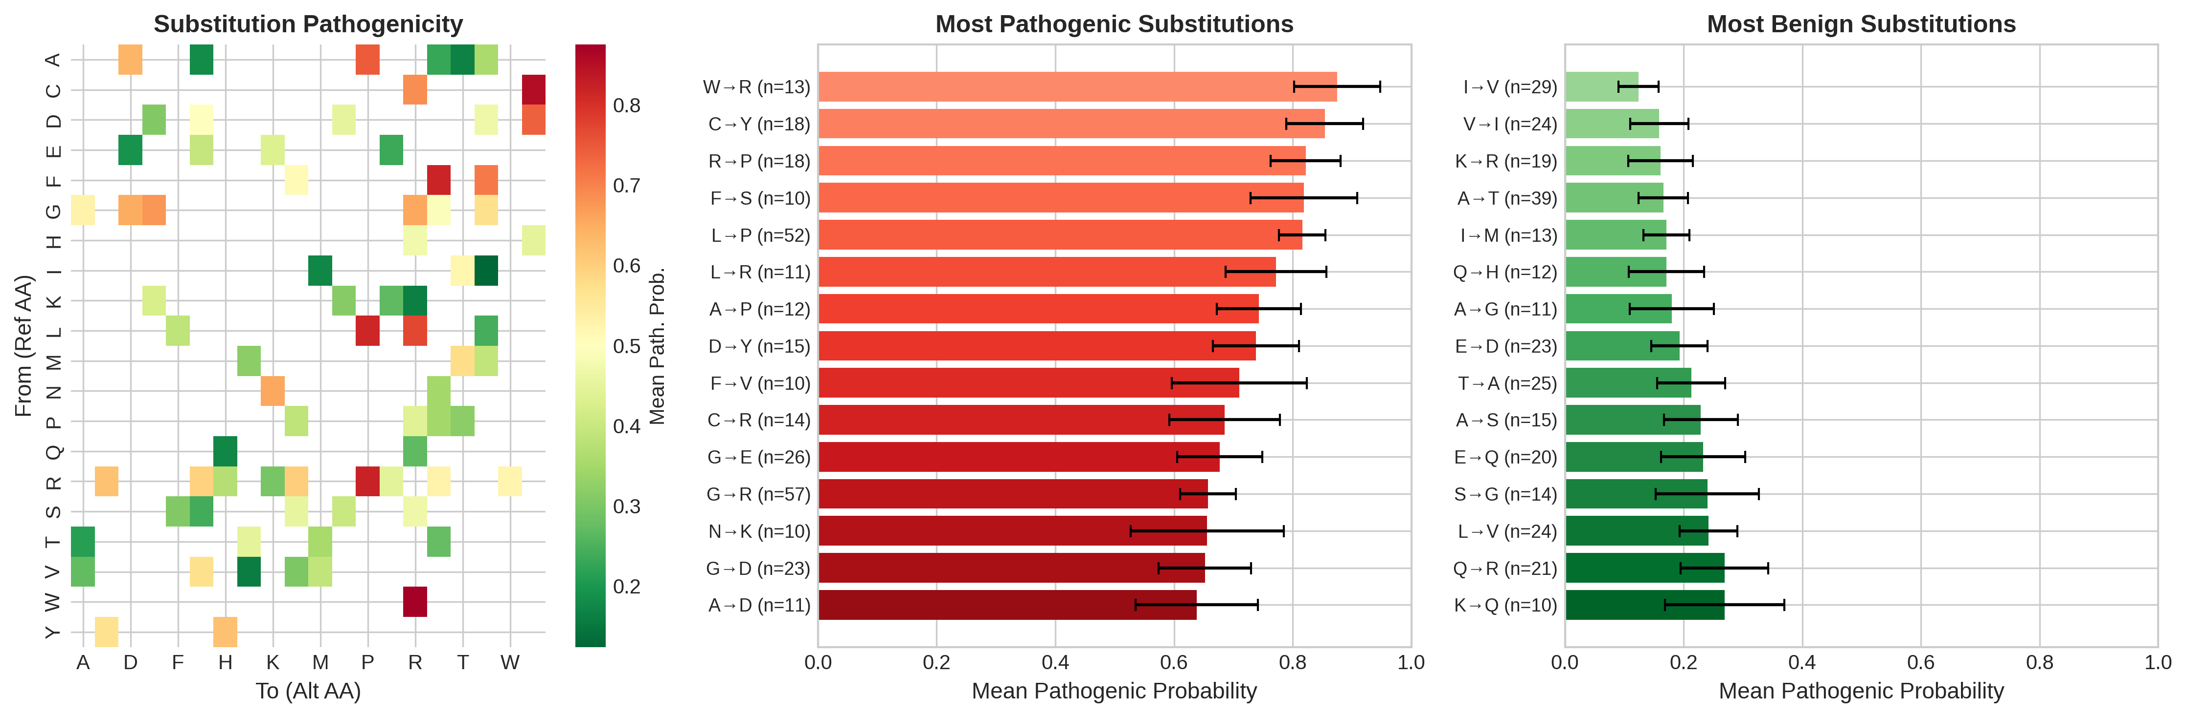
Supplementary Figure S2. Amino acid substitution heatmap. Mean predicted pathogenic probability for amino acid substitution patterns. (A) Heatmap showing pathogenicity by reference->alternate amino acid pair. Red indicates high pathogenic probability; green indicates low. (B) Most pathogenic substitutions ranked by mean probability, showing W->R, C->Y, R->P as highest risk. (C) Most benign substitutions, with I->V, V->I showing lowest pathogenic probability, consistent with conservative substitution patterns.

Supplementary Figure S3
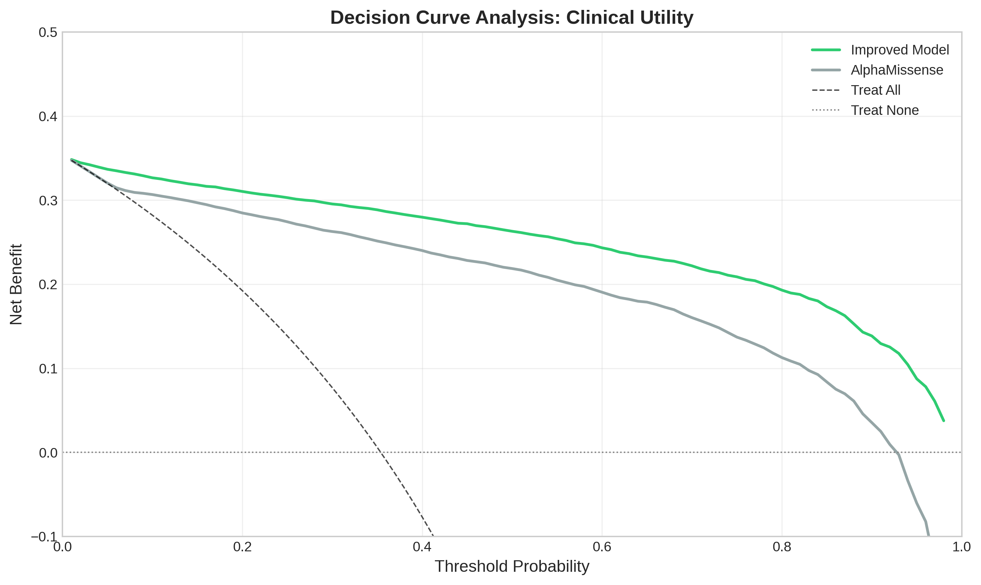
Supplementary Figure S3. Decision curve analysis. Net benefit curves comparing our model, AlphaMissense, and the default strategies of treating all or no patients. The x-axis represents the threshold probability at which a clinician would act on a pathogenic prediction. Net benefit represents the expected benefit minus expected harm, weighted by the threshold. Our model (green) shows superior net benefit across all clinically relevant thresholds (0.1-0.9) compared to AlphaMissense (gray).

Supplementary Figure S4
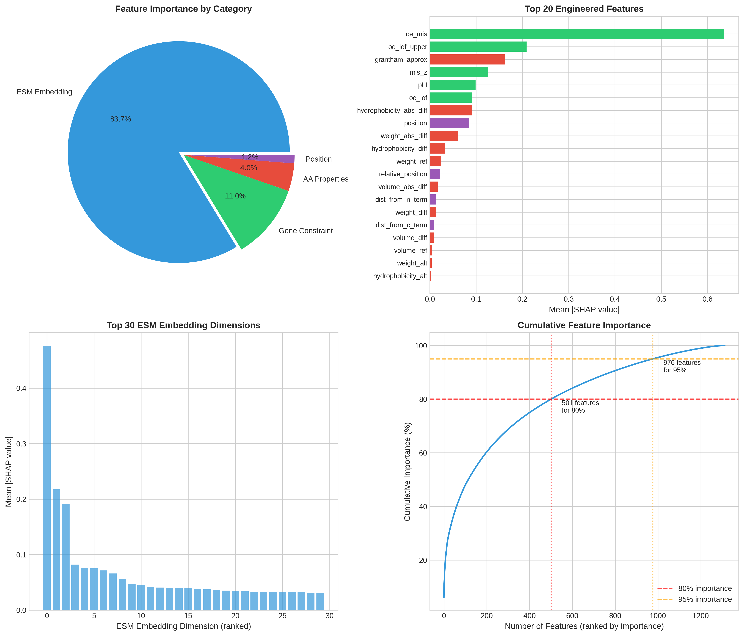
Supplementary Figure S4. Feature importance by category. Comprehensive feature importance analysis. (A) Pie chart showing feature category contributions: ESM-2 embeddings dominate at 89.4%, with amino acid properties (4.7%), AlphaMissense score (3.3%), gene constraint (0.9%), substitution matrix scores (0.9%), position features (0.5%), and disorder score (0.3%) providing complementary information. (B) Top 20 engineered features ranked by mean |SHAP| value, with oe_mis showing highest importance. (C) Top 30 ESM embedding dimensions showing rapid decay in importance. (D) Cumulative importance curve showing 501 features capture 80% of total importance.

Supplementary Figure S5
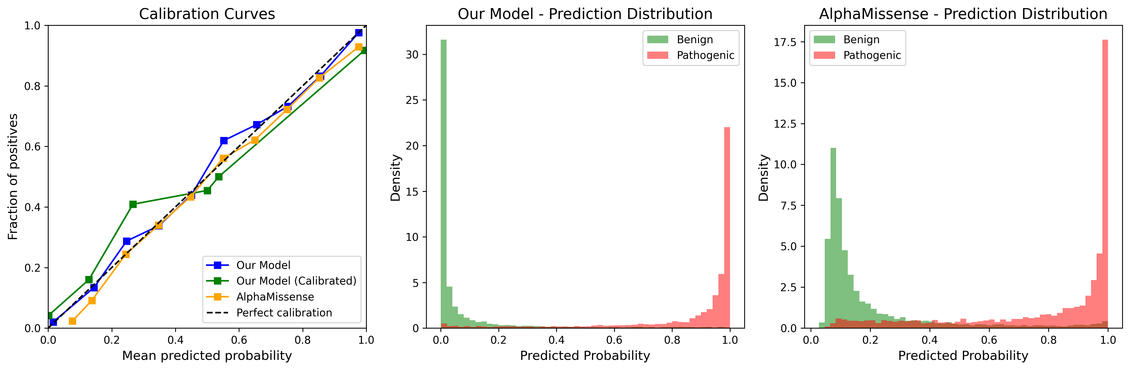
Supplementary Figure S5. Calibration reliability diagram. Calibration plot comparing predicted probabilities to observed pathogenic rates. Perfect calibration lies on the diagonal. (A) Our model (blue) and our model with Platt scaling (green) both closely follow the diagonal, indicating excellent calibration. AlphaMissense (orange) shows systematic deviation at higher probabilities. (B-C) Prediction distributions stratified by true class for our model and AlphaMissense, showing clear separation between benign (green) and pathogenic (red) variants.

Supplementary Figure S6
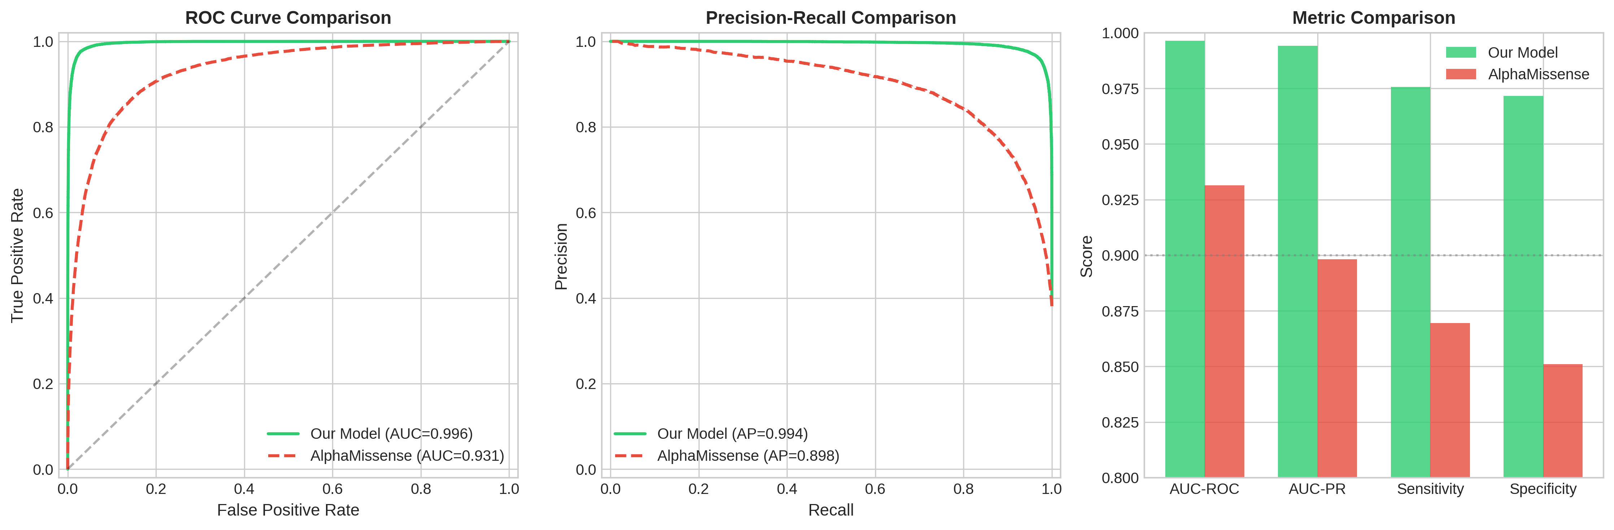
Supplementary Figure S6. ROC and PR curves with performance metrics. Receiver operating characteristic (ROC) and precision-recall (PR) curves comparing our model against AlphaMissense. (A) ROC curves showing our model achieves AUC=0.978 vs 0.934 for AlphaMissense on the held-out test set (n=12,180 variants). (B) PR curves demonstrating superior precision across all recall levels (AP=0.967 vs 0.902). (C) Bar chart comparing key metrics: AUC-ROC, AUC-PR, sensitivity, and specificity, with our model outperforming on all measures.

Supplementary Methods

ESM-2 Embedding Extraction
ESM-2 embeddings were extracted using the esm2_t33_650M_UR50D model via the Fair-ESM library. For each variant, we obtained the 1,280-dimensional representation for both the wild-type and mutant protein sequences at the variant position. The embedding difference (mutant - wild-type) was computed to capture the perturbation induced by the amino acid substitution. This approach ensures that the embeddings represent the specific effect of the variant rather than position-specific or protein-specific background signals.

Gene Constraint Metrics
Gene constraint metrics from gnomAD v4 quantify the selective pressure against different types of mutations. The observed/expected ratio for missense variants (oe_mis) represents the ratio of observed missense variants in gnomAD to the number expected under a neutral mutation model. Lower values indicate stronger selective constraint. The probability of loss-of-function intolerance (pLI) estimates the probability that a gene is intolerant to heterozygous loss-of-function variants. These metrics provide gene-level context that helps distinguish between variants in highly constrained genes (where missense variants are more likely pathogenic) versus tolerant genes.

Intrinsically Disordered Region Annotation
Intrinsically disordered regions were annotated using IUPred2A, which predicts disorder tendency from amino acid sequence alone. Residues with IUPred2A scores >0.5 were classified as disordered. Variants were assigned to the ‘disordered’ category if the variant position had a disorder score >0.5, and to the ‘ordered’ category otherwise. Approximately 20% of variants in our dataset mapped to disordered regions, consistent with estimates of IDR prevalence in the human proteome.

Bootstrap Confidence Intervals
Bootstrap confidence intervals were computed using the percentile method with 1,000 resampling iterations. For each iteration, the test set was resampled with replacement and performance metrics were recalculated. The 2.5th and 97.5th percentiles of the bootstrap distribution defined the 95% confidence interval. This approach accounts for uncertainty in point estimates and enables formal statistical comparisons between methods.

DeLong Test for Correlated ROC Curves
The DeLong test was used to compare AUC-ROC values between correlated ROC curves (i.e., different methods evaluated on the same test set). This non-parametric test accounts for the correlation structure induced by evaluating methods on identical samples. The null hypothesis is that the two AUCs are equal; rejection indicates statistically significant difference in discriminative performance.

Expected Calibration Error
Expected calibration error (ECE) quantifies the average deviation between predicted probabilities and observed rates. Predictions were binned into 10 equally-spaced intervals, and the absolute difference between mean predicted probability and observed pathogenic rate was computed for each bin. ECE represents the weighted average of these bin-wise calibration errors. Lower ECE indicates better calibration, with ECE < 0.01 indicating excellent calibration.

Code and Data Availability
All analysis code, trained model weights, and scripts for reproducing the figures in this manuscript are available at: https://github.com/hayden-farquhar/VUS-reclassification
The repository includes: - Feature engineering pipeline - Model training scripts
- Evaluation and benchmarking code - Pre-trained XGBoost model weights - Instructions for reproducing all analyses

Supplementary Materials for submission to Genome Medicine

