Analysis of potentially toxic elements (PTEs) in lichens using neutron activation analysis (NAA) as a primary method and comparison with a digestion/ICP-MS analysis protocol.
By F. Caron^{1,2*}, P. Samuleev¹, M. Lakanen^{3, 4}, J. Anderson³, G. Spiers², P. Beckett², B. Halvorson⁵, M. Charbonneau⁵
¹ Department of Chemistry and Chemical Engineering, Royal Military College of Canada, Kingston, ON
² Emeritus Professor, Laurentian University, Sudbury, ON
³ Harquail School of Earth Sciences, Laurentian University, Sudbury, ON
⁴ Queen’s University, Kingston ON
⁵ Testmark Laboratories, City of Greater Sudbury, ON
* Corresponding author, fcaron@rmc.ca

Supplementary Information
The supplementary information provides the following:
- Table of parameters necessary to calculate the B-factors in the NAA equation;
- Table of detection limits and Determination (Quantification) limits;
- Typical gamma spectra;
- Graphical comparisons of digestion/ICP-MS vs NAA concentrations for the three lichens;
- A graphical correspondence of the concentrations of elements analyzed by NAA for the lichen CRM (Pseudevernia furfuracea, BCR-482).

List of Tables
Table S 1: Parameters used to calculate the B-factor of the selected nuclides. 4
Table S 2: Typical detection limits for both NAA and digestion/ICP-MS analysis. 7

Parameters necessary to calculate the B-factors in the NAA equation
Recall Equations [2] and [3] in the main body of the paper. The B-factor is given by:
[2]
$$B= \frac{N_{A}θσ_{eff}b_{γ}ε}{M}$$

Where: N_{A} = net counts, obtained with Ortec’s GammaVision software, (counts)
θ = isotopic abundance of precursor or target element ( )
σ_{eff} = effective cross-section in barns, corrected (b, or 10⁻²⁴ cm²) – see below
b_{γ} = branching ratio of a specific gamma (γ) decay line ( )
ε = detector efficiency ( )
M = atomic mass of precursor or target element of interest (g/mol)

The equation of the detector efficiency ε (in fraction) was ε = 4.661 X^{(-0.830)} where X = energy line, in keV. Calibrations were run periodically on the “N” detector; all the results were acquired on the same detector.
Finally, the effective neutron cross-section was corrected for the epithermal neutrons using the resonance integral:
[3]
$$σ_{eff}= σ_{th}+\frac{I_{0}+0.45 σ_{th}}{17.4}$$

Where: σ_{eff} = effective neutron cross-section, corrected ( b )
σ_{th} = thermal neutron cross-section, operationally defined for 0.025 eV ( b )
I₀ = resonance integral ( b )

The values of the parameters necessary to calculate the B- factor are in Table S1 (next page).

The references are (Brown & Firestone, 1986) for the atomic masses and percent decays, and (Mughabghab & Holden, 2019) for the cross-sections.
Table S 1: Parameters used to calculate the B-factor of the selected nuclides.
Activation Product | Gamma energy line, keV | Θ % abund. of precursor | Corrected  σ_{eff}, barns  (10⁻²⁴ cm²) | Branching ratio b_{γ} | Detector efficiency ε (in %) | Atomic mass M of precursor | Thermal σ_{th}, barns (10⁻²⁴ cm²) | Resonance  I₀, barns  (10⁻²⁴ cm²)
Se-75 | 265 | 0.9% | 86.7 | 59.0% | 4.54% | 73.922 | 52.2 | 576
Ti-51 | 320 | 5.4% | 0.19 | 93.0% | 3.88% | 49.945 | 0.179 | 0.09
Cr-51 | 320 | 4.3% | 15.5 | 10.8% | 3.88% | 49.946 | 14.7 | 7.2
Zn-69 | 439 | 18.8% | 1.30 | 94.8% | 2.99% | 67.925 | 1.07 | 3.5
I-128 | 443 | 100.0% | 15.62 | 16.9% | 2.96% | 126.904 | 6.15 | 162
Br-82 | 554 | 49.3% | 5.1 | 70.9% | 2.46% | 80.916 | 2.36 | 46
As-76 | 559 | 100.0% | 7.82 | 45.0% | 2.44% | 75.922 | 4.09 | 63
Sb-122 | 564 | 57.4% | 17.7 | 70.7% | 2.43% | 120.904 | 5.77 | 205
Cs-134 | 605 | 100.0% | 56.1 | 15.4% | 2.41% | 132.905 | 30.1 | 438
Br-80 | 617 | 50.8% | 17.48 | 7.2% | 2.25% | 78.918 | 10.32 | 120
Br-82 | 777 | 49.3% | 5.1 | 43.1% | 2.25% | 80.916 | 2.36 | 46
Cs-134 | 796 | 100.0% | 56.1 | 85.4% | 1.82% | 132.905 | 30.1 | 438
Mg-27 | 844 | 11.0% | 0.040 | 73.0% | 1.74% | 25.983 | 0.037 | 0.02
Mn-56 | 847 | 100.0% | 14.47 | 98.9% | 1.73% | 54.938 | 13.360 | 13.3
Sc-46 | 889 | 100.0% | 28.6 | 100.0% | 1.66% | 44.956 | 27.200 | 12.1
Mg-27 | 1014 | 11.0% | 0.040 | 29.1% | 1.49% | 25.983 | 0.037 | 0.02
Cu-66 | 1039 | 30.8% | 2.35 | 9.2% | 1.46% | 64.928 | 2.170 | 2.19
Rb-86 | 1077 | 72.2% | 0.90 | 8.6% | 1.42% | 84.912 | 0.494 | 6.83
Fe-59 | 1099 | 0.28% | 1.44 | 56.5% | 1.39% | 57.933 | 1.32 | 1.5
Ni-65 | 1115 | 49.2% | 1.73 | 50.6% | 1.38% | 63.928 | 1.63 | 1.07
Zn-65 | 1115 | 0.9% | 0.83 | 14.8% | 1.38% | 63.929 | 0.731 | 1.37
Sc-46 | 1120 | 100.0% | 28.6 | 100.0% | 1.37% | 44.956 | 27.200 | 12.1
Co-60 | 1173 | 100.0% | 42.5 | 99.7% | 1.32% | 58.933 | 37.18 | 75.8
Fe-59 | 1291 | 0.28% | 1.44 | 43.2% | 1.22% | 57.933 | 1.32 | 1.5
Co-60 | 1333 | 100.0% | 42.5 | 100.0% | 1.19% | 58.933 | 37.18 | 75.8
Na-24 | 1369 | 100.0% | 0.56 | 100.0% | 1.16% | 23.991 | 0.53 | 0.311
V-52 | 1434 | 99.8% | 5.22 | 100.0% | 1.12% | 50.944 | 4.94 | 2.7
Ni-65 | 1481 | 0.9% | 1.73 | 25.4% | 1.09% | 63.928 | 1.63 | 1.07
K-42 | 1524 | 6.7% | 1.55 | 18.8% | 1.06% | 40.962 | 1.46 | 0.98
Cl-38 | 1643 | 24.2% | 0.46 | 31.0% | 1.00% | 36.966 | 0.433 | 0.3
Al-28 | 1779 | 100.0% | 0.24 | 100.0% | 0.94% | 26.982 | 0.231 | 0.136
Mn-56 | 1811 | 100.0% | 14.47 | 27.2% | 0.92% | 54.938 | 13.360 | 13.3
Ca-49 | 3085 | 0.2% | 1.17 | 92.1% | 0.59% | 47.953 | 1.090 | 0.89

Detection limit and Determination (Quantification) limits
Neutron activation analysis (NAA)
The detection limit (L_{C}) for the gamma analysis is chosen in this work as the signal above the background counts (C) of the region returned by Ortec’s GammaVision (5-point average; Ortec, 2014), plus 3 times the standard deviation (σ) of the background (b) value:
L_{C} = C + 3 σ_{b} [S1]
Where σ_{b} is $\sqrt{C}$. L_{C} is given in counts, which is converted into concentrations using Eq. [1] of the main article.
The Determination limit L_{D} is given by:
L_{D} = C + 10 σ_{b} [S2]
L_{D} represents the level above which detection is reliable, or generally the level above which the relative standard deviation (1σ) is constant with respect to its measurement. Note that L_{D} is often called the quantification limit.
This approach is consistent with Massart et al., (1988) and Tsoulfanidis & Landsberger, (2021), (2021).
In this work, we examined the background and the net counts for all energy peaks reported. The net counts reported by GammaVision and the average ±1σ calculated from our results were examined in the context of each peak, as the background varied by orders of magnitude over the energy range. For example, based on our experience, 400 net counts (above background) for I-128 was achievable and reproducible between replicates. Our measured background was 13.51 counts per second (cps), while 1σ was 0.11 cps, which means 3σ = 0.33 cps. Thus
L_{C} = C + 3 σ_{b} was 13.84 cps. The value of 400 net counts was 13.85 cps, which returned 0.05 µg/g. Given that we were measuring replicates, and that the decay and measuring times changed over counting times (see Eq. [1] in the text), the background decreased for each replicate. We used our experience to add a confidence factor for each peak of interest. In this example, we reported a conservative value of L_{C} = 0.1 µg/g for I-128. All other nuclides at their energy peaks were handled similarly.
Acid digestion/ICP-MS analysis
The procedure for the method detection limit (MDL) of the ICP MS analysis is documented in the lab standard operating procedures (SOPs). It is largely based upon operational experience. In our situation, the methods blanks (reagent and procedural blanks) returned below the reported MDL in Table S1.

References
Brown, E., & Firestone, R. B. (1986). Table of radioactive isotopes. Wiley-Interscience.
Massart, D. L., Vandeginste, B. G. M., Deming, S. N., Michotte, Y., & Kufman, L. (1988). Chemometrics: A textbook. Elsevier Science Publishers.
Mughabghab, S. F., & Holden, N. E. (2019). Atlas of Resonances (6th ed.) [Dataset]. https://www-nds.iaea.org/relnsd/vcharthtml/VChartHTML.html
Ortec. (2014). GammaVision V7 Software User’s Manual. Ortec.
Tsoulfanidis, N., & Landsberger, S. (2021). Measurement and Detection of Radiation (5th ed.). CRC Press. https://doi.org/10.1201/9781003009849

Table S 2: Typical detection limits for both NAA and digestion/ICP-MS analysis.
Atomic No. | Element | NAA |  | ICP-MS**
 |  | µg/g |  | µg/g
11 | Na | 3 |  | 10
12 | Mg | 50 |  | 0.4
13 | Al | 50 |  | 1-10
17 | Cl | 5 |  | -
19 | K | 60 |  | 100
20 | Ca | 50 |  | 5-50
21 | Sc | 0.02 |  | 0.1
22 | Ti | 15 |  | 1
23 | V | 0.5 |  | 0.1
24 | Cr | 0.5 |  | 0.1
25 | Mn | 0.1 |  | 0.1-1
26 | Fe | 100 |  | 20
27 | Co | 0.5 |  | 0.01
28 | Ni | 100 |  | 0.1-1
29 | Cu | 5 |  | 0.1-1
30 | Zn | 5 |  | 0.1
33 | As | 0.1 |  | 0.1
34 | Se | 0.4 |  | 0.1
35 | Br | 0.05-0.4* |  | -
37 | Rb | 3 |  | 0.1
51 | Sb | 0.01 |  | 0.1
53 | I | 0.1 |  | -
55 | Cs | 0.1 |  | 0.1
*0.4 µg/g for Br-80 (short irradiation), and
0.05 µg/g for Br-82 (long irradiation)
**typical (based on limits reported across the digestion methods and lichen species)

List of Figures
Figure S 1. Typical spectra of Cladonia sp lichen (low impact site at Secord Falls, near Sudbury). Conditions: short irradiation, 5 min; decay time 20 min, reading time 20 min; 9
Figure S 2. Typical spectra of Cladonia sp lichen (low impact site at Secord Falls, near Sudbury). Conditions: long irradiation, 120 min (2 h), decay time 40 h, reading time 2 h. 10
Figure S 3(a). Comparison of element concentrations obtained using both techniques (digestion/ICP-MS, INAA) for the lichen Pseudevernia furfuracea (certified reference material, label BCR-482). The Co result was not included in the regression. Note the logarithmic scale; the line represent a 1:1 correspondence between methods; the R squared and Slope were obtained using the data analysis Toolpak in MS Excel. 11
Figure S 4. Concentrations of elements analyzed by NAA for the CRM lichen (Pseudevernia furfuracea, BCR-482). The short-lived activated elements are shown (short irradiation, 5-min). Note the concentration axis is in log scale. 14
Figure S 5. Concentrations of elements analyzed by NAA for the lichen CRM (Pseudevernia furfuracea, BCR-482). The long-lived activated elements are shown (long irradiation, 120-min). Note the concentration axis is in log scale. 15

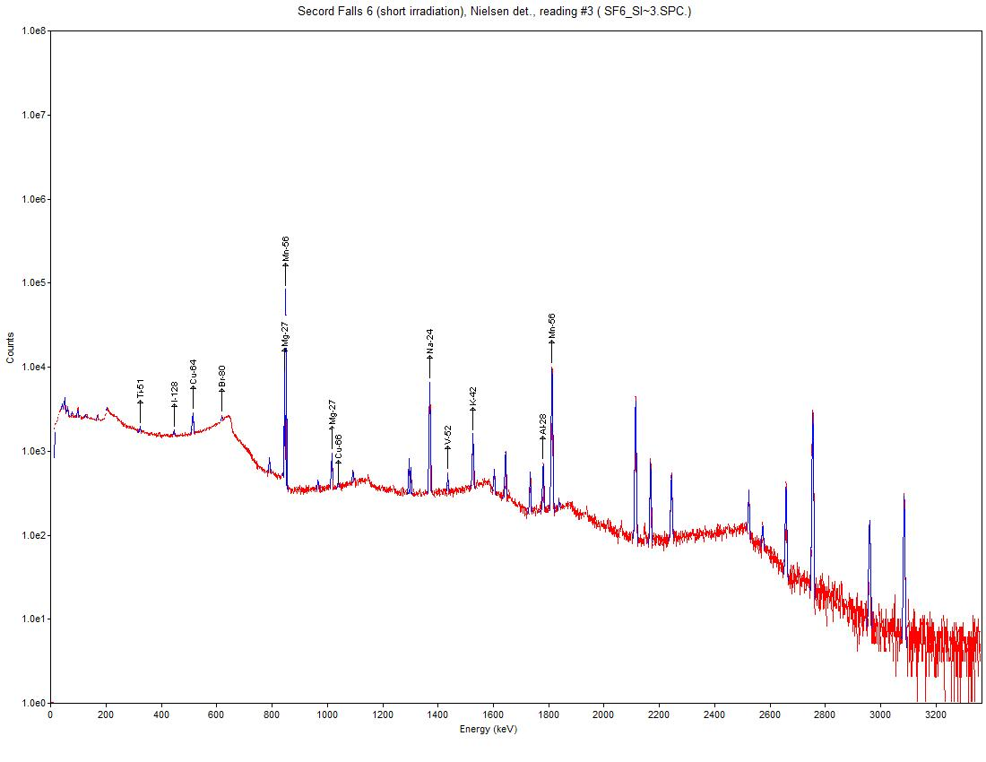
Figure S 1. Typical spectra of Cladonia sp lichen (low impact site at Secord Falls, near Sudbury). Conditions: short irradiation, 5 min; decay time 20 min, reading time 20 min;

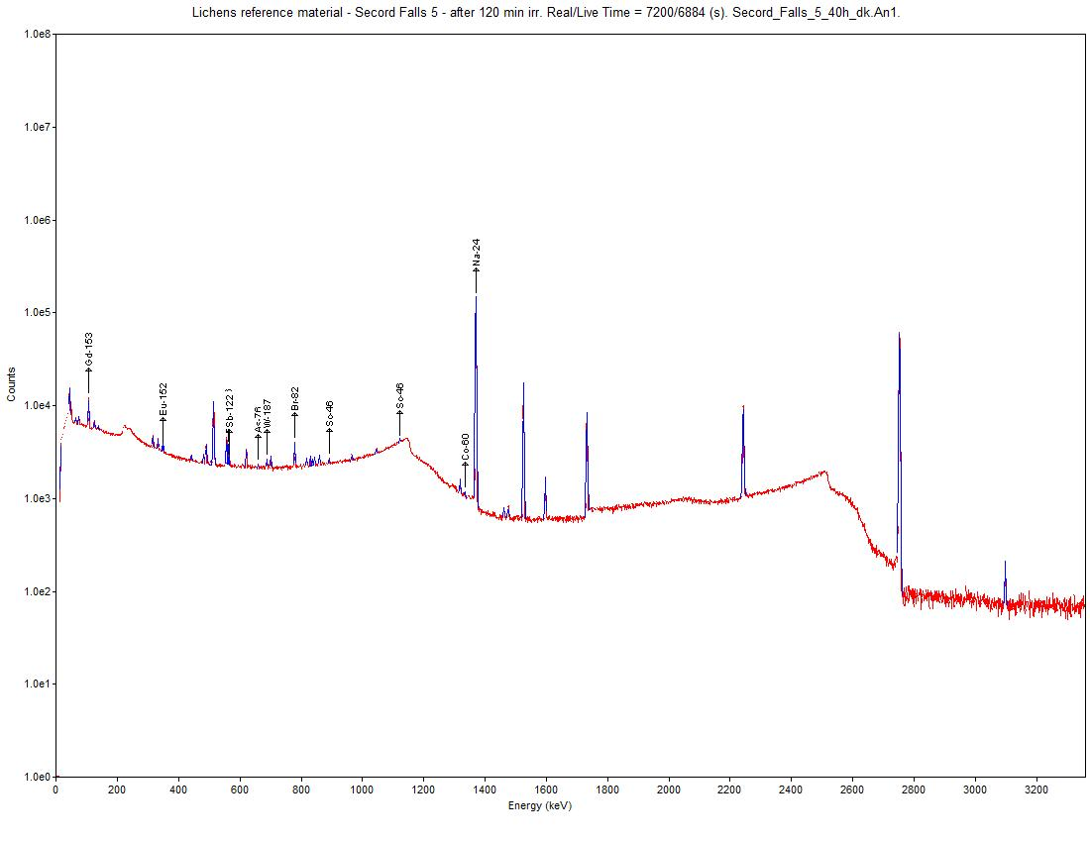
Figure S 2. Typical spectra of Cladonia sp lichen (low impact site at Secord Falls, near Sudbury). Conditions: long irradiation, 120 min (2 h), decay time 40 h, reading time 2 h.

(a)

Figure S 3(a). Comparison of element concentrations obtained using both techniques (digestion/ICP-MS, INAA) for the lichen Pseudevernia furfuracea (certified reference material, label BCR-482). The Co result was not included in the regression. Note the logarithmic scale; the line represent a 1:1 correspondence between methods; the R squared and Slope were obtained using the data analysis Toolpak in MS Excel.
(b)
Figure S3 (b). Comparison of element concentrations obtained using both techniques (digestion/ICP-MS, INAA) for the lichen Cladonia spp. at the Secord Falls site (low impact site). Note the logarithmic scale; the line represent a 1:1 correspondence between methods; the R squared and Slope were obtained using the data analysis Toolpak in MS Excel.

(c)
Figure S 3(c). Comparison of element concentrations obtained using both techniques (digestion/ICP-MS, INAA) for the lichen Stereocaulon spp. (urban/industrial site). Note the logarithmic scale; the line represent a 1:1 correspondence between methods; the R squared and Slope were obtained using the data analysis Toolpak in MS Excel.

Figure S 4. Concentrations of elements analyzed by NAA for the CRM lichen (Pseudevernia furfuracea, BCR-482). The short-lived activated elements are shown (short irradiation, 5-min). Note the concentration axis is in log scale.

Figure S 5. Concentrations of elements analyzed by NAA for the lichen CRM (Pseudevernia furfuracea, BCR-482). The long-lived activated elements are shown (long irradiation, 120-min). Note the concentration axis is in log scale.

