Integrating geodetic constraints from major faults and the subduction zone into probabilistic seismic hazard assessments (PSHA) for Guatemala

Mario Arroyo-Solórzano^{1,2}, Carlos Gamboa-Canté^{3,4}, Jeremy Maurer⁵, Omar Flores⁴, María Belén Benito³ and Fabrice Cotton^{1,2}

¹ GFZ Helmholtz Centre for Geosciences, Telegrafenberg, 14473 Potsdam, Germany.
² Institute of Geosciences, University of Potsdam, 14476 Potsdam, Germany.
³ Departamento de Ingeniería y Morfología del Terreno, Escuela Técnica Superior de Ingenieros de Caminos, Canales y Puertos, Universidad Politécnica de Madrid, 28040 Madrid, Spain.
⁴ Centro de Estudios Superiores de Energía y Minas, Facultad de Ingeniería, Universidad de San Carlos de Guatemala, Guatemala City 01012, Guatemala.
⁵ Missouri University of Science and Technology, Geological Sciences and Geological and Petroleum Engineering, 1400 N Bishop, Rolla, MO 65401, USA.

Mario Arroyo-Solórzano: marroyo@gfz.de, corresponding author ORCID: 0000-0002-1653-2680
Carlos Gamboa-Canté: carlosjose.gamboa@upm.es ORCID: 0000-0002-9921-5911
Jeremy Maurer: jmaurer@mst.edu ORCID: 0000-0002-3624-5961
Omar Flores: 1798801280101@ingenieria.usac.edu.gt ORCID: 0009-0009-2977-1638
María Belén Benito: mariabelen.benito@upm.es ORCID: 0000-0003-3582-6438
Fabrice Cotton: fcotton@gfz.de ORCID: 0000-0002-9242-3996

APPENDICES

TABLES

Table A1. Models and their dependencies used for MFD characterization of the source from geodetic data.
Models | Variables and its dependencies
Earthquake Rates (N_{min}) variation  Model 1: Equation I.10 in Anderson & Luco (1983)  $$N_{min}\text{=}\left(\frac{d\text{-}β}{d}\right)∙\left(\frac{\overset{˙}{s}}{γ}\right)∙e^{β(Mmax\text{-}Mmin)}∙e^{\text{-}((\frac{d}{2})∙Mmax)}$$ | b = b-value, of the GR relationship (Gamboa-Canté et al.,2025).  $$d\text{=}1.5∙ln(10)$$  $$β\text{=}b∙ln(10)$$  $\overset{˙}{s}$ = Slip rate, depending on considering or not SSEs (seismic slip rate).  $γ\text{=}\sqrt{{(σ∙{Mo}_{M0})}/{(μ∙W)}}$ , where 𝞂 is the slip/length ratio; Mo_{M0} is the seismic moment for M=0; $μ$ is the shear modulus and W is the seismogenic width.  M_{max} is the maximum magnitude (from the CRSHM 2022).  M_{min} is the minimum magnitude threshold defined (M_{w} 4.5).  $\overset{˙}{M_{0}}$ is the moment rate of the subduction segment, given as $\overset{˙}{M_{0}}\text{=}\overset{˙}{s}∙μ∙A$ , where $\overset{˙}{s}$ is the slip rate, $μ$ the shear modulus, and A is the seismogenic area.  Mo_{Mmax} is the seismic moment of the M_{max} associated.  Mo_{Mmin} is the seismic moment of the M_{min} defined.
Model 2*: Equation II.9 in Anderson & Luco (1983)

$$N_{min}\text{=}\left(\frac{d\text{-}β}{β}\right)∙\left(\frac{\overset{˙}{s}}{γ}\right)∙\left[e^{β\left(Mmax\text{-}Mmin\right)}\text{-}1\right]∙e^{\text{-}((\frac{d}{2})∙Mmax)}$$

And equation III.9 in Anderson & Luco (1983)

$$N_{min}\text{=}\frac{d∙(d\text{-}β)}{β}∙\left(\frac{\overset{˙}{s}}{γ}\right)∙\left\{\frac{1}{β}\left[e^{β\left(Mmax\text{-}Mmin\right)}\text{-}1\right]\text{-}\left(Mmax\text{-}Mmin\right)\right\}∙e^{\text{-}((\frac{d}{2})∙Mmax)}$$

Model 3: Youngs & Coppersmith (1985)

$$N_{min}\text{=}\frac{\overset{˙}{M_{0}}∙\left(d\text{-}b\right)∙\left[1\text{-}e^{\text{-}β\left(Mmax\text{-}Mmin\right)}\right]}{b∙MoMmax∙e^{\text{-}β\left(Mmax\text{-}Mmin\right)}}$$

Model 4: Molnar (1979)
$$N_{min}\text{=}\left(1\text{-}\frac{2∙b}{3}\right)∙\frac{\overset{˙}{M_{0}}}{MoMmax}∙{\left(\frac{MoMmax}{MoMmin}\right)}^{\frac{2b}{3}}$$

M_{max} variation  $$logN\text{=}\frac{\text{-}3}{2}∙Mw\text{-}log\overset{˙}{M_{0}}\text{+}log\left[α∙\left(1\text{-}\frac{2b}{3}\right)\right]$$  From Avouac (2015), based on Molnar (1979), but accounting for aseismic processes. | $α\text{=}{χs}/{(χs\text{+}χas\text{+}χSSE}$), where χs is the seismic coupling (ratio of cumulative seismic slip to long-term slip), χas aseismic coupling due to afterslip, and χSSE is the aseismic coupling due to SSE (ratio of cumulative aseismic SSEs to long-term slip).
* We used the average of both equations presented due to their similarity.
Table A2. Geometric and kinematic characteristics of the faults analyzed.
Seismic Zone | Fault | Seismic Source | Slip rate (mm/yr) |  | Length (km) | Width (km) | Dip (°) | Rake (°)
Seismic Zone | Fault | Seismic Source | Garnier et al. (2022) | Maurer et al. (2025)
Polochic-Motagua West  (G6) | Polochic | P01 | 3.7 | 6.6 | 250 | 20 | 90 | 0
Polochic-Motagua West  (G6) | Polochic | P02 | 3.7 | 3.0 | 190 | 20 | 90 | 0
Polochic-Motagua West  (G6) | Motagua | M01 | 5.1 | 3.0 | 170 | 20 | 90 | 0
Polochic-Motagua West  (G6) | Motagua | M02 | 11.9 | 8.8 | 140 | 20 | 90 | 0
Polochic-Motagua West  (G6) | Motagua | M03 | 13.9 | 9.7 | 85 | 20 | 90 | 0
Polochic-Motagua West  (G6) | Motagua | M04 | 16.2 | 9.0 | 100 | 20 | 90 | 0
Volcanic Arc East (G4) | Jalpatagua | J01 | 3.0 | 4.4 | 45 | 20 | 90 | 0
Volcanic Arc East (G4) | Jalpatagua | J02 | 5.5 | 7.3 | 50 | 20 | 90 | 0
Volcanic Arc East (G4) | Jalpatagua | J03 | 7.1 | 16.5 | 75 | 20 | 90 | 0
L, length; W, width; a-val, a-value; b-val, b-value; N_{min}, cumulative events from M_{min} (M_{w} 4.5); M_{max}, maximum magnitude inferred according to each approach

FIGURES
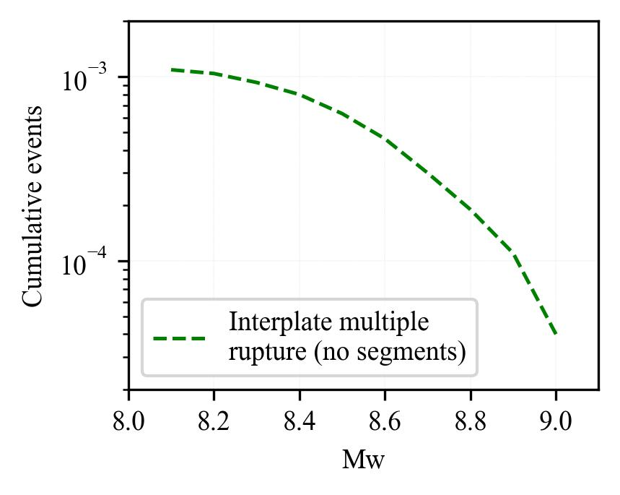
Figure A1. Resulting MFD assuming the possibility of multiple ruptures of subduction segments, following the characterization proposed in Table 1 and computed using the SHERIFS software (Chartier et al. 2019).
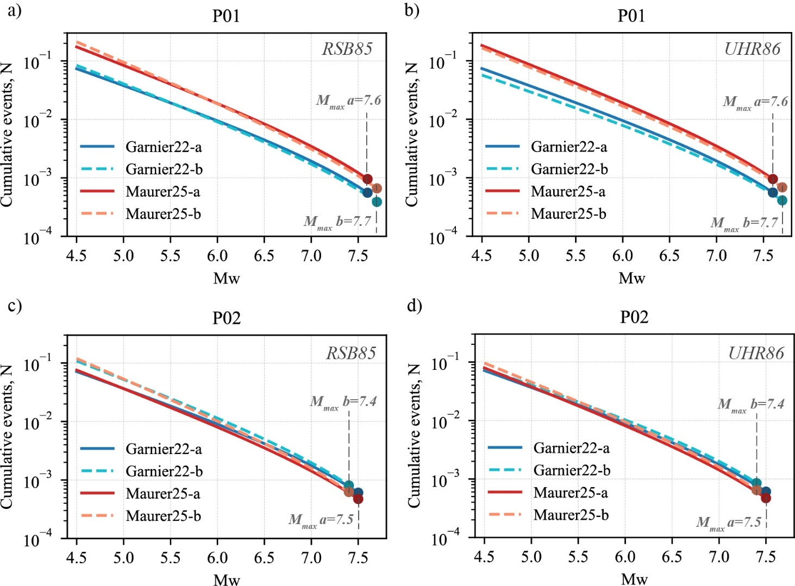
Figure A2. MFDs for the segments of the Polochic-Chixoy fault: N_{min} variation for two slip-rate models and two M_{max} constraints: M_{max}-a from scaling relations (Arroyo-Solórzano et al. 2024) and M_{max}-b from probability distribution based on both empirical and observed magnitudes (Tavakolizadeh et al. 2025). Segment P01: Reasenberg (1985) (a) and Uhrhammer (1985) (b); segment P02: Reasenberg (1985) (c) and Uhrhammer (1985) (d).
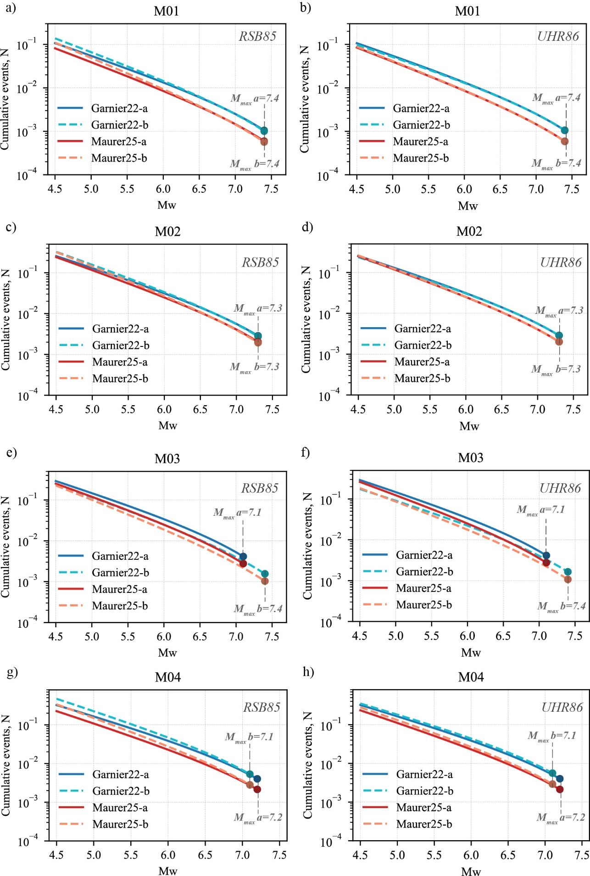
Figure A3. MFDs for the segments of the Motagua fault: N_{min} variation for two slip-rate models and two M_{max} constraints: M_{max}-a from scaling relations (Arroyo-Solórzano et al. 2024) and M_{max}-b from probability distribution based on both empirical and observed magnitudes (Tavakolizadeh et al. 2025). Segment M01: Reasenberg (1985) (a) and Uhrhammer (1985) (b); segment M02: Reasenberg (1985) (c) and Uhrhammer (1985) (d). Segment M03: Reasenberg (1985) (e) and Uhrhammer (1985) (f); segment M04: Reasenberg (1985) (g) and Uhrhammer (1985) (h).
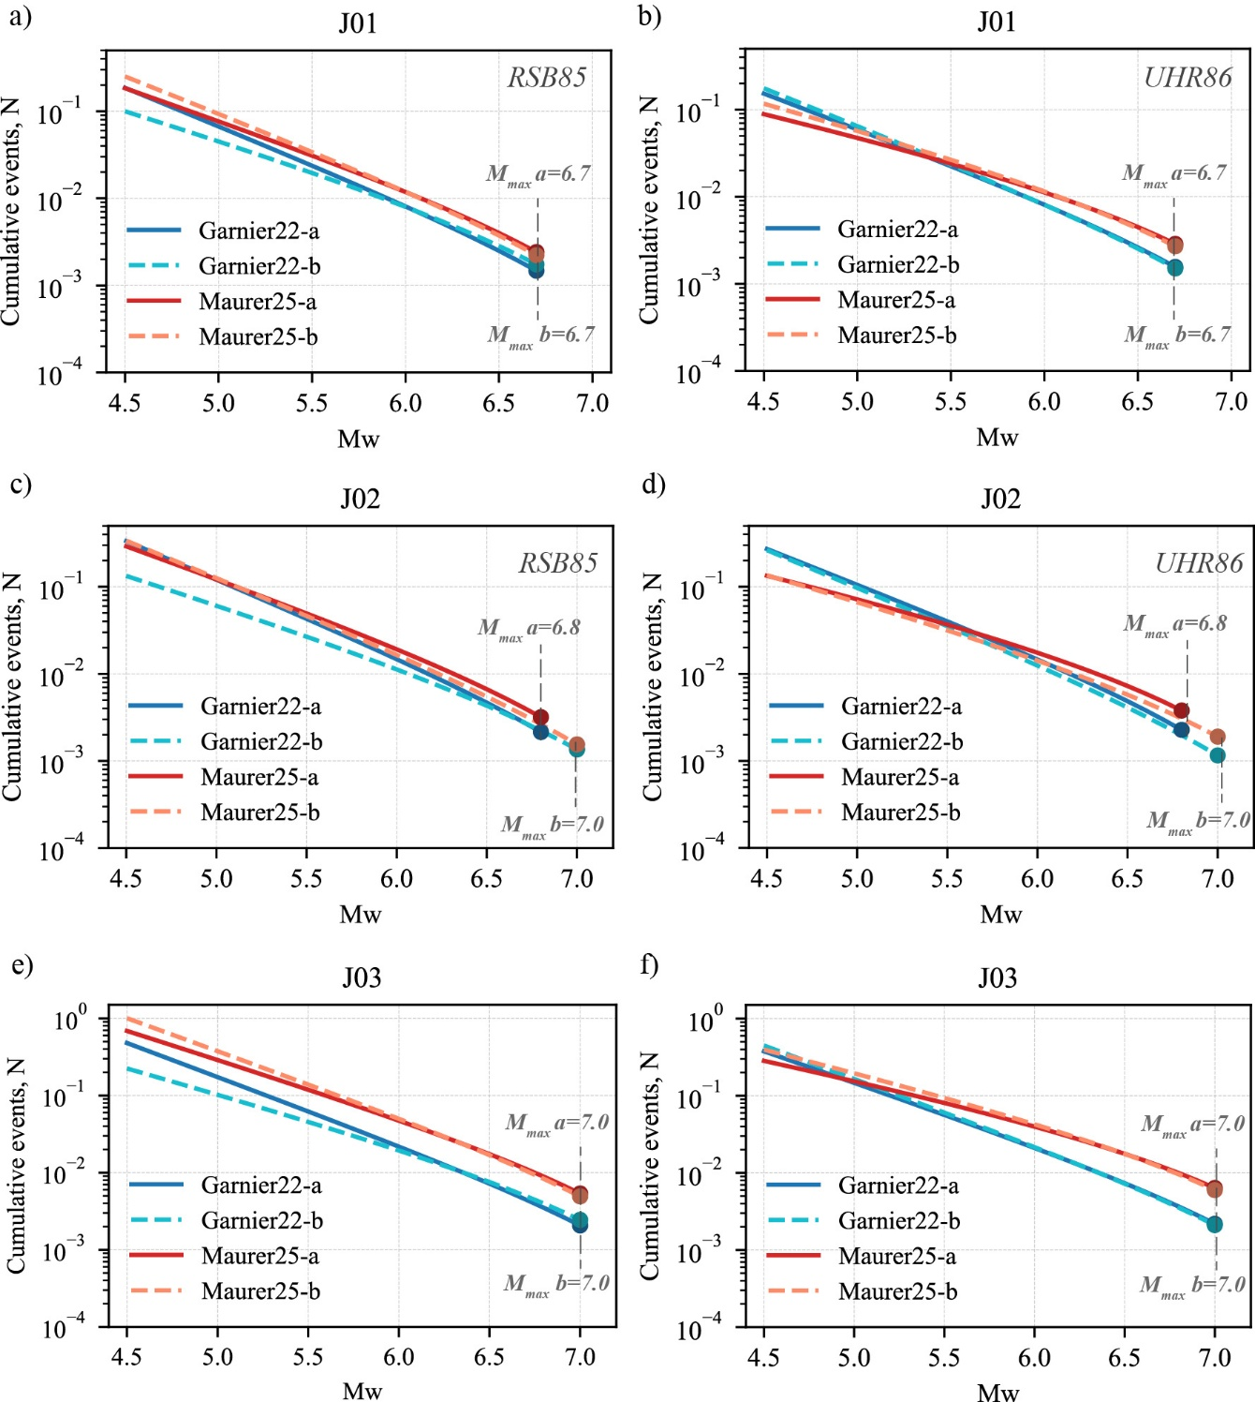
Figure A4. MFDs for the segments of the Jalpatagua fault: N_{min} variation for two slip-rate models and two M_{max} constraints: M_{max}-a from scaling relations (Arroyo-Solórzano et al. 2024) and M_{max}-b from probability distribution based on both empirical and observed magnitudes (Tavakolizadeh et al. 2025). Segment J01: Reasenberg (1985) (a) and Uhrhammer (1985) (b); segment J02: Reasenberg (1985) (c) and Uhrhammer (1985) (d). Segment J03: Reasenberg (1985) (e) and Uhrhammer (1985) (f).
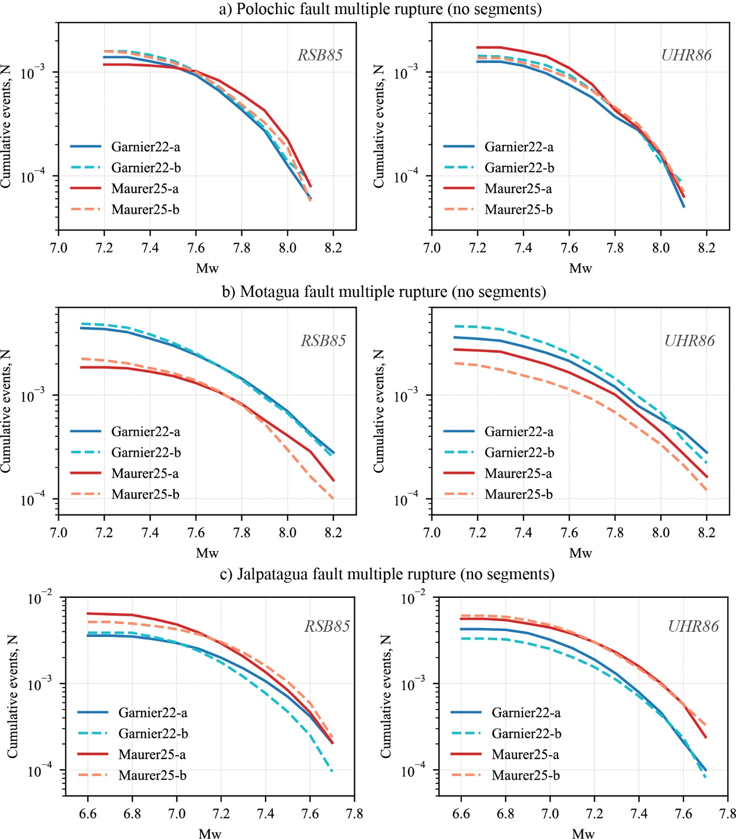
Figure A5. MFDs for the major faults considering multi-ruptures: Resulting MFD assuming the possibility of multiple ruptures of the fault systems: a) Polochic-Chixoy fault, b) Motagua fault, c) Jalpatagua fault. The estimations are based on the characterization proposed in Tables 2 and 3 and computed using the SHERIFS software (Chartier et al. 2019).
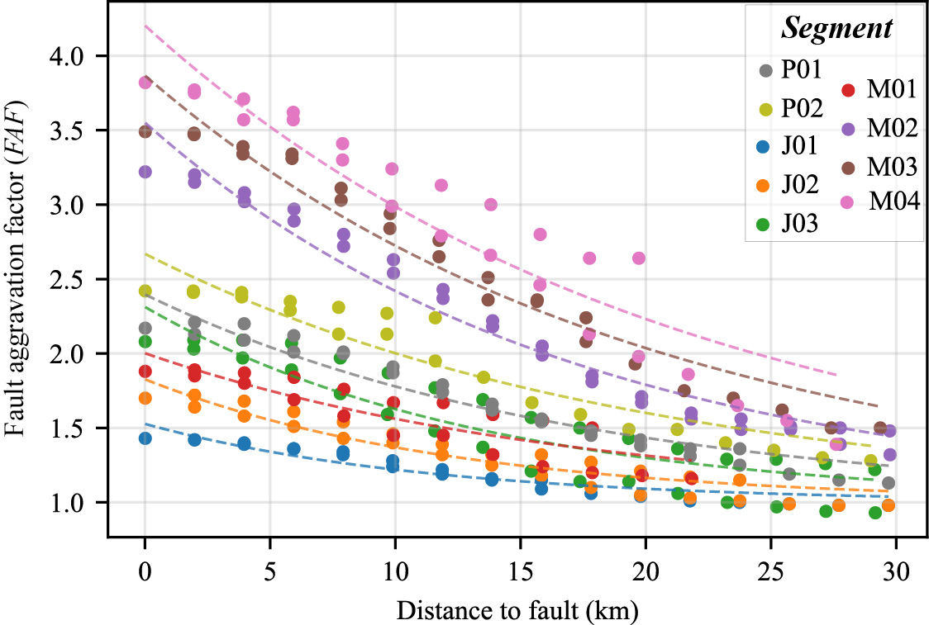
Figure A6. Fault aggravation factor (FAF) as a function of distance to the fault for individual fault segments. Each segment is shown in a different color, with dashed lines representing exponential fits of the form $FAF(d)=1+A_{0}*e^{-d/dc}$. Note the differential behavior of some segments (M02, M03 and M04) compared to others in both data trends and fitted curves.
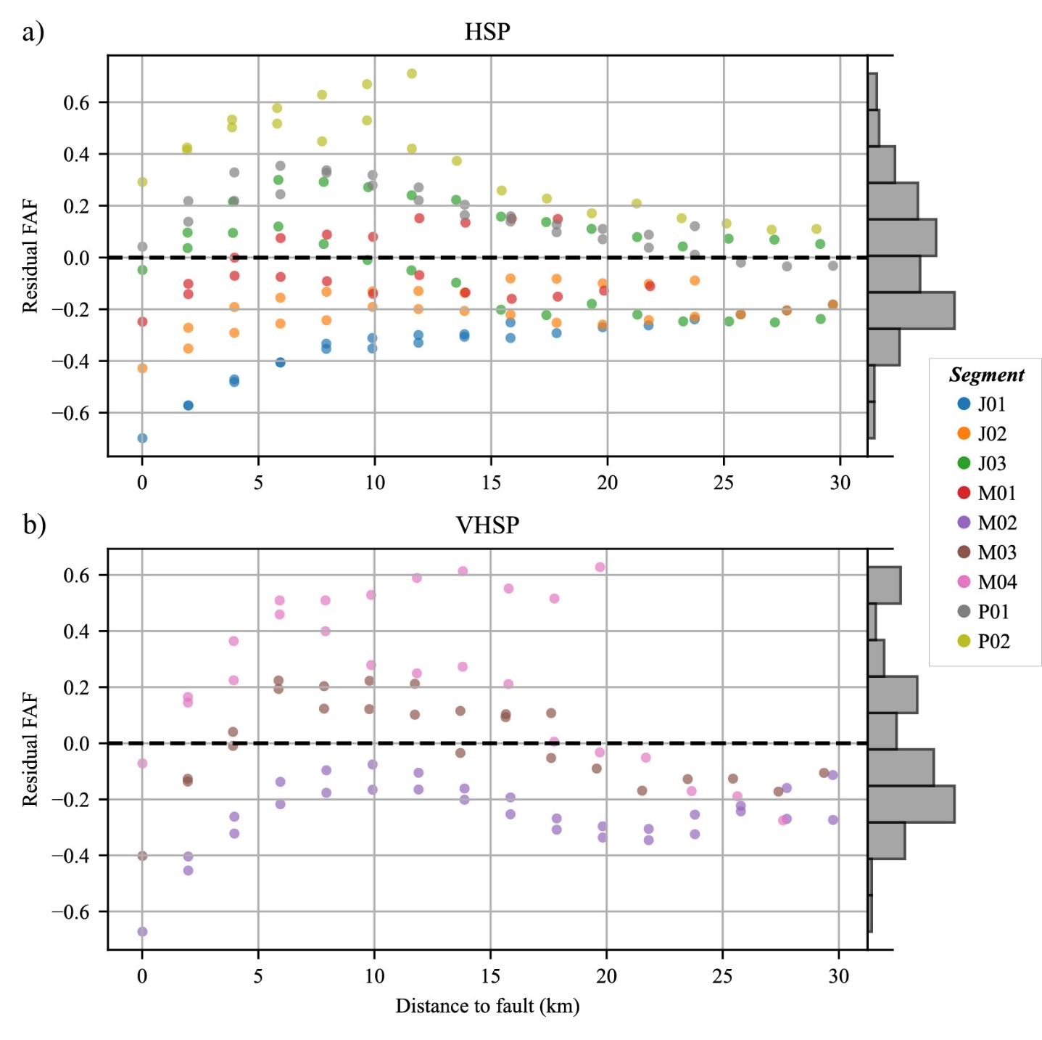
Figure A7. Residuals (observed-predicted FAF) after fitting the distance exponential models. a) High Seismic Potential (HSP) fault segments. b) Very High Seismic Potential (VHSP) fault segments. Histogram of residuals are shown on the right of each plot, and the horizontal dashed line represents zero residual.
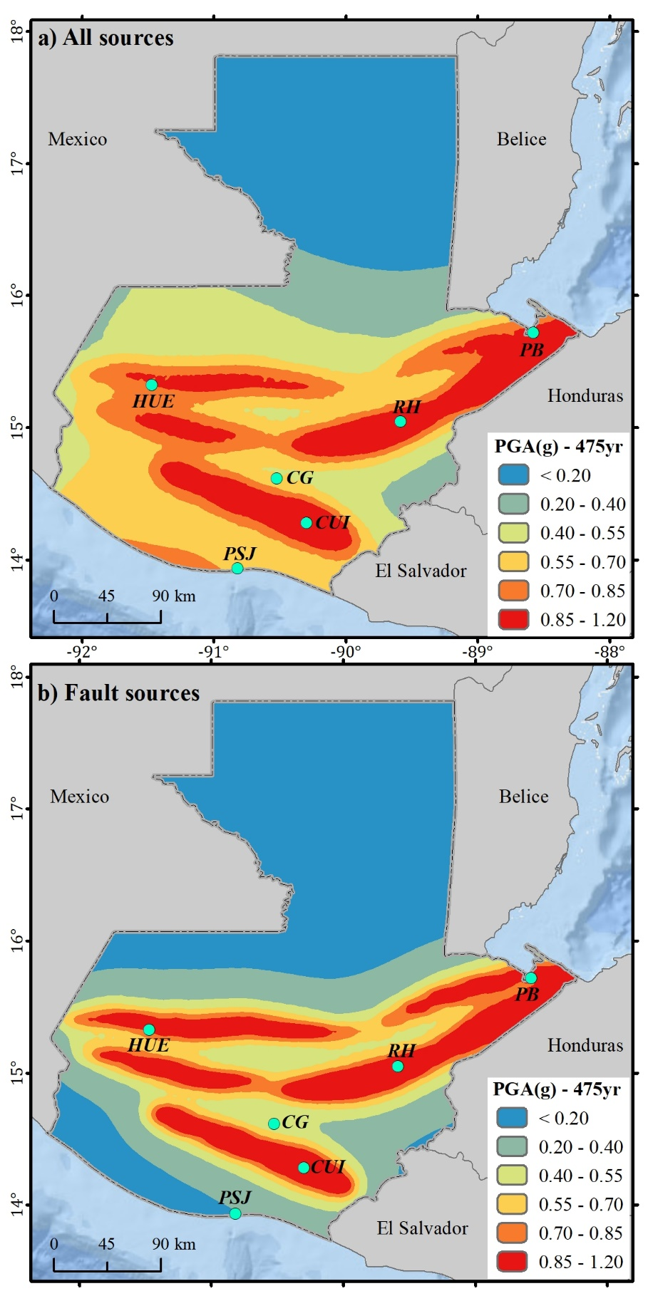
Figure A8. Comparison between hazard computations considering all seismic sources (a) and only the major faults analyzed (b) for a return period of 475yr. Turquoise points are specific inland locations. CG: Guatemala City, CUI: Cuilapa, HUE: Huehuetenango, PB: Puerto Barrios, PSJ: Puerto San José, RH: Rio Hondo.

