Supplementary material
Contents in order of appearance in main paper
Data Availability Statement 2
Kneipp essential equipment list and description 3
Interview guideline 5
Intervention Overview* 7
Per protocol and intention to treat analysis 9

s.Table 1 Kneipp essential equipment list 4
s.Table 2 Expert interview guideline 6
s.Table 3 Per protocol analysis of primary outcome 9
s.Table 4 Per protocol analysis of secondary outcome 10

s.Figure 1 Description Kneipp Activities in the Kneipp Immediate Group 8

Data Availability Statement
The quantitative datasets generated and analyzed for this study including scripts are publicly available in the [BlakesleeKneippBerlinKindergarten GitHub Repository][https://github.com/sschepanski/BlakesleeKneippBerlinKindergarten].
Qualitative data may be reviewed upon individual request.

Kneipp essential equipment list and description

Graphic | Description | No. per Kindergarten
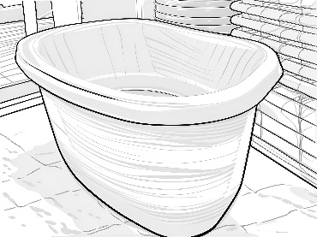_{a} | Foot bath | 4
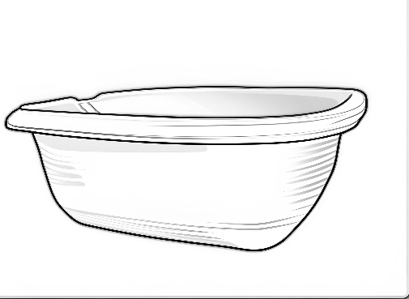_{a} | Arm bath | 2
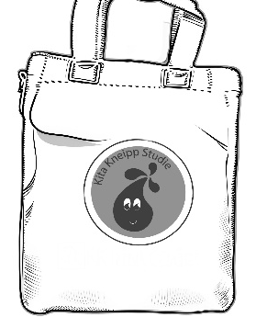_{b} | Small cotton bags | One per child
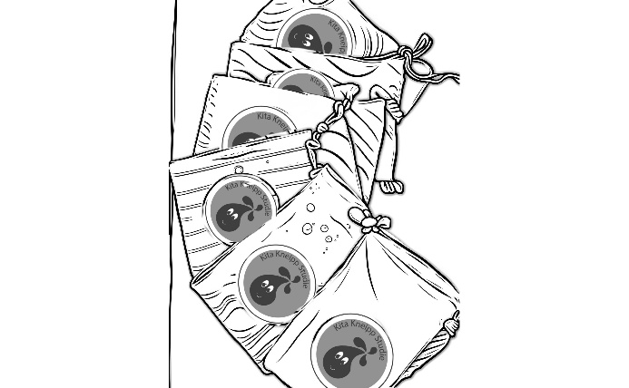_{b} | Linen washcloths | One per child
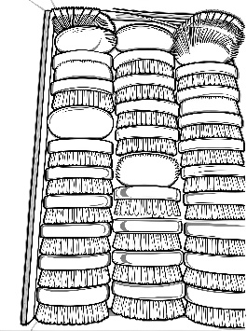_{a} | Child massage brushes | One per Child
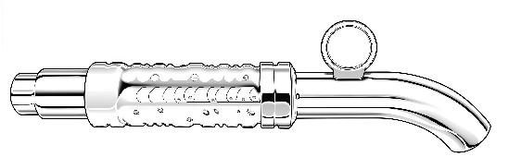_{a} | Kneipp spigot attachment | 1 or 2
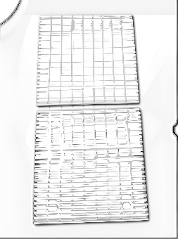_{a} | Foot mats | 2
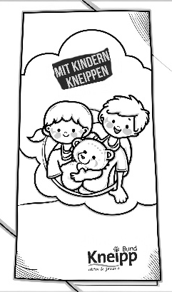_{b} | Kneipp with children Brochure | One per child
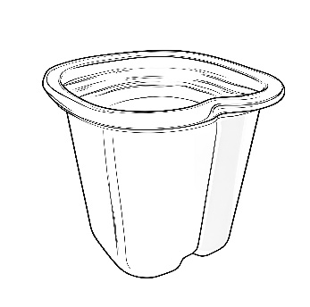_{a} | Adult foot bath | 1
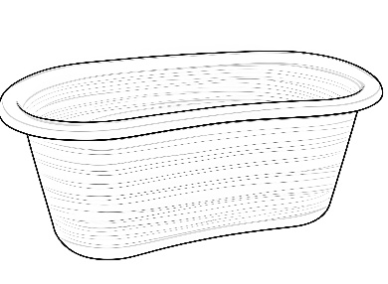_{a} | Adult arm bath | 1

ªLine drawings converted from author photographs using PortraitArt (portraitart.app).
^{b}Line drawings converted from author photographs using PortraitArt (portraitart.app) and adjusted graphically using SketchBook.
s.Table 1 Kneipp essential equipment list

Interview guideline

 | Main Questions | Follow-Up Questions
Background Teacher or Director |  | - Abbreviation, age, educator experience, length of time at the daycare center, responsibility/role.
Opening Question | You have been involved with Kneipp for some time, tell us what your experience has been like so far. | - Were there any particular formative experiences?  - Are there any examples you can give?
2. the implementation of the Kneipp concept | How did you experience the Kneipp treatments?  What activities were carried out and why?  Can you elaborate on the individual elements and what activities were done? | - What was it like for you to conduct activities and do the applications?  - How did it make you feel?  - How were activities selected?  - What was behind the selection of activities?  - How did it work to implement the activities and applications?  - Are there any favorites or applications that are not well received?  - Element water?  - Nutrition?  - Movement?  - Herbs?  - Order of life?  - How satisfied are you with the concept?  - What would you like to have changed?
3. impact on children and teachers | How well do the children react to and or accept the activities?  Thinking back over the entire time since you started practicing the Kneipp aitivities, can you describe specific experiences or impact on individual children?  How have you experienced the group dynamics over the past year (since the introduction of Kneipp treatments)?  How have you experienced the situation with sickness (children, employees) over the last year? | - How did the children react to the Kneipp applications?  - What changed in the children have you seen or experienced over time?  - Can you describe a particular experience that stands out?  - Perhaps: What activities do the children particularly like to do? Do they dislike?  - Can you describe a particularly pleasant or difficult experience?  - What effects have you observed in the children?  - What changes if any have you seen? Please describe them.  - What connection have you seen between the Kneipp concept and daily activities?  - How would you assess the level of illness this last year as compared to previous years?
4. working with the children | How has Kneipp changed your daily activities and work schedule?  How has your work with the children and Kneipp gone thus far? | - How did you feel about the changes?  - How do changes affect the quality of your work with children?  - How were the applications and activities introduced?  - How have the children reacted to you about this?  - How does it make you feel?  - Can you give us an example?
5. impact on the team | How did you feel as a team when you introduced the Kneipp activities and application?  From your perspective, how have the changes been received by the team?  How did you experience the Kneipp training? | - How were Kneipp treatments planned?  - Who planned the Kneipp treatments?  - Who implemented what?  - What went well, what didn't go as well?  - How was the team group dynamic before and after the Kneipp activities and applications?  - What new roles have been delegated within the team?  - What was well received, what was less well received?  - How did you find the training?  - What did you miss?
6. cooperation with parents | How did you inform and involve parents/families in the Kneipp concept?  How did families react to the introduction of Kneipp in the daycare center? | - How did the families react?  - How did you explain the Kneipp concept to the families?  - How do you rate the cooperation with parents/families since the introduction of Kneipp  - What feedback have you had from families?  - Can you give an example?
7.final question | What else would you like to tell us about your experience with Kneipp in the kindergarten? | - How has your overall experience been since the beginning?
Semi-structured question guideline translated from German by DeepL, edited by author, used for interviewing intervention group teachers and kindergarten teachers about Kneipp activities
s.Table 2 Expert interview guideline
.

Intervention Overview*
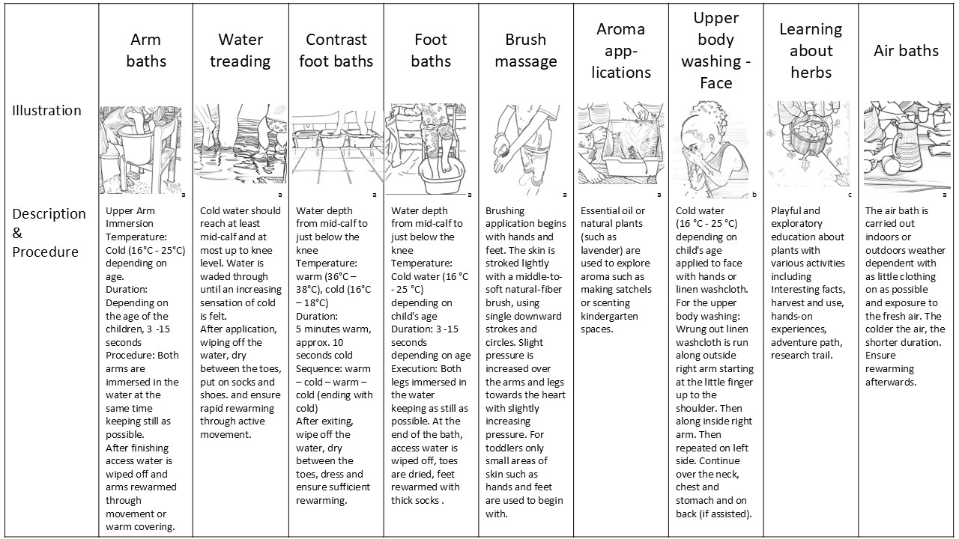
s.Figure 1 Description Kneipp Activities in the Kneipp Immediate Group
Description of the most frequently mentioned Kneipp activities in the immediate groups. Illustrations: Line drawing converted from photographs using PortraitArt (portraitart.app) – ª from author photograph, ^{b} from Unsplash (https://unsplash.com/photos/a-little-girl-is-playing-with-water-from-a-faucet-IivIqWCYgcs), and ^{c} Kneipp-Bund e.V.
*Based on the intervention course titled “Kneipp-Health for Children” activities covering water, exercise, balanced nutrition, herbal plants and life balance were taught by certified Kneipp trainers from Kneipp training institute Sebastian Kneipp Akademie and many additional activities were practiced in the kindergartens. More informationa on the curriculum details are available (Gerganova et al 2024, https://doi.org/10.3389/fmed.2024.1412971, in German: www.kneippakademie.de/kindergesundheit/)

Per protocol and intention to treat analysis
Supplementary Table 3. Primary Outcome
Per-protocol analysis
Kindergarten-reported participants
Outcome | Kneipp (n=125) | Waitlist (n=106) | Estimate (95% CI) (n=231)ª
Children absenteeism, mean (SD, range), days | 1.23 (3.13, 0-20) | 2.73 (4.25, 0-23) | IRR, 2.15 (1.21 to 3.82)
Abbreviations: CI, confidence interval; SD, standard deviation; IRR, incident rate ratio.
ªEstimates adjusted for matched pairs, kindergarten clusters, and baseline absenteeism; 95% Cis are 2sided.
s.Table 3 Per protocol analysis of primary outcome
Supplementary Table 4. Secondary Outcome
Per-protocol analysis
Questionnaire-reported participants
Outcome | Kneipp (n=77) |  | Waitlist (n=69) |  | Estimate (95% CI) (n=146)ª
CCQ score, mean (SD, range)
Boys | 8.9 (2.47, 0-13.9) |  | 9.62 (2.67, 0-16.7) |  | β, -0.79 (-1.77 to 0.19)
Girls | 9.06 (1.37, 6.4-11.7) |  | 8.91 (1.78, 2.25-11.3) |  | β, 0.11 (-0.65 to 0.87)
Cold, mean (SD, range)
Boys | 1.84 (0.37, 1-2) |  | 1.85 (0.37, 1-2) |  | β, 0.12 (-0.16 to 0.4)
Girls | 1.9 (0.31, 1-2) |  | 1.93 (0.26, 1-2) |  | β, 0.07 (-0.05 to 0.13)
Bronchitis, mean (SD, range)
Boys | 1.24 (0.44, 1-2) |  | 1.13 (0.34, 1-2) |  | β, 0.08 (-0.1 to 0.26)
Girls | 1.07 (0.25, 1-2) |  | 1.07 (0.26, 1-2) |  | β, 0.20 (-0.19 to 0.60)
Lung inflammation, mean (SD, range)
Boys | 1 (0, 1-1) |  | 1.05 (0.22, 1-2) |  | β, -0.07 (-0.15 to 0.02)
Girls | 1 (0, 1-1) |  | 1.04 (0.19, 1-2) |  | β, 0.17 (-0.18 to 0.5)
GI infections, mean (SD, range)
Boys | 1.30 (0.46, 1-2) |  | 1.18 (0.39, 1-2) |  | β, 0.09 (-0.11 to 0.29)
Girls | 1.33 (0.48, 1-2) |  | 1.29 (0.46, 1-2) |  | β, 0.06 (-0.19 to 0.30)
Antibiotics, mean (SD, range)
Boys | 1.16 (0.37, 1-2) |  | 1.08 (0.27, 1-2) |  | β, 0.08 (-0.06 to 0.23)
Girls | 1.07 (0.25, 1-2) |  | 1 (0, 1-2) |  | β, 0.08 (0.003 to 0.17)
Abbreviations: CI, confidence interval; CCQ, Common Cold Questionnaire; SD, standard deviation; GI, gastrointestinal.
ªEstimates adjusted for matched pairs, kindergarten clusters, and baseline measures; 95% Cis are 2sided.
s.Table 4 Per protocol analysis of secondary outcome

