Supporting Information
Jin Xinghui,^{*a} Liu Luhao,ª Zhou Jianhua,ª Hu Bingcheng^{b}
ªKey Laboratory of Fine Chemicals in Universities of Shandong, School of Chemistry and Chemical Engineering, Qilu University of Technology (Shandong Academy of Sciences), Ji’nan 250353, China
^{b}School of Chemical Engineering, Nanjing University of Science and Technology, Nanjing, 210094, China
*Email: jingetiema0000@126.com
Detailed Computational methods
In this work, different kinds of pyrazolo[3,4-d][1,2,3] triazole based high energy materials with different bridges and energetic groups were theoretically designed. The optimization of the structures of the designed compounds were performed on Gaussian 16 program [1] by density functional theory (DFT) method (at B3LYP/6-311G(d,p) level). Firstly, the gas-phase heats of formation (ΔH_{f,gas}) of the designed compounds were calculated by isodesmic reactions [2-4] and Eq.(1)-(2).
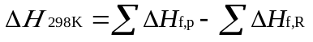 (1)
(2)
where, ∆H_{f,p} and ∆H_{f,R} were presented as heats of formation of the products and reactants, and ΔE₀, ΔZPE, ΔH_{T} were presented energy changes between products and reactants, difference between the zero-point energy (ZPE) of products and reactants, thermal correction from 0 to 298 K, respectively. Besides, n was the number of the energetic groups, ∆(PV) equals to ∆nRT.
The isodesmic reactions were designed as follows:
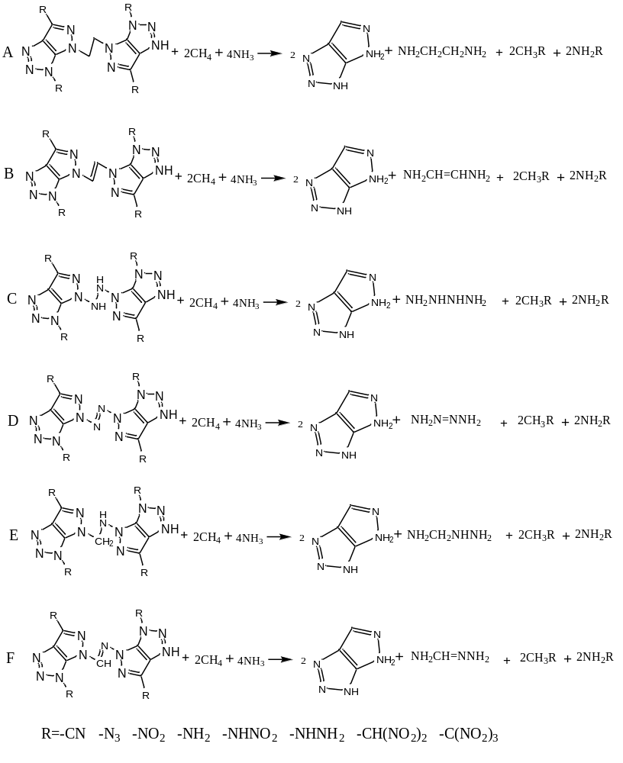
Scheme S1 The designed isodesmic reactions for the designed compounds
In the isodesmic reactions, ΔH_{f,gas} of most of the small molecules can be obtained from http://webbook.nist.gov. However, the ΔH_{f,gas} of the other molecules were not available. Therefore, atomization reactions (C_{a}H_{b}N_{c}→aC(g)+bH(g)+cN(g)) at CBS-Q level and isodesmic reactions were employed to calculated the ΔH_{f,gas} of pyrazolo[3,4-d][1,2,3] triazole, CH₃CH(NO₂)₂ and CH₃C(NO₂)₃).
CH₃CH(NO₂)₂ +2CH₄→CH₃CH₃+2CH₃NO₂
CH₃C(NO₂)₃ +3CH₄→CH₃CH₃+3CH₃NO₂
Data which were necessary to calculate the heats of formation of the designed compounds were summarized in Table S1.
Table S1. Calculated total energies (E₀), zero-point energies (ZPE), thermal corrections (H_{T}) and heats of formation (HOFs) of the reference compounds
Compound. | E₀ (a.u.)ª | ZPE (kJ mol⁻¹)ª | H_{T} (kJ mol⁻¹)ª | ΔH_{f,gas} (kJ mol⁻¹)
NH₃ | -56.576035 | 90.1 | 10.0 | -45.9^{b}
CH₄ | -40.533748 | 117.0 | 10.0 | -74.6^{b}
CH₃NHNH₂ | -151.217035 | 213.0 | 14.3 | 94.5^{b}
CH₃NH₂ | -95.888444 | 167.6 | 11.4 | -23.5^{b}
CH₃NHNO₂ | -300.434462 | 176.5 | 16.0 | -8.5^{c}
CH₃NO₂ | -245.081687 | 130.6 | 13.9 | -81.0^{b}
CH₃CN | -132.793330 | 118.7 | 11.9 | 74.0^{b}
CH₃N₃ | -204.148401 | 131.7 | 14.2 | 289.9^{c}
NH₂CH₂CH₂NH₂ | -190.576020 | 289.4 | 17.2 | -17.0^{b}
NH₂CH=CHNH₂ | -189.352947 | 225.9 | 16.3 | 95.8^{c}
NH₂NHNHNH₂ | -222.581433 | 231.1 | 15.8 | 304.2^{c}
NH₂N=NNH₂ | -221.395185 | 165.5 | 14.4 | 301.2^{c}
NH₂CH₂NHNH₂ | -206.587775 | 260.3 | 16.5 | 123.9^{c}
NH₂CH=NNH₂ | -205.386542 | 195.7 | 15.7 | 165.6^{c}
CH₃CH(NO₂)₂ | -488.950712 | 212.3 | 22.8 | 81.8^{d}
CH₃C(NO₂)₃ | -693.479196 | 215.6 | 29.3 | 105.1^{d}
NH₂CN | -148.829415 | 89.5 | 11.9 | 140.8^{c}
NH₂N₃ | -220.158873 | 101.8 | 14.0 | 416.3^{c}
NH₂NH₂ | -111.901535 | 139.9 | 11.1 | 95.4^{b}
NH₂NHNH₂ | -167.241789 | 184.7 | 13.4 | 206.8^{c}
NH₂NO₂ | -261.110946 | 100.1 | 11.7 | -6.4^{c}
NH₂NHNO₂ | -316.445860 | 146.7 | 15.5 | 119.1^{c}
NH₂CH(NO₂)₂ | -504.995416 | 182.9 | 22.8 | -73.7^{d}
NH₂C(NO₂)₃ | -709.522642 | 185.2 | 29.4 | -34.5^{d}
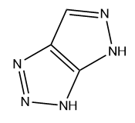 | -389.883008 | 199.6 | 16.8 | 510.6^{c}
a, calculated at B3LYP/ 6-311G (d,p) level; b, obtained from http://webbook.nist.gov; c, calculated values were calculated at the CBS-Q level; d, obtained by isodesmic reaction.
Accurate values of solid-phase HOFs (ΔH_{f,solid}) of the designed compounds were calculated Hess's law [6] :
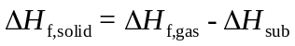 (3)
In which ΔH_{sub} stands for the heat of sublimation and can be calculated by Multiwfn program.[7]
Detonation velocities (D) and detonation pressures (P) were calculated by Kamlet-Jacobs equations (Eq.(4)-(5)) [8]:
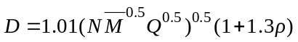 (4)
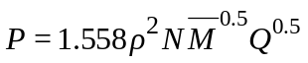 (5)
In those equations, N presented the moles of detonation gases per gram of explosive (mol·g⁻¹), M on behalf of the average molecular weight of these gases (g·mol⁻¹) and Q presented heat of detonation (cal·g⁻¹), respectively. Moreover, ρ was the density, and the accurate values of ρ can been modified by Multiwfn program.
Impact sensitivity (h₅₀) was calculated according to equation 6 since it can reflect the security of an energetic material during the storage or handling process.
h₅₀=aσ₊²+b$\frac{{\text{σ}}_{\text{+}}^{\text{2}}{\text{σ}}_{\text{-}}^{\text{2}}}{{{\text{(σ}}_{\text{+}}^{\text{2}}{\text{+σ}}_{\text{-}}^{\text{2}})}^{\text{2}}}$+c (6)
where a, b and c were constants; σ₊² was indicator of the strengths and variabilities of the positive surface potentials, σ₋² was indicator of the strengths and variabilities of the negative surface potentials.
Reference
- Frisch, M. J.; Trucks, G. W.; Schlegel, H. B.; et al, Gaussian 16, Gaussian Inc, Pittsburgh, PA, 2016.
- Chen, J. F.; Yu, Y.; Zhang, S J.; Li, Y. C.; Pang, S. P.; Energetic materials with fluorinated four-membered heterocyclic ring: 3, 3′-difluoroazetidine (DFAZ) salts[J]. New J. Chem., 2019, 43, 15115-15119.
- Ghule, V. D.; Sarangapani, R.; Jadhav, P. M.; Tewari, S. P. Theoretical Studies on Nitrogen Rich Energetic Azoles. J. Mol. Model. 2011, 17, 1507-1515.
- Tan, B. S; Li, H. Z.; Huang, H.; Han, Y.; Li, J. M.; Li, M.; Long, X. P.; Large π-π separation energies of some energetic compounds[J]. Chem. Phys., 2019, 520, 81-87.
- Zhu, W. H.; Zhang, C. C.; Wei, T.; Xiao, H. M. Theoretical Studies of Furoxan-based Energetic Nitrogen-rich Compounds. Struct. Chem. 2011, 22, 149-159.
- P. W. Atkins, Physical chemistry, 2nd edn. Oxford University Press: Oxford, 1982.
- Lu, T.; Chen, F. Multiwfn: A Multifunctional Wavefunction Analyzer. J. Comput. Chem. 2012, 33, 580-592.
- Kamlet, M. J.; Jacobs, S. J. Chemistry of Detonations. I. A Simple Method for Calculating Detonation Properties of CHNO Explosives. J. Chem. Phys. 1968, 48, 1968, 23-25.

