SUPPLEMENTARY MATERIAL

Paper: Meta-analysis of 633,317 individuals shows associations between healthy diets and mental health in 23 low- and middle-income countries

Authors: Thalia M Sparling¹, Cesar Cornejo¹, Bryan Cheng², Lisa M.Troy³, Suneetha Kadiyala¹

1 London School of Hygiene and Tropical Medicine, Keppel Street, London WC1E 7HT, UK
2 Global Mental Health Lab, Teachers College, Columbia University, New York, NY, USA
3 School of Public Health and Health Sciences, University of Massachusetts, Amherst MA, USA

Corresponding author  e-mail: thalia.sparling@lshtm.ac.uk

Contents

Supplementary Methods

Supplementary methods 1: MOOSE Checklist for Meta-analyses of Observational Studies

Supplementary methods 2: Example search strategy from Medline. Search for CAB Global Health and PsychInfo databases are similarly constructed

Supplementary methods 3: Multi-step inclusion and exclusion criteria
Supplementary methods 4: Quality in Prognostic Studies (QuiPS) Risk of Bias tool

Supplementary Results
Supplementary results 1: List of included studies in the meta-analysis
Supplementary results 2: Risk of bias in longitudinal studies (n=9), including study attrition domain
Supplementary results 3: Pooled estimated based on Risk of bias (low vs. high) overall and in study participation and confounding domains
Supplementary results 4: Outliers and influential studies
Supplementary results 5: Pooled effect estimates by dietary measure group
Supplementary results 6: Sensitivity analysis of different pooled effect measures

Supplementary Methods

Supplementary methods 1: MOOSE Checklist for Meta-analyses of Observational Studies
Item Nº | Recommendation | Reported
Reporting of background should include
1 | Problem definition | Yes
2 | Hypothesis statement | Na
3 | Description of study outcome(s) | Yes
4 | Type of exposure or intervention used | Yes
5 | Type of study designs used | Yes
6 | Study population | Yes
Reporting of search strategy should include
7 | Qualifications of searchers (eg, librarians and investigators) | Yes
8 | Search strategy, including time period included in the synthesis and key words | Yes
9 | Effort to include all available studies, including contact with authors | Yes
10 | Databases and registries searched | Yes
11 | Search software used, name and version, including special features used (eg, explosion) | Yes
12 | Use of hand searching (eg, reference lists of obtained articles) | Yes
13 | List of citations located and those excluded, including justification | Yes
14 | Method of addressing articles published in languages other than English | Na
15 | Method of handling abstracts and unpublished studies | Yes
16 | Description of any contact with authors | Na
Reporting of methods should include
17 | Description of relevance or appropriateness of studies assembled for assessing the hypothesis to be tested | Yes
18 | Rationale for the selection and coding of data (eg, sound clinical principles or convenience) | Yes
19 | Documentation of how data were classified and coded (eg, multiple raters, blinding and interrater reliability) | Yes
20 | Assessment of confounding (eg, comparability of cases and controls in studies where appropriate) | Yes
21 | Assessment of study quality, including blinding of quality assessors, stratification or regression on possible predictors of study results | Yes
22 | Assessment of heterogeneity | Yes
23 | Description of statistical methods (eg, complete description of fixed or random effects models, justification of whether the chosen models account for predictors of study results, dose-response models, or cumulative meta-analysis) in sufficient detail to be replicated | Yes
24 | Provision of appropriate tables and graphics | Yes
Reporting of results should include
25 | Graphic summarizing individual study estimates and overall estimate | Yes
26 | Table giving descriptive information for each study included | No
27 | Results of sensitivity testing (eg, subgroup analysis) | Yes
28 | Indication of statistical uncertainty of findings | Yes

Item Nº | Recommendation | Reported
Reporting of discussion should include
29 | Quantitative assessment of bias (eg, publication bias) | Yes
30 | Justification for exclusion (eg, exclusion of non-English language citations) | Yes
31 | Assessment of quality of included studies | Yes
Reporting of conclusions should include
32 | Consideration of alternative explanations for observed results | Yes
33 | Generalization of the conclusions (ie, appropriate for the data presented and within the domain of the literature review) | Yes
34 | Guidelines for future research | Yes
35 | Disclosure of funding source | Yes

From: Stroup DF, Berlin JA, Morton SC, et al, for the Meta-analysis Of Observational Studies in Epidemiology (MOOSE) Group. Meta-analysis of Observational Studies in Epidemiology. A Proposal for Reporting. JAMA. 2000;283(15):2008-2012. doi: 10.1001/jama.283.15.2008.

Supplementary methods 2: Example search strategy from Medline. Search for CAB Global Health and PsychInfo databases are similarly constructed
Ovid MEDLINE(R) and In-Process & Other Non-Indexed Citations and Daily <1946 to January 31, 2024> Searched 4th January 2024

1 ("mental health" or ((distress or stress) adj2 (psychological or psychosocial or mental)) or depression or wellbeing or "well being" or well-being or ((depressive or anxiety or anxious or affective or mood or mental) adj2 disorder*)).ti,ab,kw.
2 *depression/ or *depression, postpartum/ or *adaptation, psychological/ or *emotional adjustment/ or *survivorship/ or *mental health/ or *resilience, psychological/ or *mental disorders/ or *anxiety disorders/ or *"feeding and eating disorders"/ or *anorexia nervosa/ or *mood disorders/ or *depressive disorder/ or *adjustment disorders/ or *stress disorders, traumatic/ or *affective symptoms/dh, ec, ep, eh, et, mo, pp, pc, rh, th or *psychological trauma/ or *stress, psychological/
3 or/1-2
4 *nutrition disorders/ or *child nutrition disorders/ or *infant nutrition disorders/ or *exp malnutrition/ or *fetal nutrition disorders/ or *severe acute malnutrition/ or *kwashiorkor/ or *wasting syndrome/ or *nutritional status/
5 (nutrition* or nutrient* or micronutrient* or malnutrition or malnourish* or kwashiorkor or marasmus or undernutrition or ((iron or iodine or vitamin* or zinc) adj3 deficien*)).ti,ab,kw.
6 or/4-5
7 *dietary supplements/ or *breast feeding/ or *diet/ or *feeding behavior/ or *bottle feeding/ or *food preferences/ or *weaning/ or *food supply/ or *famine/ or *eating/ or *maternal nutritional physiological phenomena/ or *prenatal nutritional physiological phenomena/ or *nutritional requirements/ or *Infant Nutritional Physiological Phenomena/ or *Child Nutritional Physiological Phenomena/ or *infant food/ or *infant formula/
8 (diet* or ((food or eating) adj3 (pattern* or intake or shortage* or securit* or insecurit* or supplement* or access* or depriv* or belief* or consumption or cost* or purchas* or buy* or afford* or supplies or supply or availab*)) or "breast feed*" or "breast fed" or breastfeed* or breastfed or "bottle feed*" or "bottle fed" or ((infant* or child*) adj2 (feed* or food* or nutrition* or formula* or wean*))).ti,ab,kw.
9 or/7-8
10 *growth disorders/ or *fetal growth retardation/ or *fetal development/ or *fetal viability/ or *developmental disabilities/ or *pregnancy outcome/ or *pregnancy complications/px or *premature birth/ or *birth weight/ or *fetal weight/ or *thinness/ or *failure to thrive/ or *exp infant, low birth weight/ or *exp infant, premature/ or *"child of impaired parents"/ or *child development/
11 ((growth adj2 (disorder* or retard*)) or ((pregnan* or birth) adj3 outcome*) or birthweight or "birth weight" or ((premature or preterm or "pre term") adj2 (infant* or birth*)) or "failure to thrive").ti,ab,kw.
12 or/10-11
13 ((obes* or overweight or "over weight" or underweight or "under weight" or ((body or bodily) adj2 (thin or thinness))) adj5 (nutrition* or nutrient* or micronutrient* or malnutrition or malnourish* or kwashiorkor or marasmus or undernutrition or ((iron or iodine or vitamin* or zinc) adj3 deficien*))).ti,ab,kw.
14 (*obesity/dh, ep, eh, et, pc, px, rh or *obesity, maternal/dh, ep, eh, et, pc, px, rh or *obesity, morbid/dh, ep, eh, et, pc, px, rh or *pediatric obesity/dh, ep, eh, et, pc, px, rh or *overweight/dh, ep, eh, et, pc, px, rh or *thinness/dh, ep, eh, et, pc, px, rh) and (nutrition/ or nutrition disorders/ or child nutrition disorders/ or infant nutrition disorders/ or exp malnutrition/ or fetal nutrition disorders/ or severe acute malnutrition/ or kwashiorkor/ or wasting syndrome/ or nutritional status/)
15 or/13-14
16 *anthropometry/ or *apgar score/ or *"body weights and measures"/ or *body fat distribution/ or *body mass index/ or *body weight/
17 (anthropometr* or "apgar scor*" or "body measur*" or "body mass index" or BMI).ti,ab,kw.
18 or/16-17
19 6 or 9 or 12 or 15 or 18
20 ((systematic* or synthes*) adj3 (research or evaluation* or finding* or thematic* or report or descriptive or explanatory or narrative or meta* or review* or data or literature or studies or evidence or map or quantitative or study or studies or paper or impact or impacts or effect* or compar*)).ti,ab,kw.
21 ("meta regression" or "meta synth*" or "meta-synth*" or "meta analy*" or "metaanaly*" or "meta-analy*" or "metanaly*" or "metaregression" or "metaregression" or "logistic regression" or "methodologic* overview" or "pool* analys*" or "pool* data" or "quantitative* overview" or "research integration").ti,ab,kw.
22 (review adj3 (effectiveness or effects or systemat* or synth* or integrat* or map* or methodologic* or quantitative or evidence or literature)).ti,ab,kw.
23 ("meta ethnograph*" or "meta synthesis" or (synthesis and ("qualitative literature" or "qualitative research")) or "critical interpretive synthesis" or ("systematic review" and ("qualitative research" or "qualitative literature" or "qualitative stud*")) or "thematic synthesis" or "framework synthesis" or "realist review" or "realist synthesis" or "qualitative systematic review*" or "qualitative evidence synthes*" or (("quality assessment" or "critical appraisal" or "literature search*") and ("qualitative research" or "qualitative literature" or "qualitative stud*")) or (Noblit and Hare) or "meta narrative*" or "narrative synthesis").ti,ab,kw.
24 (random$ or placebo$ or single blind$ or double blind$ or triple blind$ or cohort$ or (case* adj2 control*) or ((cohort or follow up or follow-up) adj2 (control$ or series or report$ or study or studies)) or retrospective$ or ((quasi-experiment* or observ$) adj3 (study or studies or design))).ti,ab,kw.
25 meta-analysis/ or "systematic review"/ or controlled clinical trial/ or randomized controlled trial/ or random allocation/ or equivalence trial/ or pragmatic clinical trial/ or case-control studies/ or retrospective studies/ or exp cohort studies/ or controlled before-after studies/ or cross-sectional studies/ or interrupted time series analysis/ or multivariate analysis/ or qualitative research/ or risk assessment/
26 or/20-25
27 3 and 19 and 26
28 limit 27 to yr="2000 -Current"

Supplementary methods 3: Multi-step inclusion and exclusion criteria

Step 1: Evidence Gap Map exclusion criteria relevant to diets domain

 | Inclusion criteria | Exclusion criteria
Diet domain | Quantitative measures of specific food groups or dietary patterns or quality using food frequency questionnaires, dietary recall, food journals, consumption scores, indices, principal components analysis (PCA) or qualitative investigation | Dietary intake:  - Single-item foods (e.g. avocadoes, seaweed, walnuts, chocolate, therapeutic formulas, herbal remedies)  - Specialized or proprietary foods or formulas  - Probiotics and microbiome related formulas or microbiome status indicators  - Alcohol, caffeine, or stimulant foods  - Hormones, hormonal therapy  Dietary patterns:  - Studies that only describe understanding of diets and nutrition rather than actual practices.  - Perceptions, attitudes and behaviors about food or diets with no intake component (e.g. eating family dinners, weight loss, dieting)  - Emotional eating, disordered eating, night-time eating, binge eating, emotional eating scales (e.g. Power of Food index)  - Anorexia nervosa or bulimia is not considered as an FNS measure of food intake or eating patterns  - Weight loss interventions, low calorie diets, weight loss diets, change in weight or weight trajectories
Mental health domain | - Any measures of depression  - Studies examining two or more of the mental health measures above and/or investigate mood disorders or other affective symptoms  - Any measures of anxiety  - Any measures of perceived stress  - Any experiential measure of mental wellbeing, including health-related quality of life, mental quality of life, perceived wellbeing | - Studies in which the exposure is anti-depressants or other medication rather than the condition itself  - Studies that only refer to specific psychoses or disorders such as bipolar, dementia, Alzheimer’s, Parkinson’s, schizophrenia and addiction/smoking disorders  - Eating disorders  - Stressful event indices without accompanying experiential measures  - Post-traumatic stress or specific occupational stress (based on type of work, etc.) is not be included on its own  - Cortisol as an isolated measure of stress  - Happiness, general satisfaction (without specific mental health measures), or composite tools where the mental health components cannot be extracted.
Population | - General populations in any geographic location  - These may include specific age groups, specific genders or specific life-course stages such as pregnancy or older people  - Populations defined by certain equity aspects, such as low SES, income, occupations, or places of residence.  - Special populations including refugee status and prisoners will be included with a separate code | - Non-human populations  - Populations defined by specific health conditions such as heart disease, hypertension, diabetes, dementia, coeliac, anorexia, preterm birth, HIV, etc.  - Populations being treated in a clinical therapeutic setting, hospital settings  - Extremely niche populations with specific nutritional requirements such as professional athletes.

Step 2: Meta-analysis inclusion and exclusion criteria

Inclusion criteria | Exclusion criteria
Has any of the following dietary patterns which can be associated with healthy eating:  - Adherence to diet recommendations  - Nutrient adequacy  - Dietary Approaches to Stop Hypertension (DASH)  - Dietary Inflammatory Index  - Mediterranean diet  - Dietary diversity (MDD, IDDS)  - Any other Dietary Variety Scores  - Diet Quality Indexes (all)  - Global Diet Quality Score  - Global Dietary Index  - Healthy Eating Indexes (all)  - All comparisons between a healthy and an unhealthy diet. Unhealthy is a group with a processed, western, modern, traditional, or unhealthy diet determined for each study.  (AND)  Has an unhealthy eating comparison group | Out of scope in healthy eating domain:  (1) Only has a dietary intake of any food groups (FG) without a dietary pattern that could capture an aggregated ‘healthy diet’.  (2) Only has any of the following dietary patterns:  - Animal Source Foods (low or high)  - Breakfast  - Carb (low or high)  - Fruit/veg (low or high)  - Glycemia (load/index), insulin  - High protein (paleo, ketogenic)  - Low-fat, low calorie  - Meal frequency, skips, fasting  - Varied, diverse  - Vegetarian, vegan, omni  - Diet History Questionnaire (all)  - Vegetable Variety Score  - Outcome different from depression, anxiety or stress  - Duplicated data  - Lack of comparability  - Relevant estimate not reported

Supplementary methods 4: Quality in Prognostic Studies (QuiPS) Risk of Bias tool

Available at https://methods.cochrane.org/sites/methods.cochrane.org.prognosis/files/uploads/QUIPS%20tool.pdf

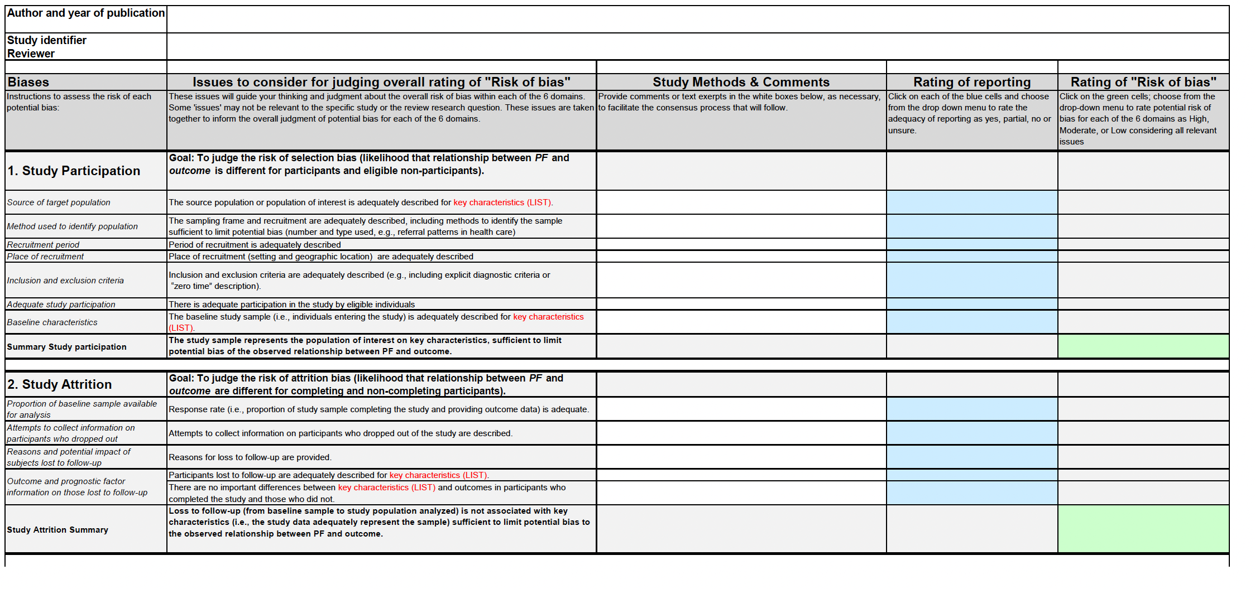

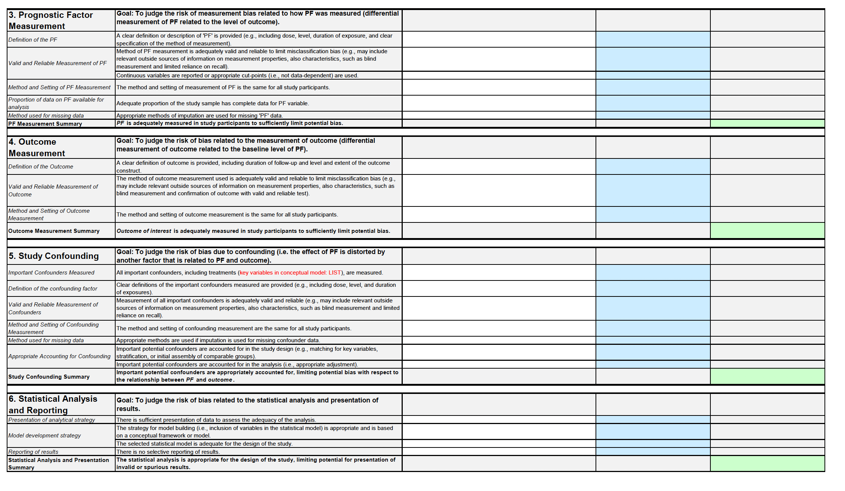

Supplementary methods 5: Population Attributable Fraction calculation

- We converted the SMDs back into odds ratios, which was the most common original effect estimate measure (n=56) with a logistic approximation
- We then calculated the population attributable fraction (PAF) of 1% the 1.68 billion people who cannot afford a healthy diet in LMICs moving to ‘healthy diet’ status (1% = 16,800,000)
- We assume in this exercise that all those who could afford a healthy diet actually ate a healthy diet
- This translates to 41% less odds of depression (OR 0.59, 95% CI 0.53 to 0.66), in turn with between 0.90–1.27 million less cases of depression per 1% change.
- These calculations are based on several strong assumptions with no assumption of causality, but are offered as an example of how modest effects can have large population-level implications.

Supplementary Results

Supplementary results 1: List of included studies in the meta-analysis
Abou-Rizk Joana, Jeremias Theresa and Cocuz Georgiana ; Nasreddine Lara ; Jomaa Lamis ; Hwalla Nahla ; Frank Jan ; Scherbaum Veronika ;. (2022). Food insecurity, low dietary diversity and poor mental health among Syrian refugee mothers living in vulnerable areas of Greater Beirut, Lebanon. The British journal of nutrition, 128(9), pp.1832-1847.
Acik M and Cakiroglu F P. (2019). Evaluating the Relationship between Inflammatory Load of a Diet and Depression in Young Adults. Ecology of Food & Nutrition, 58, pp.366-378.
Acik Murat, Altan Murat and Cakiroglu Funda Pinar;. (2022). A cross-sectionally analysis of two dietary quality indices and the mental health profile in female adults. Current Psychology: A Journal for Diverse Perspectives on Diverse Psychological Issues, 41(8), pp.5514-5523.
Adhikari R P, Williamson R and Sparling T M; Ferguson E ; Cunningham K ;. (2020). Parental depression and nutrition: findings from a cross-sectional household survey in Nepal. Public Health Nutrition, 23(16), pp.2983-2993.
Alenko Arefayne, Agenagnew Liyew and Beressa Girma ; Tesfaye Yonas ; Woldesenbet Yohannes Markos; Girma Shimelis ;. (2021). COVID-19-Related Anxiety and Its Association with Dietary Diversity Score Among Health Care Professionals in Ethiopia: A Web-Based Survey. Journal of multidisciplinary healthcare, 14, pp.987-996.
Almhdawi K A, Kanaan S F; Khader Y and Al-Hourani Z ; Almomani F ; Nazzal M ;. (2018). Study-related mental health symptoms and their correlates among allied health professions students. Work, 61, pp.391-401.
Anosike Chibueze, Anene-Okeke Chigozie G and Ayogu Ebere E; Oshigbo Mariagorathy C;. (2022). Prevalence of depression and anxiety, and attitudes toward seeking help among first-year pharmacy, medical, and nursing students at a Nigerian university. Currents in pharmacy teaching & learning, 14(6), pp.720-728.
Ayesha Saeed, Tahira Raana and Saeed A M; Ayesha Humayun ;. (2016). Effect of antenatal depression on maternal dietary intake and neonatal outcome: a prospective cohort. Nutrition Journal, 15, pp..
Barkhordari Roya, Namayandeh Mahdieh and Mirzaei Masoud ; Sohouli Mohammad Hassan; Hosseinzadeh Mahdieh ;. (2022). The relation between MIND diet with psychological disorders and psychological stress among Iranian adults. BMC Psychiatry, 22, pp..
Beigrezaei Sara, Darabi Zahra and Davies Ian G; Mazidi Mohsen ; Ghayour-Mobarhan Majid ; Khayyatzadeh Sayyed Saeid;. (2023). Higher global diet quality score is related to lower prevalence of depression and poor quality of life among adolescent girls. BMC Psychiatry, 23(1), pp..
Bousquet-Santos Kelb, Chen Ruijia and Kubzansky Laura D;. (2021). A sad heart: Depression and favorable cardiovascular health in Brazil. Preventive medicine, 142, pp.106378.
Chegini M, Shirani P and Omidvar N ; Eini-Zinab H ; Pour-Ebrahim F ; Rezazadeh A ;. (2022). Relationship between diet quality and depression among Iranian older adults in Tehran. BMC Geriatrics, 22(708), pp..
Cheng Taozhu, Fu Mingqi and Zhang Bo ; Luo Li ; Guo Jing ;. (2023). Do living arrangements and health behaviors associate with anxiety symptoms among Chinese older people? Differences between urban and rural areas. Psychology and Health & Medicine, 28(10), pp.3117-3130.
Darooghegi Mofrad, Manije and Siassi Fereydoun ; Guilani Bijan ; Bellissimo Nick ; Suitor Katherine ; Azadbakht Leila ;. (2020). The association of food quality index with mental health in women: a cross-sectional study. BMC research notes, 13(1), pp.557.
Dehghan Parvin, Nejati Marzieh and Vahid Farhad ; Almasi-Hashiani Amir ; Saleh-Ghadimi Sevda ; Parsi Reza ; Jafari-Vayghan Hamed ; Shivappa Nitin ; R Hebert ; James ;. (2022). The association between dietary inflammatory index, dietary antioxidant index, and mental health in adolescent girls: an analytical study. BMC public health, 22(1), pp.1513.
Ding Ye, Li Genyuan and Shi Xi ; Wang Mengyi ; Peng Yanxia ; Deng Huiqin ; Yang Ziqi ; Liang Qingfen ; Wang Zhixu ;. (2023). Correlation of lifestyle behaviors during pregnancy with postpartum depression status of puerpera in the rural areas of South China. Frontiers in public health, 11, pp.1304226.
El Ansari , W and Berg-Beckhoff G ;. (2015). Nutritional Correlates of Perceived Stress among University Students in Egypt. International Journal of Environmental Research & Public Health [Electronic Resource], 12, pp.14164-76.
Esin Kubra and Ayyildiz Feride . (2024). Food insecurity, Mediterranean diet adherence, and psychosocial health among university students in Turkiye. International journal of environmental health research, 34(1), pp.649-659.
Faghih S, Babajafari S and Mirzaei A ; Akhlaghi M ;. (2019). Adherence to the dietary approaches to stop hypertension (DASH) dietary pattern and mental health in Iranian university students. European Journal of Nutrition, 59(3), pp.1001-1011..
Gomes A P, Oliveira Bierhals and I ; Goncalves Soares ; A L ; Hellwig N ; Tomasi E ; Formoso Assuncao ; M C ; Goncalves H ;. (2018). Interrelatioship between Diet Quality and Depressive Symptoms in Elderly. Journal of Nutrition and Health & Aging, 22, pp.387-392.
Gomes A P, Goncalves H and Vaz J dos S; Kieling C ; Rohde L A; Oliveira I O; Soares A G;. (2021). Do inflammation and adiposity mediate the association of diet quality with depression and anxiety in young adults?. Clinical Nutrition, 40(5), pp.2800-2808.
Haghighatdoost F, Feizi A and Esmaillzadeh A ; Feinle-Bisset C ; Keshteli A H; Afshar H ; Adibi P ;. (2019). Association between the dietary inflammatory index and common mental health disorders profile scores. Clinical Nutrition, 38, pp.1643-1650.
Hajihashemi Parisa, Haghighatdoost Fahimeh and Mohammadifard Noushin ; Maghroun Maryam ; Sajjadi Firouzeh ; Najafi Farid ; Farshidi Hossein ; Lotfizadeh Masoud ; Solati Kamal ; Kazemi Tooba ; Karimi Simin ; Roohafza Hamidreza ; Sabri Mohammadreza ; de Oliveira Cesar ; Silveira Erika Aparecida; Sarrafzadegan Nizal ;. (2022). The association of dietary macronutrient quality indices with depression and anxiety symptoms and quality of life in Iranian adults: The LipoKAP study. Journal of affective disorders, 317, pp.409-416.
Heidari Z, Feizi A and Roohafza H ; Rabiei K ; Sarrafzadegan N ;. (2019). Are dietary patterns differently associated with differentiated levels of mental health problems? Results from a large cross-sectional study among Iranian manufacturing employees. BMJ Open, 9, pp.e020083.
Hemmati Amirhossein, Ghoreishy Seyed Mojtaba and Karami Keianoush ; Imani Hossein ; Farsani Gholamreza Mohammadi; Mousavi Sara Ebrahimi; Asoudeh Farzaneh ; Shariati-Bafghi Seyedeh-Elaheh ; Karamati Mohsen ;. (2021). The association between dietary patterns and depression in adolescents: A cross-sectional study. Clinical nutrition ESPEN, 46, pp.271-275.
Hosseinzadeh M, Vafa M R and Esmaillzadeh A ; Feizi A ; Majdzadeh R ; Afshar H ; Keshteli A H; Adibi P ;. (2019). Psychological disorders and dietary patterns by reduced-rank regression. European Journal of Clinical Nutrition, 73, pp.408-415.
Ibrahim M O. (2021). Association between major socio-demographic and psychosocial factors with the dietary pattern among elderly people in Amman, Jordan. Nutricion Clinica y Dietetica Hospitalaria, 41(2), pp.72-79.
Jiang W, Mo M and Li M ; Wang S ; Muyiduli X ; Shao B ; Jiang S ; Yu Y ;. (2018). The relationship of dietary diversity score with depression and anxiety among prenatal and post-partum women. Journal of Obstetrics & Gynaecology Research, 44, pp.1929-1936.
Kamali M, Dastsouz F and Sadeghi F ; Amanat S ; Akhlaghi M ;. (2016). Associations between western and Mediterranean type dietary patterns and anxiety and stress. Acta Alimentaria, 45, pp.398-405.
Kassa Getachew, Batchelder Anne and Gross Deborah ;. (2023). Prevalence and determinants of postpartum depression among adolescent and adult mothers in Northwest Ethiopia. Research in nursing & health, , pp..
Khayyatzadeh S S, Mehramiz M and Mirmousavi S J; Mazidi M ; Ziaee A ; Kazemi-Bajestani S M. R; Ferns G A; Moharreri F ; Ghayour-Mobarhan M ;. (2018). Adherence to a Dash-style diet in relation to depression and aggression in adolescent girls. Psychiatry Research, 259, pp.104-109.
Khayyatzadeh S S, Shafiee M and Far P E; Ziaee S S; Bagherniya M ; Ebrahimi S ; Boromand N ; Ferns G A; Ghayour-Mobarhan M ;. (2019). Adherence to a healthy dietary pattern is associated with less severe depressive symptoms among adolescent girls. Psychiatry Research, 272, pp.467-473.
Khorasanchi Zahra, Ahmadihoseini Asieh and Hajhoseini Omalbanin ; Zare-Feyzabadi Reza ; Haghighi Masoumeh ; Heidari Masoumeh ; Esfehani Ali Jafarzadeh; Dehnavi Zahra ; Sharifan Payam ; Rashidianyazd Simin ; Latifi MohammadReza ; Rastgooy Fatemeh ; Ildarabadi Danial ; Bajgiran Maryam Mohammadi; Soflaei Sara Saffar; Ferns Gordon ; Mobarhan Majid Ghayour;. (2022). Adherence to dietary approaches to stop hypertension (DASH) diet in relation to psychological function in recovered COVID-19 patients: a case-control study. BMC nutrition, 8(1), pp.130.
Khosravi M, Sotoudeh G and Majdzadeh R ; Nejati S ; Darabi S ; Raisi F ; Esmaillzadeh A ; Sorayani M ;. (2015). Healthy and Unhealthy Dietary Patterns Are Related to Depression: A Case-Control Study. Psychiatry Investigation, 12, pp.434-42.
Kundu Satyajit, Rejwana Najneen , Al Banna Md Hasan; Kawuki Joseph ; Ghosh Susmita ; Alshahrani Najim Z; Dukhi Natisha ; Kundu Subarna ; Dey Rakhi ; Hagan John Elvis and Jr; Nsiah-Asamoah Christiana Naa Atsreh; Malini Suttur S;. (2022). Linking Depressive and Anxiety Symptoms with Diet Quality of University Students: A Cross-Sectional Study during the COVID-19 Pandemic in India. Healthcare (Basel and Switzerland), 10(10), pp..
Lahouti Maryam, Zavoshy Roza and Noroozi Mostafa ; Rostami Reza ; Gholamalizadeh Maryam ; Rashidkhani Bahram ; Doaei Saeid ;. (2021). Dietary patterns and depressive symptoms among Iranian women. Journal of health psychology, 26(12), pp.2278-2289.
Lang XinYue, Liu ZhiGuang and Islam S ; Han GuoLiang ; Rangarajan S ; Tse LapAh ; Mushtaha M ; Wang JunYing ; Hu LiHua ; Qiang DeRen ; Zhu YingXuan ; Yusuf S ; Lin Yang ; Hu Bo ;. (2022). Interaction of depression and unhealthy diets on the risk of cardiovascular diseases and all-cause mortality in the Chinese population: a PURE cohort substudy. Nutrients, 14(23), pp..
Li Z, Yang X and Wang A ; Qiu J ; Wang W ; Song Q ; Wang X ;. (2015). Association between Ideal Cardiovascular Health Metrics and Depression in Chinese Population: A Cross-sectional Study. Scientific Reports, 5, pp.11564.
Li Lijun, Yang Pingting and Duan Yinglong ; Xie Jianfei ; Liu Min ; Zhou Yi ; Luo Xiaofei ; Zhang Chun ; Li Ying ; Wang Jiangang ; Chen Zhiheng ; Zhang Xiaohong ; Cheng Andy S. K;. (2024). Association between dietary diversity, sedentary time outside of work and depressive symptoms among knowledge workers: a multi-center cross-sectional study. BMC public health, 24(1), pp.53.
Liao K, Gu Y and Liu M ; Fu J ; Wang X ; Yang G ; Zhang Q ; Liu L ; Meng G ; Yao Z ; Wu H ; Xia Y ; Bao X ; Zhang S ; Sun S ; Wang X ; Zhou M ; Jiao H ; Jia Q ; Song K ; Wu Y ; Niu K ;. (2019). Association of dietary patterns with depressive symptoms in Chinese postmenopausal women. British Journal of Nutrition, 122, pp.1168-1174.
Luo Yating, Yang Pingting and Wan Ziyu ; Kang Yue ; Dong Xiaoqian ; Li Ying ; Wang Yaqin ; Xie Jianfei ; Duan Yinglong ;. (2023). Dietary diversity, physical activity and depressive symptoms among middle-aged women: A cross-sectional study of 48,637 women in China. Journal of affective disorders, 321, pp.147-152.
Ma Shanrui, Zhu Juan and Xie Shuanghua ; Chen Ru ; Li Xinqing ; Wei Wenqiang ;. (2023). Suboptimal dietary quality is associated with mental symptoms among adults aged 40 years and over in China: A population-based cross-sectional study. Journal of Affective Disorders, 340, pp.802-811.
Meller Fernanda de Oliveira and Manosso Luana Meller; Schafer Antonio Augusto;. (2021). The influence of diet quality on depression among adults and elderly: A population-based study. Journal of affective disorders, 282, pp.1076-1081.
Miller Laurie C, Neupane Sumanta and Sparling Thalia M; Shrestha Merina ; Joshi Neena ; Lohani Mahendra ; Thorne-Lyman Andrew ;. (2021). Maternal depression is associated with less dietary diversity among rural Nepali children. Maternal & child nutrition, 17(4), pp.e13221.
Mobarakeh M S and Eftekhari M H;. (2019). The association between diet quality and anxiety among young couples in Shiraz: a cross-sectional study. Journal of Nutrition and Food Security, 4, pp.176-185.
Mohseni-Takalloo S, Salehi-Abargouei A and Ferns G A; Ghayour-Mobarhan M ; Khayyatzadeh S S;. (2023). Adherence to the Healthy Eating Index-2015 and its association with depression score in a sample of Iranian adolescent girls. Journal of Nutrition and Food Security, 8(3), pp.452-460.
Moludi J, Moradinazar M and Hamzeh B ; Najafi F ; Soleimani D ; Pasdar Y ;. (2020). Depression Relationship with Dietary Patterns and Dietary Inflammatory Index in Women: Result from Ravansar Cohort Study. Neuropsychiatric Disease & Treatment, 16, pp.1595-1603.
Nabdi Samira, Boujraf Said and Benzagmout Mohammed ;. (2023). The influence of physical activity, social relationships, and diet intake on depression: a case-series study. Annals of medicine and surgery (2012), 85(5), pp.1395-1402.
Norhafizah Sahril, Muhammad Azri and A A ; Muhamad Khairul ; N K ; Chan YeeMang ; Kishwen Kanna ; Y R ; Lai WaiKent ; Noor Ani ; Ahmad ;. (2023). Association of dietary behaviour and depression among adolescents in Malaysia: a cross-sectional study. Journal of Health and Population and Nutrition, 42(133), pp..
Partap Uttara, Nyundo Azan and Manu Adom ; Regan Mathilda ; Ismail Abbas ; Chukwu Angela ; Dessie Yadeta ; Njau Tasiana ; Kaaya Sylvia F; Fawzi Wafaie W;. (2023). Depressive symptoms among adolescents in six sub-Saharan African countries: A pooled analysis of associated factors. Preventive medicine reports, 36, pp.102499.
Paskulin J T. A, Drehmer M and Olinto M T; Hoffmann J F; Pinheiro A P; Schmidt M I; Nunes M A;. (2017). Association between dietary patterns and mental disorders in pregnant women in Southern Brazil. Revista Brasileira de Psiquiatria, 39, pp.208-215.
Poorrezaeian M, Siassi F and Qorbani M ; Karimi J ; Koohdani F ; Asayesh H ; Sotoudeh G ;. (2015). Association of dietary diversity score with anxiety in women. Psychiatry Research, 230, pp.622-7.
Poorrezaeian M, Siassi F and Milajerdi A ; Qorbani M ; Karimi J ; Sohrabi-Kabi R ; Pak N ; Sotoudeh G ;. (2017). Depression is related to dietary diversity score in women: a cross-sectional study from a developing country. Annals of General Psychiatry, 16, pp.39.
Qi Ran, Sheng BaiHe and Zhou LiHui ; Chen YanChun ; Sun Li ; Zhang XinYu ;. (2023). Association of plant-based diet indices and abdominal obesity with mental disorders among older Chinese adults. Nutrients, 15(12), pp..
Roohafza H, Sarrafzadegan N and Sadeghi M ; Rafieian-Kopaei M ; Sajjadi F ; Khosravi-Boroujeni H ;. (2013). The association between stress levels and food consumption among Iranian population. Archives of Iranian Medicine, 16, pp.145-8.
Sadeghi Omid, Keshteli Ammar Hassanzadeh and Afshar Hamid ; Esmaillzadeh Ahmad ; Adibi Peyman ;. (2021). Adherence to Mediterranean dietary pattern is inversely associated with depression, anxiety and psychological distress. Nutritional neuroscience, 24(4), pp.248-259.
Salari-Moghaddam A, Keshteli A H and Afshar H ; Esmaillzadeh A ; Adibi P ;. (2019). Association between dietary inflammatory index and psychological profile in adults. Clinical Nutrition, 38(5), pp.2360-2368.
Salari-Moghaddam A, Keshteli A H and Mousavi S M; Afshar H ; Esmaillzadeh A ; Adibi P ;. (2019). Adherence to the MIND diet and prevalence of psychological disorders in adults. Journal of Affective Disorders, 256, pp.96-102.
Salari-Moghaddam Asma, Keshteli Ammar Hassanzadeh and Afshar Hamid ; Esmaillzadeh Ahmad ; Adibi Peyman ;. (2021). Empirically derived food-based dietary inflammatory index is associated with increased risk of psychological disorders in women. Nutritional neuroscience, 24(4), pp.260-268.
Saneei P, Hajishafiee M and Keshteli A H; Afshar H ; Esmaillzadeh A ; Adibi P ;. (2016). Adherence to Alternative Healthy Eating Index in relation to depression and anxiety in Iranian adults. British Journal of Nutrition, 116, pp.335-42.
Sharifan Payam, Darroudi Susan and Rafiee Mahdi ; Toussi Mansoureh Sadat Ekhteraei; Sedgh Doust ; Fatemeh Najar ; Taghizadeh Niloofar ; Fazl Mashhadi ; Mohammad Reza ; Ghazizadeh Hamideh ; Mohammadi Mohammad Amin; Dabagh Ali Ebrahimi; Ebrahimian Arezoo Rastegarmoghadam; Yousefi Maryam ; Esmaily Habibollah ; Ferns Gordon A; Soflaei Sara Saffar; Ghayour-Mobarhan Majid ;. (2023). Association of dietary and blood inflammatory indicators with depression, anxiety, and stress in adults with vitamin D deficiency. International journal of geriatric psychiatry, 38(8), pp.e5972.
Shivappa N, Hebert J R and Rashidkhani B ;. (2017). Association between Inflammatory Potential of Diet and Stress Levels in Adolescent Women in Iran. Archives of Iranian Medicine, 20, pp.108-112.
Shivappa N, Hebert J R and Neshatbini Tehrani ; A ; Bayzai B ; Naja F ; Rashidkhani B ;. (2018). A Pro-Inflammatory Diet Is Associated With an Increased Odds of Depression Symptoms Among Iranian Female Adolescents: A Cross-Sectional Study. Frontiers in psychiatry Frontiers Research Foundation, 9, pp.400.
Sousa K T. de and Marques E S; Levy R B; Azeredo C M;. (2020). Food consumption and depression among Brazilian adults: results from the Brazilian National Health Survey, 2013. Cadernos de Saude Publica, 36, pp..
Sparling T M and Waid J L; Wendt A S; Gabrysch S. (2020). Depression among women of reproductive age in rural Bangladesh is linked to food security, diets and nutrition. Public Health Nutrition, 23, pp.660-673.
Sun Qiuzi, Wang Hui and Zhang Huachun ; Zhang Fan ;. (2024). Association between the healthy eating index and anxiety among Chinese elderly: A population-based cross-sectional study. Preventive medicine reports, 37, pp.102576.
Tehrani A N, Salehpour A and Beyzai B ; Farhadnejad H ; Moloodi R ; Hekmatdoost A ; Rashidkhani B ;. (2018). Adherence to Mediterranean Dietary Pattern and depression, anxiety and stress among high-school female adolescents. Mediterranean Journal of Nutrition and Metabolism, 11, pp.73-83.
Torabynasab Kimia, Shahinfar Hossein and Jazayeri Shima ; Effatpanah Mohammad ; Azadbakht Leila ; Abolghasemi Jamileh ;. (2023). Adherence to the MIND diet is inversely associated with odds and severity of anxiety disorders: A case-control study. BMC Psychiatry, 23(1), pp..
Torabynasab K, Shahinfar H and Effatpanah M ; Jazayeri S ; Azadbakht L ; Abolghasemi J ; Jamali S ;. (2023). Association between empirical dietary inflammatory index, odds, and severity of anxiety disorders: a case-control study. Food Science & Nutrition, 11(10), pp.6349-6359.
Ulhaq N D, Amalia dela P; Rafa K D; Iffi Rizkiya and Astuti Y D; Farika Febriyanti ; Syafaatun Alrahmah ; Widayati K A;. (2023). Correlation between stress and eating behaviour in college students: a longitudinal study. Hayati Journal of Biosciences, 30(1), pp.88-94.
Valipour G, Esmaillzadeh A and Azadbakht L ; Afshar H ; Hassanzadeh A ; Adibi P ;. (2017). Adherence to the DASH diet in relation to psychological profile of Iranian adults. European Journal of Nutrition, 56, pp.309-320.
Varaee Hadis, Mirzaei Masoud and Salehi-Abargouei Amin ; Ahmadi Nastaran ; Hosseinzadeh Mahdieh ;. (2024). Evaluation of lifestyle and dietary inflammatory score and their relationship with the odds of depression, stress, and anxiety in adults living in Yazd, Iran; based on YaHS and TAMYZ cohort study. Journal of Affective Disorders, 347, pp.486-491.
Vilela A A, Farias D R; Eshriqui I and Vaz Jdos ; S ; Franco-Sena A B; Castro M B; Olinto M T; Machado S P; Moura da Silva; A A ; Kac G ;. (2014). Prepregnancy healthy dietary pattern is inversely associated with depressive symptoms among pregnant Brazilian women. Journal of Nutrition, 144, pp.1612-8.
Vilela A A, Pinto Tde and J ; Rebelo F ; Benaim C ; Lepsch J ; Dias-Silva C H; Castro M B; Kac G ;. (2015). Association of Prepregnancy Dietary Patterns and Anxiety Symptoms from Midpregnancy to Early Postpartum in a Prospective Cohort of Brazilian Women. Journal of the Academy of Nutrition & Dietetics, 115, pp.1626-35.
Wang Xue, Yin Zhihua and Yang Ying ; Fu Xiao ; Guo Chaowei ; Pu Keping ; Zang Shuang ;. (2024). Association of plant-based dietary patterns with depression and anxiety symptoms in Chinese older adults: A nationwide study. Journal of affective disorders, , pp..
Xie Xinyi, Li Yanqi and Zhang Yi ; Lin Xiaoyi ; Huang Mengxin ; Fu Huihang ; Ma Ying ; Chen Runsen ; Wang Xiaoyan ; Tang Jie ;. (2024). Associations of diet quality and daily free sugar intake with depressive and anxiety symptoms among Chinese adolescents. Journal of affective disorders, 350, pp.550-558.
Xu H, Sun Y and Wan Y ; Zhang S ; Xu H ; Yang R ; Wang W ; Zeng H ; Xu S ; Hao J ; Tao F ;. (2019). Eating pattern and psychological symptoms: A cross-sectional study based on a national large sample of Chinese adolescents. Journal of Affective Disorders, 244, pp.155-163.
Yazdi M, Roohafza H and Feizi A ; Rabiei K ; Sarafzadegan N ;. (2018). The influence of dietary patterns and stressful life events on psychological problems in a large sample of Iranian industrial employees: Structural equations modeling approach. Journal of Affective Disorders, 236, pp.140-148.
Zamani Behzad, Daneshzad Elnaz and Siassi Fereydoun ; Guilani Bijan ; Bellissimo Nick ; Azadbakht Leila ;. (2020). Association of plant-based dietary patterns with psychological profile and obesity in Iranian women. Clinical nutrition (Edinburgh and Scotland), 39(6), pp.1799-1808.
Zhang Xinyue, Zhou Wenqin and Wang Hui ; Bai Yan ; Zhang Fan ; Lu Wei ;. (2024). Association between healthy eating and depression symptoms among Chinese older adults: A cross-sectional study based on the Chinese Longitudinal Healthy Longevity survey. Preventive medicine reports, 38, pp.102616.
Zhou Jia, Wang Huan and Zou Zhiyong ;. (2022). Inverse Association between Dietary Diversity Score Calculated from the Diet Quality Questionnaire and Psychological Stress in Chinese Adults: A Prospective Study from China Health and Nutrition Survey. Nutrients, 14(16), pp..
Zou Hanshuang, Sun Minghui and Liu Yan ; Xi Yue ; Xiang Caihong ; Yong Cuiting ; Liang Jiajing ; Huo Jiaqi ; Lin Qian ; Deng Jing ;. (2022). Relationship between Dietary Inflammatory Index and Postpartum Depression in Exclusively Breastfeeding Women. Nutrients, 14(23), pp..

Supplementary results 2: Prediction intervals of the pooled effect comparing healthy diets to depression, anxiety and stress.

Depression
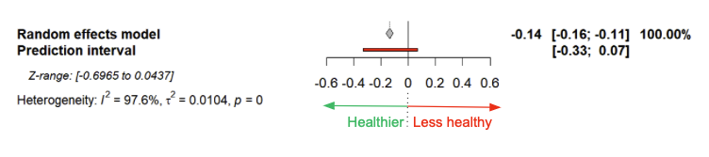

Anxiety
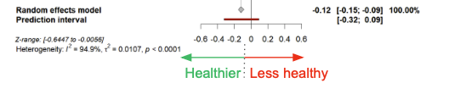

Stress
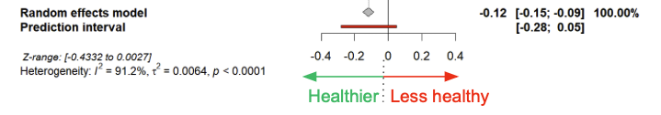
Supplementary results 3: Risk of bias (RoB) in longitudinal studies (n=9), including study attrition domain

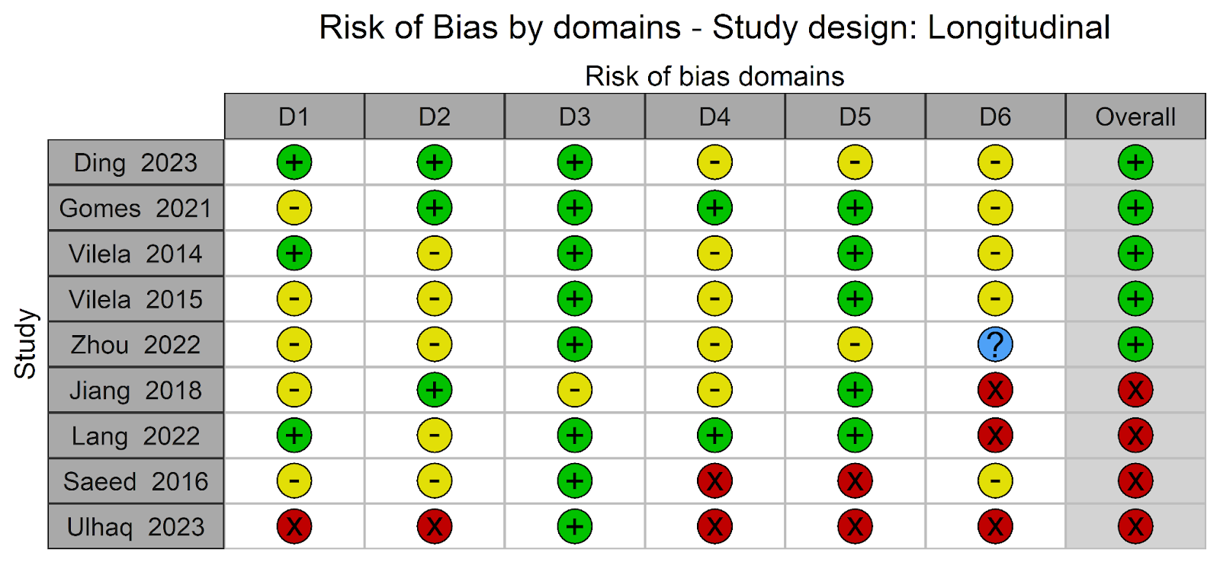
D1 = Bias due to study participation, D2 = Bias due to exposure measurement, D3 = Bias due to outcome measurement, D4= Bias due to confounding, D5 = Bias in statistical analysis and reporting, Overall = No high risk of bias in any domain, D6 = Bias due to attrition. Green = low RoB; Yellow = unclear RoB; Red = high RoB.

Supplementary results 4: Pooled estimated based on Risk of bias (RoB) grouped by low and high in overall RoB, in study participation RoB and confounding RoB
.
RoB domain | RoB Level | Depression  SMD and 95% CI | Anxiety  SMD and 95% CI | Stress  SMD and 95% CI
Overall RoB | Low | -0.23 (-0.31, -0.16) | -0.19 (-0.30, -0.09) | -0.22 (-0.34, -0.11)
Overall RoB | High | -0.35 (-0.46, -0.24) | -0.29 (-0.45, -0.14) | -0.25 (-0.41, -0.09)
Study participation RoB | Low | -0.18 (-0.26, -0.10) | -0.14 (-0.26, -0.02) | -0.11 (-0.23, -0.01)
Study participation RoB | High | -0.32 (-0.45, -0.18) | -0.38 (-0.64, -0.12) | -0.19 (-0.34, -0.04)
Confounding RoB | Low | -0.26 (-0.55, 0.02) | -0.06 (-1.05, 0.92) | -0.25 (-0.73, 0.22)
Confounding RoB | High | -0.43 (-0.67, -0.19) | -0.36 (-0.62, -0.10) | -0.42 (-3.81, 2.98)
CI: Confidence Interval; SMD: Standardised Mean Difference

Supplementary results 5: Outliers and influential studies
Two outlier studies were identified based on studentized residuals: one for depression (Ibrahim 2021) and one for anxiety (Ibrahim 2021). No outliers were detected for stress. Regarding influential studies, three studies were flagged for depression (Faghih 2019, Ibrahim 2021, and Chegini 2022), two for anxiety (Alenko 2021 and Ibrahim 2021), and one for stress (Faghih 2019). Notably, Ibrahim 2021 was consistently identified as both an outlier and an influential study across multiple outcomes. When restricting the analysis to studies with low risk of bias, no outliers remained for any outcome. However, Chegini 2022 remained an influential study for depression.

Supplementary results 6: Pooled effect estimates by dietary measure group.
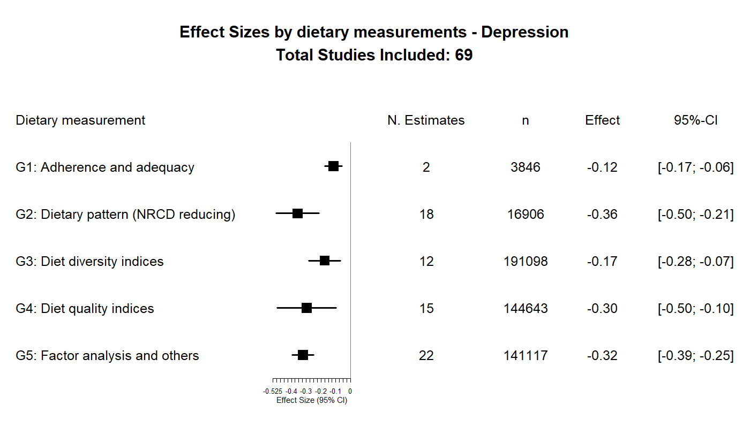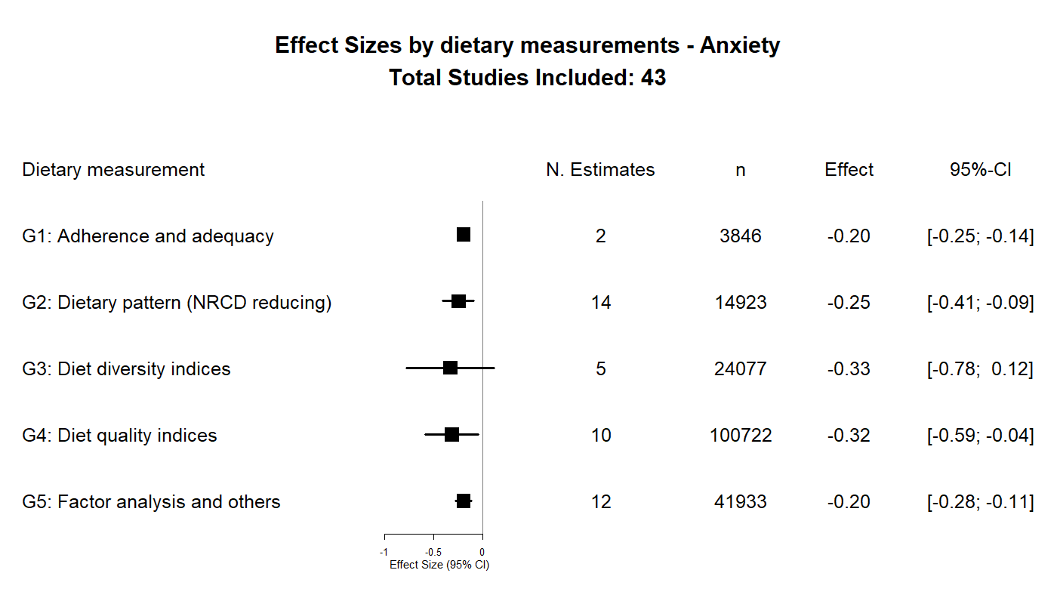

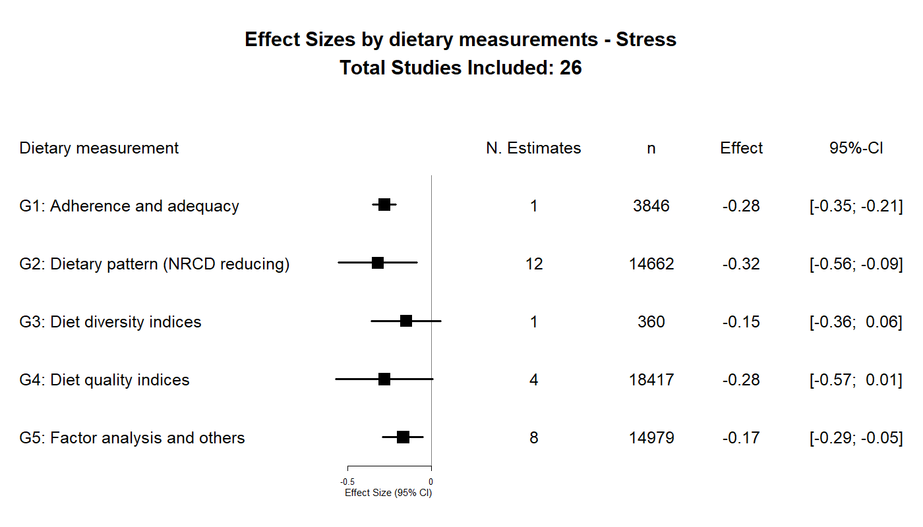

Supplementary results 7: Sensitivity analysis to effect size indices choice