Appendix A:

HEAT Emergency unit Assessment Tool (Aug 2020 version)

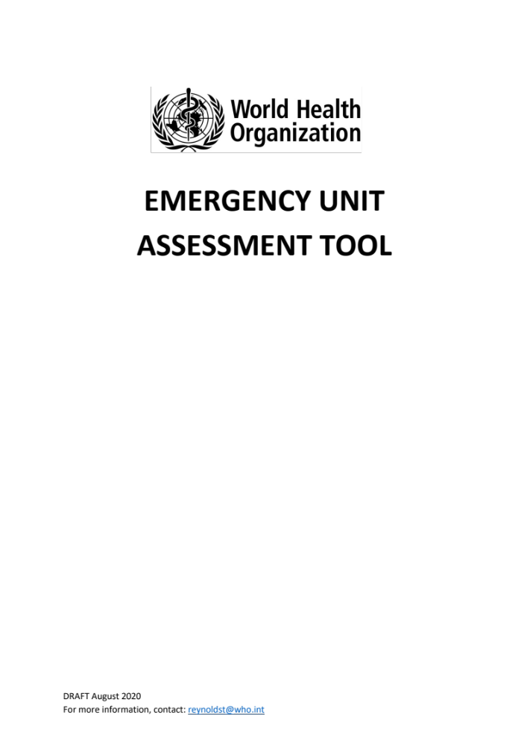

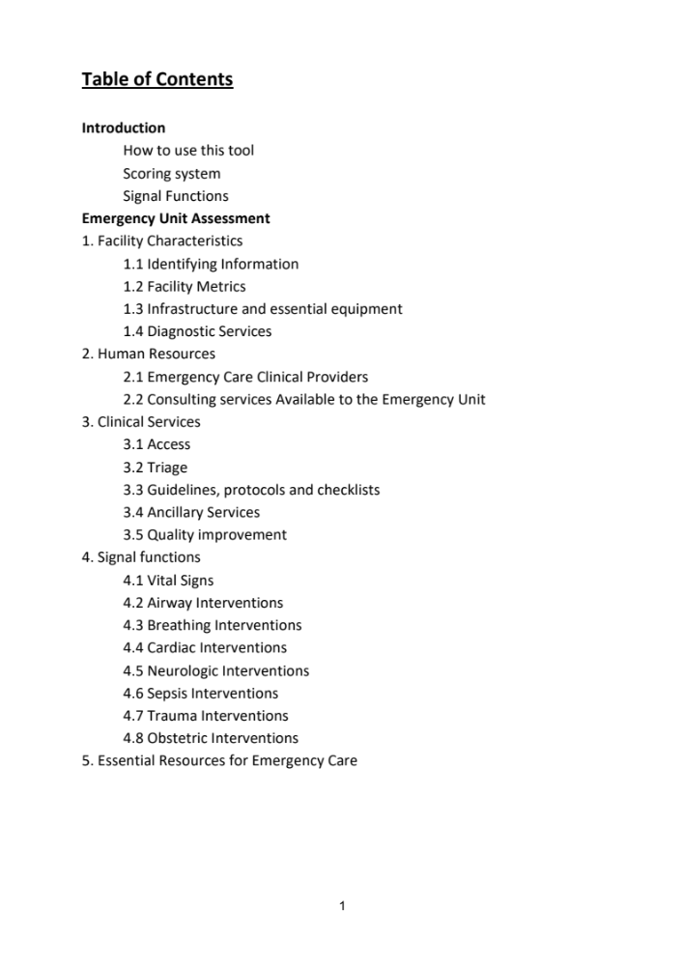
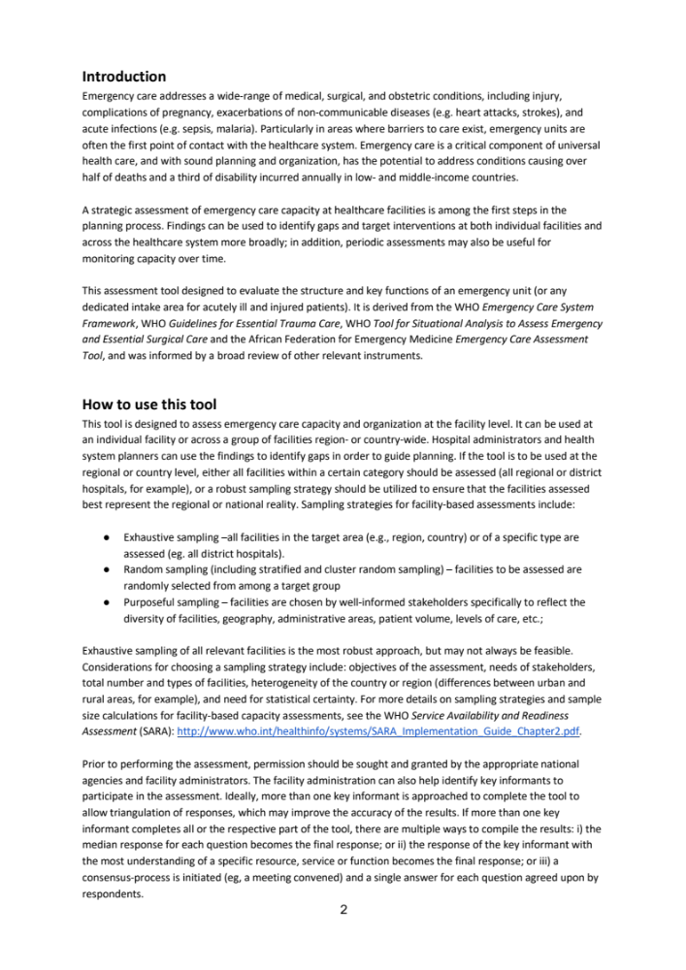

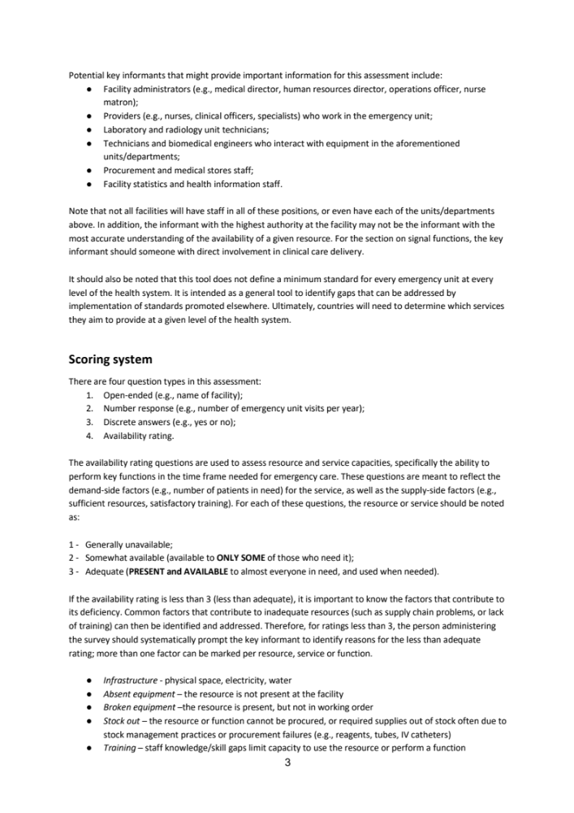
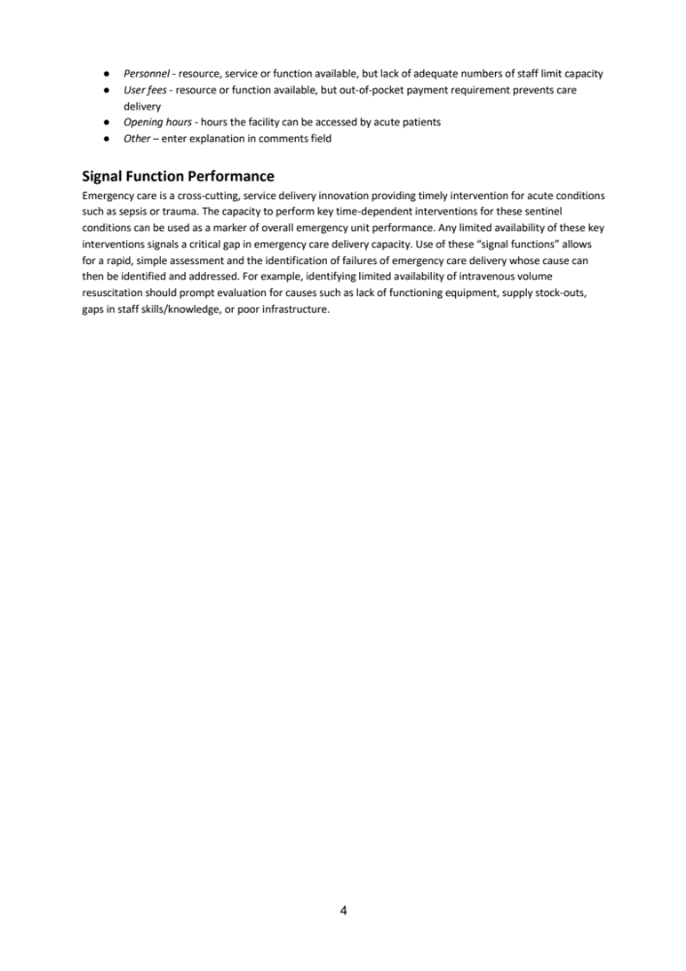
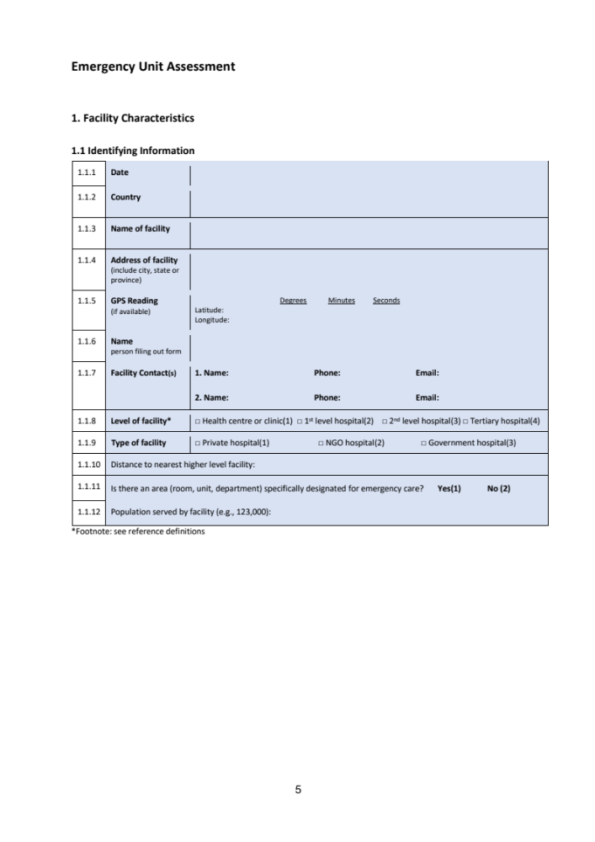
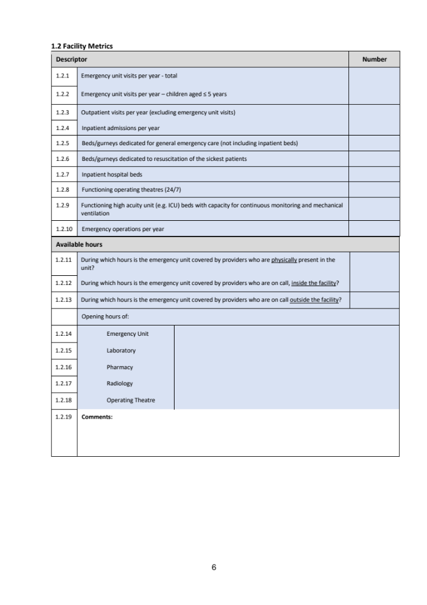
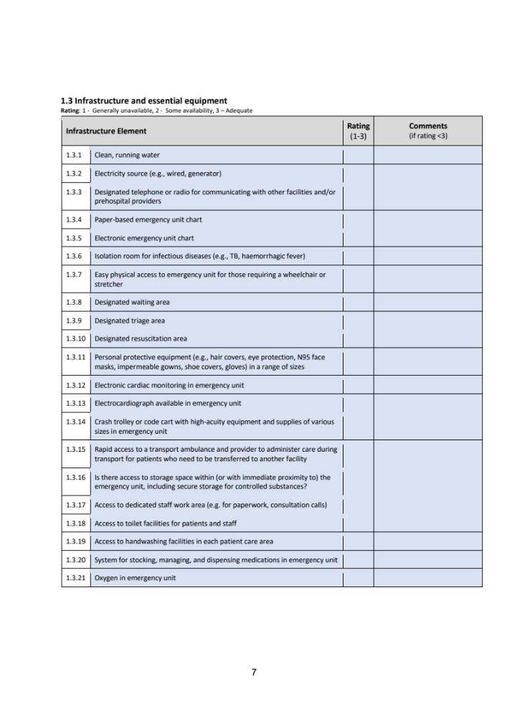
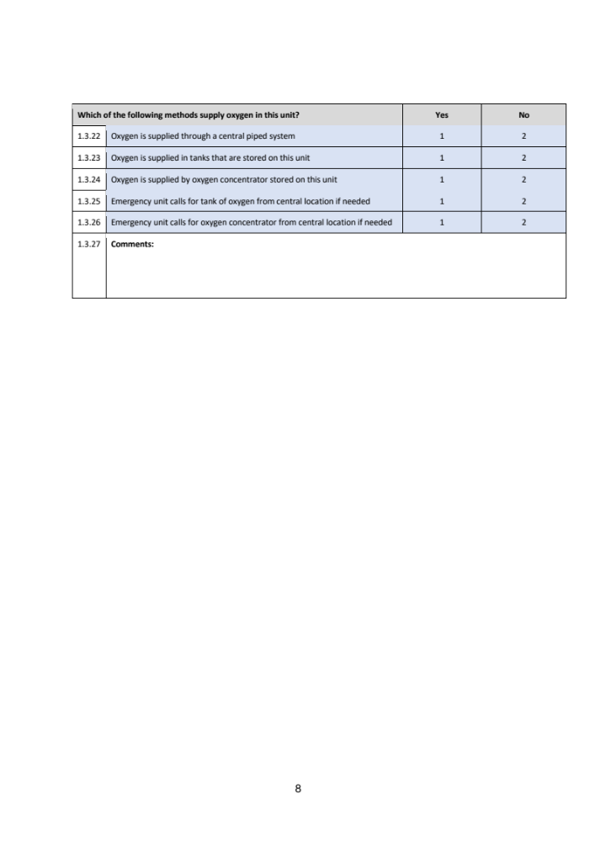
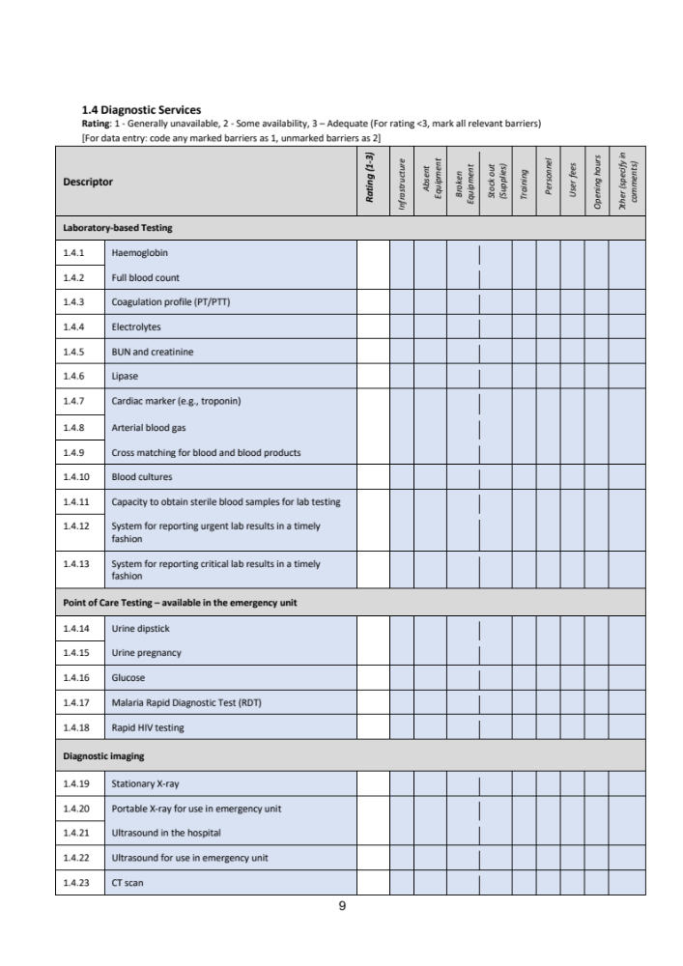

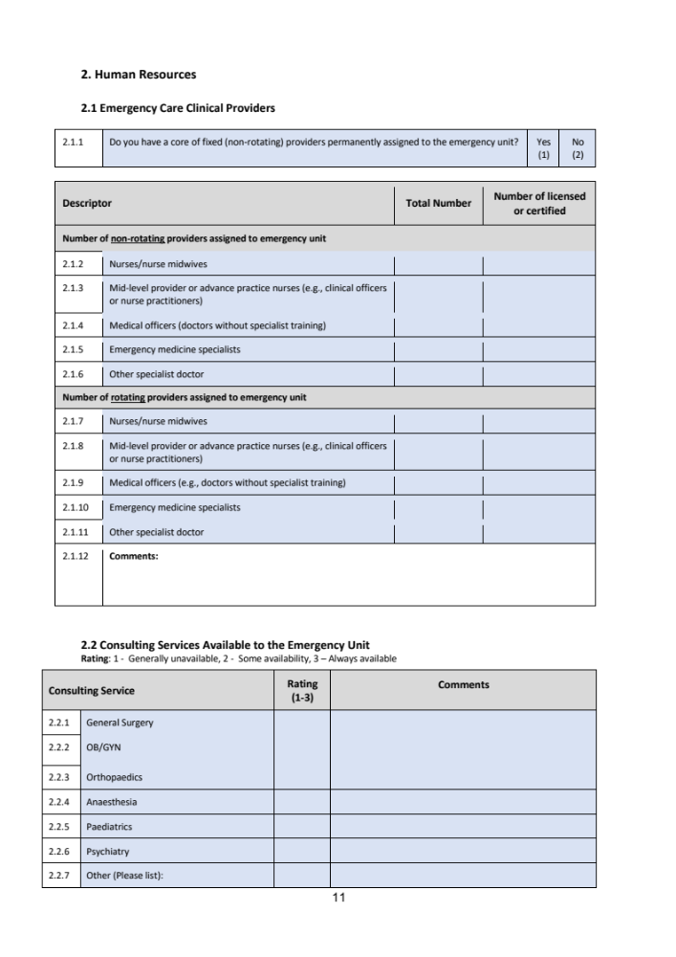

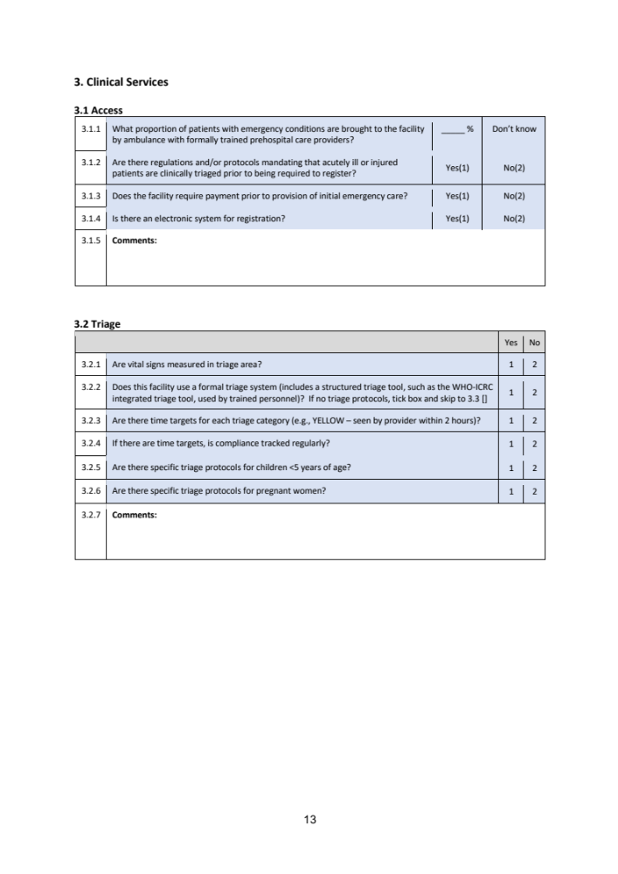
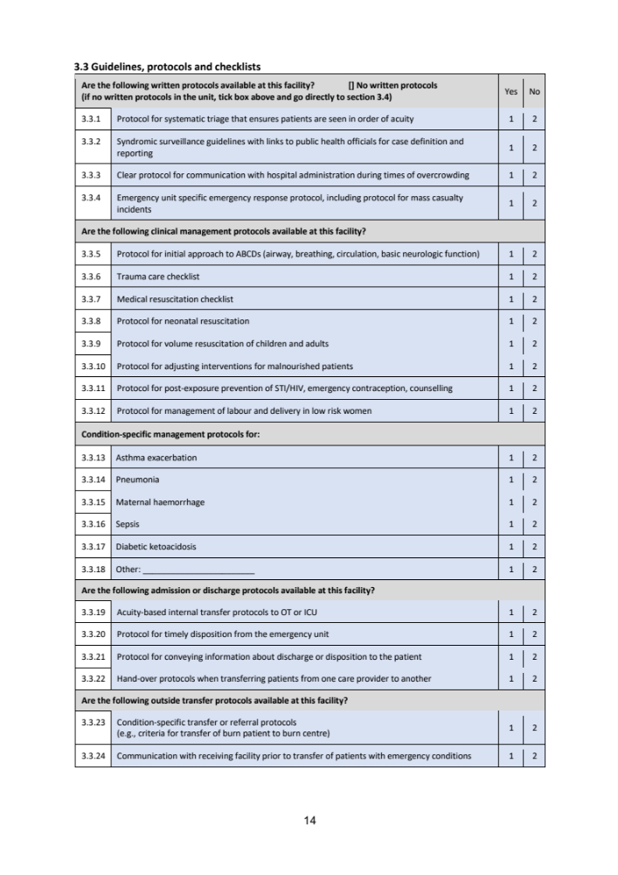
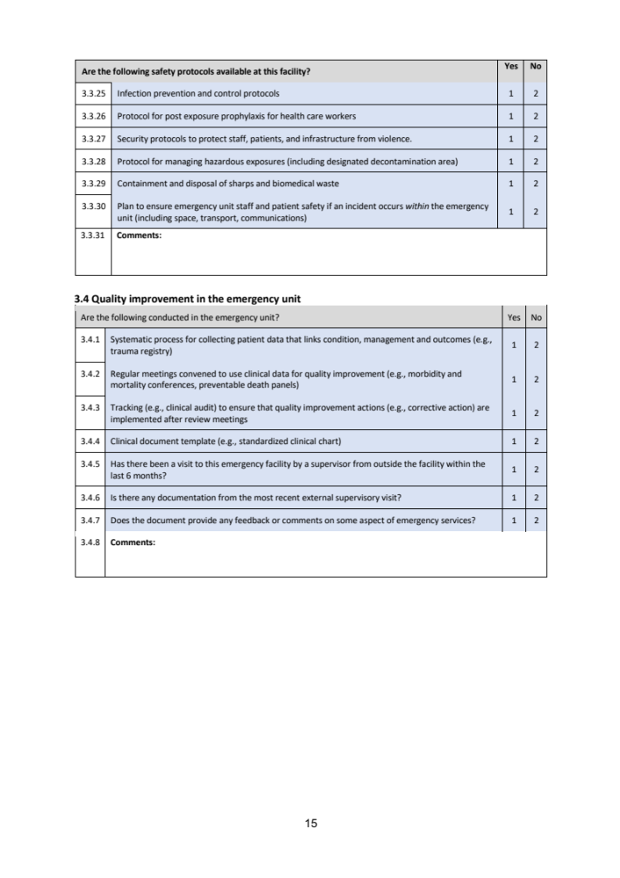
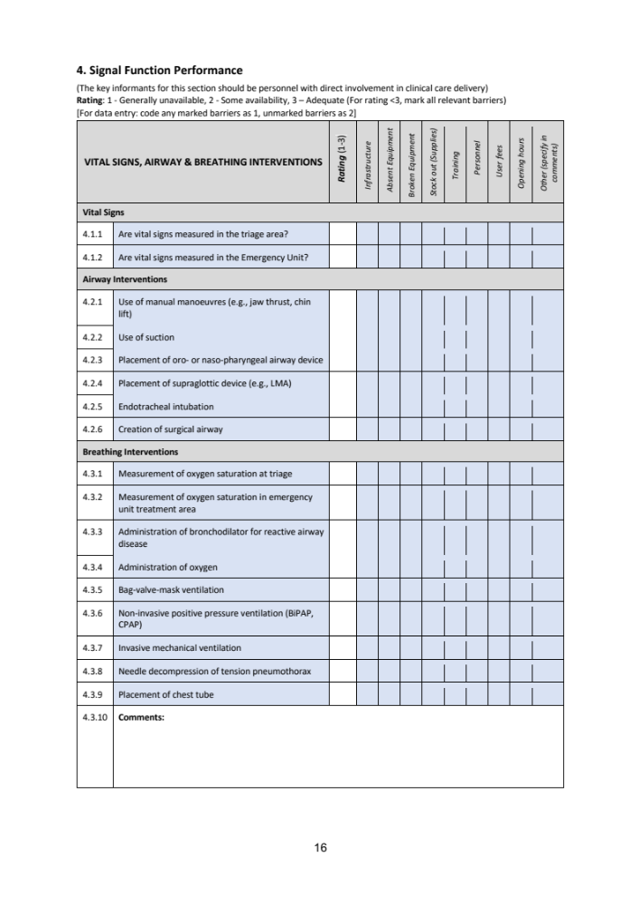
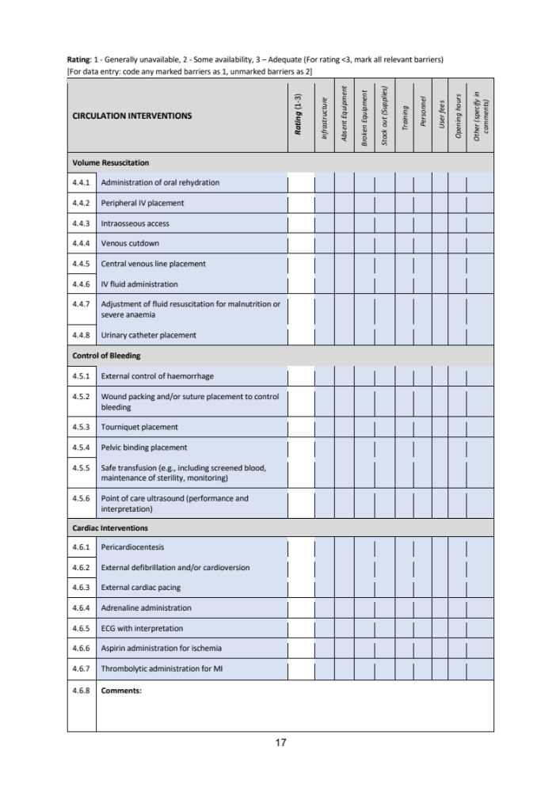
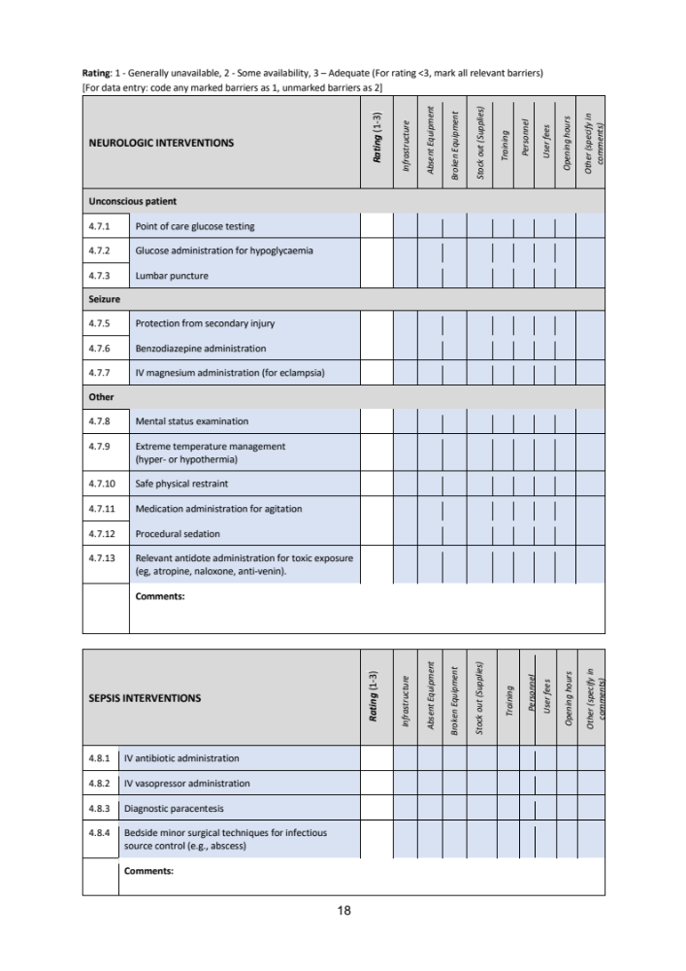
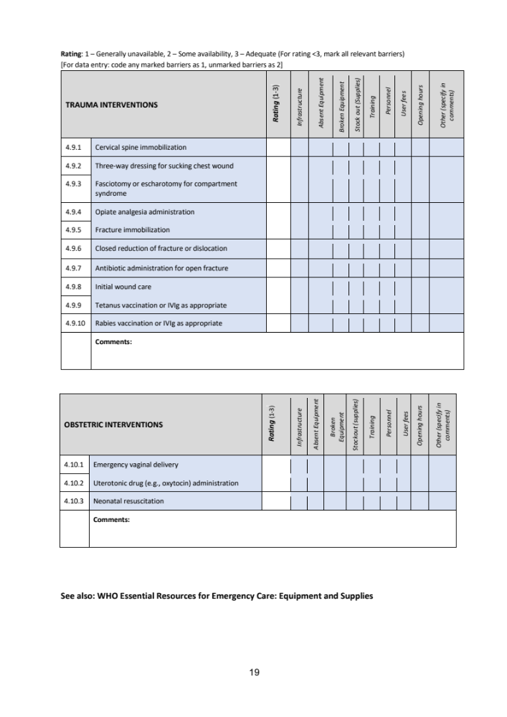

Appendix B:

List of Key Informants by Role and Speciality

Role | Speciality
Consultant | Radiology
Consultant lead | Haematology
Consultant lead | Radiology
Consultant / Clinical Director | Emergency Medicine
Lead Nurse | Emergency Medicine
Pathologist | Biochemistry
Pharmacist | Pharmacy
Senior Manager | Integrated Care Division
Transfusion Manager | Blood bank
Regional Service Manager | Microbiology

Appendix C:

Qualitative data under each HEAT-ECCS domain

Infrastructure:

Designated waiting area questions scored 3 (adequate availability) at initial interview consensus (Consensus 1). It was noted that the waiting area size was appropriate if the department had flow out but that at the time of interviewing it was overcrowded for the majority of the time; the areas was adequate for ED but not for co-located services such as primary care. At the Post ED expansion consensus interview (Consensus 2), the score remained 3 and it was noted that in general the waiting area was less congested post ED extension and further assessment areas of Same Day Emergency Care (SDEC) opening.

Designated triage area questions scored 2 (some availability) at Consensus 1. It was noted that there was sometimes a long wait for triage as demand outstripped capacity, and that the ED needed 3 triage rooms plus space to see and treat, and that a business case had been submitted for extra triage space and more patient facing space. At Consensus 2 the score improved to 3 (adequate availability); although it was noted that the department had seen no impact of ED extension opening on waiting room triage nor improved performance on ambulance triage times.

Designated resuscitation area questions scored 2 (some availability) at Consensus 1. It was noted that the resus area was often overfilled, and that there was no decent flow out of resus. At Consensus 2 the score improved to 3 (adequate availability); there were no further comments on this.

In response to questions about designated telephone or radio for communicating with other facilities and prehospital providers at Consensus 1, it was noted that there was no way to recontact providers or call them back if any issues and scored 2 (some availability). At Consensus 2 the score improved to 3 (adequate availability); there were no further comments on this.

Questions about isolation room availability for infectious diseases (e.g. tuberculosis (TB), haemorrhagic fevers) scored 2 (some availability) at Consensus 1. Comments included that the decontamination unit did not have a toilet (only showers), and that rooms with doors were available without toileting facilities incorporated. At Consensus 2 the score improved to 3 (adequate availability); it was noted that there was a single isolation room with wash facilities with plans to designate a cubicle in the ED extension resus as well as a predesignated cubicle in the original department majors area.

Rapid access to a transport ambulance and provider questions scored 2 (some availability) both at Consensus 1 and Consensus 2. It was noted that percutaneous coronary intervention (PCI) transfers were adequate, but that transfers for repatriation, for mental health patients, and for paediatrics could have long waits and that these patients were often transferred as category 4 (lowest priority ambulance transfer).

Access to dedicated staff work area questions scored 2 (some availability) at Consensus 1. It was noted that space was lacking, and that clinicians had to compete for space with each other and with speciality teams such as the stroke team. It was noted at Consensus 2 that some areas had improved, such in the ED extension resus area there was a newly dedicated area for stroke patients where it was felt that access was adequately available, but scored 2 (some availability) overall.

Access to toilet facilities for patients and staff questions scored 2 (some availability) both at Consensus 1 and Consensus 2. It was noted that staff would often see people for queuing for toilets, and that staff would use patient toilets as there were not enough staff toilets. It was noted that there were more patient toilets in the ED extension but that this had not improved the situation for staff nor patients in the main ED.

Emergency Diagnostic Services (labs):

At Consensus 1 it was noted that delays in putting blood cultures on analyser out of hours were impactful and scored 2 (some availability) due to barriers with opening hours and personnel – microbiology was not 24/7 service. It was noted that there had been recent regional auditing for blood sciences, and that the MTC was not meeting the 4-hour blood culture sample loading target. The analysers onsite at the MTC also covered other hospitals in the region (but there was not 24/7 care or transport) – if samples arrived after 20.00 hrs on a weekday they would not be processed until the following morning or after 15.30 hrs on Saturday or Sunday. It was also noted that pneumatic tube system failures mean culture conveyance was delayed from ED, if samples arrived after routine working hours. It was noted that each sample stayed on the analyser for minimum of 5 days, but that most organisms were identified within first 24 hrs incubation, so these delays were felt to be delaying results significantly. At Consensus 2 the delays were still noted, but the score improved to 3 (adequate availability). There were no further comments on this.

In response to HEAT questions regarding the capacity to obtain sterile blood cultures, it was noted that blood culture contamination rate generally at the MTC was ‘too high’ (3.6%) across the hospital, but that there was no ED-specific data. It was noted that the ED had specific blood culture collection packs and staff training; initial consensus felt that overall, the capacity to obtain sterile blood cultures was adequate and scored 3. This was also scored as adequate (3) at Consensus 2, although the delays in conveyance were noted.

In response to questions regarding reporting urgent and critical lab results in a timely fashion, it was noted that the target turnaround time of 1 hour was usually achieved. It was noted that sometimes technicians had difficulty knowing which part of ED to call as they had multiple phone numbers to report results which were found not to be the optimal phone numbers to use. It was noted that once the ED extension opened, the phone numbers would be changed to be more direct. It was noted that the ED team were not currently aware of which labs were on the critical results list.

At Consensus 2 it was noted that reporting urgent and critical results was prone to delays as some labs were now unable to tell if a sample has come from the ED extension (vs the rest of the department) - locations had been created for requests but were not being used correctly. It was noted that critical results were being phoned through to the ED extension but that there were often delays in the system also due to samples being batch delivered from ED extension by ED staff conveying to lab; it was noted that samples were delivered more often from the ED extension than previously from the original ED, but that the system was still open to delays as the pneumatic tube system was still not working so delivery required ED staff to be available to carry the samples to the lab.

Under point of care (POC) testing, it was noted at Consensus 2 that Influenza A and Covid POC tests were available 24/7; there were still some issues with machines and reagents but that staff could send samples to the lab. Malaria Rapid Diagnostic Test (RDT) and rapid HIV testing both scored 1 (Generally Unavailable) in both assessments, but KIs fed back to the research team that it was felt malaria was only appropriate as signal function in malaria-endemic areas, and for the UK other flow-informing POC tests were suggested such as Influenza A or Covid (which were not reflected in HEAT questions). These remarks have been fed back to the WHO leads who are currently further developing HEAT.

Emergency Diagnostic Services (Imaging):

Radiology results reporting was graded a 2 (some availability) at Consensus 1. This was mostly due to delays in chest Xray (CXR) reporting. It was noted that there was a system in place for timely reporting, but that CXRs could take weeks to be reported. It was noted that delays were mostly related to personnel, that in-hours was better than out of hours, and that there had been some lags in reporting trauma CTs.

At Consensus 2 it was noted that the 5-minute trauma CT reporting had improved since the initial interviews, although it was noted that the hours staffed were the same as prior to the ED extension opening and that there remained personnel issues including issues with outsourced telemedicine reporting services overnight.

CT scan availability was graded a 2 (some availability) at Consensus 1. It was noted that the CT scanner for ED was ‘meant to be replaced after 10 years, and was now 14 years old’. A business case had been submitted to replace it as provision generally did not meet demand. At Consensus 2, CT scan availability was graded a 3 (adequate availability); it was noted that the speed to scan had improved with ED extension opening and provision of 2 new scanners (= 3 total depending on staffing).

Human Resources:

Table 2 summarises the overall change in Human Resources capacity with regards to Consulting services to the ED from Consensus 1 to Consensus 2. Comments on these changes have been summarised.

Consulting services | Consensus 1 Availability Rating | Comments from consensus 1 | Consensus 2 Availability Rating | Comments from consensus 2
General surgery | 2 | Patients waiting >12hrs for review, expectation that ED will frontload patient and do CT scan etc prior to consult | 3
OB/GYN | 2 | No obstetric services available onsite, but gynae adequate | 2 | No obstetrics, gynae always available
Orthopaedics | 3 | Availability dependent on their other work/in theatre etc; felt to be adequate overall | 3
Anaesthesia | 3 | Generally available | 3
Paediatrics | 2 | Ongoing staffing issues, low critical mass of staff | 3 | Transfer out for higher levels of care
Psychiatry | 2 | Long waits for mental health assessments and beds; staffing very stretched, coordinating admission with appropriate legal staff very difficult | 2 | Liaison team present in ED but consultant can take a long time

Other consulting services were felt to be the same availability pre and post ED extension opening except interventional radiology which was noted to be easier with a new technology available in the ED extension (such as a RAPTOR theatre for polytrauma). No change in social work services, patient transport services and security personnel assigned to ED; all scored 2 at both consensus interviews.

Signal Functions:

Signal functions are a proxy for emergency clinical performance. They include a variety of skills and interventions that are seen as prognostic markers of overall emergency care capacity in the system being evaluated.

Central venous catheter access scored 3 at Consensus 1, at Consensus 2 scored 2 (some availability) due to barriers around skill set; it was noted this was usually performed by intensive care teams. Tourniquet placement scored 2 at Consensus 1 due to training, at Consensus 2 scored 3. Perform lumbar puncture scored 1 “generally unavailable” at Consensus 1, at Consensus 2 scored 2; it was noted that this procedure would be done by speciality doctor in high-resourced area rather than done by and in ED. Management of extreme temperatures and rabies both scored 2 at Consensus 1, at Consensus 2 scored 3.

Under antidotes at Consensus 1, it was noted that the MTC had no stock of antivenom as recommended by the Royal College of Emergency Medicine (RCEM), and that antidotes not kept in same location clearly marked as per RCEM recommendation. At Consensus 2 it was noted that the antidote cupboard had been moved to the ED extension and that had improved.

Under ‘administer benzodiazepines’ it was noted at Consensus 1 that all routes were available and graded a ‘3’, but at Consensus 2 this was downgraded to ‘2’ (some availability) and it was noted that staff had been found to be underdosing.

Obstetrics interventions scored 2 at both Consensus 1 and 2; it was noted that not all staff were trained in assisted vaginal delivery, and that few had significant recent experience. For Neonatal Life Support it was noted that the equipment was present (e.g. there were resuscitaires in both the ED extension and the "old resus") but that there may be times when there was no-one with the appropriate training immediately available in the ED.

Sepsis and trauma interventions either stayed the same or generally improved between Consensus 1 and 2.

Appendix D:

Full Key Informant comments on use of HEAT tool for this context, as shared with WHO

Theme 1: Equipment / Process in this context

HEAT Question | KI Comments
1.3.4 Paper-based EU chart | Not used in high-resource setting as computer-based charts, but paper charts are available for downtime
1.3.24 Oxygen is supplied by oxygen concentrator stored on this unit | Not required in this setting
1.3.26 EU calls for oxygen concentrator from central location if needed | Not required in this setting
1.4.23 CT scan | MRI scan also felt to be important for emergency diagnostics for e.g. cauda equina
1.4.6 Lipase | Amylase is not reflected in HEAT (KIs felt the preference for lipase was historical in UK labs and had been outdated)
1.4.17 Malaria Rapid Diagnostic Test (RDT) | Felt not a priority to be necessary to be a point of care test for malaria in UK as malaria not endemic, (in this centre test done in lab as thick film. measles and ptussis also tested in lab.) this question may be interpreted by those responding to reflect global variance in disease patterns (e.g. UK has Flu/RSV/Covid so would use those tests as point of care to inform emergency care vs other regions that may see more endemic malaria)
2.2.2 OB/GYN | In the UK and higher-resourced areas many hospitals are commissioned without obstetrics as these patients are streamed directly to obstetrics centres; so a high-level facility might have gynaecology specialists in-house but not obstetrics. This delineation between obstetrics and gynaecology as separate services is not reflected in HEAT
3.3.5 Protocol for initial approach to ABCs and basic neuro function | Perhaps this question is more relevant for systems with rotating / untrained staff; in higher resourced systems KIs felt that there was no clear need for specific protocols on ABC approach - they felt that this is taught and overseen by EM specialists in UK EDs
3.3.7 Medical resuscitation checklist | UK uses Acute Life Support (ALS) algorithms from Resus Council UK rather than the WHO’s ECT checklists
3.3.9 Protocol for volume resuscitation | KIs commented that ED clinicians may use a protocolised calculation for fluids for children but that this was not generally necessary for adults, although it was noted that for some specific conditions there were volume resuscitation protocols (e.g. for Diabetic Keto Acidosis)
3.3.10 Protocol for adjusting interventions for malnourished patients | Malnourished patients are not often seen in UK emergency care systems, KIs did not feel a protocol to be necessary for UK ED care
3.3.19 Acuity-based internal transfer protocols to OR/ICU | KIs felt transfer is based on clinical judgement, No written protocols but rather transfers are done on a case by case basis which was felt to be appropriate
4.4.7 Adjust of fluid resuscitation for malnutrition or severe anaemia | KIs commented that the examples given by HEAT (malnutrition and anaemia) do not encompass the pathologies seen in well-resourced emergency care systems e.g. congestive cardiac failure and frailty – it was asked should these be reflected in a global tool?
4.7.10 Ability to provide safe physical restraints | KIs noted that physical restraints are not used in UK EDs; KIs considered if this is cultural, or due to staffing availability - consensus felt restraint is not safe and questioned whether should be discouraged (as per the UK’s Royal College of Emergency Medicine guidance)
4.9.10 Administer rabies vaccination or IVIG | In the UK, patients with rabies are transferred to regional centres for treatment as rabies is not common nor endemic- KIs felt transfer out to be appropriate in our system and as such IVIG would not be initially administered
Other comments: | KIs noted treatment options for major haemorrhage such as cell-salvage and thromboelastogram (TEG) and Rotational Thromboelastometry (ROTEM) analysis were not captured by HEAT questions.

Theme 2: Skill in this context

HEAT Question | KI Comments
4.4.4 Perform venous cutdown | KIs felt venous cutdown is no longer appropriate, clinical preference was for ultrasound-guided access or IO - felt venous cutdown has been superseded by IO in all regions of the UK
4.6.1 Perform pericardiocentesis | KIs felt that pericardiocentesis would be done by a cardiac speciality doctor in the UK rather than done by and in ED
4.7.4 Perform lumbar puncture | KIs felt that lumbar puncture would be done by speciality doctor in the UK rather than done by and in ED
4.8.3 Perform diagnostic paracentesis | KIs felt that paracentesis not done in ED due to best practice being on ward in more sterile environment - normally done by gastro specialist after antibiotics
4.8.4 Bedside minor surgical techniques for source control | KIs felt that these were not done by and in ED, best practice to refer to surgeons and would be done in the operating theatre
4.9.3 Perform fasciotomy or escharotomy for compartment syndrome | KIs felt fasciotomy would not be done in the ED, but orthopaedic teams would take to the operating theatre for it to be done by specialist

Theme 3: Streaming comments

KIs commented that ED waiting room may encompass multiple 'external streams' including General Practice and minor injuries, although those services may be outwith the ED and are seen more as 'consulting services' not under the emergency care system evaluated by HEAT
KIs commented that minor injuries are often Emergency Nurse Practioner and Physiotherapist led in higher-resourced systems; these patients may be streamed to outside of ED facility
KIs commented that access and triage are both streaming services, so General Practitioners would see low acuity patients to reduce ED crowding

Theme 4: KIs felt question needed clarity

HEAT Question | KI Comments
1.3.20 System for stocking, managing and dispensing medication in EU | KIs felt it was unclear by language if question is focussed on 'is there a system in place' or 'if system is adequate'
1.4.22 Ultrasound for use in EU | KIs felt it was unclear in what capacity this means for ED ultrasound; unsure if 'adequacy' means external radiology expertise or ED clinician
2.1.5 Emergency medicine specialists | KIs felt it was unclear if this question was referring to total 'head count' or ‘whole-time equivalents’ for nursing and clinicians. KIs felt 'head count' in HEAT not a 'true' representation as “most of the team work less than full time and job share”
2.1.9 Medical officers (doctors without special training) | KIs felt it was unclear if 'rotating' means one day / week or for a period per year (weeks-months before changing specialty e.g. 4 months foundation training doctors in UK)
2.3.2 Patient transport services (wheelchairs/gurneys) | KIs felt this was unclear if this question was referring to transport for internal transfer within hospital/within ED or transport to get back to home/external transfer
2.3.3 Security personnel assigned to EU | KIs felt this was unclear if 'adequacy' is asking for dedicated security personnel solely assigned to ED, or if hospital security covering ED on call-by-call basis.
3.3.4 EU specific emergency response protocol e.g. mass casualty | KIs questioned phrasing and asked why was 'major incident' not stated rather than 'mass casualty' which is a specific type of major incident
3.3.8 Protocol for neonatal resuscitation | Signal functions - KIs felt that the Signal Functions section of HEAT did not reflect emergency paediatrics and noted although HEAT has a neonatal resus question (3.3.8) there is no question for Acute Paediatric Life Support (APLS), and a lack of HEAT questions on emergency paediatrics overall

