Supplementary file
Efficient Synthesis of Isoamyl Acetate Using a Thermostable Geobacillus kaustophilus Lipase Immobilized in TPP-Crosslinked ZIF-8
Murat Türk*

Cukurova University, Ceyhan Vocational School, 01330, Adana, Turkey
*Corresponding author: e-mail: murturk@cu.edu.tr

Table S1. Summarization of purification process of GkL.
Purification step | Volume  (mL) | Total  protein (mg) | Total  activity  (U) | Specific  activity  (U/mg protein) | Purification  (fold) | Activity  yield (%)
Cell free | 10.0 | 26.8 | 1786.3 | 66.7 | 1.0 | 100
Ni²⁺-NTA | 6 | 4.6 | 813.2 | 176.8 | 2.7 | 45.5
Concentrated protein | 2.5 | 2.3 | 437.6 | 190.3 | 2.9 | 24.5

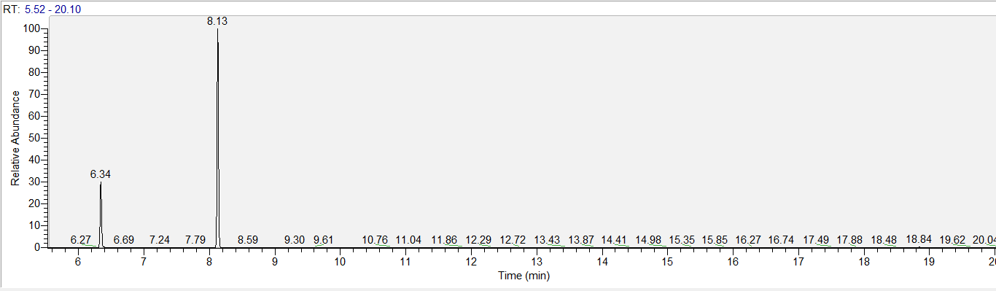
Fig. S1. The retention times of isoamyl alcohol (6.34 min) and isoamyl acetate (8.13 min).

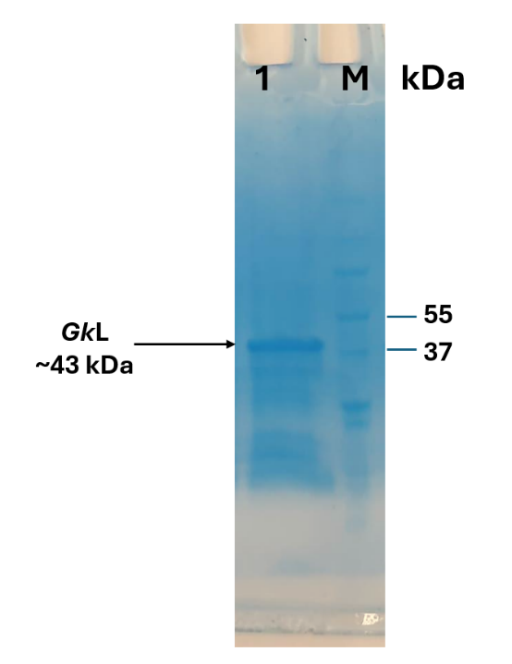

Fig. S2. SDS PAGE profile of the concentrated GkL. Lane 1 shows the GkL sample after ultrafiltration, exhibiting a distinct band at approximately 45 kDa. Lane M corresponds to the molecular weight marker (BioRad All Blue Protein Standards, catalog no. 161-0373).

