Supplementary Information for

Establishing Product Loss and Concentration Benchmarks for Two Step Tandem Electrochemical Conversion of CO₂ to C₂H₄

Akriti Sarswat¹, Anthony Cochran¹, Suhyun Kim¹, Xiaohan Yu¹, Hanjun Fang¹, Seo-Yul Kim¹, David S. Sholl²*, Ryan P. Lively¹*, Mahinder Ramdin³*

¹School of Chemical & Biomolecular Engineering, Georgia Institute of Technology, Atlanta, GA, 30332-0100, USA
²Oak Ridge National Laboratory, Oak Ridge, TN 37830, USA
³Process and Energy Department, Mechanical Engineering, Delft University of Technology, Leeghwaterstraat 39, 2628 CB, Delft, the Netherlands

*Correspondence: shollds@ornl.gov, ryan.lively@chbe.gatech.edu, M.Ramdin@tudelft.nl

List of Contents
No. | Section Title |  |  | Page No.
1. | Powder Characterizations, Isotherms and Stability Tests |  |  | 3
2. | Custom Built Pressure Decay Cell for CO Isotherm Measurement |  |  | 7
3. | Force Field Parameters |  |  | 8
4. | Process Model
 | 4.1 | Electrolyzer Calculations |  | 9
 |  | 4.1.1 | CO₂ Reduction to CO in SOEC | 9
 |  | 4.1.2 | CO Conversion to C₂₊ Products | 10
 |  | 4.1.3 | Compilation of Literature Data on CO₂R and COR | 11
 |  | 4.1.4 | Base Case Assumptions for Process Design | 12
 |  | 4.1.5 | Base Case Assumptions for Economic Analysis | 13
 | 4.2 | Modeling Cryogenic Distillation of Ethylene and CO |  | 14
 | 4.3 | Modeling of Distillation of 1-Propanol and Water |  | 16
 | 4.4 | Modeling of Distillation of Ethanol and Water |  | 18
 | 4.5 | Modeling of Liquid-Liquid Extraction of Acetic Acid and Water |  | 20
 | 4.6 | Modeling of Temperature Vacuum Swing Adsorption (TVSA) |  | 22
 |  | 4.6.1 | TVSA CO/Ethylene | 22
 |  | 4.6.2 | TVSA CO/CO₂ | 26
 |  | 4.6.3 | Sizing of TVSA Processes | 29
 |  | 4.6.4 | Adsorbers | 29
 |  | 4.6.5 | Compressors and Pumps | 31
 |  | 4.6.6 | Storage Pumps | 31
 |  | 4.6.7 | Capital and Operating cost | 31
 |  | 4.7 | CO₂ Capture Cost | 32
5. | Technoeconomic Analysis |  |  | 33
6. | References |  |  | 34

Section 1: Powder Characterizations, Isotherms and Stability Tests
This section includes powder characterizations (XRD, SEM), isotherms, and stability tests for MUF-16 and SBMOF-1.

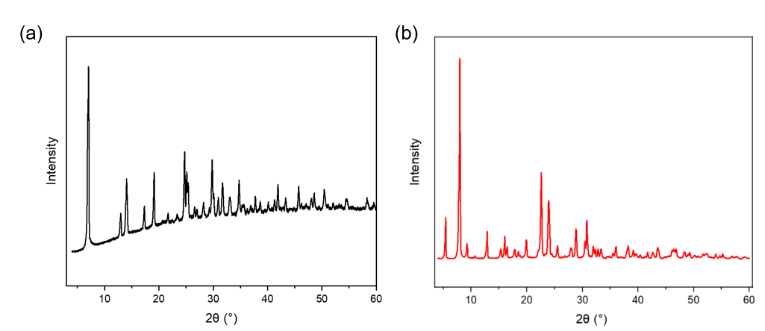
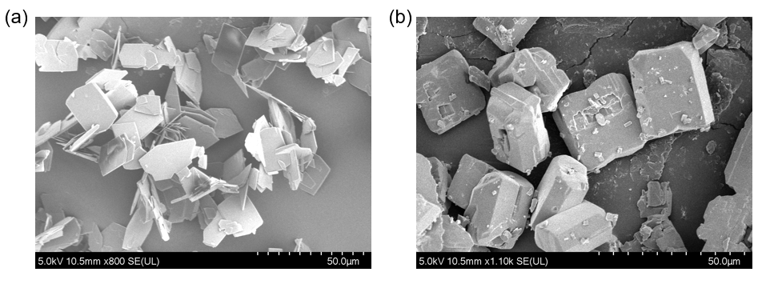
Figure S1: XRD Patterns for (a) MUF-16 (b) SBMOF-1, showing results consistent with reported powder patterns in literature. [1-3]
Figure S2: SEM Images for (a) MUF-16 showing sheet-like crystals (b) SBMOF-1 showing hexagonal pyramid shaped crystals.
Figure S3: N₂ physisorption isotherm for SBMOF-1 at 77K used for estimating the BET surface area of the MOF.
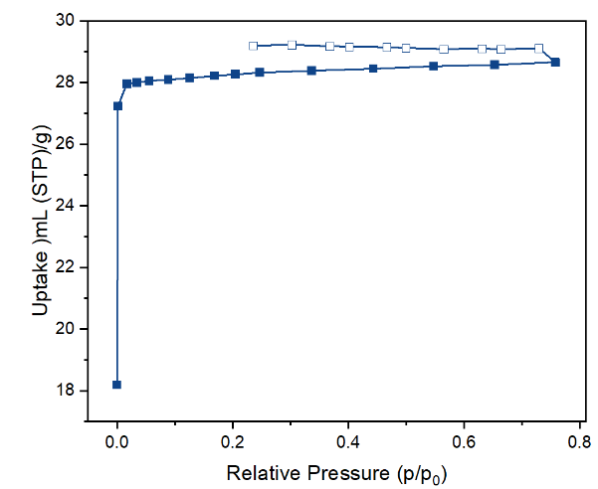

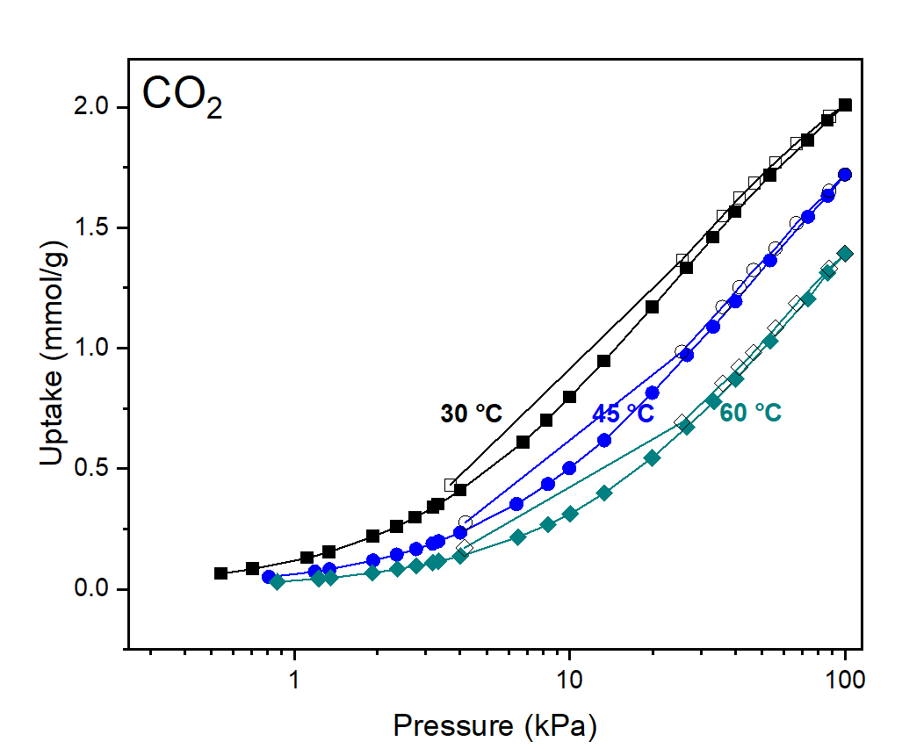
Figure S4: Experimental CO₂ isotherms for MUF-16 at three different temperatures.

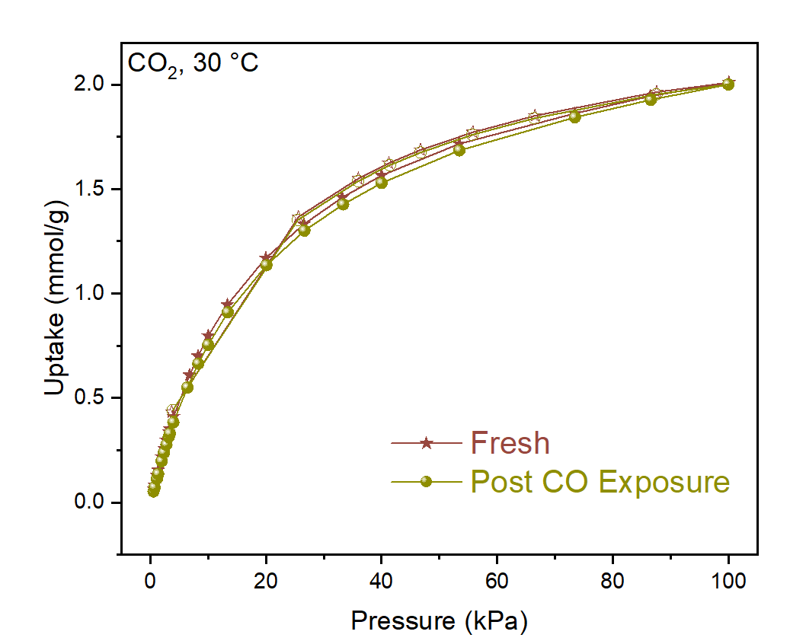
Figure S5: Experimental CO₂ isotherms for MUF-16 before and after exposure to 1 bar CO at 30 °C for 120 h.

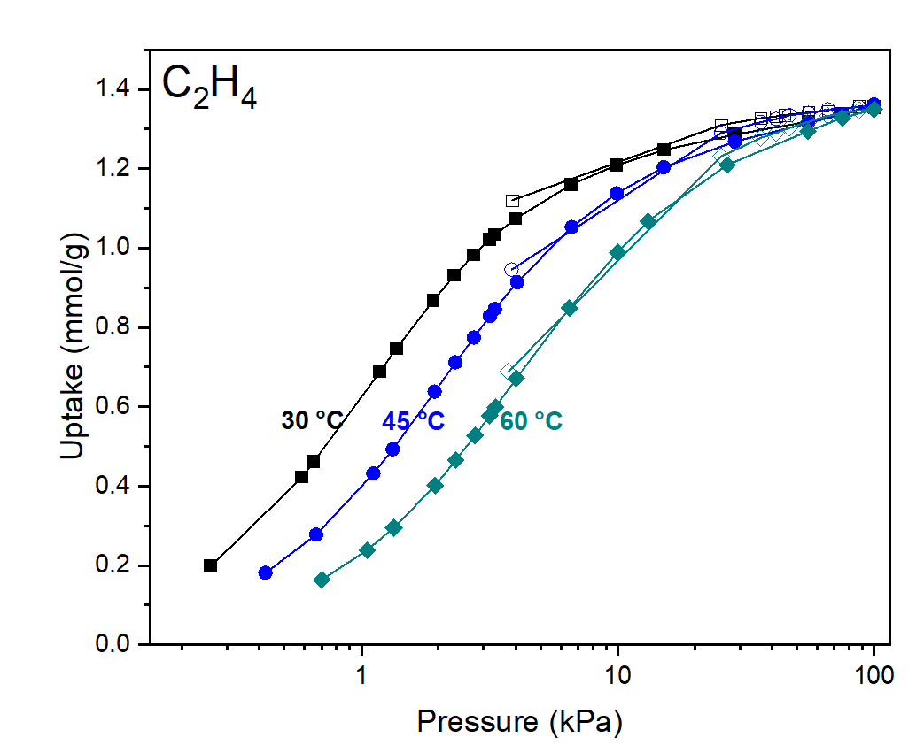
Figure S6: Experimental C₂H₄ isotherms for SBMOF-1 at three different temperatures.
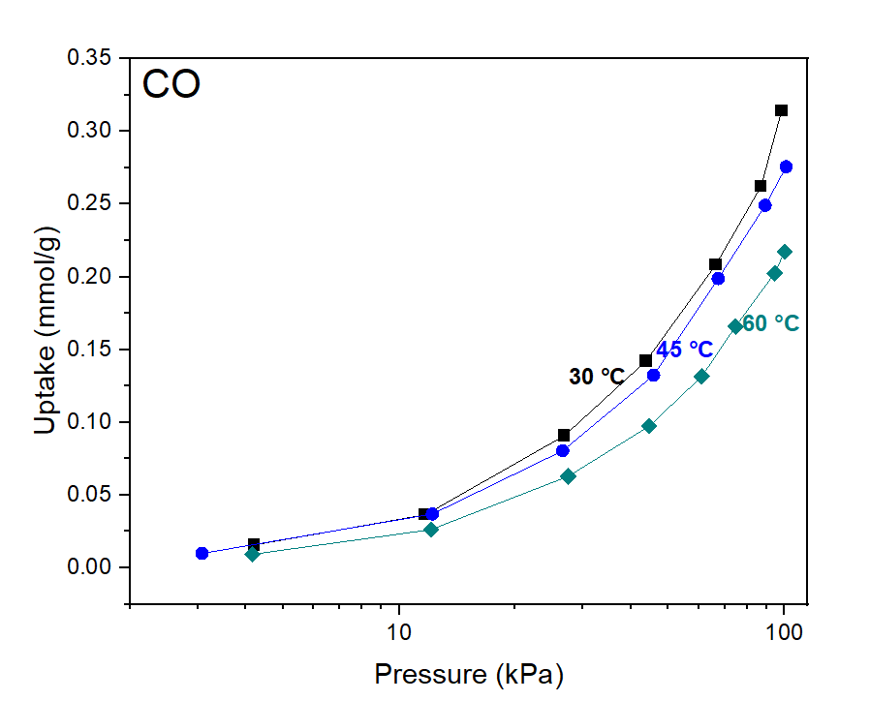
Figure S7: Experimental CO isotherms for SBMOF-1 at three different temperatures.

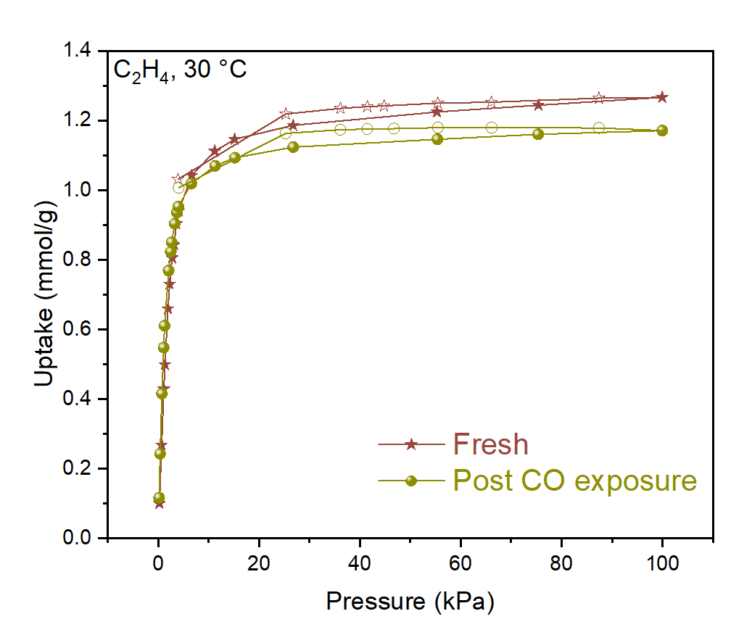
Figure S8: Experimental C₂H₄ isotherms for SBMOF-1 before and after exposure to 1 bar CO at 30 °C for 120 h.

Section 2: Custom Built Pressure Decay Cell for CO Isotherm Measurement

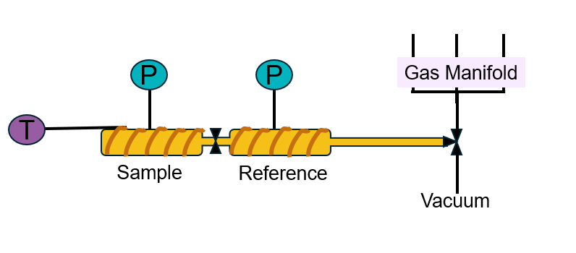
Figure S9: Custom build pressure decay cell for measurement of CO isotherms. The setup was placed in a well-ventilated hood equipped with CO sensors.
Section 3: Force Field Parameters
For the MOF structures, DREIDING force field parameters were used for the organic part and UFF parameters were used for metal centers. [4, 5] For adsorbate-adsorbent interactions, the FF parameters are given in Table S1.

Table S1: Lennard Jones FF Parameters for CO and C₂H₄
(pseudo)Atom | Force Field | Ɛ/k_{B} [K] | σ[Å]
C_CO | EPS-MM [6] | 40.2 | 3.52
O_CO | EPS-MM [6] | 40.5 | 3.08
CH2_sp2 | TraPPE [4] | 85.0 | 3.675

Section 4: Process Model
4.1 Electrolyzer Calculations
The electrolyzers have been modeled on a high level by performing mass and energy balances for a given scale using data for Faraday efficiencies (FE), cell voltages (V), and current densities from literature, see compilation of data in Table S2 and Table S3.
4.1.1 CO₂ Reduction to CO in SOEC
The electrochemical reaction of CO₂ to CO in the solid oxide electrolysis cell (SOEC) is written as:
CO₂ + 2e⁻ → CO + O²⁻
For every mole of CO₂ reacted, one mole of CO is produced and 2 moles of electrons are consumed.
The required electrolyzer area for the SOEC is calculated from:
$$A= \frac{{\dot{n}}_{{CO}_{2}}}{\left(i_{t}/F\right)\sum{ν_{j}\left({FE}_{j}/n_{j}\right)}}$$
where ${\dot{n}}_{{CO}_{2}}$ is the molar flow of converted CO₂, i_{t} the total current density, F the Faraday constant, ν_{j} is the stoichiometric number of CO₂ in the reduction reaction to CO, FE the Faraday efficiency, and n_{j} the number of electrons involved in the reaction.
The power of the electrolyzer is obtained from:
$$P=V∙A∙i_{t}$$
The heat demand of the SOEC is taken as a fraction of electrical power input. Typically, the heat demand of high temperature electrolyzers is between 10 to 20% of the electrical power. We have used 15% as the base case.
The CO₂ supply (N_{S}) to the reactor is calculated from the conversion (X):
$$N_{S}= \frac{N_{CO2}}{X}+N_{CO2, loss}$$
where N_{CO2}, _{loss} is the loss of CO₂ in the first step (taken as a fraction of the total recycle stream, 5% in the base case).
The amount of CO (N_{CO, first}) produced in the first step is equal to the amount of CO₂ converted:
$$N_{CO2}= N_{CO,first}$$
A small fraction of the produced CO is lost in the first step:
$$N_{CO,second}= N_{CO,first}-N_{CO,loss}$$

4.1.2 CO Conversion to C₂₊ Products
The following reactions are considered in the low temperature CO conversion to C2+ products:
2CO + 6H₂O + 8e⁻ → C₂H₄ + 8OH⁻ (ethylene)
2CO + 7H₂O + 8e⁻ → C₂H₅OH + 8OH⁻ (ethanol)
2CO + 3H₂O + 4e⁻ → CH₃COO⁻ + 3OH⁻ (acetate)
3CO + 10H₂O + 12e⁻ → C₃H₇OH + 12OH⁻ (propanol)
2H₂O + 2e⁻ → H₂ + 2OH⁻ (hydrogen by-product)

The required area for the CO electrolyzer is calculated from:
$$A= \frac{N_{CO,second}}{\left(i_{t}/F\right)\sum{ν_{j}\left({FE}_{j}/n_{j}\right)}}$$
where ν_{j} is the stoichiometric number of CO in the respective reduction reaction. The FEs are taken from literature data, including the FE of unidentified products.
The power of the electrolyzer is obtained from voltage and current density data from literature:
$$P=V∙A∙i_{t}$$
The conversion in the CO reactor is chosen such that the H₂/CO ratio in the product gas is roughly 2 to avoid additional hydrogen and CO separation steps. A syngas mixture with a H₂/CO ratio of 2 can be used in several chemicals processes like methanol and Fischer-Tropsch synthesis.
Furthermore, we assume that a fraction of all products are lost either in the reactor and/or the downstream separation.

4.1.3 Compilation of Literature Data on CO₂R and COR
Table S2: Compilation of data on high temperature solid oxide electrolysis of CO₂ to CO
Voltage (V) | CD (mA/cm²) | FE CO (%) | Ref.
1.0 | ~200 | 100 | [7]
1.1 | ~200 | 100 | [8]
1.0 | 250 | >96 | [9]
2.0 | 300 | 90 | [10]
1.1 | 815 | 95 | [11]
1.5 | 50 | 80% | [12]
2.0 | 521 | 72% | [13]

Table S3: Compilation of literature data on CO reduction to C₂₊ products
Reactor | Voltage (V) | CD (mA/cm²) | FE ethylene (%) | FE ethanol (%) | FE acetate (%) | FE propanol (%) | FE H₂ (%) | Ref.
Flow cell | NS | 300 | 55 | 17 | 10 | 18 | 11 | [14]
Flow cell | NS | 300 | 46 | 15 | 9 | 16 | 11 | [15]
Flow cell | NS | 700 | 42 | 27 | 14 | 8 | 12 | [16]
Flow cell | NS | 500 | 43 | 14 | 16 | 8 | 12 | [17]
Flow cell | NS | 1250 | 65 | 18 | 7 | 5 | 5 | [18]
Flow cell | NS | 200 | 16 | 2 | 48 | 2 | 16 | [19]
MEA | 2.5 | 160 | 66 | 6 | 11 | 2 | 14 | [11]
Flow cell | NS | 200 | 20 | 10 | 40 | 2 | 20 | [20]
MEA | 2.3 | 145 | 35 | 4 | 30 | 2 | 28 | [21]
MEA | 4 | 700 | 28 | 5 | 30 | 2 | 27 | [22]
MEA | 2.3 | 100 | 26 | 20 | 16 | 20 | 14 | [23]
MEA | 2.7 | 200 | 30 | 27 | 22 | 10 | 7 | [24]
MEA | 3.3 | 500 | 40 | 26 | 16 | 11 | 5 | [25]
MEA | NS | 200 | 33 | 26 | 21 | 13 | 5 | [26]
MEA | NS | 200 | 32 | 13 | 12 | 38 | 4 | [27]
Flow cell | NS | 400 | 33 | 13 | 21 | 4 | 23 | [28]
NS = not specified
4.1.4 Base Case Assumptions for Process Design

Table S4: Base case assumptions for CO₂ conversion to CO
Capacity of plant | 20 | tonne CO₂/h
Total Current density | 300 | mA/cm²
Cell voltage | 1.1 | Volt
FE CO | 1 | fraction
FE H₂ | 0 | fraction
Conversion of CO₂ | 0.6 | fraction
Loss of CO₂ | 0.1 | fraction of CO₂ recycle
Loss of CO first step | 0.1 | fraction of total produced in first step
Heat demand | 0.15 | fraction of electrical input
CO₂ input cost | 50 | $/tonne

Table S5: Base case assumptions for CO conversion to C₂₊ products
FE ethylene | 0.3 | fraction
FE ethanol | 0.075 | fraction
FE acetic acid | 0.3 | fraction
FE 1-propanol | 0.075 | fraction
FE H₂ | 0.2 | fraction
FE unidentified/loss | 0.05 | fraction
Total current density | 600 | mA/cm²
Cell voltage | 2.5 | Volt
Conversion of CO | 0.84 | fraction
Loss of ethylene | 0.1 | fraction of total produced in second step
Loss of ethanol | 0.1 | fraction of total produced in second step
Loss of acetic acid | 0.1 | fraction of total produced in second step
Loss of 1-propanol | 0.1 | fraction of total produced in second step
Loss of H₂ | 0.1 | fraction of total produced in second step
Loss of CO second step | 0.1 | fraction of unconverted CO in second step
Concentration of ethanol in liquid product stream | 0.1 | weight fraction
Concentration of acetic acid in liquid product stream | 0.1 | weight fraction
Concentration of n-propanol in liquid product stream | 0.1 | weight fraction

4.1.5 Base Case Assumptions for Economic Analysis

Table S6: Base case assumptions for prices
Product | Value | Unit
ethylene | 1000 | $/tonne
ethanol | 700 | $/tonne
acetic acid | 750 | $/tonne
1-propanol | 1300 | $/tonne
H₂ | 2500 | $/tonne
CO | 300 | $/tonne
Electricity | 25 | $/MWh
Heat | 20 | $/MWh
CAPEX SOEC | 1500 | $/kW
CAPEX CO electrolyzer | 1500 | $/kW

Table S7: Financial assumptions for the base case
Income tax | 0.25 | fraction
Interest/discount | 0.05 | fraction
working capital | 0.05 | fraction of Capital cost
Salvage value | 0.05 | fraction of Capital cost
Depreciation | 10 | years (straight line)
Operations | 8000 | hours/year
Lifetime | 20 | years

4.2 Modeling Cryogenic Distillation of Ethylene and CO

The modeling of the cryogenic distillation process for the separation of ethylene and CO is based on the patent of Green et al. [29] The cryogenic process modeled in Aspen Plus V8.8 is shown in Figure S10. The feed mixture containing different concentrations of ethylene and CO is compressed with a multistage compressor (3 stages with an isentropic efficiency of 85%) to 25 bar and cooled to 300 K. The compressed mixture is fed to the distillation column after heat exchange with the overhead stream of the cryogenic distillation column. Ethylene with a purity of 99.97 wt% is obtained as bottoms, while the CO leaves the column as tops. The refrigeration cycle needed to liquefy ethylene is not explicitly modeled, but a cold utility at the condenser is used to account for the cost. The refrigeration cost of $135/GJ was taken from Luyben. [30] The thermodynamic model used was RKS-BM, as recommended by the ASPEN Plus manual for cryogenic systems. In Figure S11, the VLE predicted by the RKS-BM is compared with experimental data. The column was optimized by using two design specifications, a mass purity of ethylene of 99.97% and a mass recovery of ethylene of 99% were set, while varying the reboiler duty and the reflux ratio. The number of stages were fixed to 20 and the feed stage was selected by minimizing the reboiler duty. After optimization, the capital and operating costs were taken directly from the Aspen Economic Analyzer.

The annualized CAPEX (C_{A}) was calculated by multiplying the total capital cost (TCC) by the capital recovery factor (CRF):

$$C_{A}=TCC\frac{i{\left(1+i\right)}^{n}}{{\left(1+i\right)}^{n}-1}$$
where i is the interest rate (5%), and n the lifetime of the project (20 years). The separation cost (C_{S}) of ethylene was then calculated from:

$$C_{S}=\frac{C_{A}+OPEX}{p}$$

where OPEX is the annual operating cost, and p the annual production capacity of ethylene.

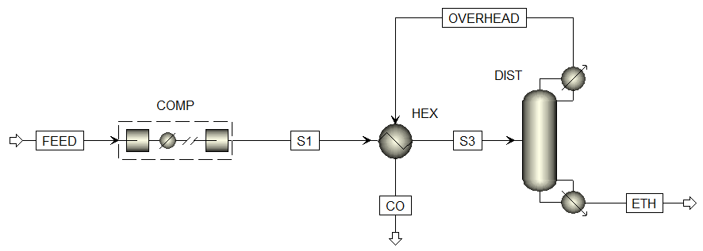
Figure S10: Cryogenic distillation of ethylene and CO modelled in ASPEN Plus.

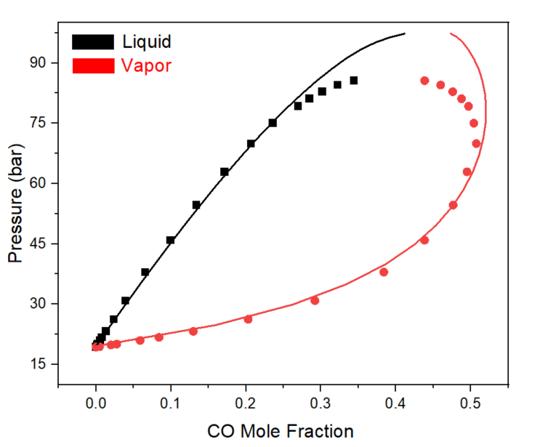
Figure S11: Comparison of VLE calculated with RKS-BM model (lines) and experimental data from Ahmar et al. [31] (symbols) at 243 K.

Table S8: Estimated capital and operating cost for cryogenic separation of ethylene and CO
CO mass fraction feed | 0.5 | 0.75 | 0.875 | 0.9375
C₂H₄ mass fraction feed | 0.5 | 0.25 | 0.125 | 0.0625
Feed (kg/h) | 10000 | 10000 | 10000 | 10000
Ethylene purity (mass %) | 99.97 | 99.97 | 99.97 | 99.97
Production ethylene (kg/s) | 1.375 | 0.6875 | 0.3437 | 0.1718
operation hours (h/year) | 8000 | 8000 | 8000 | 8000
production ethylene (tonne/y) | 39600 | 19800 | 9899 | 4948
Total CAPEX ($) from Aspen | 7609350 | 7603580 | 7677640 | 7431670
lifetime (years) | 20 | 20 | 20 | 20
Interest | 0.05 | 0.05 | 0.05 | 0.05
CRF | 0.080 | 0.080 | 0.080 | 0.080
Annual CAPEX ($/y) | 610594 | 610131 | 616074 | 596336
Total Opex ($/y) from Aspen | 3434230 | 2445700 | 1918080 | 1622590
Cost of ethylene ($/tonne)ª | 102.1 | 154.3 | 256.0 | 448.5
ª Cost holds for a product purity of 99.97%

4.3 Modeling of Distillation of 1-Propanol and Water

The separation of 1-propanol and water was modeled in Aspen Plus V8.8 using the RADFRAC unit block. The NRTL model with default Aspen Plus parameters was used for property calculations. In Figure S12, a comparison of the model with experimental data is shown. The feed to the distillation column was 10000 kg/h containing different concentrations of propanol (2.5, 5, 10, and 20 wt%). The propanol was concentrated up to 69 wt%, which is just below the azeotropic point. A total of 10 theoretical stages were used and the feed stage was optimized by minimizing the reboiler duty. The column was optimized by using two design specifications (i.e., a mass purity of propanol of 69 wt% and a mass recovery of propanol of 99% were set), which were met by changing the reflux ratio and the reboiler duty. As utilities, cooling water and low pressure steam were used at a price of $1/GJ and $6/GJ, respectively. After optimization, the CAPEX and OPEX of the process were directly taken from the Aspen Economic Analyzer.

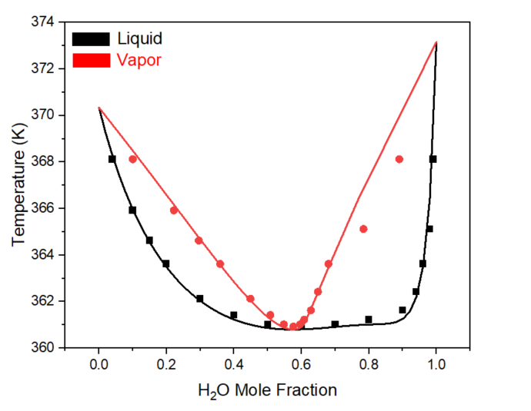
Figure S12: VLE of water and 1-propanol predicted by the NRTL model (lines) and experimental data of Doroshevskii et al. [32] (symbols) at 1 bar.

The annualized CAPEX (C_{A}) was calculated by multiplying the total capital cost (TCC) by the capital recovery factor (CRF):

$$C_{A}=TCC\frac{i{\left(1+i\right)}^{n}}{{\left(1+i\right)}^{n}-1}$$
where i is the interest rate (5%), and n the lifetime of the project (20 years). The separation cost (C_{S}) of 1-propanol was then calculated from:

$$C_{S}=\frac{C_{A}+OPEX}{p}$$

where OPEX is the annual operating cost, and p the annual production capacity of 1-propanol.
Table S9: Estimated capital and operating cost of the separation of propanol and water

Propanol mass frac feed | 0.025 | 0.05 | 0.1 | 0.2
Water mass frac feed | 0.975 | 0.95 | 0.9 | 0.8
Feed (kg/h) | 10000 | 10000 | 10000 | 10000
Recovery | 0.99 | 0.99 | 0.99 | 0.99
operation h/y | 8000 | 8000 | 8000 | 8000
production t/y | 1980 | 3960 | 7920 | 15840
CAPEX ($) | 3271770 | 3284510 | 3250730 | 3294150
lifetime (years) | 20 | 20 | 20 | 20
interest | 0.05 | 0.05 | 0.05 | 0.05
CRF | 0.080 | 0.080 | 0.080 | 0.080
Annual capex ($/y) | 262535 | 263558 | 260847 | 264331
OPEX ($/y) | 234261 | 259719 | 309784 | 406470
Cost of propanol ($/tonne)ª | 250.9 | 132.1 | 72.0 | 42.3
ª Cost of propanol separation up to the azeotropic point

4.4 Modeling of Distillation of Ethanol and Water

The separation of ethanol and water was modeled in Aspen Plus V8.8 using the RADFRAC unit block. The UNIQUAC model with default Aspen Plus parameters was used for property calculations. In Figure S13, a comparison of the model with experimental data is shown. The feed to the distillation column was 10000 kg/h containing different concentrations of ethanol (2.5, 5, 10, and 20 wt%). The ethanol was concentrated up to 92 wt%, which is just below the azeotropic point. A total of 30 theoretical stages were used and the feed stage was optimized by minimizing the reboiler duty using the Model Analysis Tool in Aspen Plus. The column was optimized by using two design specifications (i.e., a mass purity of ethanol of 92 wt% and a mass recovery of ethanol of 99.5% were set), which were met by changing the reflux ratio and the reboiler duty. As utilities, cooling water and low pressure steam were used at a price of $1/GJ and $6/GJ, respectively. After optimization, the CAPEX and OPEX of the process were directly taken from the Aspen Economic Analyzer.

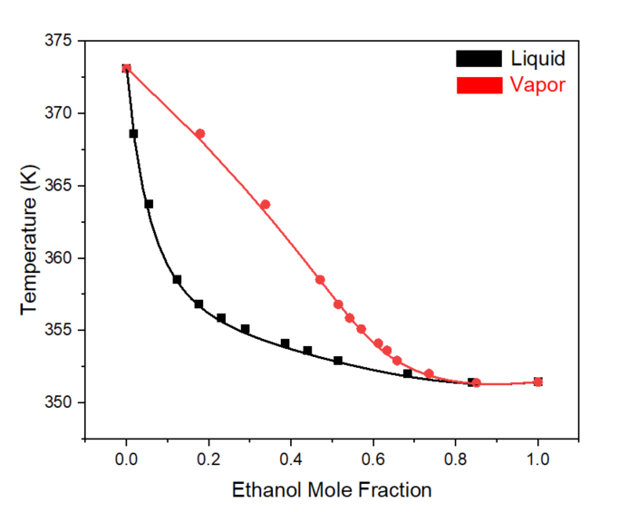
Figure S13: VLE of water and ethanol predicted by the UNIQUAC model (lines) and experimental data of Jones et al. [33] (symbols) at 1 bar.

The annualized CAPEX (C_{A}) was calculated by multiplying the total capital cost (TCC) by the capital recovery factor (CRF):

$$C_{A}=TCC\frac{i{\left(1+i\right)}^{n}}{{\left(1+i\right)}^{n}-1}$$
where i is the interest rate (5%), and n the lifetime of the project (20 years). The separation cost (C_{S}) of ethanol was then calculated from:

$$C_{S}=\frac{C_{A}+OPEX}{p}$$

where OPEX is the annual operating cost, and p the annual production capacity of ethanol.

Table S10: Estimated capital and operating cost of the separation of ethanol and water
Ethanol mass frac feed | 0.025 | 0.05 | 0.1 | 0.2
Water mass frac feed | 0.975 | 0.95 | 0.9 | 0.8
Feed (kg/h) | 10000 | 10000 | 10000 | 10000
Recovery | 0.99 | 0.99 | 0.99 | 0.99
operation h/y | 8000 | 8000 | 8000 | 8000
production t/y | 1980 | 3960 | 7920 | 15840
CAPEX ($) from ASPEN | 3493120 | 3496700 | 3562810 | 3565160
lifetime (years) | 20 | 20 | 20 | 20
interest | 0.05 | 0.05 | 0.05 | 0.05
CRF | 0.080 | 0.080 | 0.080 | 0.080
Annual capex ($/y) | 280297 | 280584 | 285889 | 286078
OPEX ($/y) from ASPEN | 264138 | 291626 | 366788 | 525117
Cost of ethanol ($/tonne)ª | 275.0 | 144.5 | 82.4 | 51.2
ª Cost of ethanol separation up to the azeotropic point

4.5 Modeling of Liquid-Liquid Extraction of Acetic Acid and Water

The liquid-liquid extraction process was modeled in Aspen Plus V8.8, see Figure S14. The feed containing acetic acid (AA) and water is sent to a counter-current extractor (CCE), which uses MTBE solvent to extract AA from the aqueous stream. The extract is fed to the azeotropic distillation column (ADC) and the raffinate is sent to the stripper. In the ADC, a water-MTBE azeotrope is removed as tops, while pure acetic acid (99.9 wt%) is obtained as bottoms. The heterogenous water-MBTE azeotrope is condensed in a decanter into a solvent-rich phase and a water-rich phase. The solvent-rich phase is recycled to the CCE, while the water-rich phase is combined with the raffinate stream and fed to the stripper. In the stripper, steam is used to strip the solvent out of the wastewater. A small amount of solvent is lost in the purified water stream, which requires a solvent make up stream.

The number of stages and the solvent flow in the CCE were optimized to have an AA recovery of 99.5%. The RADFRAC unit block in Aspen Plus was used to model the ADC and the stripper. The ADC was optimized by using two design specifications; the bottom stream should have a purity of 99.9 wt% (glacial AA) and the mass recovery of AA should be 99.9%. The design specifications were met by varying the reflux ratio and the bottoms rate. The Model Analysis Tool in Aspen Plus was used to optimize the number of stages and the feed stage. The stripper was optimized to produce nearly pure water (99.98%) by varying the reboiler duty and the number of stages. We have used the NRTL model to describe the LLE in the extractor and the decanter, while the UNIQUAC-HOC model was used for the VLE calculations in the ADC and stripper. The HOC model is required to account for the dimerization of AA in the gas phase. The thermodynamic models were validated with experimental data, see Figure S15. As utilities, cooling water, low pressure steam, and medium pressure steam were used at a price of $1/GJ, $6/GJ, and $8/GJ, respectively.

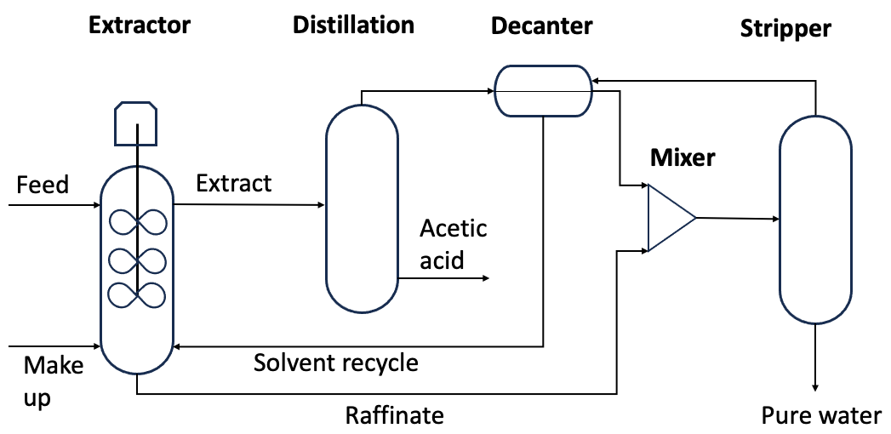
Figure S14: Liquid-liquid extraction of acetic acid with methyl tertiary butyl ether (MTBE) modelled in Aspen Plus.

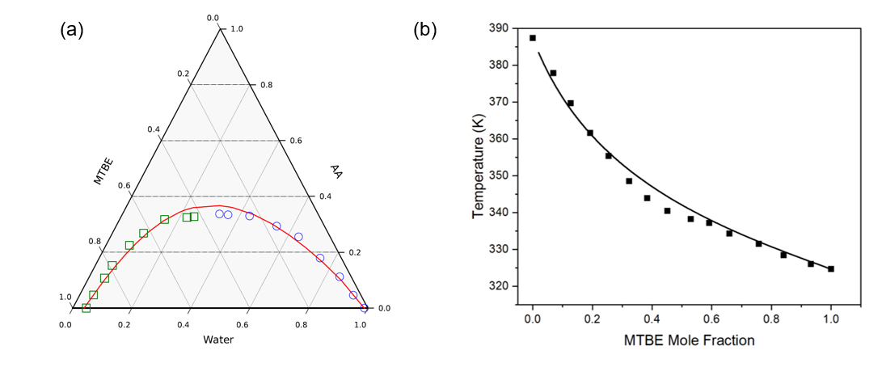
Figure S15: (a) Validation of NRTL model (line) for the LLE of MTBE-AA-water with experimental data of Miao et al. [34] (symbols) at 298.15 K, (b) validation of UNIQUAC-HOC model (line) for VLE of AA-MTBE with experimental data from Khirsariya et al. [35] (symbols) at 90 kPa.
After optimization, the capital and operating costs were taken directly from the Aspen Economic Analyzer.

The annualized CAPEX (C_{A}) was calculated by multiplying the total capital cost (TCC) by the capital recovery factor (CRF):
$$C_{A}=TCC\frac{i{\left(1+i\right)}^{n}}{{\left(1+i\right)}^{n}-1}$$
where i is the interest rate (5%), and n the lifetime of the project (20 years). The separation cost (C_{S}) of acetic acid was then calculated from:

$$C_{S}=\frac{C_{A}+OPEX}{p}$$
where OPEX is the annual operating cost, and p the annual production capacity of acetic acid.

Table S11: Estimated capital and operating cost for the separation of acetic acid and water
Acetic mass frac | 0.025 | 0.05 | 0.1 | 0.2
water mass frac | 0.975 | 0.95 | 0.9 | 0.8
Feed (kg/h) | 10000 | 10000 | 10000 | 10000
Acetic purity (mass %) | 99.9 | 99.9 | 99.9 | 99.9
Production acetic (kg/s) | 0.0686 | 0.1379 | 0.27438 | 0.5491
operation hours (h/year) | 8000 | 8000 | 8000 | 8000
production acetic (tonne/y) | 1975.68 | 3971.52 | 7902.14 | 15814.08
Total Capex ($) | 5220810 | 5191720 | 5144270 | 5723260
lifetime (years) | 20 | 20 | 20 | 20
interest | 0.05 | 0.05 | 0.05 | 0.05
CRF | 0.080 | 0.080 | 0.080 | 0.080
Annual Capex ($/y) | 418931 | 416597 | 412790 | 459249
Total Opex ($/y) | 702606 | 764907 | 680341 | 1178910
Cost of acetic acid ($/tonne) | 567.7 | 297.5 | 138.3 | 103.6

4.6 Modeling of Temperature Vacuum Swing Adsorption (TVSA)
4.6.1 TVSA CO/Ethylene
To study the performance of the MOF adsorbent, a 5-step TVSA process was developed in Aspen Adsorption V8.8, see Figure S16. The steps considered are:

- Adsorption (1.1 bar and 25 ºC)
- Blowdown (co-current blow down, 0.25 bar)
- Purge (co-current purge with 1 bar pure ethylene)
- Heating and evacuation (heating to 90 ºC and counter-current evacuation at 0.01 bar)
- Cooling and pressurization (cooling to 25 ºC and pressurization with 1.1 bar of CO)

A feed containing different mixtures of CO and ethylene is fed to the adsorber at 1.1 bar and 25 ºC. In the adsorption step, ethylene is preferentially adsorbed, while CO exits the top of the column. The second step consists of a co-current blow down step, where the column pressure is reduced to 0.25 bar to remove CO from the void spaces. In the third step, the column is co-currently purged with pure ethylene to remove adsorbed CO. In the fourth step, the column is heated to 90 ºC and the pressure is reduced to 0.01 bar to evacuate adsorbed ethylene. In the last step, the column is cooled to adsorption temperature and pressurized with pure CO to adsorption pressure.

The modeling of the 5-step TVSA process is based on the TVSA example provided by Aspen Tech for direct air capture (DAC). [36] A one-dimensional (1D) model for gas adsorption in a fixed bed is developed in Aspen Adsorption to study the separation performance of the adsorbents. The model consists of mass, energy, and momentum balances of the gas and adsorbent phases. The modeling is based on the following assumptions:

- The mixture is described by the Peng-Robinson equation of state
- Mass transfer is described by the linear driving force model
- Isothermal condition is assumed for the energy balance
- The adsorbent is considered as homogeneous phase and its properties are assumed to be constant
- The first-order upwind differencing scheme (UDS1) was used for spatial discretization with a default number of nodes of 20

The temperature dependent Langmuir equation was used to describe the adsorption of the gases:
$$w_{i}=\frac{\left({IP}_{1}-{IP}_{2}T_{s}\right){IP}_{3}e^{{{IP}_{4}}/{T_{s}}}P_{i}}{1+{IP}_{3}e^{{{IP}_{4}}/{T_{s}}}P_{i}}$$

Where maximum loading $q_{m}=IP_{1}-IP_{2}T_{S}$ Langmuir constant $b=IP_{3}e^{IP_{4}}$ and P_{i} is the partial pressure of component i. IP₁, IP₂, IP₃, and IP₄ are fitting parameters obtained from the experimental isotherms, see Table S12. A comparison between experimental isotherms and the Langmuir model fits can be found in Figure S17 and Figure S18. Since we modeled the process as isothermal, the Langmuir parameters needed to be changed in different cyclic steps corresponding with the temperature. The parameters used in the column are provided in Table S13.

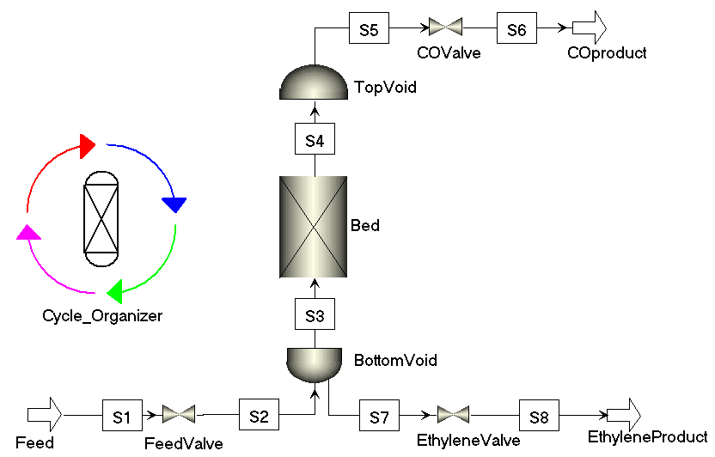
Figure S16: Aspen Adsorption flow diagram for the separation of CO and ethylene.

Table S12: Langmuir parameters for ethylene/CO adsorption on SBMOF-1
Gas | IP₁ | IP₂ | IP₃ | IP₄
ethylene | 8.61E-04 | -1.67E-06 | 3.56E-05 | 4448.10
CO | -1.92E-01 | -6.87E-05 | 2.49E-07 | 4156.86

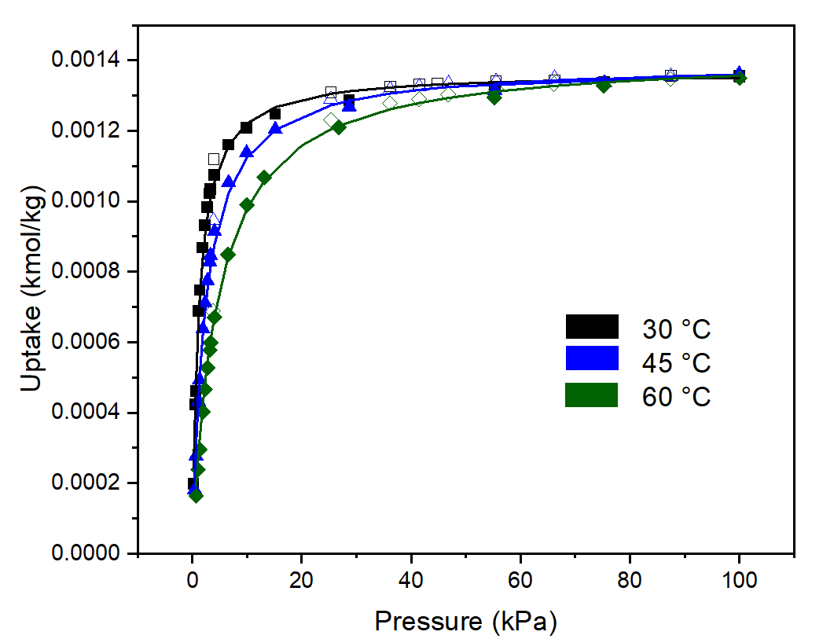
Figure S17: Comparison of experimental isotherms (symbols) and Langmuir model fits (lines) for ethylene on SBMOF-1.

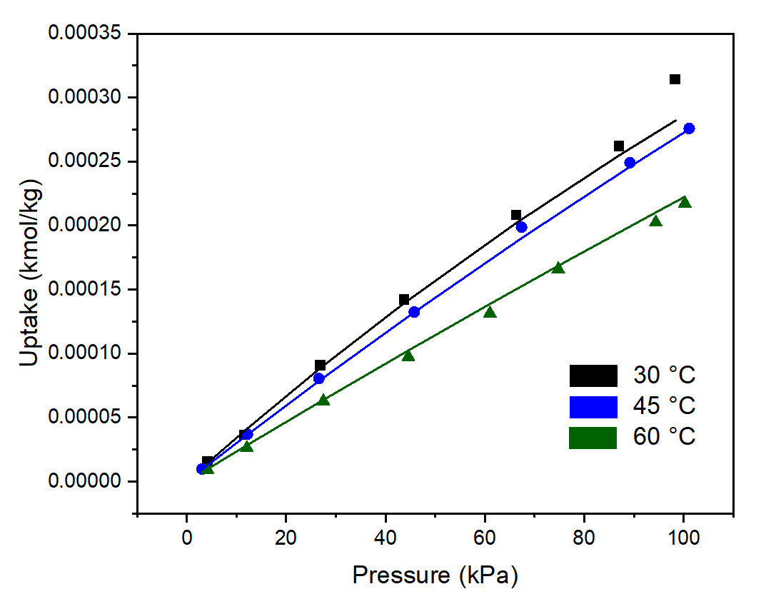
Figure S18: Comparison of experimental isotherms (symbols) and Langmuir model fits (lines) for CO on SBMOF-1.

Table S13: Column settings in Aspen Adsorption for CO/ethylene separation with SBMOF-1
Parameter | Value | Units | Description
Hb | 3 | m | Height of adsorbent layer
Db | 1 | m | Internal diameter of adsorbent layer
Ei | 0.42 | m³ void/m³ bed | Inter-particle voidage
RHOs | 1000 | kg/m³ | Bulk solid density of adsorbent
Rp | 1E-03 | m | Adsorbent particle radius
SFac | 1 | n/a | Adsorbent shape factor
MTC(*)
MTC("CO") | 0.05 | 1/s | Constant mass transfer coefficients
MTC("ETHYLENE") | 0.05 | 1/s | Constant mass transfer coefficients

4.6.2 TVSA CO/CO₂
To study the performance of the MOF adsorbent, a 3-step TVSA process was developed in Aspen Adsorption V8.8, see Figure 1. The steps considered are:

- Adsorption (1.1 bar and 25 ºC)
- Heating and evacuation (heating to 90 ºC and counter-current evacuation at 0.1 bar)
- Cooling and pressurization (cooling to 25 ºC and pressurization with 1.1 bar of CO)

A feed containing different mixtures of CO and CO₂ were fed to the adsorber at 1.1 bar and 25 ºC. In the adsorption step, CO₂ was preferentially adsorbed, while CO exits the top of the column. In the second step, the column was heated to 90 ºC and the pressure was reduced to 0.1 bar to evacuate the adsorbed CO₂. In the last step, the column was cooled to adsorption temperature and pure CO was used to pressurize the column to adsorption pressure. Adsorption of the gases was described with the temperature dependent Langmuir equation, where the parameters were fitted to experimental isotherms, see Table S14. For CO, the isotherm was only measured at 303.15 K. The temperature dependence of CO adsorption was estimated by assuming an enthalpy of adsorption of -10 kJ/mol and then applying the van ‘t Hoff equation to calculate the isotherm at other temperatures.
The model assumptions for the cycle are similar to the TVSA process of the CO/ethylene system described earlier. The parameters used in the column are provided in Table S15.

Table S14: Langmuir parameters for CO₂/CO adsorption on MUF-16
Gas | IP₁ | IP₂ | IP₃ | IP₄
CO₂ | 3.83E-03 | 4.79E06 | 1.72E-05 | 3821.82
CO | 7.17E-04 | 0 | 3.03E-03 | 1203.37

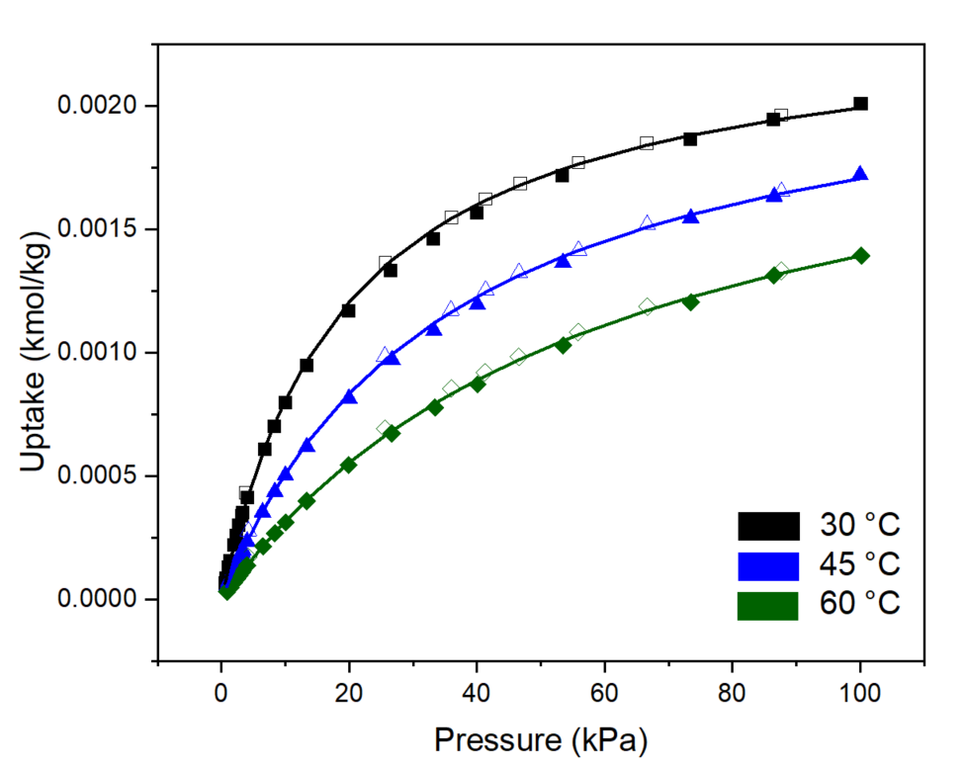
Figure S19: Comparison of experimental isotherms (symbols) and Langmuir model fits (lines) for CO₂ on MUF-16.

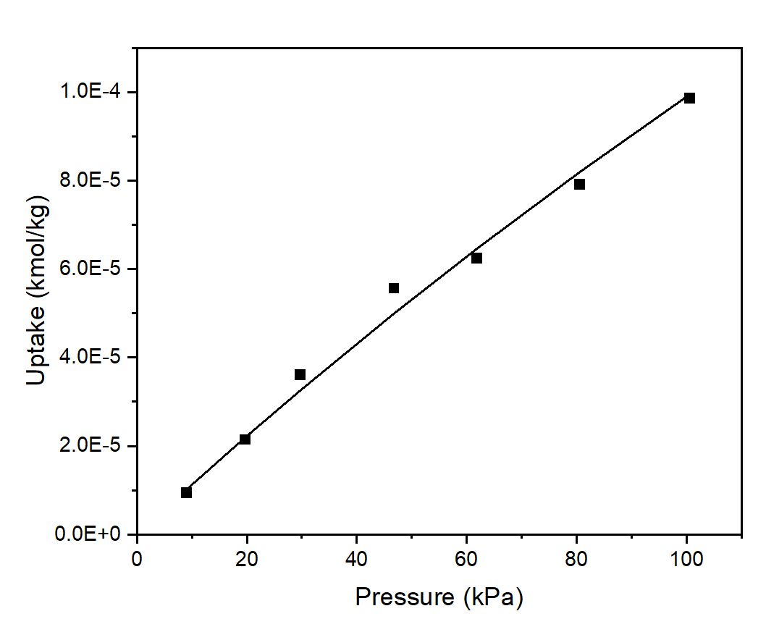
Figure S20: Comparison of experimental isotherms (symbols) and Langmuir model fits (lines) for CO on MUF-16.

Table S15: Column settings in Aspen Adsorption for CO/ethylene separation with MUF-16
Parameter | Value | Units | Description
Hb | 4 | m | Height of adsorbent layer
Db | 2 | m | Internal diameter of adsorbent layer
Ei | 0.42 | m³ void/m³ bed | Inter-particle voidage
RHOs | 1000 | kg/m³ | Bulk solid density of adsorbent
Rp | 1E-03 | m | Adsorbent particle radius
SFac | 1 | n/a | Adsorbent shape factor
MTC(*)
MTC("CO") | 0.05 | 1/s | Constant mass transfer coefficients
MTC("CO₂") | 0.05 | 1/s | Constant mass transfer coefficients

4.6.3 Sizing of TVSA Processes
The sizing of the TVSA process is based on the modeling of the systems in Aspen Adsorption. For a chosen column size (Length: Diameter ratio of 3:1 for the CO/ethylene system and 2:1 for the CO₂/CO system), feed flow (i.e., reference flow) and composition, and cycle time, the productivity of the column is calculated. The size of the column is chosen such that a reasonable superficial velocity (e.g., 0.1 – 0.6 m/s) and pressure drop is obtained for the specific feed flow. The cycle time is obtained by summing up the time of each step, where the adsorption time is determined by the breakthrough time, while the cooling, heating, and evacuation times are assumed. Based on the productivity data of a single column, the number of adsorbers (N_{a}) required are calculated:
$$N_{a}=\frac{v}{P}$$
where $v$ is the flow of adsorbing component in the electrochemical process and P the amount of adsorbing component produced per column per cycle (i.e., productivity) for the reference flow.
Then the number of valves, compressors, vacuum pumps, and storage tanks were determined. As a first estimate, the number of valves (N_{v}) were calculated as:
$$N_{v}=N_{a}∙N_{s}$$
Where N_{s} is the number of steps in a cycle. We neglect safety valves and valves needed for vacuum pumps, compressors, and storage tanks.
The number of vacuum pumps and compressors depends on the operation of the column. We need at least one vacuum pump for removing the adsorbed gases under vacuum conditions. For the CO/ethylene system, an additional vacuum pump is required for the co-current blowdown step, which is operated at 0.25 bar. For the CO/ethylene system, two compressors are required; one for the ethylene purge and one for the pressurization of the column with pure CO. For the CO/CO₂ system, only one compressor is required for pressurization of the column with pure CO after the evacuation step. Two storage tanks (one for product and one for by-product (waste) gas) are needed for both TVSA systems.
4.6.4 Adsorbers
The volume of each bed (V_{b}) is calculated from:
$$V_{b}=0.25∙π∙D^{2}∙L$$
where D is the diameter of the bed and L the length of the bed. To calculate the volume of the column (V_{c}), we have added 25% void volume:
$$V_{c}= V_{b}+0.25∙V_{b}$$
The mass of the adsorbent (M_{a}) per column is determined from:
$$M_{a}=0.25*π*D^{2}*L*ρ_{a}$$
where ρ_{a} is the density of the adsorbent.

The cost of sorbents have been calculated using unit price scale correlations for all reagents used as described by Qi et al. [37]
$$p=p_{labscale}∙{\left(\frac{q}{q_{labscale}}\right)}^{ϒ_{m}}$$
where p is estimated price of bulk quantity q, p_{labscale} is lab scale price for small quantity q_{labscale} and $ϒ_{m}$ is empirical parameter. The values of $ϒ_{m}$as reported by Qi et al. are -0.56, -0.67, and -0.56 for metal salts, organic compounds and solvents respectively.
Table S16: Cost of MUF-16
 | Lab scale | Vendor | Catalog No. | Lab price ($, as accessed on 23rd April, 2025) | Lab quantity purchased | Industry scale | Predicted Price ($)
5-aminoisopthalic acid (98%) | 2.4 g | Thermo fisher Sci | 181331000 | 116.65 | 100 g | 4000000 g | 0.096
cobalt (II) acetate tetrahydrate, ACS | 0.8332 g | Sigma-Aldrich | 208396-1KG | 244 | 1000 g | 1388666.6 g | 4.24
manganese (II) acetate | 0.0833 g | Sigma-Aldrich | 330825-100G | 344 | 100 g | 138833.3 g | 5.98
Methanol HPLC | 200 mL | Sigma-Aldrich | 646377-4X4L | 732 | 16 L | 333333.3 L | 2.79
HPLC water | 6.64 mL | Sigma-Aldrich | 270733-20L | 592 | 20 L | 11066.6 L | 17.23
Methanol for solvent exchanges | 120 mL | VWR | BDH1135-19L | 65.48 | 19 L | 200000 L | 0.366
Approx amount synthesized | 0.0006 kg |  |  |  |  | 1000 | 30.71

Table S17: Cost of SBMOF-1
 | Lab scale | Vendor | Catalog No. | Lab price ($, as accessed on 23rd April, 2025) | Lab quantity | Industry scale | Predicted Price
Calcium Chloride, Anhyd, 97% | 0.148 g | Sigma-Aldrich | C4901-2.5KG | 380 | 2500 g | 1480000 g | 10.65
4,4′-sulfonyldibenzoic acid | 0.296 g | SiKÉMIA chemicals via Sigma-Aldrich | SIK2801-10-1G | 235 | 1 g | 2960000 g | 0.0109
190 proof EtOH | 25.35 mL | Thermo fisher Sci | AC615110040 | 619 | 4 L | 253485.42 L | 1.267
Ethanol (70%) for washing | 120 mL | VWR | BDH1164-19L | 237.06 | 19 L | 1200000 L | 0.485
Approx amount synthesized | 0.0001 kg |  |  |  |  | 1000 kg | 12.41
4.6.5 Compressors and Pumps
For pumps and compressors, we used the following equation:

$$W_{c}=\left(\frac{n_{f}}{η}\right)\left(\frac{γ}{γ-1}\right)R∙T_{1}\left\lceil {\left(\frac{P_{2}}{P_{1}}\right)}^{\frac{γ-1}{γ}}-1\right\rceil$$
where n_{f} is the mole flow, η is the compressor or pump efficiency, γ = C_{p}/C_{v} is the adiabatic expansion coefficient, R the ideal gas constant, T₁ the inlet temperature, and (P₂/P₁) is the pressure ratio.

4.6.6 Storage Tanks
The volume of the storage tanks (V_{t}) has been determined by:
$$V_{t}=\frac{\dot{n}∙M_{g}∙t_{H}}{ρ_{g}}$$
where $\dot{n}$ is molar flow, Mg the molar mass of the gas, ρ_{g} the density of the gas, and t_{H} the hold-up time.

4.6.7 Capital and Operating Cost
The capital cost of the TVSA (C_{TVSA}) process was calculated from:
$$C_{TVSA}=C_{col}+ C_{ads}+ C_{comp}+ C_{pump}+ C_{val}+C_{tank}$$
where C_{col} is the cost of the adsorber columns, C_{ads} is the cost of the adsorbents, C_{comp} is the cost of the compressors, C_{pump} is the cost of the compressors, C_{val} is the cost of the valves, and C_{tank} is the cost of the storage tanks. We have used the book of Woods [33] for the cost of the columns, valves, and tanks. For pumps and compressors, we have used the correlation of Luyben. [38]

The operating cost of the TVSA (O_{TVSA}) process was calculated from:
$$O_{TVSA}= O_{comp}+O_{pump}+O_{heat}+ O_{cool}$$
where O_{comp}, O_{pump}, O_{heat}, and O_{cool} are the operating cost of the compressors, vacuum pumps, and heating and cooling, respectively. The cooling cost was neglected because the high vacuum in the desorption step causes a significant temperature drop in the column. The operating costs of the compressors and pumps were obtained by multiplying the power by the operational time (8000 h/y) and electricity price. The heating cost was estimated from the heat capacity of the bed and the adsorption heat of the adsorbing component.

The annualized CAPEX (C_{A}) was calculated by multiplying the total capital cost (TCC) by the capital recovery factor (CRF):
$$C_{A}=TCC\frac{i{\left(1+i\right)}^{n}}{{\left(1+i\right)}^{n}-1}$$
where i is the interest rate (5%), and n the lifetime of the project (20 years). The separation cost (C_{S}) of the adsorbing component (ethylene or CO₂) was then calculated from:

$$C_{S}=\frac{C_{A}+OPEX}{p}$$
where OPEX is the annual operating cost, and p the annual production capacity of the adsorbing component.

Example calculations are provided in the Supplementary Spreadsheet.

4.7 CO₂ Capture Cost
Price and concentration data for amine-based CO₂ capture from literature was used to generate a model for CO₂ inlet cost vs partial pressure. [39, 40] This model is also used as a proxy for CO₂/CO amine separation cost for comparison to MUF-16.
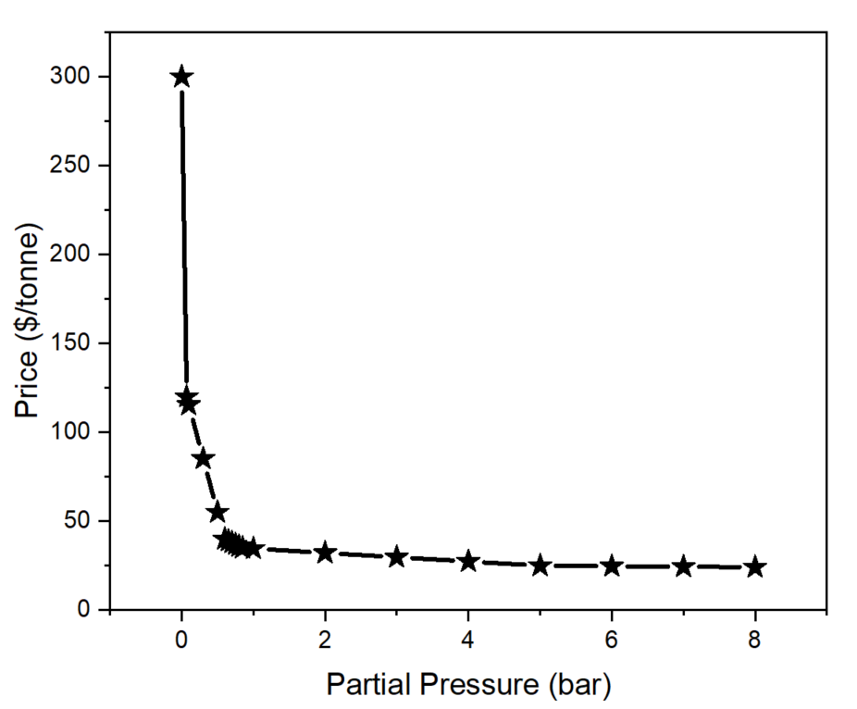
Figure S21: Price vs partial pressure for CO₂ capture using amines.

Section 5. Technoeconomic Analysis
We have evaluated the viability of the two-step tandem process by calculating the net present value (NPV):
$$NPV= \sum{\frac{C_{n}}{{\left(1+i\right)}^{t}}}$$
where C_{n} is the cash flow, i the interest rate, and t the time period. The initial investment is calculated by taking the sum of the capital cost of the electrolyzers. For the NPV analysis, we have assumed the following; an interest rate of 5% and an income tax rate of 25%, a straight-line depreciation method applied over a period of 10 years with a salvage value of 10% of the initial investment, and a working capital of 5% of the initial investment. The payback time (PBT) is obtained by plotting the NPV as a function of time, where a crossover from negative to positive NPV denotes the PBT.

The profit was calculated from the revenues generated by selling the products minus the yearly OPEX of the process:
$$Profit=Sales-Opex$$
$$Sales= {Output}_{i}*P_{i}$$
where Output_{i} is the yearly production of component i, and P_{i} the market price of component i.
The income after tax (IAT) is calculated as:
$$IAT=\left(Profit-Depreciation\right)*\left(1-tax rate\right)$$
The operating cash flow (OCF) is calculated from:
$$OCF=IAT+Depreciation$$
The discounted cash flow (DCF) is obtained from:

$$DCF= \frac{OCF}{{\left(1+i\right)}^{t}}$$
The NPV is then obtained by taking the cumulative sum of the DCFs for all years.

Example calculations are provided in the Supplementary Spreadsheet.

References

1. Sarswat, A., et al., Investigating the Effect of Trace Levels of Manganese Ions During Solvothermal Synthesis of Massey University Framework-16 on CO₂ Uptake Capacity. Chemistry of Materials, 2024. 36(11): p. 5378-5387.
2. Qazvini, O.T., R. Babarao, and S.G. Telfer, Selective capture of carbon dioxide from hydrocarbons using a metal-organic framework. Nature Communications, 2021. 12(1): p. 197.
3. Banerjee, D., et al., A Calcium Coordination Framework Having Permanent Porosity and High CO₂/N₂ Selectivity. Crystal Growth & Design, 2012. 12(5): p. 2162-2165.
4. Mayo, S.L., B.D. Olafson, and W.A. Goddard, DREIDING: a generic force field for molecular simulations. The Journal of Physical Chemistry, 1990. 94(26): p. 8897-8909.
5. Rappe, A.K., et al., UFF, a full periodic table force field for molecular mechanics and molecular dynamics simulations. Journal of the American Chemical Society, 1992. 114(25): p. 10024-10035.
6. Cho, E.H. and L.-C. Lin, Electrostatic Potential Optimized Molecular Models for Molecular Simulations: CO, CO₂, COS, H₂S, N₂, N₂O, and SO₂. Journal of Chemical Theory and Computation, 2019. 15(11): p. 6323-6332.
7. Ebbesen, S.D. and M. Mogensen, Electrolysis of carbon dioxide in Solid Oxide Electrolysis Cells. Journal of Power Sources, 2009. 193(1): p. 349-358.
8. Küngas, R., Review—Electrochemical CO₂ Reduction for CO Production: Comparison of Low- and High-Temperature Electrolysis Technologies. Journal of The Electrochemical Society, 2020. 167(4): p. 044508.
9. Wang, M., J. Wang, and J. Du, A symmetrical solid oxide electrolysis cell supported by nanostructured electrodes for highly efficient CO₂ electrolysis. Journal of Power Sources, 2024. 610: p. 234742.
10. Gan, L., et al., Titanate cathodes with enhanced electrical properties achieved via growing surface Ni particles toward efficient carbon dioxide electrolysis. Physical Chemistry Chemical Physics, 2016. 18(4): p. 3137-3143.
11. Ozden, A., et al., Cascade CO₂ electroreduction enables efficient carbonate-free production of ethylene. Joule, 2021. 5(3): p. 706-719.
12. Li, Y., et al., Efficient Carbon Dioxide Electrolysis Based on Perovskite Cathode Enhanced with Nickel Nanocatalyst. Electrochimica Acta, 2015. 153: p. 325-333.
13. Cao, Z., et al., Efficient electrolysis of CO₂ in symmetrical solid oxide electrolysis cell with highly active La_{0.3}Sr_{0.7}Fe_{0.7}Ti_{0.3}O₃ electrode material. Electrochemistry Communications, 2016. 69: p. 80-83.
14. Romero Cuellar, N.S., et al., Advantages of CO over CO₂ as reactant for electrochemical reduction to ethylene, ethanol and n-propanol on gas diffusion electrodes at high current densities. Electrochimica Acta, 2019. 307: p. 164-175.
15. Romero Cuellar, N.S., et al., Two-step electrochemical reduction of CO₂ towards multi-carbon products at high current densities. Journal of CO₂ Utilization, 2020. 36: p. 263-275.
16. Jouny, M., W. Luc, and F. Jiao, High-rate electroreduction of carbon monoxide to multi-carbon products. Nature Catalysis, 2018. 1(10): p. 748-755.
17. Jouny, M., et al., Formation of carbon–nitrogen bonds in carbon monoxide electrolysis. Nature Chemistry, 2019. 11(9): p. 846-851.
18. Li, J., et al., Constraining CO coverage on copper promotes high-efficiency ethylene electroproduction. Nature Catalysis, 2019. 2(12): p. 1124-1131.
19. Luc, W., et al., Two-dimensional copper nanosheets for electrochemical reduction of carbon monoxide to acetate. Nature Catalysis, 2019. 2(5): p. 423-430.
20. Ren, S., et al., Electrocatalysts Derived from Copper Complexes Transform CO into C₂₊ Products Effectively in a Flow Cell. Chemistry – A European Journal, 2022. 28(25): p. e202200340.
21. Ripatti, D.S., T.R. Veltman, and M.W. Kanan, Carbon Monoxide Gas Diffusion Electrolysis that Produces Concentrated C₂ Products with High Single-Pass Conversion. Joule, 2019. 3(1): p. 240-256.
22. Zhu, P., et al., Direct and continuous generation of pure acetic acid solutions via electrocatalytic carbon monoxide reduction. Proceedings of the National Academy of Sciences, 2021. 118(2): p. e2010868118.
23. Papangelakis, P., et al., Scaled CO Electroreduction to Alcohols. Nature Communications, 2025. 16(1): p. 4969.
24. Xu, Q., et al., Identifying and alleviating the durability challenges in membrane-electrode-assembly devices for high-rate CO electrolysis. Nature Catalysis, 2023. 6(11): p. 1042-1051.
25. Xu, Q., et al., Electrolyte Effects in Membrane-Electrode-Assembly CO Electrolysis. Angewandte Chemie International Edition, 2025. 64(22): p. e202501505.
26. Xu, Q., et al., Impact of Anodic Oxidation Reactions in the Performance Evaluation of High-Rate CO₂/CO Electrolysis. Advanced Materials, 2024. 36(2): p. 2306741.
27. Chen, Y., et al., Electrified synthesis of n-propanol using a dilute alloy catalyst. Nature Catalysis, 2025. 8(3): p. 239-247.
28. Kurihara, R., et al., Carbon Monoxide Reduction Reaction to Produce Multicarbon Products in Acidic Electrolytes Using Gas Diffusion Electrode Loaded with Copper Nanoparticles. Advanced Materials Interfaces, 2024. 11(6): p. 2300731.
29. William B Green, V.E.G., Removal of carbon monoxide from ethylene. 1958.
30. Luyben, W.L., Estimating refrigeration costs at cryogenic temperatures. Computers & Chemical Engineering, 2017. 103: p. 144-150.
31. El Ahmar, E., et al., Vapor–Liquid Equilibrium (PTxy) Measurements and Modeling for the CO–C₂H₄ Binary System. Journal of Chemical & Engineering Data, 2012. 57(10): p. 2744-2749.
32. A. Doroshevskii, E.P., The vapor pressures of mixtures of alcohols with water, Phys. Chem., Stoechiom. Verwandschaftsl. 1910. 73: p. 192.
33. Jones, C.A., E.M. Schoenborn, and A.P. Colburn, Equilibrium Still for Miscible Liquids. Industrial & Engineering Chemistry, 1943. 35(6): p. 666-672.
34. Miao, X., et al., Liquid−Liquid Equilibria of the Ternary System Water + Acetic Acid + Methyl tert-Butyl Ether. Journal of Chemical & Engineering Data, 2007. 52(3): p. 789-793.
35. Khirsariya, P., V.M. Parsana, and K. Joshi, Measurement & correlation of isobaric vapor-liquid equilibrium (VLE) data of methyl tert‑butyl ether (MTBE) + acetic acid (AA) system. Chemical Data Collections, 2024. 51: p. 101134.
36. Tech, A., Aspen Tech, TVSA Direct Air Capture with Aspen Adsorption. 2024.
37. Qi, W., Roger Sathre, William R Morrow III, Arman Shehabi, Unit price scaling trends for chemical products. 2015.
38. Luyben, W.L., Capital cost of compressors for conceptual design. Chemical Engineering and Processing - Process Intensification, 2018. 126: p. 206-209.
39. Adam Baylin-Stern, N.B. Is carbon capture too expensive? 2021 [cited 2025 4 June]; Available from: https://www.iea.org/commentaries/is-carbon-capture-too-expensive.
40. John Gale, J.B., Zhenlin Chen, Amit Garg, Dario Gomez, HansHolger Rogner, Dale Simbeck, Robert Williams, Ferenc Toth, Detlef van Vuuren, IPCC Special Report on Carbon dioxide Capture and Storage, Chapter 2: Sources of CO₂.

