Computational investigation of adenosine 5′- (α, β-methylene)-
diphosphate（AMPCP） derivatives as ecto-5′-nucleotidase （CD73） inhibitors by using 3D-QSAR, molecular docking, and molecular dynamics simulations
Jiatong Wen,† Heng Zhang,† Churen Meng,† Di Zhou,† Gang Chen, † Jian Wang, ‡ Yang Liu, ‡, Lei Yuan, *, ‡ Ning Li*,†

† School of Traditional Chinese Materia Medica, Key Laboratory for TCM Material Basis Study and Innovative Drug Development of Shenyang City, Shenyang Pharmaceutical University, Shenyang 110016, People’s Republic of China
‡ School of Pharmaceutical Engineering, Shenyang Pharmaceutical University, Shenyang 110016, People’s Republic of China
* To whom correspondence should be addressed. School of Traditional Chinese MateriaMedica, Shenyang Pharmaceutical University, Wenhua Road 103, Shenyang 110016, China. Tel: +86-24-43520739. E-mail address: yuanlei3094@163.com (L. Yuan), liningsypharm@163.com (N. Li).

Table S1. Docking results of the 60 compounds in the dataset with glide XP.
No | Docking score
1 | -8.202
2 | -8.84
3 | -8.587
4 | -8.438
5 | -7.84
6 | -7.394
7 | -8.304
8 | -8.83
9 | -8.143
10 | -8.534
11 | -7.88
12 | -9.377
13 | -8.286
14 | -9.601
15 | -8.769
16 | -9.653
17 | -8.939
18 | -10.172
19 | -8.77
20 | -9.811
21 | -9.44
22 | -10.37
23 | -9.136
24 | -8.736
25 | -9.524
26 | -9.204
27 | -9.094
28 | -10.491
29 | -9.187
30 | -9.575
31 | -8.812
32 | -9.333
33 | -10.536
34 | -8.874
35 | -10.401
36 | -9.872
37 | -11.649
38 | -10.81
39 | -10.385
40 | -10.173
41 | -10.036
42 | -10.471
43 | -10.236
44 | -10.029
45 | -8.352
46 | -8.958
47 | -8.947
48 | -9.604
49 | -8.517
50 | -7.944
51 | -8.492
52 | -8.794
53 | -9.231
54 | -9.2
55 | -9.278
56 | -8.461
57 | -9.23
58 | -8.745
59 | -9.183
60 | -8.956

Figure S1. The CoMSIA steric contour maps for compound 5 (A) and compound 55 (B). Green color and yellow color represent favorable and unfavorable region for steric field.
B
A
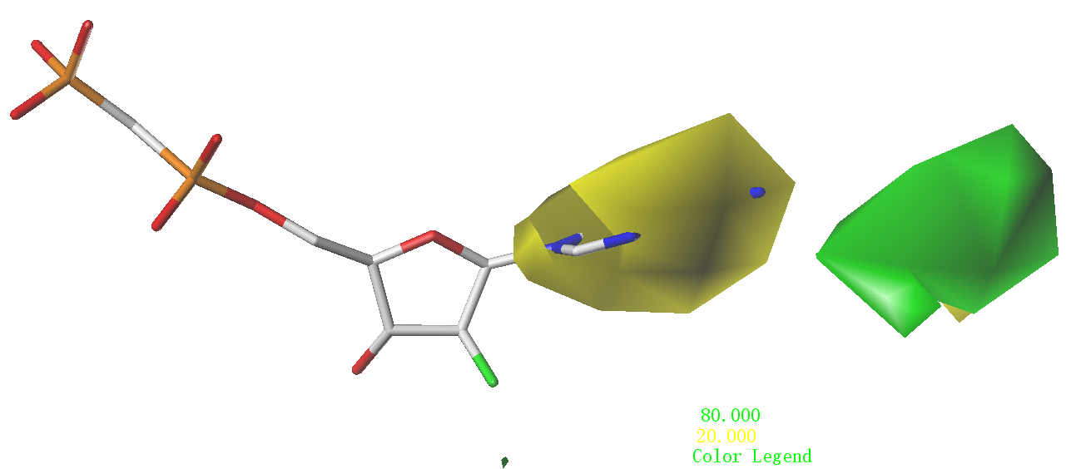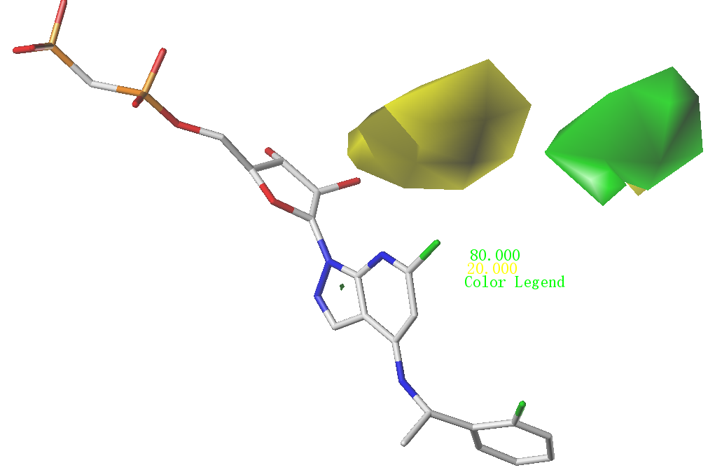

Figure S2. The CoMSIA electrostatic field contour maps for compound 5 (A) and compound 55(B). The red color shows the favored negative electrostatic region and the blue color shows the favored positive electrostatic region.
B
A
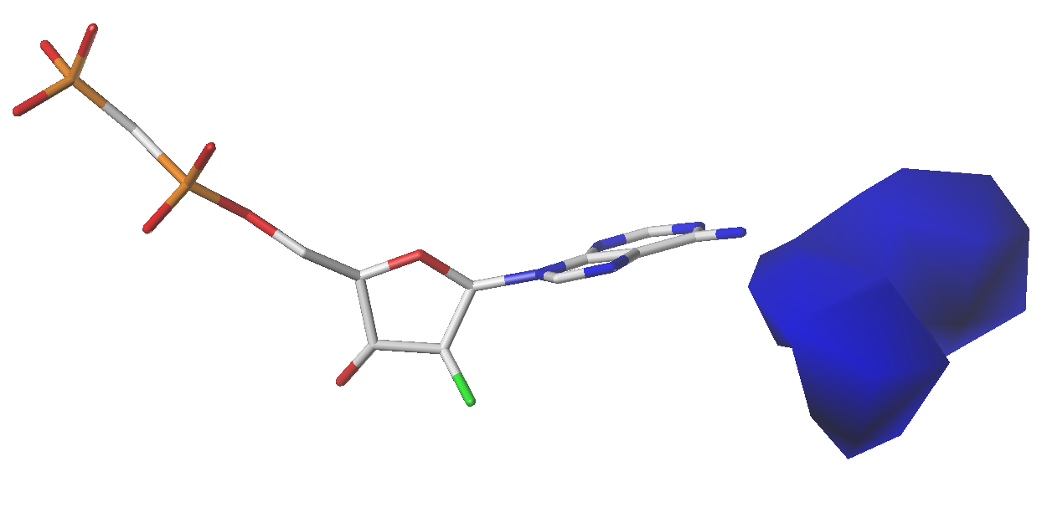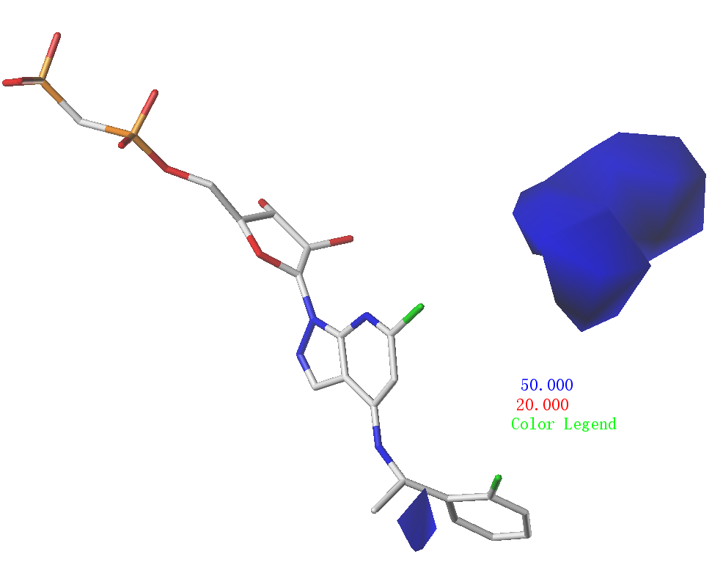

Figure S3. The plot of protein secondary structure elements (SSE) distribution by residue index throughout the protein structure.
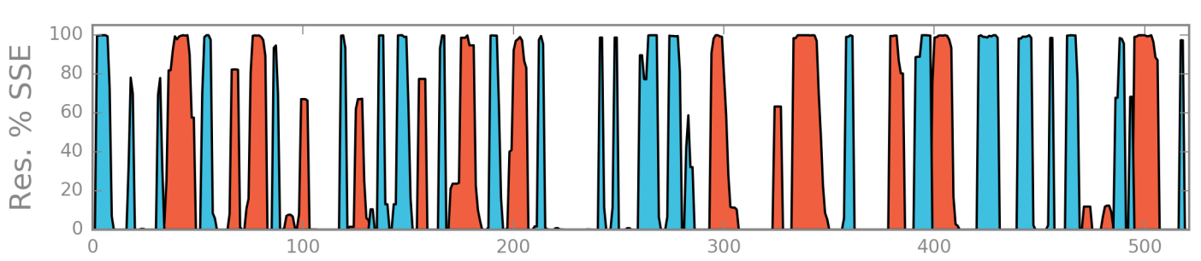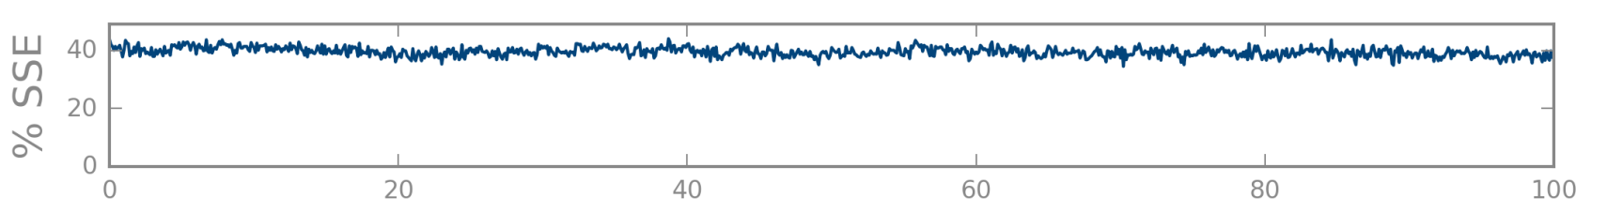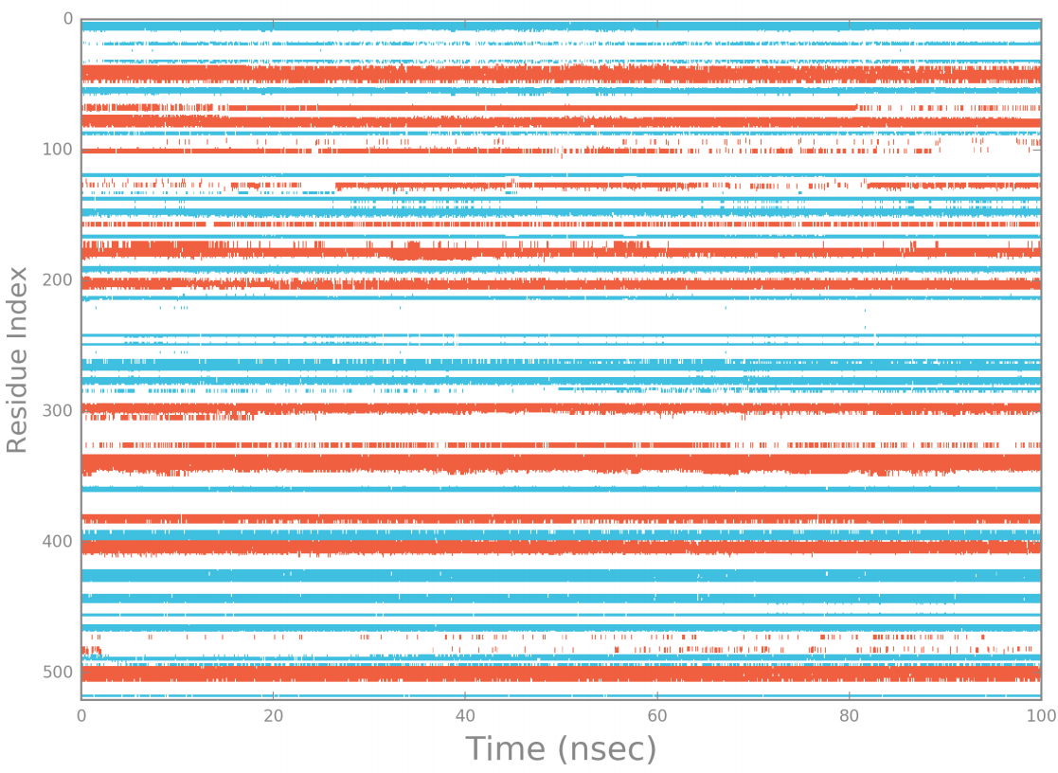

Figure S4. RMSD plot of two compound 5 and 55 calculated with the reference of themselves.
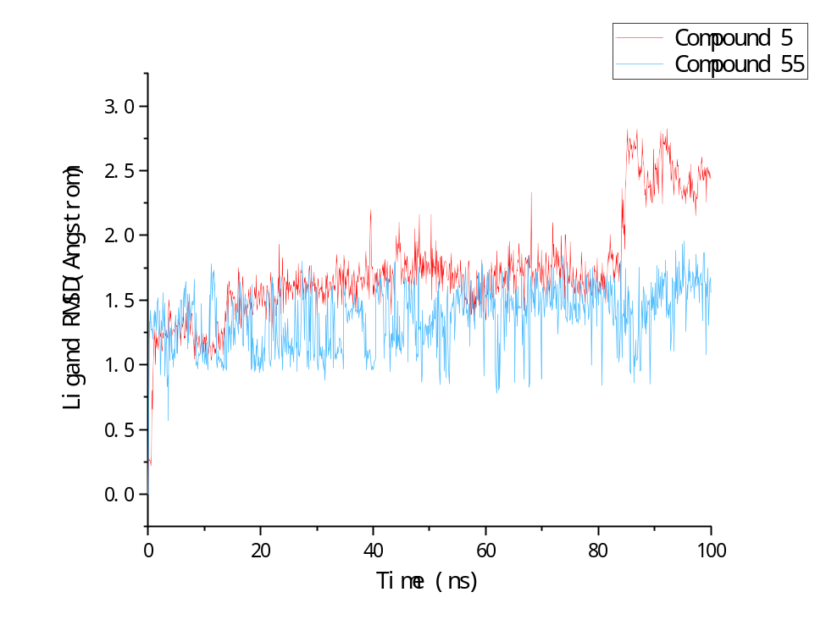

Figure S5. Conformational evolution of every rotatable bond in compounds 5 throughout 100 ns MD simulation. Radial plots describe the conformation of the torsion throughout the course of the simulation. The beginning of the simulation is the center of the radial plot, and the time evolution is plotted outward. Each rotatable bond torsion is accompanied by a dial plot and bar plots of the same color.
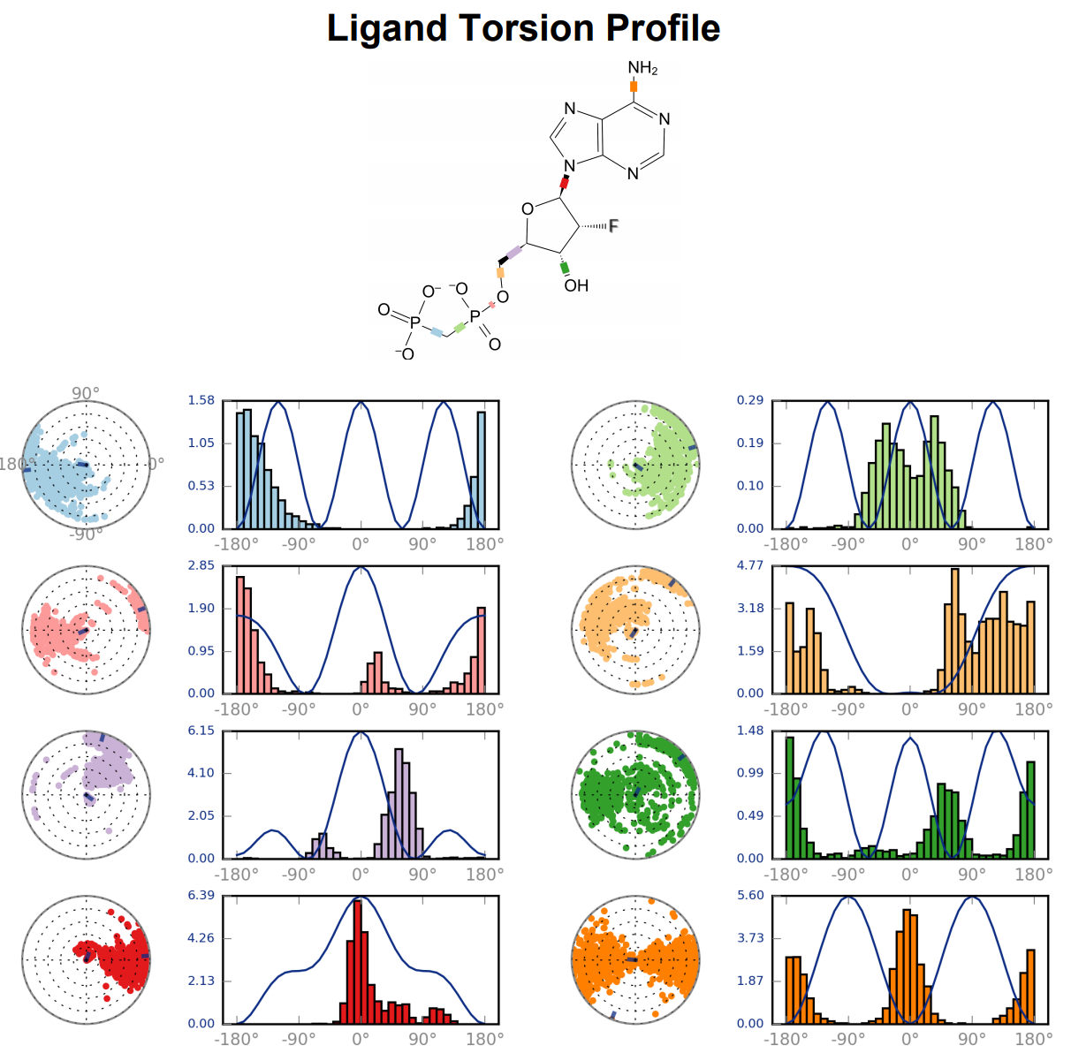

Figure S6. Conformational evolution of every rotatable bond in compounds 55 throughout 100 ns MD simulation. Radial plots describe the conformation of the torsion throughout the course of the simulation. The beginning of the simulation is the center of the radial plot, and the time evolution is plotted outward. Each rotatable bond torsion is accompanied by a dial plot and bar plots of the same color.
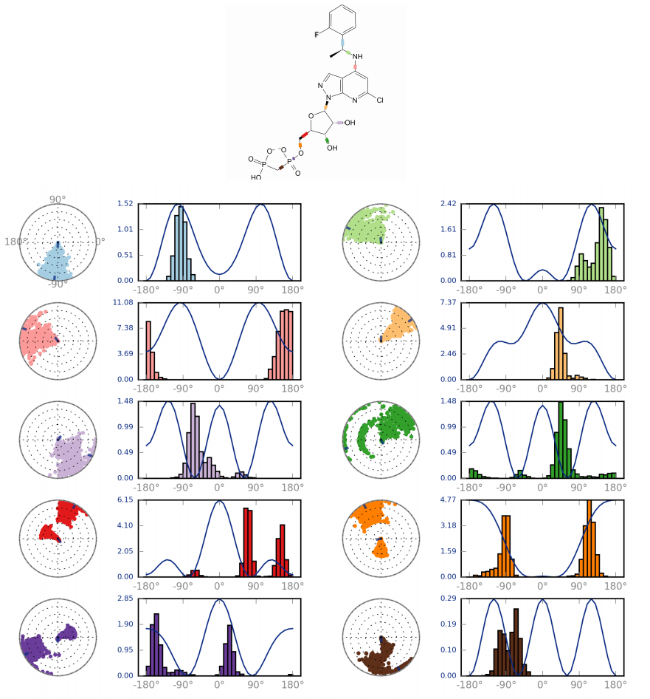
Figure S7. Histogram of binding free energy calculated with compound 5 and compound 55 with the energy decomposed into several types of interaction.

