Supplementary Materials
Table S1. Results from a dynamic multi-scale occupancy model of Bighead Carp (Hypophthalmichthys nobilis) in the Ohio River. The model was fit in a Bayesian framework, here we show the parameter scale, posterior means and 95% credibility intervals (CIs). Variables codes correspond with those in Table 1.
Scale | Parameter | Variable | Mean | 95% CI |  | Overlap 0
Annual Pool | Initial Occupancy (ψ₁) | Intercept | 0.16 | -1.62 | 2.18 | 1
Annual Pool | Initial Occupancy (ψ₁) | DIST | -2.01 | -4.11 | 0.05 | 1
Annual Pool | Persistence (ϕ_{t-1}) | Intercept | 2.53 | 1.12 | 4.26 | 0
Annual Pool | Persistence (ϕ_{t-1}) | DIST | -1.19 | -3.42 | 0.97 | 1
Annual Pool | Colonization (γ_{t-1}) | Intercept | 0.94 | -1.25 | 3.29 | 1
Annual Pool | Colonization (γ_{t-1}) | DIST | 0.08 | -2.49 | 2.72 | 1
Annual Pool | Colonization (γ_{t-1}) | FLOW_SPR | 0.63 | -2.12 | 3.33 | 1
Annual Pool | Colonization (γ_{t-1}) | HR | -0.79 | -3.33 | 1.75 | 1
Annual Site | Initial Occupancy (ω₁) | Intercept | 0.36 | -0.52 | 1.43 | 1
Annual Site | Initial Occupancy (ω₁) | SITE_DIST | -2.67 | -4.40 | -1.08 | 0
Annual Site | Persistence (ρ_{t-1}) | TYPE (Tributary) | 2.36 | 1.59 | 3.35 | 0
Annual Site | Persistence (ρ_{t-1}) | TYPE (Main Channel) | -2.70 | -4.04 | -1.35 | 0
Annual Site | Persistence (ρ_{t-1}) | FLOW_SUM_S | 1.06 | -0.15 | 2.31 | 1
Annual Site | Persistence (ρ_{t-1}) | SUM_TEMP | -0.12 | -1.56 | 1.34 | 1
Annual Site | Persistence (ρ_{t-1}) | HR | 0.77 | -0.46 | 1.94 | 1
Annual Site | Persistence (ρ_{t-1}) | TYPE (Main Channel) * FLOW_SUM_S | 1.41 | -0.64 | 3.60 | 1
Annual Site | Persistence (ρ_{t-1}) | TYPE (Main Channel) * SUM_TEMP | -0.52 | -2.53 | 1.48 | 1
Annual Site | Colonization (λ_{t-1}) | TYPE (Tributary) | -0.51 | -1.62 | 0.69 | 1
Annual Site | Colonization (λ_{t-1}) | TYPE (Main Channel) | -0.55 | -1.99 | 0.93 | 1
Annual Site | Colonization (λ_{t-1}) | DIST_SITE | -1.38 | -2.88 | 0.20 | 1
Annual Site | Colonization (λ_{t-1}) | FLOW_SPR_S | 0.46 | -0.80 | 1.83 | 1
Annual Site | Colonization (λ_{t-1}) | HR | 1.14 | -0.46 | 2.82 | 1
Annual Site | Colonization (λ_{t-1}) | TYPE (Main Channel) * FLOW_SPR_S | 1.65 | -0.19 | 3.62 | 1

Table S1. (continued)
Scale | Parameter | Variable | Mean | 95% CI |  | Overlap 0
Intra-annual Site | Initial Occupancy (ϴ₁) | TYPE (Tributary) | 2.39 | 1.59 | 3.41 | 0
Intra-annual Site | Initial Occupancy (ϴ₁) | TYPE (Main Channel) | 0.43 | -1.14 | 2.22 | 1
Intra-annual Site | Initial Occupancy (ϴ₁) | SEASON (Summer) | 0.69 | -1.80 | 3.22 | 1
Intra-annual Site | Initial Occupancy (ϴ₁) | SEASON (Fall) | -1.79 | -2.96 | -0.65 | 0
Intra-annual Site | Initial Occupancy (ϴ₁) | SEASON (Winter) | -0.01 | -2.79 | 2.77 | 1
Intra-annual Site | Initial Occupancy (ϴ₁) | TYPE (Main Channel) * SEASON (Summer) | 0.93 | -1.48 | 3.38 | 1
Intra-annual Site | Initial Occupancy (ϴ₁) | TYPE (Main Channel) * SEASON (Fall) | -0.53 | -2.37 | 1.13 | 1
Intra-annual Site | Initial Occupancy (ϴ₁) | TYPE (Main Channel) * SEASON (Winter) | 0.00 | -2.77 | 2.78 | 1
Intra-annual Site | Persistence (ε_{v-1}) | TYPE (Tributary) | 1.90 | 1.13 | 3.03 | 0
Intra-annual Site | Persistence (ε_{v-1}) | TYPE (Main Channel) | -0.62 | -1.92 | 1.09 | 1
Intra-annual Site | Persistence (ε_{v-1}) | VFLOW | 0.73 | 0.03 | 1.60 | 0
Intra-annual Site | Persistence (ε_{v-1}) | MAX_TEMP | -0.79 | -2.35 | 0.78 | 1
Intra-annual Site | Persistence (ε_{v-1}) | TYPE (Main Channel) * VFLOW | -1.53 | -2.90 | -0.32 | 0
Intra-annual Site | Persistence (ε_{v-1}) | TYPE (Main Channel) * MAX_TEMP | 0.03 | -2.81 | 3.17 | 1
Intra-annual Site | Colonization (δ_{v-1}) | TYPE (Tributary) | 0.73 | -0.72 | 2.47 | 1
Intra-annual Site | Colonization (δ_{v-1}) | TYPE (Main Channel) | 0.11 | -1.59 | 1.76 | 1
Intra-annual Site | Colonization (δ_{v-1}) | VFLOW | -0.13 | -2.05 | 1.89 | 1
Intra-annual Site | Colonization (δ_{v-1}) | VMAX | -0.15 | -2.05 | 1.82 | 1
Intra-annual Site | Colonization (δ_{v-1}) | TYPE (Main Channel) * VFLOW | 1.19 | -0.92 | 3.30 | 1
Intra-annual Site | Colonization (δ_{v-1}) | TYPE (Main Channel) * VMAX | 1.00 | -1.12 | 3.29 | 1
Sample | Detection (p) | Intercept | -0.32 | -0.60 | -0.03 | 0
Sample | Detection (p) | SITE_DIST | -1.55 | -1.96 | -1.14 | 0

Table S2. Results from a dynamic multi-scale occupancy model of Silver Carp (Hypophthalmichthys molitrix) in the Ohio River. The model was fit in a Bayesian framework, here we show the parameter scale, posterior means and 95% credibility intervals (CIs). Variables codes correspond with those in Table 1.
Scale | Parameter | Variable | Mean | 95% CI |  | Overlap 0
Annual Pool | Initial Occupancy (ψ₁) | Intercept | 0.60 | -1.87 | 3.16 | 1
Annual Pool | Initial Occupancy (ψ₁) | DIST | -1.03 | -3.34 | 1.21 | 1
Annual Pool | Persistence (ϕ_{t-1}) | Intercept | 1.04 | -0.78 | 2.97 | 1
Annual Pool | Persistence (ϕ_{t-1}) | DIST | 0.01 | -2.28 | 2.16 | 1
Annual Pool | Colonization (γ_{t-1}) | Intercept | 0.20 | -2.12 | 2.69 | 1
Annual Pool | Colonization (γ_{t-1}) | DIST | 0.44 | -2.19 | 3.02 | 1
Annual Pool | Colonization (γ_{t-1}) | FLOW_SPR | 0.39 | -2.23 | 3.04 | 1
Annual Pool | Colonization (γ_{t-1}) | HR | -0.72 | -3.34 | 1.99 | 1
Annual Site | Initial Occupancy (ω₁) | Intercept | -1.55 | -3.65 | 0.96 | 1
Annual Site | Initial Occupancy (ω₁) | SITE_DIST | -0.20 | -2.26 | 1.76 | 1
Annual Site | Persistence (ρ_{t-1}) | TYPE (Tributary) | 0.68 | -1.64 | 3.10 | 1
Annual Site | Persistence (ρ_{t-1}) | TYPE (Main Channel) | -0.36 | -3.04 | 2.46 | 1
Annual Site | Persistence (ρ_{t-1}) | FLOW_SUM_S | 0.83 | -1.20 | 3.13 | 1
Annual Site | Persistence (ρ_{t-1}) | SUM_TEMP | 0.41 | -2.19 | 3.00 | 1
Annual Site | Persistence (ρ_{t-1}) | HR | -0.43 | -3.01 | 2.12 | 1
Annual Site | Persistence (ρ_{t-1}) | TYPE (Main Channel) * FLOW_SUM_S | 0.18 | -2.51 | 2.85 | 1
Annual Site | Persistence (ρ_{t-1}) | TYPE (Main Channel) * SUM_TEMP | 0.08 | -2.70 | 2.84 | 1
Annual Site | Colonization (λ_{t-1}) | TYPE (Tributary) | 0.32 | -1.85 | 2.86 | 1
Annual Site | Colonization (λ_{t-1}) | TYPE (Main Channel) | -0.67 | -3.32 | 2.29 | 1
Annual Site | Colonization (λ_{t-1}) | DIST_SITE | 0.10 | -2.36 | 2.64 | 1
Annual Site | Colonization (λ_{t-1}) | FLOW_SPR_S | 0.07 | -2.14 | 2.31 | 1
Annual Site | Colonization (λ_{t-1}) | HR | -0.53 | -3.08 | 1.98 | 1
Annual Site | Colonization (λ_{t-1}) | TYPE (Main Channel) * FLOW_SPR_S | 0.30 | -2.25 | 2.82 | 1

Table S2. (continued)
Scale | Parameter | Variable | Mean | 95% CI |  | Overlap 0
Intra-annual Site | Initial Occupancy (ϴ₁) | TYPE (Tributary) | 0.48 | -1.08 | 2.52 | 1
Intra-annual Site | Initial Occupancy (ϴ₁) | TYPE (Main Channel) | -0.24 | -2.41 | 2.23 | 1
Intra-annual Site | Initial Occupancy (ϴ₁) | SEASON (Summer) | -0.27 | -2.99 | 2.54 | 1
Intra-annual Site | Initial Occupancy (ϴ₁) | SEASON (Fall) | -0.75 | -3.10 | 1.96 | 1
Intra-annual Site | Initial Occupancy (ϴ₁) | SEASON (Winter) | -0.01 | -2.77 | 2.76 | 1
Intra-annual Site | Initial Occupancy (ϴ₁) | TYPE (Main Channel) * SEASON (Summer) | -0.18 | -2.92 | 2.60 | 1
Intra-annual Site | Initial Occupancy (ϴ₁) | TYPE (Main Channel) * SEASON (Fall) | 0.03 | -2.38 | 2.51 | 1
Intra-annual Site | Initial Occupancy (ϴ₁) | TYPE (Main Channel) * SEASON (Winter) | 0.00 | -2.78 | 2.78 | 1
Intra-annual Site | Persistence (ε_{v-1}) | TYPE (Tributary) | -0.35 | -2.49 | 1.94 | 1
Intra-annual Site | Persistence (ε_{v-1}) | TYPE (Main Channel) | -0.65 | -3.14 | 1.89 | 1
Intra-annual Site | Persistence (ε_{v-1}) | VFLOW | 0.03 | -2.78 | 2.34 | 1
Intra-annual Site | Persistence (ε_{v-1}) | MAX_TEMP | 0.62 | -2.26 | 3.18 | 1
Intra-annual Site | Persistence (ε_{v-1}) | TYPE (Main Channel) * VFLOW | 0.16 | -2.57 | 2.89 | 1
Intra-annual Site | Persistence (ε_{v-1}) | TYPE (Main Channel) * MAX_TEMP | -0.14 | -2.89 | 2.64 | 1
Intra-annual Site | Colonization (δ_{v-1}) | TYPE (Tributary) | -0.69 | -3.22 | 2.07 | 1
Intra-annual Site | Colonization (δ_{v-1}) | TYPE (Main Channel) | -0.90 | -3.49 | 1.92 | 1
Intra-annual Site | Colonization (δ_{v-1}) | VFLOW | 0.40 | -2.28 | 2.89 | 1
Intra-annual Site | Colonization (δ_{v-1}) | VMAX | 0.03 | -2.51 | 2.54 | 1
Intra-annual Site | Colonization (δ_{v-1}) | TYPE (Main Channel) * VFLOW | 0.25 | -2.46 | 2.94 | 1
Intra-annual Site | Colonization (δ_{v-1}) | TYPE (Main Channel) * VMAX | 0.19 | -2.49 | 2.87 | 1
Sample | Detection (p) | Intercept | -2.89 | -3.72 | -2.04 | 0
Sample | Detection (p) | SITE_DIST | -0.80 | -1.77 | -0.15 | 0

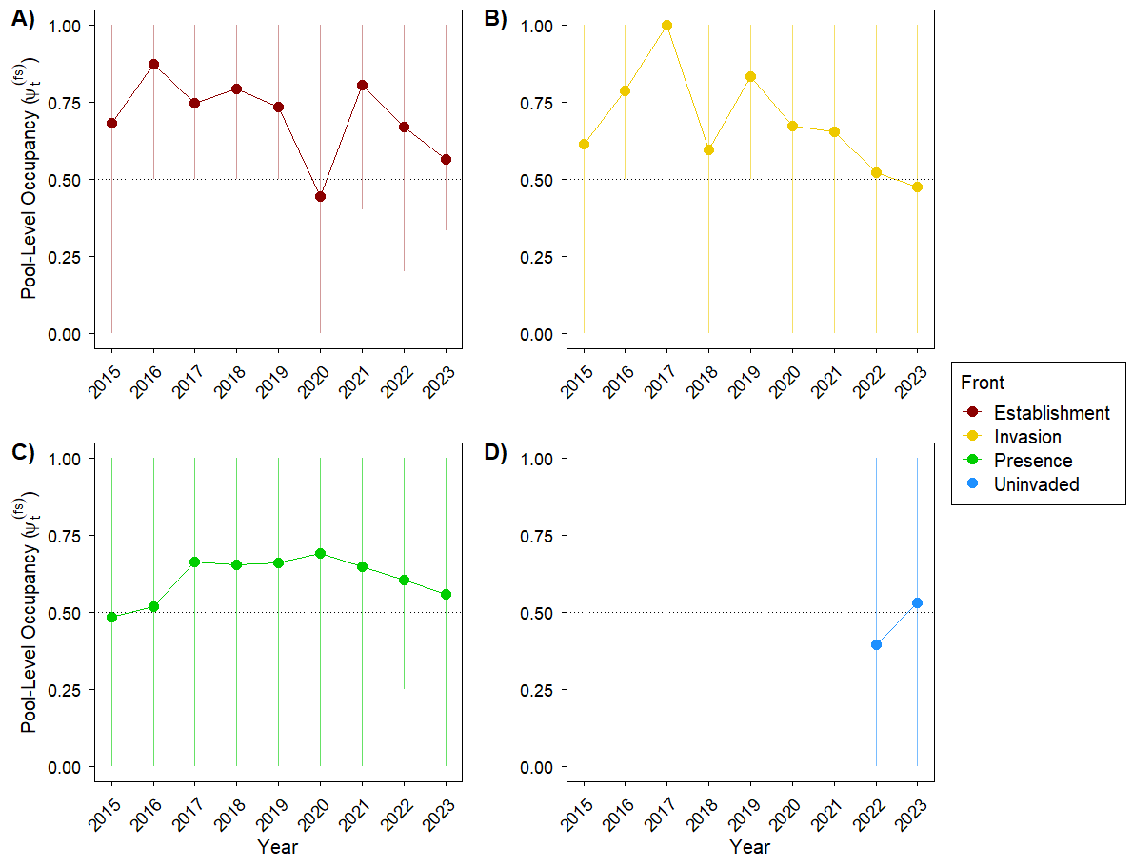
Fig. S1 Estimated annual mean pool-level occupancy probability (ψ_{t}^{(fs)}) and 95% credible intervals (CIs) for bighead carp (Hypophthalmichthys nobilis) in different invasion fronts in the Ohio River from 2015 – 2023. Panels show different fronts A) establishment front (red), B) invasion front (gold), C) presence front (green), and D) uninvaded (blue).

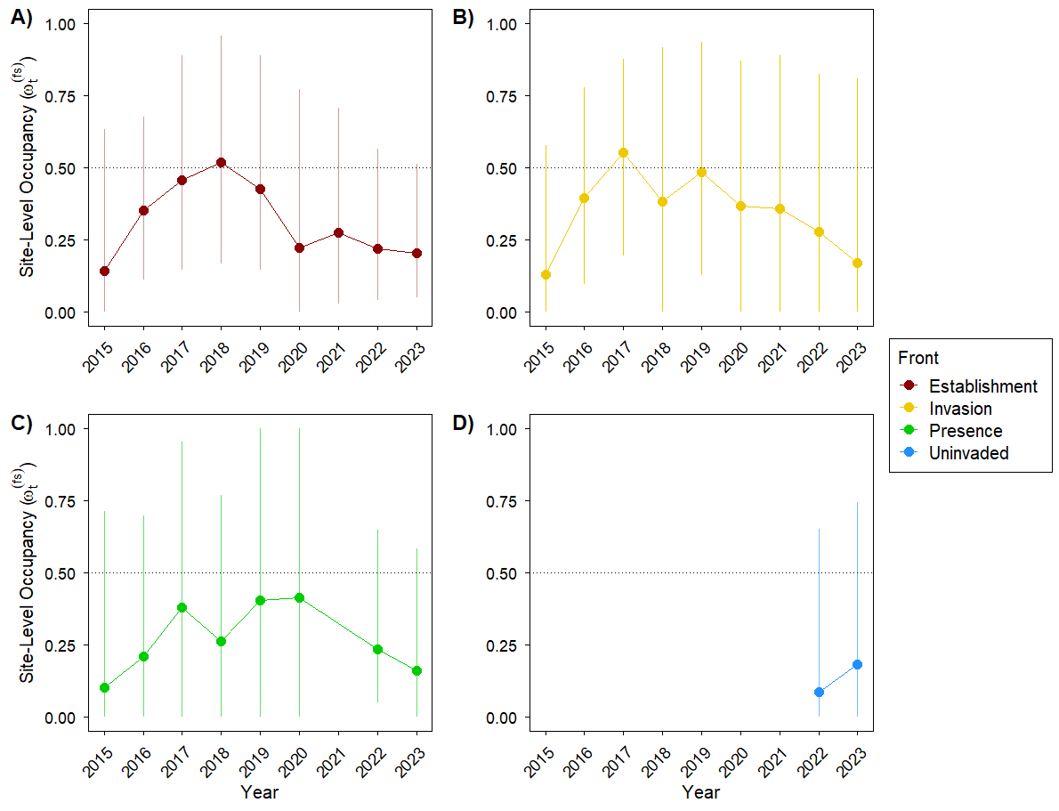
Fig. S2 Estimated annual mean site-level occupancy probability (ω_{t}^{(fs)}) and 95% credible intervals (CIs) for bighead carp (H. nobilis) in different invasion fronts in the Ohio River from 2015 – 2023. Panels show different fronts A) establishment front (red), B) invasion front (gold), C) presence front (green), and D) uninvaded (blue).

