Supplements Individual Profiling Across the Psychosis Continuum using Affinity Scores.

Supplementary Figure S1 Flow chart inclusion data

Supplementary Figure S2. Adjacency matrix

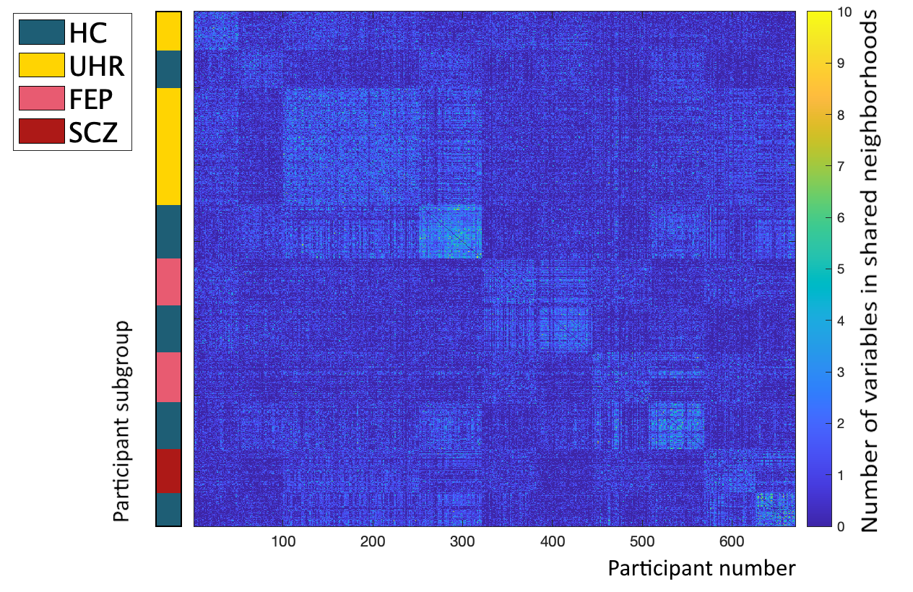

Figure S2 displays the adjacency matrix from equation E4, describing the pairwise neighbor strength. The heatmap / color shading indicates the number of variables which any of the 670 participants share a neighborhood with. A higher number of variables (lighter blue) indicates stronger relationships within the clinical, cognitive, and sociodemographic variables. Here, we see a stronger relationship emerging from participants belonging to the same diagnostic group (FEP: patients with first episode psychosis; HC: healthy controls; SCZ: individuals with a history of schizophrenia; UHR: individuals at ultra-high risk for psychosis), as indicated by the blocks visually distinguishable by the blue colorshading.

Supplementary Figure S3. ROC curves
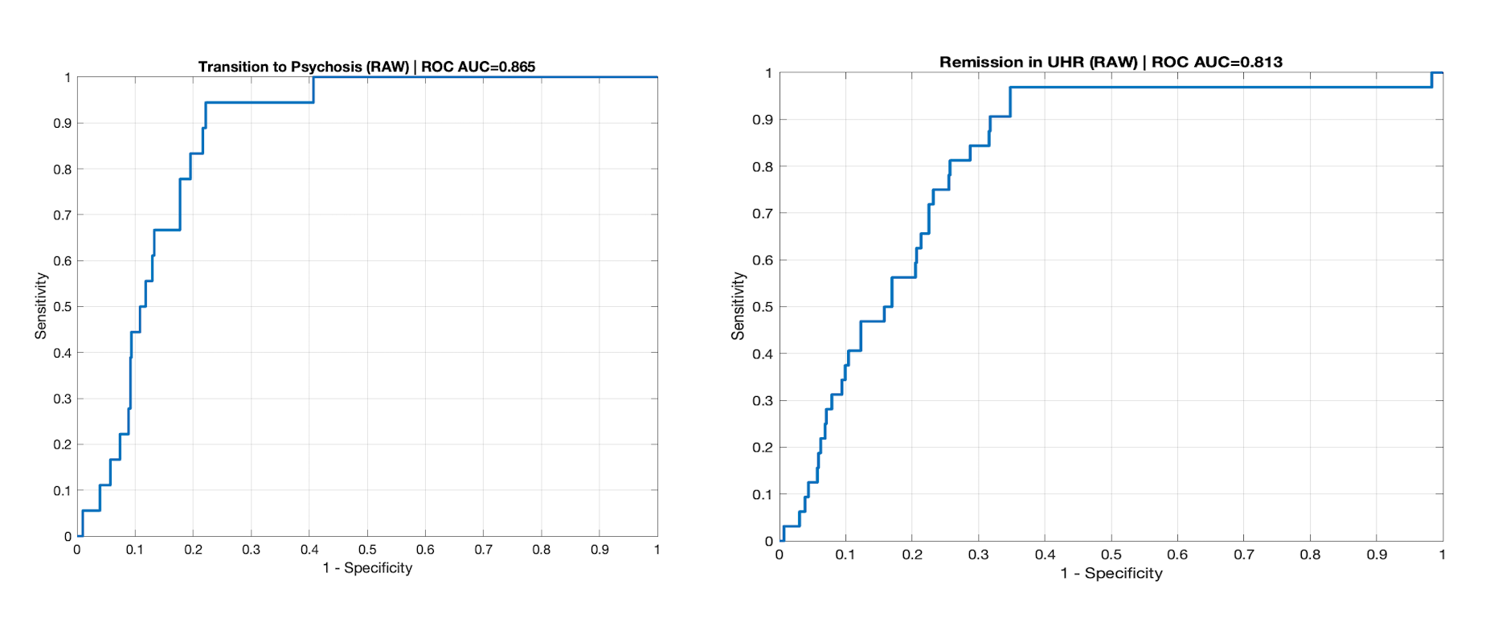

Figure S3 visualizes the ROC curve from the predictive model (using penalised logistic regression, elastic net) of the one-year UHR outcomes (transition to psychosis; remission from UHR-status), where heterogeneity indices dominance gab and UHR-rank was predictors.

Supplementary Figure S4. Affinity scores, neighborhood scores, and community scores associated with regional grey matter volume.

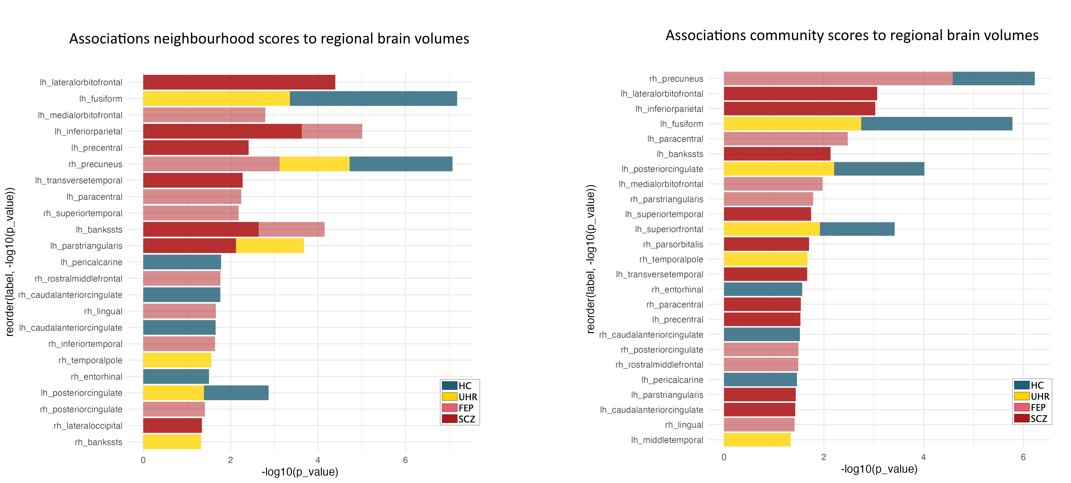

Figure S4 illustrates the significant associations between Neighborhood scores, Community scores, and regional grey matter volume. Only significant association are visualized. Significance tests are FDR corrected (q<0.05).
Supplementary Table S1 Cognitive tests included in current study:
Cognitive function | Test | Measure
The third version of the Danish Weschler Adult Intelligence Scale (WAIS-III; Wechsler, 1997)
Current Verbal IQ | (WAIS-III)  Similarities subtest of Wechsler Adult Intelligence Scale | - Number of correct responses in identifying qualitative relationships between two presented words
Current performance IQ | (WAIS-III)  Block design subtest of Wechsler Adult Intelligence Scale | - Number of correct responses when completing a visual pattern on blocks, with accuracy and time spend in consideration
Estimated full scale IQ | (WAIS-III)  Mean of Current verbal IQ and Performance IQ. | - (Verbal IQ + Performance IQ)/2
Cognitive tests from the Brief Assessment of Cognition in Schizophrenia battery (Keefe et al., 2008)
Verbal learning and memory | BACS  List learning | - Number of correct recalled words in 5 trials of remembering a list of words read aloud
Verbal working memory | BACS  Number sequencing | - Number of correct recalled and ordered sequences of digits read aloud
Verbal fluency | BACS  Verbal fluency, semantic and phonetic | - Number of correct words generated (supermarket items, F- and S-words)
Processing speed | BACS  Symbol coding | - Number of written symbols correctly associated with the numbers
Cognitive tests from the Cambridge Neuropsychological Test Automated Battery (CANTAB; Sahakian & Owen, 1992)
Spatial working memory | CANTAB (SWM)  Spatial Working Memory | - Total errors are all faulty selections of certainly empty boxes  - Between errors  - Strategy is the efficient use of search strategy (starting point in selecting boxes) in completing the task
Planning | CANTAB (SOC)  Stockings of Cambridge | - Problems solved in minimum moves is the number of completions in the possible minimum number of moves, reflecting successful planning  - Mean initial thinking time (5 moves) is the time used for planning the first move
Set shifting/mental flexibility | CANTAB (IED)  Intra-Extra-Dimensional Set-shifting | - Total errors are errors in rule acquisition and reversal, adjusted for the number of completed stages  - Total EDS errors  - Total latency in rule acquisition and reversal is the sum of response times over all presentations in all stages
Reaction time | CANTAB (RTI)  Reaction Time | - Mean simple reaction time is the speed of reaction time from predictable visual stimulus presentation, to touching the screen
Sustained Attention | CANTAB (RVP-A’)  Rapid Visual Processing | - Signal detection (a’) is the sensitivity in detecting targets, regardless of errors  - Latency

 | UHR-NT  (N=184) | UHR-T  (N=18) | Significance  (below)
Cognitive functions
Numeric Mean (SD)
mean Z-score (SD)
WAIS
Estimated Total IQ (F_IQ) | 102.96 (12.50) | 97.94 (17.14) | p=0.119, F=2.449
Verbal IQ | 102.20 (13.13) | 101.39 (28.80) | p=0.828, F=0.047
Performance IQ | 103.27 (16.22) | 100.78 (16.58) | p=0.336, F=0.384
BACS
Verbal fluency * | 57.48 (13.25) | 49.44 (11.12) | p=0.014, F=6.188
List learning | 50.98 (8.50) | 50.89 (11.00) | p=0.967, F=0.002
Number sequence | 20.29 (4.23) | 21.22 (3.72) | p=0.368, F=0.813
Symbol coding | 57.34 (11.15) | 54.94 (10.96) | p=0.384, F=0.761
CANTAB
SWM total error | 12.35 (12.65) | 10.78 (11.20) | p=0.613, F=0.257
SWM Strategy | 27.45 (6.34) | 28.33 (5.72) | p=0.570, F=0.232
SOC problem solved in minimum moves | 9.77 (1.73) | 9.78 (1.90) | p=0.989, F<0.001
SOC initial thinking time | 10245.34 (6571.14) | 7362.54 (2959.58) | p=0.667, F=3.384
RVP_A | 0.916 (0.059) | 0.917 (0.052) | p=0.949, F=0.004
RTIª | N/A | N/A | p=0.754, F=0.098
IED total errors adjusted | 19.21 (17.65) | 20.28 (16.49) | p=0.807, F=0.060
IED latency | 15459.56  (41465.70) | 139464.72  (30806.79) | p=0.134, F=2.267
IED EDS errors | 7.66 (9.44) | 8.44 (8.96) | p=0.737, F=0.113
Supplementary Table S2 Comparison UHR-individuals with transition to non-transitioners on cognitive functions

Abbreviations: FEP: patients with first episode psychosis; HC: healthy controls; IED: Intra-Extra-Dimensional Set-shifting; SCZ: individuals with a history of schizophrenia; SOC: stockings of Cambridge; SWM: spatial working memory; UHR-T/NT: individuals at ultra-high risk for psychosis with transition / non-transition; RTI: reaction time index; RVP: rapid visual processing.

Supplementary Text S1: Details on participants
UHR individuals: Both UHR samples consisted of help-seeking individuals aged 18–40 years who fulfilled one or more of the UHR criteria as assessed by the Comprehensive Assessment of At-Risk Mental State (CAARMS) (Ref). Exclusion criteria were history of a psychotic episode of ≥one-week duration; psychiatric symptoms that were explained by a physical illness with psychotropic effect (e.g. delirium) or acute intoxication (e.g. cannabis use); a diagnosis of a serious developmental disorder (e.g., Asperger's syndrome); currently receiving methylphenidate.
All the clinical assessors were psychologists and medical doctors with extensive training in using the clinical instruments. ICC was conducted on major outcomes and reported to be good/excellent (ref). Cognitive tests were done by psychologists or psychologist students trained and supervised by identical senior psychologists across cohorts
Healthy controls (HC) living in the same geographical area as the UHR individuals were recruited via a website for study participants, or via ads at local educational institutions. HC received payment for participation, and were matched with UHR individuals on sex and age (within two years). HC did not meet criteria for any DSM-IV disorder and did not have a first degree relative with a psychotic disorder currently or previously.
Study 1. The Prodromal Project was a case–control research project on UHR-individuals. Inclusion period was September 2009 to August 2014. UHR individuals were referred to the Research Unit, Mental Health Center Copenhagen, from psychiatric in- and outpatient facilities in the Copenhagen catchment area. Healthy controls were matched one-to-one with UHR individuals. The Prodromal Project was approved by the Regional Ethics Committee of the Capital Region of Denmark (H-D-2009-013) as well the Danish Data Protection Agency (2014- 41-2861). It was carried out in accordance with the Declaration of Helsinki. Clinical, functional, and cognitive data on part of the sample have previously been reported in Madsen et al (2017)¹⁶. All participants provided oral and written informed consent prior to inclusion in the study.
Study 2: The FOCUS-trial was a randomized, assessor-blinded, parallel-group, superiority clinical trial comparing treatment as usual (TAU) plus 20 weeks of intensive cognitive remediation with treatment as usual. The trial protocol has been published elsewhere⁷⁸. The study was carried out at Mental Health Centre Copenhagen, Denmark. Participants were recruited from psychiatric in-and outpatient facilities in the catchment area of Copenhagen. Healthy controls were matched 2:1 with UHR individuals. The FOCUS trial was approved by the Committee on Health Research Ethics of the Capital Region Denmark (H-6-2013-015) and the Danish Data Protection Agency (RHP-2014-009-02670). The trial was carried out in accordance with the Declaration of Helsinki, and was registered at ClinicalTrial.gov (NCT02098408). Trial protocol and results of the trial have been reported in Glenthøj et al (2016, 2020)^{17,79}. All participants provided oral and written informed consent prior to inclusion in the study.
FEP patients: Data for the FEP samples were acquired as part of two consecutive cohorts PECANS I and II (Pan European Collaboration on Antipsychotic Naïve Schizophrenia) conducted in the Capital Region of Copenhagen, Denmark, in the period of 2008–2019 [42, 43]. The studies comply with the Committee on Biomedical Research Ethics (H-D-2008-088, H-3-2013-149) and with the Helsinki Declaration of 1975, and were registered at Clinicaltrials.gov (NCT01154829, NCT02339844). All participants provided oral and written informed consent prior to inclusion in the study.
Patients were recruited from psychiatric hospitals and outpatient mental health centers in the Capital Region of Denmark. The International Classification of Diseases 10th Edition (ICD-10) diagnoses were based on a structured diagnostic interview (Schedule of Clinical Assessment in Neuropsychiatry, version 2.1)[ (Wing et al., 1990)]. Exclusion criteria for patients were previous treatment with antipsychotics or methylphenidate, a current diagnosis of drug dependency according to ICD-10, treatment with antidepressant medication within the last month, involuntary admission or treatment, or severe somatic or neurological illness; a history of head injury with loss of consciousness>5 min. Previous substance abuse, and current occasional substance use and benzodiazepine prescriptions were accepted (assessed by interview and urine screening). HCs were recruited using online advertising and matched to patients based on age, sex, and parental socioeconomic status. Exclusion criteria for HCs were any physical or mental illness, having a first degree relative with psychotic symptoms, or substance abuse during the last three months before inclusion.
Study 3: PECANS I. A total of 69 patients and 67 healthy controls were recruited, and the cohort was initially presented in Nielsen et al. (2012). PECANS II was a longitudinal cohort study in which participants underwent clinical assessment and magnetic resonance imaging at 4 visits: before first antipsychotic treatment (baseline), after 6 weeks of monotherapy with amisulpride, and after 6 months and 2 years of naturalistic treatment. Data from this study has been used in a study examining the impact of schizophrenia and intelligence on the relationship between age and brain volume⁸⁰, as well as associations between cognition and white matter microstructure in first-episode antipsychotic-naive patients with schizophrenia and healthy controls⁸¹, see also www.cinsr.dk for other publications from this cohort.
Study 2: PECANS II. A total of 65 patients and 57 healthy controls were recruited, and the cohort was initially presented in Bojesen et al (2020)²⁰. Inclusion criteria for patients were here extended to fulfilment of diagnostic criteria for schizophrenia, schizoaffective disorder, or non-organic psychosis according to ICD-10 criteria (DF 20.X assessed with the Schedules for Clinical Assessment in Neuropsychiatry (SCAN) (38). PECANS II was a longitudinal cohort study in which participants underwent clinical assessment and magnetic resonance imaging at 4 visits: before first antipsychotic treatment (baseline), after 6 weeks of monotherapy with aripiprazole, and after 6 months and 2 years of naturalistic treatment. Data from this study has been used in a study examining the differential effects of age at illness onset on verbal memory functions in antipsychotic-naïve schizophrenia patients aged 12–43 years⁸², see also www.cinsr.dk for other publications from this cohort.

SCZ patients:
Study 5: VIP. The participants with schizophrenia were part of the Vulnerability Indicators of Psychosis (VIP) study, which has been approved by The Danish Health and Medicines Authority, The Danish Data Protection Agency (2010-41-5468), and The Danish National Committee on Health Research Ethics (H-2-2010-128). All participants provided oral and written informed consent prior to inclusion in the study. Data have previously been published (Legind et al., 2019a, 2019b).
To identify monozygotic (MZ) and dizygotic (DZ) twin pairs concordant or discordant for a diagnosis in the schizophrenia spectrum (main or secondary lifetime diagnosis in ICD-8 of 295, 297, 298.29, 298.39, 298.89, 298.99, 299.05, 299.09, 301.09, 301.29, or in ICD-10 of F2x.x), The Danish Twin Register (Skytthe, Ohm Kyvik, Vilstrup Holm, & Christensen, 2011) was linked with The Danish Psychiatric Central Research Register (Mors, Perto, & Mortensen, 2011). Zygosity was verified by blood samples (PsychCHIP v.1-1, Illumina, San Diego, California, USA). In cases where DNA was not available (N = 17) register-based information was used. Register diagnoses were verified according to ICD-10 criteria using the Schedules for Clinical Assessment in Neuropsychiatry (SCAN) interview (Wing et al., 1990). In cases of discrepancy between the register and project diagnosis, the project diagnosis was used. The baseline population was restricted to twin pairs aged 18–60 years, where both twins were alive and resided in Denmark (MZ = 61, DZ = 143). All MZ pairs were invited to participate in clinical examinations. DZ proband pairs and healthy control (HC) pairs were subsequently recruited and matched on age and gender according to the included MZ proband pairs. Exclusion criteria included serious head trauma (recorded in the medical journal), drugs/ alcohol addiction, serious physical illness, and pregnancy (due
to MRI scans). HC pairs were excluded based on the presence of a diagnosis of major psychosis in any first-degree relatives (F2x.x, F30, F31, and F32.3). A total of 214 individuals participated in cognitive assessments: 32 complete MZ and 22 complete DZ proband pairs and 29 complete MZ and 20 complete DZ HC pairs. Five of the complete MZ proband pairs were concordant for a schizophrenia spectrum diagnosis. All the DZ proband pairs were discordant for the disease. Additionally, eight twins from proband pairs participated without their sibling (MZ patient = 1, MZ co twin = 1, DZ patient = 3, DZ co twin = 3). In the present study, we only included MZ and DZ patients, and excluded the proband co-twin to ensure independent data; similarly in the sample of healthy controls.
General exclusion criteria were: serious physical illness, current addiction to alcohol or illicit drugs, serious head trauma (loss of consciousness of more than 5 minutes), and pregnancy. Diagnoses were confirmed with semi-structured interviews: Schedules for Clinical Assessment in Neuropsychiatry 2.0 (Ref) and Comprehensive Assessment of At Risk Mental State. (Ref) The study was conducted in accordance with the Declaration of Helsinki II and approved by the National Committee on Health Research ethics (journal number H-2-2010-1289) and the Data Protection Agency (journal number 2010-41-5468).

Supplementary Text S2 Convertion between scales of functional measures
As some participants had functional level assessed with both PSP and SOFAS, we were able to use the converting formula as described in van Erp et al (2014)²⁹ to derive converting rates between PSP and SOFAS. A hold-out sample of 25% (n=131) that was not part of the regression analysis was randomly selected with similar proportion of groups for validation purpose, and the model was trained on the remaining 75% of the participants. Initial correlation between the PSP and SOFAS was highly significant in the training sample with r=0.94, p<0.001. Next step, we used the coefficients from the linear regression (PSP as independent and SOFAS as the dependent variable) in the training sample, in the converting formula: Converted PSP = F_SOFAS = B₀ [intercept=0.939] + B₁ [slope=0.971]*PSP). The correlation between SOFAS and F_SOFAS was high with r=0.93, p<0.001 in the training sample. Finally, we tested the interclass correlation between SOFAS and F_SOFAS testing the rating conversion accuracy of the formula in the hold out sample. We used a paired samples t-test, revealing that SOFAS (mean 87.93 (SD 5.89)) and F_SOFAS _(mean 87.89 (SD 5.56)) had high ICC (r=0.942, p<0.001), while the paired samples test were satisfactory with t=0.166, p=0.869. The procedure was repeated ten-fold.

