Supplementary Material 1
Fahraeus 0 medium:
MgSO₄, 7H₂O 0,12 g
KH₂PO₄ 0,10 g
Na₂HPO₄,12H₂O 0,12 g
Fe-citrate (1g/100 ml) 0,5 ml
Microelements 200 µl
Distilled water 1000 ml
pH adjusted to 6,5
CaCl₂,2H₂O 660 µl

Microelements:
MnCl₂,4H₂O 0,031 g
CuSO₄,5H₂O 0,031 g
ZnCl₂ 0,020 g
H₃BO₃ 0,020 g
Na₂MoO₄,2H₂O 0,023 g
Distilled water 20 ml

Supplementary Material 2
Frankia culture medium: FBM-(without NH₄Cl)
 | 1 liter FBM
KH₂PO₄ | 0.95 g
K₂HPO₄ | 0.6 g
Sodium propionate | 0.48 g
MgSO₄, 7H₂O | 0.025 g
CaCl₂, 2H₂O | 0.010 g
Oligo-elements  10 X | 0.10 ml  (100 µl)
Fe (III)Cl 45% | 5 µl

Oligo elements (10X) : H₃BO₃ (2.86g), ZnSO₄,5H₂O (0.22g), CuSO₄, 5H₂O (0.08g), Na₂MoO₄, 2H₂O (0.025g), CoSO₄, 7H₂O (0.001g) and H₂O (100 mL)

Supplementary Material 3
Mobile phase gradient used during amino acid analysis by HPLC-DAD-FLD in 26 min; solvent A: sodium dihydrogen phosphate; solvent B: mixture of water, acetonitrile and methanol.
Time (min) | Solvent A  (Na₂HPO₄, 40mM pH = 7.8) | Solvent B (CH₃CN: MeOH: H₂O, 45: 45: 10)
0 | 100 | 0
1.9 | 100 | 0
18.1 | 43 | 57
18.6 | 0 | 100
22.3 | 0 | 100
23.2 | 100 | 0
26 | 100 | 0

Supplementary Material 4
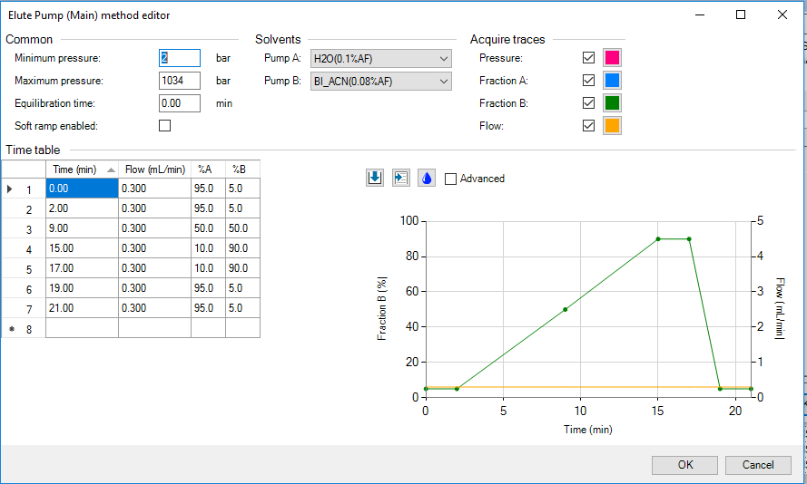
Elution gradient of Solvent B (CH₃CN + 0.1% HCOOH) of the mobile phase used in the analysis of secondary metabolites by UHPLC-Q-TOF in 21 min.

Supplementary Material 5
Zoom (Tr = 0 to 18 mins) of the chromatograms of secondary metabolites obtained by UHPLC-Q-TOF analysis for QC shoots extracts (red) and QC root extracts (purple); QC: quality control containing 5µL of all extracts per compartment; C18 column; mobile phase: H₂O + 0.4% HCOOH (Solvent A) and CH₃CN + 0.1% HCOOH (Solvent B) black square: metabolic diversity observed at the end of the chromatogram.
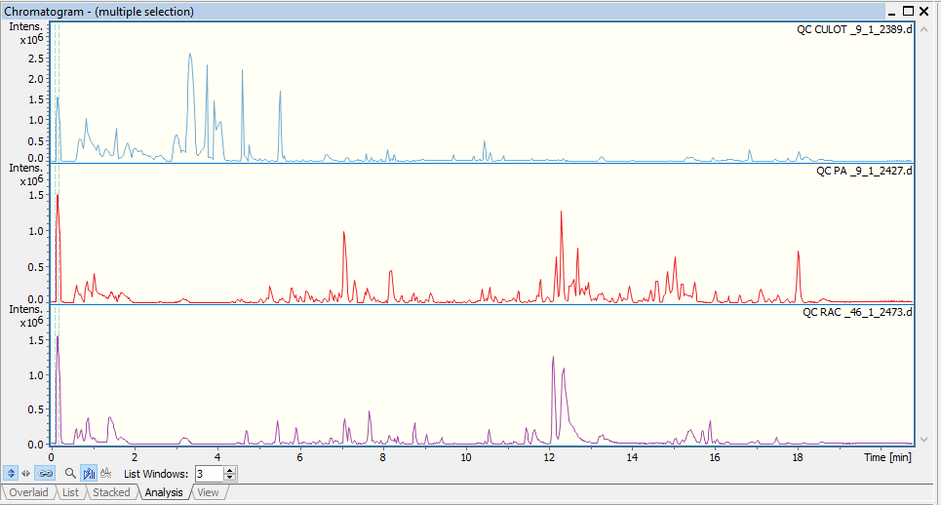

Supplementary Figure 3 : Zoom (Tr = 0 à 18 mins) des chromatogrammes des métabolites secondaires obtenus par analyse UHPLC-Q-TOF pour les extraits de QC culot ; QC : contrôle qualité contenant 5µL de tous les extraits par compartiment ; Colonne C₁₈ ; phase mobile : H₂O + 0.4% d’HCOOH (Solvant A) et CH₃CN + 0.1% d’HCOOH (Solvant B), Flèche rouge : diversité métabolique observée en début de chromatogramme.

Supplementary Material 6
Zoom (Tr = 0 to 18 mins) of the chromatograms of secondary metabolites obtained by UHPLC-Q-TOF analysis for QC Frankia extracts; QC: quality control containing 5µL of all extracts per compartment; C18 column; mobile phase: H₂O + 0.4% HCOOH (Solvent A) and CH₃CN + 0.1% HCOOH (Solvent B), Red arrow: metabolic diversity observed at the start of the chromatogram.
