Supplement Table S1. Additional covariates across six bone mass–sarcopenia strata.
Characteristic | Category | Total  (N=1786) | Normal/No  (n=312) | Normal/Yes  (n=103) | Osteopenia/No  (n=575) | Osteopenia/Yes  (n=167) | Osteoporosis/No  (n=415) | Osteoporosis/Yes  (n=214) | ASMD | P value
Lifestyle and environment (covariates in Model 3)
Diet type, n (%) |  |  |  |  |  |  |  |  | 0.319 | 0.377
 | Meat-based/animal-based | 1337 (74.9%) | 233 (74.4%) | 84 (81.6%) | 435 (75.8%) | 128 (76.6%) | 307 (74.0%) | 150 (70.1%) | — | —
 | Mixed diet | 387 (21.7%) | 65 (20.8%) | 15 (14.6%) | 118 (20.6%) | 33 (19.8%) | 97 (23.4%) | 59 (27.6%) | — | —
 | Vegetarian/mostly plant-based | 43 (2.4%) | 11 (3.5%) | 3 (2.9%) | 17 (3.0%) | 3 (1.8%) | 7 (1.7%) | 2 (0.9%) | — | —
 | Missing | 19 (1.1%) | 4 (1.3%) | 1 (1.0%) | 4 (0.7%) | 3 (1.8%) | 4 (1.0%) | 3 (1.4%) | — | —
Sleep duration, n (%) |  |  |  |  |  |  |  |  | 0.302 | 0.020
 | 4–6 h | 705 (39.5%) | 126 (40.3%) | 52 (50.5%) | 204 (35.5%) | 74 (44.3%) | 165 (39.8%) | 84 (39.3%) | — | —
 | 6–8 h | 899 (50.3%) | 166 (53.0%) | 41 (39.8%) | 309 (53.8%) | 78 (46.7%) | 203 (48.9%) | 102 (47.7%) | — | —
 | 8–10 h | 142 (8.0%) | 18 (5.8%) | 7 (6.8%) | 51 (8.9%) | 9 (5.4%) | 37 (8.9%) | 20 (9.3%) | — | —
 | ≥10 h | 30 (1.7%) | 2 (0.6%) | 1 (1.0%) | 8 (1.4%) | 3 (1.8%) | 9 (2.2%) | 7 (3.3%) | — | —
 | <4 h | 6 (0.3%) | 0 (0.0%) | 1 (1.0%) | 1 (0.2%) | 3 (1.8%) | 0 (0.0%) | 1 (0.5%) | — | —
 | Missing | 4 (0.2%) | 1 (0.3%) | 1 (1.0%) | 1 (0.2%) | 0 (0.0%) | 1 (0.2%) | 0 (0.0%) | — | —
Nocturia frequency, n (%) |  |  |  |  |  |  |  |  | 0.274 | 0.181
 | 0 times/night | 588 (32.9%) | 115 (36.7%) | 41 (39.8%) | 188 (32.8%) | 46 (27.5%) | 135 (32.5%) | 63 (29.4%) | — | —
 | 1 time/night | 967 (54.1%) | 163 (52.1%) | 53 (51.5%) | 321 (55.9%) | 89 (53.3%) | 226 (54.5%) | 115 (53.7%) | — | —
 | 2 times/night | 208 (11.6%) | 31 (9.9%) | 7 (6.8%) | 57 (9.9%) | 31 (18.6%) | 48 (11.6%) | 34 (15.9%) | — | —
 | ≥3 times/night | 20 (1.1%) | 2 (0.6%) | 2 (1.9%) | 7 (1.2%) | 1 (0.6%) | 6 (1.4%) | 2 (0.9%) | — | —
 | Missing | 3 (0.2%) | 2 (0.6%) | 0 (0.0%) | 1 (0.2%) | 0 (0.0%) | 0 (0.0%) | 0 (0.0%) | — | —
Floor level of residence, floors |  | 4 [2, 6] | 4 [2, 5] | 4 [2, 6] | 4 [2, 6] | 4 [2, 6] | 4 [2, 6] | 3 [2, 6] | 0.206 | 0.375
 | Missing | 28 (1.6%) | 5 (1.6%) | 4 (3.9%) | 4 (0.7%) | 4 (2.4%) | 5 (1.2%) | 6 (2.8%) | — | —
Elevator available at residence, n (%) |  |  |  |  |  |  |  |  | 0.242 | 0.104
 | No | 1177 (65.9%) | 211 (67.4%) | 65 (63.1%) | 394 (68.6%) | 104 (62.3%) | 270 (65.1%) | 133 (62.1%) | — | —
 | Yes | 535 (30.0%) | 90 (28.8%) | 30 (29.1%) | 166 (28.9%) | 53 (31.7%) | 130 (31.3%) | 66 (30.8%) | — | —
 | Missing | 74 (4.1%) | 12 (3.8%) | 8 (7.8%) | 14 (2.4%) | 10 (6.0%) | 15 (3.6%) | 15 (7.0%) | — | —
Stair-climbing trips per day, round-trips |  | 2 [0, 3] | 2 [0, 3] | 2 [0, 3] | 2 [0, 3] | 1 [0, 2] | 2 [0, 3] | 2 [0, 3] | 0.314 | < 0.001
Vigorous-intensity activity, min/week |  | 0 [0, 0] | 0 [0, 0] | 0 [0, 0] | 0 [0, 0] | 0 [0, 0] | 0 [0, 0] | 0 [0, 0] | 0.251 | 0.100
Moderate-intensity activity, min/week |  | 0 [0, 420] | 0 [0, 420] | 0 [0, 495] | 0 [0, 295] | 0 [0, 420] | 0 [0, 360] | 0 [0, 360] | 0.384 | < 0.001
Sitting time on a weekday, min/day |  | 120 [0, 210] | 120 [0, 240] | 120 [60, 210] | 120 [0, 210] | 120 [0, 240] | 120 [0, 190] | 120 [0, 180] | 0.200 | 0.155
Diarrhea, n (%) |  |  |  |  |  |  |  |  | 0.128 | 0.761
 | No | 1657 (92.8%) | 289 (92.3%) | 97 (94.2%) | 535 (93.2%) | 151 (90.4%) | 386 (93.0%) | 199 (93.0%) | — | —
 | Yes | 128 (7.2%) | 23 (7.3%) | 6 (5.8%) | 39 (6.8%) | 16 (9.6%) | 29 (7.0%) | 15 (7.0%) | — | —
 | Missing | 1 (0.1%) | 1 (0.3%) | 0 (0.0%) | 0 (0.0%) | 0 (0.0%) | 0 (0.0%) | 0 (0.0%) | — | —
Female-specific covariate |  |  |  |  |  |  |  |  | — | —
Menopausal status (women only), n (%) |  |  |  |  |  |  |  |  | 0.784 | < 0.001
 | Postmenopausal | 1181 (89.5%) | 136 (68.3%) | 47 (79.7%) | 373 (89.7%) | 105 (92.9%) | 345 (97.5%) | 175 (97.8%) | — | —
 | Premenopausal | 130 (9.8%) | 60 (30.2%) | 10 (16.9%) | 42 (10.1%) | 8 (7.1%) | 7 (2.0%) | 3 (1.7%) | — | —
 | Missing | 9 (0.7%) | 3 (1.5%) | 2 (3.4%) | 1 (0.2%) | 0 (0.0%) | 2 (0.6%) | 1 (0.6%) | — | —
Note: Strata were defined by cross-classification of bone mass status (normal, osteopenia, osteoporosis) and possible sarcopenia status (No/Yes). Bone mass status was categorized using lumbar spine and total hip dual-energy X-ray absorptiometry (DXA) T-scores; possible sarcopenia was defined using prespecified cut-offs (see Methods). Data are n (%) or median [interquartile range (IQR)]. Missing values are shown as a separate category where applicable. P values compare distributions across the six strata using χ² tests (categorical variables) and Kruskal–Wallis tests (continuous variables). ASMD denotes the maximum pairwise absolute standardized mean difference across the six strata (for multinomial variables, ASMD was computed as the maximum across indicator levels). Menopausal status was summarized among women only; percentages were calculated using the number of women in each stratum as the denominator. Two-sided P values are reported to three decimals (< 0.001 shown as < 0.001).
Abbreviations: ASMD, absolute standardized mean difference; DXA, dual-energy X-ray absorptiometry; IQR, interquartile range.

Supplement Table S2. Fully adjusted logistic regression for falls outcomes.
Variable | Contrast/Level | Any fall (≥1): OR  (95% CI) | P value | Recurrent falls (≥2): OR  (95% CI) | P value
Exposure group (bone mass × possible sarcopenia) | Normal/Yes vs Normal/No | 1.47 (0.79–2.71) | 0.221 | 1.34 (0.47–3.77) | 0.584
Exposure group (bone mass × possible sarcopenia) | Osteopenia/No vs Normal/No | 1.03 (0.68–1.57) | 0.889 | 1.29 (0.65–2.56) | 0.460
Exposure group (bone mass × possible sarcopenia) | Osteopenia/Yes vs Normal/No | 1.51 (0.90–2.54) | 0.119 | 1.91 (0.86–4.25) | 0.114
Exposure group (bone mass × possible sarcopenia) | Osteoporosis/No vs Normal/No | 1.38 (0.88–2.15) | 0.157 | 1.00 (0.47–2.14) | 0.994
Exposure group (bone mass × possible sarcopenia) | Osteoporosis/Yes vs Normal/No | 1.68 (1.01–2.78) | 0.045 | 1.29 (0.56–2.97) | 0.543
Sex | Female vs Male | 1.55 (1.04–2.30) | 0.030 | 1.80 (0.94–3.42) | 0.075
Age, years | Per 1-year increase | 1.02 (1.00–1.03) | 0.065 | 1.02 (0.99–1.05) | 0.276
Body mass index, kg/m² | Per 1-unit increase | 1.00 (0.98–1.02) | 0.776 | 0.98 (0.93–1.03) | 0.398
Education | Primary school vs Illiterate | 1.01 (0.48–2.10) | 0.984 | 0.72 (0.25–2.06) | 0.539
Education | Junior high school vs Illiterate | 0.92 (0.45–1.86) | 0.808 | 0.75 (0.28–2.00) | 0.560
Education | High school/technical/vocational vs Illiterate | 0.82 (0.40–1.68) | 0.592 | 0.62 (0.23–1.71) | 0.354
Education | Junior college vs Illiterate | 0.46 (0.20–1.06) | 0.068 | 0.34 (0.10–1.20) | 0.094
Education | Bachelor’s degree or above vs Illiterate | 1.10 (0.45–2.66) | 0.832 | 0.86 (0.24–3.06) | 0.810
Monthly household income | 1,000–3,000 vs ≤1,000 | 1.35 (0.86–2.14) | 0.195 | 1.34 (0.64–2.80) | 0.437
Monthly household income | 3,000–5,000 vs ≤1,000 | 1.50 (0.93–2.43) | 0.094 | 1.94 (0.91–4.12) | 0.086
Monthly household income | 5,000–8,000 vs ≤1,000 | 1.08 (0.64–1.84) | 0.773 | 0.74 (0.29–1.87) | 0.526
Monthly household income | ≥8,000 vs ≤1,000 | 0.93 (0.46–1.85) | 0.826 | 1.45 (0.51–4.14) | 0.484
Smoking status | Current vs Never | 0.86 (0.54–1.39) | 0.547 | 1.06 (0.52–2.18) | 0.868
Smoking status | Passive vs Never | 1.10 (0.45–2.65) | 0.838 | 0.83 (0.18–3.80) | 0.810
Smoking status | Former vs Never | 1.75 (0.77–3.95) | 0.180 | 0.50 (0.06–3.98) | 0.514
Alcohol drinking | Current vs Never | 0.84 (0.51–1.38) | 0.487 | 1.05 (0.48–2.28) | 0.908
Alcohol drinking | Former vs Never | 0.30 (0.07–1.32) | 0.111 | 0.69 (0.09–5.53) | 0.727
Diet type | Meat-based vs Mixed | 0.54 (0.18–1.57) | 0.255 | NE | 0.999
Diet type | Vegetarian/mostly plant-based vs Mixed | 0.95 (0.70–1.29) | 0.754 | 0.98 (0.61–1.57) | 0.932
History of chronic disease(s) | Yes vs No | 0.84 (0.64–1.10) | 0.204 | 0.67 (0.44–1.03) | 0.068
Long-term glucocorticoid use | Yes vs No | 1.99 (0.83–4.74) | 0.120 | 1.77 (0.53–5.98) | 0.355
Rheumatoid arthritis | Yes vs No | 1.32 (0.88–2.00) | 0.180 | 1.57 (0.87–2.84) | 0.135
Diarrhea | Yes vs No | 1.36 (0.86–2.16) | 0.191 | 2.03 (1.10–3.72) | 0.023
Elevator available at residence | Missing vs No | NE | 0.999 | NE | 1.000
Elevator available at residence | Yes vs No | 0.96 (0.66–1.39) | 0.833 | 0.77 (0.42–1.42) | 0.405
Height loss > 3 cm | Yes vs No | 0.98 (0.72–1.34) | 0.913 | 1.11 (0.70–1.78) | 0.654
Fatigue/joint pain affecting daily life | Yes vs No | 1.10 (0.80–1.52) | 0.563 | 1.20 (0.73–1.96) | 0.466
Parental history of fragility fracture | Yes vs No | 1.12 (0.75–1.67) | 0.592 | 1.42 (0.79–2.54) | 0.240
Minor-trauma hip fracture history | Yes vs No | 0.99 (0.47–2.08) | 0.973 | 0.35 (0.08–1.59) | 0.174
Sleep duration (ordinal) | Per 1-category increase | 1.08 (0.90–1.30) | 0.416 | 1.17 (0.88–1.54) | 0.279
Nocturia frequency (ordinal) | Per 1-category increase | 1.22 (1.01–1.48) | 0.043 | 1.55 (1.16–2.07) | 0.003
Floor level of residence | Per 1-floor increase | 0.99 (0.95–1.02) | 0.499 | 1.02 (0.96–1.08) | 0.441
Stair-climbing trips/day | Per 1 round-trip increase | 0.94 (0.84–1.06) | 0.337 | 1.05 (0.87–1.27) | 0.598
Vigorous-intensity activity | Per 60 min/week increase | 1.04 (1.02–1.07) | <0.001 | 1.02 (0.98–1.05) | 0.242
Moderate-intensity activity | Per 60 min/week increase | 1.01 (0.99–1.02) | 0.415 | 1.01 (0.99–1.04) | 0.380
Sitting time on a weekday | Per 60 min/day increase | 1.04 (0.99–1.09) | 0.182 | 1.04 (0.97–1.12) | 0.276
Note: Odds ratios (ORs) and 95% confidence intervals (CIs) are from the fully adjusted logistic regression model (Model 3). The exposure strata were defined by cross-classification of bone mass status (normal, osteopenia, osteoporosis) and possible sarcopenia status (No/Yes); the reference exposure category was Normal/No. Reference categories for covariates are shown in the “Contrast/Level” column (e.g., Never for smoking; Never for alcohol; Mixed for diet; No for elevator). Activity variables were scaled per 60 min/week, and sitting time per 60 min/day. NE indicates non-estimable/unstable estimates due to sparse data or (quasi-)complete separation (e.g., zero events in a category or missing-category indicators). Two-sided P values are reported to three decimals (< 0.001 shown as < 0.001).
Abbreviations: CI, confidence interval; NE, not estimable; OR, odds ratio.
Supplement Table S3. Stepwise-adjusted mean differences in lumbar spine and total hip DXA T-scores across bone mass × possible sarcopenia strata.
Stratum | Model 1: β  (95% CI) | P value | Model 2: β  (95% CI) | P value | Model 3: β  (95% CI) | P value
Panel A. Lumbar spine T-score (N=1785)
Normal/No | 0.00 (ref) | — | 0.00 (ref) | — | 0.00 (ref) | —
Normal/Yes | 0.13 (95% CI, -0.07–0.33) | 0.192 | 0.14 (95% CI, -0.05–0.34) | 0.149 | 0.15 (95% CI, -0.05–0.34) | 0.148
Osteopenia/No | -1.58 (95% CI, -1.70–-1.46) | < 0.001 | -1.58 (95% CI, -1.70–-1.45) | < 0.001 | -1.56 (95% CI, -1.69–-1.44) | < 0.001
Osteopenia/Yes | -1.47 (95% CI, -1.64–-1.30) | < 0.001 | -1.45 (95% CI, -1.62–-1.28) | < 0.001 | -1.45 (95% CI, -1.62–-1.28) | < 0.001
Osteoporosis/No | -2.93 (95% CI, -3.06–-2.79) | < 0.001 | -2.89 (95% CI, -3.03–-2.76) | < 0.001 | -2.88 (95% CI, -3.01–-2.74) | < 0.001
Osteoporosis/Yes | -2.82 (95% CI, -2.99–-2.66) | < 0.001 | -2.75 (95% CI, -2.91–-2.58) | < 0.001 | -2.75 (95% CI, -2.92–-2.58) | < 0.001
Panel B. Total hip T-score (N=1784)
Normal/No | 0.00 (ref) | — | 0.00 (ref) | — | 0.00 (ref) | —
Normal/Yes | 0.03 (95% CI, -0.13–0.20) | 0.683 | 0.05 (95% CI, -0.11–0.22) | 0.537 | 0.08 (95% CI, -0.08–0.25) | 0.327
Osteopenia/No | -1.09 (95% CI, -1.19–-0.98) | < 0.001 | -1.07 (95% CI, -1.17–-0.97) | < 0.001 | -1.08 (95% CI, -1.18–-0.98) | < 0.001
Osteopenia/Yes | -1.16 (95% CI, -1.30–-1.02) | < 0.001 | -1.11 (95% CI, -1.25–-0.97) | < 0.001 | -1.10 (95% CI, -1.24–-0.96) | < 0.001
Osteoporosis/No | -2.04 (95% CI, -2.16–-1.93) | < 0.001 | -2.00 (95% CI, -2.11–-1.89) | < 0.001 | -2.00 (95% CI, -2.11–-1.88) | < 0.001
Osteoporosis/Yes | -2.38 (95% CI, -2.51–-2.24) | < 0.001 | -2.30 (95% CI, -2.44–-2.16) | < 0.001 | -2.28 (95% CI, -2.42–-2.14) | < 0.001
Notes: Strata were defined by cross-classification of bone mass status (normal, osteopenia, osteoporosis) and possible sarcopenia status (No/Yes). β denotes the adjusted mean difference in T-score relative to the reference stratum (Normal/No), estimated using generalized linear models with an identity link. Model 1 adjusted for age and sex. Model 2 additionally adjusted for prespecified sociodemographic factors and lifestyle variables. Model 3 further incorporated additional prespecified covariate domains, including chronic disease history, supplement use, environmental exposures, sleep patterns/nocturia, physical activity, sedentary behavior, and general health status (full covariate list shown in Supplementary Table S2). Sample size differs across panels due to site-specific missingness. P values are two-sided and reported to three decimals (< 0.001 shown as < 0.001).
Abbreviations: CI, confidence interval; DXA, dual-energy X-ray absorptiometry; ref, reference.
Supplement Table S4. Fracture sites and triggers by bone mass × possible sarcopenia strata.
Section | Category | N/N  (n=40) | N/Y  (n=16) | OPN/N  (n=104) | OPN/Y  (n=30) | OPS/N  (n=89) | OPS/Y  (n=48)
Site | Spine | 2/40 (5.0%) | 0/16 (0.0%) | 8/104 (7.7%) | 6/30 (20.0%) | 8/89 (9.0%) | 8/48 (16.7%)
Site | Hip | 0/40 (0.0%) | 0/16 (0.0%) | 4/104 (3.8%) | 2/30 (6.7%) | 3/89 (3.4%) | 4/48 (8.3%)
Site | Clavicle | 1/40 (2.5%) | 1/16 (6.2%) | 7/104 (6.7%) | 1/30 (3.3%) | 2/89 (2.2%) | 1/48 (2.1%)
Site | Rib | 2/40 (5.0%) | 0/16 (0.0%) | 8/104 (7.7%) | 2/30 (6.7%) | 4/89 (4.5%) | 8/48 (16.7%)
Site | Limb (specified) | 33/40 (82.5%) | 13/16 (81.2%) | 69/104 (66.3%) | 18/30 (60.0%) | 58/89 (65.2%) | 24/48 (50.0%)
Site | Other/unspecified | 2/40 (5.0%) | 2/16 (12.5%) | 8/104 (7.7%) | 1/30 (3.3%) | 14/89 (15.7%) | 3/48 (6.2%)
Trigger | Traffic accident | 5/40 (12.5%) | 4/16 (25.0%) | 20/104 (19.2%) | 3/30 (10.0%) | 13/89 (14.6%) | 10/48 (20.8%)
Trigger | Fall | 23/40 (57.5%) | 9/16 (56.2%) | 65/104 (62.5%) | 19/30 (63.3%) | 60/89 (67.4%) | 30/48 (62.5%)
Trigger | Other | 12/40 (30.0%) | 3/16 (18.8%) | 17/104 (16.3%) | 7/30 (23.3%) | 14/89 (15.7%) | 6/48 (12.5%)
Trigger | Other/unspecified | 0/40 (0.0%) | 0/16 (0.0%) | 2/104 (1.9%) | 1/30 (3.3%) | 2/89 (2.2%) | 2/48 (4.2%)
Notes: This table summarizes the full breakdown of fracture sites and triggers among participants with prior fracture history (total n = 327). Values are shown as n/N (%), where N is the number of fracture cases within each stratum. Column abbreviations: N/N, normal bone mass and no possible sarcopenia; N/Y, normal and possible sarcopenia; OPN/N, osteopenia and no possible sarcopenia; OPN/Y, osteopenia and possible sarcopenia; OPS/N, osteoporosis and no possible sarcopenia; OPS/Y, osteoporosis and possible sarcopenia. “Other/unspecified” indicates missing or non-specific self-reported responses. Overall χ² P across six strata: site 0.063; trigger 0.766. Within-category χ² P (Yes vs No): Normal 0.566/0.437; Osteopenia 0.407/0.572; Osteoporosis 0.037/0.694 (site/trigger).
Abbreviations: DXA, dual-energy X-ray absorptiometry.
Supplement Table S5. Model 3–adjusted bone metabolism biomarkers across cross-classified bone mass × possible sarcopenia strata.
Biomarker | N/N | N/Y | OPN/N | OPN/Y | OPS/N | OPS/Y | P_trend | P_int
Bone turnover markers
β-CTx | 0.19 (0.18–0.20) | 0.18 (0.17–0.20) | 0.21 (0.20–0.22) | 0.22 (0.20–0.23) | 0.25 (0.24–0.26) | 0.23 (0.22–0.25) | <0.001 | 0.301
PINP | 39.57 (37.99–41.39) | 39.61 (36.98–42.73) | 45.64 (44.33–47.17) | 47.06 (44.47–49.73) | 54.25 (52.17–56.24) | 53.58 (50.78–56.29) | <0.001 | 0.602
Osteocalcin | 11.61 (11.17–12.12) | 10.85 (10.16–11.66) | 12.99 (12.63–13.40) | 12.98 (12.30–13.68) | 15.25 (14.69–15.78) | 13.91 (13.22–14.58) | <0.001 | 0.079
ALP | 72.61 (70.51–74.99) | 72.31 (68.82–76.36) | 76.38 (74.73–78.23) | 76.78 (73.75–79.88) | 82.68 (80.35–84.85) | 80.27 (77.22–83.17) | <0.001 | 0.516
Endocrine and renal markers
PTH | 2.70 (2.57–2.84) | 2.40 (2.21–2.62) | 2.64 (2.55–2.74) | 2.54 (2.37–2.71) | 2.70 (2.58–2.82) | 2.56 (2.40–2.71) | 0.849 | 0.397
Creatinine | 69.87 (68.56–71.41) | 70.47 (68.21–72.97) | 69.15 (68.09–70.25) | 68.35 (66.53–70.17) | 66.62 (65.32–67.77) | 66.19 (64.49–67.76) | <0.001 | 0.695
Mineral markers
Calcium | 2.34 (2.33–2.36) | 2.34 (2.32–2.36) | 2.34 (2.34–2.35) | 2.36 (2.34–2.37) | 2.34 (2.33–2.35) | 2.35 (2.33–2.36) | 0.509 | 0.650
Phosphorus | 1.24 (1.19–1.28) | 1.30 (1.23–1.39) | 1.27 (1.24–1.31) | 1.26 (1.20–1.32) | 1.27 (1.23–1.31) | 1.29 (1.24–1.35) | 0.292 | 0.340
Magnesium | 0.99 (0.98–1.00) | 1.00 (0.99–1.02) | 1.00 (0.99–1.01) | 1.01 (0.99–1.02) | 1.00 (0.99–1.01) | 1.00 (0.98–1.01) | 0.377 | 0.248
Vitamin D fractions
25(OH)D2 | 1.19 (1.10–1.29) | 1.18 (1.04–1.37) | 1.17 (1.11–1.25) | 1.16 (1.04–1.30) | 1.11 (1.03–1.19) | 1.08 (0.97–1.18) | 0.091 | 0.935
25(OH)D3 | 15.04 (14.38–15.81) | 14.18 (13.13–15.42) | 14.84 (14.37–15.39) | 15.17 (14.25–16.13) | 14.53 (13.92–15.12) | 13.88 (13.08–14.67) | 0.113 | 0.246
Total 25(OH)D | 16.13 (15.42–16.94) | 15.16 (14.06–16.47) | 15.98 (15.48–16.57) | 16.26 (15.28–17.27) | 15.52 (14.87–16.14) | 14.68 (13.84–15.49) | 0.050 | 0.219
Note: Strata were defined by cross-classification of bone mass status (normal, osteopenia, osteoporosis) and possible sarcopenia (No/Yes). Bone mass status was categorized using lumbar spine and left-hip dual-energy X-ray absorptiometry (DXA) T-scores; possible sarcopenia was defined dichotomously using prespecified cut-offs (see Methods). Values are Model 3–adjusted geometric means with 95% confidence intervals (95% CI) for biomarkers analyzed on the log scale (β-CTx, PINP, osteocalcin, ALP, PTH, creatinine, 25(OH)D2, 25(OH)D3, total 25(OH)D), back-transformed to the original scale; and Model 3–adjusted means with 95% CI for approximately normally distributed mineral markers (calcium, phosphorus, magnesium). P_trend was obtained by testing an ordinal trend across the six strata ordered from lowest to highest hypothesized risk gradient. P_int is the interaction p-value for bone mass status × possible sarcopenia in Model 3. P values are two-sided; values < 0.001 are reported as <0.001.
Abbreviations: ALP, alkaline phosphatase; β-CTx, beta C-terminal telopeptide of type I collagen; CI, confidence interval; Cr, creatinine; DXA, dual-energy X-ray absorptiometry; GM, geometric mean; Mg, magnesium; P, phosphorus; PINP, procollagen type I N-terminal propeptide; PTH, parathyroid hormone; 25(OH)D2, 25-hydroxyvitamin D2; 25(OH)D3, 25-hydroxyvitamin D3; total 25(OH)D, total 25-hydroxyvitamin D. N/N = Normal/No, N/Y = Normal/Yes, OPN/N = Osteopenia/No, OPN/Y = Osteopenia/Yes, OPS/N = Osteoporosis/No, OPS/Y = Osteoporosis/Yes。
Supplement Table S6. Sensitivity analyses under alternative definitions and sample restrictions.
Scenario | Outcome | Effect measure | Estimate  (lower–upper) | P value | N
Main analysis | Falls ≥1 | Odds ratio | 1.66 (1.00–2.76) | 0.045 | 1786
Main analysis | Falls ≥2 | Odds ratio | 1.35 (0.58–3.11) | 0.487 | 1786
Main analysis | Prior fracture | Odds ratio | 1.59 (0.93–2.73) | 0.089 | 1786
Main analysis | Lumbar T-score | Mean difference | −2.75 (−2.92–−2.59) | < 0.001 | 1786
Main analysis | Hip T-score | Mean difference | −2.55 (−2.68–−2.42) | < 0.001 | 1786
Bone status: lumbar only | Falls ≥1 | Odds ratio | 1.52 (0.92–2.51) | 0.103 | 1786
Bone status: lumbar only | Falls ≥2 | Odds ratio | 1.14 (0.50–2.58) | 0.758 | 1786
Bone status: lumbar only | Prior fracture | Odds ratio | 1.45 (0.85–2.49) | 0.179 | 1786
Bone status: lumbar only | Lumbar T-score | Mean difference | −2.93 (−3.10–−2.76) | <0.001 | 1786
Bone status: lumbar only | Hip T-score | Mean difference | −1.53 (−1.66–−1.40) | < 0.001 | 1786
Bone status: hip only | Falls ≥1 | Odds ratio | 1.72 (1.05–2.80) | 0.032 | 1786
Bone status: hip only | Falls ≥2 | Odds ratio | 1.37 (0.59–3.15) | 0.461 | 1786
Bone status: hip only | Prior fracture | Odds ratio | 1.72 (1.01–2.92) | 0.045 | 1786
Bone status: hip only | Lumbar T-score | Mean difference | −1.54 (−1.72–−1.36) | < 0.001 | 1786
Bone status: hip only | Hip T-score | Mean difference | −2.81 (−2.94–−2.69) | < 0.001 | 1786
Possible sarcopenia: grip only | Falls ≥1 | Odds ratio | 1.61 (0.98–2.64) | 0.059 | 1786
Possible sarcopenia: grip only | Falls ≥2 | Odds ratio | 1.28 (0.55–2.97) | 0.559 | 1786
Possible sarcopenia: grip only | Prior fracture | Odds ratio | 1.65 (0.97–2.83) | 0.066 | 1786
Possible sarcopenia: grip only | Lumbar T-score | Mean difference | −2.78 (−2.95–−2.62) | < 0.001 | 1786
Possible sarcopenia: grip only | Hip T-score | Mean difference | −2.60 (−2.73–−2.47) | < 0.001 | 1786
Possible sarcopenia: chair-stand only | Falls ≥1 | Odds ratio | 1.58 (0.97–2.58) | 0.064 | 1786
Possible sarcopenia: chair-stand only | Falls ≥2 | Odds ratio | 1.31 (0.57–3.02) | 0.523 | 1786
Possible sarcopenia: chair-stand only | Prior fracture | Odds ratio | 1.55 (0.90–2.67) | 0.113 | 1786
Possible sarcopenia: chair-stand only | Lumbar T-score | Mean difference | −2.71 (−2.87–−2.54) | <0.001 | 1786
Possible sarcopenia: chair-stand only | Hip T-score | Mean difference | −2.58 (−2.71–−2.45) | <0.001 | 1786
Complete-case (bone+grip+chair) | Falls ≥1 | Odds ratio | 1.64 (0.98–2.75) | 0.061 | 1669
Complete-case (bone+grip+chair) | Falls ≥2 | Odds ratio | 1.34 (0.55–3.27) | 0.514 | 1669
Complete-case (bone+grip+chair) | Prior fracture | Odds ratio | 1.53 (0.86–2.71) | 0.152 | 1669
Complete-case (bone+grip+chair) | Lumbar T-score | Mean difference | −2.75 (−2.91–−2.58) | < 0.001 | 1669
Complete-case (bone+grip+chair) | Hip T-score | Mean difference | −2.55 (−2.68–−2.42) | < 0.001 | 1669
Exclude prior hip fracture | Falls ≥1 | Odds ratio | 1.66 (0.99–2.78) | 0.052 | 1741
Exclude prior hip fracture | Falls ≥2 | Odds ratio | 1.43 (0.60–3.39) | 0.419 | 1741
Exclude prior hip fracture | Prior fracture | Odds ratio | 1.32 (0.75–2.33) | 0.338 | 1741
Exclude prior hip fracture | Lumbar T-score | Mean difference | −2.75 (−2.92–−2.59) | < 0.001 | 1741
Exclude prior hip fracture | Hip T-score | Mean difference | −2.55 (−2.69–−2.42) | < 0.001 | 1741
Exclude long-term glucocorticoids | Falls ≥1 | Odds ratio | 1.67 (1.00–2.80) | 0.051 | 1758
Exclude long-term glucocorticoids | Falls ≥2 | Odds ratio | 1.37 (0.59–3.19) | 0.466 | 1758
Exclude long-term glucocorticoids | Prior fracture | Odds ratio | 1.59 (0.92–2.75) | 0.096 | 1758
Exclude long-term glucocorticoids | Lumbar T-score | Mean difference | −2.74 (−2.91–−2.58) | < 0.001 | 1758
Exclude long-term glucocorticoids | Hip T-score | Mean difference | −2.55 (−2.69–−2.42) | < 0.001 | 1758
Note: Values in parentheses indicate 95% confidence intervals. Estimates compare Osteoporosis/Yes with the reference stratum Normal/No. Binary outcomes are reported as odds ratios from logistic regression; continuous outcomes are adjusted mean differences (β) from generalized linear models with an identity link. All estimates are from the fully adjusted model (Model 3) using the covariate set specified in the Methods. Sensitivity scenarios redefine bone mass status (lumbar-only or hip-only DXA T-scores), redefine possible sarcopenia (grip-only or chair-stand-only), restrict to complete-case participants with non-missing bone and muscle measures, exclude participants with prior hip fracture, or exclude long-term glucocorticoid users. N denotes the number of participants included in each model. P values are two-sided and reported to three decimals (< 0.001 shown as < 0.001).
Abbreviations: CI, confidence interval; dual-energy X-ray absorptiometry (DXA); OR, odds ratio.
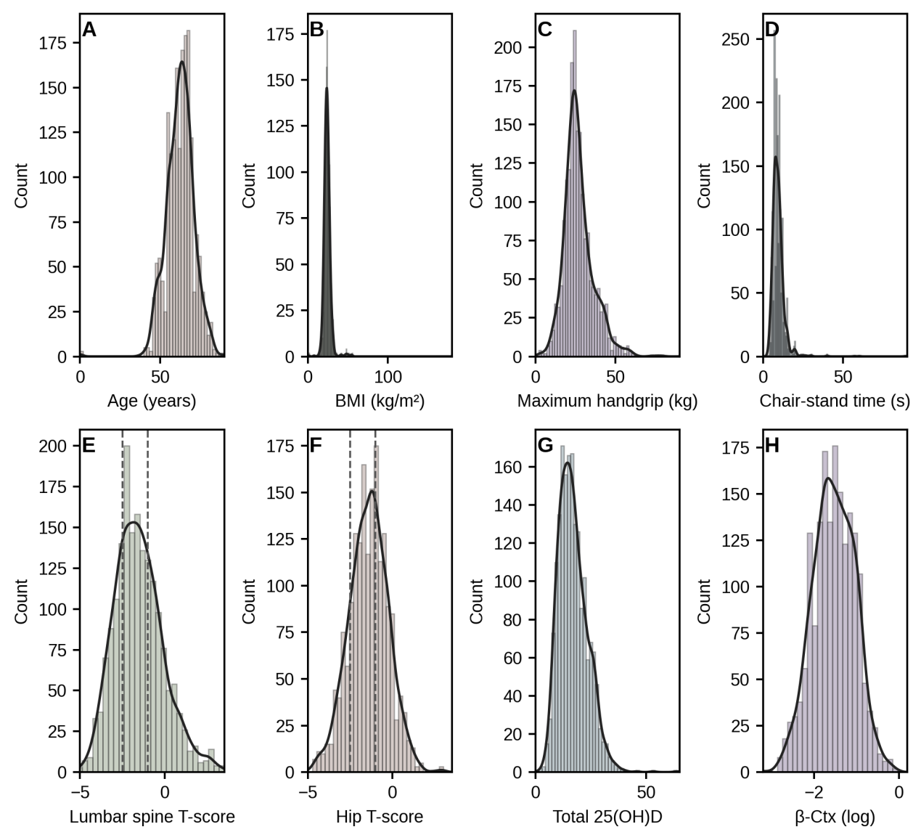

Supplement Figure S1. Distributions and tail checks for key continuous variables.
Legend: Multi-panel histograms (with kernel density overlays) summarize the distributions of key continuous measures in the analytic cohort, supporting extreme-value inspection and prespecified transformation choices for subsequent models. Panels include age, BMI, maximum handgrip strength, chair-stand time, lumbar spine and hip T-scores (with dashed lines marking −1.0 and −2.5 clinical cut-points used for bone-mass categorization), total 25(OH)D, and β-CTx displayed on the log scale.
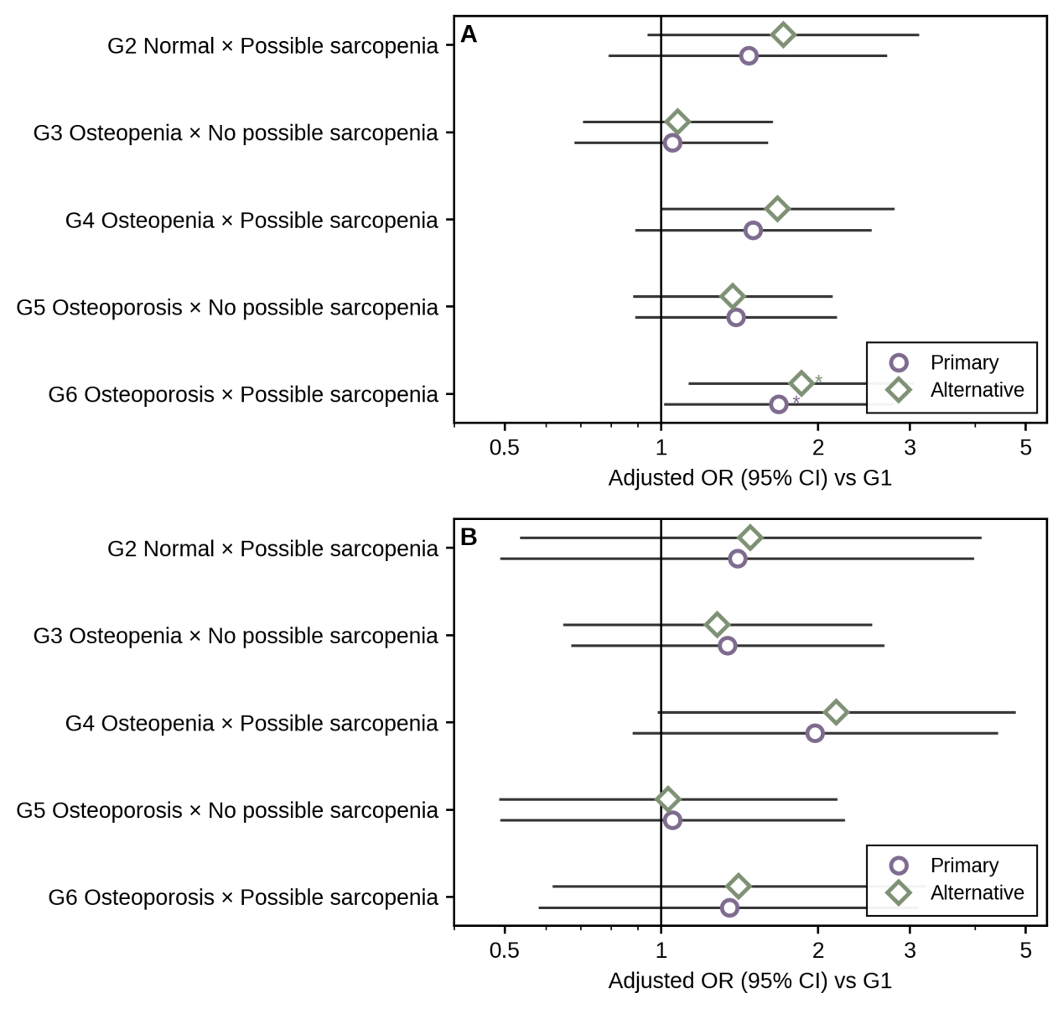

Supplement Figure S2. Sensitivity to missingness handling rules.
Legend: Fully adjusted (Model 3) associations between cross-classified strata (G2–G6) and past-year falls are shown as adjusted odds ratios (ORs) with 95% confidence intervals, using G1 as the reference. Two missingness-handling strategies are contrasted: Primary, using prespecified deterministic recoding rules for blanks to preserve the main analytic definition; and Alternative, using a missing-level/indicator approach. Panel A: falls ≥1 (primary outcome). Panel B: falls ≥2 (secondary outcome). Asterisks denote statistical significance for OR vs 1 (* p<0.05; ** p<0.01; *** p<0.001); all tests are two-sided.
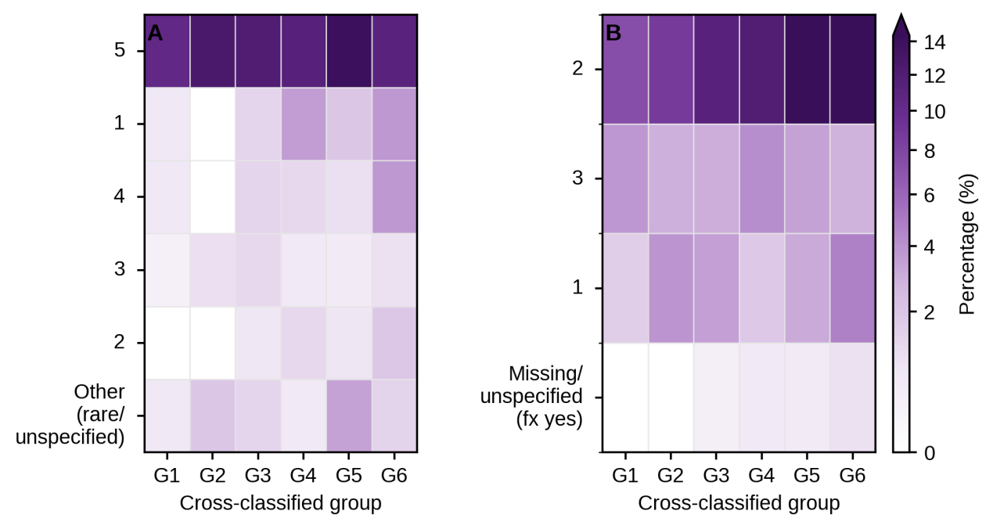
Supplement Figure S3 Expanded heatmaps of fragility fracture site and trigger distributions by cross-classified group (G1–G6).
Legend: Heatmaps display category-level profiles corresponding to the main-text “Top categories + Other” presentation, while retaining the expanded set of categories. Values represent within-stratum percentages among participants reporting a prior fragility fracture, allowing comparison of profile composition across groups without conflating composition with overall fracture prevalence. Darker shading indicates higher percentages. (A) Fracture sites. (B) Fracture triggers (including other/unknown categories where applicable).
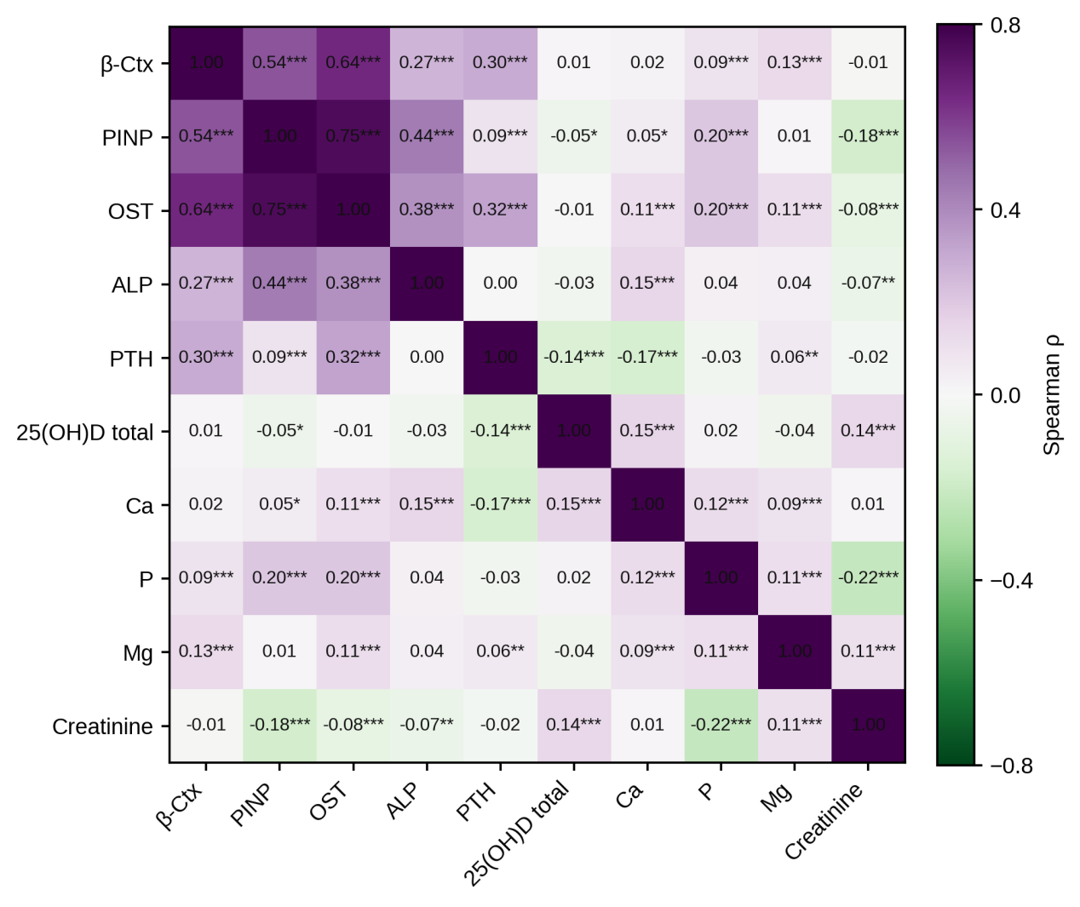

Supplement Figure S4. Correlation structure among biomarkers.
Legend: Spearman correlation matrix among bone turnover, endocrine, mineral homeostasis, vitamin D fractions, and renal background markers. Correlations are computed on the analysis scale used in modeling (log-transformed where appropriate), and cells display Spearman’s ρ. The heatmap is intended to document internal consistency of the biomarker “spectrum” as supportive evidence rather than to imply mechanistic causality.
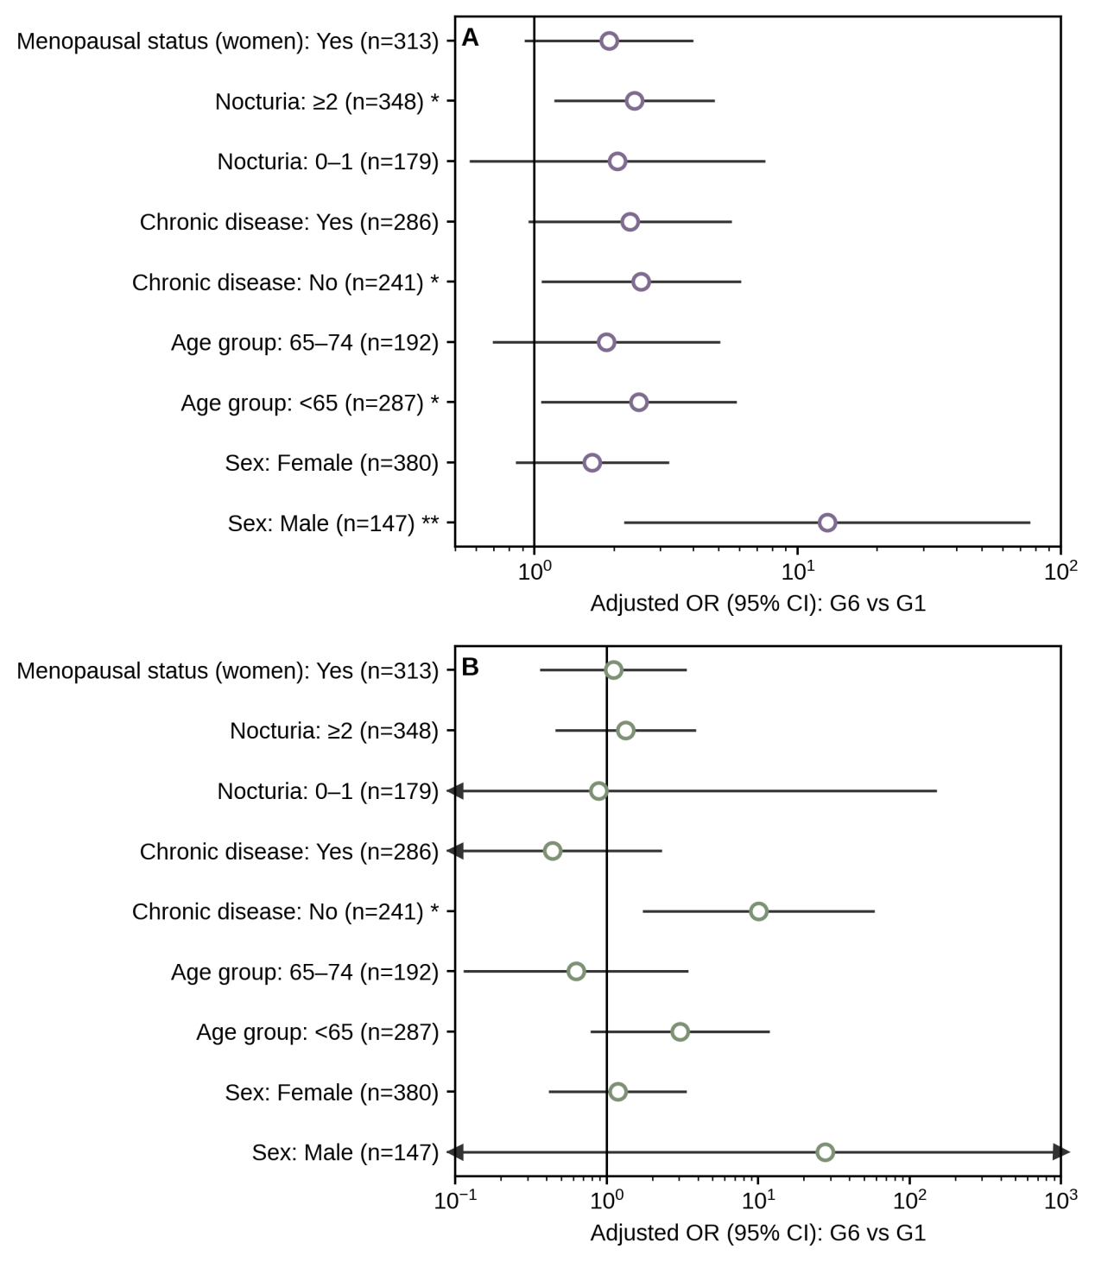

Supplementary Figure S5. Subgroup forest plots for the highest-risk contrast (G6 vs G1).

Legend: Subgroup analyses evaluate the fully adjusted (Model 3) association for the highest-risk contrast (G6 vs G1). Points and horizontal bars represent adjusted ORs and 95% confidence intervals within each subgroup stratum. Panel A: falls ≥1. Panel B: falls ≥2. Asterisks appended to subgroup labels denote statistical significance for OR vs 1 (* p<0.05; ** p<0.01; *** p<0.001); all tests are two-sided.

