Supplementary materials
Supplementary Methods
Clinical trial design and participants
Inclusion criteria for NMOSD participants comprised: (1) age ≥18 years; (2) definitive NMOSD diagnosis per established diagnostic criteria; and (3) experience of acute attacks without recent high-dose steroid immunotherapy, intravenous immunoglobulin, or plasma exchange therapy. Exclusion criteria included comorbid autoimmune diseases, central nervous system infections, stroke, epilepsy, malignancies, hematologic disorders, or pregnancy/lactation in women of childbearing age. For APS-attacked NMOSD patients, additional requirements were: (1) presence of intractable nausea, vomiting, or hiccups during acute episodes; and (2) a Revised NMOSD PUQE scale score ≥1. RRMS participants met the 2017 McDonald revised diagnostic criteria for MS and disease subtype classification, with no immunomodulatory therapy administered within the preceding 6 months (1).

Organizational processing
mouse in each group were euthanized by intraperitoneal anesthesia with sodium pentobarbital at the peak of clinical signs. Peripheral blood samples were collected from the orbital region of EAE mouse and serum was separated by centrifugation. After cardiac perfusion with ice-cold PBS, brain tissue, spinal cord tissue, and distal small intestine tissue were collected and paraffin-embedded. Brain tissues were taken from the striatum, hippocampus, and brainstem levels and cut into 8-μm thick sections.

Lactate measurement
To measure the lactate level in the CSF of the subjects. According to the manufacturer's instructions (ab65331, abcam), mix 50 μL CSF sample with the reaction mixture in a 1:1 ratio. In order to measure the lactate level in the AP area of the mouse brainstem, 10mg of fresh mouse brainstem AP tissue was lysed on ice to obtain tissue homogenate. Centrifuge at 12000rpm for 5 min at 4 ℃ to remove any insoluble substances, and remove endogenous lactate dehydrogenase (LDH) according to the manufacturer's instructions (ab204708, abcam). Prepare the reactants as described above and incubate at room temperature for 30 min. All results were measured on an OD 450 nm Microplate reader.

TEM detection of mitochondria in AP neurons
As described earlier, 1mm³ sized brainstem AP tissue was selected and fixed in electron microscopy fixative, dehydrated in alcohol and acetone, and paraffin sections with a thickness of 60nm were cut and scooped with a 150 mesh copper mesh. Copper mesh was stained in a 2% uranyl acetate saturated alcohol solution in the dark for 8 minutes, and in a 2.6% lead citrate solution in the dark for 8 min. Images were collected under a transmission electron microscope.

Determination of ATP levels
Evaluate the level of adenosine triphosphate (ATP) in brainstem AP tissue using the ATP detection kit (Beyotime, China). 10mg fresh brainstem AP tissue was lysed with 100 µL RIPA lysis buffer and centrifuged at 12000rpm for 5 min at 4℃ to obtain tissue homogenate. According to the manufacturer's regulations, use a luminometer to detect ATP levels within the organization. Calculate the ATP content within a unit organization based on the ATP standard curve.

Mitochondrial staining with MitoTracker
Mitochondrial staining was performed using MitoTracker Deep Red FM (MCE, Cat# HY-D1783). Briefly, prior to staining, the culture medium was replaced with pre-warmed (37°C) serum-free medium containing the probe at a working concentration of 100–200 nM. Cells were incubated for 30 min under standard culture conditions (37°C, 5% CO₂) protected from light. After incubation, cells were washed twice with phosphate-buffered saline (PBS), fixed with 4% paraformaldehyde for 15 min at room temperature, and counterstained with DAPI (1 μg/mL, 5 min) for nuclear visualization. Fluorescence images were acquired using an inverted fluorescence microscope.

ROS Detection by DCFH-DA Staining
To assess intracellular ROS levels, SH-SY5Y cells were seeded in 24-well plates at a density of 2×10⁵ cells/well and allowed to adhere overnight. Following the designated treatments, cells were incubated with 10 µM 2',7'-dichlorodihydrofluorescein diacetate (DCFH-DA) in serum-free medium at 37°C for 30 min in the dark. The non-fluorescent DCFH-DA probe is cleaved by intracellular esterases and oxidized by ROS to form the fluorescent compound 2',7'-dichlorofluorescein (DCF). After incubation, cells were washed twice with PBS to remove excess dye. Fluorescence intensity from microscopic images was quantified using ImageJ software by measuring the mean pixel intensity in 5 random fields per well. Statistical analysis was conducted using GraphPad Prism.

Assessment of mitochondrial membrane potential using JC-1 staining
SH-SY5Y cells were plated at a density of 2×10⁵ cells/cm² on poly-L-lysine-coated coverslips and maintained for 24 hours under standard culture conditions (37°C, 5% CO₂). Following experimental treatments, cells were incubated with 2 μM JC-1 (Thermo Fisher Scientific, Cat# T3168) in serum-free medium at 37°C for 30 minutes in the dark. After incubation, cells were washed twice with PBS. Fluorescence imaging was performed using a ZEISS LSM 880 confocal laser scanning microscope with dual-channel detection: the monomeric form was detected at 485 nm excitation/530 nm emission (green fluorescence), while J-aggregates were measured at 535 nm excitation/590 nm emission (red fluorescence). Quantitative analysis was conducted using ImageJ software (NIH) by calculating the ratio of red-to-green fluorescence intensity.

Mitochondria complex I and III activities in SH-SY5Y Cells
SH-SY5Y cells were harvested at 80-90% confluence by trypsinization and washed twice with ice-cold PBS. Mitochondria were isolated using a Mitochondrial Isolation Kit (Abcam, ab110168) according to the manufacturer's protocol. Briefly, cells were homogenized in mitochondrial isolation buffer containing protease inhibitors and centrifuged at 600 × g for 10 min at 4°C to remove nuclei and unbroken cells. The supernatant was further centrifuged at 11,000 × g for 15 min at 4°C to pellet mitochondria. The mitochondrial fraction was resuspended in mitochondrial assay buffer (MAS), and protein concentration was determined using the BCA assay.
For Complex I (NADH:ubiquinone oxidoreductase) activity assay, 20 μg of mitochondrial protein was added to MAS buffer containing 25 mM KH₂PO₄ (pH 7.4), 5 mM MgCl₂, 2 mM KCN, 2.5 mg/mL fatty acid-free BSA, and 0.13 mM NADH. The reaction was initiated by adding 100 μM decylubiquinone (DUB), and the decrease in absorbance at 340 nm was recorded for 3 min at 30°C. Rotenone (2 μM) was added to confirm Complex I-specific activity.
Complex III (ubiquinol:cytochrome c reductase) activity was determined by monitoring cytochrome c reduction at 550 nm (ε = 19.1 mM⁻¹cm⁻¹) using 50 μM decylubiquinol (DBH₂) as substrate. Mitochondria (20 μg) were incubated in MAS buffer containing 50 μM oxidized cytochrome c, 1 mM KCN, and 0.1% Tween-20. The reaction was initiated by adding DBH₂, and the absorbance increase was recorded for 3 min. Antimycin A (2 μM) was used to inhibit Complex III for background correction. All absorbance data were analyzed using GraphPad Prism 10.2.1 software.

HE staining of small intestine and brainstem tissue
Small intestine and brainstem tissue samples were fixed in 10% neutral buffered formalin, dehydrated through an ethanol series, and embedded in paraffin. Sections (4–5 μm) were cut, mounted on slides, and deparaffinized before staining with hematoxylin and eosin . After dehydration and clearing, slides were coverslipped and examined by light microscopy to assess nuclear (hematoxylin) and cytoplasmic (eosin) staining in intestinal villi and brainstem AP region.

Immunofluorescence staining
For immunofluorescence analysis, brain sections were permeabilized with 0.2% Triton X-100 in PBS for 20 min, blocked with 5% BSA for 30 min, and then incubated overnight at 4°C with primary antibody. Subsequently, the primary antibody was incubated with the species-specific Alexa Fluor-conjugated secondary antibody for 2 h at room temperature. Sections were blocked with anti-fluorescence quenching reagent with DAPI (Invitrogen). The following primary antibodies were used: anti-IBA1 (1:400; Abcam), anti-NeuN (1:500; CST), anti-GLP-1 (1:200; CST), anti-GLP-1R (1:200; CST), anti-c-FOS (1:200; proteintech), anti-RAB5a (1:200; CST). proteintech), anti-iNOS (1:200; proteintech), anti-PFKFB3 (1:200; proteintech), and anti-cAMP (1:200; proteintech). The images were scanned using a scanner and analyzed on SlideViewer. For cytofluorescence, treated SH-SY5Y cells were fixed with 4% paraformaldehyde, permeabilized with 0.2% Triton X-100, and then sealed with 5% BSA for 30 min. Cells were incubated with primary antibodies overnight at 4℃. The rest of the treatment was the same as that for brain sections. Cells were photographed using a laser confocal microscope or inverted fluorescence microscope and quantitatively analyzed on image J.

Immunohistochemistry
Brainstem slices were dehydrated with alcohol and xylene, and soaked in sodium citrate solution for high-temperature antigen repair. Slices were treated with 3% H₂O₂ to inhibit endogenous peroxidase for 15 min, then blocked at 37℃ (0.3% Triton X-100+5% goat serum) for 1 h. Specific antibodies were incubated overnight at 4℃. The main primary antibodies include: anti-AQP4(1:500; CST)，anti-GFAP(1:1000; CST)，anti-GLP-1 (1:200; CST), anti-GLP-1R (1:200; CST) and anti-NLRP3(1:500; CST), Incubate the corresponding species' secondary antibodies and horseradish peroxidase (HRP) on the second day of the experiment. After washing with PBS buffer, 3,3 '- diaminobenzidine (DAB) was used for color processing, and images were captured using a Leica SCN400 scanner. Use ImageJ Pro Plus software for image processing.

Western Blotting and Phos-tag™SDS-PAGE
Total proteins were extracted from SH-SY5Y cells or brain tissues using RIPA buffer containing 1% protease inhibitor cocktail. The lysates were centrifuged at 12,000 g and the supernatants were collected. After SDS-PAGE and protein transfer treatment, the membrane was blocked with 5% non-fat milk in TBST for 1 h at room temperature, followed by incubation with primary antibodies at 4℃ overnight. The antibodies included: anti-GLP-1 (1:800; CST), anti-GLP-1R (1:800; CST), anti-cFOS(1:500; proteinintech), anti-RAB5a(1:500; CST), anti-PFKFB3(1:500; proteinintech), anti-cAMP(1:500; proteinintech)，anti-βactin(1:1000; proteinintech). After incubating the HRP conjugated secondary antibody (1:10000, abcam) at room temperature for 1 h, bands were imaged with ChemiDoc MP (Bio-Rad, USA). Band intensities were quantified by Image J and normalize it.
To investigate the phosphorylation status of PFKFB3 in AP neurons, we employed Phos-tag™ SDS-PAGE technology for specific detection of phosphorylated PFKFB3 (p-PFKFB3). Neuronal lysates were prepared from freshly isolated AP neurons using RIPA buffer supplemented with phosphatase inhibitors (10 mM sodium fluoride, 1 mM sodium orthovanadate, and 10 mM β-glycerophosphate) and protease inhibitor cocktail. Protein concentrations were determined by BCA assay, and equal amounts of protein (30 μg per lane) were mixed with 4× Laemmli buffer containing 8% β-mercaptoethanol and denatured at 95 ℃ for 5 min. The samples were then resolved on 8% polyacrylamide gels incorporating 50 μM Phos-tag™ acrylamide (Fujifilm Wako, 304-93521) and 100 μM MnCl₂, which selectively retards the migration of phosphorylated proteins. Electrophoresis was conducted at constant voltage (90 V) for approximately 3 h in ice-cooled Tris-glycine-SDS running buffer to maintain separation efficiency. Following electrophoresis, gels were subjected to a two-step equilibration process: first in transfer buffer containing 10 mM EDTA for 15 min to chelate Mn²⁺ ions, followed by EDTA-free transfer buffer for another 15 min to ensure complete removal of metal ions. After incubation of anti-PFKFB3 primary antibody and secondary antibody of the corresponding species, total PFKFB3 and p-PFKFB3 levels were detected by dropwise addition of ECL developer. The intensity of the bands was quantified using ImageJ software, and the phosphorylation level was expressed as the ratio of p-PFKFB3 signal to total PFKFB3.

RNA isolation and quantitative real-time PCR (RT-qPCR)
As previously described (2), total RNA in brainstem AP tissue was extracted using TRIZOL reagent and the concentration of RNA was examined at a ratio of 260/280 nm. Use SweScript All in One Blue RT SuperMix kit (Servicebio, China) to synthesize cDNA from 2 µg of total RNA. Construct a PCR reaction system using the Fast SYBR Green qPCR Master Mix kit (Servicebio, China) for real-time quantitative PCR analysis. Normalize the data and perform statistical analysis using the standard 2-^{∆Δ} CT method. sTable 1 lists the specific primers used for quantitative PCR of genes.

References
- Thompson AJ, Banwell BL, Barkhof F, Carroll WM, Coetzee T, Comi G, et al. Diagnosis of multiple sclerosis: 2017 revisions of the McDonald criteria. Lancet Neurol.2018; 17(2):162-173.
- Gong Z, Pan J, Shen Q, Li M, Peng Y. Mitochondrial dysfunction induces NLRP3 inflammasome activation during cerebral ischemia/reperfusion injury. J Neuroinflammation. 2018; 15(1):242.
Supplementary Figures

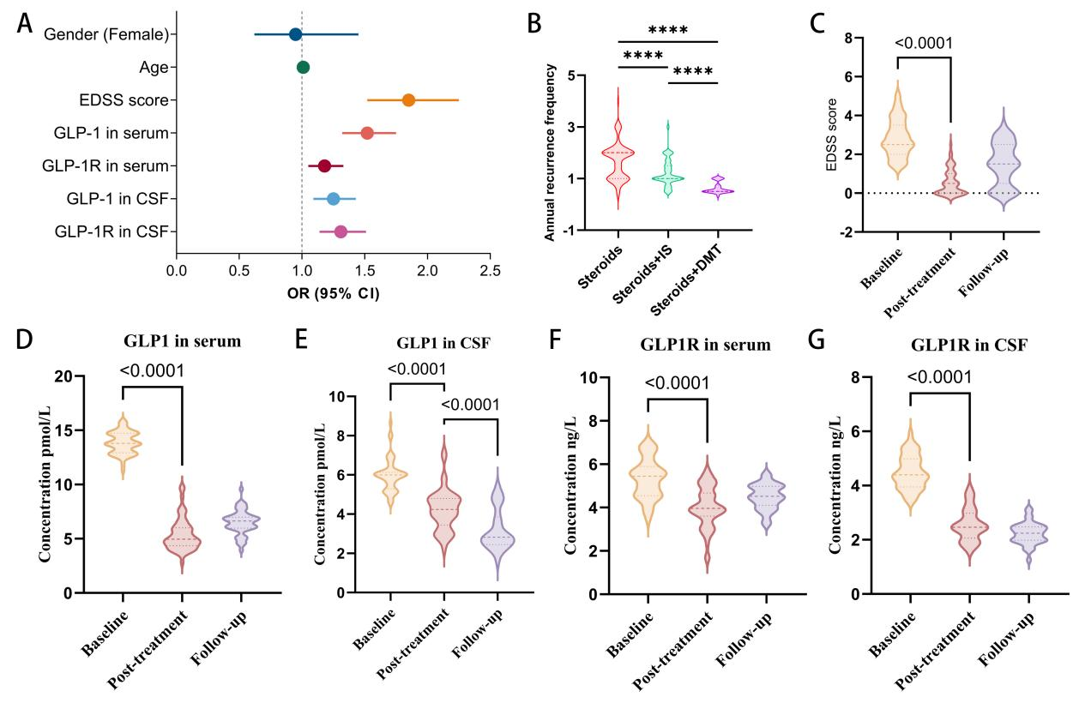
sFig 1. Supplementary analysis of clinical data. (A)Univariate logisitics regression analysis showed that EDSS score, GLP-1 in serum, GLP-1R in CSF were independent risk factors for APS-attacked (P<0.0001). (B) For NMOSD patients, the annual recurrence frequency of patients treated with steroids+immunosuppressants (IS) is lower than that of patients treated with steroids alone, while the annual recurrence frequency of patients treated with steroids+DMT (satralizumab) is the lowest (****P<0.0001). (C-G) Comparison of EDSS scores and serum and CSF levels of GLP-1 and GLP-1R at clinical baseline, post-treatment, and follow-up in patients with APS-attacked NMOSD. GLP-1 and GLP-1R levels in serum and CSF of APS-attacked NMOSD patients were significantly down-regulated by treatment without a long-term rebound trend.

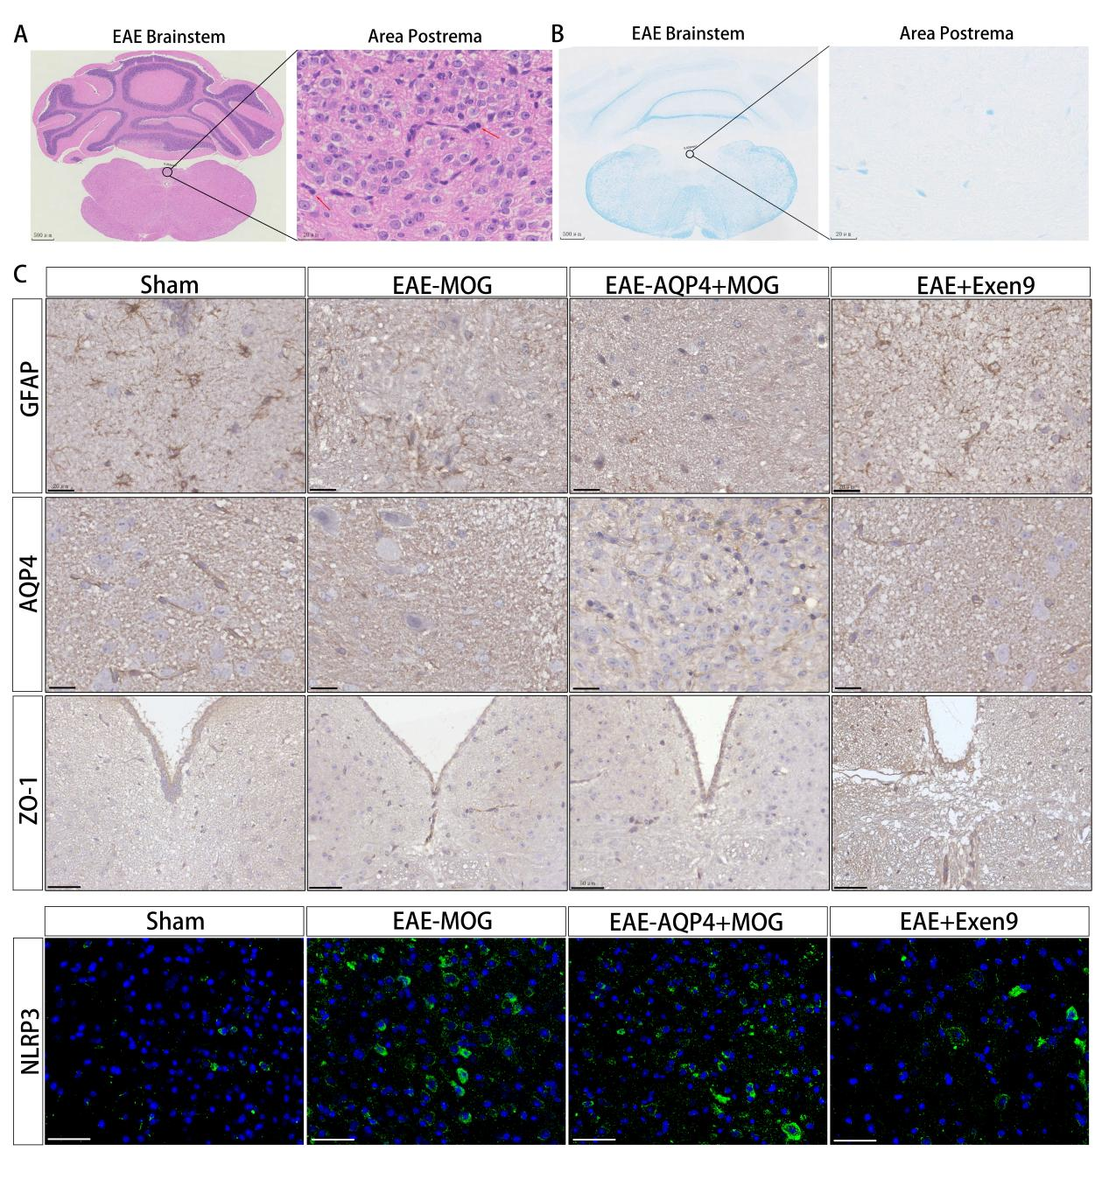
sFig 2. Pathologic changes and inflammatory activation in the AP region of EAE mouse. (A) HE staining suggested the presence of peripheral immune cell infiltration in the AP region of EAE_{AQP4+MOG} mouse. (B) LFB staining suggests demyelination in the AP region in brainstem sections of EAE_{AQP4+MOG} mouse. (C) GFAP, AQP4, and ZO-1 label astrocyte cytosol, peduncle, and tight junctions of the blood-brain barrier in the AP region of EAE_{AQP4+MOG} mouse, respectively. EAE_{MOG} and EAE_{AQP4+MOG} mouse showed GFAP and AQP4 deficiency and localized disruption of the blood-brain barrier. GFAP and AQP4 image scale bar is 20 μm. ZO-1 image scale bar is 50 μm. (D) Immunofluorescence staining showed that the expression of NLRP3 inflammatory vesicles in the AP region of EAE_{MOG} and EAE_{AQP4+MOG} mouse was significantly higher than that of sham and EAE+Exen9 groups. Images were acquired at 63x with a scale of 100 μm.

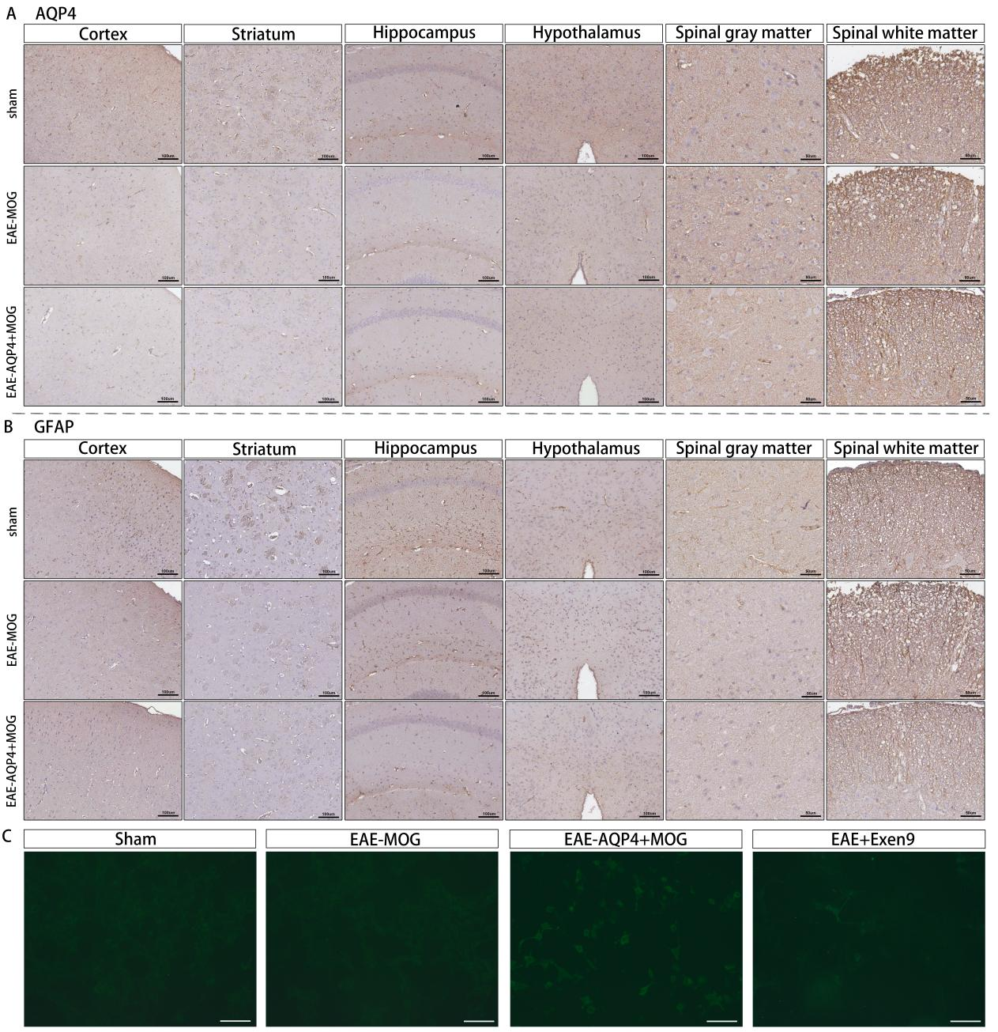
sFig 3. Astrocyte Injury and AQP4-IgG Detection. (A, B) Expression of the astrocytic markers GFAP (cell body) and AQP4 (end-feet) in the cortex, striatum, hippocampus, hypothalamus, spinal gray matter, and spinal white matter of EAE mice induced by the single-antigen (MOG) or dual-antigen (AQP4+MOG) immunization. Compared with the EAE_{MOG} and Sham groups, mice in the EAE_{AQP4+MOG} group showed significantly reduced GFAP and AQP4 expression across all examined brain regions and spinal cord areas, indicating pronounced astrocyte injury. (C) Serum levels of AQP4-specific antibodies (AQP4-IgG) measured by cytometric bead assay (CBA). The AQP4-IgG titer was significantly elevated in the EAE_{AQP4+MOG} group, displaying a weak-positive result compared with the EAE_{MOG} and Sham groups. EAE+Exen9 group reduced the serum AQP4-IgG titer. Scale bars: 100 μm for images of cortex, striatum, hippocampus, hypothalamus, and CBA-based AQP4-IgG detection; 50 μm for images of spinal gray and white matter.

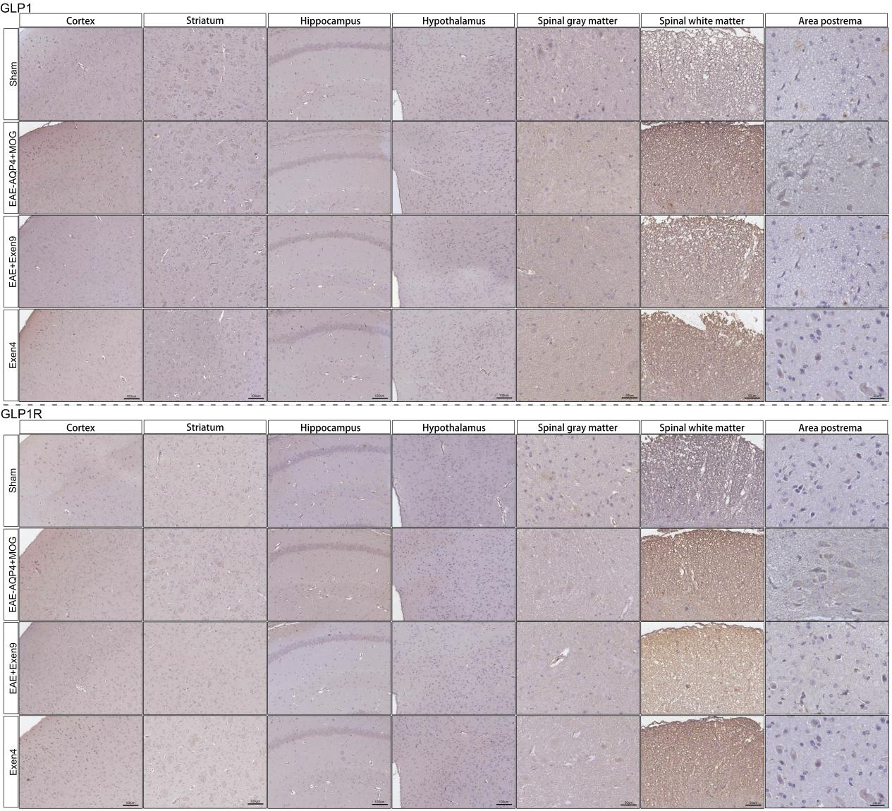
sFig 4. IHC staining was performed to quantify GLP-1 and GLP-1R content in the cortex, striatum, hippocampus, hypothalamus, spinal gray matter and white matter of each group of mouse. Cortex, striatum, hippocampus, and hypothalamus images are scaled to 100 μm. Spinal gray matter and white matter images are scaled to 50 μm. Area postrema image scale is 20 μm.

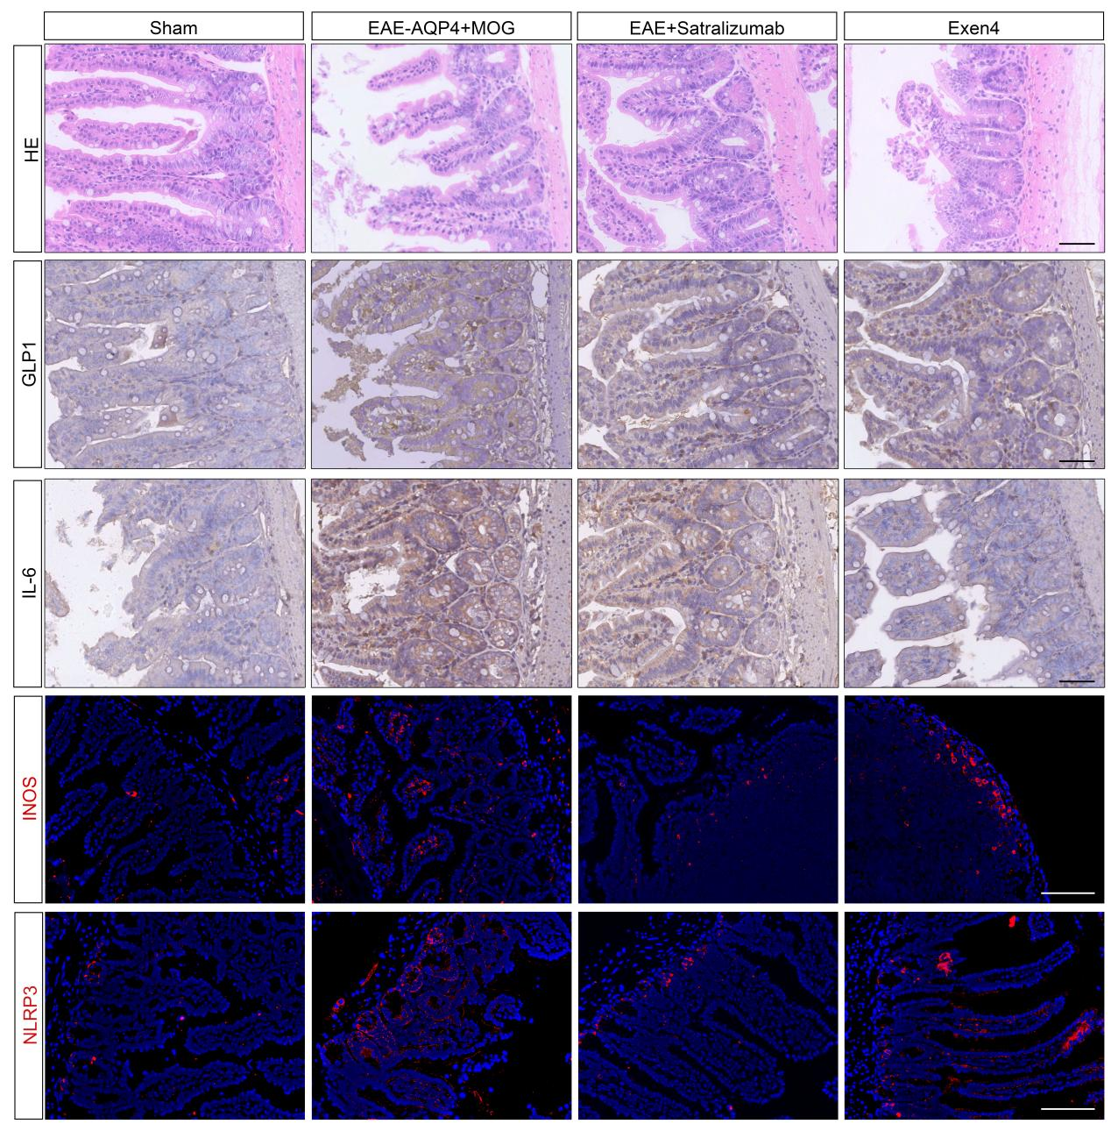
sFig 5. Histopathological analysis of intestinal villi reveals structural disintegration and necrotic fragmentation in EAE_{AQP4+MOG} mouse, as demonstrated by HE staining. GLP-1R antagonism with exendin-(9-39) ameliorates mucosal damage, whereas GLP-1R agonism (exendin-4) alone does not induce severe villous necrosis. IHC and IF staining further show elevated GLP-1 levels concurrent with IL-6-driven inflammatory activation in EAE_{AQP4+MOG} mouse, characterized by enhanced M1 macrophage polarization and upregulated NLRP3 inflammasome expression. Exendin-(9-39) attenuates these effects by reducing GLP-1 and suppressing IL-6-mediated inflammation. while exendin-4 primarily elevates GLP-1 and inhibits IL-6 activation. Exendin-4 increases GLP-1 while slightly promoting the inflammatory activation of IL-6. Images were acquired at 40x with a scale of 50 μm.
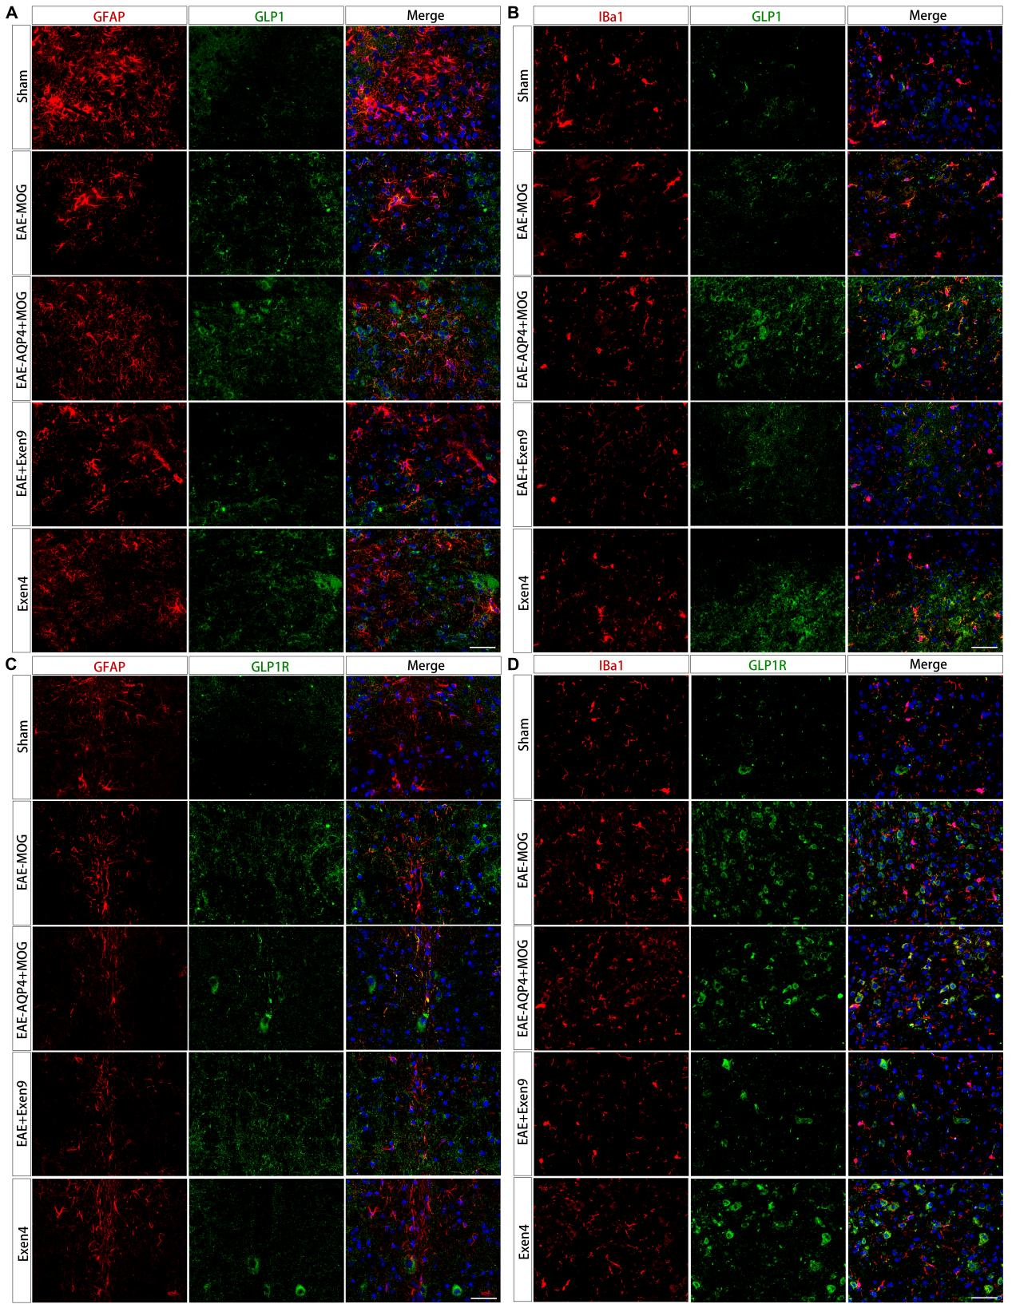
sFig 6. (A-B) Relative quantification of GLP-1 content in astrocytes and microglia in the AP region of mouse in each group by IF staining. (C-D) Relative quantification of GLP-1R content in astrocytes and microglia in the AP region of mouse in each group by IF staining. Images were acquired at 63x with a scale of 100 μm.

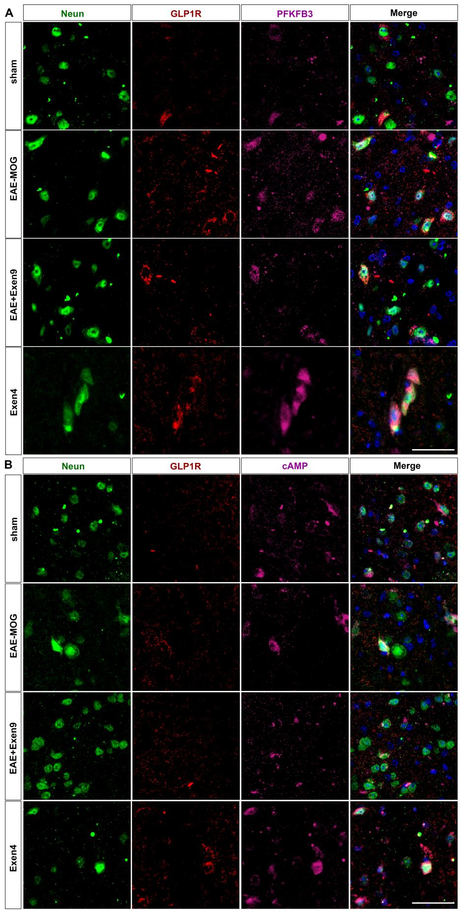
sFig 7. TSA staining was used to evaluate the differential expression of cAMP and PFKFB3 in the cAMP-PKA pathway of GLP-1R⁺AP neurons in each group of mouse. Images were acquired at 63x with a scale of 100 μm.

sTable 1 qRT-PCR Primer Sequence
Gene | NCBI Accession | Forward sequence | Reverse sequence
Human primer
GLP-1R | NM_002062.5 | CTCTGGGAGGTCAAGGCTATTC | GGTGGTGTTGATGAAGAGCAG
c-FOS | NM_005252.4 | TGGCGCTGTCACTGTCTTCT | ATGATGCCGGAACTTCACAA
RAB5a | NM_004162.4 | GTGGCTGACAAGAATGCAGAA | GAACGCCAATGTAGGTGATGT
PFKFB3 | NM_004566.4 | CAGTCAGAGCTGGCTAAACC | GCATACTGGCCTTGGAATGT
ADCY3(cAMP) | NM_004036.5 | GCTGGAGGAGTTCGAGAAGG | CACAGCCACATCTTCAGCAC
GAPDH | NM_002046.7 | GGAGCGAGATCCCTCCAAAAT | GGCTGTTGTCATACTTCTCATGG
Mouse primer
GCG(GLP-1) | NM_008100.4 | AGAGACTGGCTGAAGGACAAGA | CCTTGGTGAGGATGTTCTGAGT
GLP-1R | NM_021332.2 | CTGGATTCTGGCTACAGCAAGA | GTAGGTGGTGTTGACGAAGAGC
c-FOS | NM_010234.3 | AGGCTTCCTCTTCCAGCATCA | CCGCTTGGACTCCTTCTTG
RAB5a | NM_009003.3 | TGATGTCCAGGAGAAGGCAA | AGTTCGTCGCTGTCATCACA
PFKFB3 | NM_133232.3 | CTGAAGCACCTTGAAGTGGAGA | GTTGGCGATCTGCAGGTAGT
ADCY3(cAMP) | NM_146096.3 | GCTGGAGGAGTTCGAGAAGG | CACAGCCACATCTTCAGCAC
GAPDH | NM_001289726.1 | AGGTCGGTGTGAACGGATTTG | TGTAGACCATGTAGTTGAGGTCA

