Frustrated Smectic Liquid Crystal Elastomers as Multifunctional Mechanical Metamaterials
A. Street¹, S. R. Berrow^{1*}, Z. Wang,¹ E. J. Cooper¹, J. Mattsson¹, and H. F. Gleeson¹
¹School of Physics and Astronomy, University of Leeds, LS2 9JT
*S.R.Berrow@leeds.ac.uk
Electronic Supplementary Information
Supporting Information available: Further Experimental Information, Differential Scanning Calorimetry, Supplementary X-ray Scattering

Table Of Contents
Further Experimental Information S2
Differential Scanning Calorimetry S3
Polarised Light Optical Microscopy S5
Supplementary X-Ray Scattering S7

Further Experimental Information

Optical Microscopy
Polarised light optical microscopy (POM) was performed using a Leica DM2700P polarised light microscope (Leica Microsystems (UK) Ltd., Milton Keynes, UK), equipped with 10x and 50x magnification, and a rotatable stage. For LCE samples, the films were mounted on a glass slide, and analysed under ambient conditions, using 5x magnification. For phase identification of the liquid crystal mixtures, a Mettler Toledo FP82HT Hot Stage (Mettler-Toledo Ltd., Leicester, UK), controlled by a Mettler Toledo FP90 central processor (Mettler-Toledo Ltd., Leicester, UK) was used to control the temperature of the sample with a relative accuracy of 0.1 °C. In this case, the sample was mounted between a glass microscope slide and a glass cover slip, and samples were analysed using 50x magnification. Images were recorded using a Nikon D3500 Digital Camera (Nikon UK Ltd., Surbiton, UK), using DigiCamControl software.

Thermal Analysis
Differential scanning calorimetry (DSC) measurements were performed using a TA Instruments Q2000 DSC instrument (TA Instruments, Wilmslow UK), equipped with a RCS90 Refrigerated cooling system (TA Instruments, Wilmslow UK). The instrument was calibrated against Indium and adamantane standards, and data were processed using TA Instruments Universal Analysis Software. Samples were analysed under a nitrogen atmosphere, in hermetically sealed aluminium TZero crucibles (TA Instruments, Wilmslow, UK) and subjected to three analysis cycles.
For the analysis of the uncured LCE mixtures, each cycle consisted of: a heating phase from 0–100 °C at a heating rate of 10 °C/min; an isothermal phase at 100 °C for 2 minutes; a cooling phase from 100–0 °C at 10 °C/min; and an isothermal phase at 0 °C for 2 minutes. Clearing temperatures are reported as onset values.
For LCE analysis, each cycle consisted of: a heating phase from 50–150 °C at a heating rate of 10 °C/min; an isothermal phase at 150 °C for 2 minutes; a cooling phase from 150 – 50 °C at 10 °C/min; and an isothermal phase at -50 °C for 2 minutes. The glass transition temperatures of the polymers were recorded as the onset value, on the heating phase of the second cycle.

Differential Scanning Calorimetry
Figure S1 – A representative cooling cycle of the DSC thermograms for each precursor mixture.
Figure S2 - A representative heating cycle of the DSC thermograms for each LCE.
Table S1 – The glass transition temperatures (T_{g}) for each LCE sample and the clearing temperature (T_{c}) of the precursor mixtures employed in their synthesis.
Sample | T_{g} (°C) | T_{c} (°C)
LCE1 | -1 | 40
LCE2 | 7 | 40
LCE3 | 0 | 40
LCE4 | 1 | 81

Polarised Light Optical Microscopy

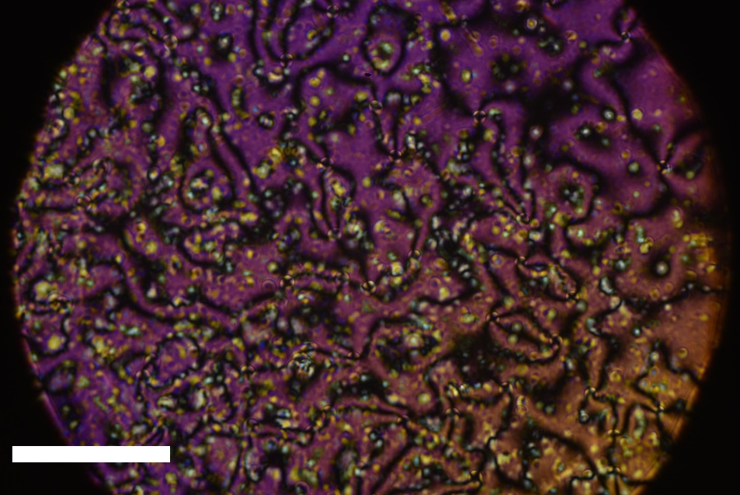
Figure S3 – The precursor mixture used in the production of LCE1 displaying a nematic Schlieren texture when viewed under crossed polarisers when sandwiched between untreated glass substrates at room temperature. The scale bar represents 100 µm.
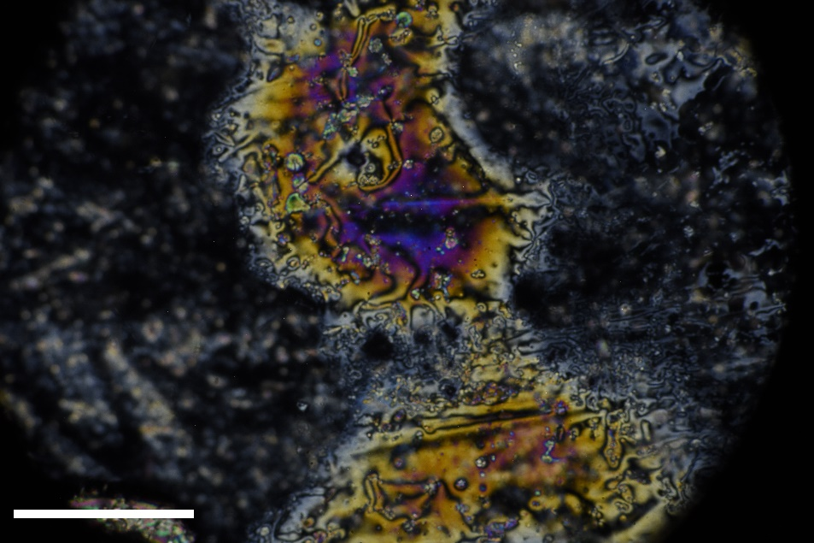
Figure S4 - The precursor mixture used in the production of LCE2 displaying a nematic Schlieren texture when viewed under crossed polarisers when sandwiched between untreated glass substrates at room temperature. The scale bar represents 1000 µm.
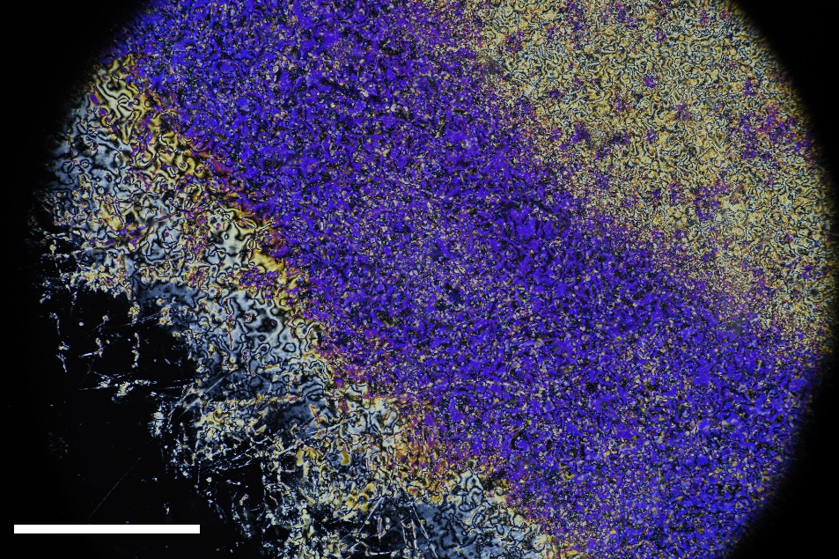
Figure S5 - The precursor mixture used in the production of LCE3 displaying a nematic Schlieren texture when viewed under crossed polarisers when sandwiched between untreated glass substrates at room temperature. The scale bar represents 1000 µm.

Supplementary X-Ray Scattering

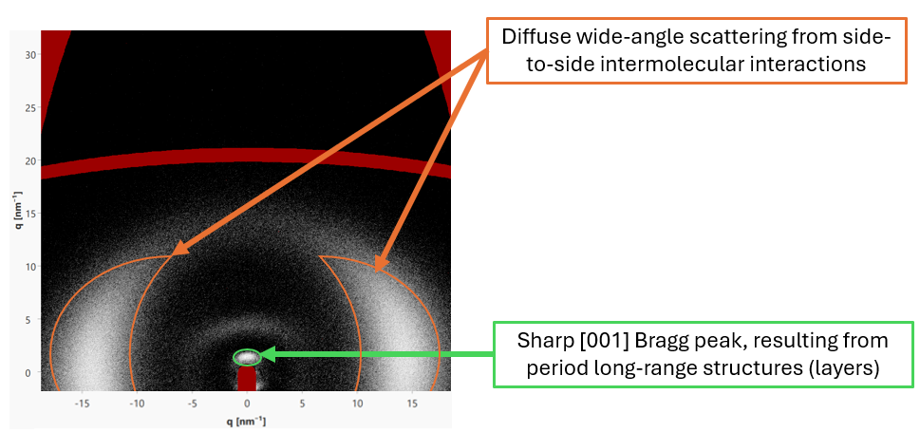
Figure S6 – An annotated wide-angle X-ray scattering figure, highlighting important characteristics of the data and the corresponding structural features to which they are attributed.

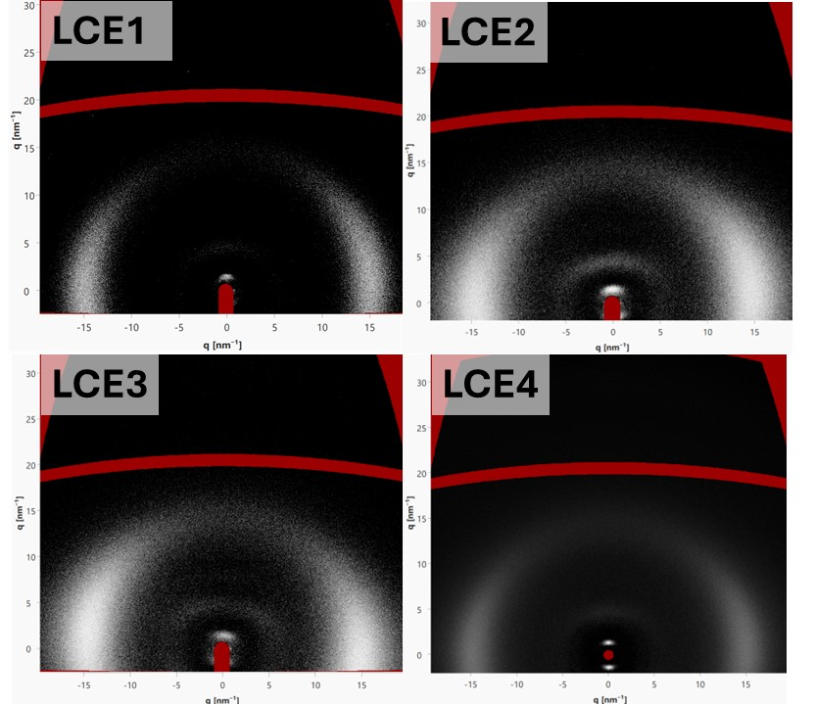
Figure S7 – Two-dimensional wide-angle X-ray scattering signals for each final LCE. The areas of the scattering patterns marked in red denote areas of the detector for which no data is recorded, due to instrument constraints. No significant features are observed in these regions.
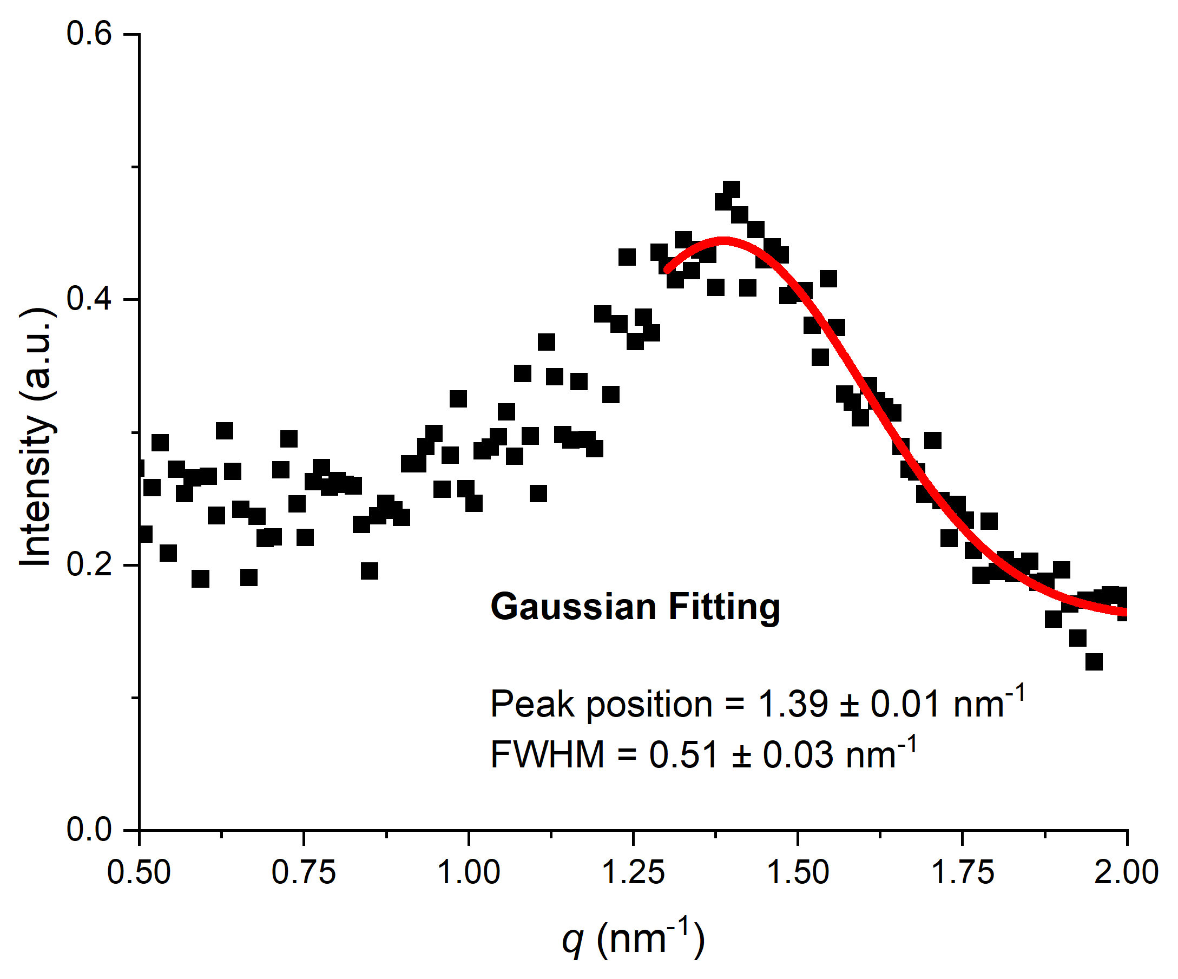
Figure S8 – An example dataset showing a Gaussian fitting of the small-angle X-ray scattering diffractograms, which is used to calculate correlation lengths for the LCEs described in this work. In this case, the data shown is a sample LCE3.

