Divergent European hail projections from machine learning and physically based models under global warming

Supplementary information

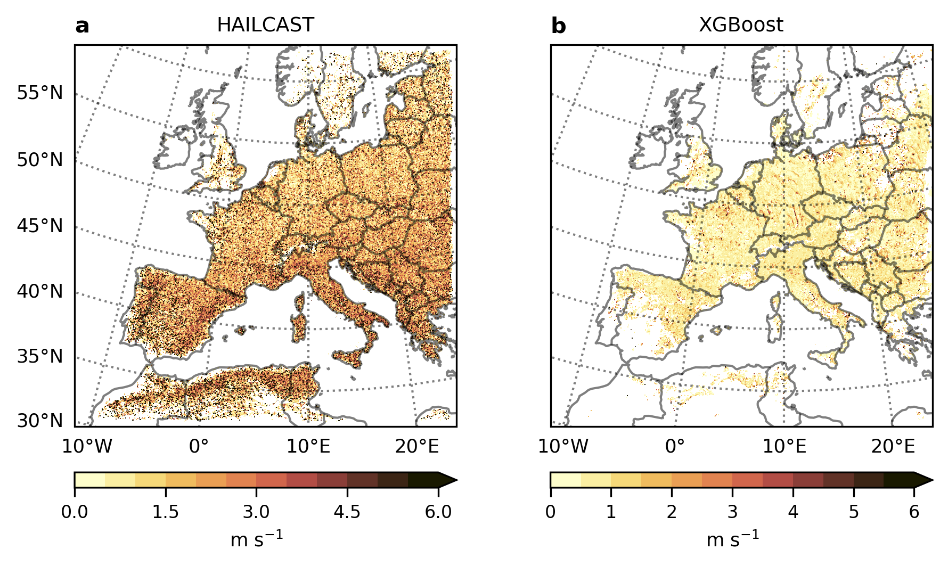
Figure S1: Storm updraft during hail days. Maximum vertical column updraft at hail locations during HAILCAST hail days (a) and XGBoost hail days (b) in the historical simulation.
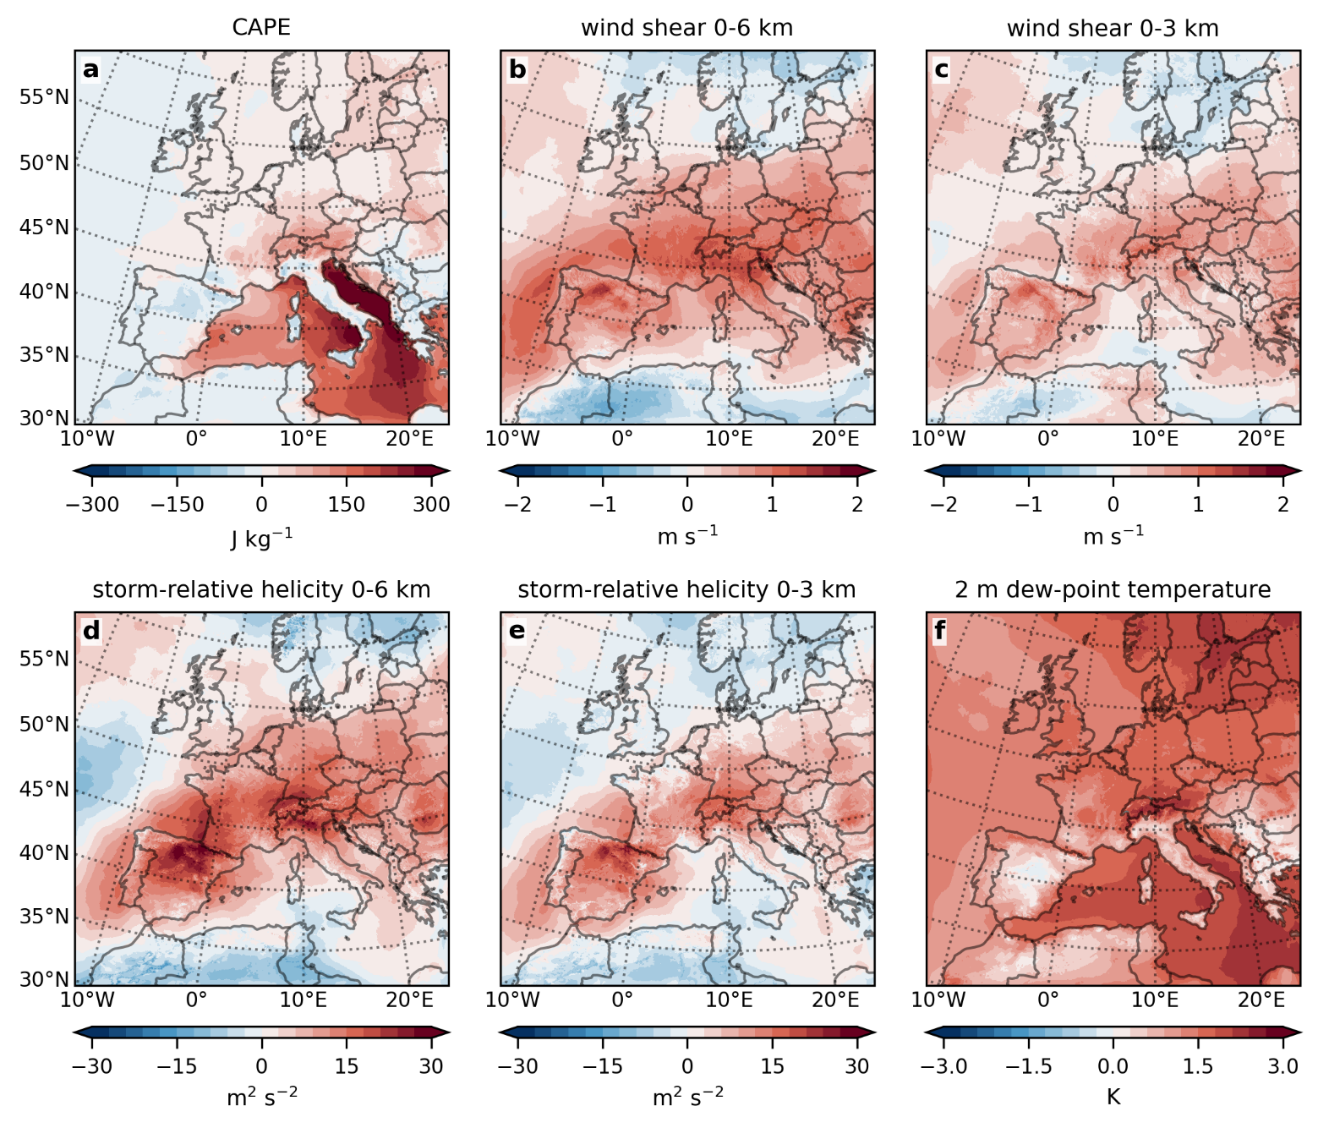
Figure S2: Hail precursors shifting toward more favourable hail environments under PGW. Climate-change signal (PGW minus historical) for: (a) maximum convective available potential energy (CAPE), (b) 0-6 km wind shear, (c) 0-3 km wind shear, (d) 0-6 km storm-relative helicity (SRH), (e) 0-3 km storm-relative helicity, and (f) 2 m dew-point temperature.
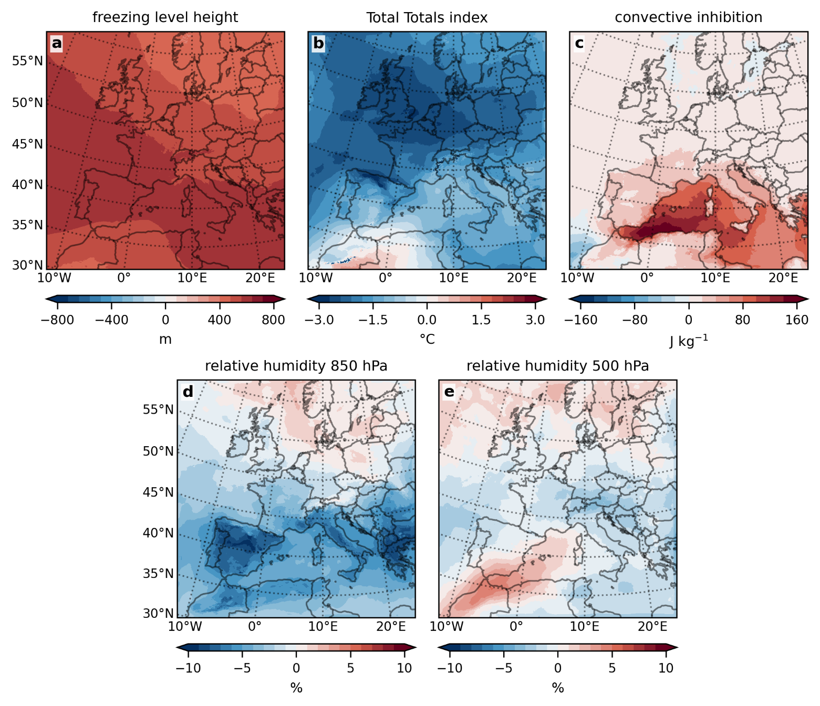
Figure S3: Hail precursors shifting toward less favourable hail environments under PGW. Climate-change signal (PGW minus historical) for: (a) freezing level height, (b) Total Totals Index, (c) convective inhibition, (d) relative humidity at 850 hPa and (e) relative humidity at 500 hPa.
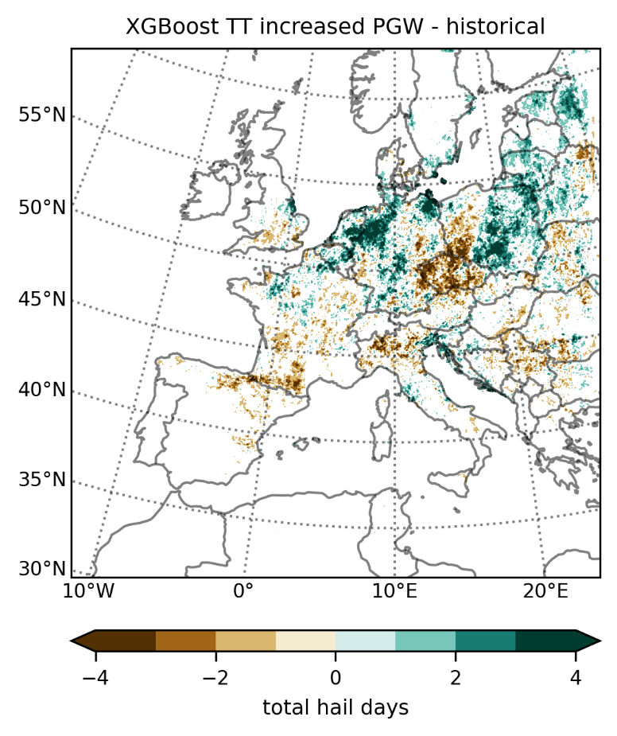
Figure S4: Sensitivity of XGBoost hail projections to Total Totals (TT) index. Climate-change signal (PGW minus historical) of severe hail days (hail diameter ≥ 25 mm), during summer (JJA), simulated by XGBoost after increasing the Total Totals index (TT) by 10% in the PGW simulation.

Synoptic-scale environments associated with hail occurrence
Identifying the synoptic environments that favour local convective initiation is essential for understanding the broader atmospheric patterns that promote hail-producing storms. In this context, geopotential height anomalies at 500 hPa (Z500) provide a robust descriptor of the synoptic situation, enabling a regional assessment of hail-favourable environments. Motivated by this, we analyse the Z500 anomalies associated with hail days simulated by HAILCAST and XGBoost. To isolate the regional synoptic signatures, the pan-European domain was divided into four subregions: western and central Europe (lat > 45°) and western and central Mediterranean (lat < 45°), separated at 8°E. For each subregion, Z500 anomalies were computed as the departure of daily Z500 during hail days from the summer climatological mean (JJA), allowing us to determine the characteristic circulation patterns linked to hail occurrence in each modelling framework.
In the historical simulation, the Z500 anomalies based on XGBoost hail days closely resemble the synoptic structures identified by ref.¹: a pronounced trough-ridge dipole over western and central Europe (Fig. S5a, b), a “Spanish Plume” pattern in the western Mediterranean² (Fig. S5c), and a shallow low-pressure system north of the Alps in the central Mediterranean³ (Fig. S5d). Together, these patterns confirm that the XGBoost model primarily responds to synoptic environments conducive to severe convection, consistent with its training on present-day reanalysis data. In contrast, the Z500 anomalies composited from HAILCAST hail days exhibit much weaker and less coherent large-scale structure (Fig. S5e-h), underscoring its primary sensitivity to local storm-scale processes rather than synoptic forcing. The synoptic anomalies do not change fundamentally in the PGW future climate (Fig. S6 vs. Fig. S5). Only a strengthening of the Z500 anomalies is evident in the XGBoost-based composites (Fig. S6a-d).

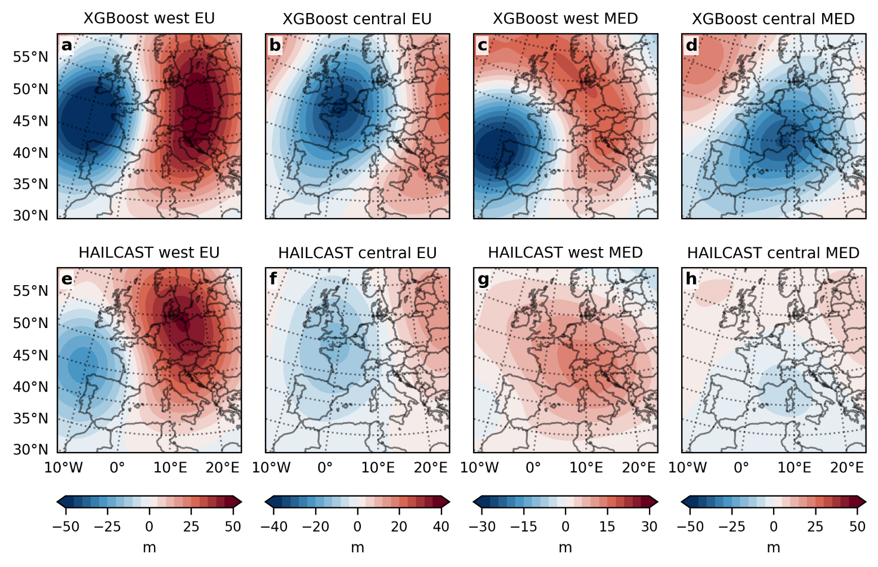
Figure S5: 500-hPa geopotential (Z500) anomalies during hail days in the historical simulation. Z500 anomalies composited for hail days from XGBoost (a-d) and HAILCAST (e-h) across four subregions: western Europe (a, e), central Europe (b, f), western Mediterranean (c, g) and central Mediterranean (d, h). Anomalies are computed as departures of Z500 during hail events from the JJA climatological mean.
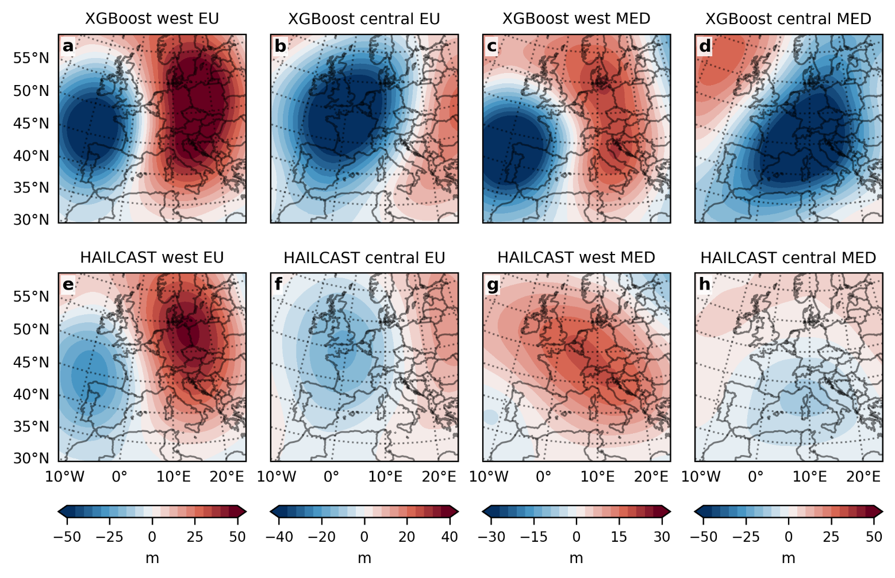
Figure S6: Same as Figure S5 but for the PGW simulation.

References
1. Feldmann, M., Domeisen, D. I. V. & Martius, O. A pan-European analysis of large-scale drivers of severe convective outbreaks. Weather and Climate Dynamics 6, 1089–1106 (2025).
2. Schultz, D. M., Young, M. V. & Kirshbaum, D. J. The Spanish Plume Elevated Mixed Layer: A Review of Its Use and Misuse within the Scientific Literature. Mon Weather Rev 153, 737–761 (2025).
3. De Martin, F., Manzato, A., Carlon, N., Setvák, M. & Miglietta, M. M. Dynamic and statistical analysis of giant hail environments in northeast Italy. Quarterly Journal of the Royal Meteorological Society 151, (2025).

