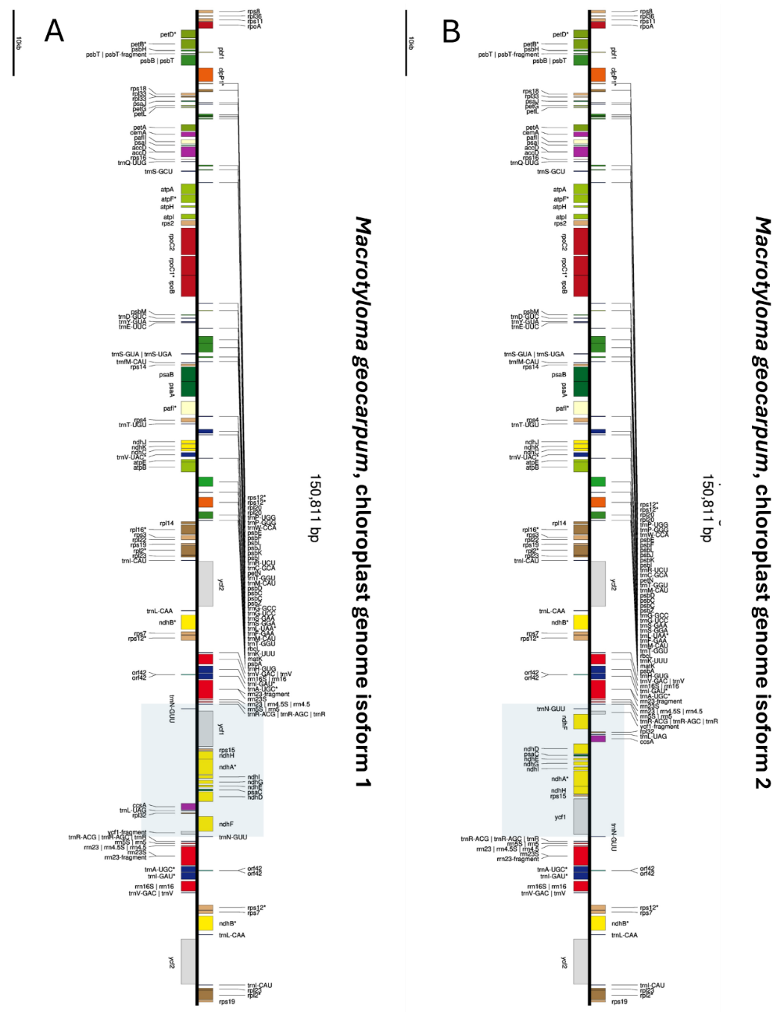

Figure S1. Linear representation of two isoforms of the chloroplast genome of the Macrotyloma geocarpum: Linear gene maps of the complete chloroplast genomes of the Macrotyloma grocarpum are shown, with each species represented by two alternative structural isoforms (A-B). The two isoforms within each species differ only in the orientation of the small single-copy (SSC) region, reflecting the well-known flip-flop recombination between inverted repeat (IR) regions

