Appendix

Table 1 Partial least squares (PLS) regression results assessing the effects of temperature difference variables on the lammas shoot needle unfolding stage in Pinus densiflora seedlings.
1st lammas shoot needle unfolding stage
Para  meter |  | Jul |  |  | Aug |  |  | Sep |  |  | Oct |  |  | Nov
Para  meter |  | R² | AIC | β | R² | AIC | β | R² | AIC | β | R² | AIC | β | R² | AIC | β
EDD₂₄ |  | 0.117 | 1853.1 | 0.317 | 0.212 | 2166.5 | 0.568 | 0.231 | 2408.7 | 0.712 | 0.214 | 1927.7 | 0.576 | 0.211 | 1686.9 | 0.574
EDD₂₅ |  | 0.116 | 1853.7 | 0.316 | 0.211 | 2167.5 | 0.566 | 0.230 | 2409.2 | 0.711 | 0.217 | 1925.4 | 0.580 | 0.214 | 1684.9 | 0.578
EDD₂₆ |  | 0.114 | 1855.3 | 0.314 | 0.208 | 2170.0 | 0.562 | 0.228 | 2411.4 | 0.708 | 0.217 | 1925.3 | 0.580 | 0.214 | 1684.8 | 0.578
EDD₂₇ |  | 0.110 | 1858.2 | 0.309 | 0.203 | 2174.5 | 0.556 | 0.224 | 2415.1 | 0.701 | 0.215 | 1927.0 | 0.577 | 0.212 | 1686.2 | 0.575
EDD₂₈ |  | 0.105 | 1862.2 | 0.302 | 0.195 | 2181.4 | 0.545 | 0.218 | 2420.3 | 0.693 | 0.212 | 1930.0 | 0.572 | 0.208 | 1688.8 | 0.570
EDD₂₉ |  | 0.101 | 1865.9 | 0.295 | 0.187 | 2188.6 | 0.533 | 0.212 | 2426.4 | 0.682 | 0.207 | 1933.7 | 0.566 | 0.203 | 1692.1 | 0.564
EDD₃₀ |  | 0.096 | 1869.5 | 0.288 | 0.180 | 2194.8 | 0.523 | 0.204 | 2432.9 | 0.670 | 0.202 | 1937.3 | 0.560 | 0.199 | 1695.3 | 0.557
EDD₃₁ |  | 0.091 | 1873.3 | 0.281 | 0.173 | 2200.9 | 0.513 | 0.197 | 2439.8 | 0.657 | 0.197 | 1941.5 | 0.552 | 0.193 | 1699.0 | 0.549
EDD₃₂ |  | 0.085 | 1878.1 | 0.272 | 0.164 | 2208.4 | 0.500 | 0.188 | 2447.2 | 0.643 | 0.191 | 1946.3 | 0.544 | 0.187 | 1703.4 | 0.540
EDD₃₃ |  | 0.079 | 1883.1 | 0.261 | 0.155 | 2216.0 | 0.486 | 0.181 | 2454.1 | 0.630 | 0.185 | 1951.2 | 0.535 | 0.180 | 1708.0 | 0.530
2nd lammas shoot needle unfolding stage
Para  meter |  |  |  |  |  |  |  | Sep |  |  | Oct |  |  | Nov
Para  meter |  |  |  |  |  |  |  | R² | AIC | β | R² | AIC | β | R² | AIC | β
EDD₂₄ |  |  |  |  |  |  |  | 0.064 | 638.4 | 0.099 | 0.152 | 1406.9 | 0.310 | 0.154 | 1379.7 | 0.358
EDD₂₅ |  |  |  |  |  |  |  | 0.064 | 638.4 | 0.099 | 0.153 | 1406.3 | 0.311 | 0.154 | 1379.3 | 0.359
EDD₂₆ |  |  |  |  |  |  |  | 0.064 | 638.4 | 0.099 | 0.154 | 1406.0 | 0.311 | 0.154 | 1379.5 | 0.359
EDD₂₇ |  |  |  |  |  |  |  | 0.064 | 638.7 | 0.098 | 0.154 | 1405.9 | 0.311 | 0.153 | 1380.2 | 0.357
EDD₂₈ |  |  |  |  |  |  |  | 0.063 | 639.4 | 0.098 | 0.153 | 1406.4 | 0.311 | 0.151 | 1381.5 | 0.355
EDD₂₉ |  |  |  |  |  |  |  | 0.062 | 640.5 | 0.097 | 0.152 | 1407.5 | 0.309 | 0.148 | 1383.2 | 0.352
EDD₃₀ |  |  |  |  |  |  |  | 0.060 | 641.6 | 0.095 | 0.150 | 1408.7 | 0.308 | 0.146 | 1384.9 | 0.349
EDD₃₁ |  |  |  |  |  |  |  | 0.058 | 642.9 | 0.094 | 0.148 | 1410.3 | 0.305 | 0.143 | 1386.9 | 0.345
EDD₃₂ |  |  |  |  |  |  |  | 0.056 | 644.3 | 0.093 | 0.145 | 1412.4 | 0.303 | 0.139 | 1389.2 | 0.341
EDD₃₃ |  |  |  |  |  |  |  | 0.054 | 646.1 | 0.091 | 0.141 | 1415.3 | 0.298 | 0.135 | 1392.1 | 0.335

Table 2 Partial least squares (PLS) regression results assessing the relative importance of environmental variables on spring needle unfolding stages in Pinus densiflora seedlings across treatments. Analysis included only months with significant treatment effects.
Treatments | Variables | May
Treatments | Variables | VIP | β
Control (C) | AHT | 0.70 | 0.00
Control (C) | ALT | 1.11 | -0.01
Control (C) | EDD₃₀ | 0.76 | 0.00
Control (C) | GDD | 1.21 | -0.01
Control (C) | GDD_{m} | 1.21 | -0.01
Control (C) | SWC₃₀ | 0.87 | -0.01
Consistent warming (W) | AHT | 0.03 | 0.00
Consistent warming (W) | ALT | 1.93 | -0.01
Consistent warming (W) | EDD₃₀ | 1.25 | -0.01
Consistent warming (W) | GDD | 0.66 | -0.01
Consistent warming (W) | GDD_{m} | 0.53 | 0.00
Consistent warming (W) | SWC₃₀ | 0.04 | 0.00
Summer warming (W_{S}) | AHT | 1.47 | 0.02
Summer warming (W_{S}) | ALT | 0.29 | 0.00
Summer warming (W_{S}) | EDD₃₀ | 1.18 | 0.01
Summer warming (W_{S}) | GDD | 0.89 | 0.01
Summer warming (W_{S}) | GDD_{m} | 0.83 | 0.01
Summer warming (W_{S}) | SWC₃₀ | 0.93 | -0.01
Spring and fall warming (W_{SF}) | AHT | 1.03 | 0.01
Spring and fall warming (W_{SF}) | ALT | 0.95 | -0.01
Spring and fall warming (W_{SF}) | EDD₃₀ | 1.32 | 0.01
Spring and fall warming (W_{SF}) | GDD | 1.17 | 0.01
Spring and fall warming (W_{SF}) | GDD_{m} | 0.75 | 0.01
Spring and fall warming (W_{SF}) | SWC₃₀ | 0.60 | 0.01
GDD: growing degree days; GDD_{m}: maximum-limited growing degree days; EDD₃₀: extreme degree days with a reference temperature of 30°C; AHT: accumulated daily maximum temperature; ALT: accumulated daily minimum temperature; SWC₃₀: 30-day mean soil water content preceding each observation. Variables with variable importance in projection (VIP) > 1 are highlighted in bold along with their regression coefficient (β).

Table 3 Partial least squares (PLS) regression results assessing the relative importance of environmental variables on first lammas shoot needle unfolding stages in Pinus densiflora seedlings across treatments. Analysis included only months with significant treatment effects.
Treatments | Variables | July |  | August |  | September |  | October |  | November
Treatments | Variables | VIP | β | VIP | β | VIP | β | VIP | β | VIP | β
Control | AHT | 1.63 | -0.03 | 1.61 | -0.06 | 1.89 | -0.06 | 1.56 | -0.05 | 1.59 | -0.06
Control | ALT | 0.11 | 0.00 | 0.49 | -0.02 | 0.54 | -0.02 | 0.44 | -0.01 | 0.34 | -0.01
Control | EDD₃₀ | 0.89 | -0.02 | 1.44 | -0.06 | 1.28 | -0.04 | 1.19 | -0.04 | 1.15 | -0.05
Control | GDD | 0.73 | 0.01 | 0.82 | -0.03 | 0.57 | -0.02 | 0.91 | -0.03 | 0.71 | -0.03
Control | GDD_{m} | 0.88 | 0.02 | 0.65 | -0.03 | 0.39 | -0.01 | 0.79 | -0.02 | 0.57 | -0.02
Control | SWC₃₀ | 1.11 | 0.02 | 0.10 | 0.00 | 0.21 | 0.01 | 0.72 | -0.02 | 1.10 | 0.04
Consistent  warming  (W) | AHT | 1.34 | -0.05 | 1.58 | -0.06 | 1.96 | -0.04 | 1.81 | -0.01 | 1.89 | -0.01
Consistent  warming  (W) | ALT | 1.73 | -0.06 | 0.50 | 0.02 | 0.74 | -0.02 | 1.07 | -0.01 | 1.17 | -0.01
Consistent  warming  (W) | EDD₃₀ | 0.16 | 0.01 | 1.33 | -0.05 | 0.62 | -0.01 | 0.26 | 0.00 | 0.16 | 0.00
Consistent  warming  (W) | GDD | 0.69 | 0.02 | 0.38 | 0.01 | 0.46 | 0.01 | 0.19 | 0.00 | 0.32 | 0.00
Consistent  warming  (W) | GDD_{m} | 0.74 | 0.03 | 0.91 | 0.03 | 0.84 | 0.02 | 0.24 | 0.00 | 0.36 | 0.00
Consistent  warming  (W) | SWC₃₀ | 0.40 | -0.01 | 0.73 | 0.03 | 0.57 | 0.01 | 1.19 | -0.01 | 0.90 | -0.01
Summer  warming  (W_{S}) | AHT | 1.20 | 0.01 | 0.93 | 0.01 | 1.20 | 0.02 | 0.85 | 0.01 | 0.95 | 0.01
Summer  warming  (W_{S}) | ALT | 0.74 | 0.01 | 0.88 | 0.01 | 0.82 | 0.01 | 0.97 | 0.01 | 0.81 | 0.01
Summer  warming  (W_{S}) | EDD₃₀ | 1.27 | 0.01 | 0.98 | 0.01 | 1.27 | 0.02 | 0.90 | 0.01 | 0.95 | 0.01
Summer  warming  (W_{S}) | GDD | 1.15 | 0.01 | 1.20 | 0.02 | 1.12 | 0.02 | 1.15 | 0.01 | 1.17 | 0.01
Summer  warming  (W_{S}) | GDD_{m} | 1.03 | 0.01 | 1.25 | 0.02 | 0.97 | 0.02 | 1.21 | 0.01 | 1.23 | 0.01
Summer  warming  (W_{S}) | SWC₃₀ | 0.10 | 0.00 | 0.63 | -0.01 | 0.27 | 0.01 | 0.87 | -0.01 | 0.81 | -0.01
Spring and fall warming (W_{SF}) | AHT | 0.93 | 0.01 | 0.98 | 0.01 | 1.04 | 0.01 | 1.14 | 0.01 | 1.23 | 0.01
Spring and fall warming (W_{SF}) | ALT | 0.11 | 0.00 | 0.22 | 0.00 | 0.40 | 0.00 | 0.26 | 0.00 | 0.42 | 0.00
Spring and fall warming (W_{SF}) | EDD₃₀ | 1.03 | 0.01 | 1.07 | 0.01 | 1.09 | 0.01 | 1.43 | 0.01 | 1.57 | 0.01
Spring and fall warming (W_{SF}) | GDD | 1.22 | 0.01 | 1.23 | 0.01 | 1.24 | 0.01 | 1.16 | 0.01 | 1.10 | 0.01
Spring and fall warming (W_{SF}) | GDD_{m} | 1.23 | 0.01 | 1.24 | 0.01 | 1.29 | 0.01 | 0.97 | 0.01 | 0.80 | 0.01
Spring and fall warming (W_{SF}) | SWC₃₀ | 1.03 | 0.01 | 0.89 | 0.01 | 0.61 | 0.01 | 0.55 | 0.00 | 0.16 | 0.00
GDD: growing degree days; GDD_{m}: maximum-limited growing degree days; EDD₃₀: extreme degree days with a reference temperature of 30°C; AHT: accumulated daily maximum temperature; ALT: accumulated daily minimum temperature; SWC₃₀: 30-day mean soil water content preceding each observation. Variables with variable importance in projection (VIP) > 1 are highlighted in bold along with their regression coefficient (β).

Table 4 Partial least squares (PLS) regression results assessing the relative importance of environmental variables on second lammas shoot needle unfolding stages in Pinus densiflora seedlings across treatments. Analysis included only months with significant treatment effects.
Treatments | Variables | September |  | October |  | November
Treatments | Variables | VIP | β | VIP | β | VIP | β
Control (C) | AHT | 1.88 | -0.01 | 1.97 | -0.02 | 1.47 | -0.02
Control (C) | ALT | 0.20 | 0.00 | 0.11 | 0.00 | 0.03 | 0.00
Control (C) | EDD₃₀ | 1.14 | -0.01 | 1.29 | -0.01 | 0.96 | -0.01
Control (C) | GDD | 0.28 | 0.00 | 0.16 | 0.00 | 0.07 | 0.00
Control (C) | GDD_{m} | 0.48 | 0.00 | 0.35 | 0.00 | 0.07 | 0.00
Control (C) | SWC₃₀ | 0.90 | 0.01 | 0.55 | 0.01 | 1.70 | 0.02
Consistent warming (W) | AHT | 0.42 | -0.01 | 0.35 | -0.01 | 0.55 | -0.01
Consistent warming (W) | ALT | 0.80 | 0.01 | 0.00 | 0.00 | 0.16 | 0.00
Consistent warming (W) | EDD₃₀ | 0.57 | 0.01 | 1.30 | 0.03 | 0.71 | 0.02
Consistent warming (W) | GDD | 1.19 | 0.02 | 0.81 | 0.02 | 0.89 | 0.02
Consistent warming (W) | GDD_{m} | 1.33 | 0.02 | 0.64 | 0.02 | 0.82 | 0.02
Consistent warming (W) | SWC₃₀ | 1.29 | -0.02 | 1.76 | -0.04 | 1.93 | -0.05
Summer warming (W_{S}) | AHT | 1.08 | 0.01 | 0.92 | 0.01 | 1.20 | 0.02
Summer warming (W_{S}) | ALT | 0.61 | 0.01 | 1.12 | -0.04 | 0.31 | 0.01
Summer warming (W_{S}) | EDD₃₀ | 1.01 | 0.01 | 0.92 | 0.02 | 1.35 | 0.02
Summer warming (W_{S}) | GDD | 1.16 | 0.01 | 1.09 | 0.04 | 1.20 | 0.02
Summer warming (W_{S}) | GDD_{m} | 1.20 | 0.01 | 1.14 | 0.04 | 1.07 | 0.02
Summer warming (W_{S}) | SWC₃₀ | 0.81 | -0.01 | 0.75 | 0.01 | 0.21 | 0.00
Spring and Fall warming (W_{SF}) | AHT | - | - | 0.41 | 0.00 | 1.05 | 0.05
Spring and Fall warming (W_{SF}) | ALT | - | - | 2.01 | -0.02 | 1.03 | 0.02
Spring and Fall warming (W_{SF}) | EDD₃₀ | - | - | 0.88 | 0.01 | 1.18 | 0.03
Spring and Fall warming (W_{SF}) | GDD | - | - | 0.75 | 0.01 | 0.88 | 0.01
Spring and Fall warming (W_{SF}) | GDD_{m} | - | - | 0.66 | 0.01 | 0.72 | 0.01
Spring and Fall warming (W_{SF}) | SWC₃₀ | - | - | 0.11 | 0.00 | 1.07 | 0.13
GDD: growing degree days; GDD_{m}: maximum-limited growing degree days; EDD₃₀: extreme degree days with a reference temperature of 30°C; AHT: accumulated daily maximum temperature; ALT: accumulated daily minimum temperature; SWC₃₀: 30-day mean soil water content preceding each observation. Variables with variable importance in projection (VIP) > 1 are highlighted in bold along with their regression coefficient (β).

Table 5 Values for spring needle unfolding and lammas shoots development stages of Pinus densiflora seedlings in response to seasonal warming treatments.
 |  |  | May |  |  |  | June |  |  |  | July |  |  |  | August |  |  |  | September |  |  |  | October |  |  |  | November
 |  |  | Avg | SE | diff (%) |  | Avg | SE | diff (%) |  | Avg | SE | diff (%) |  | Avg | SE | diff (%) |  | Avg | SE | diff (%) |  | Avg | SE | diff (%) |  | Avg | SE | diff (%)
Spring needle  final stage  attainment rates | C |  | 0.00 | 0.00 |  |  | 0.29ª | 0.06 |  |  | 1.00 | 0.00 |  |  | 1.00 | 0.00 |  |  | 1.00 | 0.00 |  |  | 1.00 | 0.00 |  |  | 1.00 | 0.00
Spring needle  final stage  attainment rates | W |  | 0.00 | 0.00 | 0.00 |  | 0.13^{c} | 0.04 | -57.14 |  | 1.00 | 0.00 | 0.00 |  | 1.00 | 0.00 | 0.00 |  | 1.00 | 0.00 | 0.00 |  | 1.00 | 0.00 | 0.00 |  | 1.00 | 0.00 | 0.00
Spring needle  final stage  attainment rates | W_{S} |  | 0.00 | 0.00 | 0.00 |  | 0.32ª | 0.07 | 7.14 |  | 1.00 | 0.00 | 0.00 |  | 1.00 | 0.00 | 0.00 |  | 1.00 | 0.00 | 0.00 |  | 1.00 | 0.00 | 0.00 |  | 1.00 | 0.00 | 0.00
Spring needle  final stage  attainment rates | W_{SF} |  | 0.00 | 0.00 | 0.00 |  | 0.17^{b} | 0.04 | -42.86 |  | 1.00 | 0.00 | 0.00 |  | 1.00 | 0.00 | 0.00 |  | 1.00 | 0.00 | 0.00 |  | 1.00 | 0.00 | 0.00 |  | 1.00 | 0.00 | 0.00
Spring needle  unfolding stage | C |  | 1.67^{ab} | 0.03 |  |  | 3.29 | 0.03 |  |  | 4.00 | 0.00 |  |  | 4.00 | 0.00 |  |  | 4.00 | 0.00 |  |  | 4.00 | 0.00 |  |  | 4.00 | 0.00
Spring needle  unfolding stage | W |  | 1.90^{b} | 0.03 | 13.81 |  | 3.13 | 0.02 | -4.96 |  | 4.00 | 0.00 | 0.00 |  | 4.00 | 0.00 | 0.00 |  | 4.00 | 0.00 | 0.00 |  | 4.00 | 0.00 | 0.00 |  | 4.00 | 0.00 | 0.00
Spring needle  unfolding stage | W_{S} |  | 1.60ª | 0.04 | -4.20 |  | 3.31 | 0.03 | 0.64 |  | 4.00 | 0.00 | 0.00 |  | 4.00 | 0.00 | 0.00 |  | 4.00 | 0.00 | 0.00 |  | 4.00 | 0.00 | 0.00 |  | 4.00 | 0.00 | 0.00
Spring needle  unfolding stage | W_{SF} |  | 1.85^{ab} | 0.03 | 11.11 |  | 3.16 | 0.03 | -3.84 |  | 4.00 | 0.00 | 0.00 |  | 4.00 | 0.00 | 0.00 |  | 4.00 | 0.00 | 0.00 |  | 4.00 | 0.00 | 0.00 |  | 4.00 | 0.00 | 0.00
1st Lammas shoot  occurrence rates | C |  | 0.00 | 0.00 |  |  | 0.01 | 0.01 |  |  | 0.43^{ab} | 0.06 |  |  | 0.61ª | 0.05 |  |  | 0.72ª | 0.04 |  |  | 0.91ª | 0.02 |  |  | 0.91ª | 0.02
1st Lammas shoot  occurrence rates | W |  | 0.00 | 0.00 | 0.00 |  | 0.02 | 0.01 | 200.00 |  | 0.81^{c} | 0.02 | 89.61 |  | 0.97^{b} | 0.01 | 60.52 |  | 0.99^{b} | 0.01 | 38.12 |  | 1.00^{b} | 0.00 | 10.39 |  | 1.00^{b} | 0.00 | 10.27
1st Lammas shoot  occurrence rates | W_{S} |  | 0.00 | 0.00 | 0.00 |  | 0.01 | 0.01 | 0.00 |  | 0.64^{bc} | 0.06 | 50.65 |  | 0.92^{b} | 0.02 | 51.27 |  | 1.00^{b} | 0.00 | 39.69 |  | 1.00^{b} | 0.00 | 10.39 |  | 1.00^{b} | 0.00 | 10.27
1st Lammas shoot  occurrence rates | W_{SF} |  | 0.00 | 0.00 | 0.00 |  | 0.00 | 0.00 | -100.00 |  | 0.34ª | 0.10 | -19.48 |  | 0.50ª | 0.13 | -17.43 |  | 0.62ª | 0.12 | -13.08 |  | 0.97^{b} | 0.01 | 7.61 |  | 0.98^{b} | 0.01 | 7.91
1st lammas shoots unfolding stage | C |  | 0.00 | 0.00 |  |  | 0.01 | 0.01 |  |  | 0.67^{ab} | 0.07 |  |  | 1.36ª | 0.09 |  |  | 2.33ª | 0.12 |  |  | 2.72ª | 0.12 |  |  | 2.74ª | 0.13
1st lammas shoots unfolding stage | W |  | 0.00 | 0.00 | 0.00 |  | 0.03 | 0.02 | 500.00 |  | 1.37^{c} | 0.07 | 105.83 |  | 2.57^{b} | 0.06 | 89.40 |  | 3.67^{b} | 0.05 | 57.72 |  | 3.94^{b} | 0.03 | 44.89 |  | 3.94^{b} | 0.03 | 43.80
1st lammas shoots unfolding stage | W_{S} |  | 0.00 | 0.00 | 0.00 |  | 0.01 | 0.01 | 100.00 |  | 1.02^{bc} | 0.07 | 52.50 |  | 2.22^{b} | 0.07 | 63.70 |  | 3.54^{b} | 0.05 | 52.17 |  | 3.81^{b} | 0.04 | 40.23 |  | 3.81^{b} | 0.04 | 39.06
1st lammas shoots unfolding stage | W_{SF} |  | 0.00 | 0.00 | 0.00 |  | 0.00 | 0.00 | -100.00 |  | 0.49ª | 0.06 | -26.67 |  | 1.17ª | 0.09 | -13.52 |  | 1.92ª | 0.13 | -17.49 |  | 2.55ª | 0.11 | -6.25 |  | 2.53ª | 0.12 | -7.74
2nd lammas shoots occurrence rates | C |  | 0.00 | 0.00 |  |  | 0.00 | 0.00 |  |  | 0.00 | 0.00 |  |  | 0.00 | 0.00 |  |  | 0.01ª | 0.01 |  |  | 0.03ª | 0.02 |  |  | 0.04 | 0.02
2nd lammas shoots occurrence rates | W |  | 0.00 | 0.00 | 0.00 |  | 0.00 | 0.00 | 0.00 |  | 0.00 | 0.00 | 0.00 |  | 0.00 | 0.00 | 0.00 |  | 0.18^{b} | 0.03 | 1498.59 |  | 0.40^{b} | 0.06 | 1153.80 |  | 0.43^{b} | 0.07 | 1083.33
2nd lammas shoots occurrence rates | W_{S} |  | 0.00 | 0.00 | 0.00 |  | 0.00 | 0.00 | 0.00 |  | 0.00 | 0.00 | 0.00 |  | 0.00 | 0.00 | 0.00 |  | 0.11^{b} | 0.03 | 898.59 |  | 0.24^{b} | 0.06 | 656.96 |  | 0.29^{b} | 0.03 | 693.48
2nd lammas shoots occurrence rates | W_{SF} |  | 0.00 | 0.00 | 0.00 |  | 0.00 | 0.00 | 0.00 |  | 0.00 | 0.00 | 0.00 |  | 0.00 | 0.00 | 0.00 |  | 0.00ª | 0.00 | -100.00 |  | 0.03ª | 0.02 | 0.00 |  | 0.04ª | 0.02 | 20.29
2nd lammas shoot  unfolding stage | C |  | 0.00 | 0.00 |  |  | 0.00 | 0.00 |  |  | 0.00 | 0.00 |  |  | 0.00 | 0.00 |  |  | 0.02ª | 0.01 |  |  | 0.06ª | 0.03 |  |  | 0.07ª | 0.03
2nd lammas shoot  unfolding stage | W |  | 0.00 | 0.00 | 0.00 |  | 0.00 | 0.00 | 0.00 |  | 0.00 | 0.00 | 0.00 |  | 0.00 | 0.00 | 0.00 |  | 0.24^{b} | 0.04 | 1307.86 |  | 0.81^{b} | 0.09 | 1331.22 |  | 0.96^{b} | 0.11 | 1229.12
2nd lammas shoot  unfolding stage | W_{S} |  | 0.00 | 0.00 | 0.00 |  | 0.00 | 0.00 | 0.00 |  | 0.00 | 0.00 | 0.00 |  | 0.00 | 0.00 | 0.00 |  | 0.16^{b} | 0.04 | 872.10 |  | 0.44^{ab} | 0.07 | 682.70 |  | 0.57^{b} | 0.08 | 695.72
2nd lammas shoot  unfolding stage | W_{SF} |  | 0.00 | 0.00 | 0.00 |  | 0.00 | 0.00 | 0.00 |  | 0.00 | 0.00 | 0.00 |  | 0.00 | 0.00 | 0.00 |  | 0.00ª | 0.00 | -100.00 |  | 0.03ª | 0.01 | -44.44 |  | 0.07ª | 0.03 | -9.35
Avg: average; SE: standard error; diff: difference compared to the control plot; C: control; W: constant warming; W_{S}: summer warming; W_{SF}: spring and fall warming. Significant (p-values) responses to the treatments per month of assessment are highlighted in bold.

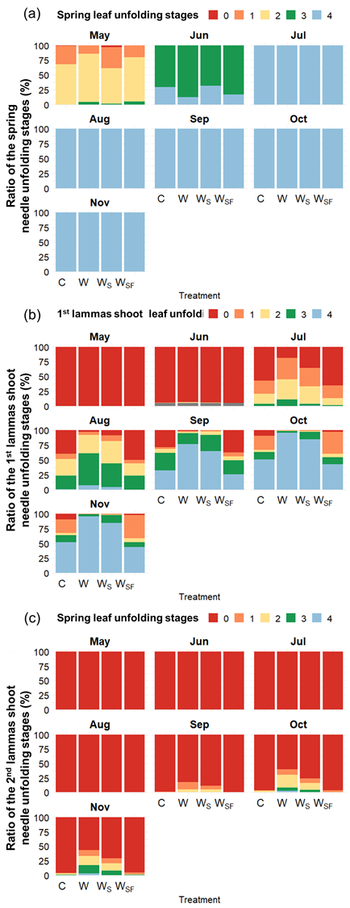
Fig. 1. Proportion of Pinus densiflora seedlings at each developmental stage of (a) spring needle unfolding, (b) first lammas shoot needle unfolding, and (c) second lammas shoot unfolding.

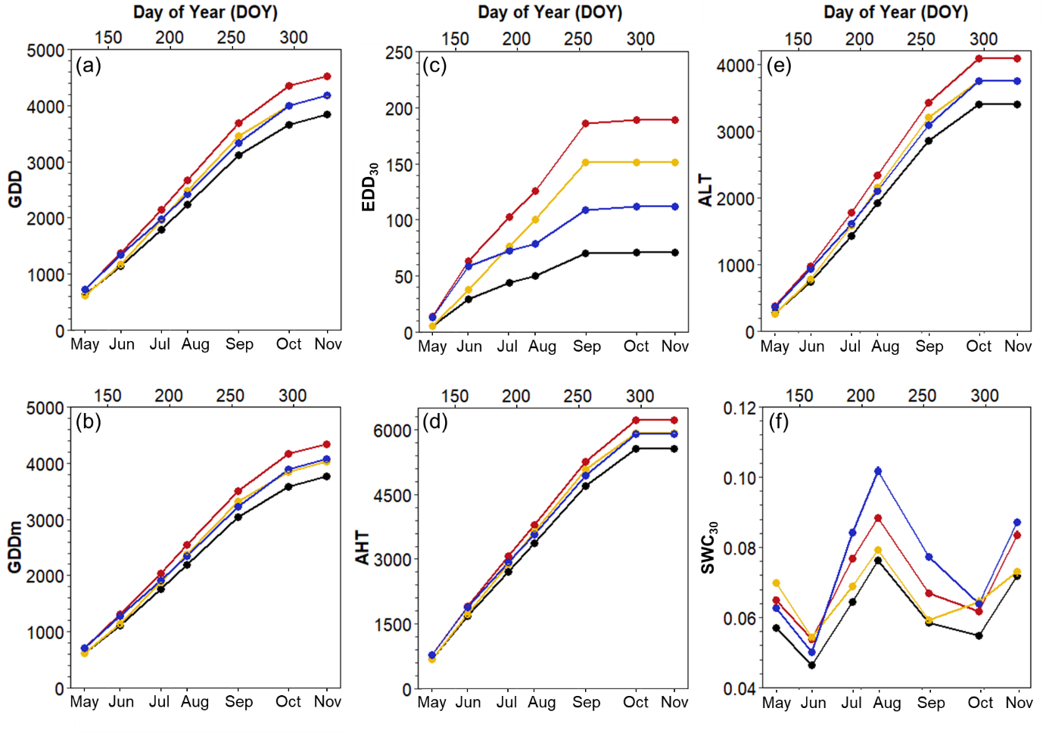
Fig. 2. Temporal changes in influential environmental variables across the experimental period (shown for each of the four treatments).

