Thermodynamic, Electrostatic and Interaction Energy Insights into Reactive Dye Behavior in Aqueous/Non-aqueous Polyester/Cotton Dyeing Systems

Danni Lu^{a,b,c}, Liujun Pei^{a,b}*, Jun Zhu^{a,b}, Wenhui Niu^{a,b}, Jifang Shen^{d}, Wenmiao Chen^{d}, Jiping Wang^{a,b,d}

ªShanghai Engineering Research Center for Clean Production of Textile Chemistry; Shanghai University of Engineering Science, Shanghai 201620, PR, China
^{b}School of Textiles and Fashion; Shanghai University of Engineering Science, Shanghai 201620, PR, China
^{c}Department of Biological and Agricultural Engineering, University of California, Davis,California 95616, United States
^{d}Zhejiang Green Universe Technology Co., Ltd, Haining 314408, Zhejiang, PR, China

Experimental
Standard working curve
Fig. S1 The standard curves of three reactive dyes (a)C.I. Reactive red 19, (b)C.I. Reactive blue 19, (c)C.I. Reactive black 5

Standard working curveInfluence of Thermodynamics on Reactive Dyeing in Different Media
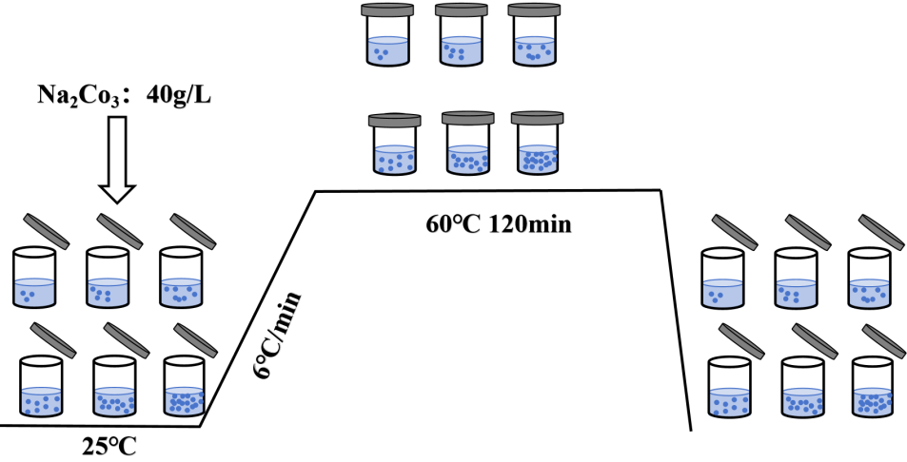
Fig. S2 Preparation of hydrolyzed dye samples at different concentrations
Fig. S3 Dyeing process for adsorption isotherm testing

Results and discussion
Ratio of Hydrolysed Dye to Reactive Dye on Fabric at Different Stages
Fig. S4 Chromatogram of C.I. Reactive blue 19 (a)Chromatograms of C.I. Reactive blue 19 unhydrolyzed for 60 min (R-60min), hydrolyzed for 5 min (H-5min), and hydrolyzed for 60 min (H-60min) (b)Chromatograms of rinsing residues collected after dyeing polyester and cotton fabrics with C.I. Reactive blue 19 (W denotes water bath; D5 denotes D5 system; D denotes the dyeing stage; F denotes the fixation stage; T denotes polyester; C denotes cotton)
Fig. S5 Chromatogram of C.I. Reactive black 5 (a)Chromatograms of C.I. Reactive black 5 unhydrolyzed for 60 min (R-60min), hydrolyzed for 5 min (H-5min), and hydrolyzed for 60 min (H-60min) (b)Chromatograms of rinsing residues collected after dyeing polyester and cotton fabrics with C.I. Reactive black 5 (W denotes water bath; D5 denotes D5 system; D denotes the dyeing stage; F denotes the fixation stage; T denotes polyester; C denotes cotton)

Thermodynamics of the Adsorption of C.I. Reactive blue 19 onto Polyester in Different Media
Fig. S6 Adsorption Nernst Isotherms of reactive blue 19 and hydrolyzed blue 19 on Polyester under different media conditions (a)Adsorption Nernst isotherm of reactive blue 19 in a water bath system, (b)Adsorption Nernst isotherm of hydrolyzed blue 19 in water bath system, (c)Adsorption Nernst isotherm of reactive blue 19 in D5 system, (d)Adsorption Nernst isotherm of hydrolyzed blue 19 in D5 system
Fig. S7 Adsorption Langmuir Isotherms of reactive blue 19 and hydrolyzed blue 19 on Polyester under different media conditions (a)Adsorption Langmuir isotherm of reactive blue 19 in a water bath system, (b)Adsorption Langmuir isotherm of hydrolyzed blue 19 in water bath system, (c)Adsorption Langmuir isotherm of reactive blue 19 in D5 system, (d)Adsorption Langmuir isotherm of hydrolyzed blue 19 in D5 system
Fig. S8 Adsorption Freundlich Isotherms of reactive blue 19 and hydrolyzed blue 19 on Polyester under different media conditions (a)Adsorption Freundlich isotherm of reactive blue 19 in a water bath system, (b)Adsorption Freundlich isotherm of hydrolyzed blue 19 in water bath system, (c)Adsorption Freundlich isotherm of reactive blue 19 in D5 system, (d)Adsorption Freundlich isotherm of hydrolyzed blue 19 in D5 system

Spatial Conformation and Structure of Dye Molecules
Fig. S9 Spatial Structures of Dye Molecules (a)C.I. Reactive red 195, (b)C.I. Reactive blue 19, (c)C.I. Reactive black 5

